**Client**

My client is an Algonquin student who wants to share all the parks he has been to and create a handpicked national park that are near to Ottawa and worth visiting in all to any season. He is an individual and looking for a budget friendly and easy on eye looking website with as responsive as possible.

Project name: Algonquin’s Pick

Logo: (Text type) The Parks

**Style**

The website is a combination of responsive with one page and multi page website. While menu helps navigate on a single page. The different parks have different pages. This design is a direct descendant of the MVC design of the Angular js. Very effective way to add content dynamically from the backend. It has a lot of room of development as it can easily be converted into a repeated design with a streamline non-breakable flow of the data across the website.

Platform

As the client has asked to target smallest device possible and do a budget friendly too. I’ve tried to squeeze as much as possible responsive layout using CSS3 and hence it can support many small devices and all the large devices.

Although target device is 1024 X 768 and grater. I have made sure it can support a few smaller devices also. That way client can get best value for the money and in future when there is more room for the budget we can have a proper responsive layout.

**Semantic Design Guide:**

I’ve used an external css for icons

CSS: https://cdnjs.cloudflare.com/ajax/libs/font-awesome/4.7.0/css/font-awesome.min.css

To keep the design simple all my content is encapsulated in <div> tag.

**<div>:**

Expected use: Container element will be used to organize content and provide them with styles.

Name: tm-topbar, tm-container, tm-about, parks-list, contact, tm-form

Main fonts: Verdana, sans-serif

Color: White, 333333 and black to contrast with each other.

Images: Being main container there is not assigned image to it.

Location: all pages

<a>: Main navigation element

Expected use: Main navigation element

Name:

Main fonts: Verdana, sans-serif

Color: White, 333333 and black to contrast with each other.

Images: None

Location: all pages

I tag:

Expected use: The i element represents the symbol for the home and dropdown for list.

Color #009688 for home and white for Lists

h1, h2, h3, h4, h5, h6: Will be **used** the parks description although not element is used but specifying will help in create a singular css that can help in create a semantic web flow.

**Fonts** preferred are Segoe UI, Arial and sans-serif.

**Website map:**

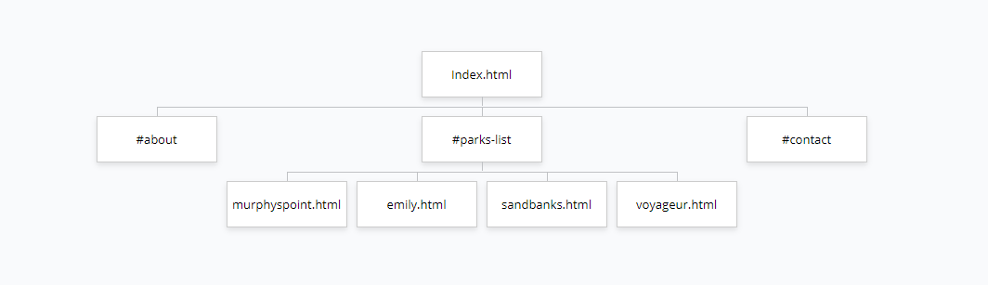

**Colour Palette:**

The site uses a mix of black, white, and red. The black surrounds the page and allows the other colours to help draw the eye towards those elements.

The red is used to wrap various buttons to draw the eye to the colour that pops out in comparison to the flatter colours used within the rest of the webpages.

**Typography:**

The font used is a default font set meant to be fairly easy on one’s eyes. The font is kept at a fairly standard font size to help prevent the users eyes from becoming strained from staring at a larger font size.