Members, Family, Friends and Interested Parties
Please Join West Great Lakes ACA Intergroup
For a Spaghetti Potluck Dinner and Open ACA Meeting
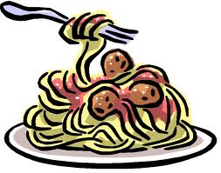
Three Great ACA Speakers

Saturday, February 25, 2012 (DRAFT FLYER – ALL INFO LIKELY TO CHANGE UPDATE)
4:30 Fellowship
5:00 Dinner and Dessert
5:30 to 7:15 Meeting

Unity in Chicago, 1925 West Thome, Chicago, IL 60660 (has a parking lot)

(ACA is not affiliated with event locations; ACA does not endorse, finance, or lend the ACA name to any related facility or outside enterprise)

(TBD a basket for Seventh Tradition donations will be passed for event expenditure TBD)

Come on down for food, fun, fellowship and great speakers
Contact person (312) 344-3859 www.westgreatlakesaca.org

