Question Set 1

a. The relationship between Genus and Species object is a parent-child relationship, with genus as the parent , and species as the child.

b. No relationship between Species and Specimen objects.

c. 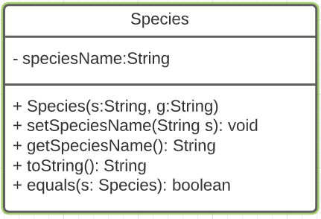

d. -The code will be reusable with the help of inheritance. It is easy to create a new species that inherits the generic traits and methods of the Genus. On top of that, each of the species can have their own unique attributes and functions.

- Easier troubleshooting. In object oriented programming, there is a concept called encapsulation. Meaning each object is self-contained and each bit only does one thing whilst the other does other different things. This is nice as if one class broke down, other class won’t be affected.

e. (I). Although species class inherits the toString method of genus class, the method can be made unique for the species class. This is called method overriding meaning, the toString method that is inherited is adjusted to suit the class therefore no exception is thrown.

(ii). This is applying the polymorphism concept, method overriding.

Question Set 2

a. Encapsulation is binding data and methods that work on that data within one unit. This concept is often used to hide the internal representation of the state of an object from the outside.

b. The first benefit of using encapsulation is it can prevent people that are working on the code from making mistakes. This is done by making sure they can only access things they are supposed to access. Another benefit is that the author of the class is free to do anything they want with the internals of the class, as long as they don’t change its behaviour. This is thanks to the fact that they can be sure that no one depends on these details.

c. getCage()

d. cageNumber