# Is economics a good major for future Financial Specialists?

# Evidence from earnings data

# Nathaniel A. Olisa

Department of Economics, San Jose State University, San Jose, CA, USA

**Abstract**

This study is reporting data on earning differences of financial specialist by

Undergraduate major while focusing on economic majors compared to other majors. Economic majors have a significant difference in earnings compared to other Business related Majors such as Finance, Accounting, and Business Management and Administration aren’t that far behind with similar median and mean earnings to Each other. In this article I report data from a difference in means and regression control to represent an unbiased casual effect. This information would be beneficial for undergraduates planning to go Into a career in the finance sector.

1. Introduction and Literature Review

A undergraduate degree in Economics in the published works I reviewed have shown it to be a very beneficial major to pursue. In this article by Dan A. Black, Seth Sanders, and Lowell Taylor, the authors use data sourced from the 1993 National Survey of College Graduates to see wether the economic rewards compared to different college majors. They find out that economics undergrads have a lot of options when it comes to pursing different career, including economics-related roles, analysis administration, and consulting. Compared to other college graduates economics majors earn more than all other business-related degrees with engineering degrees being the highest earner. Additionally, the study highlights that economics remains a great major for any gender and age. The research concludes that economics is a valuable field of study, offering wide career choices and serving as strong preparation for graduate education in business and law.

The article by Winter, John A explores the relationship between undergraduate college majors and earnings among practicing lawyers in the United States. Using data from the American Community Survey, the author finds that economics majors have high earnings, ranking around the top for both median and mean earnings among lawyers. In this article Winters used a regression control concept to estimate a less baised result because he concluded that the difference in means alone was not a good representation of casual effect. He took into consideration factores such as sex, age, and enthicity in his regression equation to provide a less biased result.

These articles both show that economics can be a great major to pursue, with Winters focusing on how it transitions to a career in Law. In this article, I will shift the focus to Financial Specialists. I will explore the difference in means between economic majors compared to other majors and apply regression control to evaluate a less biased result.

2. The Data

Each year, the American Community Survey (ACS) conducts surveys on 1 percent of the U.S. population, inquiring about a wide range of subjects related to households, demographics, education, employment, income, and occupations. Since 2009, the ACS has also included questions for individuals holding a bachelor's degree or higher, requesting information about their specific field of study during their undergraduate education. I analyzed the disparities in annual earnings among practicing financial specialists based on their undergraduate college majors using the combined data from 2009 to 2013 obtained from the Integrated Public Use Microdata Series. All earnings reported are annual and adjusted for inflation for the 2015 US dollar. Table 1 shows the popular undergraduate majors for all financial specialists. Listed in the table are the top 20 majors with a frequency amount and percent of how many people chose each major as well as the mean and median of the earnings. Finance is the most popular major among financial specialists accounting for 18% of the occupation by itself with business administration accounting and economics following right behind it. Economics is the fourth most popular major with a 7.9% size. The Top 5 majors account for 55% of financial specialists.

Next up, I'm going to use data from the ACS (American Community Survey) to figure out how much money people typically make after studying the 20 most popular majors. Plus, This equation is a multivariate this allows me to take multiple variables into account that can alter the dependant variable to reduce the bias. The two variables i will be using are economic major and gender to help us figure out how much your major may influence the amount of income you will earn, and to help us figure out if there's a connection between what major someone picks and how much money they'll make down the road. It's like trying to find out if your major choice can affect your future income. Here's what the equation looks like:

EARNINGSi = α + βECONi + γFEMALEi + ei

In this formula, EARNINGSi represents how much money a person (let's call them individual i) makes in a year, ECONi tells us if they studied economics as their major (1 if yes, 0 if they picked something else), and FEMALEi helps us know if individual i is a female (1 for yes, 0 for male). The variable ei helps us deal with any mistakes or things we might have missed in our calculations.

Now, the α, β, and γ values are like the coefficients we'll figure out using that ACS data I mentioned earlier. There are alot of variables that can affect a persons future income not just a major that is why we use regression models with the major being the dependant variable. These regression models is how economist try to take those other variables into account. It's kind of like peeling back layers to see what's really going on with major choices and future paychecks.

3. Analysis: Median and mean earnings by major

Are the average earnings of economics majors statistically different from the average earnings of business and related majors? The mean and median presented in Table 1 provide descriptive statistics. It is good information but cannot represent causal inference because it doesn’t take into account a person’s work ethic or sex which may affect how much they earn. The regression results in Table 2 collum 1 is a bivariate regression with the following equation EARNINGSi = α + βECONi where α = 122,928.7000 and β = 42,804 while ECONi is a binary dependant variable that can either be 1 for Econ majors or 0 for any other major and this equation shows that people who major in economics make 42,804 dollars more than people who don’t choose economics as their major. This difference in means is biased and cannot be looked at as a casual inference because it’s calculated using observational data and doesn’t include enough control variables. To improve the regression results I added sex to the equation as an independent variable this reduces omitted variable bias by accounting for the effects sex has on earnings. The OVB is 6,902.7 and this is the difference in earnings between the short and equation long equation (the one we added a variable). This gives us a less biased result. Collum 3 is an auxiliary regression with FEMALE as a dependent variable the equation for this auxiliary regression is FEMALE = Pi0 + Pi1*ECON where Pi1 is -0.1085 and γ = -63,619.3200 When you substitute these numbers into the OVB equation you get a balanced equation so this is the amount of bias by omitting the female variable. In tabe 2 R^2 is a measure of fit 0 for it doesn’t fit the data at all and 1 for it fits the data if you compare collum 1 and 2 you can see that collum 2 fits the data much better than collum 1 with a higher R^2 of .0628 compared to collum 1 with .0094. The adjusted R^2 is the same because our data set is so big. All of the cofficents and t-statistics are significant at the 1% level. This regression model isn’t as good as a experiment but provide good descriptive statistics and with more control variables could provide less biased results that could represent casual inference.

Financial_specialists

| **major** | **freq** | **Cumuli_percent** | **mean** | **median** |
| --- | --- | --- | --- | --- |
| **Finance** | 2840 | 18 | 118,820 | 81,378 |
| **Business Management and Administration** | 1846 | 11.7 | 97,377 | 70,370 |
| **Accounting** | 1574 | 9.9 | 101,878 | 75,735 |
| **Economics** | 1258 | 7.9 | 146,7464 | 93,577 |
| **General Business** | 1160 | 7.3 | 108,4093 | 75,396 |
| **Marketing and Marketing Research** | 481 | 3 | 108,533 | 70,370 |
| **Psychology** | 441 | 2.8 | 90,3626 | 60,317 |
| **Political Science and Government** | 419 | 2.6 | 124,1466 | 79,393 |
| **Communications** | 327 | 2 | 83,3104 | 59,545 |
| **English Language and Literature** | 281 | 1.72 | 93,858 | 68,778 |
| **History** | 274 | 1.71 | 116,278 | 69,469 |
| **Mathematics** | 265 | 1.6 | 115,537 | 80,410 |
| **Biology** | 184 | 1.1 | 123,249 | 76,199 |
| **Computer Science** | 168 | 1 | 113,087 | 75,396 |
| **Criminal Justice and Fire Protection** | 166 | 1 | 65,120 | 50,264 |
| **Sociology** | 150 | 0.95 | 109,181 | 56,567 |
| **Business Economics** | 135 | 0.85 | 129,604 | 79,574 |
| **Liberal Arts** | 126 | 0.8 | 89,208 | 63,197 |
| **Electrical Engineering** | 124 | 0.7 | 136,732 | 90,476 |
| **International Business** | 118 | 0.71 | 92,769 | 64,084 |

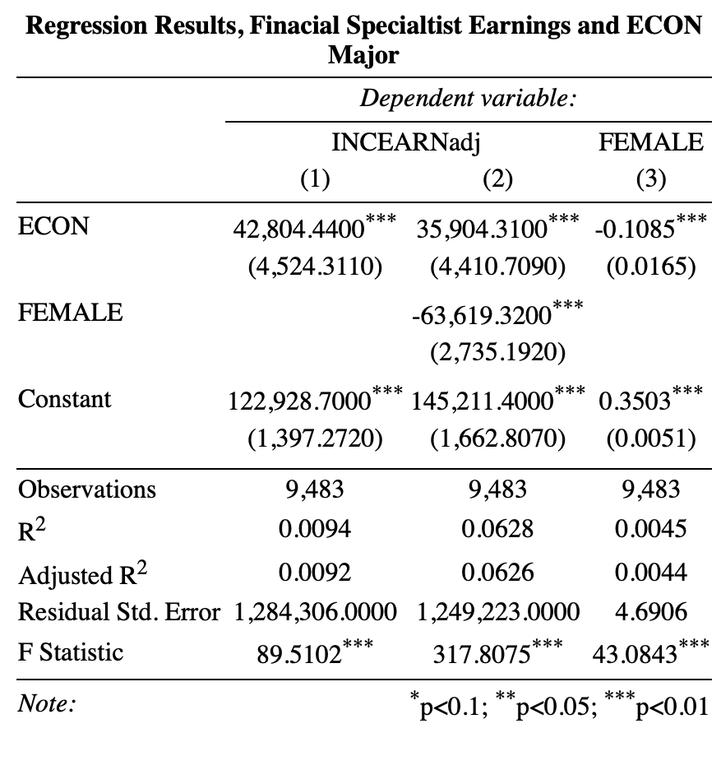

4. Conclusion

In this article, I share informative statistics regarding the varying income levels among undergraduate majors pursued by financial professionals in the United States, with particular emphasis on economics majors. Notably, some majors outperform others significantly in terms of earnings. Within the 20 most prevalent undergraduate majors for individuals in the financial field, economics boasts the highest average and median incomes. Consequently, economics emerges as an exceptionally lucrative choice for undergraduates contemplating a career in finance or consulting. This data proves valuable for those planning to embark on a finance-related path and considering economics as their undergraduate major.

5. Acknowledgments

## Professor [Matthew Holian](https://sjsu.instructure.com/courses/1573025/users/3368785), Peer reviewer Trent Peters

6. Notes

1. I used the IPUMS occ1990 variable and narrowed down the dataset to individuals possessing an occ1990 code of 25.
2. The ACS college major codes for economics (5501) and business economics (6205) were merged into a unified category known as economics.
3. Although, numerous potentially crucial factors remain inaccessible within the ACS dataset, and the allocation of college majors is not subject to randomization. As a result, regression estimates provide only a restricted advantage when compared to measures such as means and medians.
4. People make diverse choices, both apparent and hidden, which influence their selection of an undergraduate major, their decision to enter the field of finance, the specific financial roles they pursue, their choice of workplace, and their potential earnings. As a result, it is not advisable to definitively attribute observed variations in earnings between majors to a causal affect.

7. References

Winters, John V. "Is economics a good major for future lawyers? Evidence from earnings data." *The Journal of Economic Education* 47, no. 2 (2016): 187-191.

Black, Dan A., Seth Sanders, and Lowell Taylor. "The economic reward for studying economics." *Economic Inquiry*41, no. 3 (2003): 365-377.