Nate Evans

Mike Mooney

BMI665

11/6/18

HW 5

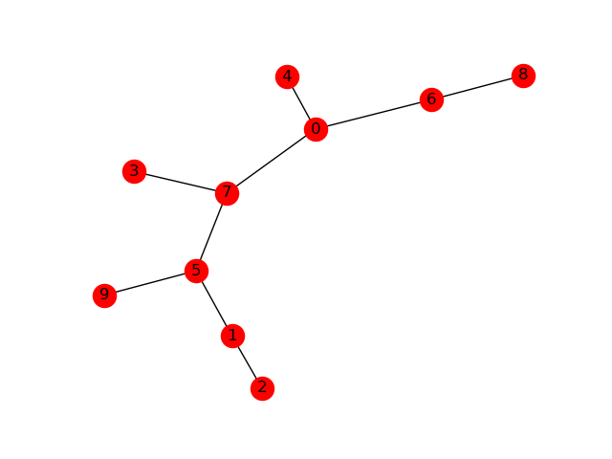

----------------------------------------------------------------

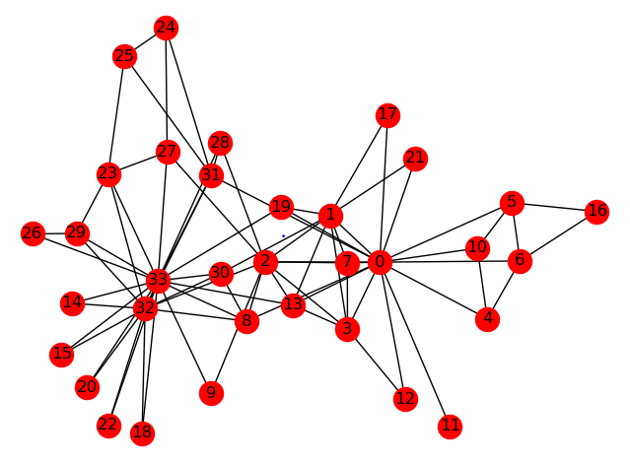

----------------------------------------------------------------

Node origin: 0

depth first search: [9, 2, 1, 5, 3, 7, 8, 6, 4, 0]

----------------------------------------------------------------

node origin: 1

breadth first search: [1, 2, 5, 9, 7, 0, 3, 4, 6, 8]

graph is connected: True

----------------------------------------------------------------

----------------------------------------------------------------

----------------------------------------------------------------

Node origin: 0

[karate club] depth first search

[11, 16, 10, 5, 6, 4, 21, 17, 19, 9, 26, 29, 28, 31, 27, 24, 25, 23, 22, 20, 18, 15, 14, 32, 30, 8, 33, 13, 12, 7, 3, 2, 1, 0]

----------------------------------------------------------------

Node origin: 0

[karate club] breadth first search:

[0, 1, 2, 3, 4, 5, 6, 7, 8, 10, 11, 12, 13, 17, 19, 21, 31, 30, 32, 9, 27, 28, 16, 33, 24, 25, 14, 15, 18, 20, 22, 23, 29, 26]

[karate club] graph is connected: True