FootFallCam technical assessment

Overview
I built a video pipeline to identify when a person wearing the supplied staff badge is present. The program detects people, follows them across frames, searches their image crops for the badge, and combines those matches over time. It exports an annotated video, frame-level results, and plots.

Approach
I used a pretrained YOLO11s model to detect people. Because the camera looks down on the scene, the detector checks each frame at four rotations and maps the boxes back to the original image. Non-maximum suppression removes duplicate boxes. A background subtractor can add moving-object proposals when YOLO misses something; this option assumes a fixed camera and a motion proposal is not proof of a person.

Tracking and badge matching
ByteTrack associates person detections across frames and assigns track IDs. These IDs can break or switch when people overlap, so the program splits a track into separate segments after a long gap or a large position jump. For badge detection, I used the three reference crops supplied with the assessment. The code resizes and rotates them, then searches within each person crop using grayscale and local-detail correlation. This is a reference-template baseline; I did not train a badge model. The resulting score measures image similarity and is not a probability.

Staff decision and outputs
By default, a track segment is classified as staff when at least two badge matches score 0.85 or higher within two seconds. Once confirmed, the staff label is applied across that segment, including frames where the badge is hidden. The code interpolates person boxes only across short gaps and marks those estimates. The output includes results.csv (one row per frame), people.csv (person and badge details), annotated.mp4, timeline.png, trajectory.png, metrics.json, and a run manifest. Coordinates are the person-box centre in image pixels, with the origin at the top left; they are not real-world floor coordinates.

Visual outputs

Timeline of predicted staff presence
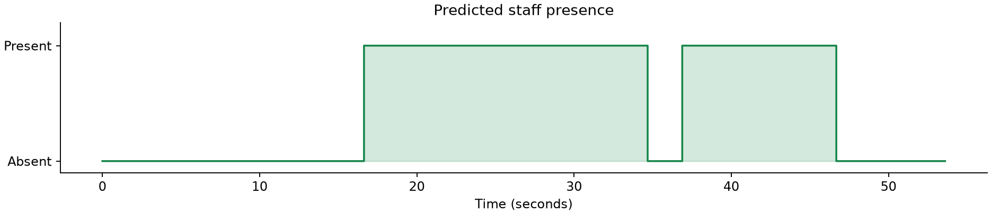
The green line shows the system’s frame-by-frame staff presence prediction over the sample video.

Staff position trajectory
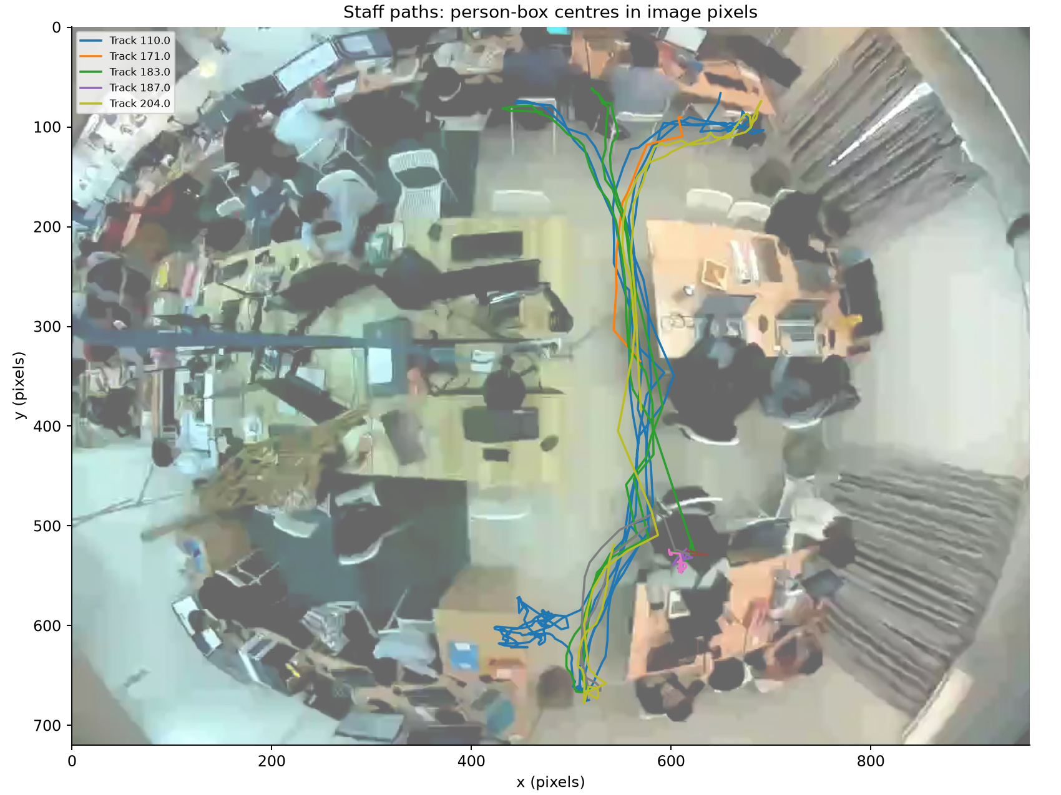
Paths show staff person-box centres in image pixels. The image origin is at the top left; these are not calibrated floor coordinates.

