Electric Field Lines

# Goals

* Visualize electric fields
* Observe the behavior of parallel plates.

# Part 1: Field

## Background

We have already seen Coulomb’s law: that charges attract or repel other charges: that charge *Q* will attract or repel some other charge *q* with a force equal to:

We might want to know how some other charge *q’* would react in the same situation. To do that, we would have to work out the above equation all over again, possibly adding up the force from many other charges.

An alternative is to find the **field** generated by all the other *Q* charges and add it up to make a new vector *E.* The force on charge *q* is then simply

and if we we want the force on *q’,* then we just use a *q’* in the equation above, which is much less work. Remember that if *q* changes sign, then that flips the direction of the ***F*** vector.

At first, fields were simply a mathematical convenience. It is now known that fields are real things, not simply abstractions.

## Drawing field lines

One way you can estimate the electric field is to draw field lines. Below are several examples of electric field maps.

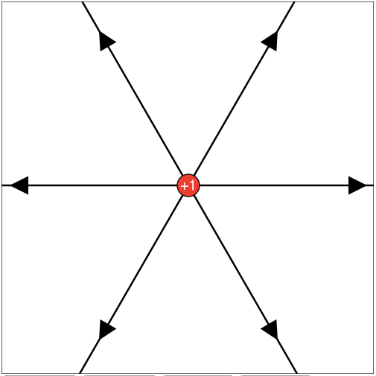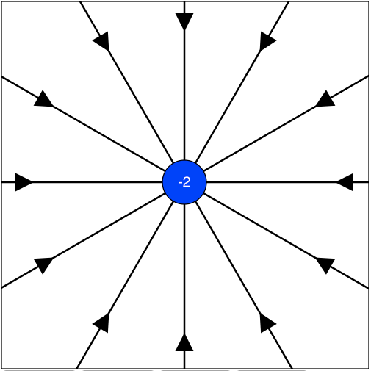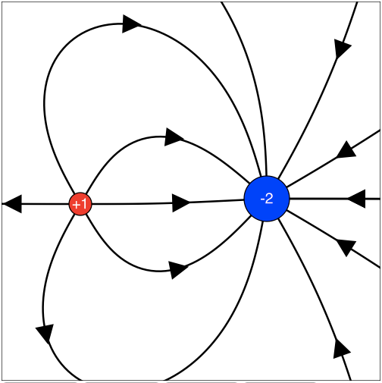

From the above images, we can infer some rules:

What does the direction of the arrow mean?

If there are many lines close together, what does it mean? (For instance, compare the corners of the left diagram to the center of the right diagram.)

Where can an arrow start? (That is, where do tails of arrows connect?)

Where can an arrow end? (That is, where to heads of arrows connect?)

How do you know if a charge is big or little from the arrows?

Let’s try out our rules. Try to draw the field lines for each of the examples below.

This one is called an ‘electric dipole’.

This one is tricky! Remember the arrow rules. If in doubt, ask yourself which way a tiny test charge would be pushed...

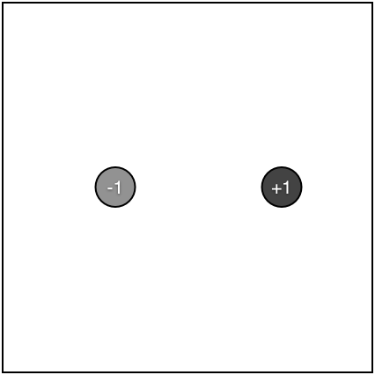

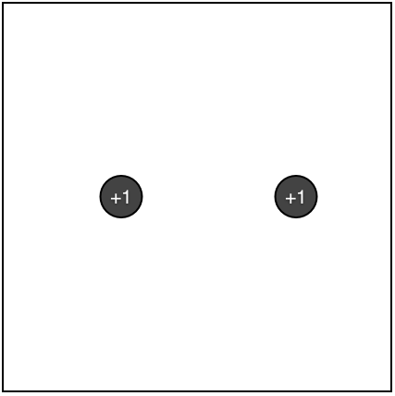

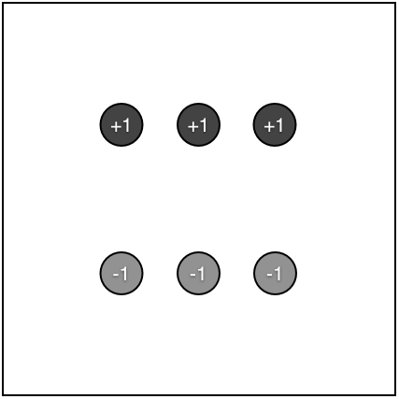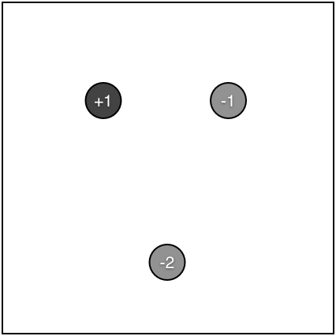

After you have tried each of these, check your answers with a computer program. Open a web page at:

This is like having two charged parallel plates.

Just an oddball

<http://neutrino.otterbein.edu/~tagg/fieldlines>

Fix your above answers as necessary.