Sexuality, Migration, and LGB Policy: A Portrait of Immigrants in Same-Sex Couples in the United States
Both internationally and in the U.S., the policy landscape for same-sex couples is changing rapidly, and surveys report swiftly increasing numbers of immigrants in same-sex couples in the U.S. Yet few researchers have examined immigrant-containing lesbian, gay, and bisexual (LGB) couples on a large scale, especially regarding their relationship to LGB policy. Are these immigrants disadvantaged and fleeing anti-LGB contexts, or empowered to migrate by progressive origin-country LGB policy? Using the American Community Survey from 2008 to 2019 and original datasets indexing LGB policy changes in 121 countries and all U.S. states, this study characterizes and assesses the scale of LGB migration to the U.S. as well as the role of LGB policy. Compared to different-sex immigrant couples, immigrants in same-sex couples come from richer, more democratic countries that are less represented among immigrants in the U.S. They also tend to be more highly educated, work in more prestigious occupations, and have higher incomes. Contrary to previous work focusing on LGB immigrants from repressive contexts, fixed-effect models show that higher proportions of these immigrants come from LGB-friendly countries, and they are more likely to live in progressive U.S. states. These findings highlight how sexuality as well as state policies seemingly unrelated to migration can shape migratory pathways.

Introduction
In 2013, the U.S. Supreme Court overturned the Defense of Marriage Act and required the U.S. government to recognize marriages between same-sex spouses. Among many consequences, this decision radically changed the immigration landscape: For the first time, same-sex spouses of U.S. citizens and lawful permanent residents were eligible to file a spousal petition for an immigrant visa (Edwards, 2013). Since, the U.S. population of immigrants in same-sex couples has grown rapidly (Redpath, 2022; Ruggles et al., 2021). According to American Community Survey data, numbers of different-sex couples including immigrants increased by 13 percent from 2013 to 2019 (from 8.4 million to 9.5 million), while those of corresponding same-sex couples grew from 61 thousand to 107 thousand in the same period, an increase of 76 percent. While some cursory descriptions exist (Gates, 2013; Goldberg & Conron, 2021), there is now a pressing need to understand the contours of this burgeoning population and the relevant forces shaping their migratory pathways.
While immigrants in same-sex couples may resemble their heterosexual co-nationals and respond to similar forces (e.g., economic benefits and network effects), there is good reason to suspect distinction. As the Supreme Court decision indicates, this population may be particularly responsive to changes in state policy. Indeed, the Supreme Court decision occurred against a backdrop of rapidly changing laws concerning same-sex couples – and lesbian, gay, and bisexual (LGB) communities, generally – both in the U.S. and abroad. As some countries expanded rights and social recognition, others imposed new forms of repression (Hadler & Symons, 2018). Emerging qualitative work demonstrates that changing policy landscapes are highly salient factors influencing migration decisions to the U.S., especially for asylees seeking refuge from more repressive contexts (Ahmad, 2013; Carrillo, 2018; Gorman-Murray, 2009; Mai & King, 2009; Vogler, 2016). However, given that sexuality receives relatively scant attention within migration research, there has yet to be a quantitative, representative investigation into how changing policy environments influence the migration patterns of individuals in same-sex couples into and across the U.S. Through studying the migration of same-sex couples, then, this study allows us to get a fuller understanding of migratory pathways by underscoring the importance of political and “lifestyle” considerations within migration decisions (Benson & O’Reilly, 2012; Fitzgerald et al., 2014).
How does the U.S. population of immigrants in same-sex couples differ from their different-sex counterparts? And how does country-of-origin and U.S. state LGB policy relate to their relative numbers? To address our research questions, we integrate two types of data. First, we rely on American Community Survey (ACS) data from 2008 to 2019 (Ruggles et al., 2021), which allows the identification of individuals in cohabiting same-sex couples as well as their country of origin, U.S. state of residence, education, income, and other individual characteristics. Second, we merge these data with country- and state-level datasets on variables relevant to these migrants, most notably an original dataset indexing LGB policy changes in 121 countries and all U.S. states from 1991 to 2019.
Our analytic strategy proceeds in two parts. First, we descriptively understand who these cohabiting LGB immigrants are. This first step is important because little is known about this growing population. Second, we focus on country-of-origin and U.S.-state effects, modeling how representation of immigrants in same-sex partnerships changes over time in relation to the LGB policy in both contexts. We control for numbers of immigrants in different-sex couples by modeling the proportion of immigrants from a given country that are in cohabiting same-sex couples, out of all cohabiting immigrants from that country.
Our investigation offers several novel insights. First, we find the immigrants in same-sex couples differ markedly compared to co-nationals in different-sex relationships. Specifically, those in same-sex relationships are often better educated, have higher incomes, and appear less influenced by network effects. Second, we find that origin countries with more LGB-friendly policies send higher proportions of immigrants in same-sex couples into the U.S. This finding is unexpected given existing queer migration scholarship which largely focuses on asylum seekers fleeing repressive contexts and seeking entry into the U.S. and other countries in the Global North (Akin, 2017; Dhoest, 2019; Giametta, 2020a; Karimi, 2020; Murray, 2014; Saleh, 2020; Sam & Finley, 2015). Our findings also indicate that immigrants in same-sex couples are more likely to reside in U.S. states with progressive policies, especially if they come from countries with more supportive policies as well. By showing how policies seemingly unrelated to migration can shape migration decisions and actions, this projects shows how identity – and the state’s governance of it – can interact with broader institutional contexts to yield unexpected results.

Background: Changing Policy Landscapes and Same-Sex Immigrant Couples
The U.S. continues to undergo significant shifts in the policies governing LGB populations at both state and federal levels. Since 2003, the U.S. Supreme Court has ruled sodomy laws and the Defense of Marriage Act unconstitutional, federally recognized same-sex marriages, and curtailed employment discrimination. In response, though, several U.S. states have implemented new policies hindering LGB communities on top of existing discriminatory practices (Kazyak et al., 2018). These dynamics create a varied landscape in which state lines significantly demarcate the types of rights and legal environments LGB people experience. Now, a burgeoning area of scholarship exists to understand the causes of these transformations (Lax & Phillips, 2009; Soule, 2004) and their distinct consequences on the lives and well-being of LGB people (Boertien & Vignoli, 2019; Carpenter, 2020; Kail et al., 2015; Levy & Levy, 2017).
Although this changing policy landscape affects LGB populations of all types, particular sub-groups within this broad umbrella are differentially impacted. Same-sex immigrant couples represent a population especially vulnerable to recent changes. This is because prior to being able to experience recognized rights like marriage or non-discrimination protections, immigrants in same-sex couples must first be able to enter into the U.S. While single queer migrants could potentially enter the U.S. through some existing visa pathways (e.g., employment-sponsored, family-sponsored, asylum), federal U.S. law historically hindered LGB couples’ ability to enter the country due to the government’s lack of recognition of their relationship (Human Rights Watch, 2006). While, in theory, queer asylum seekers could enter with a same-sex spouse through the “derivative asylee status,” lack of spousal recognition by sending countries and invasive requirements to “prove” one’s sexuality rendered this avenue effectively inaccessible (Human Rights Watch, 2006; Ritholtz & Buxton, 2021).
The federal environment governing immigration significantly changed after 2013. The U.S. Supreme Court decision ruling the Defense of Marriage Act (DOMA) unconstitutional opened the door for same-sex immigrant couples to enter the U.S. through the same process long governing different-sex couples (Edwards, 2013). Now, couples could enter together, or one partner already in the U.S. could sponsor their same-sex fiancé(e) or spouse. As Figure 1 highlights, the number of same-sex immigrant couples in the U.S. grew significantly following this ruling – especially when compared to different-sex couples. Aside from allowing gay and lesbian families to remain unified, this national opening creates an important moment for the scholarly community to begin investigating the factors motivating this emerging population to migrate to the U.S.
[FIGURE 1 ABOUT HERE]
The U.S. is not alone in seeing rapid policy change related to LGB couples. Recent changes in LGB rights around the world are increasing the salience of one’s sexuality as an important decision point to leave one’s home country (Mole, 2018; Murray, 2016). This is partly driven by the transnational flow of information and general visibility of those with diverse sexualities that accompanies policy change (Ayoub, 2016; Ayoub & Garretson, 2017). Greater circulation of cultural content makes one cognizant of how they are treated in their home country due to their sexuality, for better or worse, compared to these outside contexts (Carrillo, 2018; Karimi, 2020; Vuckovic Juros, 2022). Indeed, international organizations contribute to this increased salience by constructing sexuality as a legitimate basis for leaving. For example, in 2008 the United Nations High Commissioner for Refugees issued a new guidance note for why and how countries should consider sexual orientation and gender identity when granting asylum claims (UNHCR, 2008). The note guides various authorities to consider discriminatory domestic policies when evaluating asylum claims as such policies “can create or contribute to an oppressive atmosphere of intolerance and generate a threat of prosecution” (UNHCR, 2008, p. 8). International organizations such as the European Union and several countries now incorporate the U.N. guidance (Giametta, 2020b). As the DOMA decision demonstrates, too, these LGB policies are important as they can condition initial access to a country and the quality of life once there.
Current research on the types of policy environments likely to influence the migration of those in same-sex couples is both limited in scope and mixed in outcomes. This is partly due to emerging scholarship at the intersection of sexuality and migration being overwhelmingly qualitative. Only recently have representative samples that allow identification of LGB immigrants been available, yet these have thus far been underutilized. Thus a broader portrait of LGB migrants, and how policy environments influence them, is urgently needed.

Empirical Expectations
Migration scholars have long accepted that migration is more likely when economic gain is likely (Hatton & Williamson, 2005; Todaro, 1980), established migration flows exist (Hernández-León, 2013; Massey et al., 1987, 1999), and countries are physically and culturally proximate (Karemera et al., 2000; Mayda, 2010). Despite a lack of research applying these theories to migration of same-sex couples, previous demographic research on non-immigrant same-sex couples suggests how they might apply. In the labor market, men in same-sex couples tend to earn less than their heterosexual counterparts, but women tend to earn more (Klawitter, 2015) – though the gap for the latter has decreased in recent years (Badgett et al., 2021). On average, married same-sex couples are older and have higher earnings than their different-sex counterparts (Fisher et al., 2018), while results for unmarried couples are mixed (Badgett et al., 2021; Baumle et al., 2009). If immigrants in same-sex couples similarly have higher earnings than heterosexual immigrants, then the typical economic push and pull factors of immigration may affect them differently. One difference is that these higher earnings may open pathways for lifestyle factors to influence their migration decisions (Benson & O’Reilly, 2009; Dixon, 2020). Finally, although same-sex romantic relationships between men generally have higher levels of instability than between two women or different-sex relationships (Joyner et al., 2017), the dissolution rates for cohabiting same- and different-sex couples are similar (Manning et al., 2016). If LGB immigrants experience higher rates of union dissolution, then our estimates of the proportion of immigrants who are in same-sex couples represents a lower bound.

Are LGB immigrants coming from generally repressive or progressive contexts? Despite representative research on this population, there is evidence to support both hypotheses. On the one hand, much queer migration research reflects Adur’s suggestion that (2018, p. 321, emphasis theirs), “LGBTI immigrants relocate in pursuit of spaces that they imagine will be safer and more liberal.” Indeed, this reflects the numerous studies characterizing migrants in same-sex relationships as largely escaping repressive contexts (Akin, 2017; Dhoest, 2019; Giametta, 2020a; Murray, 2014; Saleh, 2020; Sam & Finley, 2015). This narrative is, in part, due to most scholarship within this area focusing on asylum processes, especially after the U.N. guidance note in 2008 and after then-President Obama made queer refugees a “population of concern” for the U.S. in 2011 (Lewis & Naples, 2014; Luibhéid, 2008; Vogler, 2016). Although the U.S. is less progressive and inviting compared to many other Western states, high-profile developments such as marriage equality can contribute to an imagined openness relative to many locations around the world. For example, access to gay content in film and on the Internet contributed toward Iranian refugees’ decision to seek sexual freedom in the West (Karimi, 2020). Moreover, another strand of research documents how people in more oppressive contexts seek out partners in more equitable locations who can then sponsor them through the immigration process (Carrillo, 2018; Corey-Boulet, 2019).
Though such studies suggest immigrants in same-sex couples are largely fleeing repressive contexts, Luibhéid (2005, p. xxv) cautions against overemphasizing queer migration as “a narrative of movement from repression to freedom, or a heroic journey undertaken in search of liberation.” Even when migrants imagine they are moving to a much more progressive context, actual policy differences may be relatively minor. Carrillo (2018) explores a prominent case of this in his study of the “sexual migration” of gay Mexican men to the U.S. Overall, U.S. LGB policy is somewhat more progressive than Mexico’s, but Mexico’s large, cosmopolitan cities are more welcoming to queer people than many parts of the U.S. Why, then, do these young men feel like they must cross the northern border in order to live their authentic lives? Carrillo argues that their often rural birthplaces, conservative upbringings, and unsympathetic family members lead these men to believe that only by migrating to the U.S. can they live openly. Since northward migration is a common choice for young Mexicans seeking upward mobility, family members are less likely to question this decision, and steady remittances help ward off prying questions. This observation may generalize to other contexts: LGB immigrants may believe they are moving to a much more progressive country, when actual policy differences are relatively minor.
On the other hand, immigrants in same-sex couples may come from countries with greater recognition and access to sexuality-related rights and services than the U.S. There are two interrelated reasons for this. First, affirming policy environments are likely to enable people’s capacity to make such an important, expensive move (de Haas, 2021). Long-standing research on immigrant selection demonstrates that migrants typically occupy stronger social positions – more formal education, higher incomes, and more prestigious occupations (Feliciano, 2020). Supportive policies like marriage equality and protections against employment discrimination may enable the capacity to migrate by providing more access to necessary social, human, and economic capitals. Second, same-sex coupledom, like marriage, is a culturally contingent artifact (Philpot et al., 2016). Consequently, the interactive dynamics between policy and culture within an immigrant’s country of origin is likely to influence both their decision to “come out” and then their desire to be part of a couple (Baiocco et al., 2014; Flores & Barclay, 2016; Ocobock, 2020; Suen, 2021). Policies supportive of LGB communities normalize and validate the disclosure of such identities and partnerships (Ocobock, 2020) – influencing those with same-sex attractions to imagine and aspire such possibilities for themselves. And, relatedly, being from a country where the state recognizes one’s sexuality and validates these relationships may make survey respondents, once in the U.S., more comfortable disclosing their relationship.
Unlike our mixed expectations for origin-country policy, we are more confident that LGB immigrants will locate to U.S. states with progressive policy contexts. Gay and lesbian couples within the U.S. were likely to leave states without marriage equality prior to national recognition (Beaudin, 2017), and queer migrants often have strong cross-national networks for relaying information (Stella & Gawlewicz, 2020). These factors likely results in a greater concentration of coupled LGB immigrants in states with marriage equality and other protective policies. Additionally, if migrants are coming from a country with greater legal protections, they are unlikely to want to relocate to a state where such rights are no longer recognized – rendering the political environment acutely important. Of course, this is predicated on the assumption that migrants take such distinct sub-national variations into account – which they very well may not. Consequently, the “pull” to individual states may operate independently from specific state laws affirming LGB people and their relationships.

Data and Methods

Identifying Same-Sex Couples in the ACS
We merge individual-level data on immigrants in the U.S. with state- and country-level variables from a variety of datasets. The individual data come from the 2008 to 2019 ACS (Ruggles et al., 2021). Each year, the ACS surveys a 1-percent representative sample of the U.S. population about their education, occupation, income, family structure, immigration status, country of origin, location, and a variety of other individual and household attributes. We define a same-sex couple as two individuals of the same sex in the same household who report their relationship as “spouse” or “unmarried partner.” We limit the sample to individuals who immigrated at the age of 18 or older and in 1991 or later. Hence this analysis considers four types of couples: (1) two-immigrant couples who came to the U.S. together; (2) two-immigrant couples that formed once in the U.S.; (3) mixed status couples where an immigrant migrated to be with their U.S.-born partner; and (4) mixed status couples that formed in the U.S. In the Online Appendix, we present results separately for one- and two-immigrant couples. We are unable to differentiate between couples that partnered or married abroad and those that did so in the U.S. We elaborate on the implications of these scope conditions in the Discussion.
The 12 years of survey data contain 6,349 same-sex couples that include at least one immigrant, for a total of 7,077 immigrants in same-sex couples with complete data. These immigrants are compared to 641,521 corresponding different-sex couples containing 900,571 individual immigrants. All analyses incorporate ACS sampling weights.
Measuring the prevalence of same-sex couples in the U.S. is difficult (Michaels, 2013). As in most nationally representative demographic work on same-sex couples (Baumle, 2013; Baumle & Dreon, 2019), we are able to identify only LGB couples that cohabit; unpartnered LGB individuals and those who do not live with their partner are not included in the analysis (Baumle et al., 2009, p. 6). In addition, LGB individuals who do not feel comfortable with the partner labels of the ACS are not in the sample. Another pitfall is measurement error: Misreporting may result when different-sex couples accidentally misspecify the gender of one of the partners (Gates & Steinberger, 2009; Goodnature & Neto, 2021). Beginning in 2008 the Census Bureau made changes to ACS gender and partnership questions in order to prevent such errors (U.S. Census Bureau, 2013), so we rely on data only from 2008 onward, but difficulties remain. If even a small number of different-sex couples misreport one partner’s sex, the counts of same-sex couples will be inflated. Following Gates & Steinberger (2009), we remove all respondents that had either their relationship or sex variable allocated by the Census Bureau, which results in dropping 606 immigrants in same-sex couples and 49,204 in different-sex couples, or 5.2 percent of the sample. This is the strategy used by most studies of same-sex couples in the ACS (e.g. Boertien & Vignoli, 2019; Christafore & Leguizamon, 2019; Gates, 2013; Goldberg & Conron, 2021; Martell & Nash, 2020). We also include robustness checks to test the sensitivity of our results to high rates of misreporting.

Analytic Strategy
Many of our analyses entail descriptive statistics of ACS data. For these, we apply survey weights from the ACS.
One of our goals is to isolate the effects of country-of-origin LGB policy on the immigration of immigrants in same-sex couples. The ideal survey would follow potential immigrants over time and have information about sexual orientation, allowing us to estimate how the probability of migrating and choice of U.S. state of residence vary by sexual orientation. This ideal dataset does not exist, but we attempt to approximate it.
We reshape the data so that each observation is the proportion of individual cohabiting immigrants in same-sex couples from country $x$ in state $y$ in survey year $z$, then multiply by 100. For example, the observation for France $×$ New York $×$ 2015 is 2, meaning that among coupled ACS respondents who immigrated from France and resided in New York at the time of the 2015 survey, a weighted 2 percent were in same-sex couples. This transformation of the data results in 37,980 country-state-year observations. This reshaping acts to control for aspects of migrant settlement common to immigrants from the same country. We regress the country-state-survey year proportion on state and sending-country policy scores and adjust for state and origin-country controls (listed below) using OLS. State-level measures are linked to survey year, while origin-country LGB policy and controls are linked to the mean year of immigration for each country-state-year immigrant group. In our final models, we include state and country-of-origin fixed effects, and we cluster errors at the state and country levels.

Variables
Our country- and state-level variables come from a variety of sources. Country-of-origin variables include bilateral distance, contiguous border, common official language, common ethnic language, and whether the country was a former colony of the U.S., come from CEPII’s GeoDist dataset (Mayer & Zignago, 2011). Difference in living standards, calculated as difference in per capita GDP at purchasing power parity (U.S. minus country of origin), come from the RGDP$​^{\text{e}}$ variable of the Penn World Table (Feenstra et al., 2015), and we rely on World Bank data for differences in unemployment rates (World Bank, 2020). We use Varieties of Democracy (V-Dem) measures of liberal democracy of the country of origin (Coppedge et al., 2021). We proxy network effects by dividing each country’s immigrant stock by the total number of immigrants in the U.S. in a given year, using the UN’s Trends in International Migrant Stock report for (United Nations, 2017) for 1990, 1995, 2000, 2005, 2010, 2015, and 2017, linearly interpolating to yield an annual time series from 1990 to 2020. For state controls, we use per capita income by year from the Bureau of Economic Analysis (BEA, 2020) and state-level annual unemployment rates from the Bureau of Labor Statistics (BLS, 2020). All monetary variables are adjusted to 1999 U.S. dollars.
To examine LGB policies at country of origin and state of destination, we use original datasets. To create the U.S. state policy index, we compile data from the Movement Advancement Project, a leading LGB organization in the U.S. that collects data on a number of relevant policies. Our state index encompasses both progressive policies (full marriage equality, state recognition of civil unions and domestic partnerships, ban on all employment and housing discrimination based on sexual orientation, hate crime protections based on sexual orientation, legal joint adoption by same-sex couples, and a ban on conversation therapy for minors) and regressive policies (criminalization of sodomy, state constitutional bans of marriage equality, religious freedom exemptions to discriminate against same-sex couples in adoption, and state-level bans on local non-discrimination ordinances encompassing sexual orientation). The state index ranges from -1 to 7, and the mean state policy score for immigrants in our sample is 3.2.
We measure the origin country policy environment using a modified LGBT Policy Index (Velasco, 2018). The index comprises 16 policies, many similar to those above, but including additional policies like the death penalty for homosexual acts, propaganda laws limiting free speech for LGB communities, and equal age of consent between same-sex and different-sex couples. We remove policies targeting gender identity and transgender communities from the original index. Both state and country indices are created by summing the net total of progressive policies (scored $+1$) over regressive policies (scored $-1$). For the 121 countries of origin for our sample, country index ranges from -3 to 10, and the mean score of country of origin for immigrants in our sample is 1.7. Immigrants are assigned U.S. state index scores based on their state of residence as reported in the ACS, and they are assigned country-of-origin index scores based on their birthplace and year of immigration.
We also include a binary variable to indicate the change in national policy environment within the U.S. following the overturning of DOMA in 2013. This represents an important shift opening up traditional pathways of immigration to same-sex couples. We include an interaction term between this post-DOMA indicator and country-of-origin index because we theorize that the effects will be more pronounced following this period.
For individual characteristics, we rely on ACS variables for reported sex, age, education (with categories for less than high school, high school, some college, and college), year of immigration, inverse hyperbolic sign of positive income in thousands in the past year [similar to the natural log transformation; see Burbidge et al. (1988)], and a binary unemployment indicator (for income reported to be 0 or less). Descriptive statistics for variables used in all analyses are included in Section A of the Online Appendix.

Results

Descriptive Trends
We first estimate total numbers of immigrants in same- and different-sex couples, applying survey weights to obtain population-level estimates from the ACS. Recall that Figure 1 showed that, whereas numbers of different-sex immigrant couples have steadily increased over the period of study, numbers of same-sex immigrant couples have increased much more rapidly, especially since the the 2013 Supreme Court decision overturning DOMA.
[FIGURE 2 ABOUT HERE]
How do same- and different-sex immigrant couples differ in their origin-country and individual attributes? Do variables typically used in models for migration differ between the groups? Figure 2 compares immigrants in same- and different-sex couples on five origin country-level variables. First, macroeconomic theory predicts that differences in wages and living standards across countries is one of the most important motivations for migration. Panel A in Figure 2 shows that per-capita GDP is indeed higher in the U.S. than the average country of origin for both groups of immigrants, but the gap is significantly greater for immigrants in different-sex couples. This means that immigrants in same-sex couples are coming from countries with higher standards of living than those in different-sex couples. Statistics for the unemployment rate differential (Panel B) indicate similar trends: LGB immigrants come from countries with lower unemployment rates. These findings indicate that macroeconomic considerations may be less important to the migration of LGB immigrants.
Models of migration also often use distance between countries as a proxy for migration costs, with closer countries often having more migration between. Panel C of 2 shows that immigrants in same-sex couples tend to come from somewhat more distant countries. Panel D looks at a measure of network effects: At the time of immigration, what is the proportion of total immigrants in the U.S. from the country of origin? Compared to different-sex couples, immigrants in same-sex couples immigrated from countries that were less represented in the U.S. population at the time of migration. This indicates that the network effects that attract migrants from the same country of origin may be less relevant to LGB immigrants. Finally, Panel E of Figure 2 compares V-Dem democracy level for country of origin at time of migration. We see that levels of liberal democracy tend to be higher for immigrants in same-sex couples, indicating that political context may play a more important or different role in their migration decisions.
[FIGURE 3 ABOUT HERE]
Immigrants in same-sex couples appear to come from more advantaged countries, but are they more advantaged on an individual level as well? Previous studies on LGB immigrants show those coming from advantaged countries may still be fleeing individual disadvantage. Figure 3 presents results from four individual attributes. Panels A and B show that immigrants in same-sex couples tend to be more highly educated than immigrants in different-sex couples, with about 10 percent more having high school and four-year college degrees. Panel C corroborates the macroeconomic findings at the individual level: Not only do immigrants in same-sex couples come from countries with higher per capita GDP, but they individually tend to earn more than immigrants in different-sex couples. Panel D demonstrates that immigrants in same-sex couples also tend to work in professions with higher occupational prestige scores. Together, these findings indicate that LGB immigrants may come from more privileged social origins than their heterosexual counterparts.
Figure 2 implies that there is between-country selection of immigrants in same-sex couples, but Figure 3 does not necessarily imply within-country selection as well. Section B of the Online Appendix examines within-country selection explicitly, subtracting the individual attributes in Figure 3 from country-year averages in the ACS. The steadily positive values for immigrants in same-sex couples mean that not only do immigrants in same-sex couples come from more advantaged countries, but they tend to be among the most advantaged immigrants from a given country, as well.
[FIGURE 4 ABOUT HERE]
Although we see significant differences between same- and different-sex couples on a number of important migration variables, none shows the sudden jump in recent years reflected in Figure 1. Turning to LGB policy may better explain this surge. Figure 4 charts the average country-of-origin and U.S.-state LGB policy score for the immigrants in our sample over time, comparing means for immigrants in same- and different-sex couples. The left panel shows that country-of-origin index at time of migration is generally higher for immigrants in same-sex couples, and since 2013 it has rapidly increased. Immigrants in same-sex couples tend to come from more progressive countries, and this trend tracks closely with the overall population of this group. The right panel indicates less of a difference in U.S. state policies, although states where immigrants in same-sex couples live tend to score somewhat higher.
Figure 5 shows the percentage of immigrants to the U.S. in same-sex couples from each country of origin, averaging over the 12 years of survey data, and Table 1 presents the top ten of these along with average LGB policy score over these years. The top sending countries include interesting diversity. Although countries with more progressive policies top the list, Malaysia, Zimbabwe, and Singapore make the list with their relatively repressive contexts. Having countries within the top 10 span multiple regions and cultures provides preliminary evidence that LGB policy is not substantially affecting willingness to respond truthfully on the ACS about being in a same-sex couple. Nor does it appear as though responses to the ACS are simply a function of country-of-origin LGB policies, as policy scores vary significantly across the top 10. Figure 6 presents the percentage of immigrants in same-sex couples in U.S. states, averaging over the survey years and possible countries of origin, and Table 2 ranks the top ten. Although states with progressive policies occupy the top spots, Montana, Missouri, and Florida still make the list with less affirming policy environments.
[FIGURE 5 ABOUT HERE]
[FIGURE 6 ABOUT HERE]
[TABLE 1 ABOUT HERE]
[TABLE 2 ABOUT HERE]

Model Results
Although the trends in Figure 4 are suggestive, other factors correlated with LGB policy may be confounding results. To address this, Table 3 presents OLS models of the U.S. state-level proportion of immigrants in same-sex couples, from a given country of origin in a given survey year. We present only coefficients of interest here, but Section D of the Online Appendix contains full tables of regression coefficients.
[TABLE 3 ABOUT HERE]
Model 1 contains only one predictor: origin-country LGB policy score, for average year of immigration for immigrants in the country-state-year cell. We see that countries with more progressive LGB policies tend to send more immigrants to the U.S. who end up in same-sex couples. The average percentage of immigrants in same-sex couples is only 0.9 percent, so an increase of 0.14 percent per point increase in LGB policy score represents a substantial effect.
Model 2 turns to the role of U.S. state policy score in a given survey year, adjusting only for this variable. We see that, on average, states with more friendly LGB policies have somewhat higher proportions of immigrants in same-sex couples, on the order of 0.11 percentage points per point of LGB policy score. Model 3 includes both country and state LGB scores; results barely change from the first two models, suggesting that LGB policy in both sending country and receiving state have somewhat independent relationships with LGB migration.
According to the descriptive analysis above, immigrants in same-sex couples tend to have higher incomes and hold more prestigious occupations than immigrants in different-sex couples, and they tend to come from wealthier countries. This implies that immigrants in same-sex couples may be attracted to progressive states for their economic rather than political benefits, so Model 4 adds state and origin-country controls and fixed effects. Intriguingly, the coefficients for state score and country score grow in strength. More progressive sending countries are represented by greater proportions of same-sex couples, and they tend to settle in more progressive U.S. states.
Model 5 adds an interaction between state and country LGB scores. It is positive and significant; progressive states attract higher proportions of same-sex immigrant couples, and this effect is stronger for immigrants from more progressive countries. To aid interpretation, we use simulation to predict representation of same-sex couples. Country and state LGB policy score are set to the same value for the entire sample, and the outcome is simulated and averaged over the entire sample. The left panel of Figure 7 has country-of-origin LGB policy on the horizontal axis and the percentage of immigrants in same-sex couples depending on vertical axis, with separate prediction lines shown for immigrants living in U.S. states with the minimum or maximum LGB policy score. The right panel switches the role of country and state policy. Both panels show that LGB immigrants tend to originate from more progressive countries and live in more progressive U.S. states. But the relationship is strongest when both country and state policy scores are high; at low levels of either score, the difference in the other score has little effect on the expected percentage of immigrants in same-sex couples.
Finally, Model 6 augments Model 4 with a dichotomous variable for the post-2013 DOMA decision era, and Model 7 adds the same variable to Model 5. The significant post-2013 variable in both regressions implies that proportions LGB have increased across the country in the past few years. The coefficient for state policy become less important in Model 7, whereas origin-country score retains its effect. This means that, after 2013, the proportion of immigrants in same-sex couples increased across states for those from more progressive countries. With increasingly progressive federal policy, state policy appears to matter less in the post-DOMA era, or to matter only in conjunction with origin-country policy.
Our results hold up to a variety of robustness checks presented in Section C of the Online Appendix. These include hypothetically high levels of sex misreporting; weighting by the relative size of a country’s immigrant population in the U.S.; and restricting the sample to married, one-immigrant, or two-immigrant couples. For most robustness checks, results are substantively the same as in the main analysis. For weighted regressions that include controls and fixed effects, coefficients for origin-country and state policy scores become nonsignificant, but their interaction retains significance. This implies that results apply more at the country level than to absolute numbers of immigrants in the U.S. One interesting finding is that results are stronger for married and one-immigrant couples than two-immigrant couples, suggesting that marriages between the U.S.-born and immigrants are driving the results.

Discussion and Conclusion
In 2013, there were 61 thousand same-sex couples that included immigrants in the U.S. By 2019, this number had nearly doubled to 107 thousand. Despite this expansive growth far outpacing overall migration rates, there is little demographic research investigating the characteristics of these couples or the factors influencing their migratory patterns. The research on queer migrants that does exist is largely qualitative and focused on asylum claims. Consequently, we know little about the broader population: who these migrants are, why they are leaving their home countries, or where they are choosing to locate once in the U.S. Answering these questions is important, not just because this represents an increasing number of border crossers, but because this process has the potential to reshape our conceptualization of who immigrants are, their motivations for moving, and how policy unrelated to migration can shape the aspirations and capabilities of potential migrants.
The rising number of immigrants in same-sex couples coincides with a dramatic change in policy environments governing LGB communities, both within the U.S. and abroad. Thanks to the 2013 Supreme Court decision striking down DOMA, same-sex couples now have a broader legal pathway into the U.S. (Edwards, 2013). This project leverages changing policy landscapes at both country of origin and U.S. state of residence to understand the migratory patterns of these couples. Engaging in such a question adds to emerging demographic research evaluating how recent policy changes are influencing the health, well-being, and lifestyles of LGB people, while also recognizing that these policies differentially impact LGB people based on different social positions (Boertien & Vignoli, 2019; Carpenter, 2020; Kail et al., 2015; Levy & Levy, 2017). In addition, this project contributes to an important gap within migration studies, highlighting the role of the state and the salience of sexuality in conditioning migratory patterns (Carrillo, 2018; Fitzgerald et al., 2014).
To address our research question, we take advantage of an underutilized data source: self-reports of same-sex immigrant couples in the American Community Survey from 2008 to 2019. Despite this being one of the few national surveys to identify immigrants in same-sex couples, these data are virtually untapped for this purpose. In light of possible reporting issues (Gates, 2013; Goodnature & Neto, 2021), we probe the sensitivity of our findings only to find remarkable robustness, even to potentially high levels of misreporting. As such, these data allow for us to make one of the first large-$N$ investigations of same-sex immigrant couples within the U.S. and to make an important addition to this area of scholarship.
Our findings offer number of important correctives to the literature. First, existing scholarship on immigrants in same-sex couples, and queer migration more broadly, largely focuses on the asylum and refugee processes (Luibhéid, 2008; Vogler, 2016). Even research on non-refugee LGB immigrants tends to select cases from relatively repressive contexts (Carrillo, 2018; e.g. Manalansan IV, 2003). While such studies are not seeking generalizability, this emphasis within queer migration scholarship can leave an impression that fleeing repressive contexts is typical and may distort our understanding of who these immigrants are, the types of environments they are leaving, and their motivations to seek entry into the U.S. Indeed, when comparing the demographics of same-sex immigrant couples to different-sex immigrant couples, we find same-sex couples generally have higher incomes and occupational prestige and are somewhat more educated. Understanding this profile alone is an important insight as it reveals that these communities are of privileged social standing, constituting a substantial amendment to the queer migration literature.
Building on our understanding of who these migrants are, how do LGB policies in their countries of origin influence their desires to come to the U.S.? Despite existing scholarship portraying LGB couples fleeing repression, same-sex couples in our analysis are leaving countries with more progressive policy environments. As results in Table 3 and trendlines in Figure 4 reveal, couples are coming from environments that are increasingly more open. This is true even after accounting for factors from conventional migration models. Though more research is needed, these results, in conjunction with the fact that these same-sex couples achieve higher incomes and greater occupational prestige, describe a situation in which perhaps it is precisely due to the supportive policy environment, access to material benefits that come from marriage and employment protections, and cultural and state validation of these family formations that enable immigrants to achieve the resources necessary to migrate and seek out partnership. Such an explanation fits within an aspirations-capabilities framework (de Haas, 2021): Migration is enabled when desires and resources align within an auspicious international opportunity structure.
After same-sex couples migrate to the U.S., we find that they tend to cluster in states with more progressive policy environments, net of confounders. This finding is important as it helps to address a particular puzzle in LGB international migration. As a whole, the U.S. has less affirming and supportive policies for LGB communities than many countries, both in Europe and Latin America. So why would LGB immigrants from supportive environments choose to come to a country that guarantees fewer rights? One possible answer is that the unique federated system creates variation among U.S. states where more progressive and affirming policy environments can exist, even if the U.S. as a whole may be more repressive. The higher incomes, occupational prestige, and education levels of immigrants in same-sex couples – as well as greater familiarity with progressive policies in their countries of origin – may endow them with the necessary capital to understand and navigate the federated U.S. system. This pattern matches research finding U.S.-born LGB individuals to also be more likely to live in states with affirming policies (Beaudin, 2017) and research on privileged same-sex immigrant couples in other national contexts able to navigate complex policy environments (Suen, 2021). An alternative answer as to why LGB immigrants would still migrate to the U.S. is that during his presidency, Barack Obama promoted LGBTQ equality in foreign policy, burnishing an LGB-friendly image of U.S. in the imagination of global communities despite realities.
These insights provide a number of implications for future research. First, in demonstrating the importance of the state beyond migration-specific policy, the theoretical model presented here can be applicable in other domains. The state may condition other dimensions of well-being that are relevant to migration, such as those affected by climate policy. Second, finding that immigrants in same-sex couples are both coming from more open policy environments and locating to progressive U.S. states riases an important follow-up question: Are there reciprocal effects? Once rights are granted, LGB communities are instrumental in consolidating new benefits by bringing them to life – utilizing them, demonstrating supposed negative effects do not occur, and normalizing them to non-LGB communities through interaction (Ocobock, 2020). As such, immigrants who once had access to benefits, but no longer do, can impact policy changes by similarly bringing benefits to life and becoming agents of change (Ayoub & Bauman, 2019; Ocobock, 2020; Suen, 2021).
Third, do different policy environments have differential effects based on couple composition? While our primary motivation is to understand differences between same- and different-sex couples, same-sex couples are a heterogeneous category. Results in the Online Appendix show stronger results for containing one U.S.-born and one immigrant member, compared to couples with two immigrants. Current data limit our ability to understand partnering processes and modes of entry into the U.S. Future research should seek to understand whether those who come to the U.S. as couples are different from those who form relationships once in the U.S., or the degree to which mixed-nativity couples result from U.S. citizens meeting a partner abroad.
Fourth, and relatedly, this is an analysis of cohabiting couples, in part due to the DOMA decision’s relevance for them. However, our results may not generalize to U.S. immigrants who remain single or do not cohabit, whether LGB or straight. More data, especially data on single LGB migrants, is urgently needed. As mentioned, supportive policy environments may both be the result of and further reinforce self-disclosure and same-sex coupledom. Consequently, data on single LGB migrants may include a more diverse set of origin policy environments. If single LGB individuals are more likely to come from repressive contexts, the LGB sample identified by the ACS may systematically exclude LGB migrants from less favorable policy environments. Although the cultural and geographic variation in responses shown in Table 1 suggests that responses are not a function of culture itself, future work on single immigrants is needed to understand the generalizability of our findings.
Fifth, although we find compelling patterns, our statistical investigation cannot determine why these couples are deciding to migrate to the U.S. and their motivations for choosing their state of residence. We encourage future scholarship to further investigate these processes and mechanisms. Finally, our results are descriptive, not causal; more rigorous methods of causal inference are necessary to invoke causality.
Recent research has argued that sexuality is a salient factor determining immigration decisions. We show that differences between immigrants in same- and different-sex couples cannot be explained solely using classic theories of migration; policy context and sexuality interact in complicated ways to shape migratory flows. Although our focus is on same-sex couples, this study offers a broader correction to standard models of migration. Theories of lifestyle migration generally describe affluent people moving in search of a better way of life (Benson & O’Reilly, 2009). But what the present study contributes is that sexuality shapes how that “better way of life” is conceptualized and motivated, contributing toward understanding these dynamics (Dixon, 2020). Our findings raise additional questions as to how sexuality motivates migration patterns and are (in)directly influencing seemingly economic or network dynamics, even for heterosexual couples. Finally, to borrow the line from Theda Skocpol (1985), we are “bringing the state back in.” Conventionally, state policies are less integrated into models of migration, especially those policies that do not explicitly govern migration. But what this study demonstrates is that, once the DOMA ruling created a legal opening to migration for same-sex couples, it was policy specific to LGB issues, rather than to migration more broadly, that enabled their entry into the U.S. This opens up questions as to how state policies relative to a particular group, but not explicitly in the domain of immigration, create structural opportunities for certain individuals to leave their home country. This points to the importance of further studying the role of identity, and the state’s governance of it, in migratory processes.

References

Adur, S. M. (2018). In pursuit of love: “Safe passages,” migration and queer South Asians in the US. Current Sociology, 66(2), 320–334.
Ahmad, P. A. N. (2013). Sexuality and Migration: Thinking beyond the Economic. In Masculinity, Sexuality and Illegal Migration: Human Smuggling from Pakistan to Europe (pp. 67–93). Ashgate Publishing, Ltd.
Akin, D. (2017). Queer asylum seekers: Translating sexuality in Norway. Journal of Ethnic and Migration Studies, 43(3), 458–474. https://doi.org/10.1080/1369183X.2016.1243050
Ayoub, P. (2016). When States Come Out. Cambridge University Press.
Ayoub, P., & Bauman, L. (2019). Migration and queer mobilisations: How migration facilitates cross-border LGBTQ activism. Journal of Ethnic and Migration Studies, 45, 1–21. https://doi.org/10.1080/1369183X.2018.1497955
Ayoub, P., & Garretson, J. (2017). Getting the message out: Media context and global changes in attitudes toward homosexuality. Comparative Political Studies, 50(8), 1055–1085.
Badgett, M. V. L., Carpenter, C. S., & Sansone, D. (2021). LGBTQ Economics. Journal of Economic Perspectives, 35(2), 141–170. https://doi.org/10.1257/jep.35.2.141
Baiocco, R., Argalia, M., & Laghi, F. (2014). The Desire to Marry and Attitudes Toward Same-Sex Family Legalization in a Sample of Italian Lesbians and Gay Men. Journal of Family Issues, 35(2), 181–200. https://doi.org/10.1177/0192513X12464872
Baumle, A. K. (Ed.). (2013). International Handbook on the Demography of Sexuality (Vol. 5). Springer Netherlands. https://doi.org/10.1007/978-94-007-5512-3
Baumle, A. K., Compton, D., & Poston, D. L. (2009). Same-Sex Partners: The Social Demography of Sexual Orientation. SUNY Press.
Baumle, A. K., & Dreon, B. (2019). The Demography of Sexuality. In D. L. Poston Jr. (Ed.), Handbook of Population (pp. 279–288). Springer International Publishing. https://doi.org/10.1007/978-3-030-10910-3_11
BEA. (2020). Regional Data: GDP and Personal Income. Bureau of Economic Analysis, U.S. Department of Commerce.
Beaudin, L. (2017). Marriage equality and interstate migration. Applied Economics, 49(30), 2956–2973. https://doi.org/10.1080/00036846.2016.1251565
Benson, M., & O’Reilly, K. (2009). Migration and the Search for a Better Way of Life: A Critical Exploration of Lifestyle Migration. The Sociological Review, 57(4), 608–625. https://doi.org/10.1111/j.1467-954X.2009.01864.x
Benson, M., & O’Reilly, K. (2012). Lifestyle Migration: Expectations, Aspirations and Experiences (Har/Ele edition). Ashgate.
BLS. (2020). Monthly state unemployment rates. U.S. Bureau of Labor Statistics.
Boertien, D., & Vignoli, D. (2019). Legalizing same-sex marriage matters for the subjective well-being of individuals in same-sex unions. Demography, 56(6), 2109–2121.
Burbidge, J. B., Magee, L., & Robb, A. L. (1988). Alternative Transformations to Handle Extreme Values of the Dependent Variable. Journal of the American Statistical Association, 83(401), 123–127. https://doi.org/10.1080/01621459.1988.10478575
Carpenter, C. S. (2020). The Direct Effects of Legal Same-Sex Marriage in the United States: Evidence From Massachusetts. Demography, 57(5), 1787–1808.
Carrillo, H. (2018). Pathways of Desire: The Sexual Migration of Mexican Gay Men. University of Chicago Press.
Christafore, D., & Leguizamon, S. (2019). Taste-Based Discrimination, Tolerance and the Wage Gap: When Does Economic Freedom Help Gay Men? Kyklos : Jahrbuch Des Instituts Für Geschichte Der Medizin an Der Universität Leipzig, 72(3), 426–445. https://doi.org/10.1111/kykl.12206
Coppedge, M., Gerring, J., Knutsen, C. H., Lindberg, S. I., Teorell, J., Alizada, N., Altman, D., Bernhard, M., Cornell, A., Fish, M. S.others. (2021). V-dem dataset V11. 1. Varieties of Democracy Project.
Corey-Boulet, R. (2019). Love Falls On Us: A Story of American Ideas and African LGBT Lives. Zed Books Ltd.
de Haas, H. (2021). A theory of migration: The aspirations-capabilities framework. Comparative Migration Studies, 9(1), 8. https://doi.org/10.1186/s40878-020-00210-4
Dhoest, A. (2019). Learning to be gay: LGBTQ forced migrant identities and narratives in Belgium. Journal of Ethnic and Migration Studies, 45(7), 1075–1089. https://doi.org/10.1080/1369183X.2017.1420466
Dixon, L. (2020). Gender, sexuality and lifestyle migration: Exploring the impact of cosmopolitan place-marketing discourses on the post-migratory experiences of British women in Spain. Current Sociology, 68(3), 281–298. https://doi.org/10.1177/0011392119850231
Edwards, B. P. (2013). Welcoming a Post-DOMA World: Same-Sex Spousal Petitions and Other Post-Windsor Immigration Implications. Family Law Quarterly, 47(2), 173–189.
Feenstra, R. C., Inklaar, R., & Timmer, M. P. (2015). The Next Generation of the Penn World Table. American Economic Review, 105(10), 3150–3182. https://doi.org/10.1257/aer.20130954
Feliciano, C. (2020). Immigrant Selectivity Effects on Health, Labor Market, and Educational Outcomes. Annual Review of Sociology, 46(1), 315–334. https://doi.org/10.1146/annurev-soc-121919-054639
Fisher, R., Gee, G., & Looney, A. (2018). Same-Sex Married Tax Filers After Windsor and Obergefell. Demography, 55(4), 1423–1446. https://doi.org/10.1007/s13524-018-0684-5
Fitzgerald, J., Leblang, D., & Teets, J. C. (2014). Defying the Law of Gravity: The Political Economy of International Migration. World Politics, 66(3), 406–445. https://doi.org/10.1017/S0043887114000112
Flores, A., & Barclay, S. (2016). Backlash, Consensus, Legitimacy, or Polarization: The Effect of Same-Sex Marriage Policy on Mass Attitudes. Political Research Quarterly, 69. https://doi.org/10.1177/1065912915621175
Gates, G. J. (2013). LGBT Adult Immigrants in the United States. The Williams Institute.
Gates, G. J., & Steinberger, M. D. (2009). Same-sex unmarried partner couples in the American Community Survey: The role of misreporting, miscoding and misallocation. Annual Meetings of the Population Association of America, Detroit, MI.
Giametta, C. (2020a). New asylum protection categories and elusive filtering devices: The case of “Queer asylum” in France and the UK. Journal of Ethnic and Migration Studies, 46(1), 142–157. https://doi.org/10.1080/1369183X.2018.1500172
Giametta, C. (2020b). New asylum protection categories and elusive filtering devices: The case of “Queer asylum” in France and the UK. Journal of Ethnic and Migration Studies, 46(1), 142–157.
Goldberg, S. K., & Conron, K. J. (2021). LGBT Adult Immigrants in the United States. The Williams Institute.
Goodnature, M., & Neto, A. B. F. (2021). Same-Sex Unmarried Partners in the Census. Journal of Regional Analysis & Policy, 51(1), 43–66.
Gorman-Murray, A. (2009). Intimate mobilities: Emotional embodiment and queer migration. Social & Cultural Geography, 10(4), 441–460. https://doi.org/10.1080/14649360902853262
Hadler, M., & Symons, J. (2018). World Society Divided: Divergent Trends in State Responses to Sexual Minorities and Their Reflection in Public Attitudes. Social Forces, 96(4), 1721–1756.
Hatton, T. J., & Williamson, J. G. (2005). Global Migration and the World Economy: Two Centuries of Policy and Performance. The MIT Press. https://doi.org/10.7551/mitpress/3303.001.0001
Hernández-León, R. (2013). Conceptualizing the migration industry. In T. Gammeltoft-Hansen & N. Nyberg Sorensen (Eds.), The migration industry and the commercialization of international migration (pp. 42–62). Routledge.
Human Rights Watch. (2006). Family, Unvalued: Discrimination, Denial, and the Fate of Binational Same-Sex Couples under U.S. Law.
Joyner, K., Manning, W., & Bogle, R. (2017). Gender and the Stability of Same-Sex and Different-Sex Relationships Among Young Adults. Demography, 54(6), 2351–2374. https://doi.org/10.1007/s13524-017-0633-8
Kail, B. L., Acosta, K. L., & Wright, E. (2015). State-level marriage equality and the health of same-sex couples. American Journal of Public Health, 105(6), 1101–1105.
Karemera, D., Oguledo, V. I., & Davis, B. (2000). A gravity model analysis of international migration to North America. Applied Economics, 32(13), 1745–1755. https://doi.org/10.1080/000368400421093
Karimi, A. (2020). Refugees’ Transnational Practices: Gay Iranian Men Navigating Refugee Status and Cross-border Ties in Canada. Social Currents, 7(1), 71–86.
Kazyak, E., Burke, K., & Strange, M. (2018). Logics of Freedom: Debating Religious Freedom Laws and Gay and Lesbian Rights. Socius : Sociological Research for a Dynamic World, 4, 1–18.
Klawitter, M. (2015). Meta-Analysis of the Effects of Sexual Orientation on Earnings. Industrial Relations: A Journal of Economy and Society, 54(1), 4–32. https://doi.org/10.1111/irel.12075
Lax, J. R., & Phillips, J. H. (2009). Gay rights in the states: Public opinion and policy responsiveness. American Political Science Review, 103(3), 367–386.
Levy, B. L., & Levy, D. L. (2017). When Love Meets Hate: The Relationship Between State Policies on Gay and Lesbian Rights and Hate Crime Incidence. Social Science Research, 61, 142–159.
Lewis, R. A., & Naples, N. A. (2014). Introduction: Queer migration, asylum, and displacement. Sexualities, 17(8), 911–918. https://doi.org/10.1177/1363460714552251
Luibhéid, E. (2008). Queer/Migration: An Unruly Body of Scholarship. GLQ: A Journal of Lesbian and Gay Studies, 14(2-3), 169–190. https://doi.org/10.1215/10642684-2007-029
Luibhéid, E., & Cantú, L. (2005). Queer Migrations: Sexuality, U.S. Citizenship, and Border Crossings. U of Minnesota Press.
Mai, N., & King, R. (2009). Love, Sexuality and Migration: Mapping the Issue(s). Mobilities, 4(3), 295–307. https://doi.org/10.1080/17450100903195318
Manalansan IV, M. F. (2003). Global Divas: Filipino Gay Men in the Diaspora. Duke University Press Books.
Manning, W. D., Brown, S. L., & Stykes, J. B. (2016). Same-Sex and Different-Sex Cohabiting Couple Relationship Stability. Demography, 53(4), 937–953. https://doi.org/10.1007/s13524-016-0490-x
Martell, M. E., & Nash, P. (2020). For Love and Money? Earnings and Marriage Among Same-Sex Couples. Journal of Labor Research, 41(3), 260–294. https://doi.org/10.1007/s12122-020-09305-4
Massey, D. S., Alarcon, R., Durand, J., & González, H. (1987). Return to Aztlan: The Social Process of International Migration from Western Mexico. University of California Press.
Massey, D. S., Arango, J., Hugo, G., Kouaouci, A., Pellegrino, A., & Taylor, J. E. (1999). Worlds in Motion: Understanding International Migration at the End of the Millennium. Oxford University Press.
Mayda, A. M. (2010). International migration: A panel data analysis of the determinants of bilateral flows. Journal of Population Economics, 23(4), 1249–1274.
Mayer, T., & Zignago, S. (2011). Notes on CEPII’s Distances Measures: The GeoDist Database. SSRN Electronic Journal. https://doi.org/10.2139/ssrn.1994531
Michaels, S. (2013). Sexual behavior and practices: Data and measurement. In International handbook on the demography of sexuality (pp. 11–20). Springer.
Mole, R. (2018). Sexualities and queer migration research. Sexualities, 21(8), 1268–1270.
Murray, D. A. B. (2014). Real Queer: "Authentic" LGBT Refugee Claimants and Homonationalism in the Canadian Refugee System. Anthropologica, 56(1), 21–32.
Murray, D. A. B. (2016). Queering Borders: Language, Sexuality, and Migration. John Benjamins Publishing Company.
Ocobock, A. (2020). Leveraging Legitimacy: Institutional Work and Change in the Case of Same-Sex Marriage. American Journal of Sociology, 126(3), 513–544.
Philpot, S. P., Ellard, J., Duncan, D., Dowsett, G. W., Bavinton, B. R., Down, I., Keen, P., Hammoud, M. A., & Prestage, G. (2016). Gay and bisexual men’s interest in marriage: An Australian perspective. Culture, Health & Sexuality, 18(12), 1347–1362. https://doi.org/10.1080/13691058.2016.1184314
Redpath, C. (2022). Spousal Visa Policy and Mixed-Citizenship Couples: Evidence from the End of the Defense Of Marriage Act. SocArXiv. https://doi.org/10.31235/osf.io/mzuwe
Ritholtz, S., & Buxton, R. (2021). Queer kinship and the rights of refugee families. Migration Studies, mnab007. https://doi.org/10.1093/migration/mnab007
Ruggles, S., Flood, S., Foster, S., Goeken, R., Pacas, J., Schouweiler, M., & Sobek, M. (2021). IPUMS USA: Version 11.0 American Community Survey 2008-2019. IPUMS.
Saleh, F. (2020). Queer/Humanitarian Visibility: The Emergence of the Figure of The Suffering Syrian Gay Refugee. Middle East Critique, 29(1), 47–67. https://doi.org/10.1080/19436149.2020.1704501
Sam, K., & Finley, S. (2015). A teacher’s journey: A first-person account of how a gay, Cambodian refugee navigated myriad barriers to become educated in the United States. International Journal of Qualitative Studies in Education, 28(6), 714–729. https://doi.org/10.1080/09518398.2015.1017858
Skocpol, T., Evans, P., & Rueschemeyer, D. (Eds.). (1985). Bringing the State Back In. Cambridge University Press.
Soule, S. (2004). Going to the chapel? Same-sex marriage bans in the United States, 1973. Social Problems, 51(4), 453–477.
Stella, F., & Gawlewicz, A. (2020). Social networks, language and identity negotiations among queer migrants in Scotland. Journal of Ethnic and Migration Studies, 1–19.
Suen, Y. T. (2021). Sexual minority expatriates as agent of change? How foreign same-sex couples won the recognition of same-sex relationship for immigration purposes in Hong Kong. Journal of Ethnic and Migration Studies, 47(13), 2961–2978. https://doi.org/10.1080/1369183X.2019.1690980
Todaro, M. (1980). Internal migration in developing countries: A survey. In Population and economic change in developing countries (pp. 361–402). University of Chicago Press.
UNHCR. (2008). Claims to Refugee Status based on Sexual Orientation and/or Gender Identity within the context of Article 1A(2) of the 1951 Convention and/or its 1967 Protocol relating to the Status of Refugees. United Nations High Commissioner for Refugees.
United Nations. (2017). Trends in International Migrant Stock: The 2017 Revision (United Nations database, POP/DB/MIG/Stock/Rev.2017). United Nations, Department of Economic and Social Affairs, Population Division.
U.S. Census Bureau. (2013). Frequently Asked Questions About Same-Sex Couple Households. U.S. Census Bureau Fertility and Family Statistics Branch.
Velasco, K. (2018). Human Rights INGOs, LGBT INGOs, and LGBT Policy Diffusion, 1991. Social Forces, 97(1), 377–404. https://doi.org/10.1093/sf/soy030
Vogler, S. (2016). Legally Queer: The Construction of Sexuality in LGBQ Asylum Claims. Law & Society Review, 50(4), 856–889. https://doi.org/10.1111/lasr.12239
Vuckovic Juros, T. (2022). A lesbian, gay and bisexual migration tale: On the role of intimate citizenship for transforming sexual subjectivities. Sexualities, 136346072211032. https://doi.org/10.1177/13634607221103207
World Bank. (2020). Unemployment, total (% of total labor force) (modeled ILO estimate). International Labour Organization, ILOSTAT database.

Tables
Table 1: Sending countries ranked by proportion immigrant couples with same-sex partners
Rank | Country of origin | Proportion same-sex | Mean policy score
1 | Belgium | 2.89 % | 5.377
2 | Australia | 2.66 % | 4.563
3 | Netherlands | 2.54 % | 7.201
4 | Malaysia | 2.49 % | -1.005
5 | Mongolia | 2.36 % | 2.147
6 | Zimbabwe | 2.32 % | -1.072
7 | Finland | 2.31 % | 4.420
8 | Singapore | 2.28 % | -0.018
9 | Cyprus | 2.25 % | 0.658
10 | Spain | 2.22 % | 6.331
Source: American Community Survey 2008-2019. Authors' calculations.

Table 2: States ranked by proportion immigrant couples with same-sex partners
Rank | State | Proportion same-sex | Mean policy score
1 | Vermont | 1.56 % | 5.27
2 | Montana | 1.50 % | 0.92
3 | Maine | 1.32 % | 4.85
4 | Mississippi | 0.99 % | -0.46
5 | New York | 0.96 % | 4.89
6 | Massachusetts | 0.92 % | 4.80
7 | Missouri | 0.92 % | 1.96
8 | New Hampshire | 0.92 % | 4.40
9 | Hawaii | 0.91 % | 4.49
10 | Florida | 0.90 % | 1.00
Source: American Community Survey 2008-2019. Authors' calculations.

Table 3: Percent same-sex in by country of origin, U.S. state, and survey year.
 | (1) | (2) | (3) | (4) | (5) | (6) | (7)
Country LGB policy score | 0.140 *** |  | 0.136 *** | 0.244 *** | 0.156 * | 0.231 *** | 0.141 *
 | (0.025) |  | (0.026) | (0.068) | (0.068) | (0.067) | (0.066)
State LGB policy score |  | 0.106 *** | 0.101 *** | 0.139 *** | 0.108 * | 0.109 * | 0.075
 |  | (0.020) | (0.020) | (0.040) | (0.042) | (0.047) | (0.049)
State score × country-score |  |  |  |  | 0.022 ** |  | 0.022 ***
 |  |  |  |  | (0.007) |  | (0.007)
Post-2013 |  |  |  |  |  | 0.183 * | 0.196 *
 |  |  |  |  |  | (0.089) | (0.089)
State controls and FEs? | no | no | no | yes | yes | yes | yes
Country controls and FEs? | no | no | no | yes | yes | yes | yes
Observations | 37980 | 37980 | 37980 | 37980 | 37980 | 37980 | 37980
*** p < 0.001; ** p < 0.01; * p < 0.05; † p < 0.1. Country and state two-way clustered standard errors are shown in parentheses. State controls include unemployment rate and per-capita income. Country controls include population-weighted distance, contiguous border, common official language, common ethnic language, colonial relationship, per-capita GDP differential, unemployment differential, proportion same-country stock, and democracy. Source: American Community Survey 2008-2019. Authors' calculations.

Figures
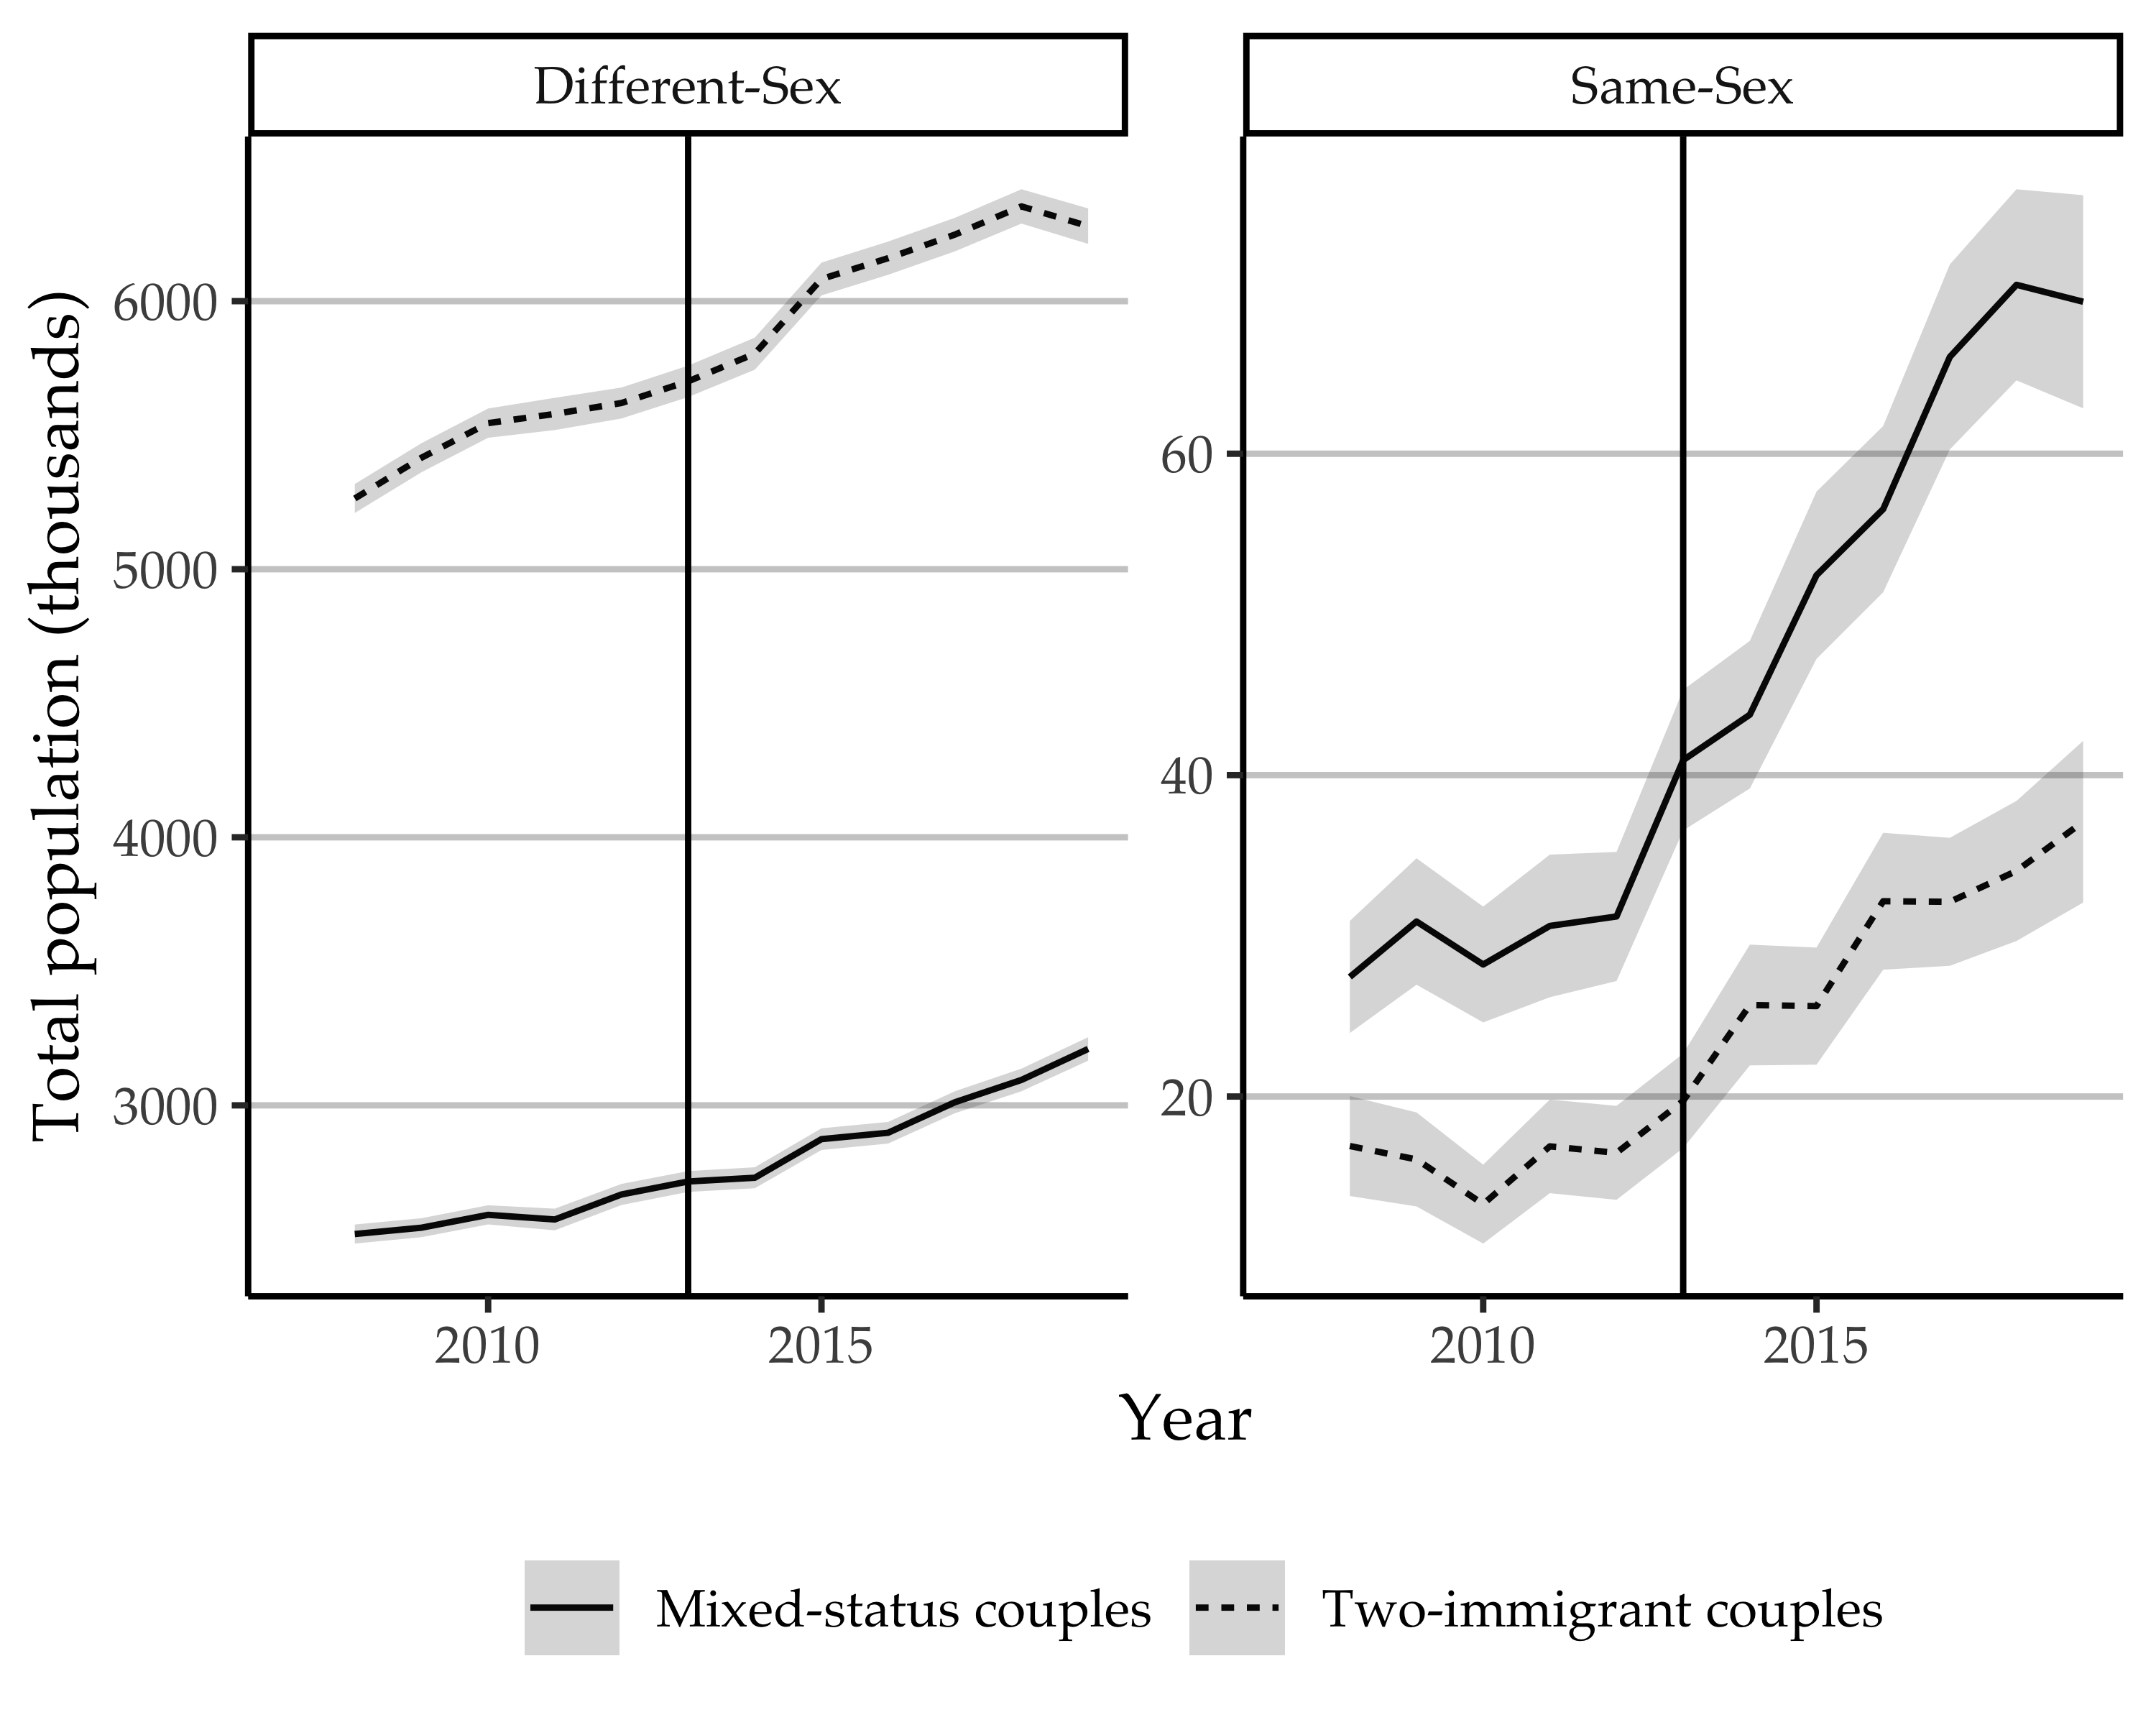
Figure 1: Estimated totals of different- and same-sex couples containing one (“mixed status”) or two immigrants, 2008-2019, with 95% confidence intervals. Vertical line placed at the year 2013, when DOMA was overturned.

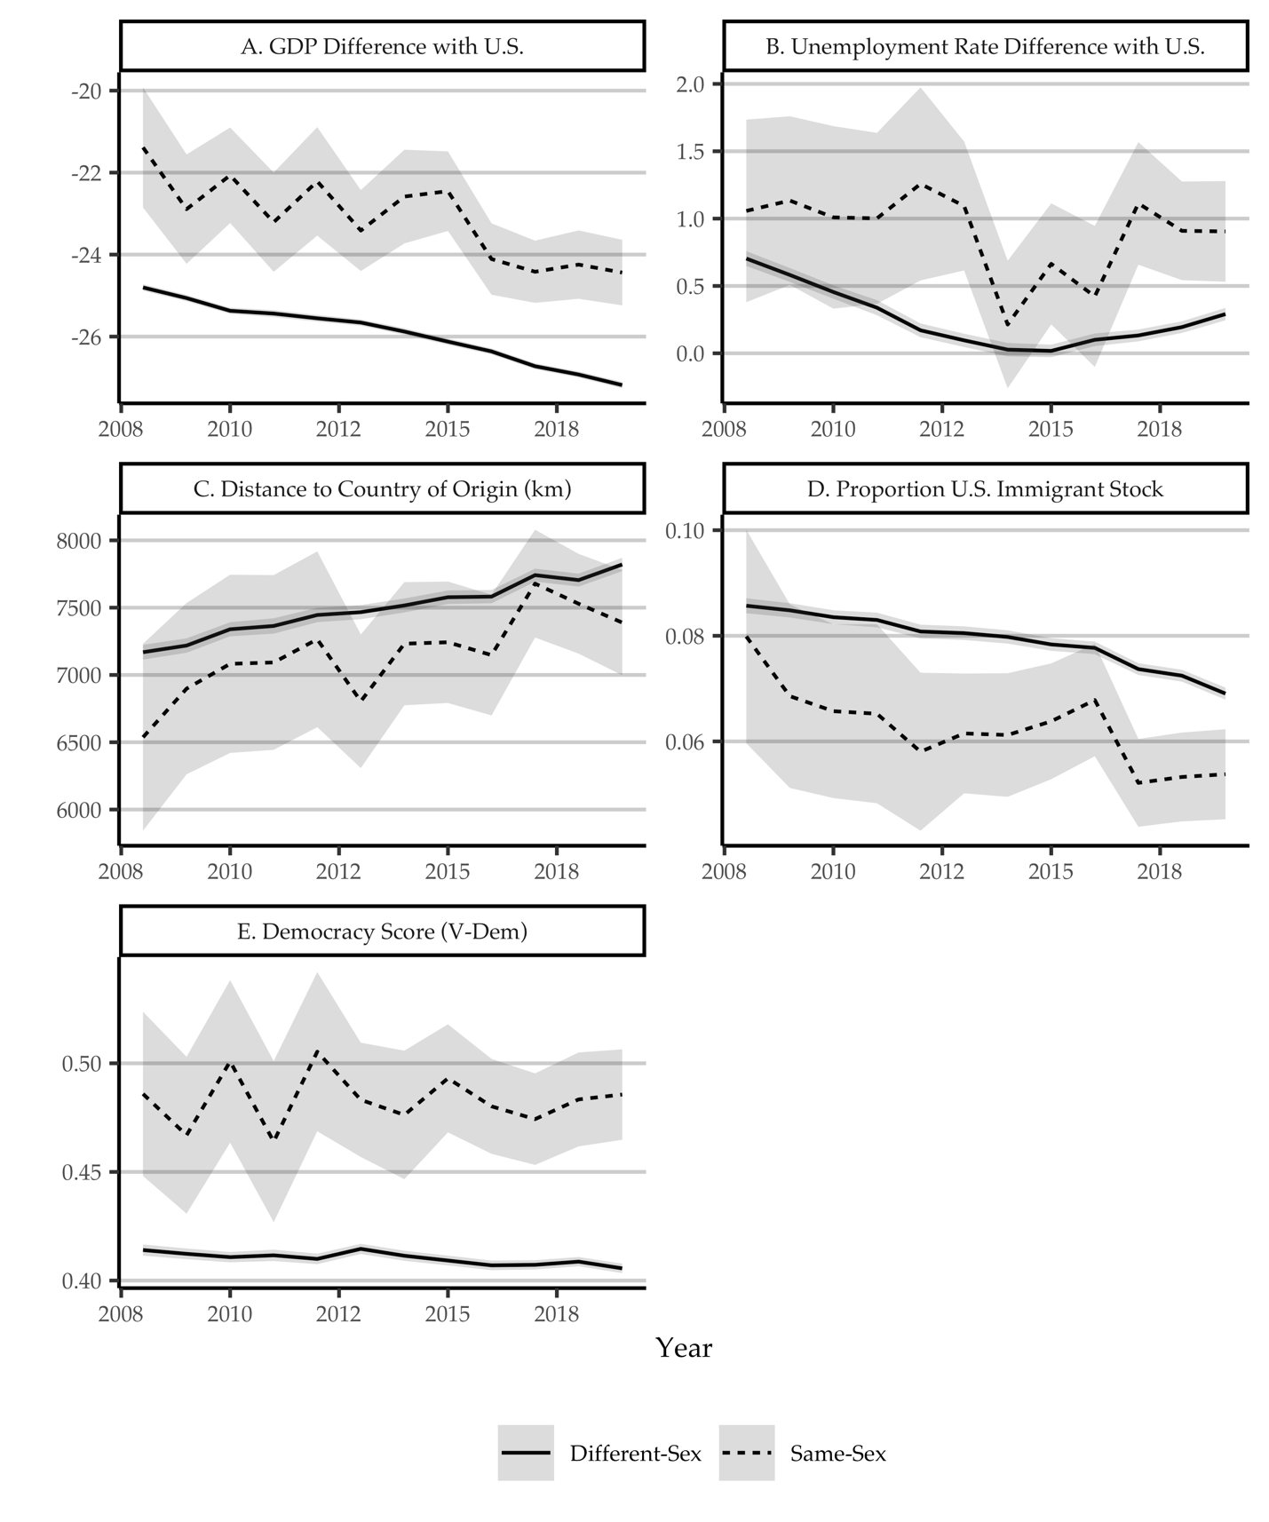
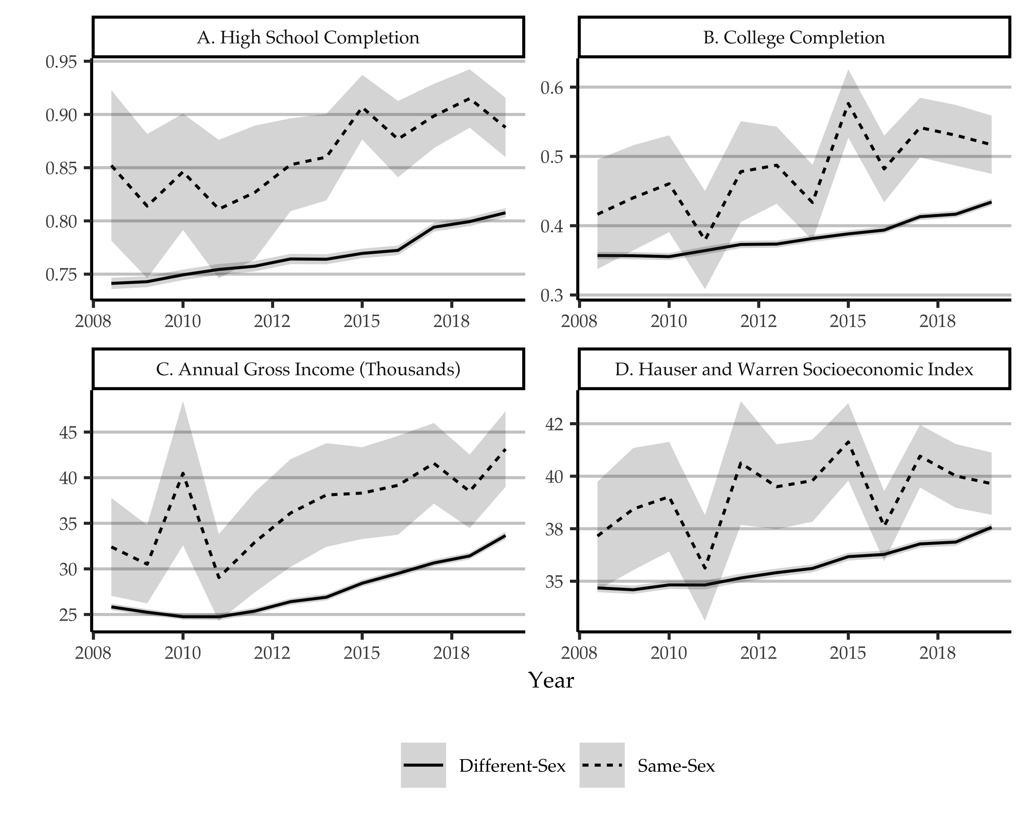
Figure 3: Individual descriptive statistics for immigrants in couples 2008-2019, with survey weights and 95% confidence intervals. Currency in thousands of 1999 dollars.

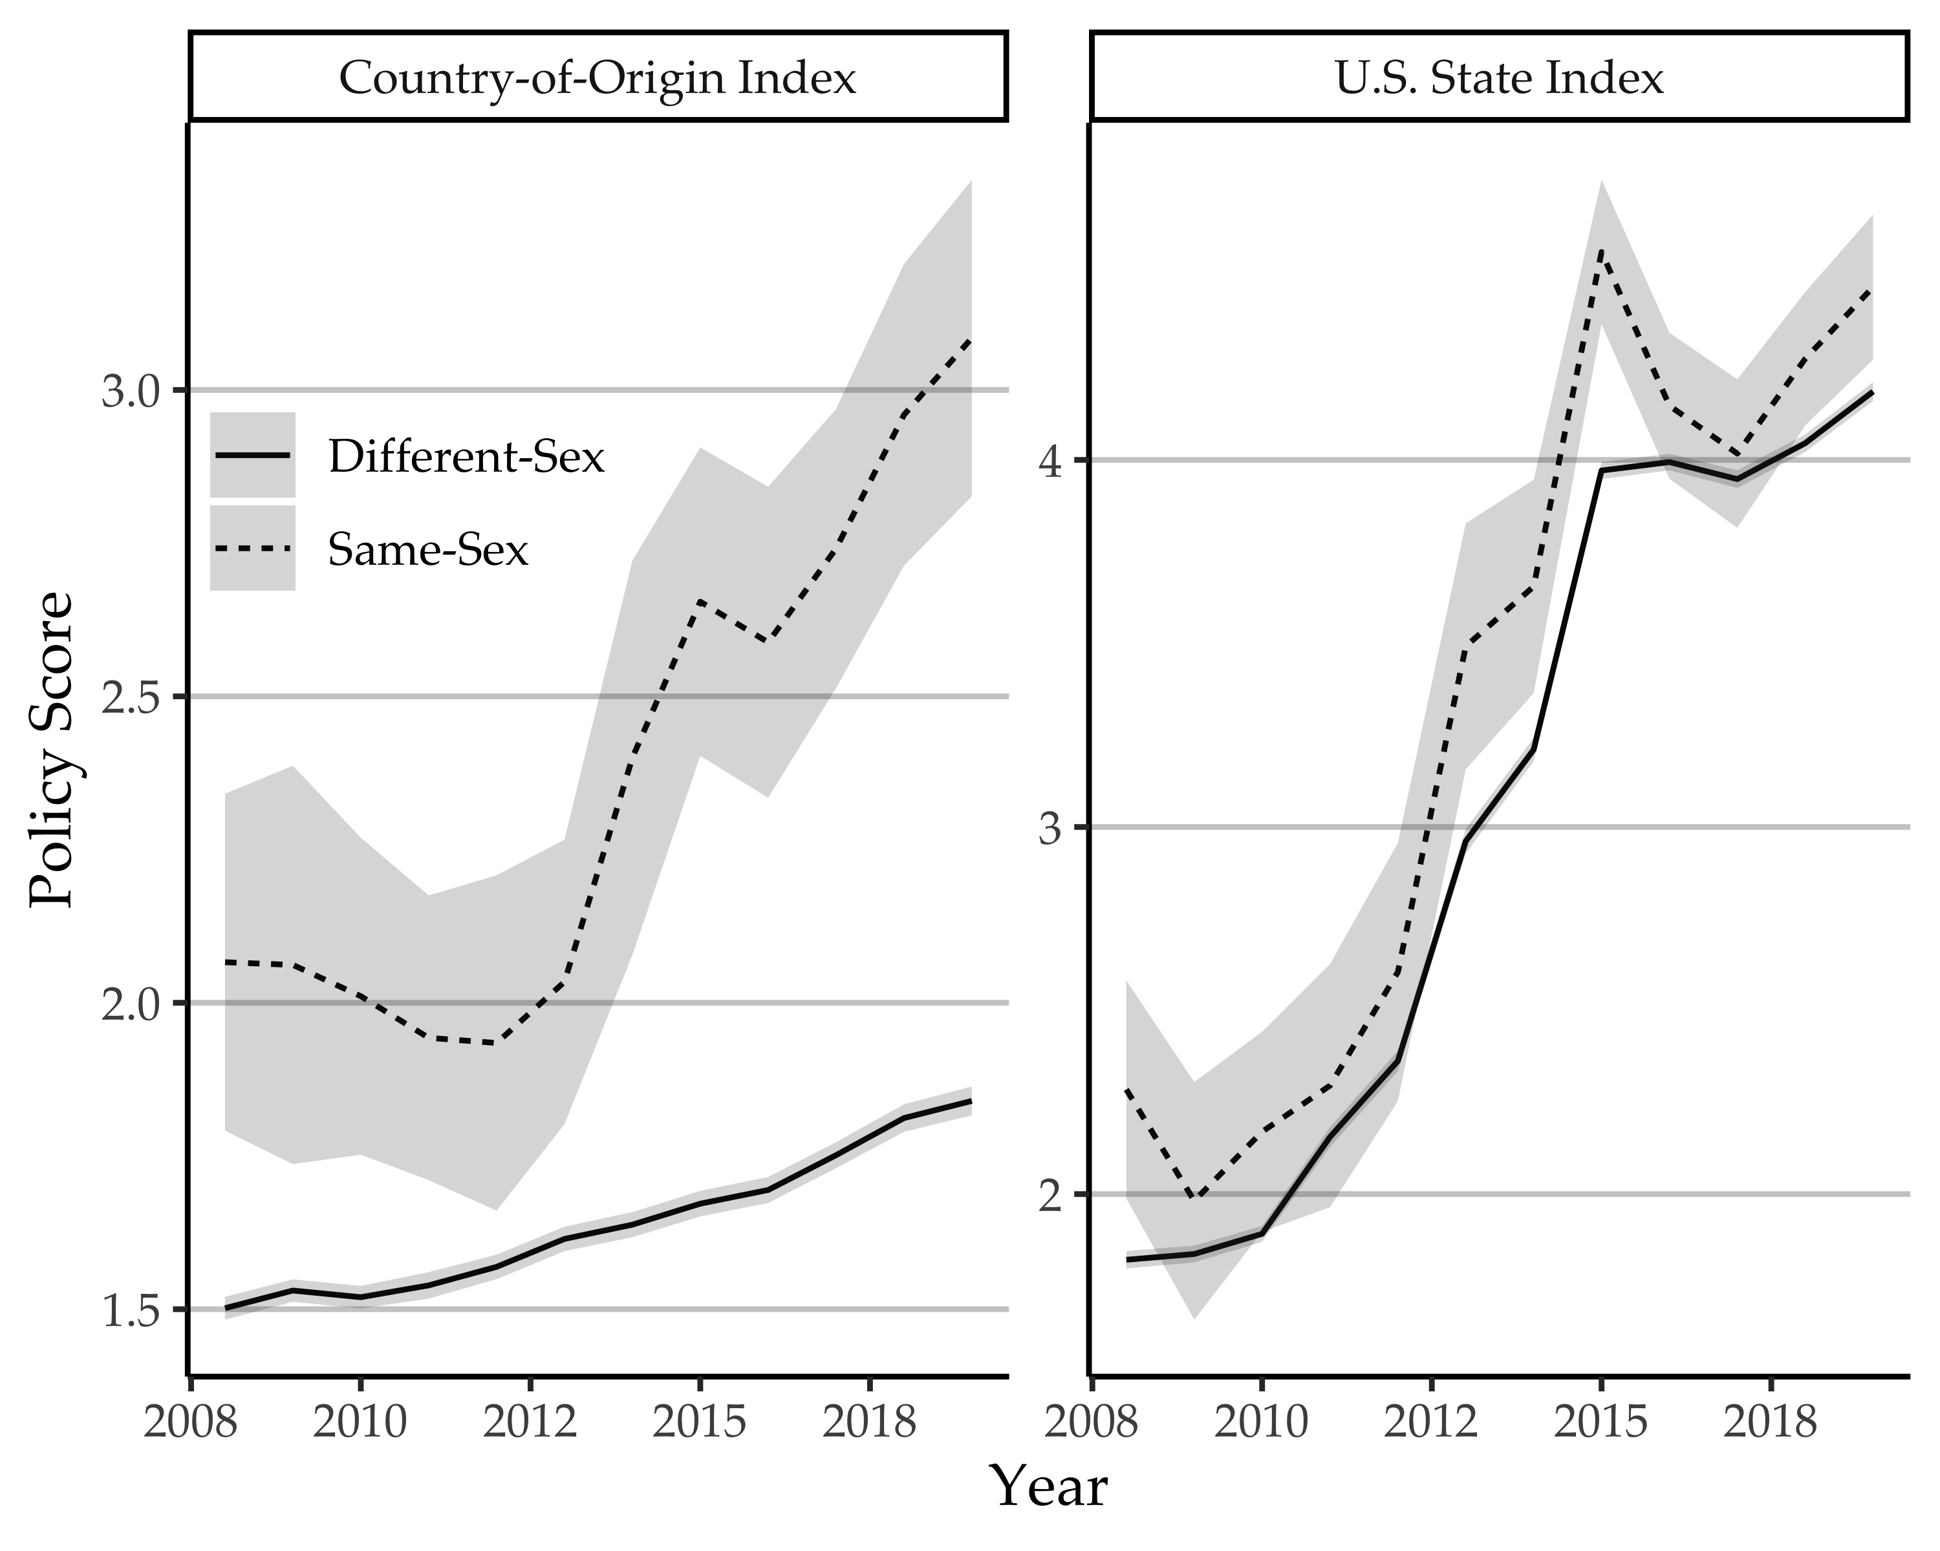
Figure 4: Mean country-of-origin and U.S. state policy index score for immigrants in same- and different-sex couples, 2008-2019, with 95% confidence intervals.

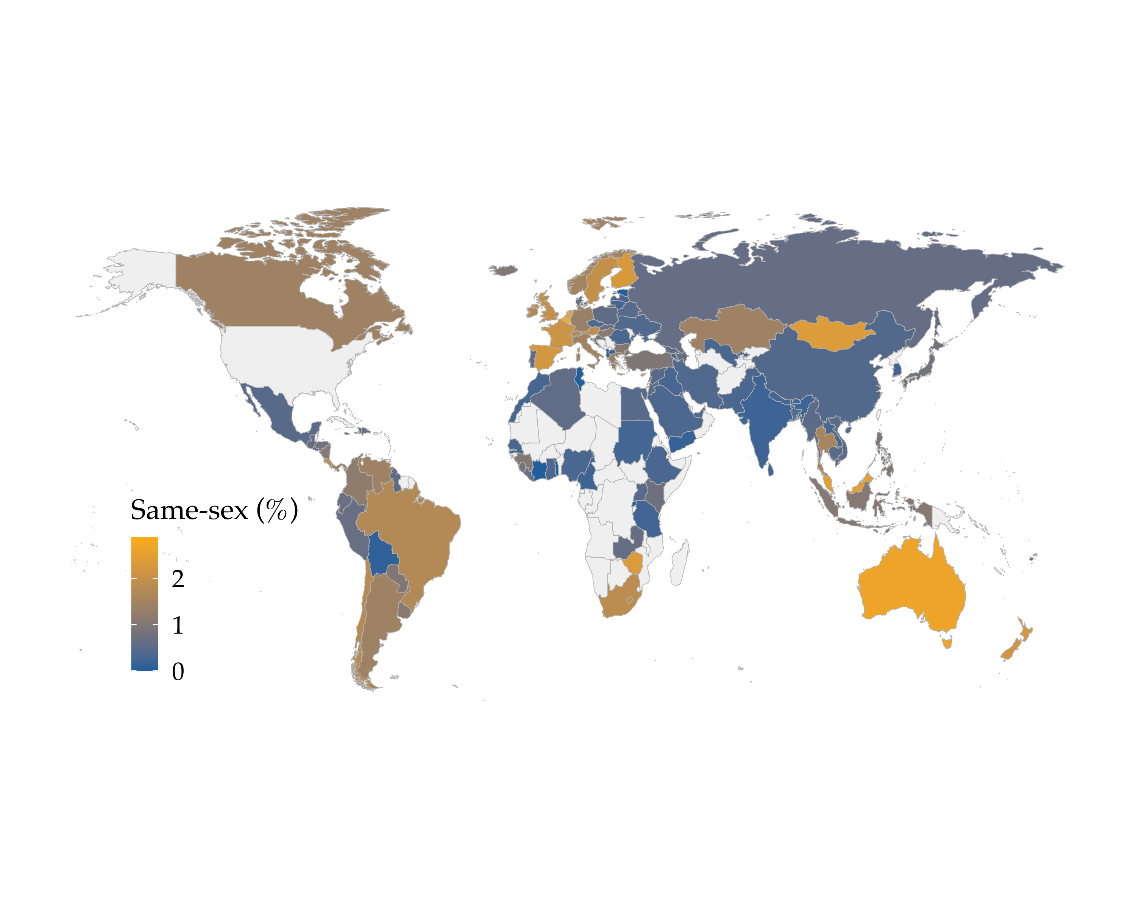
Figure 5: Percentage of cohabiting immigrants in the U.S. in same-sex couples by country of origin, averaging over ACS survey years 2008 to 2019.

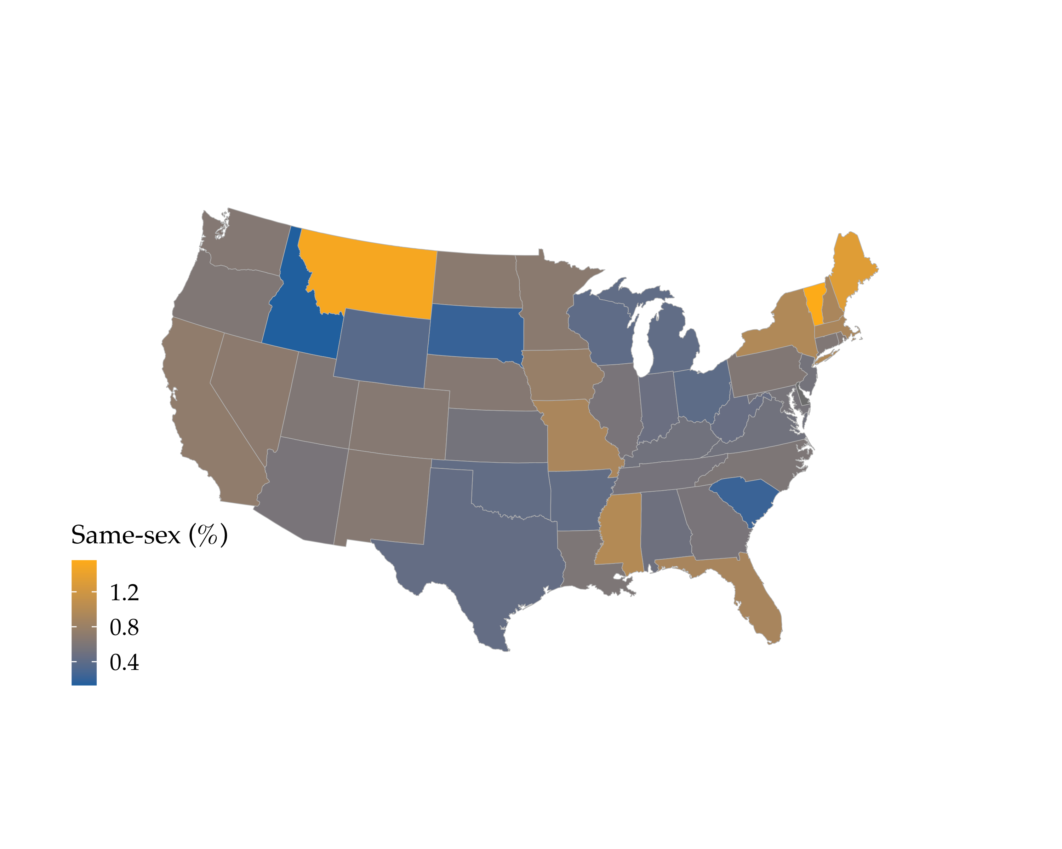
Figure 6: Percentage of cohabiting immigrants in same-sex couples in U.S. states, averaging over ACS survey years 2008 to 2019.

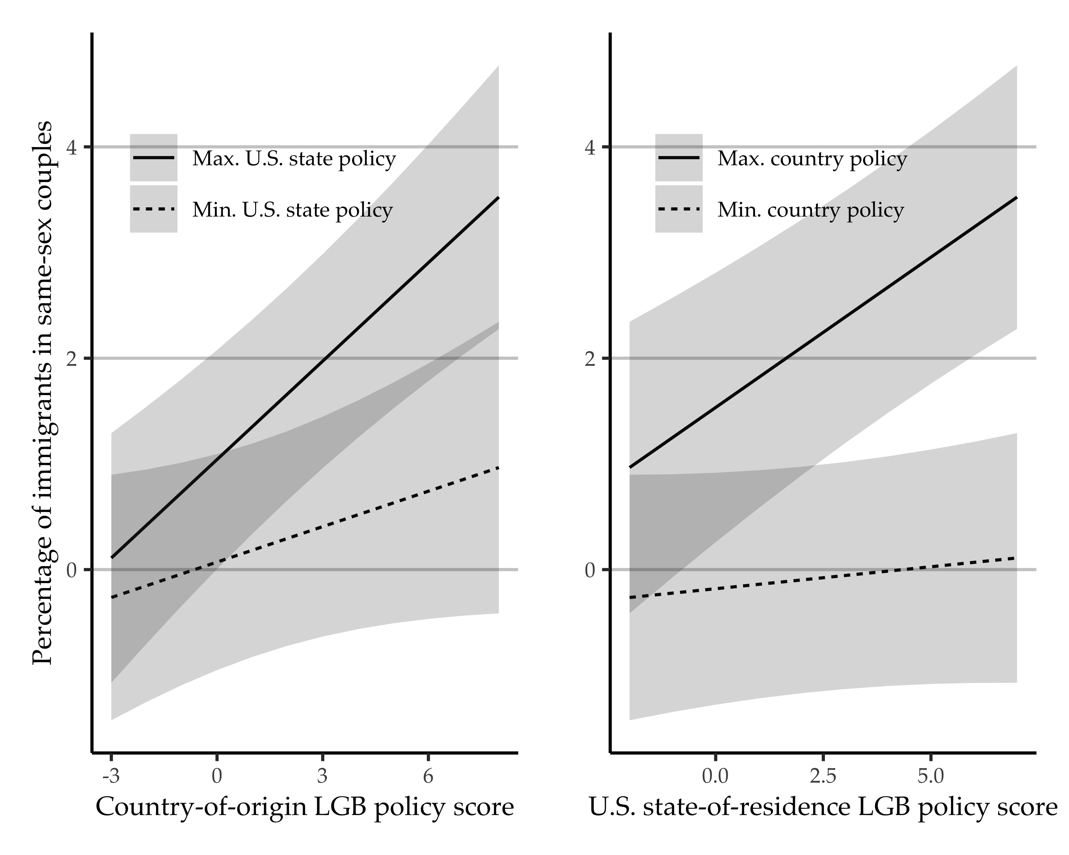
Figure 7: Predicted percentage of immigrants in same-sex couples by country-state, using Model 5 from Table 3.

The exception is for for Figure 1, where we include those who immigrated in any year, at age 18 or older.
Cells without any immigrants from a given country are necessarily dropped from the analysis.
https://www.lgbtmap.org/

