Appendix

The Geography of Immigrants in Same-Sex Couples in the United States

Nathan I. Hoffmann, Department of Sociology, UCLA

Kristopher Velasco, Department of Sociology, Princeton University

February 4, 2025

# Maps of state-level proportions for subgroups

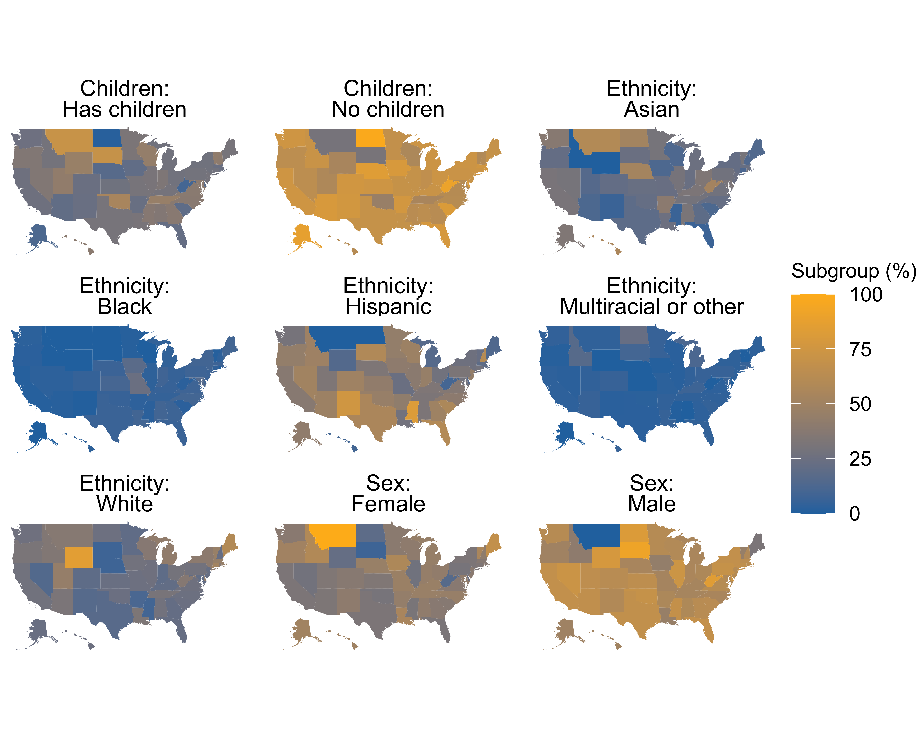

Figure 1: Percentage of migrants in same-sex couples in each state consisting of particular subgroups, from ACS estimates that incorporate sampling weights (2008-2019 and 2021-2022).