
Industrial IoT Smart HVAC Controller
COMP50069 Hardware, Microcontrollers and Sensors

May 11, 2026
Nathaniel kianzimbu
23036044

Contents
1. Executive summary 2
2. Commercial IoT context and value proposition 2
3. System architecture and hardware design 2
3.1 Pin and component summary 3
4. FreeRTOS task design and concurrency management 4
5. Embedded logic, ADC calibration and filtering 5
5.1 Sensor baseline logic 5
5.2 ADC configuration and calibration 5
5.3 Filtering and optimisation 5
6. Safety logic, cybersecurity and fault tolerance 6
7. Structured C design and memory management 7
8. Testing and validation plan 7
9. Industrial deployment strategy and lifecycle planning 9
10. Conclusion 10
References 10
Appendix A - Code file map 10

1. Executive summary
This report documents the design, implementation and commercial reasoning for an Industrial IoT Smart HVAC Controller built on the ESP32 platform. The prototype demonstrates how a small Industrial IoT HVAC controller can be simulated using Wokwi. The ESP32 board reads the temperature and humidity from a DHT22 sensor and the air pressure from a 12-bit analogue to digital converter (ADC) converter. The analogue signal from the sensor is smoothed before being processed by the ESP32 microcontroller to control a set of relays represented by LEDs. Additionally, another LED, a buzzer and an LCD display are used to indicate to the operator the status of the system’s safety controls.
The implementation satisfies the requirements of the assessment regarding a real-time IoT programming environment. The code is organised into the sketch file, the source file and the header files. Such a structure provides more clarity than a single file containing all the code. The main control is managed at the edge of the network to ensure that the functioning of the system does not rely upon an internet connection. The interaction with the system is simulated over the serial communication link and includes authentication text, rate limiting, validation of user inputs and staying within specified boundaries for the parameters of the system.
The controller can be helpful for factories, warehouses, plant rooms, and small industrial buildings. The prototype includes all of the necessary features to control the climate in the room automatically, including emergency controls, sensor failure detection, and logging capabilities. Additionally, while not included in the current prototype, the project also considers the importance of cybersecurity for the project and plans for its lifecycle.

2. Commercial IoT context and value proposition
Beyond providing comfort to building occupants, HVAC systems in production environments can have a significant impact on staff, machines, products, and energy usage. As such, HVAC controllers have inherent business values as well. Their ability to react to changes in the environment, alert staff of potential issues, or even provide data to track maintenance efforts can provide significant value to the organization. This project indicates that it may be possible to build a cost-effective edge device that can form the basis of such a product.
The value proposition is based on four points. Firstly, local automation allows for a reduction in response time as the ESP32 does not have to wait for a cloud system to respond before taking corrective action. Secondly, the logging of sensor data allows for improved maintenance of the equipment as the data can be used to identify issues such as stale sensor readings, low airflow from the equipment, or unsafe temperature levels. Thirdly, if a fault is detected in the system, the fail-safe system will automatically switch off the heating, cooling, and fan outputs to prevent further damage to the equipment. Finally, the simulated command interface allows for the testing of various temperature settings that may be implemented by a supervisor or cloud system.
Instead of installing the system in each room, it is possible to install the controller for each zone. Each zone controller would manage one room, duct section or plant unit. Multiple zone controllers could send telemetry data to a central building management system while still retaining the ability to manage emergencies within each zone. The control logic would reside on the edge devices to manage and respond to emergencies while cloud services manage fleet monitoring, analytics, alerts and maintenance reports. This architecture provides fault tolerance to the network while providing data for management of the building or facility.

3. System architecture and hardware design
The hardware design uses the ESP32 development board as the controller. The DHT22 sensor will be connected to GPIO15 to read the temperature and humidity values. The potentiometer connected to GPIO34 will be used to simulate the reading of an analogue sensor for detecting airflow within the environment. The airflow sensor is configured to read values between 0 and 4095 using a 12-bit ADC and to map those values to a percentage value representing the airflow level in the environment. The simulated relays for controlling the operation of the various components of the simulated HVAC system are controlled using the LEDs connected to GPIO26 (cooling), GPIO27 (heating), GPIO25 (fan) and GPIO23 (fault). The buzzer is connected to GPIO19 to provide audible alarms under specific conditions. Finally, the LCD1602 display is used to show the current operating mode of the system and the status of the operator using I2C on GPIO21 and GPIO22.
The two operator inputs are an emergency button on GPIO4 and a reset button on GPIO18. Both buttons have pull-ups with external interrupts on the falling edge. As a result, they are quickly dealt with without having to poll the buttons in the main control task. The interrupt service routines just notify the input task. This is a better design because the interrupt service routines do not have to do much work.
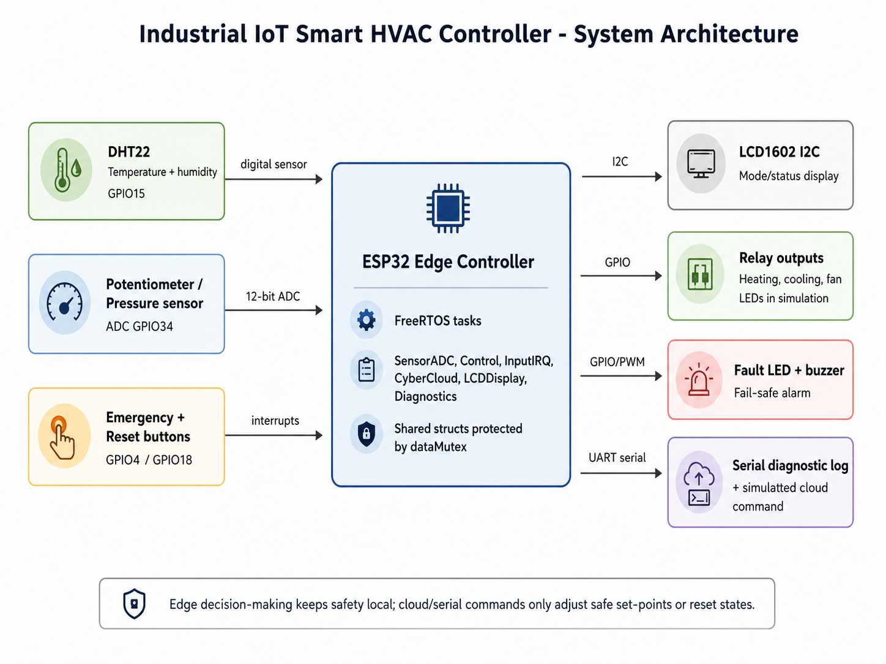
Figure 1. System architecture showing sensor inputs, ESP32 edge logic and operator outputs.

3.1 Pin and component summary
Component | GPIO / interface | Purpose in prototype
DHT22 | GPIO15 | Temperature and humidity monitoring
Pressure / airflow potentiometer | GPIO34 ADC | Analogue airflow simulation and ADC calibration
Cooling relay LED | GPIO26 | Cooling output indicator
Heating relay LED | GPIO27 | Heating output indicator
Fan relay LED | GPIO25 | Ventilation/fan output indicator
Fault LED | GPIO23 | Visual warning during fault state
Buzzer | GPIO19 | Audible alarm during fault state
Emergency button | GPIO4 | Interrupt-driven emergency override
Reset button | GPIO18 | Interrupt-driven reset after a fault or override
LCD1602 | I2C GPIO21/22 | Local status display

4. FreeRTOS task design and concurrency management
The controller uses six FreeRTOS tasks with different priorities. FreeRTOS tasks are appropriate for this system because different tasks do not need to have the same level of priority as others. The task to handle the input interrupts has the highest priority, as the system must be able to quickly respond to emergency or reset commands. The control task should have the next highest priority, as the system must continuously calculate the appropriate HVAC settings for the system. The task to acquire sensor input has a lower priority than the control task, as the sensors only have to be acquired every two seconds. The tasks to handle cloud commands and displaying information on the LCD screen are important but do not need to be urgent. Finally, the task to log system diagnostics has the lowest priority within the system.
Two mutexes are used. One mutex protects access to the sensor data and control state structures. Each task that wishes to access this data must take the mutex, perform its operation on the structure, and then release the mutex. This ensures that only one task can be accessing the structure at any time, reducing the potential for race conditions. The second mutex protects the formatted data that is output over the serial link. Again, only one task can access the mutex at any time. Finally, mutexes are appropriate for this situation because they are designed to provide protected access to shared resources between tasks.(FreeRTOS, n.d.).
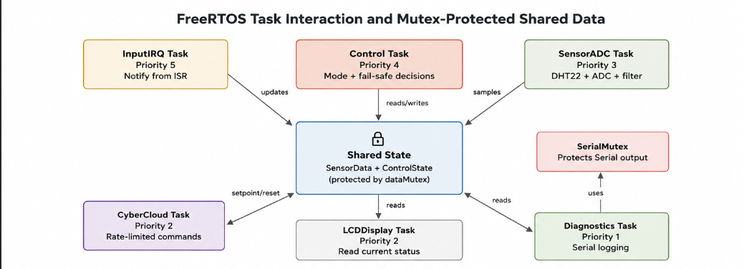
Figure 2. Task interaction and mutex-protected shared resources.
Task | Priority | Period / trigger | Main responsibility
InputIRQ | 5 | Task notification from interrupt | Debounces emergency/reset buttons and updates override state
Control | 4 | Every 500 ms | Runs safety checks and selects IDLE/HEAT/COOL/VENT/FAULT
SensorADC | 3 | Every 2000 ms | Reads DHT22, reads ADC, calibrates and filters airflow
CyberCloud | 2 | Every 200 ms / serial input | Processes authenticated set-point/reset commands
LCDDisplay | 2 | Every 1000 ms | Displays mode and fault/emergency status
Diagnostics | 1 | Every 3000 ms | Prints structured serial status logs

5. Embedded logic, ADC calibration and filtering

5.1 Sensor baseline logic
The DHT22 sensor provides the temperature and humidity readings. The control code ensures that the values from the DHT22 sensor are valid before using them. Readings outside of a certain range are considered invalid. For instance, temperatures below -10C and above 80C are invalid, as are humidity readings outside of the 0-100% range. These sensors should not be blindly trusted. In the case of invalid sensor readings due to a broken sensor wire or sensor failure, the controller should enter a safe state rather than continuing to operate in its normal state.
The mode logic uses a default set-point of 24C. If the temperature is at least 1C above the set-point, the system selects cooling. If it is at least 1C below the set-point, the system selects heating. If temperature is within the band but humidity is at least 70%, the system selects ventilation. Otherwise, the system stays idle. This avoids rapid switching around the set-point and gives simple hysteresis behaviour.

5.2 ADC configuration and calibration
The ADC input on GPIO34 represents the industrial airflow and pressure signal. The ADC can return a 12-bit value between 0 and 4095 when set to 12-bit resolution (Espressif Systems, n.d.). The analogReadResolution() function is used to set the resolution to 12-bit and the ADC_11db attenuation is used to amplify the input signal. The calibration function converts the ADC raw value to voltage and maps the voltage from the sensor between 0.3V and 3.0V to a percentage value between 0% and 100%. Any value outside of the expected percentage range is clamped to prevent impossible percentage values from being sent to the control logic.
The calibration equation within hvac_logic.cpp is: voltage = raw x 3.3 / 4095, and then pressurePercent = ((voltage - 0.3) / (3.0 - 0.3)) x 100. This is a linear calibration model. The values would be replaced with the actual values from the sensor’s datasheet. Additionally, the controller could store this calibration history to allow maintenance personnel to monitor the sensor drift.

5.3 Filtering and optimisation
The analogue readings from the sensor can contain noise, especially over long cable runs within the industrial plant room and with the variable loads of the room’s industrial equipment. The prototype uses a low-pass filter with an alpha of 0.20. This causes the airflow value to be displayed and used for control to change gradually according to the formula: SmoothPct = previous + alpha x (new - previous). The low-pass filter will smooth out the sudden changes in measured values from the simulated potentiometer, but at the cost of introducing a small delay in the system’s response to any sudden changes in the true airflow of the space. The alpha value of the low-pass filter can be tuned to provide an appropriate delay relative to the response times of the actual HVAC equipment in the space.
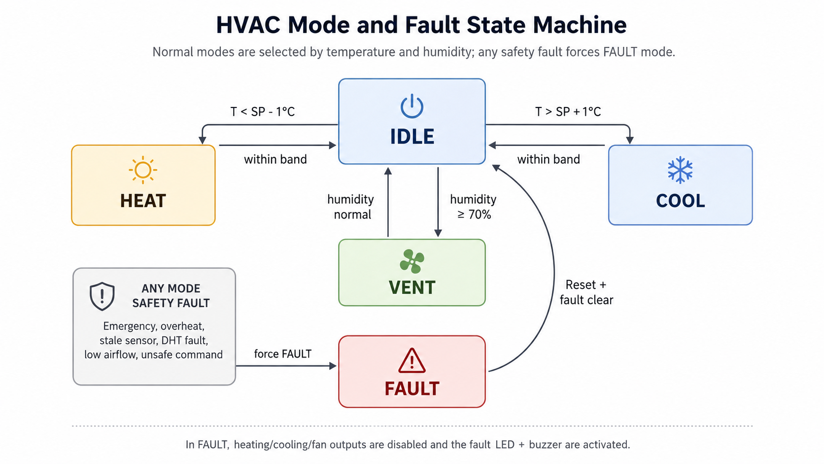
Figure 3. HVAC state machine and fault transitions.

6. Safety logic, cybersecurity and fault tolerance
The most important of the design rules is that unsafe conditions must move the system into FAULT mode. In FAULT mode, the heater, cooler and fan are disabled, but the fault LED and buzzer are enabled. Conditions that cause the system to enter FAULT mode are the activation of the emergency override switch, the temperature reaching 35C, stale sensor data lasting more than 6000 ms, a failed DHT22 reading, humidity outside of its normal range, or airflow levels falling below 5%. This type of fault detection and response system is appropriate for a prototype stage to ensure that the system behaves in a fail-safe manner when faults occur.
The emergency button is latched. Pressing the button enables the override and the reset button is needed to clear the emergency button. This is better than a momentary switch that would disappear when the button is released. The reset logic clears the latched emergency flag, but the control task still checks the real sensor readings to see if the fault is still present. If it is still present when the reset button is pressed, the controller will return to FAULT mode.
Security is provided for the system at the prototype level through the validation of the commands that are sent to the system. All commands must include the text “AUTH=HVAC2026” and the command string must be 80 characters or shorter and occur at a rate of one command per second. Additionally, the set point that is requested by the user must be within the range of 16C to 30C. Any commands that are invalid, flooded or that request unsafe settings will be rejected by the system. These security measures provide protection for the system through concepts like authentication, validation, rate limiting and the principle of least privilege. While these security measures may provide some level of security for the system, they are not secure enough to be used within a real world product. A deployment version of the system would need to implement measures like device authentication, encrypted communications, firmware signing, secure storage, access control lists and audit logs. For instance, the open web application security project (OWASP) has published information regarding common security issues for IoT devices, including weak credentials, insecure services and insecure IoT ecosystem interfaces (OWASP, 2018). Additionally, the National Institute of Standards and Technology (NIST) has developed a framework for cyber security of IoT devices, the NIST Cyber Security Framework 2.0 (NIST, 2018).
Risk / fault | Prototype control measure | Further industrial improvement
Overheat | Shutdown at 35C and enter FAULT mode | Use rated thermal cut-outs and certified safety relay
Low airflow | Pressure percentage threshold below 5% | Commissioned sensor calibration and duct pressure testing
Emergency activation | Latched interrupt-driven override | Physical emergency stop circuit with manual reset procedure
Sensor failure | DHT NaN and range checks; stale-data watchdog | Redundant sensors and maintenance alarms
Command flooding | One command per second rate limit | Network firewall, API throttling and anomaly monitoring
Unauthorised set-point change | Token and range check | Unique credentials, TLS, signed messages and RBAC

7. Structured C design and memory management
The main sketch contains the hardware setup, creation of tasks, ISRs, and the task functions. The hvac_types.h header file contains the enumeration of the possible HvacModes as well as the two structures that are shared between the sensor data and control state. Finally, the hvac_logic.h and hvac_logic.cpp files contain the functions that perform the logic necessary to calibrate and read the ADC values, filter the sensor data, detect anomalies in the sensor data, and determining which HvacMode to use. This modularization makes it easier to modify the HVAC system’s logic without having to rewrite the code that controls the hardware.
Structures are used to group related data together. SensorData includes fields for temperature, humidity, raw ADC, calibrated airflow, smoothed airflow, set-point, and DHT validity and timing. ControlState includes fields for mode, output flags, fault status, emergency override, cybersecurity lock state, fault message, and command counters. These structures are passed by reference to the logic functions to avoid unnecessary copying of the data. The shared data is copied whilst holding the mutex, then the copy is processed outside of the critical section. This reduces the amount of time that the mutex needs to be held, which improves the scheduler’s ability to make accurate predictions about when each task will be scheduled.
Dynamic memory allocation is avoided in the core control path. The fault message uses a fixed array of chars of size 96 bytes with snprintf to avoid buffer overflows. This is the preferred approach for microcontroller based work. The only use of the Arduino String class is in the command handler with length checks on the commands being received. A version of the command handler using fixed size buffers would be preferable in production.

8. Testing and validation plan
The testing plan that follows will be utilized during the Wokwi demonstration and will inform the screenshots that will be placed within the final appendix. As the zip file that was submitted contains the project code but not the final running screenshots of the project, the evidence table informs the student what screenshots to take after running the project.
Test ID | Test scenario | Steps | Expected result | Screenshot
T01 | Boot and normal idle | Start Wokwi with DHT22 around 24C and pressure above minimum | LCD shows normal/IDLE; no fault LED or buzzer | 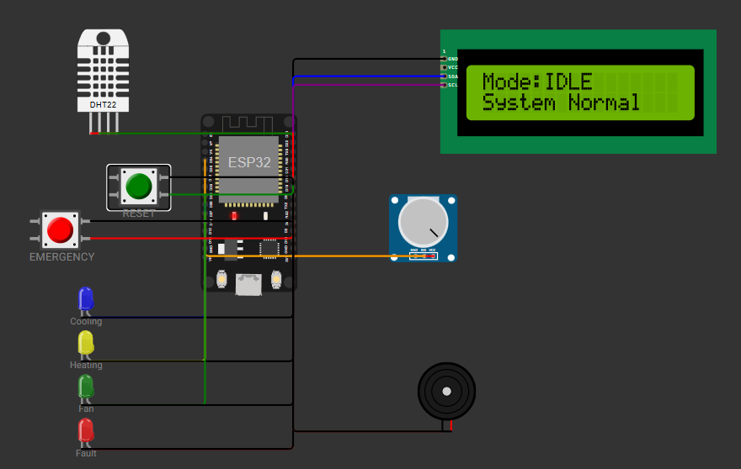
T02 | Cooling mode | Increase DHT22 temperature above set-point + 1C | Cooling LED and fan LED turn on; mode is COOL | 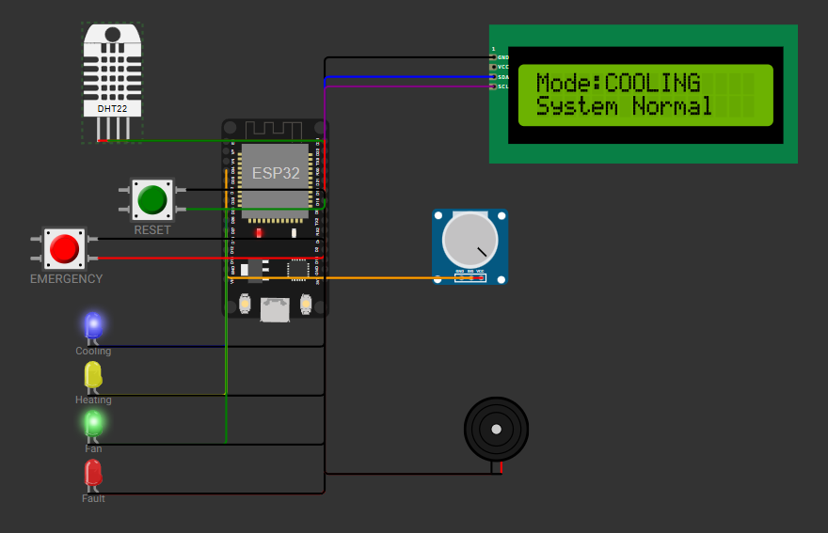
T03 | Heating mode | Decrease DHT22 temperature below set-point - 1C | Heating LED and fan LED turn on; mode is HEAT | 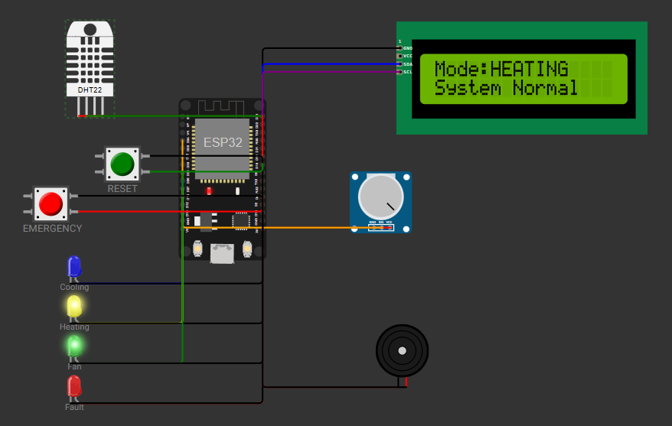
T04 | Ventilation mode | Set humidity to 70% or higher while temperature is in normal band | Fan LED turns on; mode is VENT | 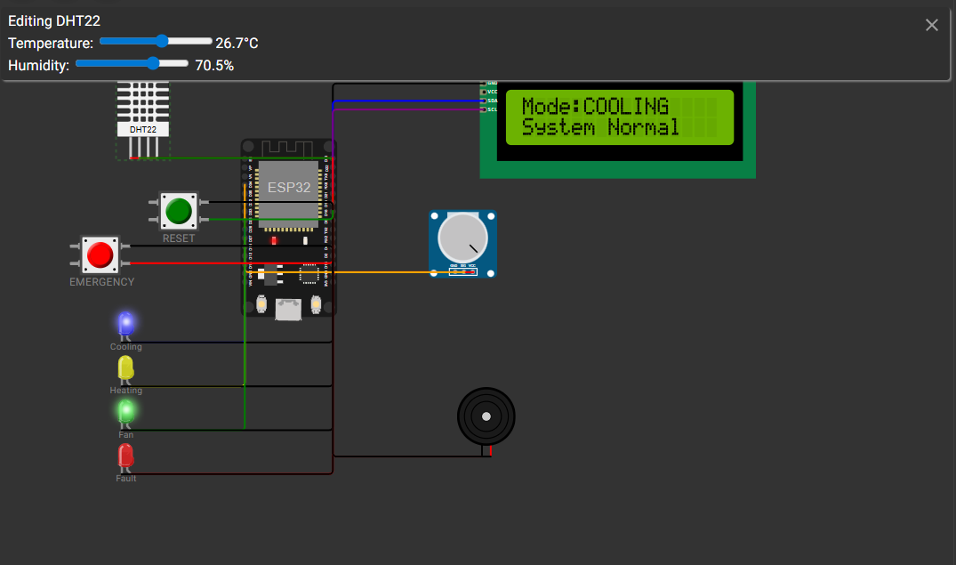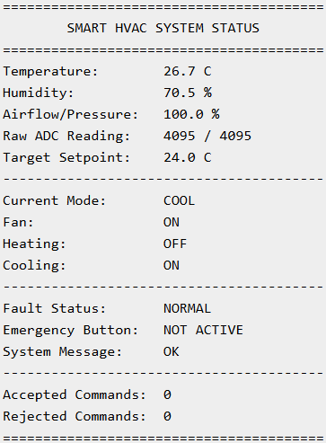
T05 | Overheat shutdown | Set DHT22 temperature to 35C or above | System enters FAULT; relay outputs off; fault LED and buzzer activate | 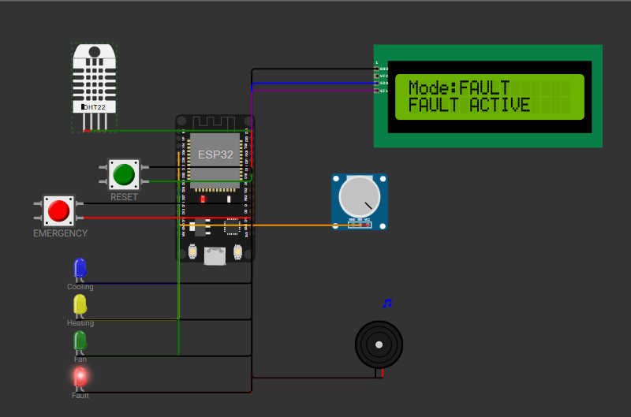
T06 | Low airflow anomaly | Turn potentiometer to a very low value | Airflow/pressure too low message; FAULT mode active | 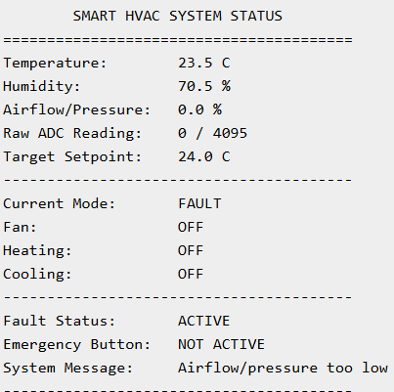
T07 | Emergency override | Press emergency button | FAULT mode latches; fault LED and buzzer activate | 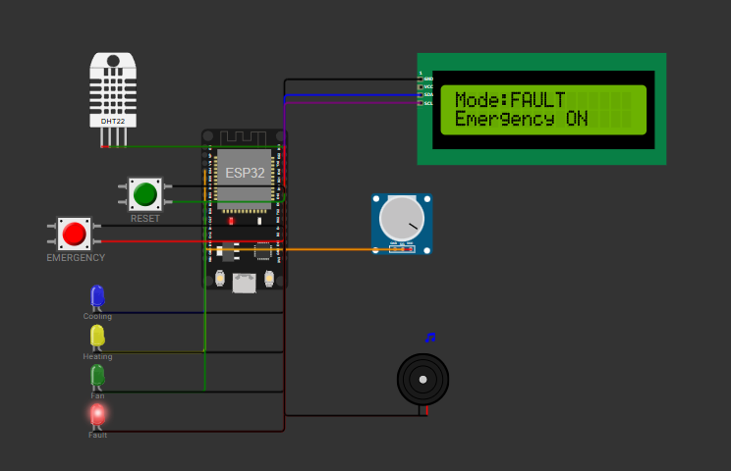
T08 | Manual reset | After emergency, press reset button | Emergency flag clears if no real sensor fault remains | 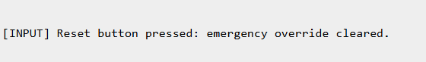
T09 | Authenticated set-point | Send AUTH=HVAC2026;SET=23.5 in serial monitor | Accepted command counter increases; set-point changes | 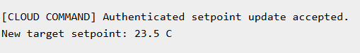
T10 | Rejected cyber command | Send invalid token or repeated commands quickly | Rejected command counter increases; cyber warning printed | 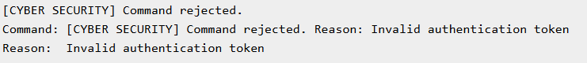

9. Industrial deployment strategy and lifecycle planning
A real deployment should be planned in stages. The prototype stage proves the control logic in Wokwi. A bench-test stage would then connect real DHT22 or industrial sensors, relays and a safe test load. A pilot stage would run the controller in one building zone while logging data to a dashboard. Only after validation should the system be rolled out across multiple HVAC zones. This lifecycle reduces risk because faults are found before full deployment.
The recommended architecture is for the system to be edge-first. Each ESP32 will control the appliance locally. Telemetry will then be sent to the cloud for viewing on the dashboards and for reporting on energy use, maintenance, etc. The cloud is not required for emergency shutdown. The firmware will need version control. Finally, maintenance will be required for the sensors, relays, logs and cybersecurity of the system.
Compliance awareness is also important. The system would need to follow electrical safety rules, installation practices and industrial control security expectations. For cybersecurity governance, NIST CSF 2.0 can be used to organise risk management and improvement actions. For IoT design risks, OWASP IoT guidance highlights the need to avoid weak credentials, insecure interfaces and missing update mechanisms. In commercial terms, these controls protect the vendor and customer by reducing downtime, unauthorised control and safety incidents.

10. Conclusion
The Industrial IoT Smart HVAC Controller successfully demonstrates the major technical and commercial features required by this assignment. The design and implementation of the controller’s code utilises FreeRTOS to provide multitasking, task prioritisation, interrupt-driven button inputs, ADC calibration and filtering, mutexes to enable shared access to data between tasks, and modular code structures written in C and C++. Furthermore, the controller includes features to provide safety to the system during operation, such as overheating shutdown, airflow detection, emergency override, and stale data detection with alarm outputs. Finally, cybersecurity protections are provided through user authentication, rate limiting, validation of data inputs, and limiting allowed setpoints.
The commercial credibility of the prototype is demonstrated through its focus on local safety while allowing for future integration with cloud-based monitoring systems. The current simulation of the product does not include all of the features that are required for certification as a controller for industrial environments. To become certified for production of industrial controllers, calibration of sensors, use of certified relays, implementation of encrypted communications, secure storage of credentials, and testing for both safety and reliability would be required. However, within these limitations, the project still forms a solid foundation for demonstrating understanding of the development of embedded IoT devices and the preparation of professional documentation for such a device according to the COMP50069 brief.

References
Espressif Systems (n.d.) ADC - Arduino ESP32 latest documentation. Available at: https://docs.espressif.com/projects/arduino-esp32/en/latest/api/adc.html (Accessed: 11 May 2026).
FreeRTOS (n.d.) Mutexes. Available at: https://freertos.org/Documentation/02-Kernel/02-Kernel-features/02-Queues-mutexes-and-semaphores/04-Mutexes (Accessed: 11 May 2026).
FreeRTOS (n.d.) RTOS task notifications. Available at: https://freertos.org/Documentation/02-Kernel/04-API-references/05-Direct-to-task-notifications/00-RTOS-task-notifications (Accessed: 11 May 2026).
NIST (2024) The NIST Cybersecurity Framework (CSF) 2.0. Available at: https://nvlpubs.nist.gov/nistpubs/CSWP/NIST.CSWP.29.pdf (Accessed: 11 May 2026).
OWASP (2018) OWASP Internet of Things Top 10. Available at: https://www.lcie.fr/wp-content/uploads/2021/02/OWASP-IoT-Top-10-2018-final.pdf (Accessed: 11 May 2026).
SparkFun (n.d.) DHT22 Humidity and Temperature Sensor Datasheet. Available at: https://cdn.sparkfun.com/assets/f/7/d/9/c/DHT22.pdf (Accessed: 11 May 2026).
Staffordshire University (n.d.) COMP50069 Level 5 Hardware, Microcontrollers and Sensors: Industrial IoT Smart HVAC Controller Assessment Brief and Full Rubric. Unpublished module assessment brief.
Wokwi (n.d.) Wokwi Docs: Welcome to Wokwi. Available at: https://docs.wokwi.com/ (Accessed: 11 May 2026).
Wokwi (n.d.) wokwi-dht22 Reference. Available at: https://docs.wokwi.com/parts/wokwi-dht22 (Accessed: 11 May 2026).

Appendix A - Code file map
File | Purpose
sketch.ino | Main ESP32/Wokwi program: pin map, setup, FreeRTOS task creation, ISRs, tasks and serial command processing.
hvac_types.h | Shared enum, constants and struct definitions for SensorData and ControlState.
hvac_logic.h | Function declarations for calibration, filtering, anomaly detection and mode selection.
hvac_logic.cpp | Reusable implementation of ADC calibration, low-pass filtering, anomaly checks and HVAC mode decision logic.
diagram.json | Wokwi circuit containing ESP32, DHT22, potentiometer, LCD, LEDs, buzzer and visible emergency/reset buttons.
libraries.txt | Required Wokwi libraries: DHT sensor library for ESPx and LiquidCrystal I2C.
wokwi-project.txt | https://wokwi.com/projects/463693586112634881
Github repository | https://github.com/nathankian/Industrial-IoT-Smart-HVAC-Controller.git

