1. Run the App on Expo with an emulator or an actual device.
2. Verify that the screen looks like this:

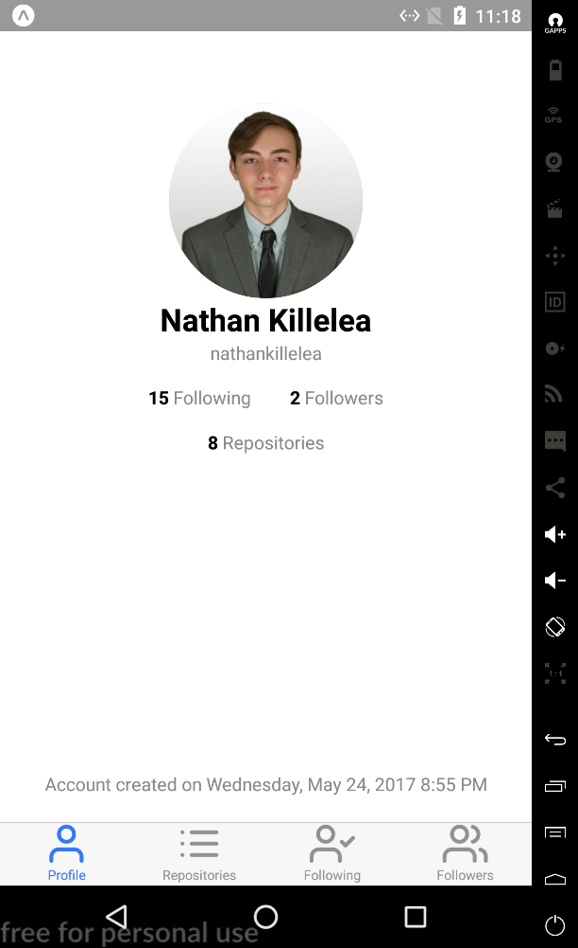

1. Press “**15** Following” (Note that the actual number may not be the same).
2. Verify that the screen looks like this:

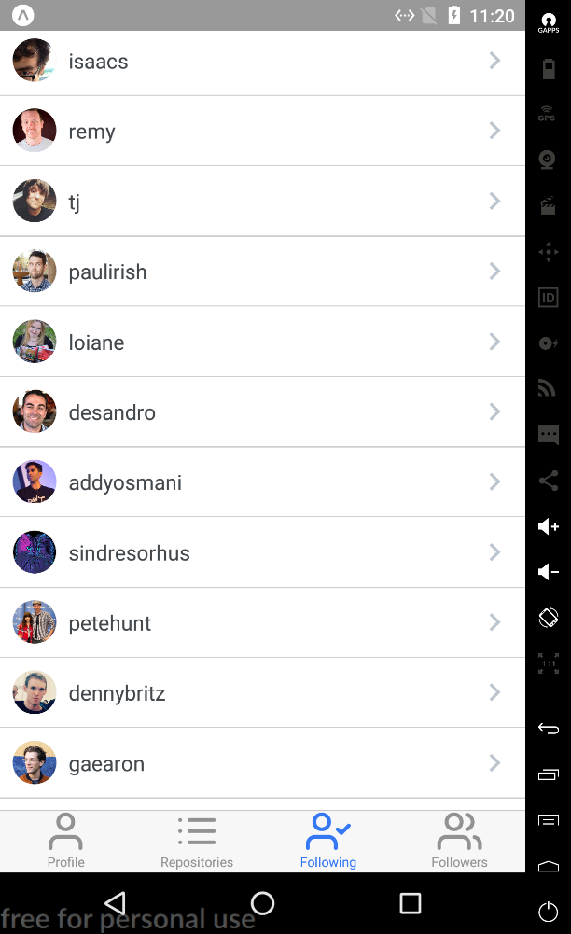

1. Press the “Profile” tab at the bottom of the screen to navigate back to the Profile page.
2. Press “**2** Followers” (Note that the actual number may not be the same).
3. Verify that the screen looks like this:

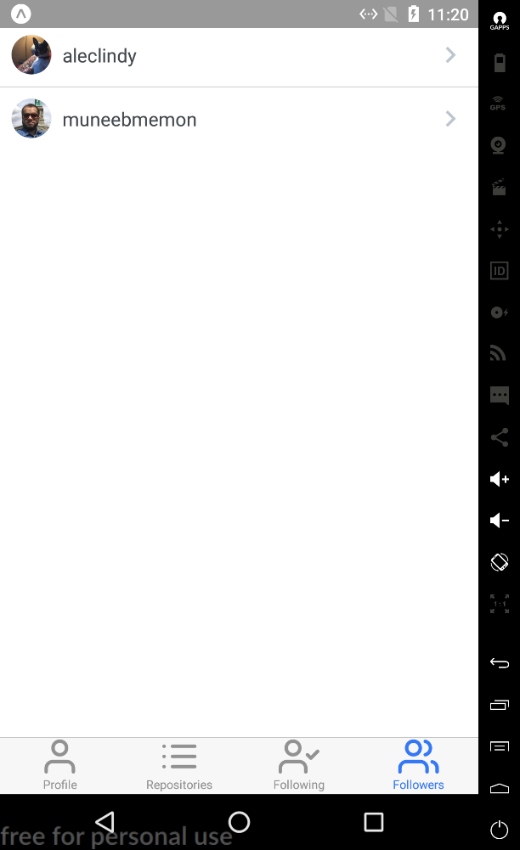

1. Press the “Profile” tab at the bottom of the screen to navigate back to the Profile page.
2. Press “**8** Repositories” (Note that the actual number may not be the same).
3. Verify that the screen looks like this:

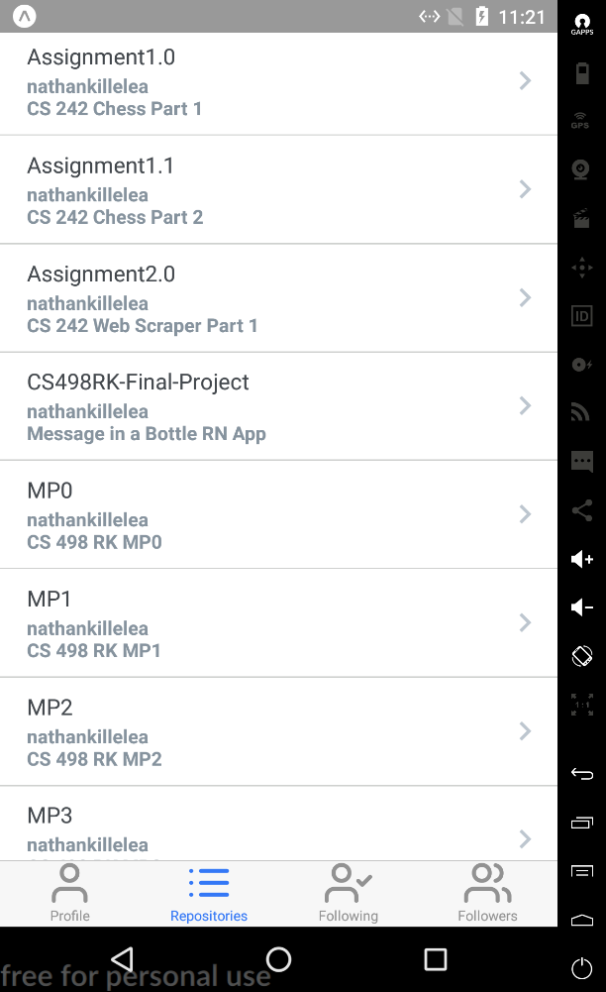

1. Press the first list item “Assignment1.0”
2. Verify that the repository opened in another browser.

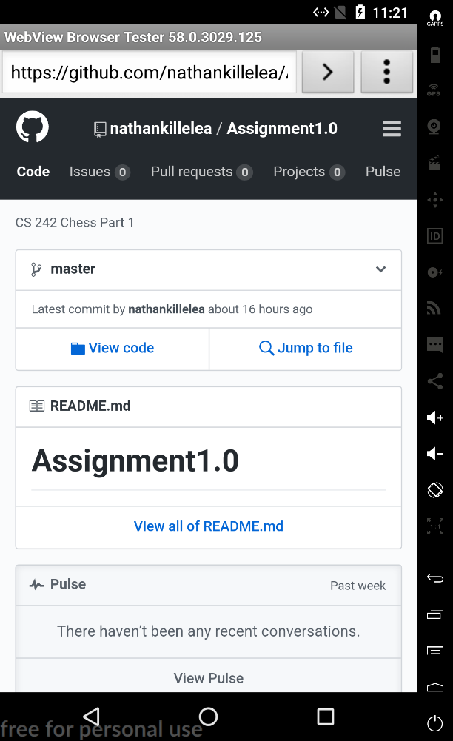

1. Navigate back to the app.
2. Press every tab at the bottom of the screen and verify that they navigate to the correct screen.