**IS607**

**Week 2 Assignment**

**Seoungyoon Lim**

1. Which destination in the flights database is the furthest distance away?

To HNL From JFK is the longest trip in the database

SELECT DISTINCT dest, origin, distance FROM flights

ORDER BY distance DESC limit 1;

SELECT DISTINCT dest, origin, distance FROM flights ORDER BY distance DESC limit 1;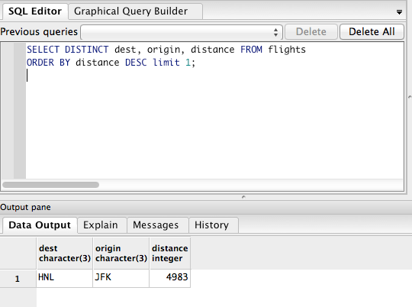

1. What are the different numbers of engines in the planes table? For each number of engines, which aircraft have the most number of seats?
2. What weather conditions are associated with New York City departure delays?
3. Are older planes more likely to be delayed?

No it is hard to say there is a correlation between two

SELECT planes.year, AVG(dep_delay)

FROM planes JOIN flights ON planes.tailnum=flights.tailnum

WHERE planes.year>0

GROUP BY planes.year

ORDER BY planes.year

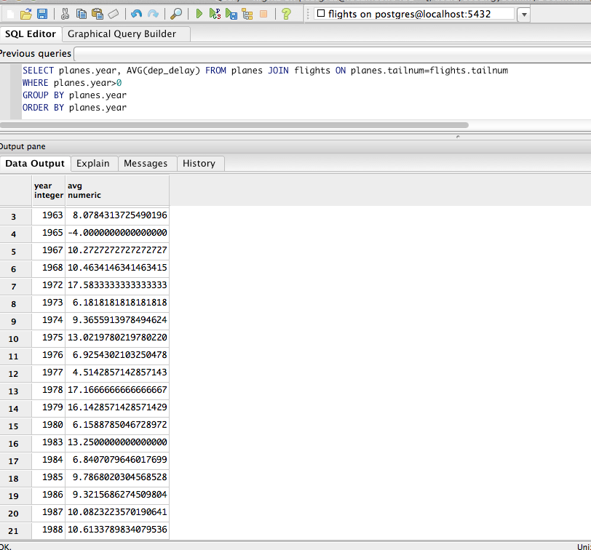

5. Ask (and if possible answer) a question that also requires joining information from two or more tables in the flights database, and/or assumes that additional information can be collected in advance of answering your question.

Do speed of planes affect to the air_time/distance?

Planes’ Speed does not affect the time in the air of the flights

SELECT AVG(flights.air_time*100/flights.distance), planes.speed FROM flights JOIN planes ON flights.tailnum=planes.tailnum
GROUP BY planes.speed
ORDER BY AVG(flights.air_time*100/flights.distance) DESC