Design and Implementation of a Context-Aware Student Enquiry Chatbot with Analytics-Driven Decision Support System
Case study: DELSU Student Enquiry System
Field | Value
Project type | B.Sc. Computer Science final-year project (MVP)
Frontend | Next.js (App Router), React, Material UI
Backend | Next.js API routes (Node.js runtime)
Database | Supabase (PostgreSQL) with the pgvector extension
AI provider | OpenAI (chat completions + text embeddings)
Deployment | Vercel

Table of Contents

1. Introduction
1.1 Project Purpose
The system is a web-based student enquiry platform that helps prospective and current students obtain academic, admission, and institutional information through a conversational chatbot. It combines four capabilities: (i) a student enquiry chatbot, (ii) conversational context awareness, (iii) Retrieval-Augmented Generation (RAG) grounded in an institutional knowledge base, and (iv) analytics-driven decision support for administrators.
1.2 Scope
The implementation is a realistic MVP suitable for a final-year project: it is functionally complete for its stated goals, uses a small and well-justified set of technologies, and avoids speculative features. Where the original specification's suggested design (e.g. a document/chunk knowledge base) was not the simplest solution preserving the requirement, a simpler equivalent was used instead and is documented as such (see Section 5.4).
1.3 Objectives
- Allow students to submit enquiries through a chatbot interface and receive answers grounded in approved institutional information rather than the language model's general knowledge.
- Maintain conversational context so follow-up questions (e.g. “what about the deadline?”) are understood in relation to the preceding exchange.
- Support both anonymous (“prospective student”) and authenticated (“current student”) use, with the latter gaining a saved conversation History and a Profile.
- Give administrators a dashboard that turns stored enquiry data into decision-support information: categories, volumes, trends, and reply feedback.
- Enforce role-based access so students cannot reach administrator functionality.

2. System Overview & User Roles
Role | Capabilities | Restrictions
Prospective Student | Access the chatbot at /chat with no account; submit enquiries; ask a follow-up in the same browser session. | No saved History/Profile; cannot leave reply feedback (tied to an account); no admin access.
Current Student | Log in; chat; conversation History (/history); Profile (/profile) with academic details; leave thumbs up/down feedback with an optional comment. | Cannot reach any /admin/** route, even by typing the URL directly.
Administrator | Analytics dashboard; browse any student's enquiries; manage the knowledge base; create/delete student & admin accounts; edit app-wide settings. | Distinct login is not separate — the same /login page routes admins here by their account's role.
Core system flow
Student submits enquiry → system checks relevant previous conversation context → the enquiry is embedded → a pgvector cosine-similarity search runs against the knowledge base → relevant chunks are retrieved → the retrieved knowledge, current enquiry, and recent context are supplied to the language model → the model generates a response → the response is shown and the interaction stored → stored data feeds the analytics dashboard.

3. System Architecture
The system follows a layered, component-oriented architecture. Presentation, application logic, retrieval/analytics, and storage are kept as separate concerns even though they are co-located in one Next.js codebase (API routes serve as the application layer, avoiding a duplicate backend service for what is already a server-capable framework).
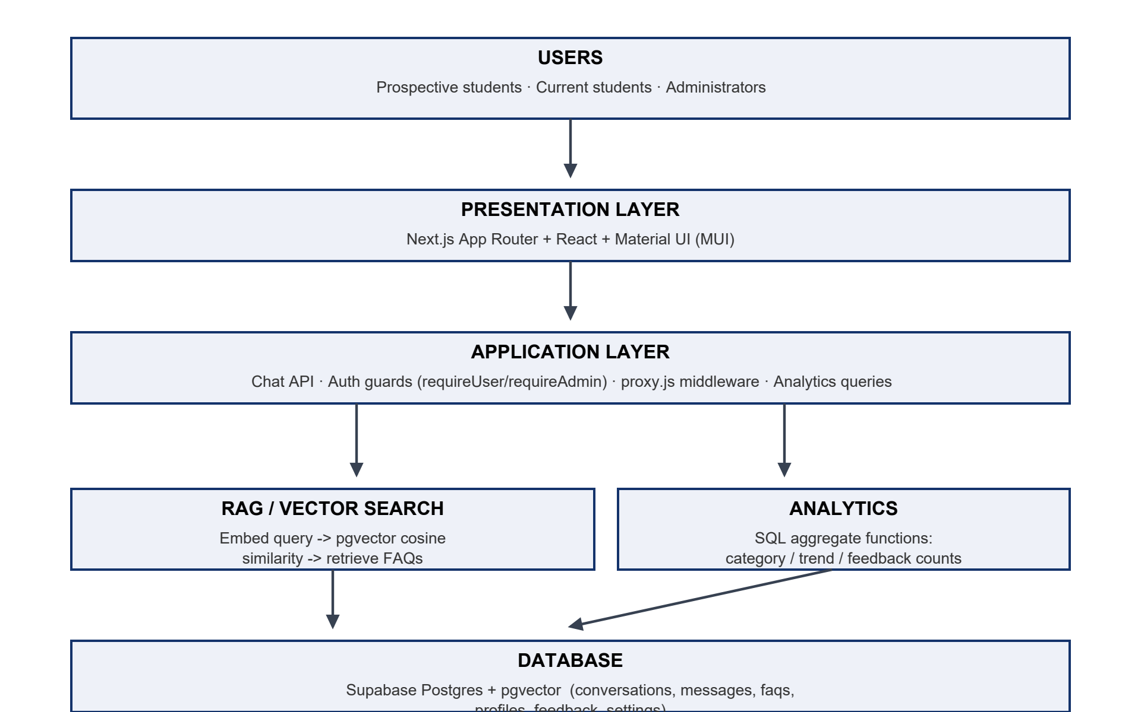
Figure 3.1 — System architecture

4. Database Design
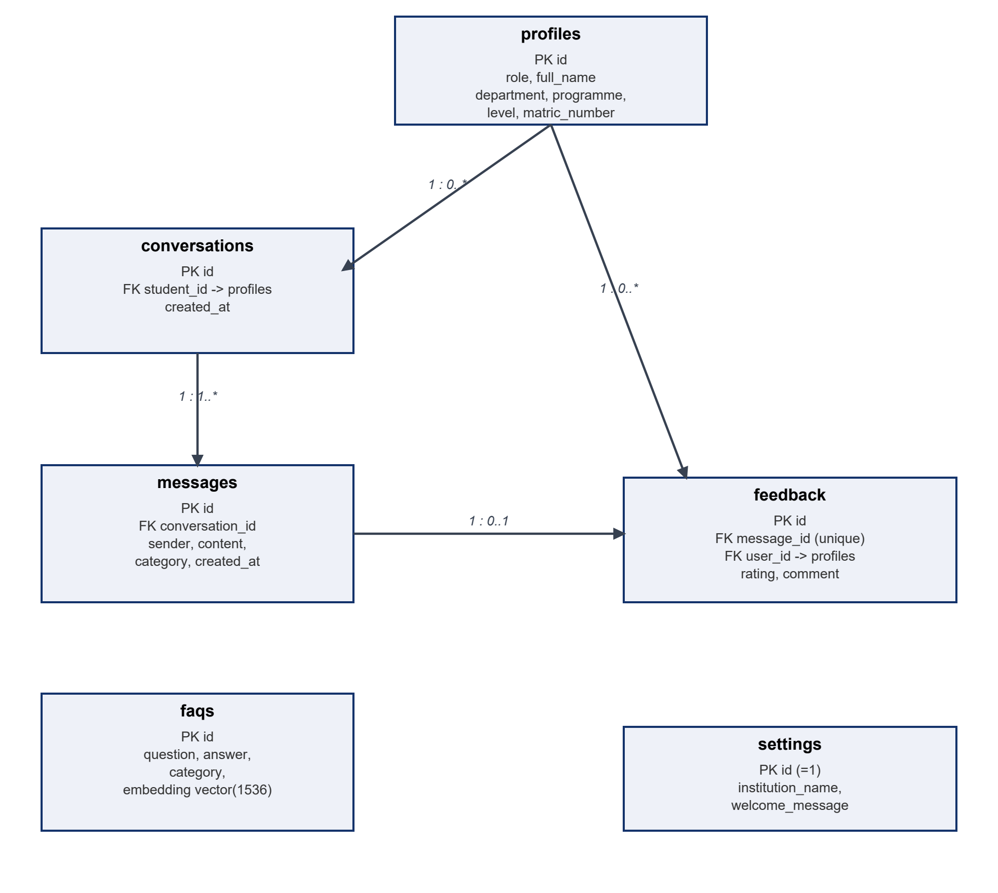
Figure 4.1 — Entity-relationship diagram

Data dictionary
profiles
Column | Type | Notes
id | uuid, PK | Same value as the Supabase Auth user id.
role | text | 'student' or 'admin'. Mirrors the JWT's user_metadata.role, which is the actual access-control source of truth.
full_name, department, programme, level, matric_number | text | Academic profile fields; set by an admin when the account is created.
conversations
Column | Type | Notes
id | uuid, PK
student_id | uuid, FK → profiles | Nullable — null for an anonymous/prospective-student conversation.
messages
Column | Type | Notes
id | uuid, PK
conversation_id | uuid, FK
sender | text | 'student' or 'bot'.
category | text | Keyword-classified enquiry topic, set on student messages only; powers the analytics charts.
faqs (knowledge base)
Column | Type | Notes
id | uuid, PK
question, answer, category | text | Approved institutional Q&A content.
embedding | vector(1536) | OpenAI text-embedding-3-small output; indexed with an ivfflat cosine index.
feedback
Column | Type | Notes
id | uuid, PK
message_id | uuid, FK, unique | One rating per bot message.
user_id | uuid, FK → profiles | The student who left the feedback.
rating, comment | text | 'up'/'down' plus an optional free-text comment.
settings
Column | Type | Notes
id | int, PK (=1) | A CHECK constraint enforces exactly one row.
institution_name, welcome_message | text | Admin-editable; used live by the chat page and the AI system prompt.

5. UML Design
Internal technical operations (embedding generation, cosine-similarity computation, the vector search itself) are deliberately not modelled as use cases below — they are implementation detail behind a single user-facing goal, “Submit Enquiry”.

5.1 Use-Case Diagram
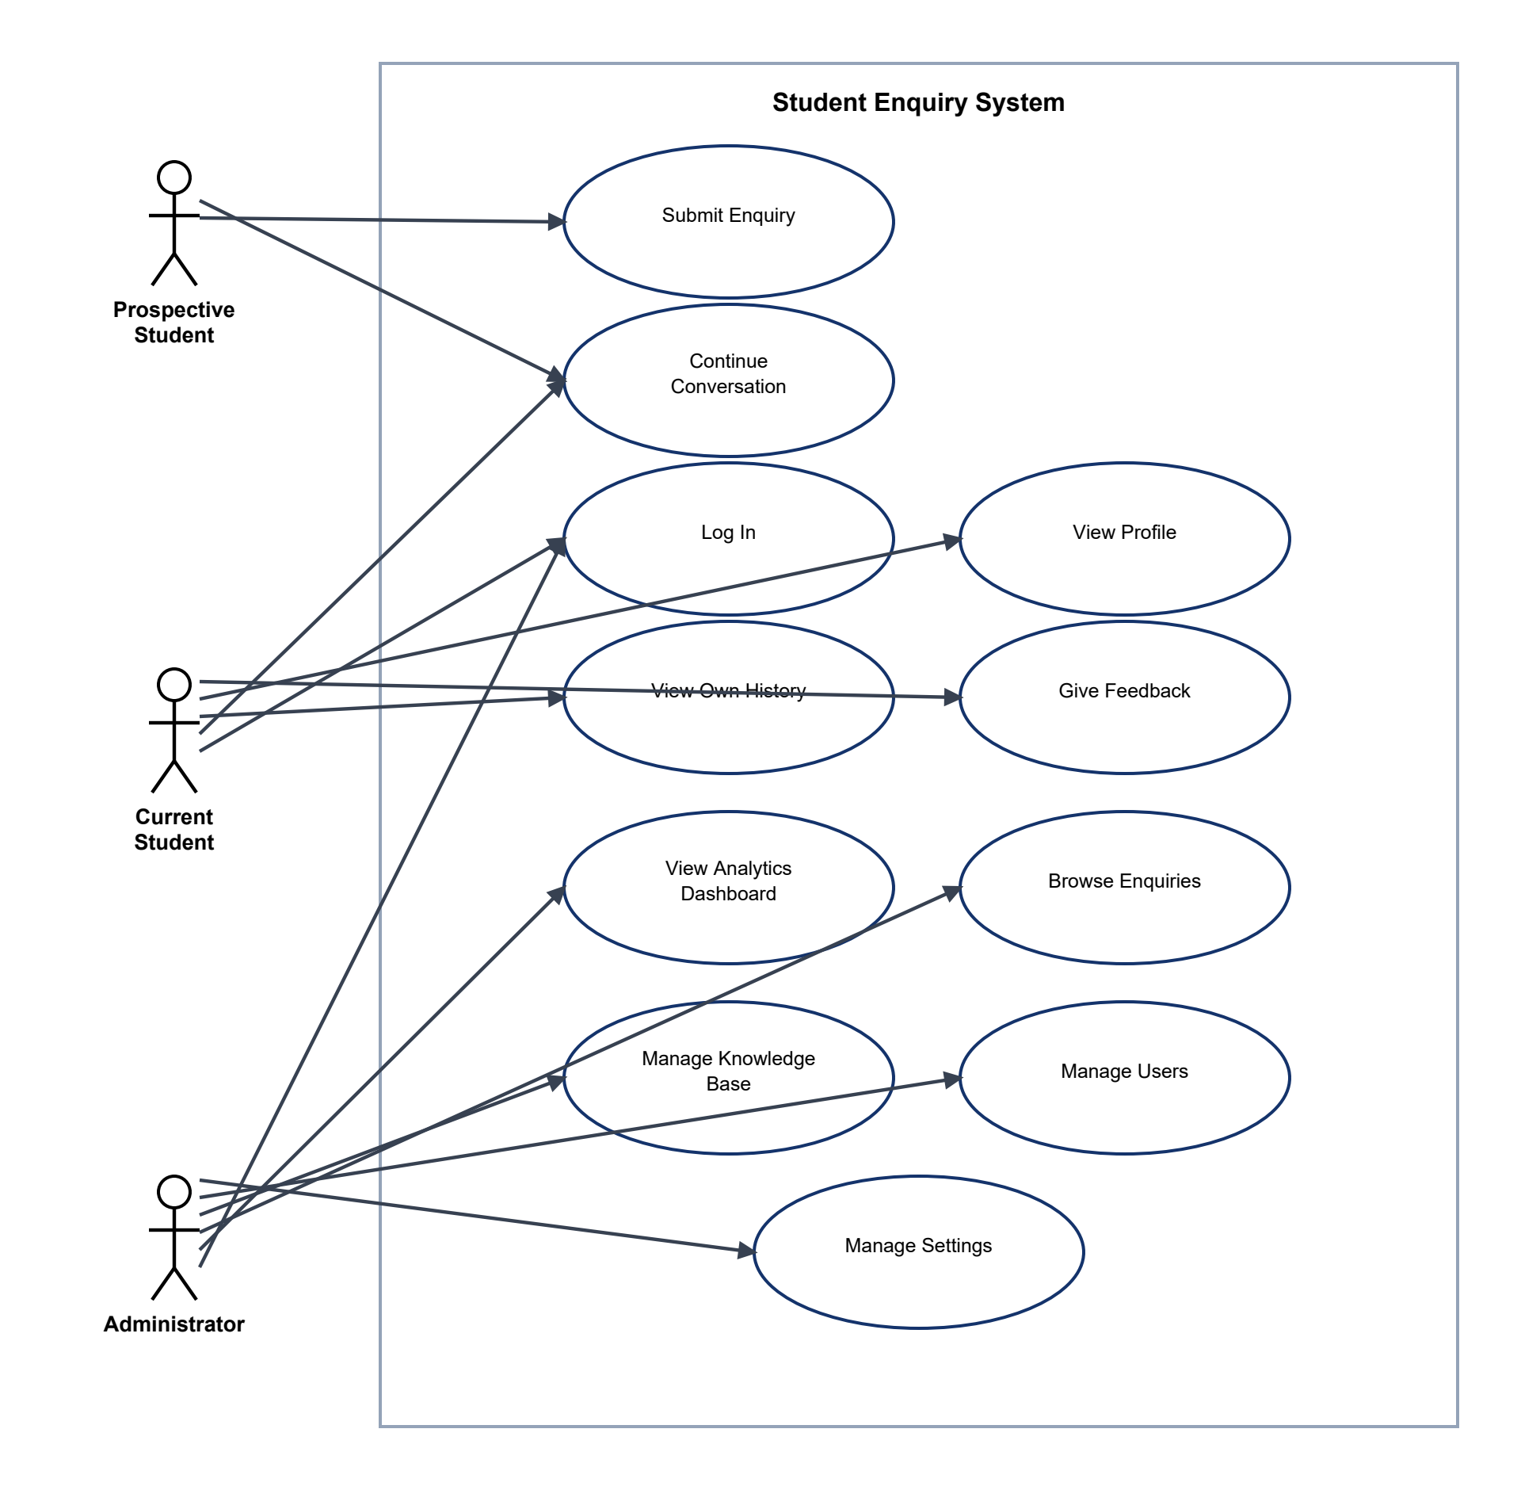
Figure 5.1 — Use-case diagram
Use case | Actor(s) | Description
Submit Enquiry | Prospective, Current Student | Type a question and send it; a stored, RAG-grounded reply is returned.
Continue Conversation | Prospective, Current Student | Ask a follow-up; the last 6 messages are used as context.
Log In | Current Student, Admin | Authenticate; routed to /chat or /admin/dashboard by role.
View Own History | Current Student | Browse and re-open past conversations.
View Profile | Current Student | See name, email, role, academic details.
Give Feedback | Current Student | Rate a bot reply, optionally with a comment.
View Analytics Dashboard | Administrator | KPI cards + category/trend charts, computed live.
Browse Enquiries | Administrator | Read-only view of any conversation.
Manage Knowledge Base | Administrator | Add/edit/delete FAQs; each is embedded automatically.
Manage Users | Administrator | Create/delete student & admin accounts.
Manage Settings | Administrator | Edit institution name & chatbot welcome message.

5.2 Activity Diagram
Swimlanes: Student, Chatbot System, RAG/Knowledge Base, Database.
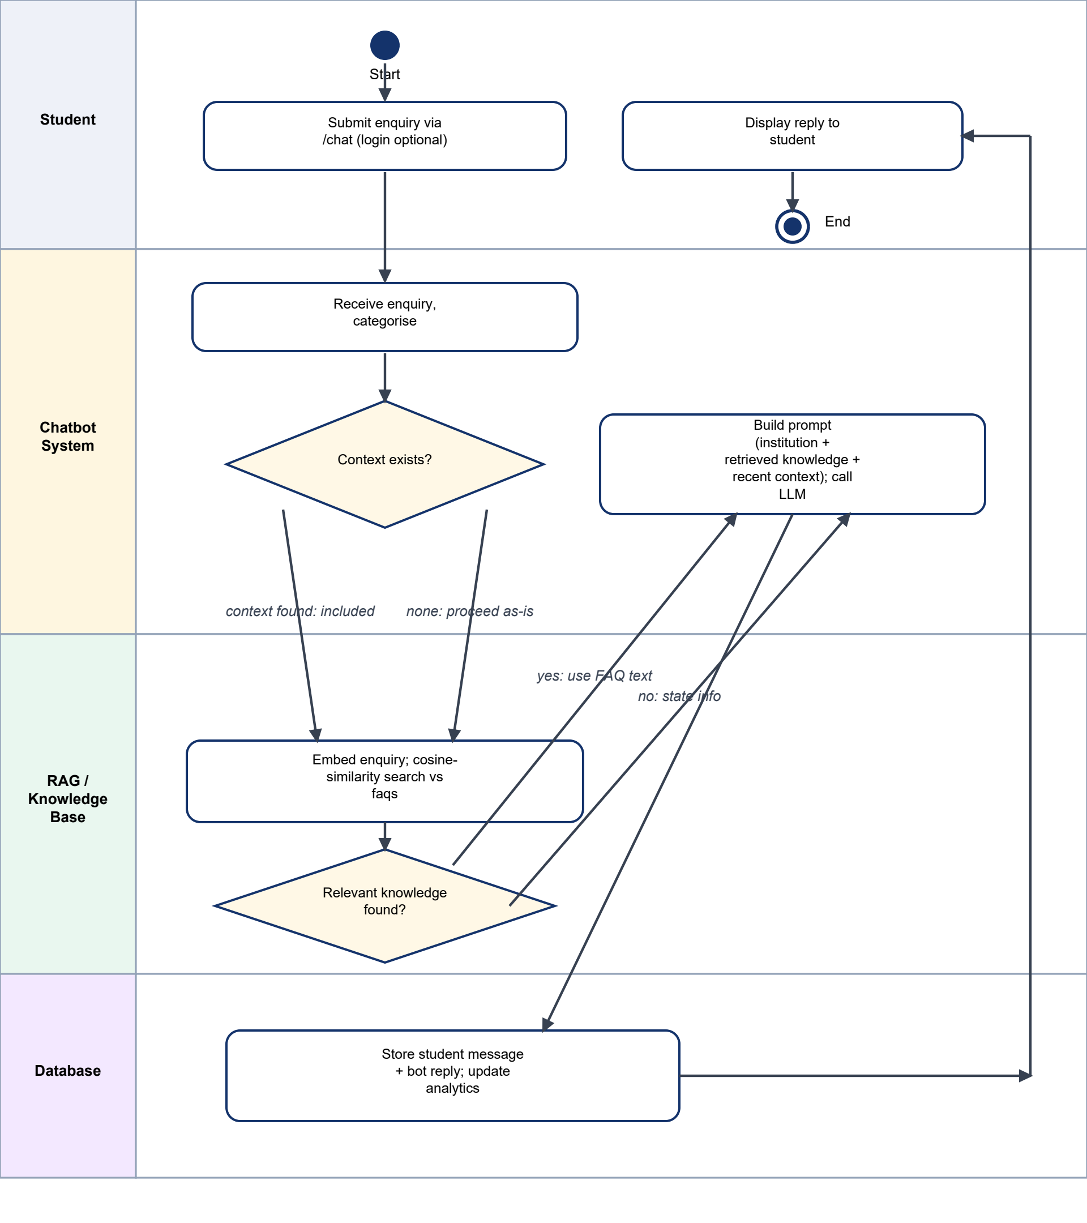
Figure 5.2 — Activity diagram of the enquiry-handling process

5.3 Sequence Diagram
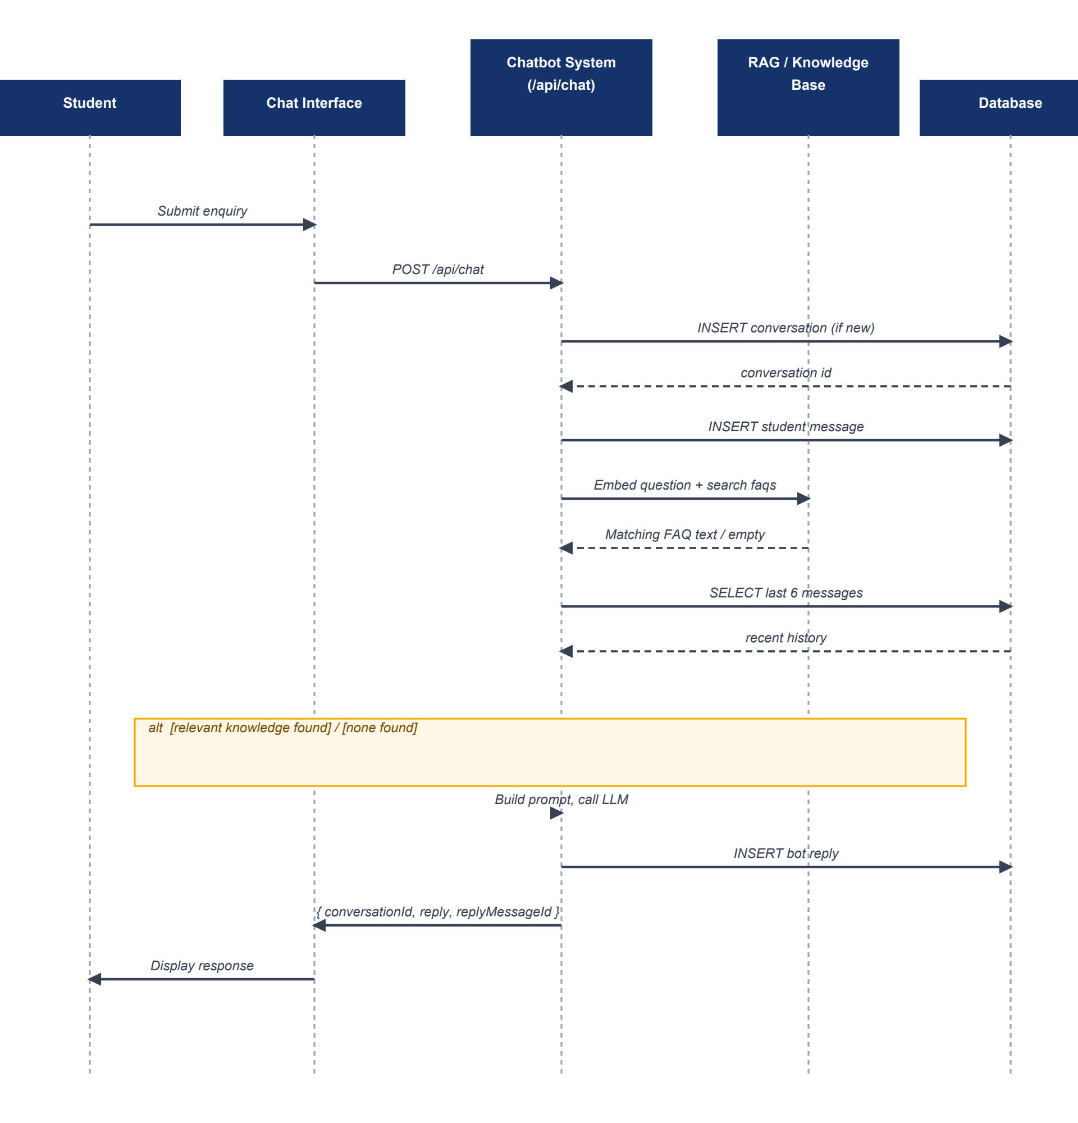
Figure 5.3 — Sequence diagram for one chat exchange

5.4 Class Diagram
Note on a deliberate deviation: a document/chunk knowledge-base model (separate KnowledgeDocument and DocumentChunk classes) was considered, but the implemented knowledge base is FAQ-entry based — each entry is short enough to embed directly, with no chunking step. Modelling a DocumentChunk class that does not exist in the code would misrepresent the implementation, so KnowledgeEntry below maps onto the real faqs table instead.
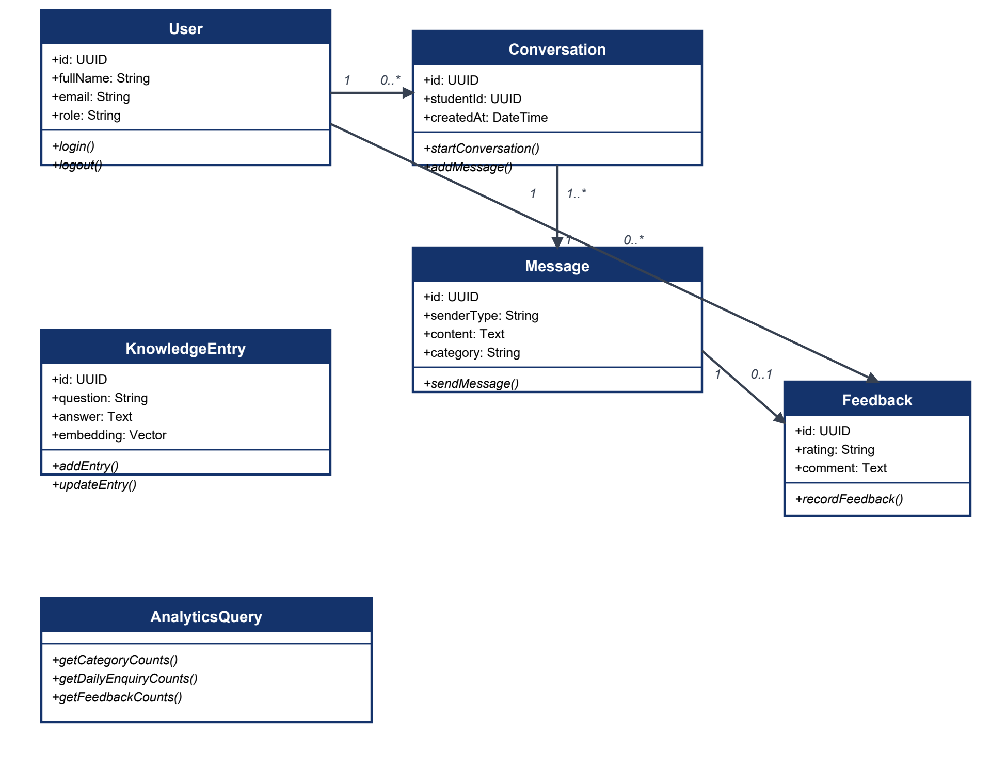
Figure 5.4 — Class diagram

6. Context-Aware Chatbot & RAG Pipeline
6.1 Context awareness
Every request identifies its conversation (creating one on the first message) and retrieves the most recent messages within it before generating a reply. Those messages are translated into the language model's role format and prepended to the prompt, so a follow-up such as “what about the deadline?” is interpreted using the immediately preceding exchange rather than as an isolated question. This is bounded context (the last 6 messages), not unlimited memory of the entire conversation history.
6.2 Retrieval-Augmented Generation
The knowledge base (approved institutional Q&A content) is embedded once, at write time, using OpenAI's text-embedding-3-small model (1536-dimensional vectors). Every incoming enquiry is embedded the same way, and pgvector's cosine-distance operator ranks knowledge-base entries by similarity:
cos(θ) = (A · B) / (||A|| · ||B||)
where A is the query embedding and B is a stored knowledge embedding. Entries above a similarity threshold are supplied to the language model as context; the system prompt explicitly instructs the model not to answer from outside that context. No TF-IDF or keyword-matching step is part of this pipeline — retrieval is embeddings → vector search → cosine similarity → ranked chunks → language model, exactly as specified.
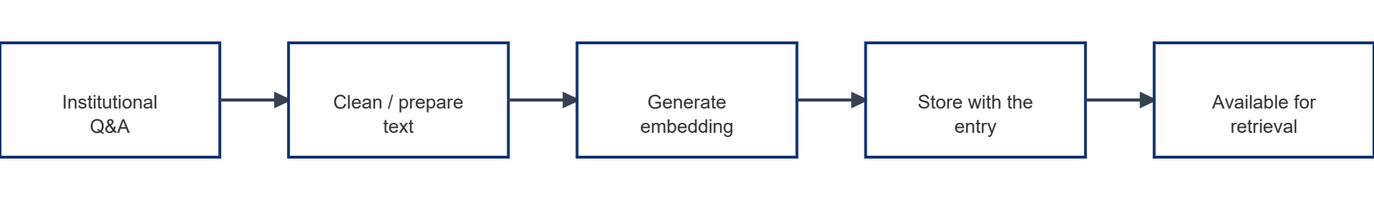
Figure 6.1 — Knowledge ingestion pipeline
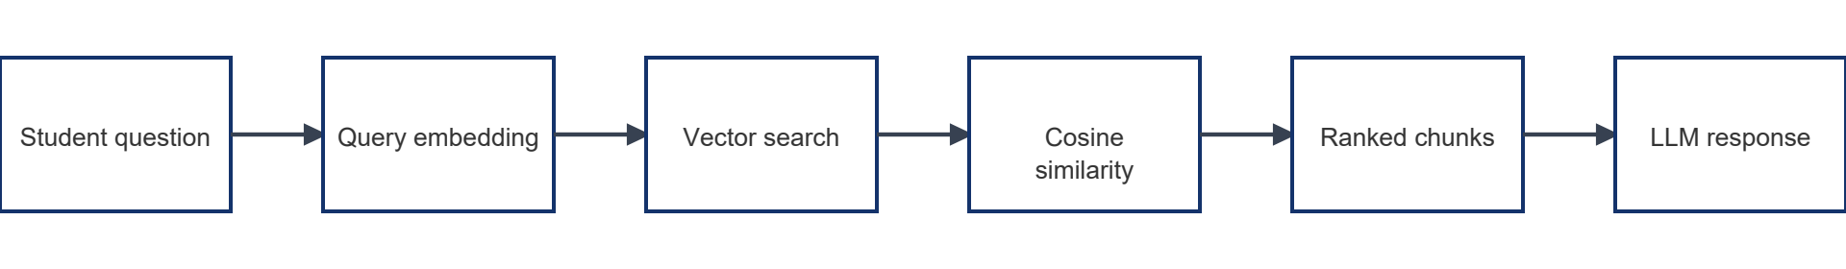
Figure 6.2 — RAG retrieval pipeline

7. Frontend Design
Built with Next.js (App Router) and Material UI, chosen over a plain client-side SPA because the project needs authenticated, role-gated areas and server-side data fetching (see Section 9) that a framework-less frontend would otherwise have to hand-roll.
Route | Purpose
/ | Public landing page.
/login | Single login for students and admins; redirects by role after sign-in.
/chat | Chat widget; works signed-out (anonymous) or signed-in.
/history, /history/[id] | A signed-in student's own past conversations and their transcripts.
/profile | Signed-in student's account details.
/admin/dashboard | KPI cards + charts.
/admin/enquiries, /admin/enquiries/[id] | Browse any conversation.
/admin/knowledge-base | FAQ CRUD with automatic embedding.
/admin/users | Create/list/delete accounts.
/admin/settings | Institution name & welcome message.
UI design language: a deep navy primary colour, a warm gold accent, a light grey/off-white background, white cards with subtle borders, and Material UI's default sans-serif type scale. Both the student and admin sidebars collapse to a mobile top-bar-and-drawer pattern below the small-screen breakpoint.

8. Backend / API Reference
The “backend” is the set of Next.js API routes and server components under app/api and app/**/page.js — kept modular by responsibility (chat, feedback, faqs, admin/users, admin/settings) rather than as one monolithic handler.
Endpoint | Auth | Purpose
POST /api/chat | Optional | Submit an enquiry; returns the reply and its message id.
POST /api/feedback | Required (any account) | Upsert a rating (+ optional comment) for one bot message.
GET/POST/PUT/DELETE /api/faqs | Admin | Knowledge-base CRUD; embeds on save.
GET/POST/DELETE /api/admin/users | Admin | Account management; returns a one-time temp password on creation.
GET/PUT /api/admin/settings | Admin | Read/update the settings row.
Each chat request performs, in order: identify user (optional) → identify/create conversation → retrieve context → create query embedding → search the vector database → retrieve relevant chunks → build the prompt → generate the response → store both messages → record analytics (implicitly, via the stored category) → return the response — each stage its own function rather than one large handler.

9. Authentication, Roles & Security
Measure | Implementation
Authentication | Supabase Auth (email + password); no public sign-up — accounts are created by an admin only.
Role-based access | Role travels in the account's JWT (user_metadata.role); read with no extra database call.
Route protection | proxy.js (edge middleware) redirects logged-out visitors away from /history & /profile, and any non-admin away from /admin/**, before the page even renders.
API-level protection | Each admin API route independently re-checks role server-side (requireAdmin()), since middleware alone doesn't stop a direct request to the route.
Secrets | OPENAI_API_KEY and the Supabase secret key are read from environment variables server-side only; never referenced in any “use client” file, never present in the built client bundle, never committed to git.
Row Level Security | Enabled on every table with no permissive policies (“deny all”), as a safety net — all real access goes through the server-only secret-key client, which bypasses RLS by design.
Input validation | Empty/whitespace-only messages are rejected client-side (disabled send button) and server-side (400 response).

10. Administrator Analytics Dashboard
The dashboard is decision support, not decoration: every number is a live query against the same tables the chatbot writes to, computed by dedicated SQL functions rather than hard-coded.
KPI / chart | Source
Total Enquiries | get_category_counts() totals
Active Users | get_active_student_count(30) — distinct students who've chatted in the window
Knowledge Documents | count(*) on faqs
Feedback | get_feedback_counts() (up/down totals)
Top Enquiry Topics (bar chart) | get_category_counts()
Enquiry Trends (line chart) | get_daily_enquiry_counts(14)
Enquiries list | get_recent_conversations() — joins profiles for the student's name

11. Functional Testing
Results below reflect what was actually verified during development, or are explicitly marked pending where a live database with real accounts is required — no result is invented.
# | Test case | Expected result | Status
1 | Greeting | Friendly acknowledgement, no fabricated facts | Pending manual QA
2 | Admission enquiry | Reply grounded in a matching FAQ | Pending manual QA
3 | Academic enquiry | Reply grounded in a matching FAQ | Pending manual QA
4 | Follow-up enquiry (context) | Follow-up interpreted using prior context | Code path verified
5 | No relevant knowledge | States it lacks the information; does not invent an answer | Code path verified
6 | Out-of-scope enquiry | Redirected to the system's actual purpose | Pending manual QA
7 | Prospective (anonymous) chat | Works with no login; no History entry created | Verified
8 | Student authentication | Redirected to /chat; History/Profile reachable | Pending manual QA
9 | Administrator authentication | Redirected to /admin/dashboard | Pending manual QA
10 | Analytics dashboard display | Live figures, not placeholders | Code path verified
11 | Access restriction (student to admin) | Redirected away from /admin/** | Verified
12 | Access restriction (logged-out) | Redirected to /login | Verified
13 | Invalid input (empty message) | Send blocked client- and server-side | Verified
14 | Knowledge-base management | New FAQ usable by the chatbot with no code change | Pending manual QA
15 | Feedback with comment | Row written; dashboard Feedback count updates | Pending manual QA
16 | Error handling (misconfiguration) | Clean error message, not a stack trace | Verified

12. Performance Evaluation
The specification calls for accuracy, precision, recall, F1-score, and response time. None of these have been measured yet — computing them honestly requires a labelled evaluation set (realistic student questions with a human-judged expected answer), running each through the deployed chatbot once the knowledge base holds real institutional content, and a human grading each response. Reporting numbers without that process would mean inventing results, which this report deliberately does not do.
Metric | Formula | Result
Accuracy | Correct responses / Total queries | Not yet measured
Precision | TP / (TP + FP) | Not yet measured
Recall | TP / (TP + FN) | Not yet measured
F1-score | 2 · P · R / (P + R) | Not yet measured
Avg. response time | Request-to-reply wall clock | Not yet measured
Context-retention rate | % of follow-ups answered correctly using prior context | Not yet measured

13. Deployment
The application is deployed to Vercel as a single unit (frontend, API routes, and edge middleware together); the database is a managed Supabase Postgres project. Environment variables (the OpenAI key and the Supabase secret key) are stored encrypted in the hosting platform and read only at request time on the server — never present in any file shipped to the browser.
Environment variables
Variable | Where used
NEXT_PUBLIC_SUPABASE_URL | Browser + server — project URL, not sensitive.
NEXT_PUBLIC_SUPABASE_PUBLISHABLE_KEY | Browser + server — public key, restricted by RLS.
SUPABASE_SECRET_KEY | Server only — bypasses RLS; the one client used for all application data.
OPENAI_API_KEY | Server only — embeddings + chat completions.

14. Conclusion & Future Work
The implemented system meets its stated objectives: a context-aware, RAG-grounded chatbot available to both anonymous and authenticated students, and an administrator back office that turns the same stored data into decision-support analytics, all behind role-based access control. The design deliberately favoured the simplest solution that preserves each requirement — a single Next.js codebase instead of a separate frontend/backend split, FAQ entries instead of a document-chunking pipeline the knowledge base doesn't need, and a manually shared temporary password instead of an email-invite system that would require additional infrastructure.
Future work
- Run the functional test suite (Section 11) against a populated knowledge base and record the performance metrics in Section 12 honestly, once real data exists.
- Replace the temporary-password account creation flow with Supabase's inviteUserByEmail, once an email provider is configured.
- Add an admin Reports page (data export) if a future requirement calls for it — the original specification marks this optional.
- Consider chunking for any future knowledge-base entries long enough to need it, rather than retrofitting a document/chunk model the current content does not require.

