**Background**

In the Categorical OEL framework, initial groups of materials are created based on the potency estimates (e.g. benchmark doses) from many different materials. Thus, many dose-response relationships must be modeled in order to derive the many potency estimates.

For dichotomous (quantal) responses, EPA’s Benchmark Dose Software (BMDS) can be used to fit multiple model shapes to a single dose-response relationship. Using the Dose Response Session feature, every model of interest can be fit to a dataset sequentially with a single run of the session. While this feature speeds up the model fitting process, there is still a requirement to modify the input dataset of the session for a new relationship. When many relationships need to be modeled, this can take a significant amount of time.

Other software, such as SAS or R, allow for custom scripts to be written to repeat, or loop, a process for many datasets. These software also allow for the fitting of user-defined models to a relationship.

The next step currently in evaluating the Categorical OEL quantitative framework is to evaluate the NTP histopathology data, namely lung inflammation. The current subset of interest is approximately 100 dose-response relationships, and a BMD estimate is required for each. SAS was chosen as the software in which EPA BMDS will be replicated and modified, namely to automatically fit models to an arbitrary number of relationships. This effort builds upon the paper by Matt Wheeler (Wheeler 2005).

In addition, EPA BMDS does not enable model averaging. Separate software is available (MADr), but also requires additional effort to allow for model averaging in many different relationships. This process can translated into SAS and included with the replicated BMDS output.

There are pros and cons to this endeavor:

* Benefits of replicating EPA BMDS (dichotomous models) in SAS
  + Allows for the modeling of an arbitrary number of dose-response relationships quickly
  + Customizable output
  + More detailed modeling diagnostics available
  + May be able to estimate a benchmark dose when BMDS could not (Wheeler 2005)
  + Can include model averaging
* Disadvantages of replication
  + Each nonlinear model must be manually coded in SAS
  + BMD and BMDL estimations must be coded, which may require numeric analysis methods due to the nonlinear model forms
  + Diagnostic output must be either manually created or captured
  + Plots must be manually created
  + BMDS is user friendly, including graphical user interfaces

**Methods**

The code provided in Wheeler 2005 shows the BMD and BMDL estimation for the Weibull model. As shown below, 8 other model forms are available in BMDS

Logistic:

*π*1(*d*) = 1 / (1 + exp[−(*α* + *βd*)]) (2.1.1)

Log-logistic:

*π*2(*d*) = *γ* + (1 − *γ* ) / (1 + exp[−(*α* + *β* ln(*d*))] )*,*

0 ≤ *γ <* 1*, β*≥ 1 (2.1.2)

Gamma:

*π*3(*d*) = *γ* + (1 − *γ* ) (1/*Γ*(*α*)) $\int_{0}^{βd}{t^{α-1}e^{-t}}$*dt,*

0 ≤ *γ <* 1 *α* ≥ 1*, β*≥ 0 (2.1.3)

Multistage:

*π*4(*d*) = *γ* + (1 − *γ* )[1 − exp(−*θ*1*d* − *θ*2*d*2 *. . .*)]*,*

0 ≤ *γ <* 1 *θ*1 ≥ 0*, θ*2 ≥ 0 *. . .* (2.1.4)

Probit:

*π*5(*d*) = *Φ*(*a* + *βd*) (2.1.5)

Log-probit:

*π*6(*d*) = *γ* + (1 − *γ* ) *Φ* [*a* + *β* ln *d*]*,*

0 ≤ *γ <* 1 *β* ≥ 0*.*5 (2.1.6)

Quantal-linear:

*π*7(*d*) = *γ* + (1 − *γ* )[1 − exp(−*βd*)]*,*

0 ≤ *γ <* 1 (2.1.7)

Quantal-quadratic

*π*8(*d*) = *γ* + (1 − *γ* )[1 − exp(−*βd*2)]*,*

0 ≤ *γ <* 1 (2.1.8)

Weibull

*π*9(*d*) = *γ* + (1 − *γ* )[1 − exp(−*βdα*)]*,*

0 ≤ *γ <* 1 *α* ≥ 0*.*5*, β*≥ 0 (2.1.9)

For each of the models, the BMD (Crump 1984) represents the dose associated with a given probability of response called the benchmark response (BMR). The BMR represents a level of risk.

There are two types of BMR available, Extra or Added risk.

$$Extra:BMR= \frac{π\left(BMD\right)- π(0)}{1- π(0)}$$

$$Added:BMR= π\left(BMD\right)- π(0)$$

$$π\left(BMD\right) is the estimated probability of a response at dose=BMD$$

$$π\left(0\right)is the estimated probability of a response at background, or dose=0$$

Thus, for each model, the BMD estimate can be found analytically or numerically by solving the chosen BMR equation for the BMD.

For example, in the Quantal Linear model with Added Risk:

$$BMR=\left[\hat{γ}+\left(1-\hat{γ}\right)*\left(1- e^{-\hat{β}*\hat{BMD}}\right)\right]-\left[\hat{γ}+\left(1-\hat{γ}\right)*\left(1- e^{-\hat{β}*0}\right)\right]$$

$$BMR= \left[\hat{γ}+\left(1-\hat{γ}\right)*\left(1- e^{-\hat{β}*\hat{BMD}}\right)\right]-\left[\hat{γ}\right]$$

$$BMR=\left(1-\hat{γ}\right)*\left(1- e^{-\hat{β}*\hat{BMD}}\right) \\ \frac{BMR}{\left(1-\hat{γ}\right)}=1- e^{-\hat{β}*\hat{BMD}} \\ e^{-\hat{β}*\hat{BMD}}=1- \frac{BMR}{\left(1-\hat{γ}\right)} \\ -\hat{β}*\hat{BMD}=\ln\left(1- \frac{BMR}{\left(1-\hat{γ}\right)}\right) \\ \hat{BMD}= \frac{\ln\left(1- \frac{BMR}{\left(1-\hat{γ}\right)}\right)}{-\hat{β}}$$

That is, the BMD can be reparameterized as a function of the BMR and maximum likelihood estimates of the other parameters in the model. There reparamaterizations are shown in the User’s Manual (EPA).

For the multistage models (degree 2 or 3 only considered here), the BMD cannot be reparameterized. Instead, the BMD is the root of polynomial function, so Newton’s Method was used to numerically identify the BMD estimate.

$$Multistage 2 BMD, Extra Risk:Find the root of the equation \\ β_{1}*BMD+ β_{2}*{BMD}^{2}+\ln\left(1-BMR\right)=0$$

Once the maximum likelihood estimate of the BMD is obtained, an iterative procedure is used to estimate the BMDL via the profile likelihood method proposed by Crump and Howe 1985.

Wheeler 2005 illustrated that SAS can obtain BMD and BMDL estimates that match those from EPA BMDS to three significant figures; they are not exactly the same due to differences in numerical algorithms and convergence criteria. While useful, it isn’t clear at this point which model best fits the data, if any.

EPA BMDS provides two diagnostic criteria and corresponding guidance. First, a Chi-square goodness-of-fit test is conducted, which evaluates how close the observed proportion of responders is to the expected proportion from a given model. If the p-value is greater than 10%, this indicates the model fits the data. Second, of all models which adequately fit the data, the best model is chosen as the one with the smallest Akaike Information Criterion (AIC), which is a penalized function (based on number of parameters) of the model’s log likelihood. Thus, the best model is that which fits the observed data and is parsimonious.

This output was manually created in SAS.

EPA BMDS also provides graphs of the dose response relationships. These are not created by default in SAS. First, the model has to be visualized by generating “doses” from the minimum to the maximum in small increments, then plugging those doses into the model equation with the maximum likelihood estimates for each parameter.

**Results**

In approximately 1 minute, the following output is generated in the current version of BMDS in SAS:

|  |  |  |  |  |  |  |  |  |
| --- | --- | --- | --- | --- | --- | --- | --- | --- |
| **Obs** | **ChiSq** | **GoF_pvalue** | **AIC** | **BMR** | **BMD** | **BMDL** | **Model** | **Risk** |
| **1** | 0.9635503902 | 0.8100707008 | 16.823549045 | 0.1 | 0.5855120269 | 0.3988698946 | LOGISTIC | EXTRA |
| **2** | 1.0465388662 | 0.7899928999 | 16.913425316 | 0.1 | 0.5572407065 | 0.3952629621 | PROBIT | EXTRA |
| **3** | 0.2233900508 | 0.8943169598 | 18.074369156 | 0.1 | 1.0964357026 | 0.4157524355 | LOG PROBIT | EXTRA |
| **4** | 0.2384377697 | 0.8876134944 | 18.089753198 | 0.1 | 1.0732442748 | 0.3908430242 | LOG-LOGISTIC | EXTRA |
| **5** | 0.4028318852 | 0.8175722977 | 18.25921056 | 0.1 | 1.0112416865 | 0.2832029239 | GAMMA | EXTRA |
| **6** | 0.604639533 | 0.7391016871 | 18.471018108 | 0.1 | 0.8776287941 | 0.2611412058 | WEIBULL | EXTRA |
| **7** | 0.6044242565 | 0.739181247 | 18.472139892 | 0.1 | 0.8625634154 | 0.2515252859 | MULTISTAGE 2 | EXTRA |
| **8** | 2.9874691732 | 0.393561221 | 19.065057214 | 0.1 | 0.2920933286 | 0.1835360492 | QUANTAL LINEAR | EXTRA |
| **9** | 0.6044242631 | 0.4368949309 | 20.472139892 | 0.1 | 0.8625634617 | 0.2464947934 | MULTISTAGE 3 | EXTRA |

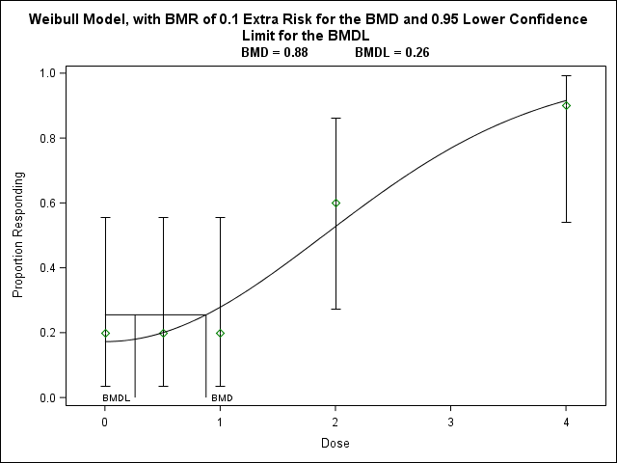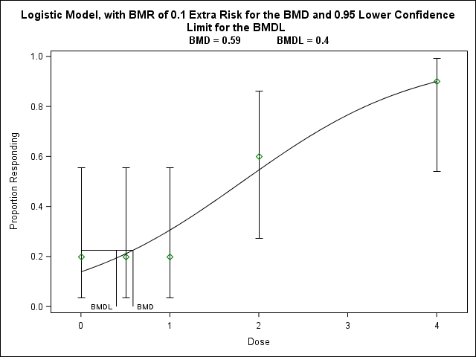

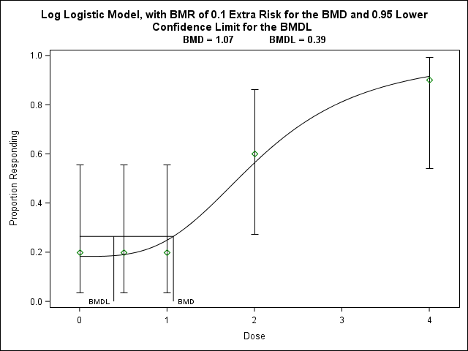

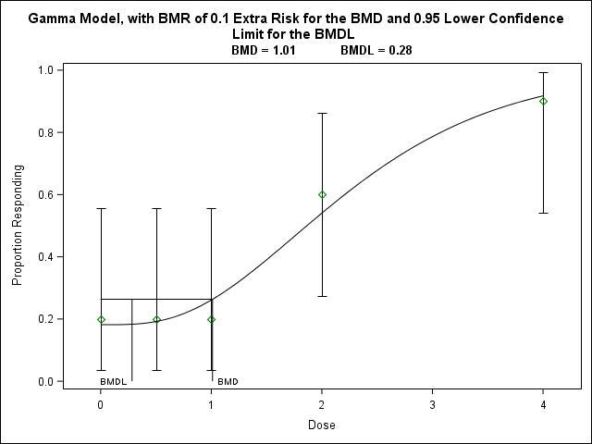

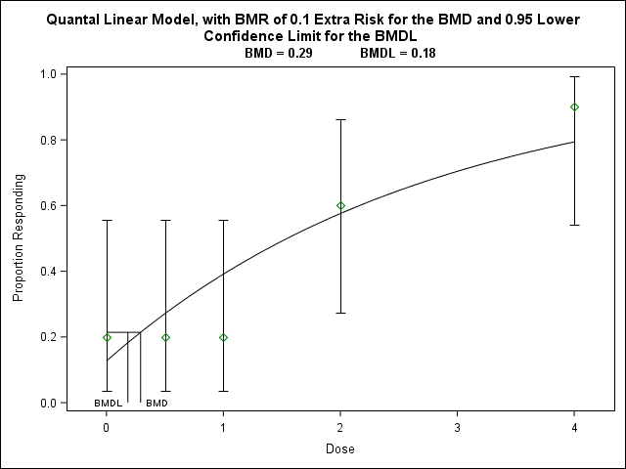

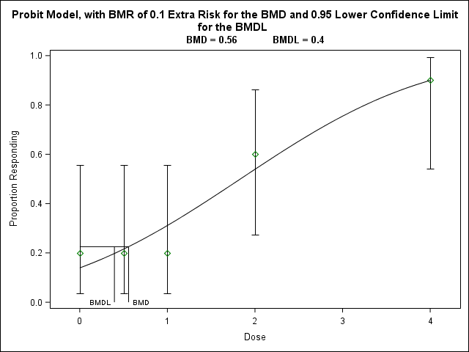

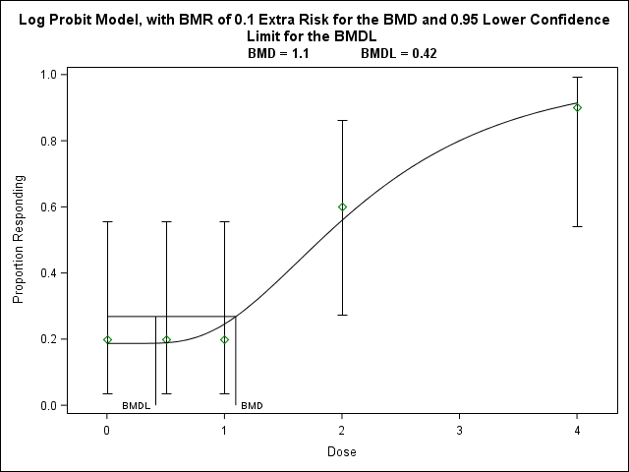

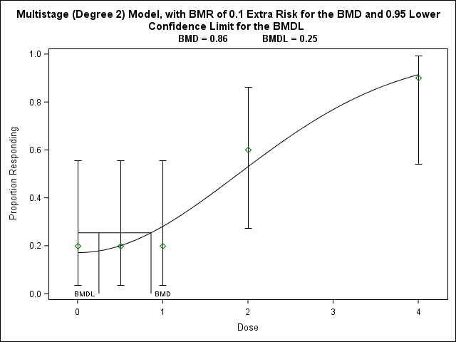

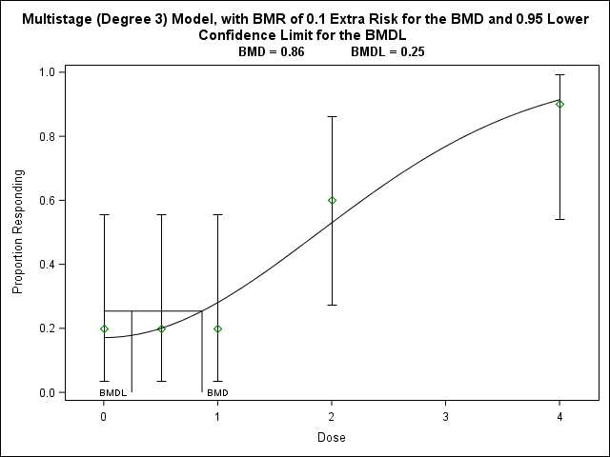

The next step is to incorporate model averaging. As discussed in Wheeler and Bailer (2007), the selection of a single “best fitting model” ignores the other models which were considered and also adequately fit the data (i.e. Goodness-of-Fit p-value > 0.1), adding model uncertainty into the estimation of the BMD and BMDL. Wheeler and Bailer proposed the model average fit as a weighted sum of some subset of models.

A stand alone software, MADr, was released in order to obtain model average BMD and BMDL estimates.

Using the example data from Wheeler 2005, MADr was used to estimate the BMD and BMDL for 10% extra risk. All models were included except Quantal Quadratic and Multistage 3. The resulting BMD was 0.750856; percentile BMDL was 0.2386012; bias corrected and accelerated BMDL was 0.28098266.

A model averaging script was written in SAS, following the bracketing-and-bisection method for BMD interpolation as mentioned in Wheeler 2007. The BMD was estimated to be 0.750604627, matching that from MADr to the third digit.

BMDL estimation is computationally intensive, given the following process:

1. Fit all models to the dataset of interest.
2. Obtain the model average using the chosen best models
   1. Estimate BMD
3. Generate a new dataset, where at each dose, X ~ Binomial(n, p=model average probability)
4. Fit all models to this new bootstrap dataset
5. Obtain the model average using the chosen best models
   1. Estimate BMD
6. Repeat steps 3-5 2000 times, acquiring a distribution of 2000 BMD estimates
7. Choose the percentile of the BMD distribution matching the confidence limit of interest
   1. E.g. 5th percentile for the 95% BMDL

This script follows the format of MADr, in which the user can indicate which models to include in the averaging process.

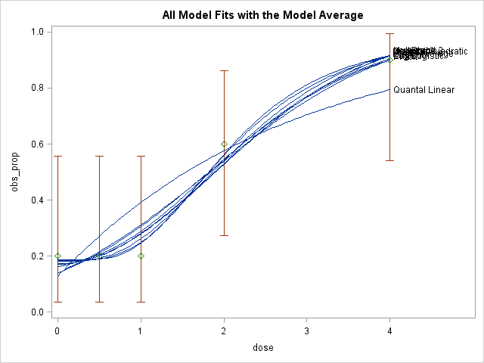

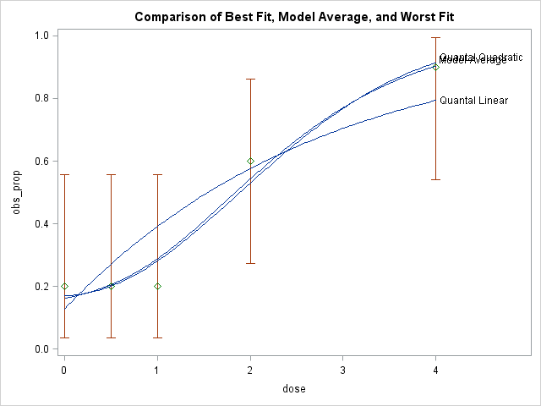

**References**

Wheeler, M. Benchmark Dose Estimation Using SAS. 2005. SUGI 30.

EPA. BMDS 2.6 User’s Guide

Wheeler, M., Bailer, J. Properties of Model-Averaged BMDLs: A Study of Model Averaging in Dichotomous Response Risk Estimation. Risk Analysis, Vol. 27, No 3, 2007

Wheeler, MADr

Crump K. 1984. A new method for determining allowable daily intakes. Fundamental and Applied Toxicology 4: 854-871

Crump, K.S. and R. Howe. 1985. A review of methods for calculating statistical confidence limits in low dose extrapolation in Clayson, D. Krewski, I. Munro (eds). Toxicological Risk Assessment, Vol. I (pp. 187 – 203). Boca Raton, Fl: CRC Press.