Penetration Testing Report:

All Types of attacks attempted: ['Error Based SQL Injection']

General Scan information:

|  |  |  |  |
| --- | --- | --- | --- |
| Website | No. Of URL's Tested | No. Of Successful Attacks | Time Taken |
|  |  |  |  |
|  |  |  |  |
| DVWA | 125 | 4 | 201 Seconds |
| XVWA | 162 | 1 | 1663 Seconds |
| Test_Website | 6 | 1 | 1 Seconds |

Website Vulnerability Statuses:

|  |  |
| --- | --- |
| Website | Safety |
|  |  |
|  |  |
| DVWA | Website Vulnerable! |
| XVWA | Website Vulnerable! |
| Test_Website | Website Vulnerable! |

DVWA

Date and Time of Report: 12-09-2023, 02:56:53

Types of Successful attacks: ['Error Based SQL Injection']

SQLI Strings Attempted in Total: 3039

### SQLI Strings Used:

[-] OR 3409=3409 AND ('pytW' LIKE 'pytW

[-] OR 3409=3409 AND ('pytW' LIKE 'pytW

[-] OR 3409=3409 AND ('pytW' LIKE 'pytW

[-] OR 3409=3409 AND ('pytW' LIKE 'pytW

### Vulnerable Pages:

[-] http://127.0.0.1/dvwa/dvwa/vulnerabilities/brute/

[-] http://127.0.0.1/dvwa/dvwa/vulnerabilities/sqli/

[-] http://127.0.0.1/dvwa/dvwa/vulnerabilities/brute/?Login=Login&password=ZAP&username=ZAP

[-] http://127.0.0.1/dvwa/dvwa/vulnerabilities/sqli/?Submit=Submit&id=ZAP

Vulnerability Statistics:

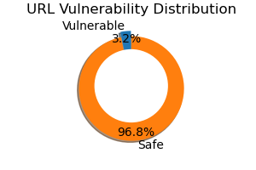

Recommendations:

SQL Injection: https://owasp.org/www-community/attacks/SQL_Injection

XVWA

Date and Time of Report: 12-09-2023, 02:56:54

Types of Successful attacks: ['Error Based SQL Injection']

SQLI Strings Attempted in Total: 2997

### SQLI Strings Used:

[-] OR 3409=3409 AND ('pytW' LIKE 'pytW

### Vulnerable Pages:

[-] http://127.0.0.1/xvwa/vulnerabilities/sqli/

Vulnerability Statistics:

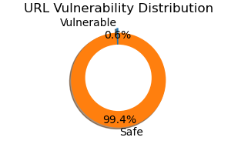

Recommendations:

SQL Injection: https://owasp.org/www-community/attacks/SQL_Injection

Test_Website

Date and Time of Report: 12-09-2023, 02:56:54

Types of Successful attacks: ['Error Based SQL Injection']

SQLI Strings Attempted in Total: 13

### SQLI Strings Used:

[-] ' OR '1'='1

### Vulnerable Pages:

[-] http://127.0.0.1/Test_Website/index.html

Vulnerability Statistics:

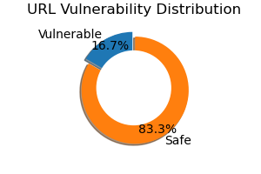

Recommendations:

SQL Injection: https://owasp.org/www-community/attacks/SQL_Injection