Penetration Testing Report:

All Types of attacks attempted: ['Error Based SQL Injection']

General Scan information:

|  |  |  |  |
| --- | --- | --- | --- |
| Website | No. Of URL's Tested | No. Of Successful Attacks | Time Taken |
|  |  |  |  |
|  |  |  |  |
| DVWA | 125 | 0 | 461 Seconds |
| XVWA | 162 | 1 | 2220 Seconds |
| Test_Website | 6 | 1 | 2 Seconds |

Website Vulnerability Statuses:

|  |  |
| --- | --- |
| Website | Safety |
|  |  |
|  |  |
| DVWA | Website Secure! |
| XVWA | Website Vulnerable! |
| Test_Website | Website Vulnerable! |

DVWA

Date and Time of Report: 13-09-2023, 03:38:33

Vulnerability Statistics:

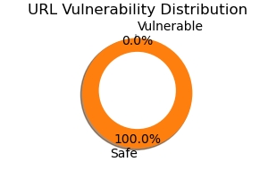

Recommendations:

Nothing To Recommend, Your Webpage is Secure!

XVWA

Date and Time of Report: 13-09-2023, 03:38:33

Types of Successful attacks: ['Error Based SQL Injection']

SQLI Strings Attempted in Total: 5627

### SQLI Strings Used:

[-] AND 1 = utl_inaddr.get_host_address ( ( SELECT DISTINCT ( table_name ) FROM ( SELECT DISTINCT ( table_name ) , ROWNUM AS LIMIT FROM sys.all_tables ) WHERE LIMIT = 5 ) ) AND 'i' = 'i

### Vulnerable Pages:

[-] http://127.0.0.1/xvwa/vulnerabilities/sqli/

Vulnerability Statistics:

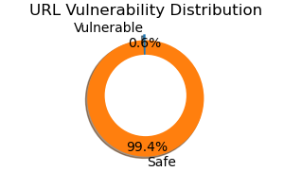

Recommendations:

SQL Injection: https://owasp.org/www-community/attacks/SQL_Injection

Test_Website

Date and Time of Report: 13-09-2023, 03:38:33

Types of Successful attacks: ['Error Based SQL Injection']

SQLI Strings Attempted in Total: 48

### SQLI Strings Used:

[-] or 1 --'

### Vulnerable Pages:

[-] http://127.0.0.1/Test_Website/index.html

Vulnerability Statistics:

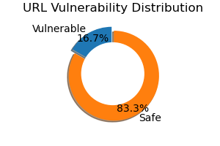

Recommendations:

SQL Injection: https://owasp.org/www-community/attacks/SQL_Injection