Penetration Testing Report:

All Types of attacks attempted: ['BLind SQL Injection']

General Scan information:

|  |  |  |  |
| --- | --- | --- | --- |
| Website | No. Of URL's Tested | No. Of Successful Attacks | Time Taken |
|  |  |  |  |
| DVWA | 127 | 6 | 0 Seconds |
| XVWA | 117 | 2 | 0 Seconds |

Website Vulnerability Statuses:

|  |  |
| --- | --- |
| Website | Safety |
|  |  |
| DVWA | Website Vulnerable! |
| XVWA | Website Vulnerable! |

DVWA

Date and Time of Report: 16-02-2023, 11:21:59

Types of Successful attacks: ['Blind SQL Injection']

SQLI Strings Attempted in Total: 0

### SQLI Strings Used:

### Vulnerable Pages:

[-] http://127.0.0.1/vulnerabilities/brute/

[-] http://127.0.0.1/vulnerabilities/sqli/

[-] http://127.0.0.1/vulnerabilities/sqli_blind/

[-] http://127.0.0.1/vulnerabilities/brute/?Login=Login&password=ZAP&username=ZAP

[-] http://127.0.0.1/vulnerabilities/sqli/?Submit=Submit&id=ZAP

[-] http://127.0.0.1/vulnerabilities/sqli_blind/?Submit=Submit&id=ZAP

Vulnerability Statistics:

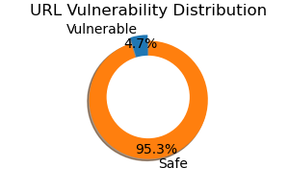

Recommendations:

SQL Injection: https://owasp.org/www-community/attacks/SQL_Injection

XVWA

Date and Time of Report: 16-02-2023, 11:22:01

Types of Successful attacks: ['Blind SQL Injection']

SQLI Strings Attempted in Total: 0

### SQLI Strings Used:

### Vulnerable Pages:

[-] http://127.0.0.1:1234/xvwa/vulnerabilities/sqli/

[-] http://127.0.0.1:1234/xvwa/vulnerabilities/sqli_blind/

Vulnerability Statistics:

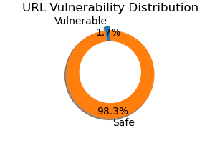

Recommendations:

SQL Injection: https://owasp.org/www-community/attacks/SQL_Injection