Penetration Testing Report:

General Scan information:

|  |  |  |  |
| --- | --- | --- | --- |
| Website | No. Of URL's Tested | No. Of Successful Attacks | Time Taken |
| Bodgeit | 397 | 0 | 40 Seconds |

Website Vulnerability Statuses:

|  |  |
| --- | --- |
| Website | Safety |
| Bodgeit | Website Secure! |

Bodgeit

Date and Time of Report: 23-03-2023, 18:43:52

Vulnerability Statistics:

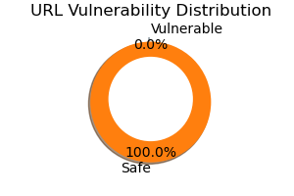

Recommendations:

Nothing To Recommend, Your Webpage is Secure!