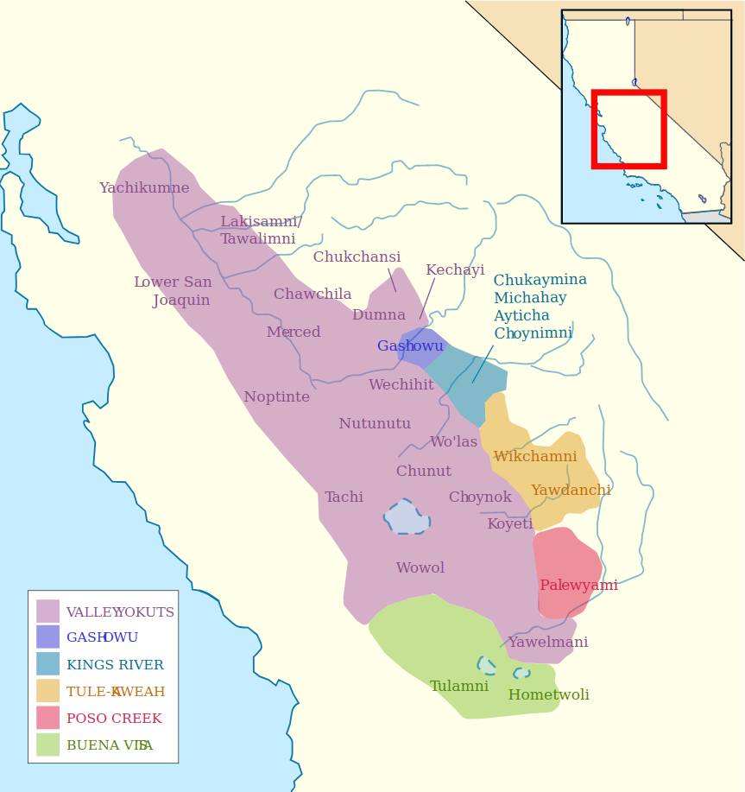Tw 1

Yowlumne (aka Yawelmani) is a Yokuts language of the Valley Yokuts branch native to California. It appears near the bottom right of the large purple area of the map.

Tw 2

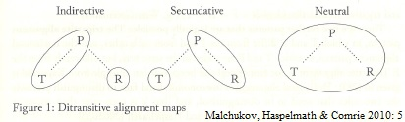

Yowlumne has a complicated system of secundative alignment in ditransitive constructions (Weigel 2005). Secundative alignment is where the indirect object (R) with a ditransitive verb patterns like the direct object (P) of a transitive verb (Malchukov, Haspelmath & Comrie 2010).

Tw 3

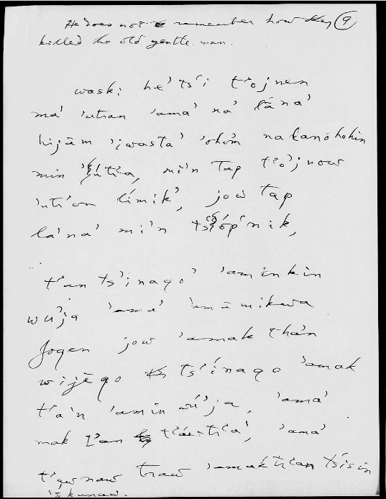

Large amounts of available data that document the alignment system in Yowlumne are found in messy, handwritten archival documents in the archives of John Peabody Harrington and Stanley Newman, recorded between 1910 and 1940. This data is not readily searchable in this form.

Tw 4

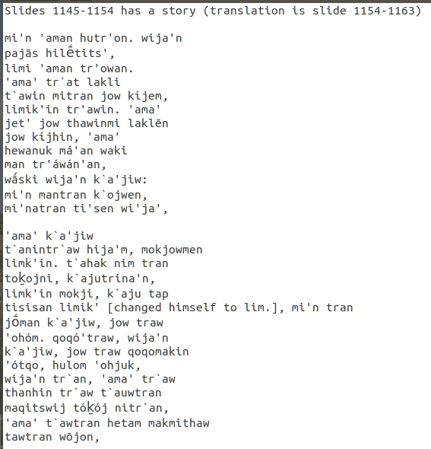

Digitization and accessibility to these documents takes place in several stages. The first is digital transcription of 17 texts (so far).

Tw 5

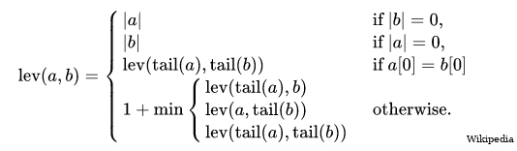

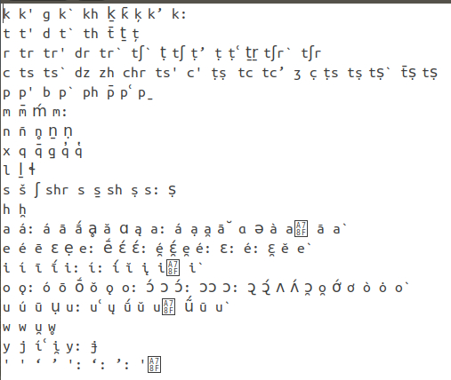

The second stage is running a preliminary text normalization process using an algorithm involving Levenshtein distance. Harrington in particular confused many sounds in his transcriptions, so I use sound classes to group these sounds in the Levenshtein distance calculations.

Tw 6

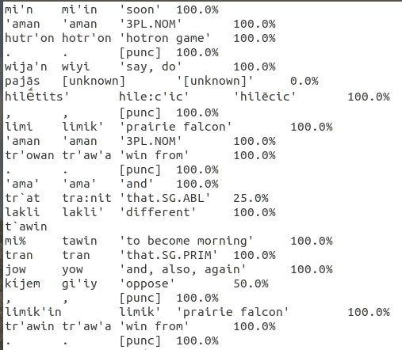

This first pass at normalization is then hand-checked and corrected for accuracy, with a percentage given to indicate subjective certainty for the word identified.

Tw 7

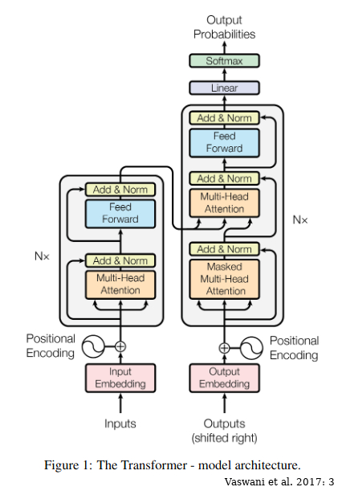

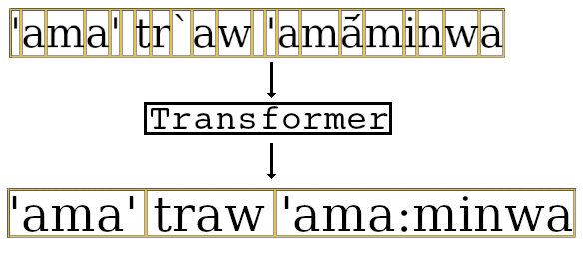

This first-pass normalized data is used to train a Transformer model (Vaswani et al. 2017) that maps from characters to lexemes. The Transformer model can then be used to normalize other data obtained from the archives.

Tw 8

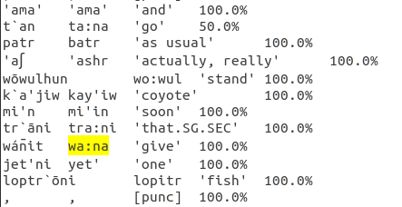

The data normalized by the Levenshtein distance calculations and the Transformer model can be searched by lexeme. This enables selecting individual ditransitive verbs (e.g. \*wa:na ‘give’) to chart out their attested argument structures, including in passive environments.

Tw 9

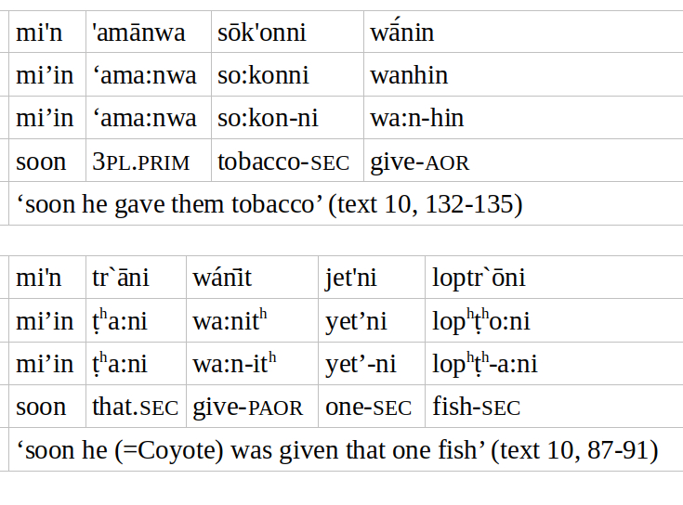

The data obtained provide preliminary results for ditransitive alignment with passivization: the example above shows \*wa:na ‘give’. The primative-marked argument in the active sentence is the recipient, while the secundative-marked argument is the theme in active and passive.

Tw 10

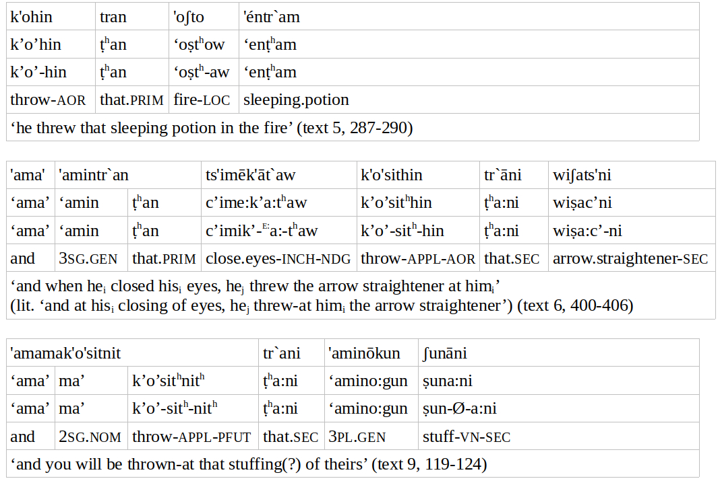

Applicativized verbs work the same way, as with \*k’o’o ‘throw’. For the base verb, the theme is primative-marked. The applicative demotes the theme to secundative, and the recipient/target is primative. In the passive, the target is subject, and the theme remains secundative.

Tw 11

[what to put?]

In either case, the preliminary results show that passivization applies to the recipient/target argument: the recipient/target becomes subject. The theme remains a secundative-marked argument regardless. This is true for both ditransitive verbs and applicative-marked verbs.

Tw 12

[sources]

In conclusion, the computational approach used to access the data should be useful to anyone working with archival data. Here, this approach enabled analysis of the ditransitive alignment in Yowlumne and found that passivization promotes the primative-marked argument to subject.