Local environment Setup:

* Download the whole package
* Install wamp server/xampp
* Copy the download folder to your local server
  + Wamp – wamp64/www
  + Xampp – htdocs
* Change the .htaccess in root folder according to your local server
* Open config file “application/config/config.php”
  + Edit line number 26 – according to your local server
* Open database config file “application/config/database.php”
  + Update your db credentials on line 78, 79, 80, 81
* You can find the sql file in this package

Server requirements:

PHP 7.2

Mysql 5.7

Wamp server - 3.1.9

Task System – Home page

Below is our application landing page. You can see list of tasks…

To add new task – Click the link “Add new task” link (Marked circle)

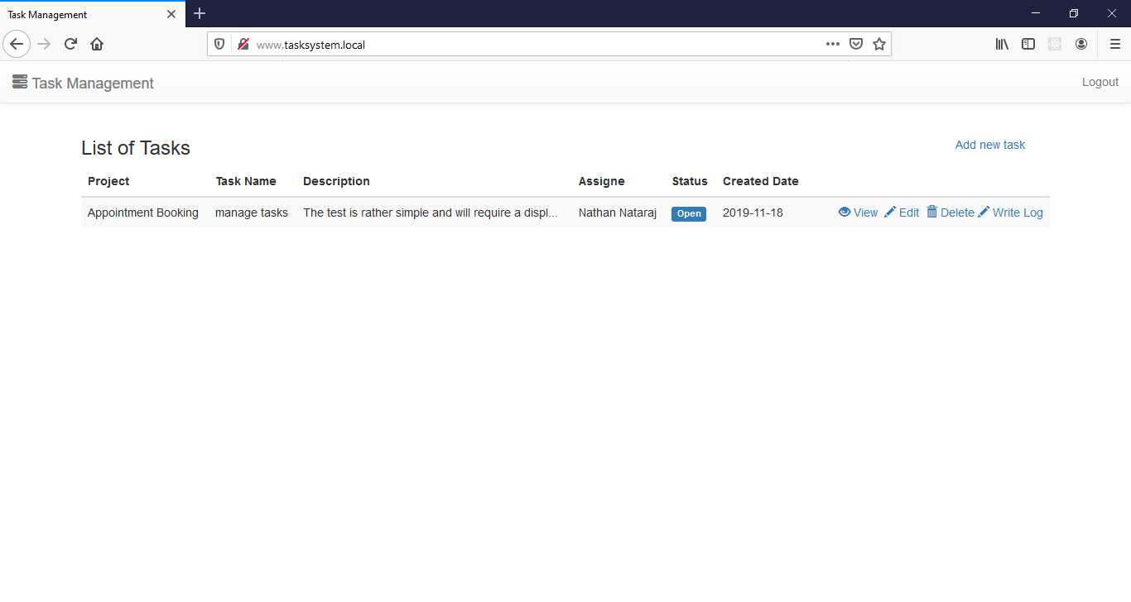

Add new task page

All the fields are required whichever is marked as \*

Uploads – IF any reference files related to task, you can attach it

Project – Task should be added to any one of the project. So project is required

Assigned To – user who is going to work on task

Approx. Duration – This is approximate days to complete the task

Status – Open (Initial stage for all task), In-Progress (User starts working on task), Hold (if task put on hold), Completed (task after completed)

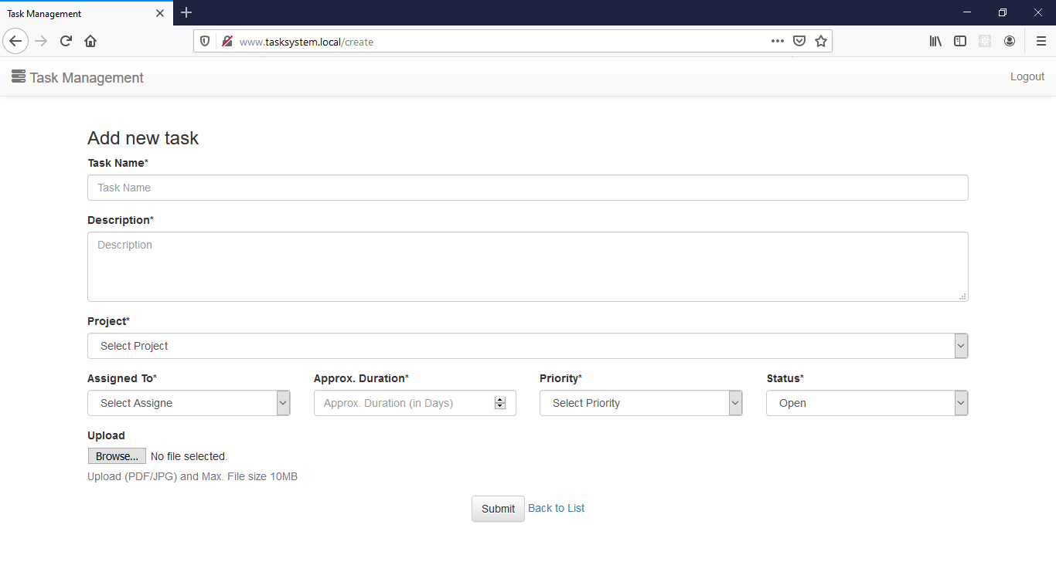

View Task

Users can see task details, task reference files, task logs, task status.

Once completed graph will be displayed based on duration…

After task completed, you can see the task duration and sample screen below

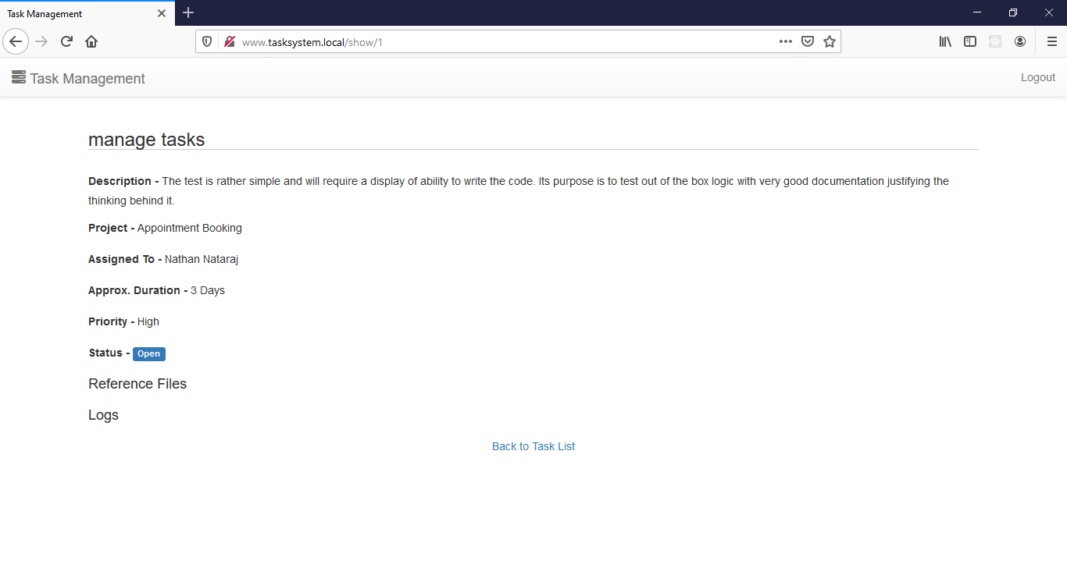

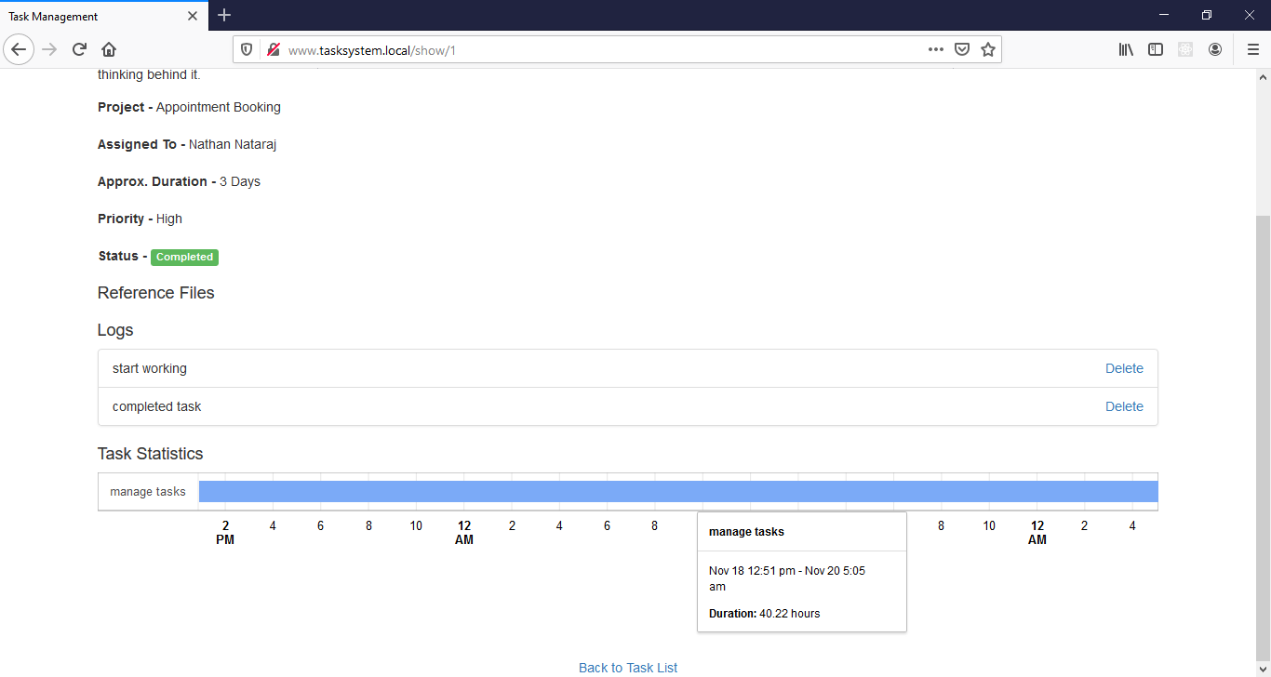

Edit task

User can upload reference files in edit page if required

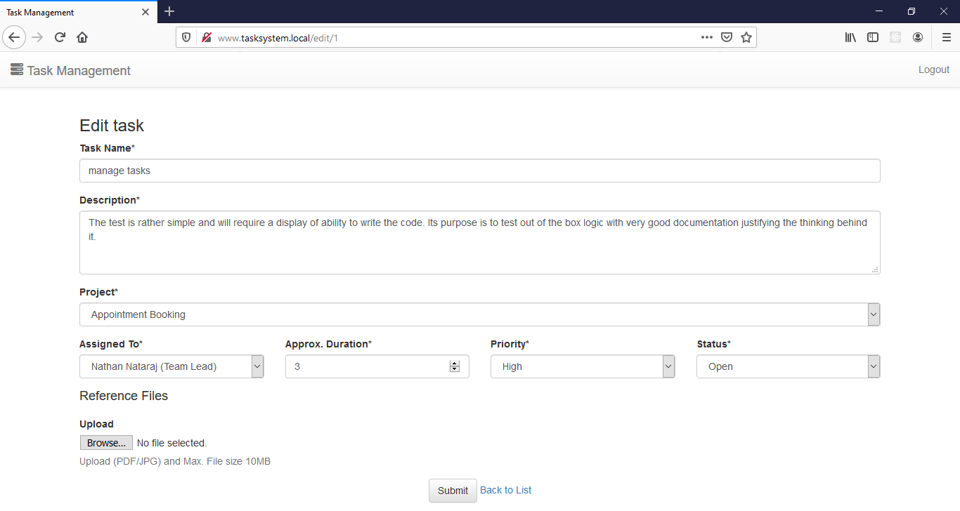

Write Log to task

Click on write log link. To view all the logs – User can view in view task page

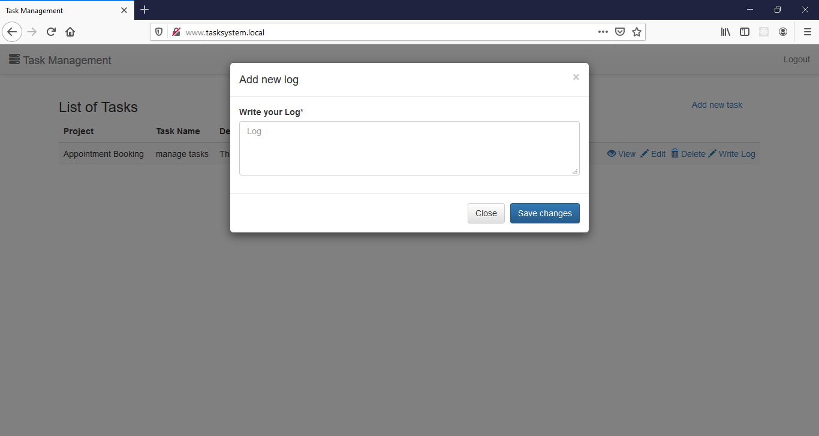

To update Task status

Click on Status label in task list – marked below

Select the status and add your log to update the task status

Task start time and end time will be calculated automatically based on status change.

