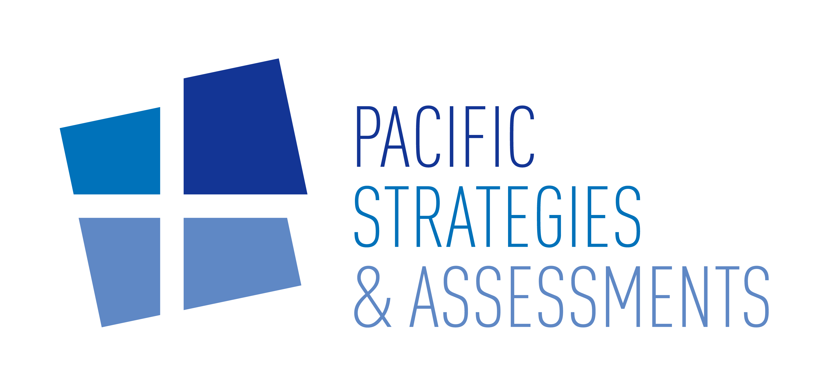

Due Diligence

Investigations

Advisory

a



www.psagroup.com

**PSA BRIEF**

**Asset Tracing and Property Valuations in China**

**Introduction**

China’s property sector has entered a period of adjustment which is causing significant financial stress. As a consequence, there has been a noticeable increased interest in our services to locate and value property assets for potential legal proceedings.

**Misconceptions About Available Information**

A common misconception is that public information in China is opaque and limited. In fact, a large amount of information is readily available through public sources – often going far beyond what is available in countries which are perceived as more transparent.

Chinese commercial data aggregators serving the domestic market are successful and popular, with advertisements even appearing in major city metro stations, offering to help people understand their business partners.

This relative openness provides many avenues to explore in asset tracing.

**Enforcement Targets**

As the start of an asset tracing project our clients may not know which assets can be targeted for enforcement, and require support in undertaking detailed exploratory research. PSA methods vary from project to project, but typically include mapping out the business interests of individuals and ownership structures of companies, and generating substantive leads to identify assets held by them or their nominees, including family members.

With the right approach and knowledge, a skilled analyst can provide a detailed assessment of a company or individual’s footprint and connections, and find specific assets for enforcement.

For example, a target subject may turn out to be the owner of several companies, all of which share the same operations address – a large warehouse in an industrial zone.

**Valuing Property**

With the asset identified, the first step is to estimate its value. Land in China is categorized and rated by local governments, with 1 being for land of the highest quality, and 7 for the lowest. An area designated for industrial use with a low-quality rating of 6 or 7, could be valued at less than one tenth of the value of a prime quality residential area with a rating of 1 or 2 – even if in the same city and of the same size. Using the land category and rating as a baseline, this initial valuation can be refined by cross-referencing transactions for similar properties.

Sadly, even for properties which look excellent on paper, the reality often proves to be distressingly different. A warehouse is likely to sell for far below its claimed value if it is rundown and surrounded by neighbors going out of business. Therefore, a key step is for our professional analysts to visit the property in person, and interview people in the surrounding area. Is the property in good condition and well managed? Are there broken windows on nearby buildings? How active is the area – are there many nearby businesses, is there a lot of traffic and footfall? This all helps determine the true value of the asset.

In addition, further on-the-ground interviews can be conducted with knowledgeable contacts at local bureaus and departments whose remit covers the area where the property is located. These contacts can share information such as:

**1**

Valuations for similar properties in their area, and any transfer fee policies for land.

**2**

Future development plans for the area in question (and whether this might lead to a change in land type classifications), any additional rates companies or properties must pay, and any preferential policies they might benefit from.

**3**

Other relevant costs and fees such as deed taxes and urban land use taxes, soil and water conservation fees, and utility rates.

This combination of in-depth research, site visits, and on-the-ground interviews allows PSA to develop a detailed independent assessment of a property’s value.

**Looking Ahead**

Driven by the stress in the property sector, asset tracing in China is becoming an important tool to identify both enforcement targets and investment opportunities, however locating and valuing property may only be one aspect of a dispute resolution or investment opportunity.

Another common requirement is estimating a high net-worth individual’s current wealth and verifying the source of that wealth. If you are interested in future articles explaining this and other details on how such professional research can be carried out in China and other jurisdictions, please sign up with the link or QR code below for our free email newsletter.

Scan QR code or [sign-up here](https://psagroup.us19.list-manage.com/subscribe?u=06ab79792165e0a7fb818d578&id=2014c8b935)

to receive our free newsletter



[info@psagroup.com](mailto:info@psagroup.com)

[**www.psagroup.com**](http://www.psagroup.com)

Better Intelligence

*Pacific Strategies & Assessments (PSA) is a global specialist risk consultancy, delivering critical information to our clients through our three core service lines: Due Diligence, Investigations, and Advisory services. We operate where our clients do business, with regional offices staffed by investigators and responders who have extensive in-region experience gained from professional backgrounds in corporate investigations, government intelligence and law enforcement.*

*Pacific Strategies & Assessments (PSA) is a global specialist risk consultancy, delivering critical information to our clients through our three core service lines: Due Diligence, Investigations, and Advisory services. We operate where our clients do business, with regional offices staffed by investigators and responders who have extensive in-region experience gained from professional backgrounds in corporate investigations, government intelligence and law enforcement.*