MAT 115
Fall 2001
Chris Christensen
Class notes

Multiplication Modulo n

For multiplication modulo n (as for addition and subtraction), we can either reduce modulo n and then multiply (and, perhaps, have to again reduce modulo n), or we can first multiply and then reduce the product modulo n.

For example,

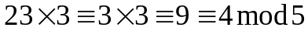 or 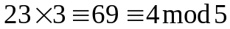.

Here is the table for multiplication modulo 5.

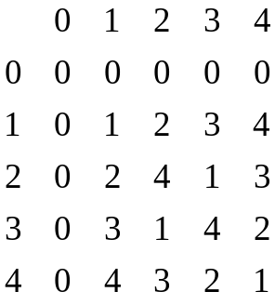

More interesting, perhaps, is the table for multiplication modulo 6.

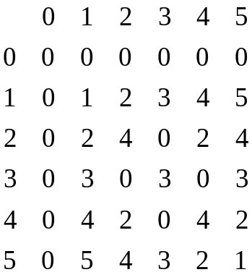

Notice that although neither 3 nor 2 is congruent to 0, the product 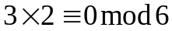. This is not something we encounter when working in the real numbers. We call 3 and 2 zero divisors modulo 26. Two integers are called zero divisors modulo n if neither of them is congruent to 0 modulo n but their product is congruent to 0 modulo n.

Division Modulo n

We can approach division in a manner that is similar to subtraction. We thought of subtraction as "just adding the (additive) inverse;" we can think of division as "just multiplying by the (multiplicative) inverse." The multiplicative inverse of a number m is denoted 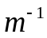 and is the number that when multiplied by m results in 1. For example, in the real numbers, the multiplicative inverse of 3 is 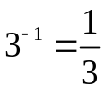.

Inverses modulo n are more problematic.

Look back at the table for multiplication modulo 5. 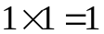; so, 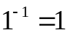. 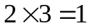; so, 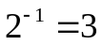 and 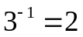. 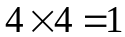; so, 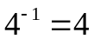. 0 has no multiplicative inverse. (0 has no multiplicative inverse in the real numbers either.)

Now look at the table for multiplication modulo 6. ; so, . 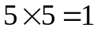; so, 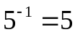. But, 0 has no multiplicative inverse, and the zero divisors 2, 3, and 4 have no multiplicative inverses.

So, we can only sometimes undo multiplication. Because in cryptology, when we encipher we want an inverse process to decipher, we must be careful using multiplication modulo n for enciphering.

Solving Linear Congruences Modulo n

In algebra, we learn to solve linear equations; e.g.,

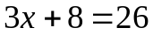

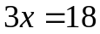

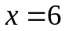

(We call a linear equation because the variable x appears only to the first degree – there are not squares, cubes, or higher powers of x. This should remind us of the equation of a line 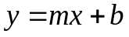.)

We can mimic this process for modular arithmetic provided we only use multipliers that have (multiplicative) inverses.

For example, we can solve

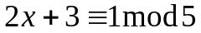

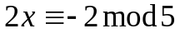

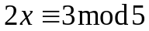

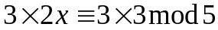

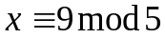

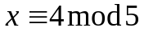

because 3 is the inverse of 2 modulo 5.

Of course, because the only possible values of x are 0, 1, 2, 3, or 4; we could just try all of the possibilities until we found a solution (or not).

Sometimes we are forced into trying all possible solutions. Consider solving the linear congruence 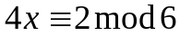. We saw above that 4 does not have a multiplicative inverse modulo 6. So, our usual method of solution will not work. That does not mean that there is no solution. If we try all the possibilities (0, 1, 2, 3, 4, and 5), we see that there are two solutions 2 and 5.

Notice that

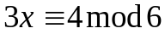

has no solution.

The mathematical area known as number theory discusses solutions of such congruences (and many other interesting properties of the integers).
Solving Pairs of Linear Congruences Modulo n

A system of two linear congruences can be solved in the same manner as we use to solve a system of two linear equations provided that the only multipliers we encounter during solution have inverses.

For example, modulo 5 we can solve the system of linear congruences

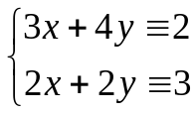

Multiply the second congruence by 2.

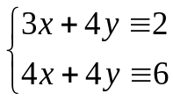

Subtract the first congruence from the second.

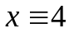

Substitute into the first congruence.

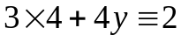

And, solve the linear congruence for y.

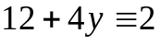

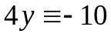

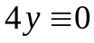

Because 4 is the inverse of 4,

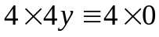

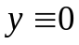

Bow check that the pair and is a solution to the pair of linear congruences.

Just like in the case of a single congruence, if our method of solution does not work, that does not mean that there is no solution. Try all possible solutions. How many possible solutions would we have to try?

Positive Integer Exponents Modulo n

Recall that positive integer exponents correspond to repeated multiplications.

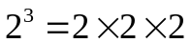

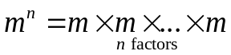

Recall that when we multiply modulo n we can either first reduce modulo n and then multiply or we can first multiply and then reduce modulo n. For exponentiation, it makes most sense to reduce as much as possible along the way.

Consider the following example.

If we first multiply and then reduce modulo 2,

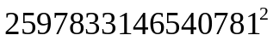

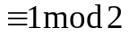

But, if we first reduce modulo 2,

Carl Friedrich Gauss (1777 – 1855)

The idea of modular arithmetic was introduced by the mathematician Carl Friedrich Gauss in his 1801 book Disquisitiones Arithmeticae (Investigations in Arithmetic).

Gauss was born into a family which, like many others of the time, had recently moved into town, hoping to improve its lot from that of impoverished farm workers. One of the benefits of living in Brunswick was that the young Carl could attend school. There are many stories about Gauss’ early developing genius. At the beginning of the school year, to keep his 100 pupils occupied, the teacher, J. G. Buttner, assigned them the task of summing the first 100 integers. He had barely finished explaining the assignment when the 9 year old Gauss wrote the single number 5050 on his slate and deposited it on the teacher’s desk. Gauss had noticed that the sum in question was simply 50 times the sum 101 of the various pairs 1 and 100, 2 and 99, 3 and 98, ... and had performed the required multiplication in his head. Impressed by his young student, Buttner arranged for Gauss to have special textbooks, to have tutoring by his assistant Martin Bartels (1769 - 1836), who himself later became a professor of mathematics in Russia, and to be admitted to a secondary school where he mastered the classical curriculum.

In 1791, the Duke of Brunswick granted Gauss a stipend which enabled him first to attend the Collegium Carolinium, a new science oriented academy funded by the Brunswick government to train bureaucrats and military officers, then to matriculate at the University of Gottingen in neighboring Hanover, which already had a reputation in the sciences, and finally to continue his research back in Brunswick while receiving a Ph.D. from the local University of Helmstedt. Not only did Gauss publish his researches in number theory in 1801, with the book being dedicated to his patron the Duke, but he also developed at the same time a new method for calculating orbits which enabled several asteroids to be discovered. The Duke’s patronage lasted until the Duke was killed in battle against France in 1806 and the duchy was occupied by the French army. Fortunately for science, the French general had been given explicit orders to look out for Gauss’ welfare. Thus Gauss was able to stay in Brunswick until he accepted a position at Gottingen the following year as professor of astronomy and director of the observatory. Gauss remained at Gottingen for the remainder of his like, doing research in pure and applied mathematics as well as astronomy and geodesy.

Gauss was never particularly happy with teaching classes, because most of the students were uninterested in, and not well prepared for, mathematics, but he was willing to work privately with any actively interested student who approached him. Compared to his predecessor Euler and to his French contemporary Cauchy, Gauss ultimately published little, his collected works occupy only (?) 12 volumes. Nevertheless, his mathematical papers are of such profundity that they have influenced the progress of the subject to the present. A History of Mathematics: An Introduction by Victor J. Katz page 588.

Exercises

11. Multiply.

11a. 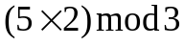
11b. 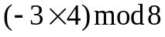
11c. 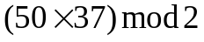
11d. 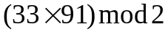
11e. 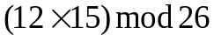

12. Determine the following powers.

12a. 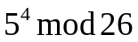
12b. 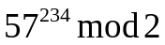
12c. 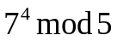
12d. 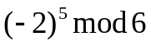
12e. 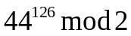

13. Find the multiplicative inverses of 1, 3, 5, 7, 9, 11, 15, 17, 19, 21, 23, 25 modulo 26.

14. Find the multiplicative inverses of 1, 2, 3, 4, 5, 6 modulo 7.

15. 0, 1, 2, 3, 4, 5, 6, 7 is a complete set of representatives modulo 8.

15a. Find the additive inverse of each number modulo 8.
15b. For each number that has a multiplicative inverse modulo 8, find that multiplicative inverse.
15c. For each nonzero number that does not have a multiplicative inverse modulo 8, show that it is a zero divisor.

16. Solve, if possible.

16a. 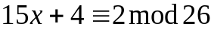
16b. 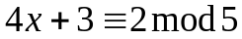
16c. 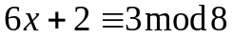
16d. 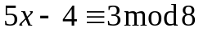

17. Solve, if possible.

17a. 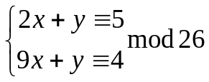

17b. 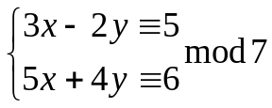

17c. 