Running a KAREL program
we're going to get into the habit of running our programs from the terminal. To run a program, open a new terminal. The terminal prompt (the text before the cursor in the terminal) should have "Assignment1" in it, indicating that you're currently in the Assignment1 folder. If not, make sure to change your directory to the Assignment1.
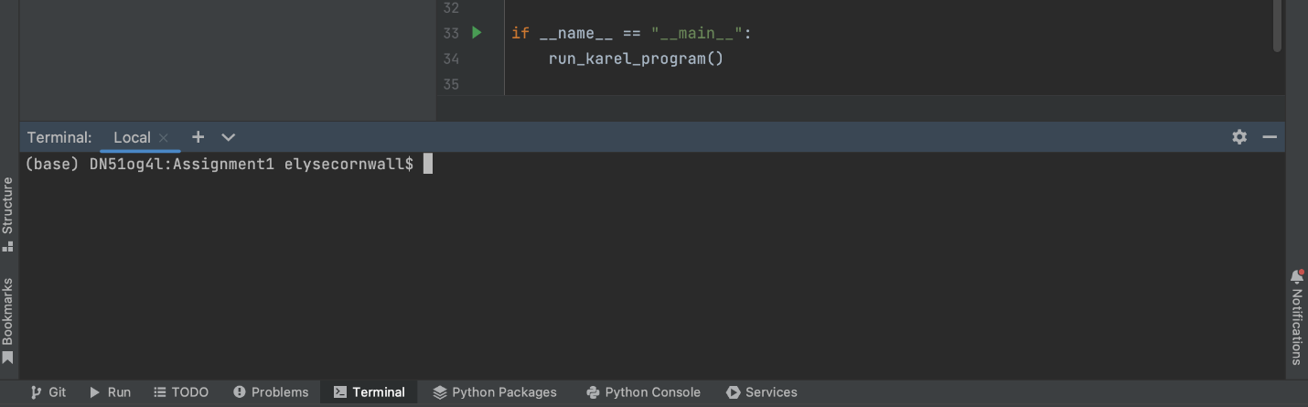
To run any Karel program, all you have to do is type the following command into the Terminal and hit the Enter or Return button on your keyboard:python3 InsertNameHereKarel.py (on Mac) or py InsertNameHereKarel.py (on Windows). To run the code in CollectNewspaperKarel.py on a Windows computer, for example, we would run python3 CollectNewspaperKarel.py and hit "Enter".
Depending on how the python in your system is named, you may need to type python (instead of python3 in the above).
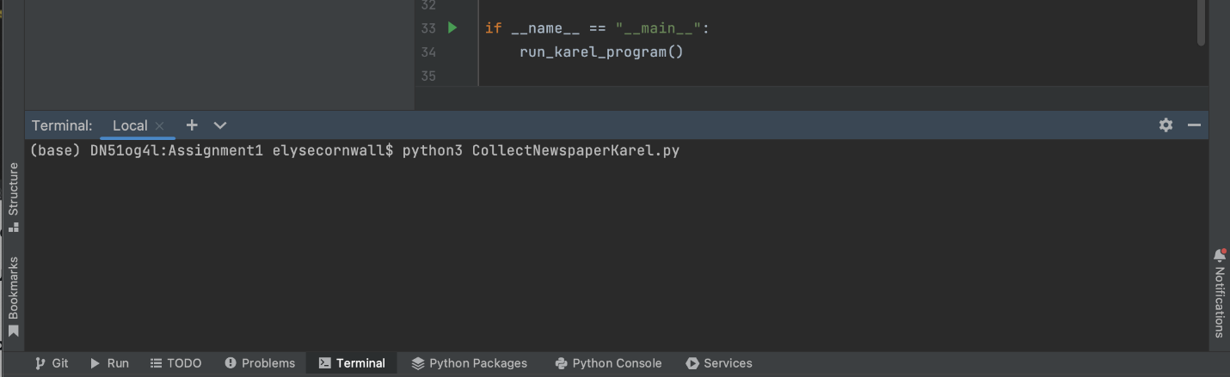
This will display a window as seen in the figure below. If Karel and the beeper appear, but you don't see any of the walls around the world, this might be because your computer is in dark mode. To fix this, go into your computer settings, and in the "Appearance" section, change the appearance to light.
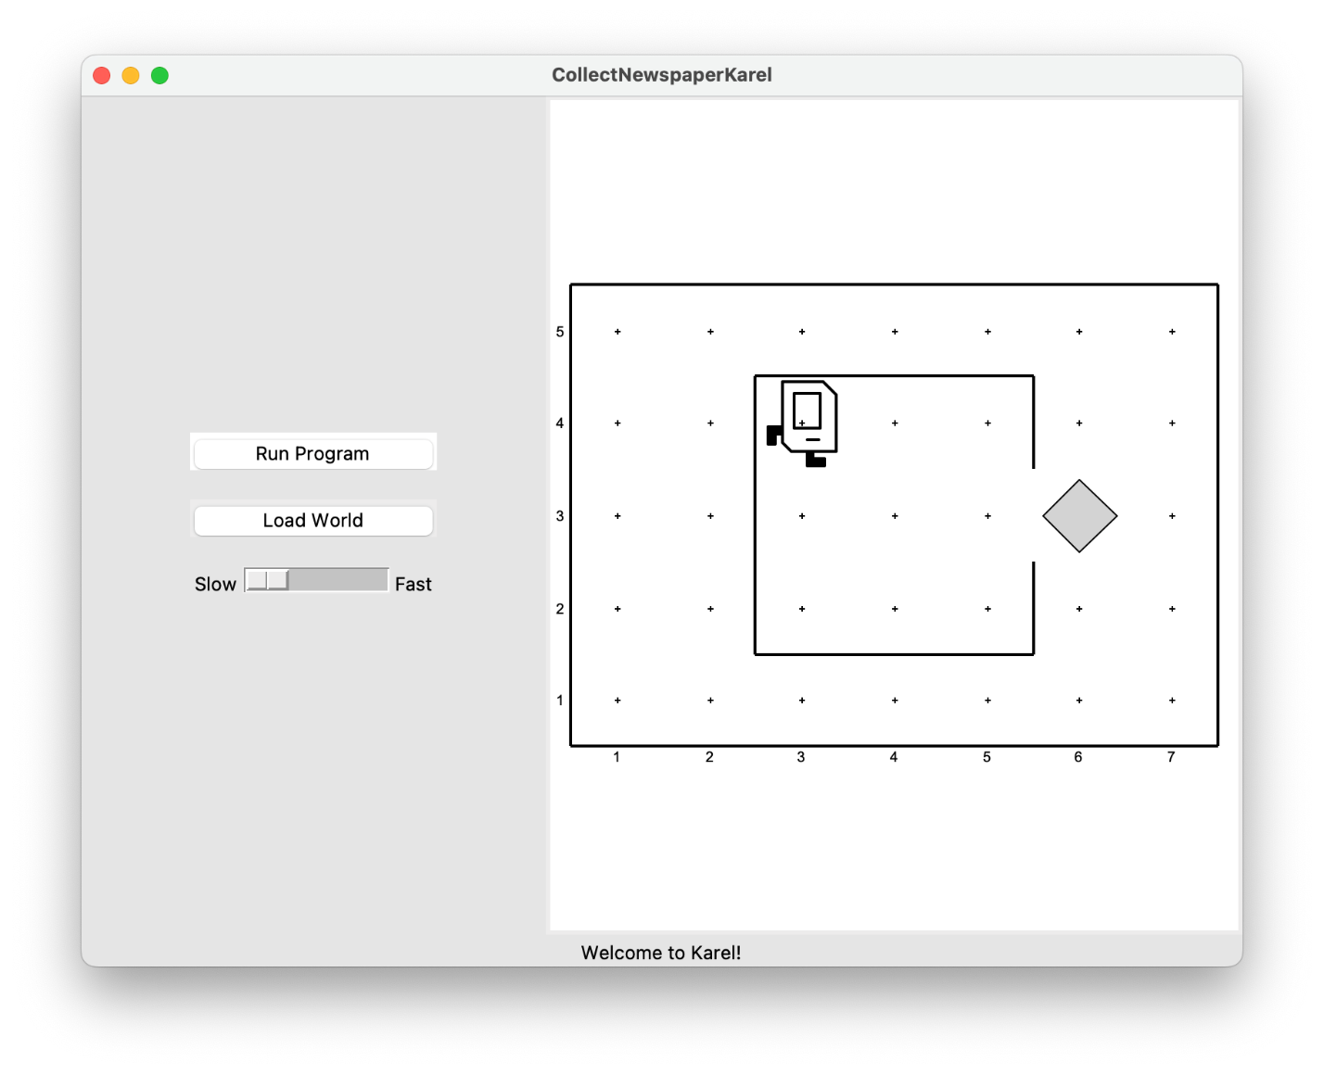
If you then press the Run Program button, Karel will go through the steps in the main() function that you wrote. To change the speed at which Karel runs through its commands, you can use the slider underneath the two buttons. Moving the slider to the right increases the speed at which Karel runs, while moving the slider to the left causes Karel to move slower. Setting the slider to the far-right will cause Karel to almost instantly finish its task, with all intermediate action happening too quickly for the human eye to distinguish.
In this case, however, all is not well, even after writing the turn_right() function. Karel begins to move as if trying to exit from the house, but ends up one step short of the beeper. When Karel then executes the pick_beeper() command at the end of the main() method, there is no beeper to collect. As a result, Karel stops, a popup window appears, red text is displayed at the bottom of the window, and an error is displayed in PyCharm's bottom panel, as shown in the figures below.
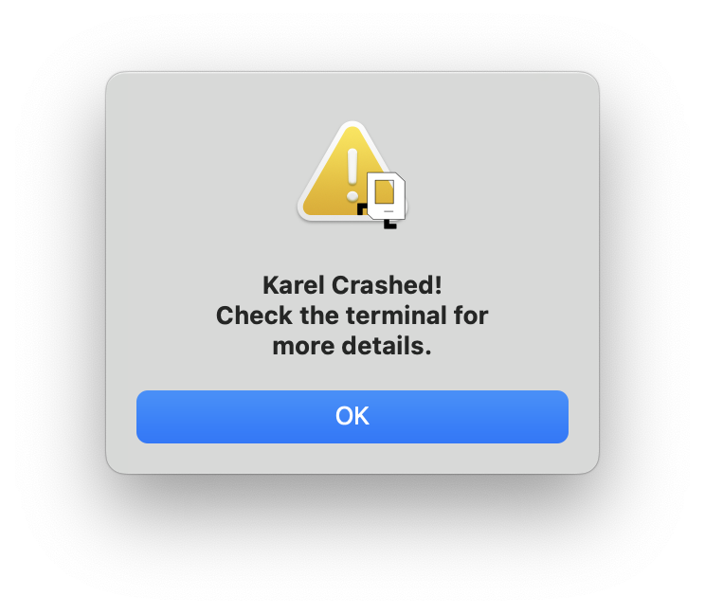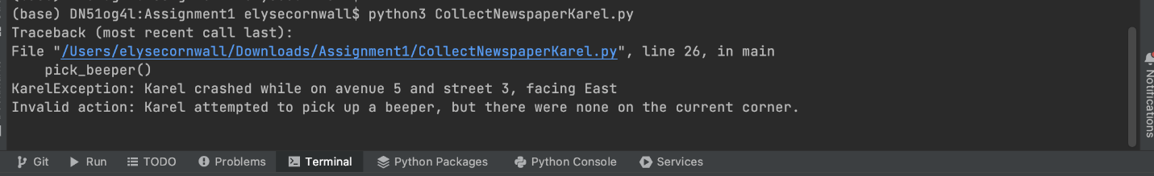
This is an example of a logic bug, in which you have correctly followed the syntactic rules of the language but nonetheless have written a program that does not correctly solve the problem. The error message doesn't tell you how to fix the issue, but if you look at what it says carefully, you'll see that it does tell you why Karel stopped (Karel tried to pick up a beeper at (5,3) when there were none at that corner) and what line of your program Karel was executing when the error occurred ("line 26 in main" in CollectNewspaperKarel.py).
Running into bugs like these is a very common thing for all programmers, and though the text looks scary, you are equipped with all the tools you need to think through the issue and to update your code accordingly. To make Karel run again, after you've made changes to your code, you can close the original window and run the same command as before to re-run the program.
This assignment consists of four Karel programs. There is a starter project linked here that contains the files you will write your Karel code in.
ASSIGNMENT 1 and 2
Here's an overview of what you'll need to do for this assignment:
- Download the starter code.
- Edit the Karel program files so that the assignment code does what each task described that it is supposed to do. This will involve a cycle of coding, testing, and debugging until everything works.
- Once you have gotten each part of the program to run correctly in the default world associated with the problem, you should make sure that your code runs properly in all of the worlds that we have provided for a given problem.
The Karel problems to solve are described later in this handout.
Please remember that your Karel programs must limit themselves to the language features described in “Karel the Robot Learns Python”. You may not use other features of Python (including variables, parameters, break, and return), even though the PyCharm-based version of Karel accepts them.
Problem 0. See Moveanddrop
Problem 1: Collect Newspaper Karel (CollectNewsaperKarel.py)
Your first task is to solve a simple story-problem in Karel's world. Suppose that Karel has settled into its house, which is the square area in the center of the image below.
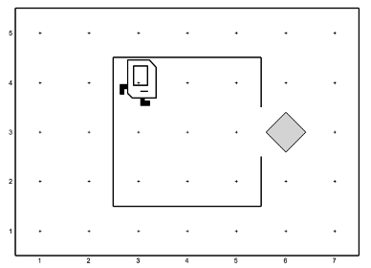
Karel starts off in the northwest corner of its house as shown in the diagram. The problem you need to solve is to get Karel to collect the newspaper. The newspaper, like all objects in Karel's world, is represented by a beeper. You must get Karel to pick up the newspaper located outside the doorway and then to return to its initial position.
This exercise is meant to help you get you started programming with Karel. You can assume that every part of the world looks just as it does in the diagram: the house is exactly this size, the door is always in the position shown, and the beeper is just outside the door. Thus, all you have to do is write the sequence of commands necessary to have Karel:
- Move to the newspaper
- Pick it up
- Return to its starting point.
Although the program does not have many lines of code, it is still worth getting some practice with decomposition. In your solution, you must write at least two helper functions: one for step 1 and another for step 3 in the outline above. You're welcome to write a helper function for step 2 as well, but since picking up a beeper is only one line of code, it's okay to do this step without a helper function.
Your program should run successfully in the following world: CollectNewspaperKarel.w (default world). Note that all Karel worlds are located in the worlds folder in the assign1 project folder.
Problem 2: Stone Mason Karel (StoneMasonKarel.py)
Your next task is to repair the damage done to the Main Quad in the 1989 Loma Prieta earthquake. In particular, Karel should repair a set of arches where some of the stones (represented by beepers, of course) are missing from the columns supporting the arches, as illustrated below.
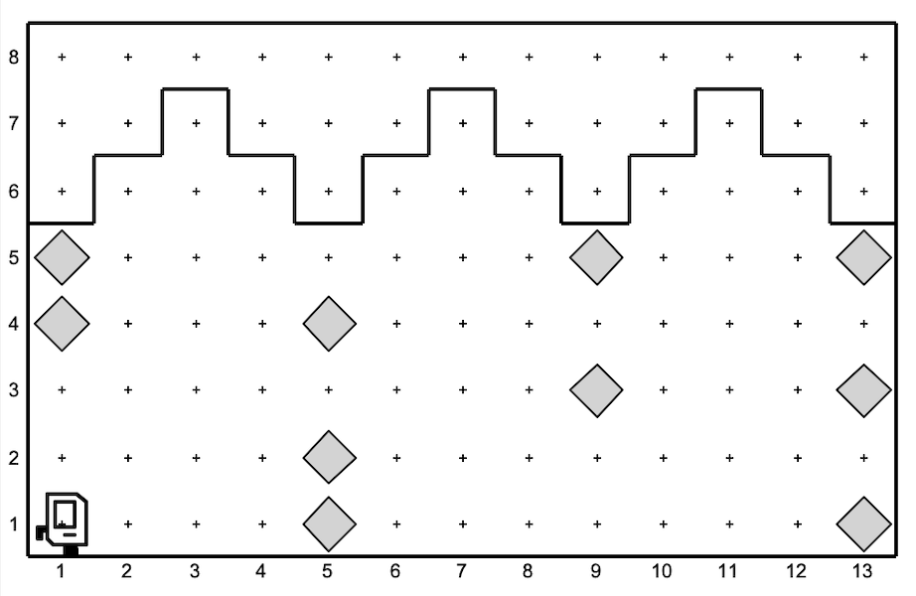
Your program should work on the world shown above, but it should be general enough to handle any world that meets the basic conditions outlined at the end of this problem. There are several example worlds in the starter folder, and your program should work correctly in all of them.
When Karel is done, the missing stones in the columns should be replaced by beepers, so that the final picture resulting from the initial world shown above would look like the illustration below.
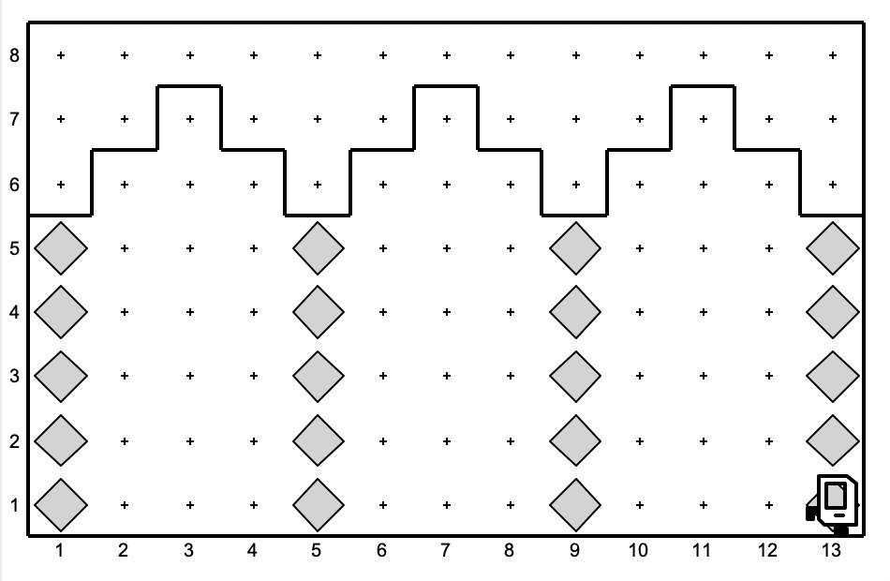
Karel's final location and the final direction Karel is facing at the end of the run do not matter.
Karel may count on the following facts about the world:
- Karel starts at the corner where 1st Avenue and 1st Street meet, facing east, with an infinite number of beepers in Karel's beeper bag. The first column should be built on 1st Avenue.
- The columns are always exactly four Avenues apart, so they would be built on 1st Avenue, 5th Avenue, 9th Avenue, and so on.
- The final column will always have a wall immediately after it. Although this wall appears after 13th Avenue in the example figure, your program should work for any number of beeper columns.
- The top of a beeper column will always be marked by a wall. However, Karel cannot assume that columns are always five units high, or even that all columns within a given world are the same height.
- In an initial world, some columns may already contain beepers representing stones that are still in place. Your program should not put a second beeper on corners that already have beepers. Avenues that will not have columns will never contain existing beepers.
You should make sure your program runs successfully in all of the following worlds (which are just a few different examples to test out the generality of your solution): StoneMasonKarel.w (default world), SampleQuad1.w, SampleQuad2.w. Note that all Karel worlds are located in the worlds folder in the assign1 project folder.
Problem 3: Checkerboard Karel (CheckerboardKarel.py)
Your third task is to get Karel to create a checkerboard pattern of beepers inside an empty rectangular world, as illustrated below. (Karel's final location and the final direction it is facing at the end of the run do not matter.)
Example Start | Example End
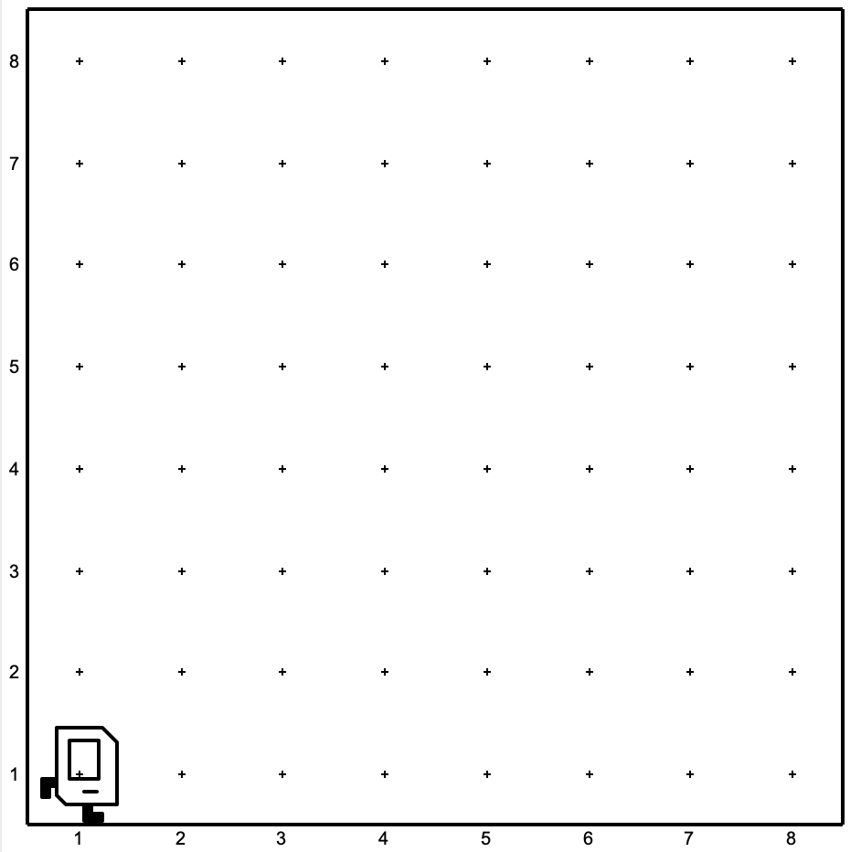 | 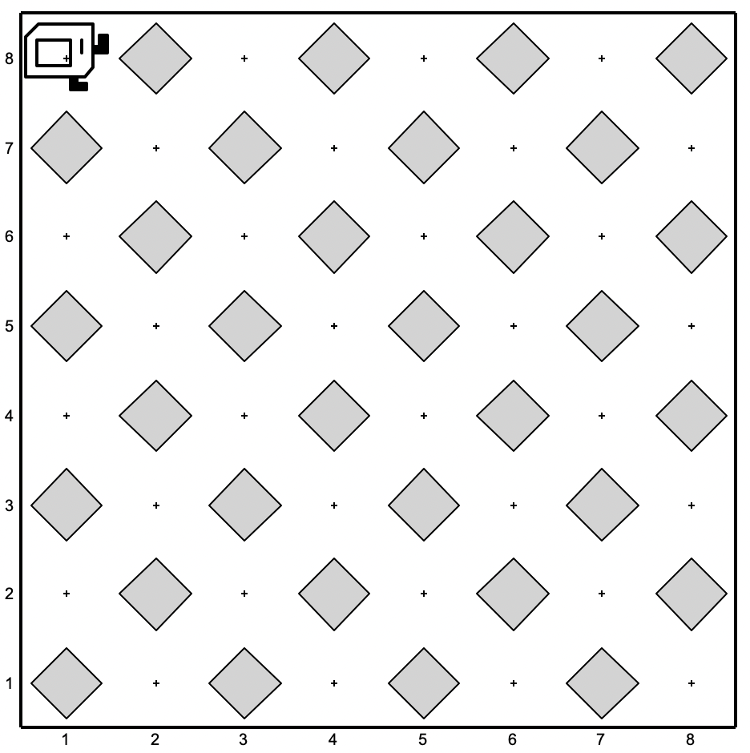
This problem has a nice decomposition structure along with some interesting algorithmic issues. As you think about how you will solve the problem, you should make sure that your solution works with checkerboards that are different in size from the standard 8x8 checkerboard shown in the example above. Some examples of such cases are discussed below. Odd-sized checkerboards are tricky, and you should make sure that your program generates the following pattern in a 5x3 world:
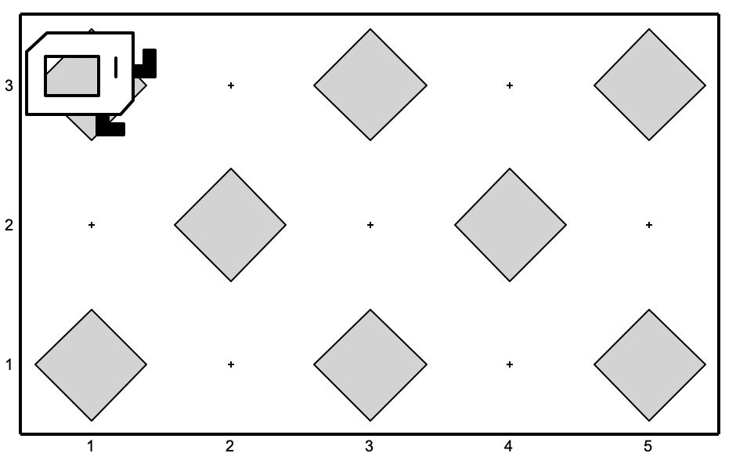
Other special cases you should consider are worlds with only a single column or a single row. The starter code folder contains several sample worlds with these special cases, and you should make sure that your program works for each of them.
This problem is hard: Try simplifying your solution with decomposition. Can you checker a single row/column? Make the row/column work for different widths/heights? Once you've finished a single row/column, can you make Karel fill two? Three? All of them? Incrementally developing your program in stages helps break it down into simpler parts and is a wise strategy for attacking hard programming problems.
You should make sure your program runs successfully in all of the following worlds (which are just a few different examples to test out the generality of your solution): CheckerboardKarel.w (default world), 8x1.w, 1x8.w, 7x7.w, 6x5.w, 3x5.w, 40x40.w, 1x1.w. Note that all Karel worlds are located in the worlds folder in the assign1 project folder.
Problem 4: Midpoint Karel (MidpointKarel.py)
As an exercise in solving algorithmic problems, you will program to find the midpoint of 1st Street. Say Karel starts in the 5x5 world at 1st Street, 1st Avenue. Karel should end in the center of 1st Street.
Example Start | Example End
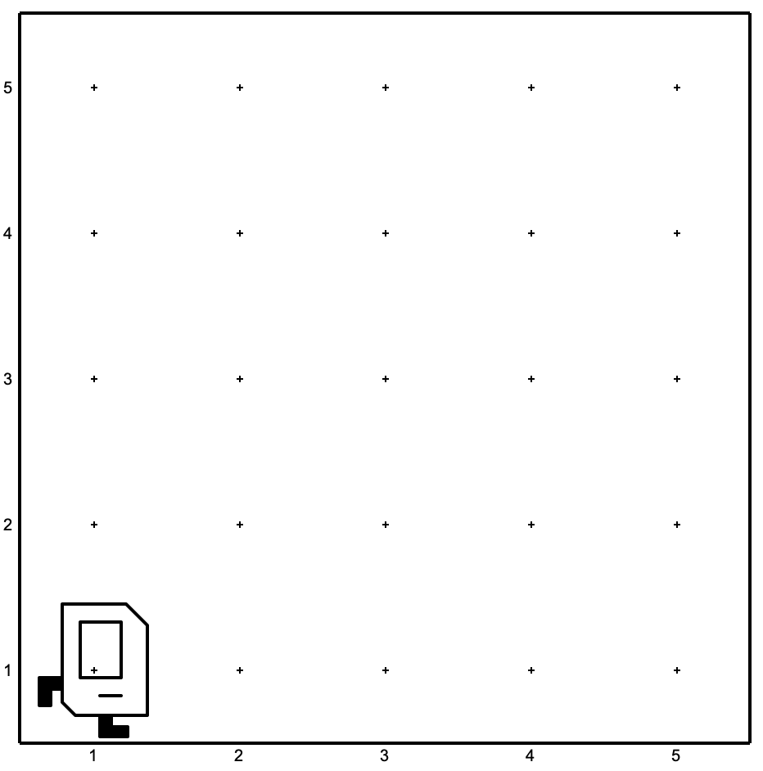 | 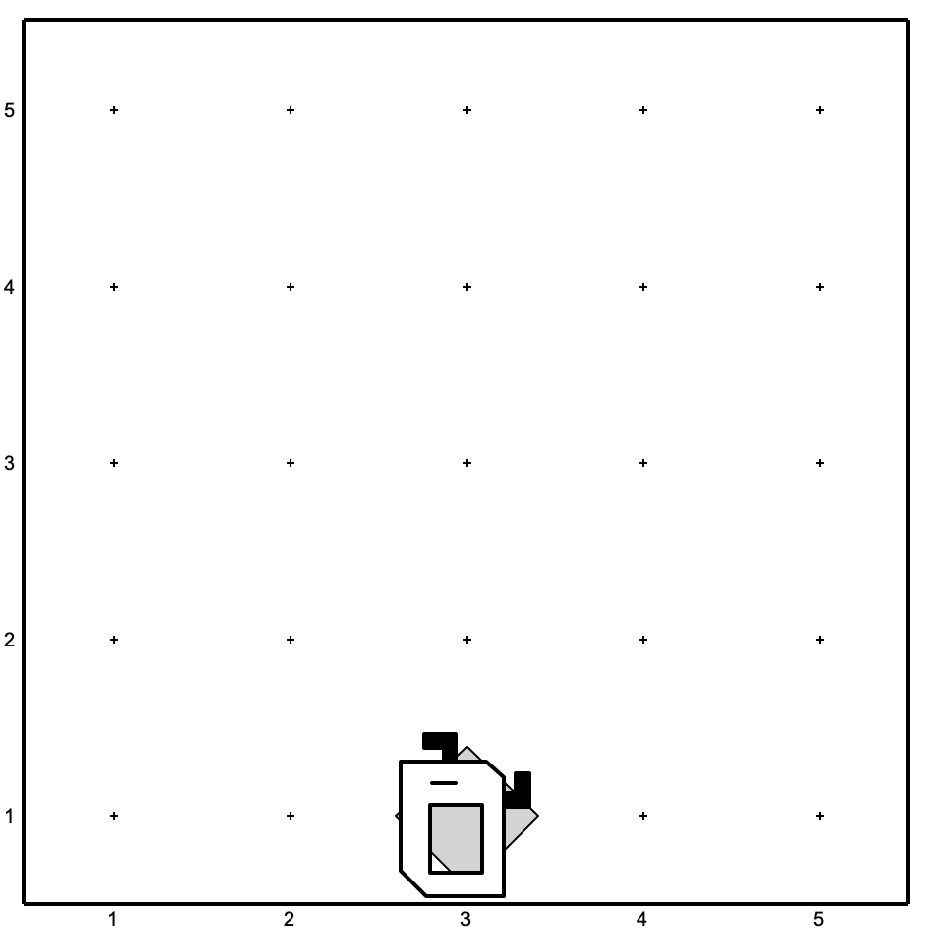
Note that the final configuration of the world should have only a single beeper at the midpoint of 1st Street. Along the way, Karel is allowed to place additional beepers wherever it wants to, but must pick them all up again before it finishes. Similarly, if Karel paints/colors any of the corners in the world, they must all be uncolored before Karel finishes.
In solving this problem, you may count on the following facts about the world:
- Karel starts at 1st Avenue and 1st Street, facing east, with an infinite number of beepers in its bag.
- The initial state of the world includes no interior walls or beepers.
- The world need not be square, but you may assume that it is at least as tall as it is wide.
Your program, moreover, can assume the following simplifications:
- If the width of the world is odd, Karel must put the beeper in the center square. If the width is even, Karel may drop the beeper on either of the two center squares.
- It does not matter which direction Karel is facing at the end of the program.
There are many different algorithms you can use to solve this problem so feel free to be creative!
You should make sure your program runs successfully in all of the following worlds (which are just a few different examples to test out the generality of your solution): MidpointKarel.w (default world), Midpoint1.w, Midpoint2.w, Midpoint8.w. Note that all Karel worlds are located in the worlds folder in the Assignment1 project folder.
Problem 5. See Corner.karel

Running Karel in different worlds
In order to successfully complete Assignment 1, the last piece of the puzzle that we haven't worked through yet is how to run your Karel program in different worlds. Say we are working on StoneMasonKarel.py and we think that we have gotten our code to work in the default world, which looks like this:
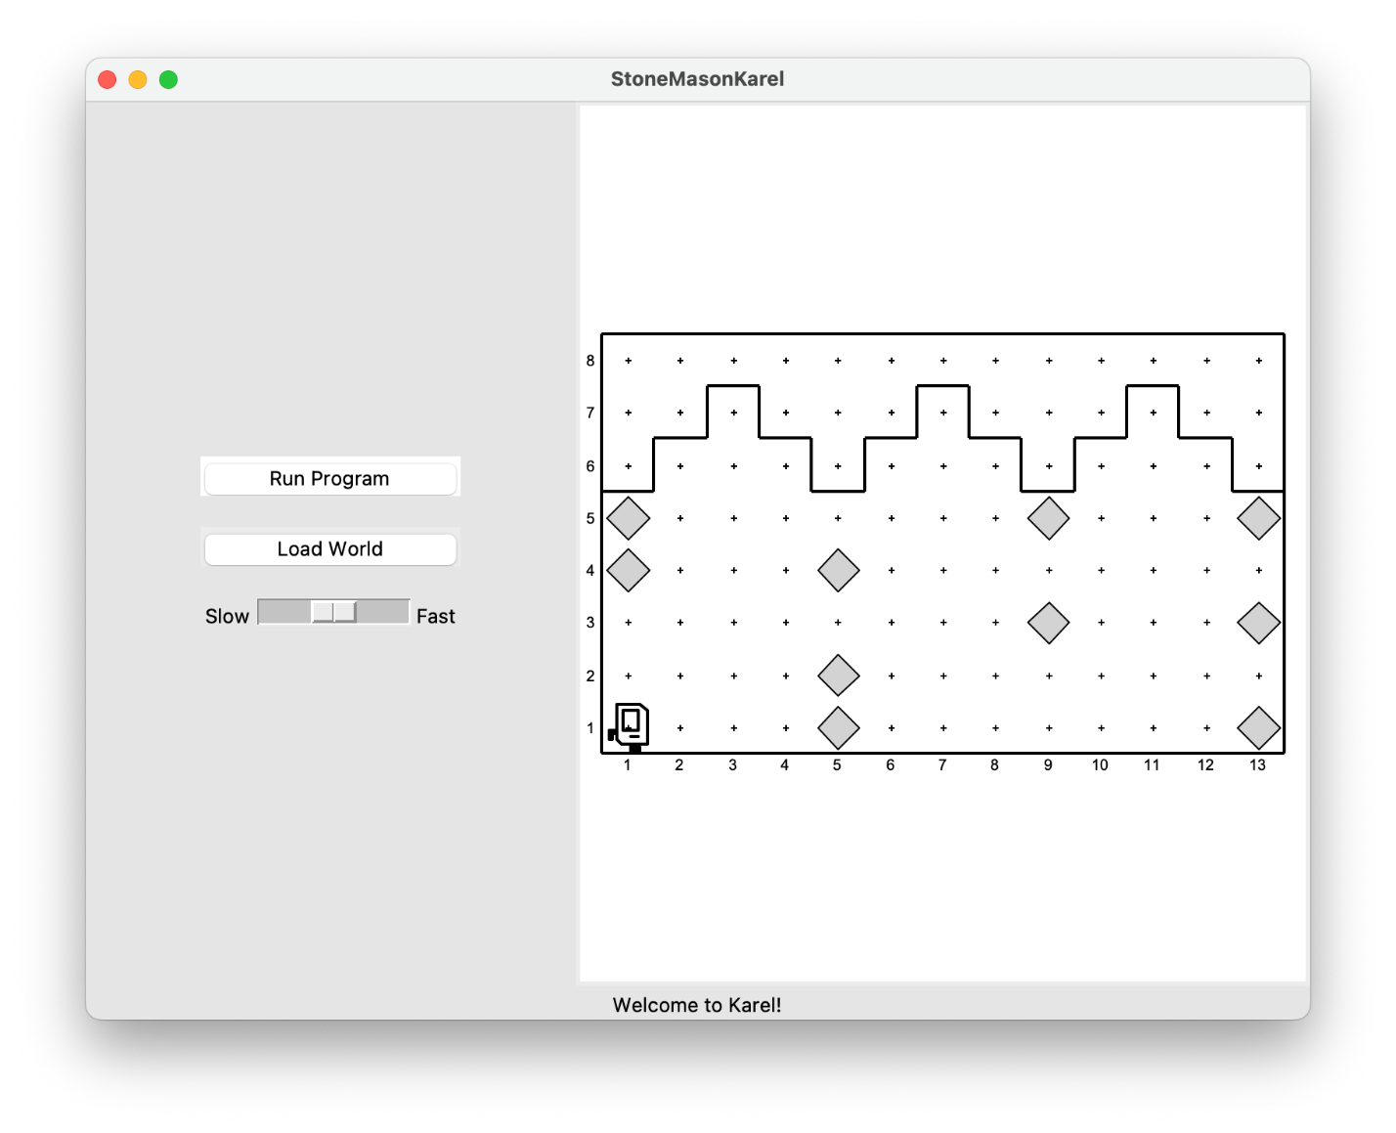
We want to make sure that Karel works in different worlds so that the code we wrote is bug-free and generalizes to new worlds. To do so, click on the Load World button, which brings up a file browser view that lists all of the provided worlds that come packaged with Assignment 1. If you don't see this, navigate to the Assignment 1 folder on your computer, and click on the worlds folder to get to this view.
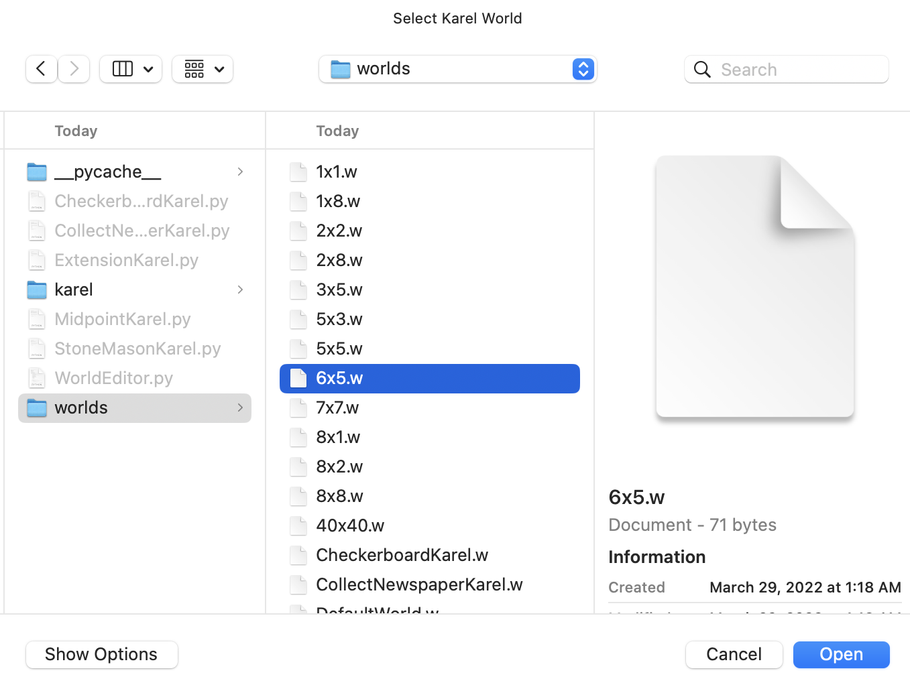
Select and open the world in which you want to run Karel. The new world will now appear on the right-hand side of the Karel window. You can then test Karel in this new world by clicking on the Run Program button.

