Do World Cup Downhill Racers Actually Perform Better When Racing in Their Home Country?

It is widely believed that world cup downhill racers perform better when they are racing in their home country. Last season there were some notable examples of this; with Finn taking his first podium at home in Monte-Saint-Anne and the all French podium at World Champs in Les Gets. However, just because we can think of some big examples of home country wins does not mean that a home country advantage is general reality. In fact, focusing on wins is a good example of a common cognitive bias, known and salience bias, which is the tendency to seek generalization from events that are emotionally striking while ignoring those that are unremarkable. As someone who is inclined to be skeptical I am curious if there is actually an advantage to racing in your home country.

There are also some good reasons to expect that an average rider would race better in their home country. First, riders that have come up racing national races in their home country would have had more chances to race on a track than most competitors. Second, there may be a boost to having a home country crowd cheering you on. Or finally, perhaps riders are just better rested and resourced when they are closer to home. Competing at home has been shown to have advantages in other sports. For competitive team sports if there was no advantage of playing at home then on average there should be 50% of wins at home and 50% of wins away. However, this is not the case with many major sports. For instance; 59% of National Hockey League games are won at home, 57% of American Football games are won at home, and 54% percent of U.S. Major League Baseball games are won at home. While this evidence seems like it creates a strong pattern of advantage of competing at home, the largest part of the advantage in team sports is currently attributed to referring – which should have minimal impacts in World Cup Downhill.

The presence of a cultural expectation for riders to produce better results in a home country could also lead to riders performing worse than they would otherwise. Racing at home, and the added pressure to have a good result could tempt riders to push it over the edge, and actually end up with worse results. In fact, the probability of both good and bad results in a home country could be increased as riders may be more inclined to take a checkers-or-wreckers approach. It is also possible that where a rider is racing doesn’t matter, and riders are just going to send it as hard as they can at every race. Hopefully, digging into the data will show us what is going on.

I wanted to test if there is an advantage for world cup riders racing in their home country, and to try and estimate how big that advantage is. Specifically I wanted to test whether:

1. Does the probability of rider having a good or bad result relative to their other performances increase when they are racing in their home country?
2. Which riders show the biggest effects of racing their home country?
3. Are home country racers overrepresented among world cup winners?





Is the probability of a good or bad result higher when racing in your home country?

I am going to try my best to keep this interesting and not indulge myself too much is describing the process of this. I scraped the data for elite men and elite women for all races going back to 1995 from Roots and Rain. I transformed the results to express each race result as a percentage back from the race winning time, with the winner was 0% back. A big part of why I am working with percentages is that we tend to see tighter gaps on faster tracks and larger gaps on slower tracks so working with percentages should help normalize across races a bit. For example, this is a figure of the 10 riders who competed in the most World Cup races, with their results presented as a percent back from the winning time, and the home races represented by the black points.

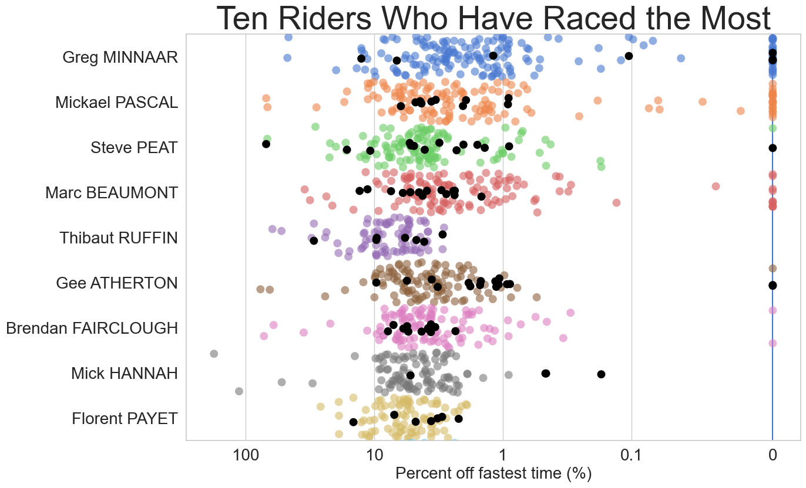

I decided to classify a good race result as one in the top 25% percent of a riders finishes based on the percent back from the fastest time, and bad results as the bottom 25% plus races where the rider did not start, did not qualify, did not finish, or was disqualified. I limited my analysis to riders who had competed in at least 20 races which left me with 18,888 results from 209 races and 425 riders. I used logistic regression to estimate the probability that a rider had a good or bad race in their home country and out of their home country.

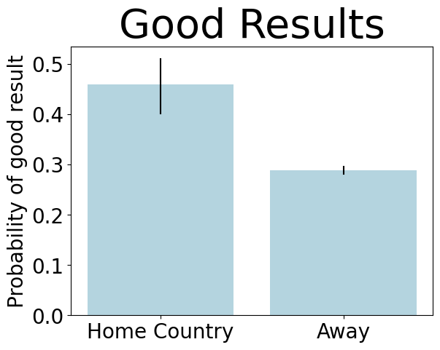

# On average, when rider are competing at home the probability of having a good result was increased by between 21 and 54%

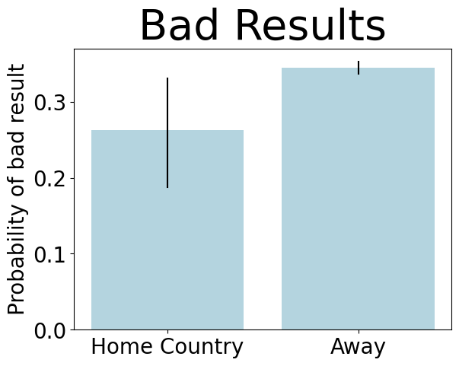

# The probability of a bad result was reduced when racing at home by between 3 and 24%.

I found that racing at home considerably increase the probability of having a good result by between 21 and 54%, and decreases the probability of having a bad result by between 3 and 24%. This is pretty clear evidence for their being an advantage to racing home in the aggregate.

Which riders show the biggest effects?

While I found that on average there is a positive effect of racing at home, there is likely some variation among riders. To explore this, I fit the same logistic regression to the data for each rider individually, to estimate how racing at home affected their probability of having a good or bad result. While the average effect of racing at home increased the probability of a good result by between 21 and 54%, I found that some riders had much larger apparent effects. Below are the 10 riders with the largest effects of racing at home, each of which had the probability of a good result increase by over 200% when they raced at home.

# Some riders had much bigger effects of racing at home, with the probability of good results when racing at home increasing by over 200 % for these riders.

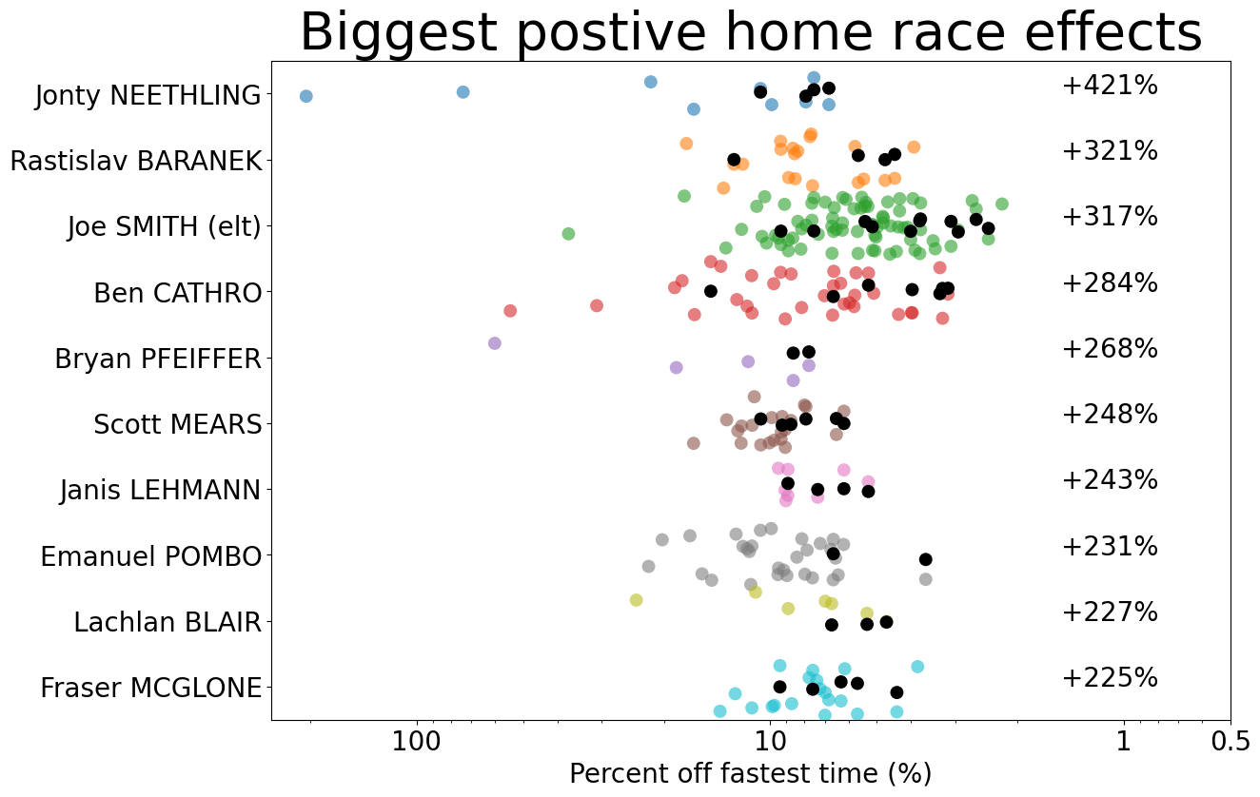

Similarly, while on average the probability of having a bad result declined when racing at home by between 3 and 24%, some riders did have an increased probability of bad results when racing at home. Each of the riders below had the probability of bad result increase by over 100% when they raced in their home country. So, while we were able to estimate average effects of racing at home, we see that there is a considerable amount of variation among riders.

# Some had the probability of bad result increase by over 100% when they raced in their home country.

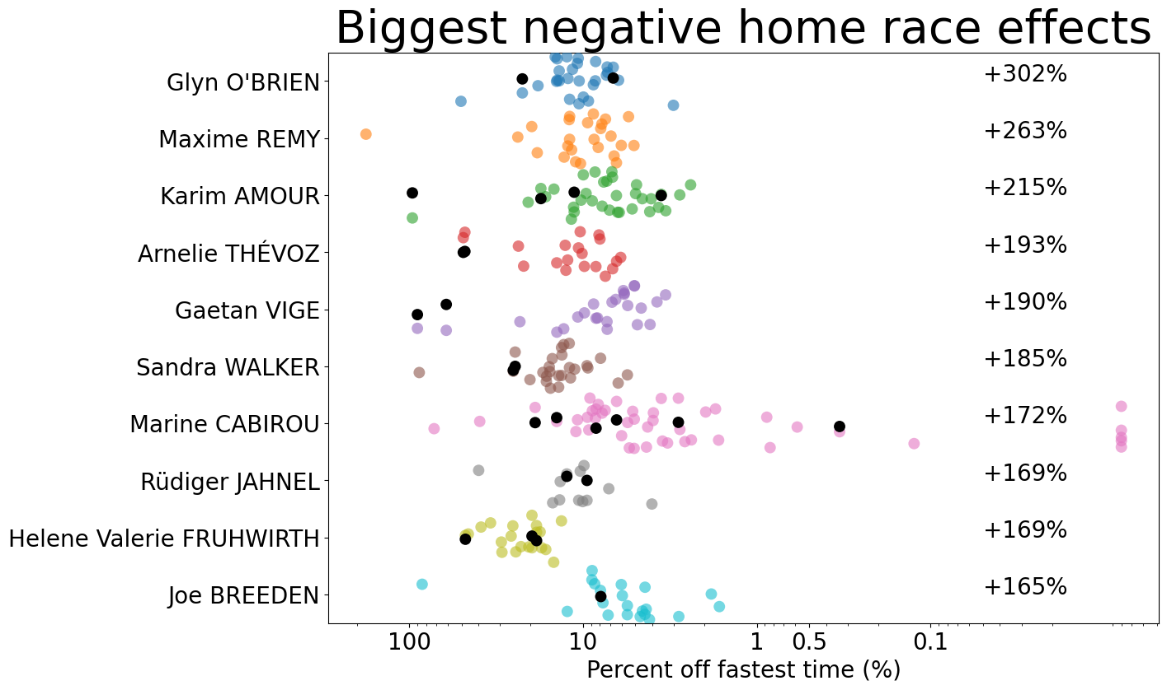

Are home country racers overrepresented among world cup winners?

In a team sport half of the matches are played at home and half are played away and this allows us to set an expectation that if there is no home field advantage then on average only 50% of matches should be won at home. Because World Cup races have happened in 20 countries and been won by riders from 13 countries, setting a baseline expectation for what would happen if there was no advantage to racing at home is a little more involved. We first examine how many races were won by riders in their home country, which is 21 races for men and 24 races for women. Then we create a hypothetical where the country that each rider wins in is random and unaffected by the country the rider is from. We do this by shuffling the riders, and matching each rider to one of the races. Thus, the total amount of wins and races associated with each country stays constant, but how they are matched changes randomly. I’ve illustrated this below.

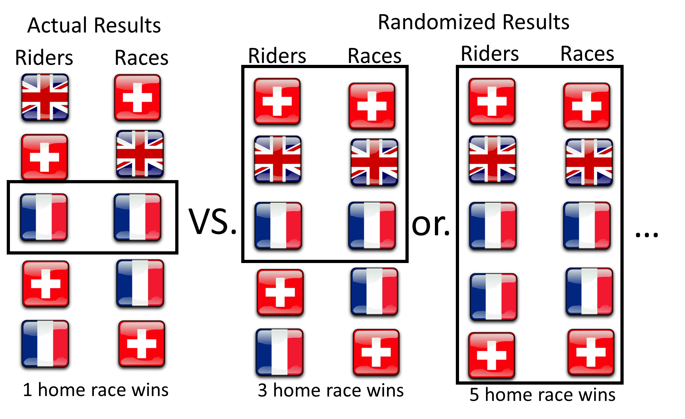

I did this 10,000 times to generate a really good idea how many home race wins to expect if there was no influence of rider/ race country on winning. Doing this, I found that the actual number home race wins (solid red and blue lines in figure below) is greater than the average number we would expect if rider/ race country didn’t matter (light colored distributions below). Specifically, the actual number, of 21 home country wins for men, was higher than 95% of the randomized race results and the actual result, of 24 home country wins for women, was higher than 74% of the randomized race results. This suggests that riders are a bit more likely to win races in their home country.

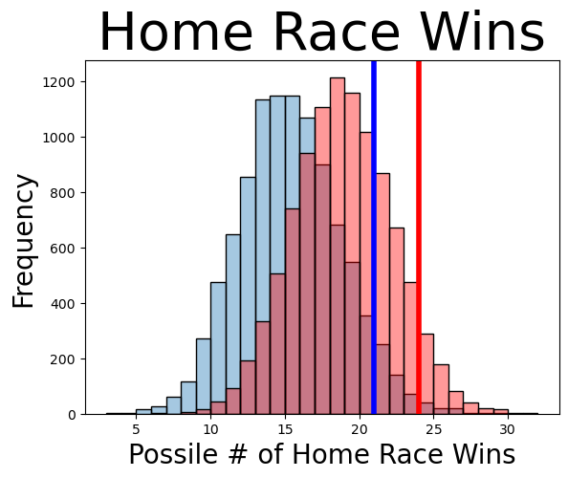

Summary:

There does appear to be a home country advantage in downhill and the probability of a rider having a good result increases by between 21 and 54% when they race in their home country. There is also a considerable amount of variation among riders in how racing at home affects their results, with some riders, like Pinkbike’s own Ben Cathro having a much higher chance of having good results when racing in their home country. Personally, I thought this analysis was going to show that there was no effect of racing at home, and I am pleasantly surprised to see that there is on, and it seems like a fairly substantial effect to me. If you want to look around at how individual riders fell on these metrics check out the web app I developed:

Concluding thoughts:

I had a lot fun thinking though this and working with these data and I hope some of you find this interesting as we all wait for the 2023 downhill season to start. If you want more depth on what I actually did, or you want to work with the data yourself check out my GitHub. I want to thank Roots and Rain for aggregating all the race data they do, this probably wouldn’t have been possible otherwise. Also thanks to my girlfriend Kathryn Baker for edits and input on the analysis. What other common wisdom about World Cup Downhill would be interesting to test?

https://www.chicagobooth.edu/review/home-field-advantage-facts-and-fiction#:~:text=Soccer%20has%20the%20largest%20average,are%20won%20by%20home%20teams.