Do World Cup Downhill Racers Actually Perform Better When Racing in Their Home Country?

Last season of World Cup Downhill racing provided some amazing examples of riders winning races in their home country. Finn Iles taking his first podium in Monte-Saint-Anne was unforgettable and felt so much more meaningful for being in his home country. The excitement of the all-French podium at World Champs in Les Gets and the ensuing wildness of the French crowd was palpable over the live broadcast. However, these results beg the question: Did racing in their respective home countries propel these riders to these great results?

Just because we can think of some big examples of home country wins does not mean that a home country advantage is a generality. In fact, focusing on wins is a good example of a common cognitive bias, known as salience bias, which is the tendency to seek generalization from events that are emotionally striking while ignoring those that are unremarkable. As someone who is inclined to be skeptical, I am curious if there is actually an advantage to racing in your home country.

There are some good reasons to expect that an average rider would race better in their home country. First, riders who have come up racing a national series in their home country would have had more chances to race on a track than most competitors. Second, there may be a boost to having a home country crowd cheering you on. Or finally, perhaps riders are just better rested and resourced when they are closer to home.

Competing at home has been shown to have advantages in other sports. In competitive team sports, if there were no advantage of playing at home, then on average there should be 50% of wins at home and 50% of wins away. However, this is not the case with many major sports. For instance, 59% of National Hockey League games, 57% of American Football, and 54% percent of U.S. Major League Baseball games are won at home. While this evidence seems like it shows a strong pattern of advantage of competing at home, the largest part of the advantage in team sports is currently attributed to refereeing – which should have minimal impacts in World Cup Downhill.

The presence of a cultural expectation for riders to produce better results in a home country could also lead to riders performing worse than they would otherwise. Racing at home and the added pressure to have a good result could tempt riders to push it over the edge and actually end up with worse results. In fact, the probability of both good and bad results in a home country could be increased as riders may be more inclined to take a checkers-or-wreckers approach. It is also possible that where a rider is racing doesn’t matter, and riders are just going to send it as hard as they can at every race. I dug into the data to test whether racing at home increase the chances of a good result, specifically I tested:

1. Does the probability of rider having a good or bad result increase when racing in their home country?
2. Which riders show the biggest effects of racing in their home countries?
3. Are home country racers overrepresented among world cup winners?



Photo Credit: Ross Bell at Pinkbike



Photo Credit: Ross Bell at Pinkbike

Is the probability of a good or bad result higher when racing in your home country?

I am going to try my best to keep this interesting and not indulge myself too much in describing the process of data gathering and analysis. I scraped the data for elite men and elite women for all races going back to 1995 from Roots and Rain. I transformed the results to express each race result as a percentage back from the race winning time, with the winner as 0% back. A big part of why I am working with percentages is that we tend to see tighter gaps on faster tracks and larger gaps on slower tracks, so working with percentages should help normalize across races a bit. For example, this is a figure of the 10 riders who competed in the most World Cup races, with their results presented as a percent back from the winning time and the home races represented by the black points and races where the rider did not finish, start, and qualify on the left side of the figure.

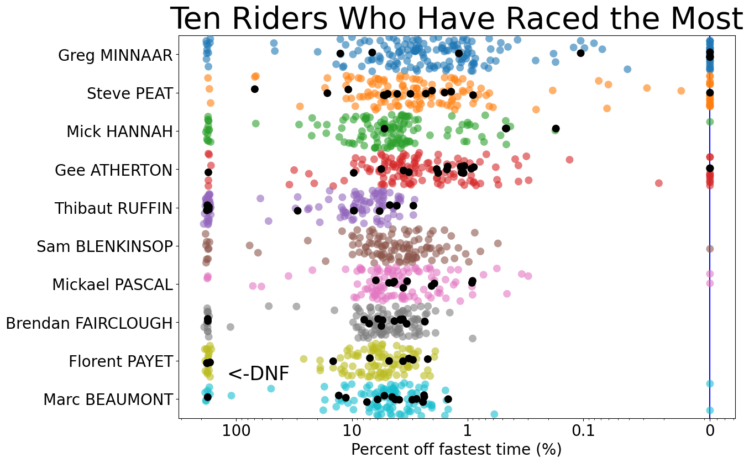

I decided to classify a good race result as one in the top 25% percent of a rider’s finishes and bad results as the bottom 25% plus races where the rider did not start, did not qualify, did not finish, or was disqualified. I limited my analysis to riders who had competed in at least 20 races which left me with 18,888 results from 209 races and 425 riders. I used logistic regression to estimate the probability that a rider had a good or bad race in their home country and out of their home country.

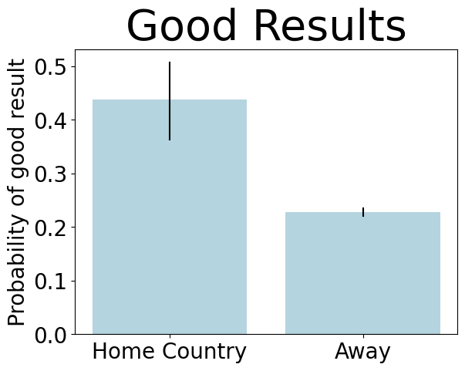

# On average, when rider are competing at home the probability of having a good result was increased by between 21 and 54%

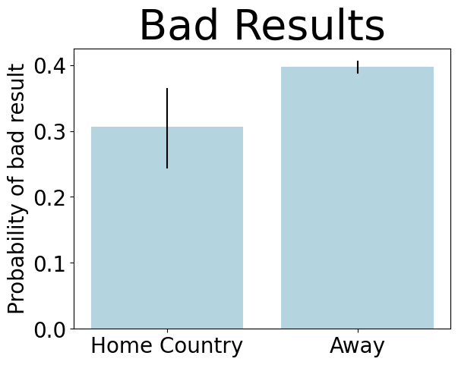

# The probability of a bad result was reduced when racing at home by between 6 and 26%.

I found that racing at home considerably increases the probability of having a good result by between 21 and 56% and decreases the probability of having a bad result by between 6 and 26%. This is pretty clear evidence for their being an advantage to racing home in the aggregate.

Which riders show the biggest effects?

While I found that on average there is a positive effect of racing at home, there is likely some variation among riders. To explore this, I fit the same logistic regression to the data for each rider individually, to estimate how racing at home affected their probability of having a good or bad result. While the average effect of racing at home increased the probability of a good result by between 21 and 56%, I found that some riders had much larger apparent effects. Below are the 10 riders with the largest positive effects of racing at home, each of which had the probability of a good result increase by over 200% when they raced at home.

# Some riders had much bigger effects of racing at home, with the probability of good results when racing at home increasing by over 200 % for these riders.

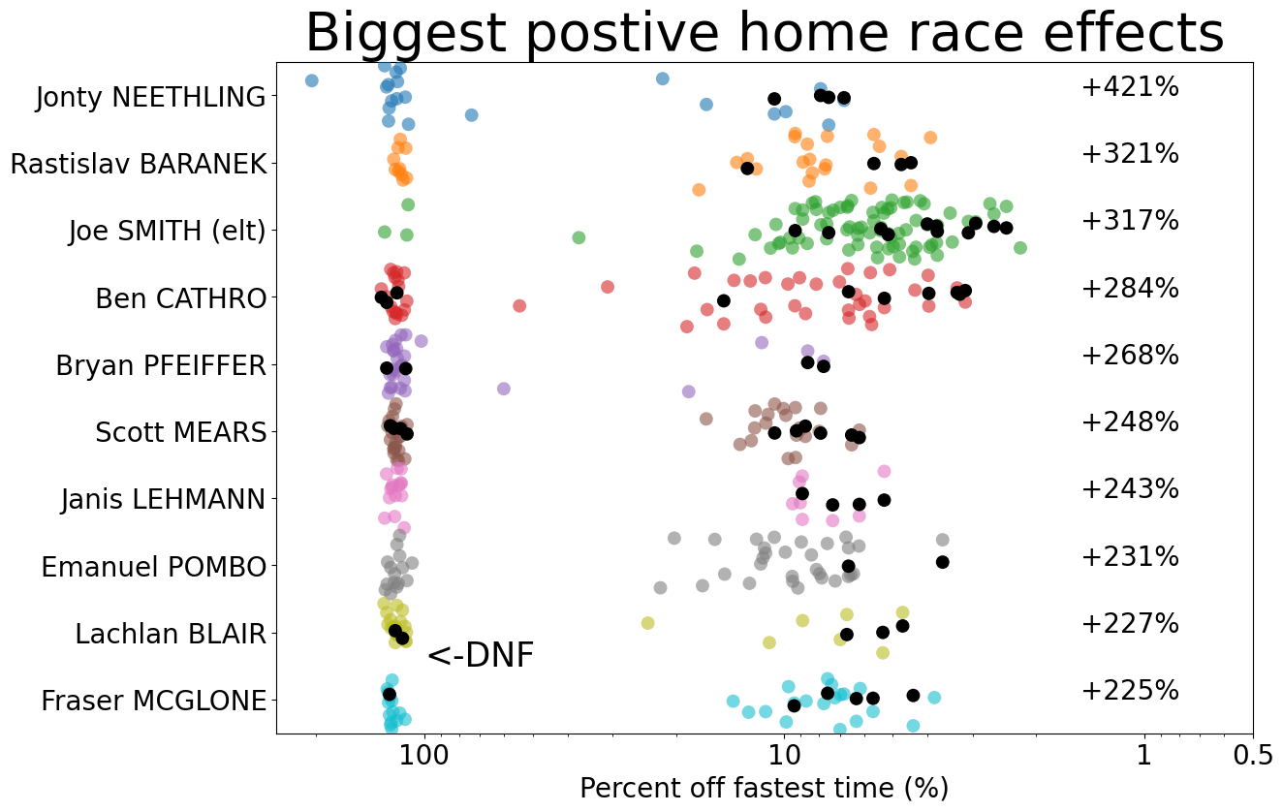

Similarly, while on average the probability of having a bad result declined when racing at home by between 3 and 24%, some riders did have an increased probability of bad results when racing at home. Each of the riders below had the probability of a bad result increase by over 100% when they raced in their home country. So, while we were able to estimate average effects of racing at home, we see that there is a considerable amount of variation among riders.

# Some had the probability of bad result increase by over 100% when they raced in their home country.

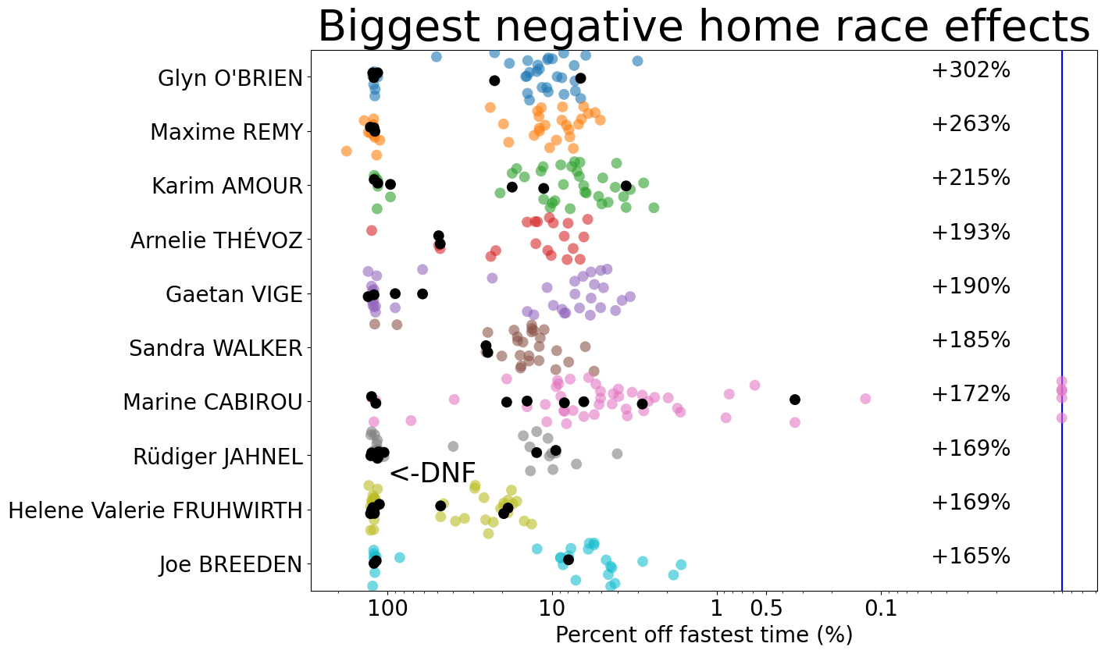

Are home country racers overrepresented among world cup winners?

In a team sport where half of the matches are played at home and half are played away, we can set an expectation that, without a home field advantage, on average only 50% of matches should be won at home. Because World Cup races have happened in 20 countries and been won by riders from 13 countries, setting a baseline expectation for what would happen if there were no advantage to racing at home is a little more involved. We first examine how many races were won by riders in their home country, which is 21 races for men and 24 races for women. Then, we create a hypothetical where the country that each rider wins in is random and unaffected by the country the rider is from. We do this by shuffling the riders and matching each rider to one of the races. Thus, the total amount of wins and races associated with each country stays constant, but how they are matched changes randomly. I’ve illustrated this below.

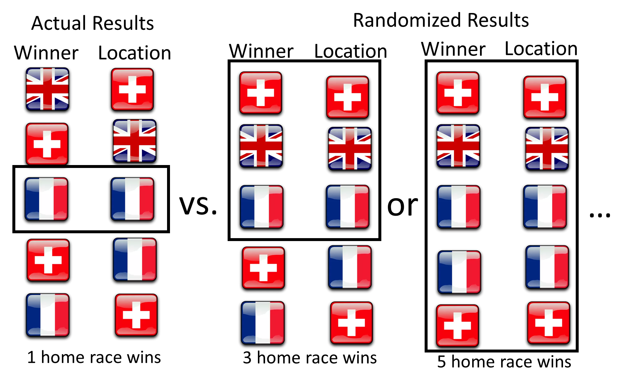

I reshuffled this 10,000 times to generate a really good idea of how many home race wins to expect if there were no influence of rider/race country on winning. I found that the actual number home race wins (solid red and blue lines in figure below) is greater than the average number we would expect if rider/race country didn’t matter (light colored distributions below). Specifically, the actual number of 21 home country wins for men was higher than 95% of the randomized race results and the actual result of 24 home country wins for women was higher than 74% of the randomized race results. This suggests that riders are a bit more likely to win races in their home country.

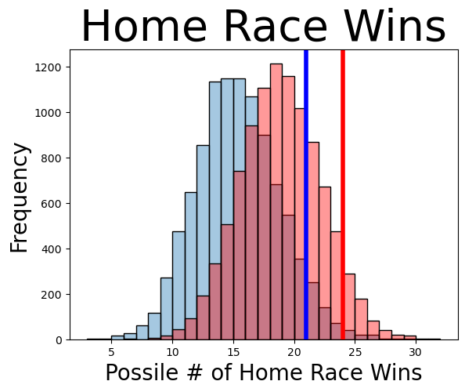

Summary:

There does appear to be a home country advantage in downhill, and the probability of a rider having a good result increases by between 21 and 54% when they race in their home country. There is also a considerable amount of variation among riders in how racing at home affects their results, with some riders, like Pinkbike’s own Ben Cathro, having a much higher chance of having good results when racing in their home country.

Personally, I expected this analysis to show that there was no effect of racing at home. I am pleasantly surprised to see that there is, and it seems like a fairly substantial effect which is interesting. I also made a couple of interactive web apps to visualize the data. If you want to look at particular riders to see where their home races all out relative to the rest of their results check out this web app: <https://nathantomczyk.shinyapps.io/dh_data_shiny_app/> And if you want to explore trends in which riders performed better or worse at home check out this web app: https://nathantomczyk.shinyapps.io/dh_shiny_app_2/

Concluding thoughts:

I had a lot fun thinking through this and working with these data and I hope some of you find this interesting as we all wait for the 2023 downhill season to start. If you want more depth on what I actually did or want to work with the data yourself, check out my GitHub: <https://github.com/nathantomczyk/world_cup_downhill_data_science>. I want to thank Roots and Rain for aggregating all the race data; this probably wouldn’t have been possible otherwise. Also, thanks to my girlfriend Kathryn Baker for edits and input on the analysis.

https://www.chicagobooth.edu/review/home-field-advantage-facts-and-fiction#:~:text=Soccer%20has%20the%20largest%20average,are%20won%20by%20home%20teams.