1. Login Screen

This is the screen which allows users to login to site.

I have changed nothing about this page.

2. Register Screen

This is the screen which allows users to register.

There are two user roles – student and instructor

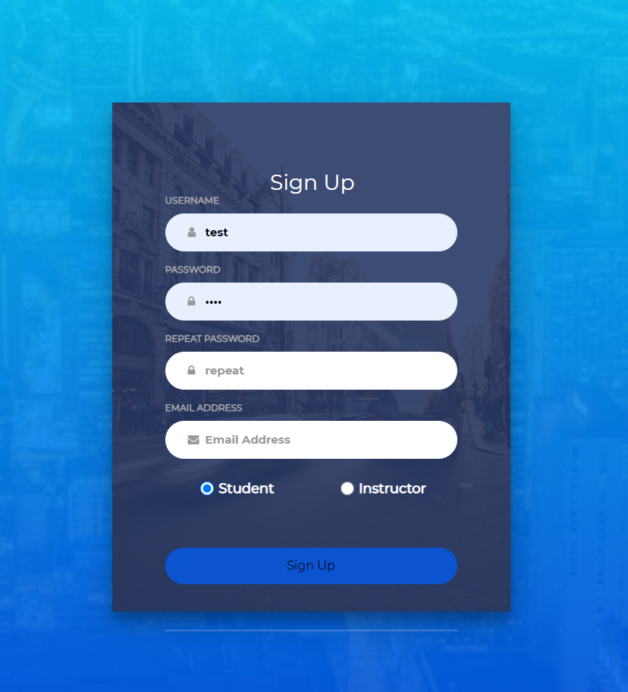

3. Home Screen

This is the screen which allows users to see all courses which are created already.( I have added this with all courses and redirect to the specific course screen per each course)

The screen is differently shown if the user is an instructor or a student.

- Instructor

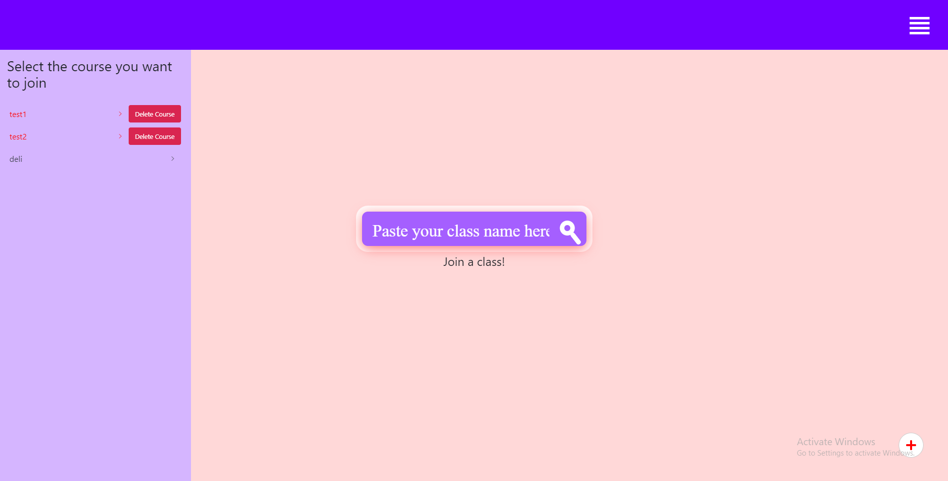

This is the Home Screen for an instructor.

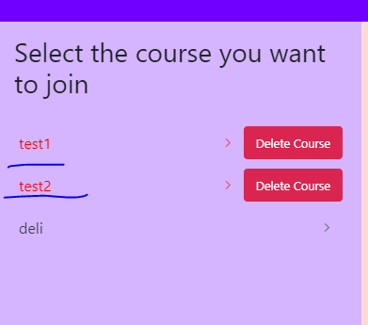

The courses which are created by login instructor are marked as a red color with the “Delete Course” button at the right of the nav item.

Here you can see test1 and test2 courses are created by current instructor but deli course is not.

If you are an instructor , you can see the “+” button on the right bottom of the Home Screen and you can add course using this button.

This is the form for adding a course.

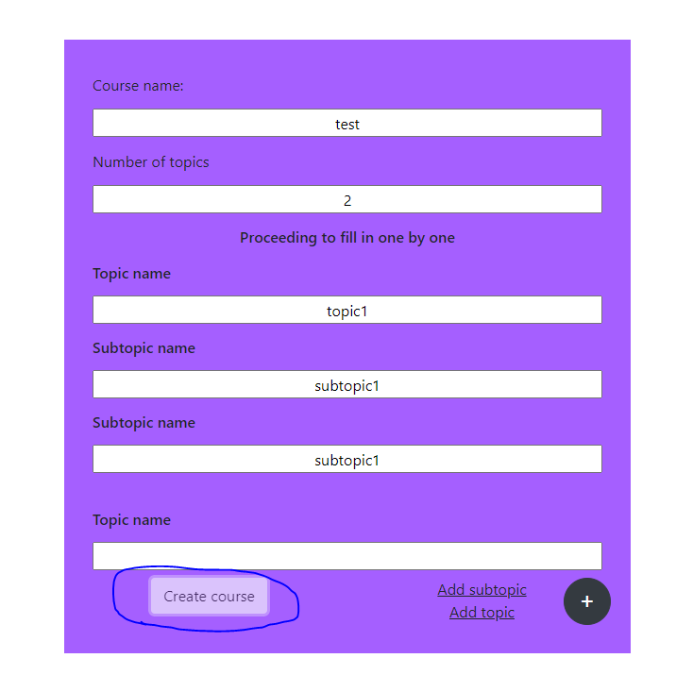

Here the style is not changed ( I will do it later with modern style) and I have done some validation with course information.

For example if you type the course count as 2, but you don’t type the two topics then “Create Course” button will be disabled and you can’t create.

And also if there is no subtopic for each topic, then you can’t create topic and also can’t create a course.

And empty fields are not allowed for creating a course.

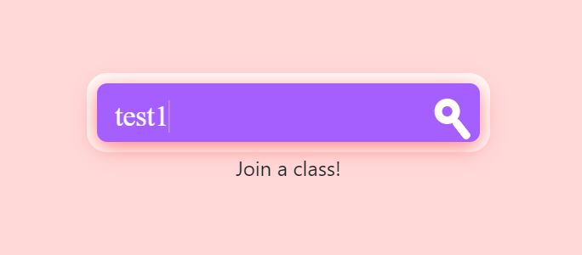

At Home Screen, you can see this field in the center of the page.

This field helps users join a class easily by writing course name on input box and join a class.

This field is now working same for a student and also an instructor.

- Student

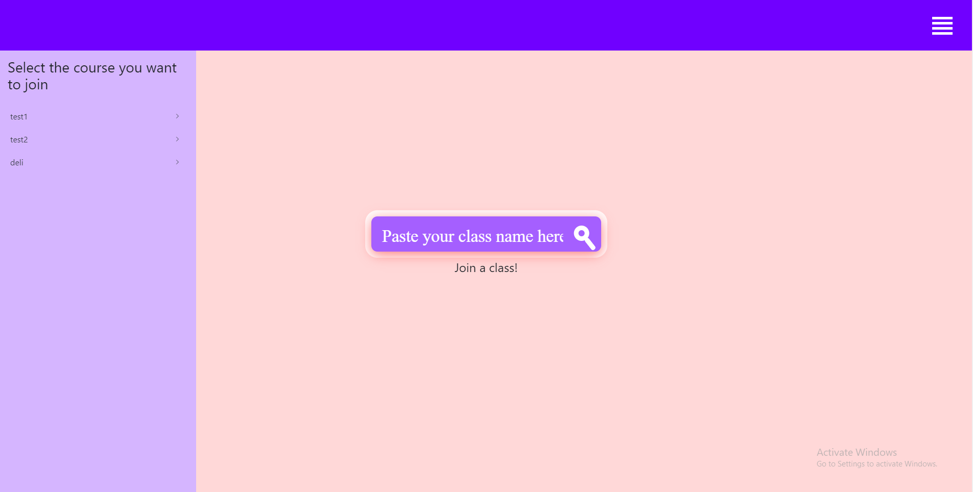

This is the Home Screen for student accounts.

This is the nearly the same for a Home Screen for instructors.

The differences are

~All nav items for each courses are not marked because user is an student.

~There is no “Create Course” item on the right bottom of the page.

From Home Screen each time you click the nav items for courses for join a class, you redirect to the course Screen for an instructor and also a student.

4. Course Screen

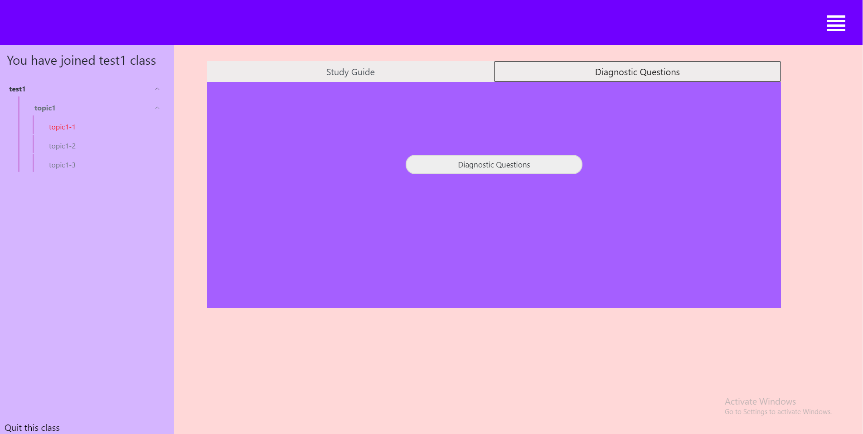

This is the screen which allows instructors to add questions and students to take test and study with specific course.

Even though , user is created with instructor role , if he enters into the course which he hasn’t created, then he has the role like a student.

It means that he can study and test on that course, but can’t manage test questions for that course.

- Instructor

When instructor clicks “Diagnostic questions” then the modal dialog appears with options to add questions with manually and images.

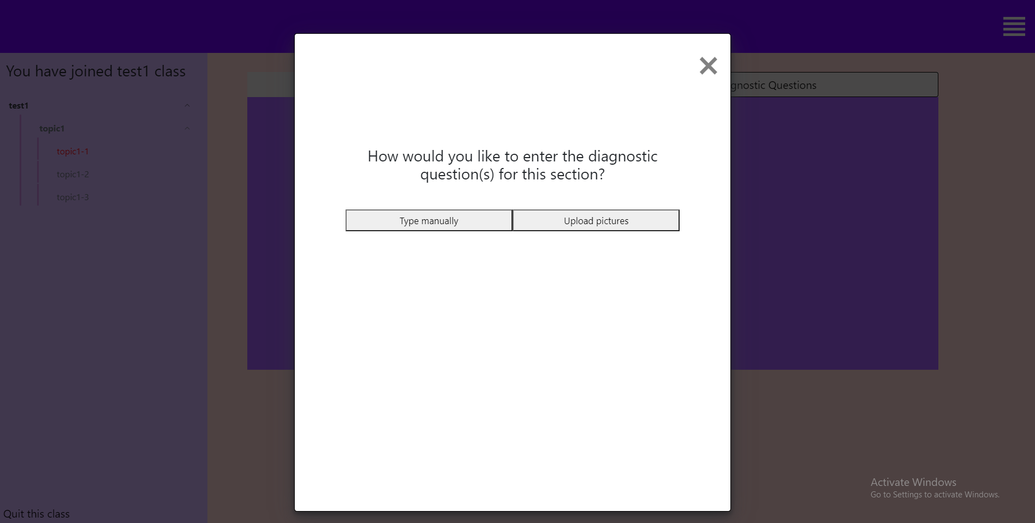

When click Manually

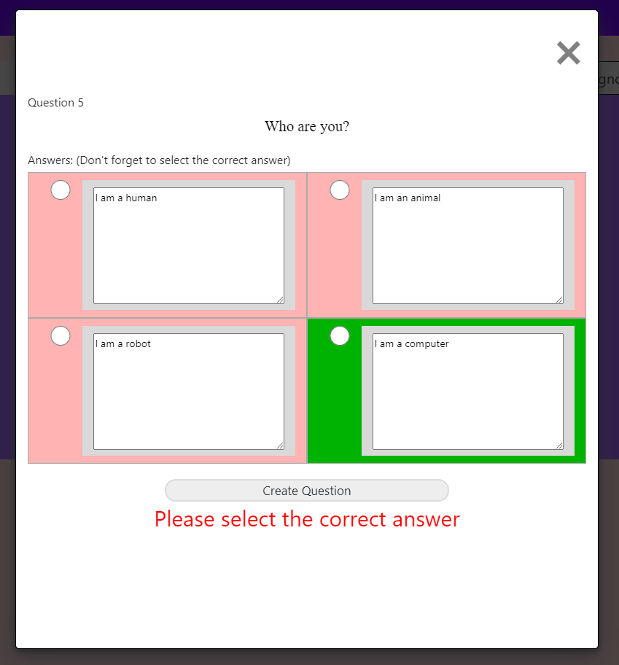

- Student

The interface here is just like what it was, I just did validation only here and changed some title style.

When click Image

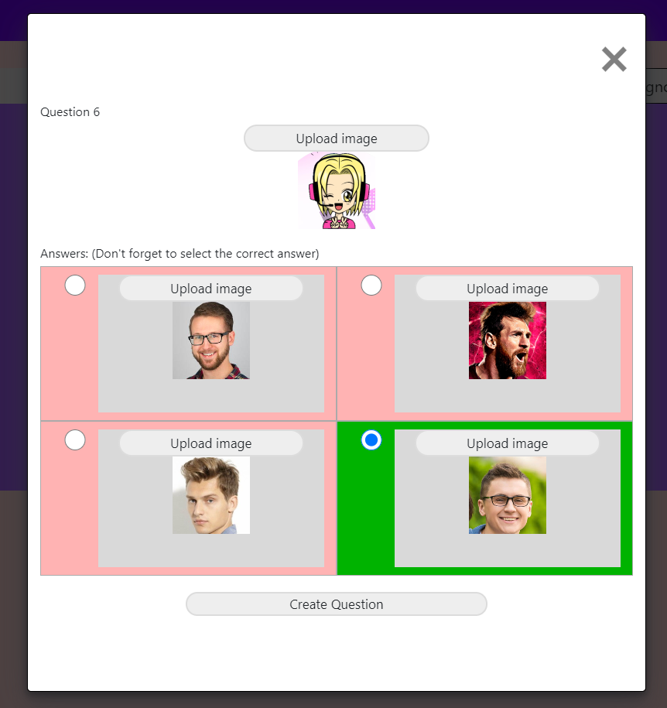

After the essential information is ready, when you click “Create Question”, then this question is stored in db for specific subtopic and created userid.

And students are able to get test with this question.

-student

The interface for course screen for student is just the same as an instructor.

The difference is when click “Diagnostic Questions”

This button allows for instructor to create question, on the other hand allows students to take test and look at the result which question they have wrong answers and right answers.

When click “Diagnostic Questions”

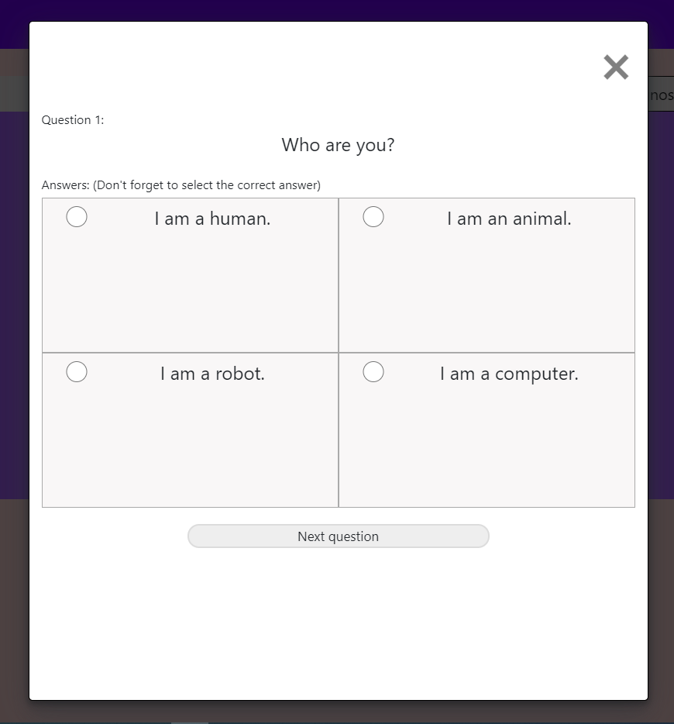

The test is started with questions which instructor added for this subtopic.

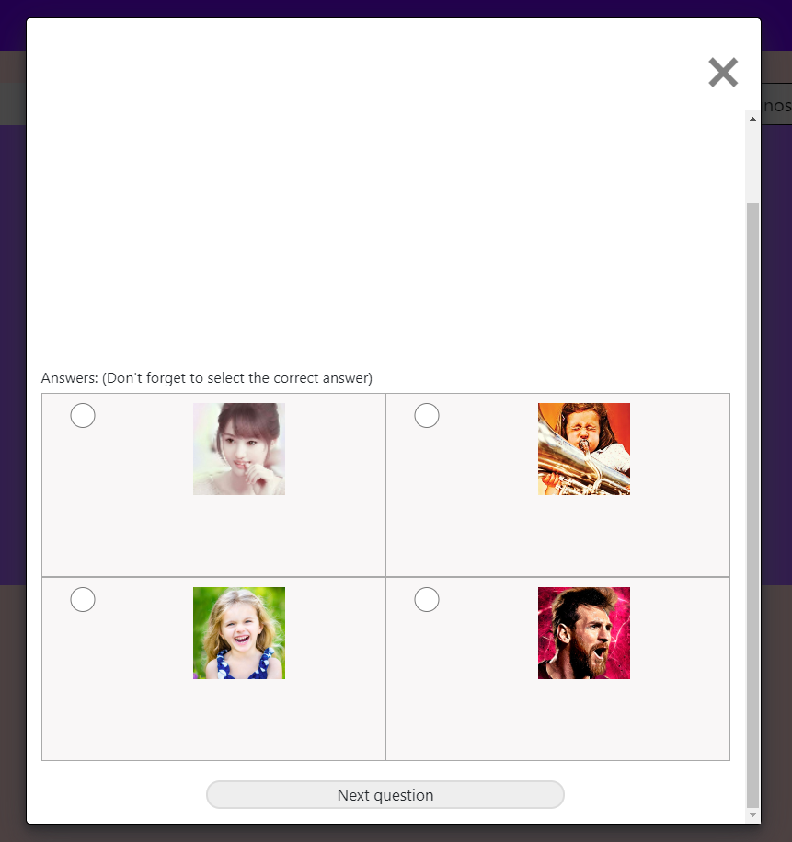

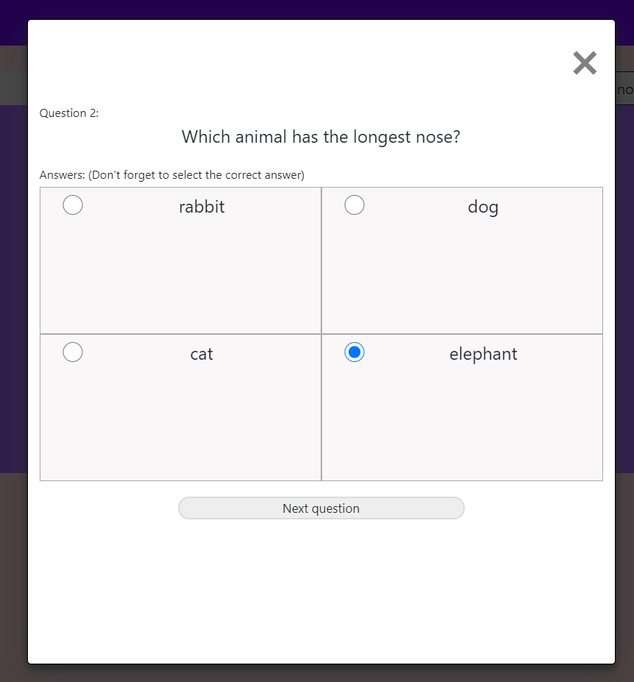

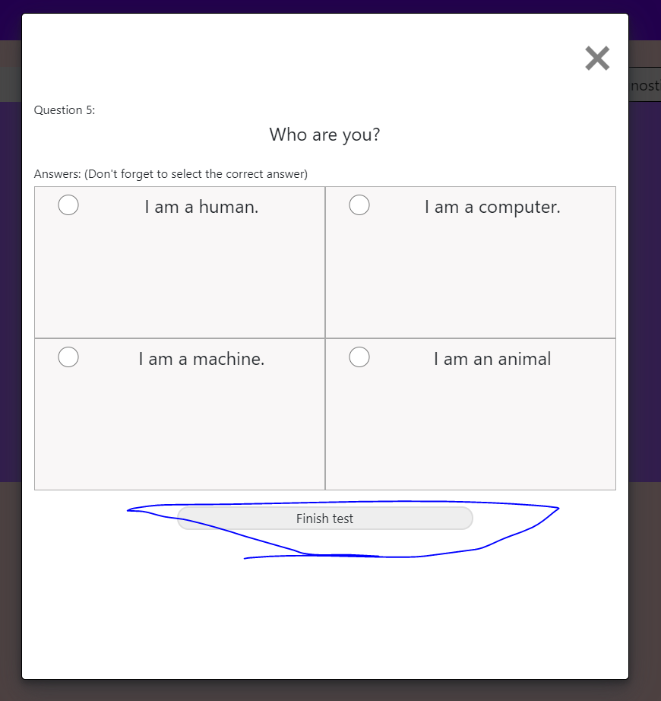

At the last question, the finish test button is appeared and when click this button, it stores test result for a student for this subtopic to db.

Once student finishes the test, he can see the result for the test which answers he got right or wrong.

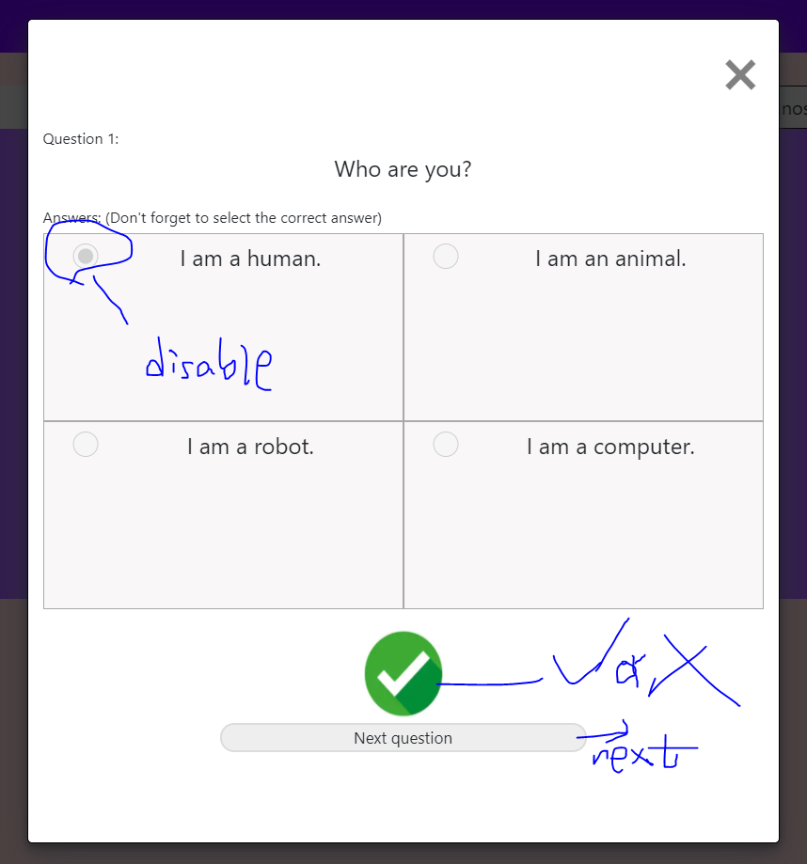

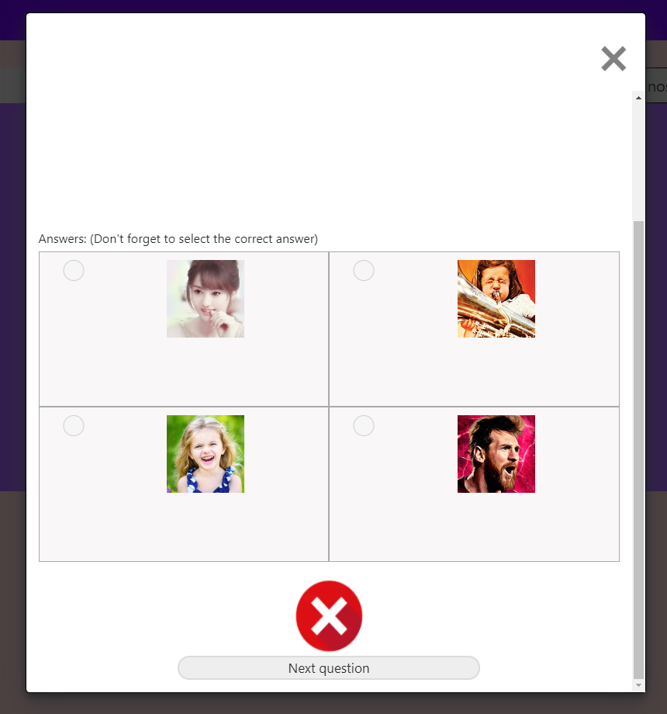

If students didn’t select any radio button for answers , then it became also wrong answers like above image.

This is the mainly what current site is.

Some features are missing here, I think.

-Join google doc feature. ( I want to discuss about google doc which will be created)

-Edit course feature for an instructor. ( I want to discuss about this feature how to implement)

-Change with modern style. ( I will do this at the last after I implement all features you want)