As Marc Andreessen, the creator of Mosaic (the first widely used Web browser), claimed in his 2012 interview with wired, “everything will be social”, he is indeed insightful. Not only does different social media sites connect friends together, they also make coding a networking activity. GitHub is one of these sites (in fact the largest one so far) that brings programmers together and makes group projects easier to accomplish.

What is GitHub
GitHub is a storage space for collaborative works (usually software codes). It is based on a distributed version control system called git. What git does is it enables users to track the different versions of their products and to merge desirable features if needed.

Here is a demo of what git can do:
// First initiate a repository (the place where the codes hold) using git init
// Then check to see what is in the repository using git status
// In this case I created two files: the one I'm writing now and the outline for this paper
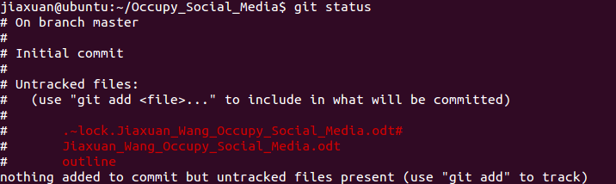
// Add the two documents to the stage (where commit takes place) using git add
// Commit them (it's like saving them in the repository) using git commit
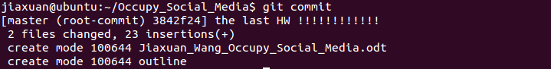
// Check to see if all documents have been committed (in this case yes)
// Check the branch I'm working in using git branch

branch is actually a big advantage of using git. What a branch does is it allows you to create a playground to try new ideas. Often, when people are creating stuffs, they are not sure whether it works. By using branch, they won't affect the part they know it's good as will be illustrated in this demo.
// Create a new branch called crazy_ideas using git branch
// Switch to crazy_ideas by git checkout
// Now I have two branches (branch master is the default main branch)
// Create a new file in the new branch
// This is the folder that I'm working on (notice that I have git_hub_great in the folder before I
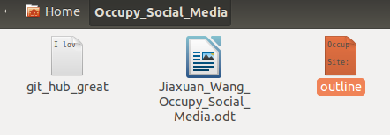
commited it)

// Add and commit the new file under crazy_ideas branch
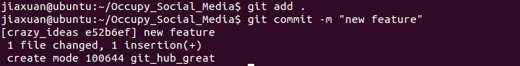
// Switch back to master
// Observe that the new file disappears and that is because the master branch has no knowledge of the

existence of the file since it is created in the other branch. This makes sure that working on one branch is independent from working on others.

// Merge the crazy_ideas to master using git merge (merge is a powerful command that merges two versions of the codes together)
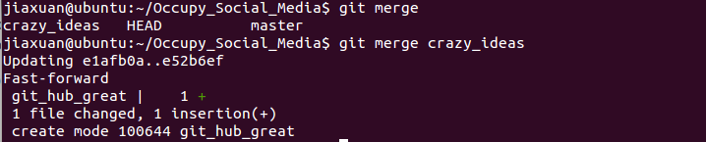
// See the history of my commits using git log (observe that each commit is hashed to a unique value and that's how different version of the product can be retrieved)
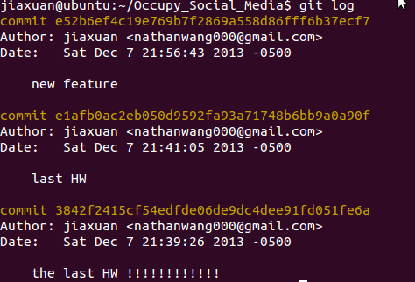

Now I have my project saved, but all these processes are done locally. What if I want to invite a friend to work on the project with me? That's where GitHub comes in.

http://www.forbes.com/sites/anthonykosner/2012/04/22/always-early-marc-andreessens-five-big-ideas-that-have-shaped-the-internet/

