Training data
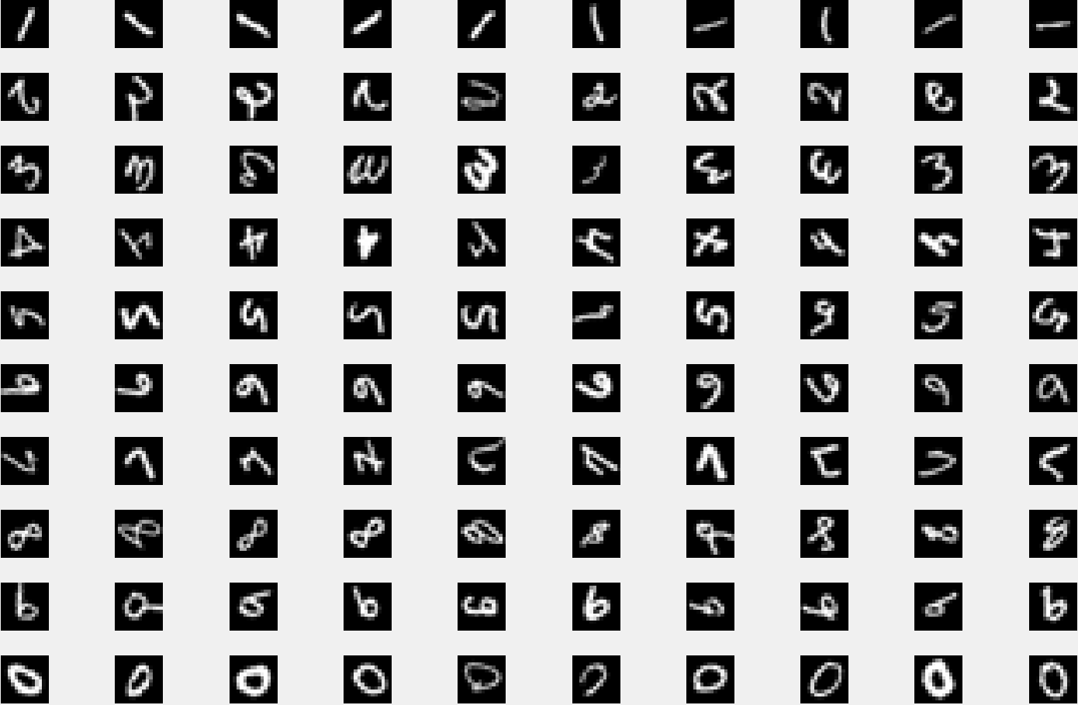
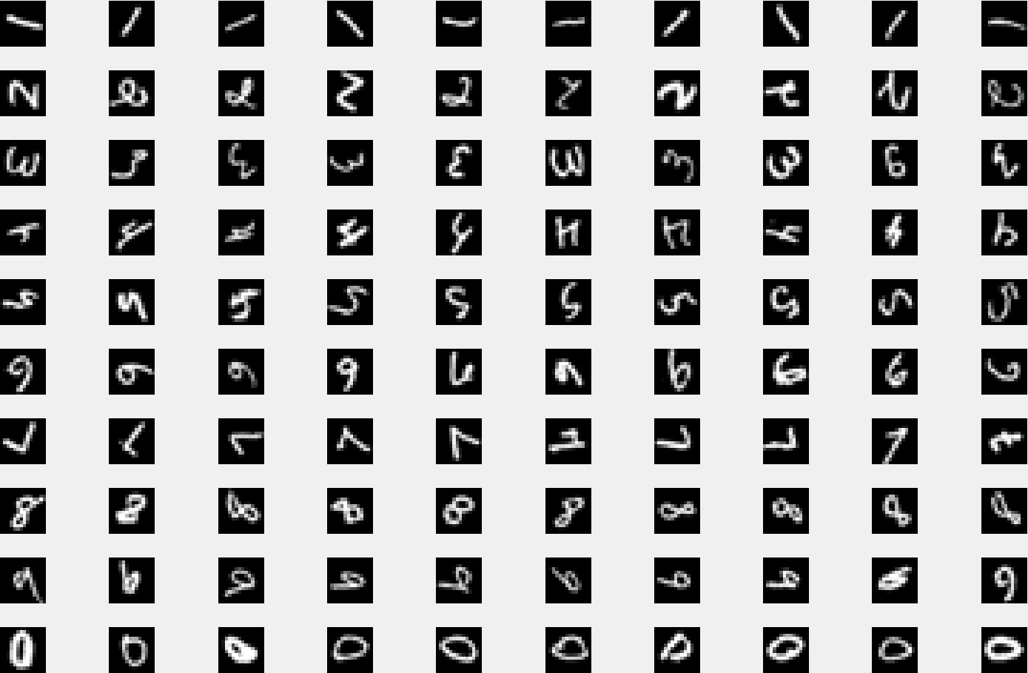
Test data
Learned filters
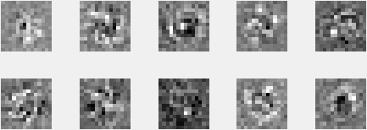

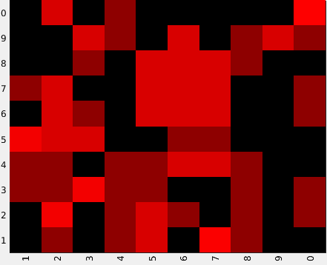
Confusion matrix (column actual, row predicted)
0 1 0 1 2 0 5 1 0 0
0 4 0 1 2 1 0 1 0 1
1 1 4 1 1 0 0 1 0 1
1 1 0 1 1 3 2 1 0 0
4 2 2 0 0 1 1 0 0 0
0 2 1 0 2 2 2 0 0 1
1 2 0 0 2 2 2 0 0 1
0 0 1 0 3 3 2 1 0 0
0 0 2 1 0 3 0 1 2 1
0 2 0 1 0 0 0 0 0 7

Archetecture

