Photon-counting CT thermometry via material decomposition and machine learning

Nathan Wang1, Mengzhou Li2, Petteri Haverinen3

1Department of Biomedical Engineering, Johns Hopkins University, Baltimore, MD, USA

2Department of Biomedical Engineering, Rensselaer Polytechnic Institute, Troy, NY, USA

3Aalto Design Factory, Aalto University, Espoo, Helsinki, FI

*swang279@jh.edu

**Abstract**

Thermal ablation procedures, such as high intensity focused ultrasound (HIFU) and radiofrequency ablation (RFA), are often used to eliminate tumors by minimally invasively heating a target region. In this task, real-time 3D temperature visualization is key to treat the diseased tissues while minimizing damage to the surrounding. Current CT thermometry is based on energy-integrated CT, tissue-specific experimental data, and linear relationships between attenuation coefficient and local temperature. In this letter, we develop a novel approach combining photon-counting CT for material decomposition and a neural network to predict temperature based on CT number thermal characteristics of base materials and spectral tomographic measurements of a volume of interest. In our feasibility study, distilled water, 50 mM CaCl2, and 600 mM CaCl2 are chosen as the base materials. Their X-ray linear attenuation coefficients are measured in four energy bins at various temperatures. The neural network was trained on the experimental data on the base materials and tested on 300 mM CaCl2 and a milk-based protein shake achieving a mean absolute error of 1.80 °C and 3.97 °C respectively. These experimental results indicate that our approach is promising for handling nonlinear thermal properties of materials that are either similar or dissimilar to sufficiently representative base materials.

**Keywords:** CT thermometry, machine learning, neural network, photon-counting CT, thermal ablation

**Introduction**

Annually, over 100,000 patients undergo thermal ablation procedures for a wide range of benign and malignant tumors [1]. As a primary example, high intensity focused ultrasound (HIFU), which heats a focal region using a concave transducer, is an effective minimally invasive treatment for prostate and other cancers [2,3]. Currently, the delivery of the thermal dose is guided by invasive thermistors which can be fragile and only read from a limited number of points [4,5]. Over the past decades, significant research efforts were devoted to extracting and analyzing thermal data from medical imaging modalities like ultrasound (US), magnetic resonance imaging (MRI), and computed tomography (CT). Among these modalities, CT is particularly desirable for its real-time acquisition, high spatial resolution, and full-body coverage. In contrast, MRI has significant drawbacks in scanning speed, geometric accuracy, and cost, while US suffers from strong artifacts and little penetration through hard tissues and across air-tissue interfaces [6, 7].

While ionizing radiation to the patient is the main problem associated with CT, solutions are being rapidly developed over the past years. For instance, interior tomography allows for targeted imaging of a region of interest (ROI) [8]. Also, data-driven methods (i.e., machine learning especially deep learning) have been applied to low-dose CT image reconstruction and denoising [9]. Synergistically, hardware-based innovations enabled photon-counting CT (PCCT), which is a new frontier of medical imaging. PCCT can reduce radiation dose by eliminating electron noise, minimizing beam hardening effect, optimizing X-ray photon weighting, increasing spatial resolution with fine detector pitch, and performing multiple material decomposition beyond the capabilities of dual energy CT [10, 11]. With FDA approval, these advancements have already been used in multiple clinical applications.

**Principle.** The ability for CT to measure temperature changes is based on the temperature-induced change in the X-ray linear attenuation coefficient (LAC) as the result of material thermal expansion. In general, heat applied to a tissue causes an increment in volume and thus decrement in density, which leads to a drop in the LAC. The relationship between CT number, which is a normalized measure of the LAC expressed in the Hounsfield unit (HU), and temperature is modeled as Equation 1.

**(1)**

**Fig 1.** Illustration of the experimental setup and procedure. **a)** A photograph of the photon-counting CT platform used to take 2D projections of the phantom, **b)** the 200th row in the projection selected as the line of interest (LOI) to obtain the projection profiles of the phantom when it is empty or filled with liquid material (The projections enhanced for better viewing), and **c)** The difference between the projection profiles of the empty and liquid-filled phantom used to determine the LAC of the liquid material.

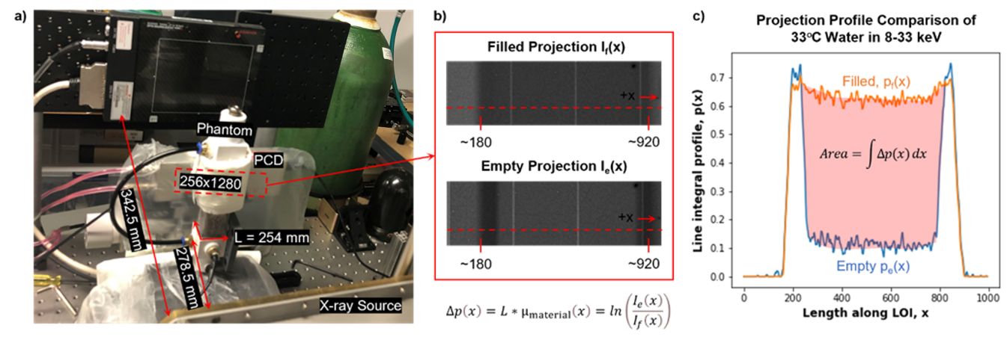

where *T0* is a baseline temperature and *α* is the material-specific thermal expansion coefficient [12]. The change in HU per degree Celsius is referred to as the thermal sensitivity and typically approximated as a constant over a relevant temperature range (for example, from 30 °C to 90 °C). This linear trend is confirmed in the prior studies, which examined substances including water, fat, liver, kidney, and so on [13, 14]. While this principle of CT thermometry is conceptually simple, the variability in thermal sensitivity is a critical challenge between various tissues, different patients, and under diverse scanning protocols [1]. It would be difficult or impossible to obtain these highly specific measures in-vivo, and there are substantial differences between in-vivo and ex-vivo measurements under different physiological conditions. Furthermore, exposure to intense heat during thermal ablation may alter the thermal properties of the target region, introducing additional errors.

To address these problems with traditional CT thermometry, here we present the PCCT thermometry approach that allows for superior material decomposition and data-driven temperature prediction relying on basis material data that do not need patient-specific calibration. Using PCCT to simultaneously capture the LAC of a substance at several energy levels, we can perform material decomposition, which is demonstrated in Equation 2 for three base materials without loss of generality [15, 16]:

**(2)**

where *µ1*, *µ2*, and *µ3* are the known energy-dependent LACs of the base materials, and *V1*, *V2*, and *V3* are the corresponding unknown volume fractions. Physically speaking, the LAC of a mixture of the base materials must be the linear combination of the LACs of the material components with the corresponding volume fractions as the weighting factors.

Given the above formulation, one might reasonably expect that thermal sensitivity could be linearly computed according to the material composition. In other words, given that where *T0* is a reference temperature and *αi* is the thermal expansion coefficient, a linear model for the LAC for *n* base materials could be as follows:

**(3)**

where and are the volume fraction weighted thermal expansion coefficient and similarly weighted offset, respectively. However, in reality the thermal expansion coefficient relies primarily on the thermal expansion mechanism, which is directly related to the strength of intermolecular bonds, and as a result quite nonlinear. Hence, the above linear model is significantly inaccurate. According to our experimental data in Figure 2, thermal expansion follows a quadratic/higher order relationship with the concentration of CaCl2 (Figure 2g), indicating that data-driven nonlinear modelling would be suitable for PCCT thermometry. Since a fully connected neural networks with proper activations can approximate any continuous function, it is an ideal choice for prediction of temperature given spectrally resolved LAC values, which is essentially a multivariate regression task.

**Methods/Experimental**

**Figure 2.** Summary of experimental data of all studied materials. **a)** X-ray linear attenuation coefficient vs. photon-counting energy bin plots for water compared to the NIST values. The end points of the energy bins (33 keV, 45 keV, 60 keV, and 110 keV) were selected for the figure. Compton scattering of high energy photons accounts for the observed attenuation discrepancy. **b-f)** The attenuation vs. temperature plots for all the materials used in our study. The positive trend in the 8-33 keV bin is due to the reduced Compton scattering at increased temperature in the higher energy bins. **g)** The scatterplot summary of thermal sensitivities with error bars. It is observed that the non-linear trend between thermal sensitivity and material composition for 0-, 50-, 300-, and 600-mM solutions of CaCl2 respectively.

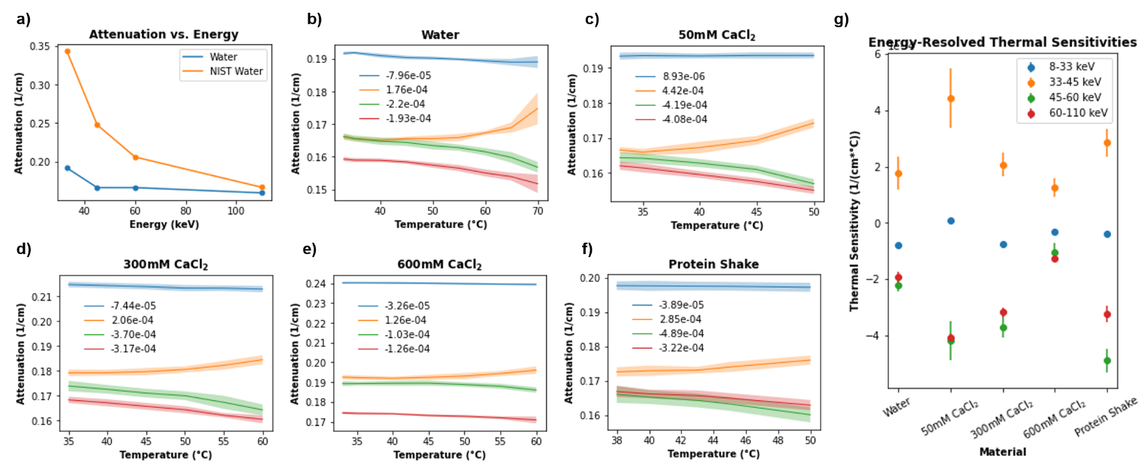

In our feasibility study, we selected (1) water, (2) 50 mM CaCl2 and (3) 600 mM CaCl2 aqueous solutions as our three base materials since the human body is characteristically composed of water and bone. These substances were heated in a hot water bath with precision temperature control and immediately transferred to a custom-built cuboidal phantom with a digital thermometer (DS18B20 thermometer, ±0.25°C) for real-time temperature monitoring. The thermal expansion of the acrylic phantom container is negligible in comparison to the substances being measured. The LAC values of the homogeneous base substances were measured in four energy bins (8-33 keV, 33-45 keV, 45-60 keV, and 60-110 keV) at approximately every 5°C temperature drop during a natural cooling process. The X-ray photon-counting imaging system consists of an X-ray source (SourceRay SB-120-350, 75µm focus) and an X-ray photon-counting detector (ADVACAM WidePIX1x5, Medipix3, 55µm pitch, 256x1280 pixels). In our experiments, the source was operated at 100kVp 100µA with 0.1mm copper filtration. The detector was set to the charge-summing mode with two thresholds for each acquisition. After 1-hour stabilization, projections were collected at 8keV and 45 keV thresholds followed by the same number of projections at thresholds of 33keV and 60keV respectively. All projections were captured within 1.5 °C of the digital thermometer reading. Since the X-ray tube emits photons in a small-angle cone-beam geometry, we cannot assume that all beam paths through the phantom are in parallel. Thus, a weak perspective imaging geometry was assumed to compensate for beam divergence. In the 2D projection after removal of dead pixels, we selected a horizontal line of interest (LOI) that spans the internal width of the phantom. Using *x* to denote the position along the LOI, the differences between the line integral profiles of the phantom when it is filled with liquid of interest and those when it is empty were computed according to Equation 4.

**(4)**

where *f* stands for liquid filled in the phantom, *e* stands for the empty phantom, *I* for the raw photon counts, and *L* (2 mm) is the internal side length of the square cross-section of the phantom. By taking the difference, the attenuation contribution of the phantom enclosure was almost eliminated. Finally, a sliding average over five pixels and a median filter over seven pixels were sequentially applied to remove noise from the projection profiles before the X-ray LAC of the material is found according to Equation 5 with the weak perspective approximation:

**(5)**

where the correction factor of 1.23 is the magnification power, defined as the ratio of the distance from source to the phantom center (278. 5 mm) and that from source to detector (342.5 mm), and the detector element pitch is 55 μm. The error in *µmaterial* is theoretically no more than 3% compared to that measured with a parallel beam source (See the appendix). Note that our weak perspective method is rotation-invariant and uses all data points in the LOI to yield a high signal to noise ratio. The variance of all measurements was quantified by computing the LAC from 10 adjacent lines of interest (LOIs).

To predict the temperature changes, we designed a neural network with an input layer of eight nodes, two hidden layers of four nodes, and an output layer of a single node. The training examples were measured on the three base material data, which are formulated in Equation 6, where the first four elements of the input vector are the baseline LACs of a material at a reference temperature of 33°C and the last four elements are the attenuation residuals due to temperature elevation. The ground truth is the temperature. The multiplicative factor of 100 was introduced to scale all residual features into a similar range.

Figure 3. Summary of experiment results. a) The fully connected neural network architecture used to non-linearly model the relationship between attenuation and temperature. The input to the network is the spectral attenuations of a material at a baseline temperature concatenated with the attenuation residuals due to heating. b) Visualization for network performance for predicting temperature on 300 mM CaCl2 and a milk-based protein shake. The data points are labeled in the (xx, yy) format where xx is the predicted temperature and yy is the ground truth temperature synchronously measured with a digital thermometer. Data from the testing samples were not included in the training data.

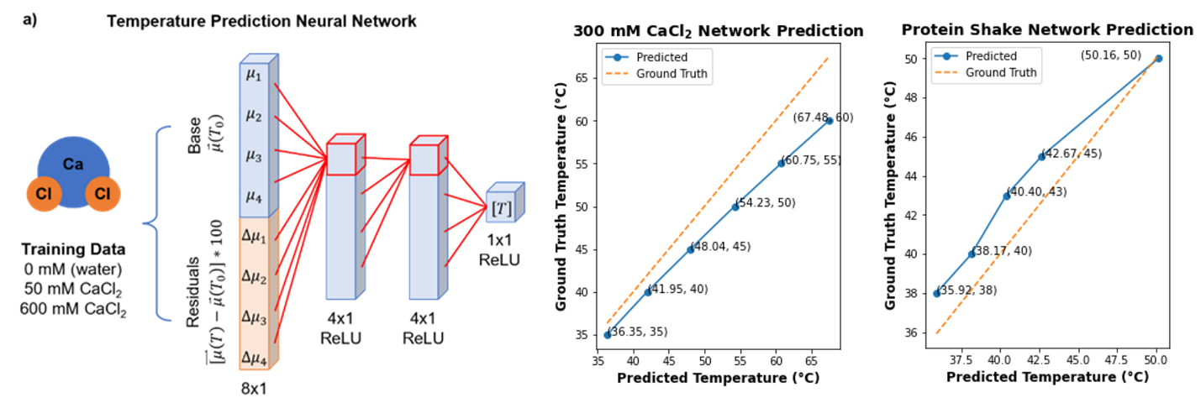

**(6)**

The network architecture and its predictions are in Figure 3. In total, 333 unique training inputs representing a reasonable range of temperatures were generated for each of the three base materials where a Gaussian random noise consistent to the data noise level was added for data augmentation. The ReLU activation was used for all layers. The loss function was defined as the mean squared error. The stochastic gradient descent method served as the optimizer, with a learning rate of 1E-5. The dataset was split with 80% for training and 20% for validation. The testing set consisted of data collected from 300 mM aqueous CaCl2, which is similar in composition to the base materials, and from a milk-based protein shake (30g protein, 4g carbohydrates, 2.5g fat per 340 m), which is organic and dissimilar to the base materials.

**Results and Discussions**

All the collected data illustrated in Figure 2 and the raw data and code are openly available. Figure 2a depicts the trend of X-ray LAC with increasing energy levels, which is generally expected. However, in the lowest energy bin, our measured LACs for water are lower than those reported by NIST [17]. This discrepancy is due to Compton scattering of high energy photons from our polychromatic source which were recorded as low energy photons. In a medical PCCT scan with collimated X-rays, this error will be effectively suppressed. Note that all errors and biases in our experimental measures will be automatically compensated for by our proposed neural network in the data-driven fashion.

Figure 2b-f shows the relationship between LAC and temperature, which show negative trends in all the cases except the 33-45 keV bin. The positive trend in the 33-45 keV channel can be explained as follows. The reduced attenuation of a material due to thermal expansion leads to two competing effects: (1) fewer high energy (45-60 keV and 60-110 keV) photons are Compton scattered into the 33-45 keV energy bin, and (2) more low energy (33-45 keV) photons pass through the material in the 33-45 keV energy bin. Evidently, the former mechanism has a greater effect since it occurs over a much wider energy range. Hence, the net effect is that LAC in the 33-45 keV bin appeared increased with higher temperature. Despite this effect, the data in the 33-45 keV channel is still informative and was incorporated for the network training and inference.

After 73 epochs of training, the mean absolute error (MAE) on the validation data smoothly converged from 43.13 °C to 3.40 °C. On the testing data, the network achieved a MAE of 3.97 °C on 300 mM CaCl2 over a temperature range of 35 °C to 60 °C and an MAE of 1.80 °C on milk-based protein shake over a temperature range of 38 °C to 50 °C. Note that 300 mM CaCl2 can be directly made from the bases (i.e., 50% water and 50% 600 mM CaCl2) while the protein shake contains significant amounts of other substances. In both cases, the network is highly accurate. These results are displayed in Figure 3b and 3c.

Thanks to the non-linear data-driven learning capability of a neural network, complicated LAC data with respect to temperature modulation and material composition can be conveniently modeled as a multi-layer perceptron system for temperature mapping based on PCCT measurement. It is hypothesized that with a representative set of basis materials, PCCT thermometry would be capable of mapping temperature distributions in live animal and human for a wide arrange of applications including but not limited to HIFU and microwave thermal ablation of tumors, hyperthermia therapy with which the temperature inside a patient VOI is kept in the region of 40–45 °C as an aid for other therapeutic means, basic physiological and pathological research.

**Conclusion**

In future studies, an active temperature measure (as opposed to passive cooling) could be used to ensure better thermal accuracy of the data points. A better calibrated PCD and increased source filtration can also reduce the adverse effects of fluorescence escape and beam hardening effects respectively [20,21]. Additionally, more material bases can be incorporated for the neural network to cover more material types and better neural networks can be designed to improve temperature prediction. Furthermore, tomographic PCCT on human tissue samples are necessary before in-vivo studies can be planned. For preclinical evaluation, mouse experiments can be used to compare the efficacy of thermal ablation using classical approaches (e.g., thermistors) and the novel PCCT thermometry imaging presented in this letter. Clearly, PCCT thermometry will offer a thermal dimension to a spectral CT volume and may potentially bring new diagnostic and therapeutic tools to clinical practice.

In this study, we demonstrate a data driven PCCT thermometry algorithm that can accurately predict the temperature of unknown materials given spectrally resolved LACs of a set of known, base materials at various temperatures. This is an important result toward surgical translation as it presents a solution for handling variability in tissue property without direct calibration to the tissue in vivo.

**Declarations**

**Availability of data and materials**

The datasets generated and/or analysed during the current study are available upon reasonable requests

**Availability of data and materials**

Not applicable

**Acknowledgements**

Not applicable

**Competing interests**

The authors declare that they have no competing interests

**Authors’ contributions**

Nathan Wang proposed the method for network-based photon-counting CT thermometry and drafted the paper. Nathan Wang and Mengzhou Li designed the experiments, collected data, and performed analyses. Petteri Haverinen designed and fabricated the phantom device used in the experiments. All the authors participated in discussions and edited the manuscript.

**References**

1. Fani F, Schena E, Saccomandi P, Silvestri S. CT-based thermometry: An overview. International Journal of Hyperthermia. 2014;30(4):219–227. doi:10.3109/02656736.2014.922221

2. Brace C. Thermal Tumor Ablation in Clinical Use. IEEE pulse. 2011;2(5):28–38. doi:10.1109/MPUL.2011.942603

3. Alkhorayef M, Mahmoud MZ, Alzimami KS, Sulieman A, Fagiri MA. High-Intensity Focused Ultrasound (HIFU) in Localized Prostate Cancer Treatment. Polish Journal of Radiology. 2015;80:131–141. doi:10.12659/PJR.892341

4. Saccomandi P, Frauenfelder G, Massaroni C, Caponera MA, Polimadei A, Taffoni F, Di Matteo FM, Costamagna G, Giurazza F, Schena E. Temperature monitoring during radiofrequency ablation of liver: In vivo trials. In: 2016 38th Annual International Conference of the IEEE Engineering in Medicine and Biology Society (EMBC). 2016. p. 344–347. doi:10.1109/EMBC.2016.7590710

5. Saccomandi P, Schena E, Silvestri S. Techniques for temperature monitoring during laser-induced thermotherapy: An overview. International Journal of Hyperthermia. 2013;29(7):609–619. doi:10.3109/02656736.2013.832411

6. Winter L, Oberacker E, Paul K, Ji Y, Oezerdem C, Ghadjar P, Thieme A, Budach V, Wust P, Niendorf T. Magnetic resonance thermometry: Methodology, pitfalls and practical solutions. International Journal of Hyperthermia. 2016;32(1):63–75. doi:10.3109/02656736.2015.1108462

7. Ebbini ES, Simon C, Liu D. Real-time Ultrasound Thermography and Thermometry. IEEE signal processing magazine. 2018;35(2):166–174. doi:10.1109/MSP.2017.2773338

8. Wang G, Yu H. Meaning of Interior Tomography. Physics in medicine and biology. 2013;58(16):R161–R186. doi:10.1088/0031-9155/58/16/R161

9. Wang G. A Perspective on Deep Imaging. IEEE Access. 2016;4:8914–8924. doi:10.1109/ACCESS.2016.2624938

10. Taguchi K, Polster C, Segars WP, Aygun N, Stierstorfer K. Model-based pulse pileup and charge sharing compensation for photon counting detectors: A simulation study. Medical Physics. 2022;49(8):5038–5051. doi:10.1002/mp.15779

11. Photon-counting CT: Technical Principles and Clinical Prospects. [accessed 2022 Sep 14]. https://pubs.rsna.org/doi/epdf/10.1148/radiol.2018172656. doi:10.1148/radiol.2018172656

12. Homolka P, Gahleitner A, Nowotny R. Temperature dependence of HU values for various water equivalent phantom materials. Physics in Medicine and Biology. 2002;47(16):2917–2923. doi:10.1088/0031-9155/47/16/307

13. Heinrich A, Schenkl S, Buckreus D, Güttler FV, Teichgräber UK-M. CT-based thermometry with virtual monoenergetic images by dual-energy of fat, muscle and bone using FBP, iterative and deep learning–based reconstruction. European Radiology. 2022;32(1):424–431. doi:10.1007/s00330-021-08206-z

14. Pandeya GD, Klaessens JHGM, Greuter MJW, Schmidt B, Flohr T, van Hillegersberg R, Oudkerk M. Feasibility of computed tomography based thermometry during interstitial laser heating in bovine liver. European Radiology. 2011;21(8):1733–1738. doi:10.1007/s00330-011-2106-6

15. Li Z, Leng S, Yu L, Yu Z, McCollough CH. Image-based Material Decomposition with a General Volume Constraint for Photon-Counting CT. Proceedings of SPIE--the International Society for Optical Engineering. 2015;9412:94120T. doi:10.1117/12.2082069

16. Yang Q, Cong W, Wang G. Material decomposition with dual energy CT. In: 2015 41st Annual Northeast Biomedical Engineering Conference (NEBEC). 2015. p. 1–2. doi:10.1109/NEBEC.2015.7117206

17. NIST: X-Ray Mass Attenuation Coefficients - Water, Liquid. [accessed 2022 Sep 16]. https://physics.nist.gov/PhysRefData/XrayMassCoef/ComTab/water.html