NeurIPS 2025
Conference Recap & Key Takeaways
San Diego Convention Center | December 2–7, 2025
The 39th Annual Conference on Neural Information Processing Systems

What Is NeurIPS?
NeurIPS (Neural Information Processing Systems) is the world’s premier academic conference in machine learning and artificial intelligence, held annually since 1987. The 2025 edition attracted over 21,500 paper submissions with roughly 5,200 accepted (a 24.5% acceptance rate), alongside invited talks, tutorials, workshops, and an industry expo. This year’s conference was notable for introducing a Position Paper Track for broad AI perspective pieces and a Journal Track featuring top papers from JMLR and the Annals of Statistics.
This document synthesizes personal notes from the talks, tutorials, and workshops attended across five days of the conference. It is designed to be accessible to readers with no prior AI/ML background while still providing actionable depth for practitioners.

The Big Picture: Five Themes That Defined NeurIPS 2025
Across dozens of sessions, five interconnected themes emerged repeatedly. Think of these as the gravitational centers around which nearly every talk, paper, and hallway conversation orbited.

1. The Shift from Brute-Force Scaling to Smart Scaling
For years, the recipe for better AI was straightforward: train bigger models on more data with more compute. At NeurIPS 2025, the consensus was clear — that era is ending. Multiple speakers emphasized that conventional scaling through brute force has hit diminishing returns. There simply isn’t enough high-quality data to keep improving models the old way. The field is now pivoting to what was described as “smart scaling,” captured in a four-stage evolution:
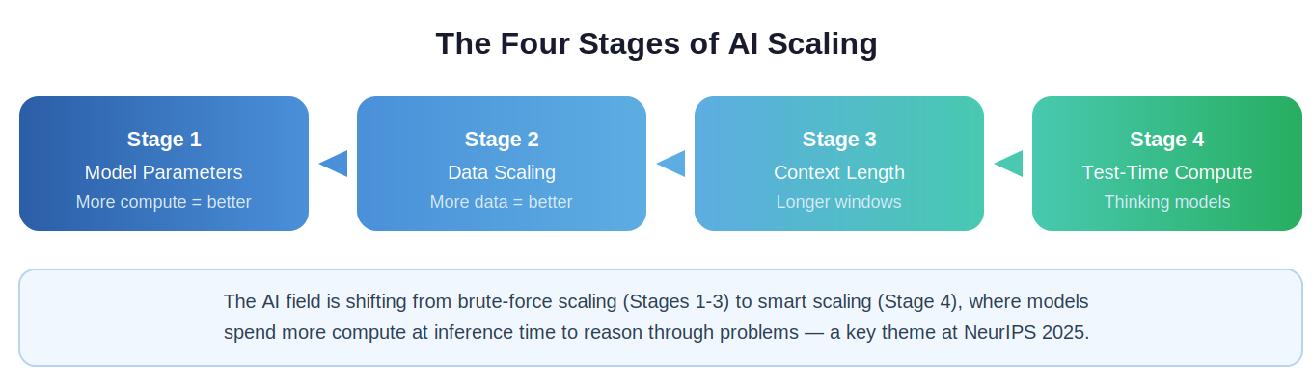
The “Scale Test-Time Compute on Modern Hardware” tutorial dove deep into this shift. The core insight: instead of making the model itself larger, you let the model “think longer” at inference time. Techniques like chain-of-thought prompting and sampling-based search allow smaller models with extended reasoning to outperform objectively larger ones. This has enormous practical implications — it means you don’t necessarily need a frontier model (with 100B+ parameters) for most problems; a well-tuned smaller model (under 20B parameters) with sufficient inference compute can often achieve comparable results at a fraction of the cost.
Key Takeaway: The demand for smaller, more efficient models is growing because demand for AI far exceeds current infrastructure capacity. Test-time scaling lets you improve both open-source and closed-source models without retraining.

2. The Rise of Agentic AI
If there was a single word that defined the conference, it was “agents.” Nearly every workshop track touched on agentic AI in some form. An AI agent is a system that doesn’t just generate text — it plans, reasons, uses tools, and takes actions in an environment to achieve goals.
Several key patterns emerged for building effective agents. First, the multi-agent architecture — rather than one monolithic model trying to do everything, the future involves specialized agents that collaborate: a planner, an executor, a verifier, and a router that coordinates them. This mirrors how distributed computing systems are designed and was a recurring theme across the “Agentic Development at the Frontier” and “Multi-Agent Systems in Industry” sessions.
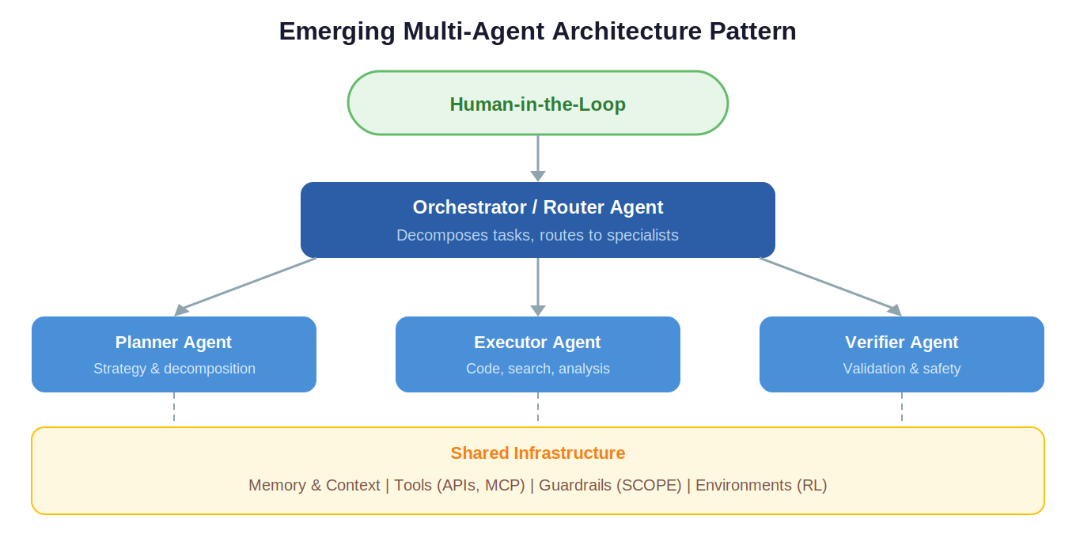
Second, memory is critical. Multiple talks highlighted that agents without persistent memory cannot solve long-running problems. The “Co-X Framework” talk specifically noted that agent memory loss is one of the biggest obstacles to reliability, and that the memory layer is arguably the most important component — using history to predict the future and personalize responses.
Third, environments are the new data. Just as language models need text to learn from, agents need environments to practice in. The “Scaling Environments for Agents” workshop showed how reinforcement learning environments — from web browsers to code sandboxes to MCP simulators — provide the feedback loops agents need to improve. One speaker drew a compelling analogy to robotics: watching agents improve over time in simulated environments is like watching robots learn to walk.
Key Takeaway: Agents are not reliable yet, and human interaction is still needed. But the trajectory is clear — agent capabilities are roughly doubling every 7 months. Invest in understanding agentic architectures now.

3. The Reasoning Reckoning: Can LLMs Actually Think?
One of the most thought-provoking threads at NeurIPS was a sustained, honest examination of whether large language models can truly reason — or whether we’re just seeing very sophisticated pattern matching. The “Beyond Benchmarks” talk framed it most sharply: intelligence is not the same as achievement. A capable system is not necessarily an intelligent one.
The speaker drew an important distinction: IQ should be thought of as the slope of progress (how fast a system can learn novel things), not its current capabilities. True reasoning involves solving novel problems, decomposing them into steps, generalizing to new contexts, and generating new hypotheses — capabilities that current systems largely lack.
Concrete evidence of these limitations was compelling. When researchers changed variable names in grade-school math problems (GSM8K benchmark) but kept the math identical, performance degraded significantly. Adding irrelevant information (like “5 bananas were smaller”) caused many models to incorporate the noise into their answers. On the Towers of Hanoi problem, models could solve the simple version but collapsed catastrophically on slightly more complex variants — burning through tokens before giving up and reverting to their first answer.
The invited talk “The Art of (Artificial) Reasoning” reinforced these findings: a best paper runner-up showed that reinforcement learning with verifiable rewards (RLVR) primarily improves sampling efficiency, not reasoning capacity. At large sample sizes, the base model often already contains the correct answer somewhere. This was described as one of the most strategically important results of the conference.
Key Takeaway: Don’t confuse benchmark performance with genuine intelligence. When evaluating AI tools, test with novel scenarios, not just standard benchmarks. Tool use improves achievement (like humans using calculators) but is not the same as intelligence.

4. Safety, Governance, and the Guardrails Imperative
As AI systems become more autonomous, the urgency around safety and governance was palpable. The SCOPE framework presentation (Safety, Compliance, Observability, Permissions, Escalation) offered a practical blueprint for deploying agents in regulated industries like banking and healthcare.
Key principles included: building a sandbox around agents so they can’t take unconstrained actions; using a “shield agent” that runs in parallel with your target agent to evaluate risk in real time; implementing role-based access control (RBAC) baked into the agent’s core; and maintaining the ability to hot-patch business rules without code changes.
The “Frontier AI for Secure Code” talk raised an urgent concern: if 80% of all code will soon be AI-generated, the security of that code matters enormously. A practical recommendation was to include security reminders directly in prompts when using AI for code generation. The “Modular Agents” talk also flagged that there is not yet a standard way to validate agents, and without proper loop-closure, agents can run unchecked and generate enormous compute bills.
Key Takeaway: Safety isn’t optional — it’s a prerequisite. For any agent deployment, implement guardrails from day one. Look into frameworks like SCOPE and tools like ContextForge, and always have a human-in-the-loop escalation path.

5. Societal Impact: Thinking Beyond Benchmarks
Zeynep Tufekci’s invited talk “Are We Having the Wrong Nightmares About AI?” was a standout. Her core argument: generative AI is not human intelligence — it’s something else entirely, just as a car is not a faster horse. She argued that we consistently fail to imagine the scale of consequences from new technology. The printing press didn’t just make books cheaper — it enabled indulgence pamphlets that sparked religious wars causing more deaths proportionally than both World Wars combined.
Her most striking point: technology’s revolutionary impact comes from making what’s already possible cheap, fast, and scalable — not from the futuristic capabilities researchers fixate on. “Artificial Good-Enough Intelligence” can unleash chaos long before AGI arrives. The engagement model of AI (personalized, always-on influence) could be more devastating than social media for propaganda and control.
Richard Sutton’s “Oak Architecture” talk struck a complementary chord: the AI field has lost its way by focusing too much on scale and not enough on learning agents that build world models, plan, and discover their own abstractions. His “bitter lesson” reminder — that most hand-engineered approaches get overtaken by general methods leveraging computation — was a call to return to first principles.
Key Takeaway: Never assume technology will be used as it’s currently used. When evaluating AI’s impact, think about second- and third-order effects, not just the immediate capability. The biggest disruptions will come from making existing tasks trivially cheap, not from AGI.

Practical Insights for Your AI Journey

Tools & Resources Worth Exploring
Several specific tools and papers were recommended across multiple sessions:
- PlanUtils — A package manager and Docker for planning technology. Captures all modern AI planning tooling in one place.
- L2P (Language to Plan) — Converts natural language descriptions into general plans that AI planners can execute.
- SWE-Bench — The leading benchmark for evaluating AI coding agents against real software engineering tasks. Referenced in multiple talks.
- DS-Star — A state-of-the-art data science agent with sub-agents for planning, routing, coding, and verification.
- Monarch (HuggingFace) — Updated reinforcement learning framework for training agents within environments that emulate the real world.
- ContextForge — A tool for building guardrails and context management for agentic systems.
- Rovo Dev (Atlassian) — AI agents integrated into Atlassian’s workflow tools.
- Memory Bank — Research paper on persistent agent memory architectures (recommended during Co-X talk).

Coding Agents: What’s Working Now
The “Deep Learning for Code in the Agentic Era” workshop provided especially actionable insights:
- Coding agents can deliver roughly 4x the number of pull requests. The key advice: don’t watch agents work — let them run asynchronously.
- Provide agents with proper tools: linters, GitHub integration, test runners. Good APIs lead to better results than web-based interfaces — clicks are slow, APIs and MCP connections are faster and more reliable.
- Current LLMs are strong at code generation but weaker at understanding, design, testing, and debugging. These other dimensions need more focus.
- Agentic coding is more costly in tokens but delivers better quality. Any evaluation can be turned into an RL opportunity for model improvement.
- AI-generated code security is a real concern. A simple mitigation: include security requirements in your prompts.

Expo Floor Wisdom
Conversations at the expo reinforced several practical principles. A Snowflake representative emphasized experimenting with multiple models since some perform better than others for specific tasks. For agentic planning, the advice was to think about how you would solve a problem yourself, then decompose it for the agent. Always make sure your agent knows what tools are available to it. Google’s booth featured research on benchmarking models through games (using Elo ratings compared against human masters and grandmasters), which provides clearer reward signals than open-ended benchmarks.

Quick Glossary
For readers new to AI/ML, here are key terms used throughout this recap:
Term | Definition
LLM | Large Language Model — an AI model trained on vast text to generate human-like text (e.g., GPT-4, Claude).
LRM | Large Reasoning Model — an LLM enhanced with chain-of-thought to “think” step by step (e.g., o1).
RL | Reinforcement Learning — training by rewarding good behavior and penalizing bad, like training a dog with treats.
Test-Time Compute | Extra computation spent when the model is answering (not training), allowing it to reason longer.
Agent | An AI system that plans, reasons, uses tools, and takes actions to achieve goals autonomously.
MCP | Model Context Protocol — an open standard for connecting AI agents to external tools and data sources.
SWE-Bench | A benchmark measuring how well AI agents solve real software engineering tasks.
PDDL | Planning Domain Definition Language — a formal language for specifying AI planning problems.
KV Cache | Key-Value Cache — memory used during text generation to avoid redundant computation.
Fine-tuning | Adapting a pre-trained model to a specific task using additional, targeted training data.
RLVR | RL with Verifiable Rewards — RL training where correctness can be objectively checked.
SFT | Supervised Fine-Tuning — training a model on curated input-output examples.

Session Links & Resources
All of the sessions attended are linked below for further exploration of slides, recordings, and materials:
Tutorials
Planning in the Era of Language Models
Scale Test-Time Compute on Modern Hardware
Invited Talks
The Oak Architecture: A Vision of SuperIntelligence from Experience
Are We Having the Wrong Nightmares About AI?
The Art of (Artificial) Reasoning
On the Science of “Alien Intelligences”
From Benchmarks to Problems
Expo Talks
Building Safe, Compliant, and Observable Agentic Systems (SCOPE)
Beyond Benchmarks: Rethinking Reasoning in Language Models
Agentic Development at the Frontier
The Co-X Framework
Workshops
Multi-Agent Systems in Industry
Deep Learning for Code in the Agentic Era
Modular Agents and Orchestrated Coordination
Reasoning in Motion: How Agents Learn to Think

Next Steps: Use this document as a living reference. The links above provide access to slides and recordings for deeper dives into specific topics. Consider exploring the tools listed above, and start experimenting with agentic workflows in a sandboxed environment.

