NeurIPS 2025: The Short Version
Seven things the AI research community wants you to know
San Diego • December 2–7, 2025 • 21,500+ papers submitted • 5,200 accepted

If You Read Nothing Else
NeurIPS is where the AI research community shows its hand. After five days, 20+ sessions, and countless hallway conversations, here is the honest picture: AI is extraordinarily capable at moderate-complexity tasks, but the field is now grappling with the fact that scaling alone won’t get us to genuine intelligence. The most important shift is from making models bigger to making them think smarter. And the most important gap is between what benchmarks say models can do and what they actually do when you throw something genuinely new at them.
Below are seven takeaways, each paired with concrete actions. This is meant to be a two-page coffee-break read, not an encyclopedia.
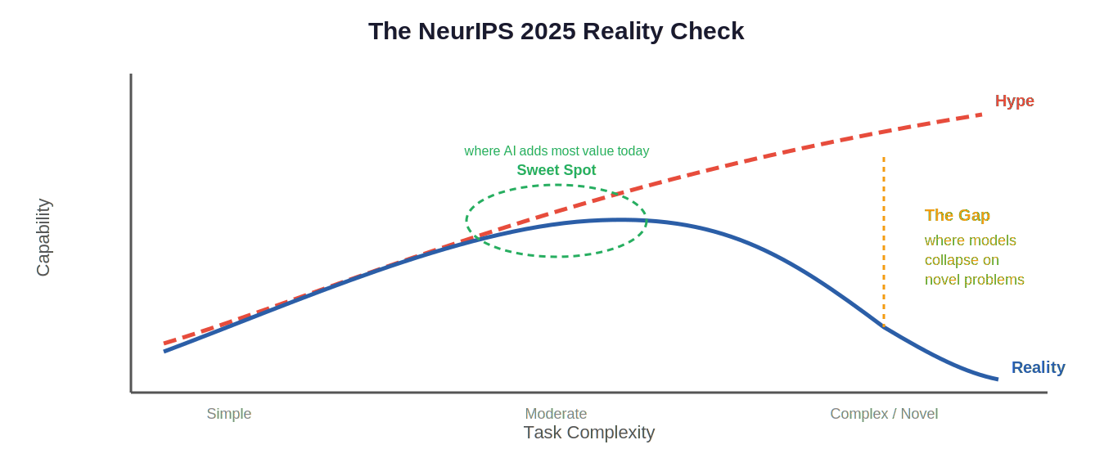

The Seven Takeaways
#1 Bigger models are yesterday’s game
The field has moved through four scaling eras: more parameters, more data, longer context windows, and now more inference-time compute. The consensus at NeurIPS was that brute-force scaling has hit diminishing returns. A well-tuned 7B-parameter model that “thinks longer” at inference can outperform a 100B+ model that answers immediately. This is a massive cost shift: you’re trading training expense for inference expense, and inference is much easier to control.

What to do about it:
→ Don’t default to the biggest model available. Test smaller models with chain-of-thought prompting first.
→ Track your inference costs separately from training costs — the economics of AI are changing fast.

#2 Benchmarks are lying to you (a little)
Multiple talks demonstrated that standard benchmarks overstate model capabilities. Change the variable names in a math problem and performance drops. Add an irrelevant sentence and models get confused. On the Towers of Hanoi, models solve the easy version then catastrophically fail on slightly harder variants. The phrase of the conference was “jagged intelligence” — models that ace one test and fail its trivial variation. Reinforcement learning with verifiable rewards (RLVR) was shown to improve sampling efficiency but not create genuinely new reasoning ability.

What to do about it:
→ When evaluating an AI tool, always test with your own novel scenarios, not vendor-provided demos.
→ Treat benchmark scores as a floor, not a ceiling. The real question is: how does it handle your edge cases?

#3 Agents are the future, but they’re not ready yet
The most consistent message across the conference: multi-agent architectures (a planner, executor, and verifier working together) will replace monolithic models for complex tasks. Coding agents already deliver roughly 4x the pull requests of solo developers. But agents are unreliable, lose memory over long tasks, sometimes run up enormous compute bills without closing the loop, and don’t yet have standardized validation methods. The capability is doubling roughly every 7 months — but today, human oversight is non-negotiable.

What to do about it:
→ Start experimenting with agentic workflows in sandboxed environments now, even if results are imperfect.
→ Give agents good APIs and tools (linters, test runners, MCP connections) — not web UIs. API-driven agents are faster and more accurate.
→ Never let an agent run without a cost cap and a human escalation path.

#4 Safety is an engineering discipline, not an afterthought
The SCOPE framework (Safety, Compliance, Observability, Permissions, Escalation) provided the clearest practical blueprint. Key ideas: run a “shield agent” in parallel with your main agent to evaluate risk in real time; implement role-based access control at the agent’s core, not bolted on later; design for hot-patchable business rules. With 80% of code expected to be AI-generated soon, security prompts should be standard practice for any code-generation workflow. Poisoned prompts that hijack agents are a real red-team concern.

What to do about it:
→ Add security requirements directly into your AI code-generation prompts.
→ For any production agent, implement guardrails before features. Look into SCOPE, ContextForge, and shield-agent patterns.

#5 The second-order effects will be bigger than the first
Zeynep Tufekci delivered the most memorable talk of the conference. Her argument: we obsess over whether AI will reach human-level intelligence, but “Artificial Good-Enough Intelligence” is already reshaping the world. The printing press didn’t just make books cheaper — it accidentally triggered wars that killed more people proportionally than WWI and WWII combined. Cars weren’t just faster horses — they caused obesity, climate change, and suburban sprawl. We are currently making the same mistake with AI: imagining it as a better chatbot instead of asking what happens when persuasion, content creation, and impersonation become nearly free.

What to do about it:
→ When evaluating AI risks, ask: “What happens when this capability is 1,000x cheaper and available to everyone?”
→ Think about AI’s engagement model (personalized, always-on) as potentially more destabilizing than social media.

#6 Memory is the missing ingredient
This came up in nearly every agent-focused session. Current AI systems have no persistent memory across conversations. The Co-X framework talk called memory the most important layer in any agent architecture. Without it, agents can’t solve problems that span multiple sessions, can’t learn from their mistakes, and can’t personalize to your needs. Richard Sutton’s Oak Architecture keynote argued that continual learning from experience — not pre-training on static data — is the real path to intelligence. The practical implication: look for tools that build in memory and context management as a core feature, not an add-on.

What to do about it:
→ Favor AI tools and frameworks that support persistent memory and context across sessions.
→ Explore the Memory Bank research paper and ContextForge for practical implementations.

#7 You don’t need to be a researcher to ride this wave
One of the most encouraging themes: the barrier to entry is lowering, not rising. Smaller models are getting better. Open-source frameworks like Monarch (HuggingFace), PlanUtils, and PyTorch make experimentation accessible. Coding agents already outperform manual development on structured tasks. The practical advice from multiple speakers was consistent: you don’t need a frontier model for most problems. A sub-20B parameter model with the right prompting and tool access can handle the vast majority of real-world tasks. The expensive part isn’t the model — it’s knowing how to frame the problem.

What to do about it:
→ Start with problem framing, not model selection. Ask: how would I solve this myself, step by step?
→ Experiment with open-source models before paying for frontier APIs.
→ Use the learning roadmap below as a starting point for deepening your AI skills.

Where to Go from Here
Based on the talks attended and the recurring advice across sessions, here is a phased approach to continuing your AI learning journey:
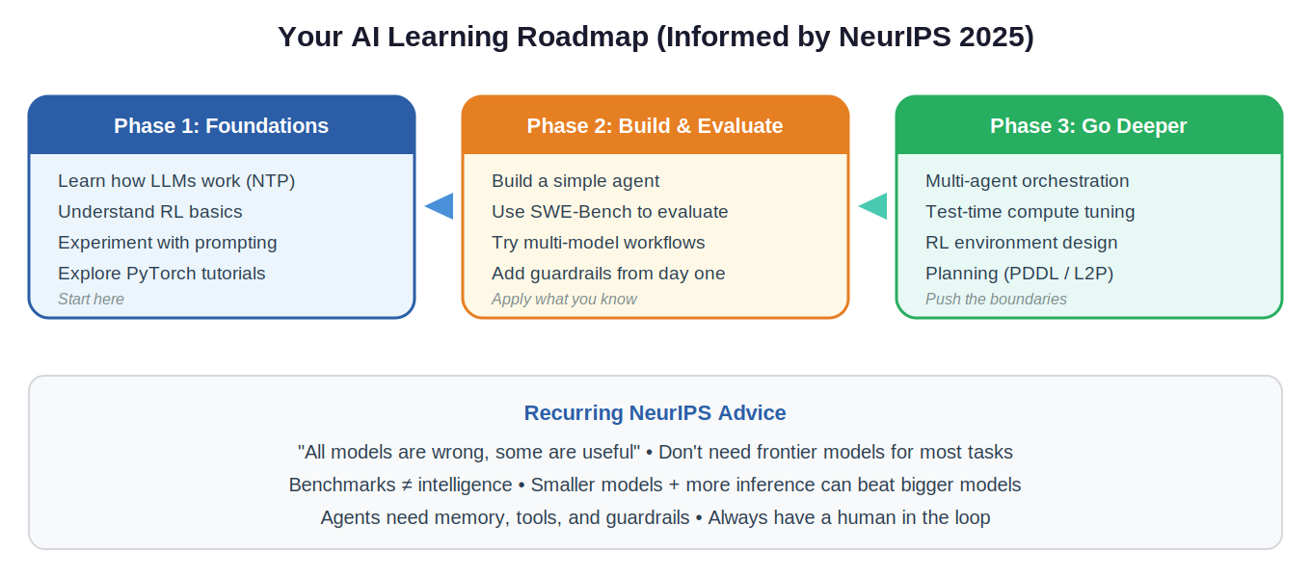
The most important thing the conference reinforced: this field moves fast, but the fundamentals remain stable. Understanding how models learn (next-token prediction, reinforcement learning), how to evaluate them honestly (novel test cases, not benchmarks), and how to deploy them safely (guardrails, memory, human oversight) will serve you regardless of which specific model or framework dominates next year.

The one sentence to remember:
The AI field is shifting from “make the model bigger” to “make the system smarter” — and the organizations that treat AI as infrastructure with engineering rigor will pull ahead of those still treating it as a magic feature.

Session Links for Deeper Dives
All sessions referenced above are available with slides and materials at neurips.cc/virtual/2025. Key sessions:
Planning in the Era of LMs (Tutorial)
Scale Test-Time Compute (Tutorial)
Beyond Benchmarks: Rethinking Reasoning
The Oak Architecture (Sutton)
Are We Having the Wrong Nightmares? (Tufekci)
The Art of (Artificial) Reasoning (Choi)
SCOPE: Safe Agentic Systems
The Co-X Framework
Deep Learning for Code Workshop
Multi-Agent Systems in Industry

