**Inventory and Asset**

**Management system**

Software Requirement Specification

By

**Mr. Nathawut Supavananusorn 542115020**

**Mr. Tanadol Parn-ong 542115021**

Department of Software Engineering

College of Arts, Media and Technology

Chiang Mai University

Project Advisor

________________________

**Dr. Prompong Sugunnasil**

**Document History**

|  |  |  |  |  |  |  |
| --- | --- | --- | --- | --- | --- | --- |
| **Document Name** | **Version** | **Status** | **Date** | **Viewable** | **Reviewer** | **Responsible** |
| **Documents** | | | | | | |
| Inventory and Asset Mangement-Requirement_v0.1.docx | Create  - Chapter One–Introduction  - Chapter Two–Overall Description | Draft | 18 June 2015 | NS, TP, PS | NS,TP | NS |
| Inventory and Asset Mangement-Requirement_v0.2.docx | Create  - Chapter Two–Requirement  - Chapter Three – Specific Requirement  - Chapter Four – Use case description | Draft | 18 June 2015 | NS, TP, PS | NS,TP | TP |
| Inventory and Asset Mangement-Requirement_v0.3.docx | Fix  - Fix Chapter Two–Requirement | Draft | 25 June 2015 | NS, TP, PS | NS,TP | TP |

**\*NS = Nathawut Supavananusorn**

**\*TP = Tanadol Parn-ong**

**\*PS = Dr. Prompong Sugunnasil**

Contents

**Chapter One | Introduction** 5

**1.1** **Purpose** 5

**1.2** **Software Scope** 5

**1.3** **Operation Environment** 5

**1.4 Definition, Acronyms add Abbreviation** 6

**Chapter Two | Overall Description & Requirement** 7

**2.1 Product Perspective** 7

**2.2 User Characteristics** 7

**2.3 Features** 8

**2.4 Functional & User Requirement** 11

**Chapter Three | Specific Requirement** 31

**3.1 Use case Diagram** 31

**Chapter Four | Use case description** 35

**4.1 User can login (UC1)** 35

**4.2 Administrator can register a technician/reporter account (UC2)** 39

**4.3 Administrator can view all technician accounts (UC3)** 45

**4.4 Administrator can view all reporter accounts (UC4)** 48

**4.5 Administrator can change an active status of technician/ reporter account (UC5)** 51

**4.6 Administrator can delete a technician/ reporter account (UC6)** 55

**4.7 Administrator can view all IT equipment (UC7)** 59

**4.8 Administrator can add IT equipment (UC8)** 62

**4.9 Administrator can edit IT equipment (UC9)** 68

**4.10 Administrator can view IT equipment that expire (UC10)** 77

**4.11 Administrator can view IT equipment that are often broken (UC11)** 80

**4.12 Administrator can view an IT equipment Information (UC12)** 83

**4.13 Administrator can define type of broken of IT equipment (UC13)** 86

**4.14 Administrator can view all repair tasks of a technician (UC14)** 89

**4.15 Administrator can request to distribute repair tasks again to the system (UC15)** 93

**4.16 Administrator can update his account information (UC16)** 96

**4.17 Administrator can get a notification via email. (UC17)** 103

**4.18 Technician can view all new repair task information (UC18)** 105

**4.19** **Technician can update repair task status (UC19)** 108

**4.20** **Technician can view IT equipment information (UC20)** 111

**4.21** **Technician can view Reporter information (UC21)** 114

**4.22** **Technician can view all IT equipment that live in repair process (UC22)** 117

**4.23** **Technician can update repair task information (UC23)** 120

**4.24 Technician can view history IT equipment that were repaired by himself (UC24)** 125

**4.25 Technician can update his account information (UC25)** 128

**4.26 Technician can get a notification via email. (UC26)** 135

**4.27 Reporter can inform a broken IT equipment. (UC27)** 137

**4.28 Reporter can view all IT equipment that he inform. (UC28)** 142

**4.29 Reporter can view IT equipment information. (UC29)** 145

**4.30 Reporter can update his account information (UC30)** 148

**4.31 Technician can get a notification via email. (UC31)** 155

**4.32 User can logout. (UC32)** 157

# **Chapter One | Introduction**

## **Purpose**

The purpose of this Software Requirement Specification (SRS) is used to describe the functional requirement. The functional requirements depend on the stakeholders e.g. CAMT’s IT staff and CAMT’s staff, and researching of current problems and current solutions. The requirements in this document explain how to use the system to solve problems. This document will encourage the users, developers, and who read this document to understand the detail of each requirement. In addition, the SRS document is used as a communication medium between the customer and the supplier and used in the software design phase which is leading to the consistency of the software product and functional requirement.

## **Software Scope**

The scope of application use is designated by the user’s requirements. Inventory and asset management system is accessible via the web browser to provide IT staff manage IT equipment, repair information and plan for purchasing. Moreover, this system can provide CAMT's staff or lecturer view the repair history and get new repair information via email. Features of the system will be divided into three types of users:

1. The Administrator handles user account management, IT equipment management (record IT equipment information), and summary report.
2. The Technician handles recording the repair information and checking the notification of new task via email. Also, the Technician will be assigned task equally by the tasks distribution system.
3. The Reporter handles informing the broken IT equipment via the web application and checking new repair information via email.

The users must login before operating the activities in the system. The users who use this system must have a user account for login. Also, Inventory and asset management can be managed via the Internet.

## **Operation Environment**

Inventory and asset management is developed in a form of the web application. This system provides IT staffs manage all of information via the Internet and access the system via a web browser. Also, CAMT’s staffs or lecturers can inform the broken IT equipment via the web application and get the notification of new repair information via email.

## **1.4 Definition, Acronyms add Abbreviation**

**1.4.1 Key Definition**

**Requirement** (1) A condition or capability needed by a user to solve a problem or achieve an objective. (2) A condition or capability that must be met or possessed by a system or system component to satisfy a contract, standard, specification, or other formally imposed document. (3) A documented representation of a condition or capability as in definition (1) or (2). [IEEE90]

**Feature** Transformation of input parameters to output parameters based on a specified algorithm. It describes the functionality of a product in the language of the product. Used for requirements analysis, design, coding, testing or maintenance. [IEEE90]

**Use Case** (1) Concept to describe a system based on usage of system resources by its environment. Characterized by an objective set of interactions within and at the borders of that system. (2) Notation from UML for describing a scenario (Usage approach, operational scenario) from the perspective of tis users. [IEEE90]

**1.4.2 Key Acronyms and Abbreviation**

**URS X**  User Requirement Specification number X

**SRS X**  Software Requirement Specification number X

**UC X** Use Case Description number X

*** X means the identification number of the item.

# **Chapter Two | Overall Description & Requirement**

## **2.1 Product Perspective**

Inventory and asset management system is the web application for the administrator, the technician and the reporter manage IT equipment in CAMT. The system helps the administrator manage IT equipment information efficiently by the management information system. Also, it helps the technician be assigned tasks equally by the tasks distribution system. The system is accessible via the web browser to provide the user can access in everywhere.

## **2.2 User Characteristics**

The system supports three types of users:

1. **The Administrator** handles user account management, IT equipment management (record IT equipment information), and summary report.
2. **The Technician** handles recording the repair information and checking the notification of new task via email. Also, the Technician will be assigned task equally by the tasks distribution system.
3. **The Reporter** handles informing the broken IT equipment via the web application and checking new repair information via email.

## **2.3 Features**

**Feature#1** Account management

**Description:** This feature provides the Administrator to create account and define Technician and Reporter active status in this system.

**User:** Administrator.

**Details:**

**1-1 Administrator:** Administrator can create technician/reporter accounts.

**1-2 Administrator:** Administrator can define active status of technician/reporter accounts.

**Feature#2** Login/Logout System

**Description:** This feature provides the user to sign-in by username and password for use this system.

**User:** Administrator, Technician, Reporter

**Details:**

**2-1 Administrator/Technician/Reporter:** User can log in to the system.

**2-2 Administrator/Technician/Reporter:** Usercan log outfrom the system.

**Feature#3** IT equipment management

**Description:** This feature provides the Administrator to manage IT equipment.

**User:** Administrator

**Details:**

**3-1 Administrator:** Administrator can add IT equipment to the system.

**3-2 Administrator:** Administrator can update IT equipment information in the system.

**3-3 Administrator:** Administrator can delete IT equipment in the system.

**Feature#4** Management Information system

**Description:** This function provides the Administrator to get repairing summary per month or per year, to report repairing summary of each person per month or per year, and to report almost expire of IT equipment to the administrator.

**User:** Administrator

**Details:**

**4-1 Administrator:** Administrator can view report almost expire of IT equipment in the system.

**4-2 Administrator:** Administrator can view IT equipment that are often broken

**Feature#5** Repair informing system

**Description:** This feature provides the Reporter to inform about broken IT equipment for the Technician.

**User:** Reporter

**Details:**

**5-1 Reporter:** Reporter can inform broken IT equipment to the system.

**5-2 Reporter:** Reporter views history of his repairing informs in the system.

**Feature#6** Repair management system

**Description:** This feature provides the Administrator to define repairing’s jobs type, which get from informing of reporter. Moreover, this feature provides the Technician to update or view his jobs.

**User:** Technician, Administrator

**Details:**

**6-1 Technician:** Technician can view his repairing job detail in the system.

**6-2 Technician:** Technician can update his repairing job detail in the system.

**6-3 Technician:** Technician can view history his repairing jobs in the system.

**6-4 Administrator:** Administrator can define repairing’s job type in the system.

**6-5 Technician:** Technician can get tasks automatically by calculating from time to repair in each technician.

**6-4 Administrator:** Administrator can request to distribute repair tasks again to the system.

**Feature#7** Tracking system

**Description:** This feature provides the Technician/ the Reporter to receive repairing detail via them email.

**User:** Technician, Reporter

**Details:**

**7-1 Technician:** Technician can receive an email about repairing inform detail.

**7-2 Reporter:** Reporter can receive an email about updating status of repairing when technician update their status.

## **2.4 Functional & User Requirement**

**URS1 User can login.**

SRS1-1 The system validates username and password.

SRS1-2 The system redirect to Administrator main page or Technician main page or Reporter main page

SRS1-3 The system displays “Please fill username and password” on the web application.

SRS1-4 The system displays “Please you fill username 4-16 characters” on the web application.

SRS1-5 The system displays “Please you fill password 4-16 characters” on the web application.

SRS1-6 The system displays “username or password incorrect” on the web application.

SRS1-7 The system displays “your username still not approve from administrator” on the web application.

**URS2 Administrator can register a technician/reporter account.**

SRS1-4 The system displays “Please you fill username 4-16 characters” on the web application.

SRS1-5 The system displays “Please you fill password 4-16 characters” on the web application.

SRS2-1 The system displays yes/no dialog massage “Do you sure for registration ?”.

SRS2-2 The system validates username, password, name, department, room, address, telephone number, email, and user type information.

SRS2-3 The system records username, password, name, department, room, address, telephone number, email, and user type information to the system.

SRS2-4 The system displays “Registration successful” on the web application.

SRS2-5 The system redirects to Reparation Management page.

SRS2-6 The system redirects to Users Management page.

SRS2-7 The system redirects to Items Management page.

SRS2-8 The system redirects to Items MIS page.

SRS2-9 The system redirects to Admin Information page.

SRS2-10 The system redirects to Login page.

SRS2-11 The system displays “Please you fill username” on the web application.

SRS2-12 The system displays “Please you fill password” on the web application.

SRS2-13 The system displays “Please you fill name” on the web application.

SRS2-14 The system displays “Please you fill department” on the web application.

SRS2-15 The system displays “Please you fill room” on the web application.

SRS2-16 The system displays “Please you fill address” on the web application.

SRS2-17 The system displays “Please you fill telephone number” on the web application.

SRS2-18 The system displays “Please you fill email” on the web application.

SRS2-19 The system displays “Your username are duplicate with other username” on the web application.

SRS2-20 The system clears the user session.

**URS3 Administrator can view all technician accounts.**

SRS2-5 The system redirects to Reparation Management page.

SRS2-6 The system redirects to Users Management page.

SRS2-7 The system redirects to Items Management page.

SRS2-8 The system redirects to Items MIS page.

SRS2-9 The system redirects to Admin Information page.

SRS2-10 The system redirects to Login page.

SRS2-20 The system clears the user session.

SRS3-1 The system redirects to Technician Management page.

SRS3-2 The system displays all technician account information in Technician Management page.

**URS4 Administrator can view all reporter accounts.**

SRS2-5 The system redirects to Reparation Management page.

SRS2-6 The system redirects to Users Management page.

SRS2-7 The system redirects to Items Management page.

SRS2-8 The system redirects to Items MIS page.

SRS2-9 The system redirects to Admin Information page.

SRS2-10 The system redirects to Login page.

SRS2-20 The system clears the user session.

SRS4-1 The system redirects to Reporter Management page.

SRS4-2 The system displays all reporter account information in Reporter Management page.

**URS5 Administrator can change an active status of technician/ reporter account.**

SRS2-5 The system redirects to Reparation Management page.

SRS2-6 The system redirects to Users Management page.

SRS2-7 The system redirects to Items Management page.

SRS2-8 The system redirects to Items MIS page.

SRS2-9 The system redirects to Admin Information page.

SRS2-10 The system redirects to Login page.

SRS2-20 The system clears the user session.

SRS3-2 The system displays all technician account information in Technician Management page.

SRS4-2 The system displays all reporter account information in Reporter Management page.

SRS5-1 The system displays yes/no dialog massage “Do you sure to change active status?”.

SRS5-2 The system changes active status of a technician in the system.

SRS5-3 The system displays “Active” to “Inactive” status or “Inactive” to “Active” status of a technician in Technician management.

SRS5-4 The system changes active status of a reporter in the system.

SRS5-5 The system displays “Active” to “Inactive” status or “Inactive” to “Active” status of a reporter in Reporter management.

**URS6 Administrator can delete a technician/ reporter account.**

SRS2-5 The system redirects to Reparation Management page.

SRS2-6 The system redirects to Users Management page.

SRS2-7 The system redirects to Items Management page.

SRS2-8 The system redirects to Items MIS page.

SRS2-9 The system redirects to Admin Information page.

SRS2-10 The system redirects to Login page.

SRS2-20 The system clears the user session.

SRS3-2 The system displays all technician account information in Technician Management page.

SRS4-2 The system displays all reporter account information in Reporter Management page.

SRS6-1 The system displays yes/no dialog massage “Do you sure to delete this account?”

SRS6-2 The system deletes a technician account in the system.

SRS6-3 The system deletes a reporter account in the system.

SRS6-4 The system displays “Delete user successful” on the web application.

SRS6-5 The system displays “Can't delete user” on the web application.

**URS7 Administrator can view all IT equipment.**

SRS2-5 The system redirects to Reparation Management page.

SRS2-6 The system redirects to Users Management page.

SRS2-7 The system redirects to Items Management page.

SRS2-8 The system redirects to Items MIS page.

SRS2-9 The system redirects to Admin Information page.

SRS2-10 The system redirects to Login page.

SRS2-20 The system clears the user session.

SRS7-1 The system displays all IT equipment information in Items Management page**.**

SRS7-2 The system redirects to Add Item page.

SRS7-3 The system redirects to Item Information page.

**URS8 Administrator can add an IT equipment.**

SRS2-5 The system redirects to Reparation Management page.

SRS2-6 The system redirects to Users Management page.

SRS2-7 The system redirects to Items Management page.

SRS2-8 The system redirects to Items MIS page.

SRS2-9 The system redirects to Admin Information page.

SRS2-10 The system redirects to Login page.

SRS2-20 The system clears the user session.

SRS7-2 The system redirects to Add Item page.

SRS8-1 The system redirects to Owner page.

SRS8-2 The system displays all technician and reporter information.

SRS8-3 The system displays yes/no dialog massage “Do you sure to add an item?”.

SRS8-4 The system validates item brand, item name, item description, CAMT number, CMU number, serial number, time end, item status, owner, and picture information.

SRS8-5 The system records item information in the system.

SRS8-6 The system records a component information to the system.

SRS8-7 The system displays “Add items is success” on the web application.

SRS8-8 The system displays “Add Component” form.

SRS8-9 The system displays “Please you fill Item brand, Item name, Item description, Item status, and Item picture information” on the web application.

SRS8-10 The system displays “Please you fill CAMT number, CMU number, or Serial number” on the web application.

**URS9 Administrator can edit an IT equipment.**

SRS2-5 The system redirects to Reparation Management page.

SRS2-6 The system redirects to Users Management page.

SRS2-7 The system redirects to Items Management page.

SRS2-8 The system redirects to Items MIS page.

SRS2-9 The system redirects to Admin Information page.

SRS2-10 The system redirects to Login page.

SRS2-20 The system clears the user session.

SRS8-2 The system displays all technician and reporter information.

SRS8-4 The system validates item brand, item name, item description, CAMT number, CMU number, serial number, time end, item status, owner, and picture information.

SRS8-10 The system displays “Please you fill CAMT number, CMU number, or Serial number” on the web application.

SRS9-1 The system displays item information and item component information.

SRS9-2 The system redirects to Edit Item page.

SRS9-3 The system display item information in editing form.

SRS9-4 The system redirects to Edit Owner page.

SRS9-5 The system displays item information in editing form.

SRS9-6 The system displays yes/no dialog massage “Do you sure to edit this item?”.

SRS9-7 The system updates item information in the system.

SRS9-8 The system displays “Edit this item is success” on the web application.

SRS9-9 The system redirects to Add Component page.

SRS9-10 The system displays Add Component form.

SRS9-11 The system displays yes/no dialog massage “Do you sure to add Item Component?”

SRS9-12 The system records a component information to the system.

SRS9-13 The system displays “Add component success” on the web application.

SRS9-14 The system displays yes/no dialog massage “Do you sure to remove this item component?”.

SRS9-15 The system displays “Please you fill Item brand” on the web application.

SRS9-16 The system displays “Please you fill Item name” on the web application.

SRS9-17 The system displays “Please you fill Item description” on the web application.

SRS9-18 The system displays “Please you fill Item status” on the web application.

SRS9-19 The system displays “Please you select Item picture” on the web application.

**URS10 Administrator can view IT equipment that expire.**

SRS2-5 The system redirects to Reparation Management page.

SRS2-6 The system redirects to Users Management page.

SRS2-7 The system redirects to Items Management page.

SRS2-8 The system redirects to Items MIS page.

SRS2-9 The system redirects to Admin Information page.

SRS2-10 The system redirects to Login page.

SRS2-20 The system clears the user session.

SRS10-1 The system redirects to Items MIS page.

SRS10-2 The system displays all IT equipment that will expire in Items MIS page.

**USR11 Administrator can view IT equipment that often are broken.**

SRS2-5 The system redirects to Reparation Management page.

SRS2-6 The system redirects to Users Management page.

SRS2-7 The system redirects to Items Management page.

SRS2-8 The system redirects to Items MIS page.

SRS2-9 The system redirects to Admin Information page.

SRS2-10 The system redirects to Login page.

SRS2-20 The system clears the user session.

SRS10-1 The system redirects to Items MIS page.

SRS11-1 The system displays all IT equipment that are often broken from information type in Items MIS page.

**USR12 Administrator can view an IT equipment Information.**

SRS2-5 The system redirects to Reparation Management page.

SRS2-6 The system redirects to Users Management page.

SRS2-7 The system redirects to Items Management page.

SRS2-8 The system redirects to Items MIS page.

SRS2-9 The system redirects to Admin Information page.

SRS2-10 The system redirects to Login page.

SRS2-20 The system clears the user session.

SRS7-3 The system redirects to Item Information page.

SRS12-1 The system displays IT equipment information in Items Information page.

**URS13 Administrator can define type of broken of IT equipment.**

SRS2-5 The system redirects to Reparation Management page.

SRS2-6 The system redirects to Users Management page.

SRS2-7 The system redirects to Items Management page.

SRS2-8 The system redirects to Items MIS page.

SRS2-9 The system redirects to Admin Information page.

SRS2-10 The system redirects to Login page.

SRS2-20 The system clears the user session.

SRS13-1 The system redirects to New Reparation page.

SRS13-2 The system displays all new reparation that are informed by Reporter.

SRS13-3 The system displays yes/no dialog massage “Do you sure to define type of broken?”.

SRS13-4 The system distributes a task automatically by calculating the average of time to repair in each job of the technician

SRS13-5 The system updates report information in the system.

SRS13-6 The system displays “Define type of broken already” on the web application.

**URS14 Administrator can view all repair tasks of a technician.**

SRS2-5 The system redirects to Reparation Management page.

SRS2-6 The system redirects to Users Management page.

SRS2-7 The system redirects to Items Management page.

SRS2-8 The system redirects to Items MIS page.

SRS2-9 The system redirects to Admin Information page.

SRS2-10 The system redirects to Login page.

SRS2-20 The system clears the user session.

SRS14-1 The system redirects to All Reparation page.

SRS14-2 The system displays all technician information.

SRS14-3 The system redirects to Technician’s Reparation page.

SRS14-4 The system displays all repair task information of that Technician in Technician’s Reparation page.

**URS15 Administrator can request to distribute repair tasks again to the system.**

SRS2-5 The system redirects to Reparation Management page.

SRS2-6 The system redirects to Users Management page.

SRS2-7 The system redirects to Items Management page.

SRS2-8 The system redirects to Items MIS page.

SRS2-9 The system redirects to Admin Information page.

SRS2-10 The system redirects to Login page.

SRS2-20 The system clears the user session.

SRS13-4 The system distributes a task automatically by calculating the average of time to repair in each job of the technician

SRS13-5 The system updates report information in the system.

SRS15-1 The system displays yes/no dialog massage “Do you sure to distribute repair tasks again ?

SRS15-2 The system displays “Repair task is distributed to a technician” on the web application.

**URS16 Administrator can update his account information.**

SRS2-5 The system redirects to Reparation Management page.

SRS2-6 The system redirects to Users Management page.

SRS2-7 The system redirects to Items Management page.

SRS2-8 The system redirects to Items MIS page.

SRS2-9 The system redirects to Admin Information page.

SRS2-10 The system redirects to Login page.

SRS2-20 The system clears the user session.

SRS2-13 The system displays “Please you fill name” on the web application.

SRS2-14 The system displays “Please you fill department” on the web application.

SRS2-15 The system displays “Please you fill room” on the web application.

SRS2-16 The system displays “Please you fill address” on the web application.

SRS2-17 The system displays “Please you fill telephone number” on the web application.

SRS2-18 The system displays “Please you fill email” on the web application.

SRS16-1 The system provides Admin Information form. Which consists username, name, room, address, phone, email, old password, new password, and confirm password textbox.

SRS16-2 The system provides username text field that cannot edit text.

SRS16-3 The system displays yes/no dialog massage “Do you sure for edit information ?”

SRS16-4 The system validates name, department, room, address, telephone number, and email.

SRS16-5 The system updates user account information in the system

SRS16-6 The system displays “Update Administrator information successful” on the web application.

SRS16-7 The system displays yes/no dialog massage “Do you sure for edit password?”.

SRS16-8 The system validates new password, old password, and confirm password.

SRS16-9 The system displays “Update your password successful” on the web application

SRS16-10 The system displays “Please you fill old password” on the web application.

SRS16-11 The system displays “Please you fill new password” on the web application.

SRS16-12 The system displays “Please you fill confirm password” on the web application.

SRS16-13 The system displays “Please you fill new password 4-16 characters” on the web application.

SRS16-14 The system displays “Please you fill confirm password 4-16 characters” on the web application.

SRS16-15 The system displays “New Password and confirm password are not match” on the web application.

SRS16-16 The system displays “Old password incorrect” on the web application.

**URS17 Administrator can get a notification via email.**

SRS17-1 The system send an email about IT equipment information to mail box of Administrator.

**URS18 Technician can view all new repair task information.**

SRS2-10 The system redirects to Login page.

SRS2-20 The system clears the user session.

SRS18-1 The system displays all new repair task information in Technician Main page.

SRS18-2 The system redirects to Technician Main page.

SRS18-3 The system redirects to Repairing page.

SRS18-4 The system redirects to History page.

SRS18-5 The system redirects to Technician Information page.

**URS19 Technician can update repair task status.**

SRS2-10 The system redirects to Login page.

SRS2-20 The system clears the user session.

SRS18-1 The system displays all new repair task information in Technician Main page.

SRS18-2 The system redirects to Technician Main page.

SRS18-3 The system redirects to Repairing page.

SRS18-4 The system redirects to History page.

SRS18-5 The system redirects to Technician Information page.

SRS19-1 The system changes a repair task status from “Wait to process” to “In processing” in the system.

SRS19-2 The system displays a repair task that was updated in Repairing page.

**URS20 Technician can view IT equipment information.**

SRS2-10 The system redirects to Login page.

SRS2-20 The system clears the user session.

SRS18-2 The system redirects to Technician Main page.

SRS18-3 The system redirects to Repairing page.

SRS18-4 The system redirects to History page.

SRS18-5 The system redirects to Technician Information page.

SRS20-1 The system redirects to IT equipment information page.

SRS20-2 The system displays IT equipment information in IT equipment information page.

**URS21 Technician can view Reporter information.**

SRS2-10 The system redirects to Login page.

SRS2-20 The system clears the user session.

SRS18-2 The system redirects to Technician Main page.

SRS18-3 The system redirects to Repairing page.

SRS18-4 The system redirects to History page.

SRS18-5 The system redirects to Technician Information page.

SRS21-1 The system redirects to Reporter information page.

SRS 21-2 The system displays reporter information in Reporter information page.

**URS22 Technician can view all IT equipment that live in repair process.**

SRS2-10 The system redirects to Login page.

SRS2-20 The system clears the user session.

SRS18-2 The system redirects to Technician Main page.

SRS18-3 The system redirects to Repairing page.

SRS18-4 The system redirects to History page.

SRS18-5 The system redirects to Technician Information page.

SRS22-1 The system displays all IT equipment that live in repair process in Repairing page.

**URS23 Technician can update repair task information.**

SRS2-10 The system redirects to Login page.

SRS2-20 The system clears the user session.

SRS18-2 The system redirects to Technician Main page.

SRS18-3 The system redirects to Repairing page.

SRS18-4 The system redirects to History page.

SRS18-5 The system redirects to Technician Information page.

SRS22-1 The system displays all IT equipment that live in repair process in Repairing page.

SRS23-1 The system redirects to Repairing Information page.

SRS23-2 The system displays IT equipment information in Repairing Information page.

SRS23-3 The system provides a repairing process form, which consists broken type, broken description, reporter contact, and repairing description text field in Repairing information page.

SRS23-4 The system provides the Update Repairing and Release Repairing button in Repairing information page.

SRS23-5 The system displays yes/no dialog massage “Do you sure for updating reparing status?”.

SRS23-6 The system validates repairing description.

SRS23-7 The system updates repair task information in the system.

SRS23-8 The system displays “Repairing information is updated” on the web application.

**URS24 Technician can view history IT equipment that were repaired by himself.**

SRS2-10 The system redirects to Login page.

SRS2-20 The system clears the user session.

SRS18-2 The system redirects to Technician Main page.

SRS18-3 The system redirects to Repairing page.

SRS18-4 The system redirects to History page.

SRS18-5 The system redirects to Technician Information page.

SRS24-1 The system displays all IT equipment information that were repaired by that technician in History page.

**URS25 Technician can update his account information.**

SRS2-10 The system redirects to Login page.

SRS2-20 The system clears the user session.

SRS2-13 The system displays “Please you fill name” on the web application.

SRS2-14 The system displays “Please you fill department” on the web application.

SRS2-15 The system displays “Please you fill room” on the web application.

SRS2-16 The system displays “Please you fill address” on the web application.

SRS2-17 The system displays “Please you fill telephone number” on the web application.

SRS2-18 The system displays “Please you fill email” on the web application.

SRS16-2 The system provides username text field that cannot edit text.

SRS16-3 The system displays yes/no dialog massage “Do you sure for edit information ?”

SRS16-4 The system validates name, department, room, address, telephone number, and email.

SRS16-5 The system updates user account information in the system.

SRS16-8 The system validates new password, old password, and confirm password.

SRS16-9 The system displays “Update your password successful” on the web application

SRS16-10 The system displays “Please you fill old password” on the web application.

SRS16-11 The system displays “Please you fill new password” on the web application.

SRS16-12 The system displays “Please you fill confirm password” on the web application.

SRS16-13 The system displays “Please you fill new password 4-16 characters” on the web application.

SRS16-14 The system displays “Please you fill confirm password 4-16 characters” on the web application.

SRS16-15 The system displays “New Password and confirm password are not match” on the web application.

SRS16-16 The system displays “Old password incorrect” on the web application.

SRS18-2 The system redirects to Technician Main page.

SRS18-3 The system redirects to Repairing page.

SRS18-4 The system redirects to History page.

SRS18-5 The system redirects to Technician Information page.

SRS25-1 The system provides Technician Information form. Which consists username, name, room, address, phone, email, old password, new password, and confirm password textbox.

SRS25-2 The system displays “Update Technician information successful” on the web application

**URS26 Technician can get a notification via email.**

SRS26-1 The system send an email about broken IT equipment information to mail box of Technician.

**URS27 Reporter can inform a broken IT equipment.**

SRS2-10 The system redirects to Login page.

SRS2-20 The system clears the user session.

SRS27-1 The system provides reparation inform form. Which consists serial number text field, description text field, and contact information text field in Reporter Main page.

SRS27-2 The system provides notification modes, which consists allow mode and disallow mode.

SRS27-3 The system validate serial number, description, contact information, and notification mode

SRS27-4 The system records repair task to the system.

SRS27-5 The system displays “Your report are send” on the web application

SRS27-6 The system redirects to Reporter Main page.

SRS27-7 The system redirects to Report History page.

SRS27-8 The system redirects to Reporter Information page.

SRS27-9 The system displays “Please you fill Serial number” on the web application.

SRS27-10 The system displays “Please you fill description” on the web application.

SRS27-11 The system displays “Please you fill contact” on the web application.

SRS27-12 The system displays “Please you select Notification mode” on the web application.

SRS27-13 The system displays “Can't send report, please contact to Administrator” on the web application.

**URS28 Reporter can view all IT equipment that he inform.**

SRS2-10 The system redirects to Login page.

SRS2-20 The system clears the user session.

SRS27-6 The system redirects to Reporter Main page.

SRS27-7 The system redirects to Report History page.

SRS27-8 The system redirects to Reporter Information page.

SRS28-1 The system displays all IT equipment that were informed by that reporter in Report History page.

**URS29 Reporter can view IT equipment Information.**

SRS2-10 The system redirects to Login page.

SRS2-20 The system clears the user session.

SRS20-1 The system redirects to IT equipment information page.

SRS20-2 The system displays IT equipment information in IT equipment information page.

SRS27-6 The system redirects to Reporter Main page.

SRS27-7 The system redirects to Report History page.

SRS27-8 The system redirects to Reporter Information page.

SRS28-1 The system displays all IT equipment that were informed by that reporter in Report History page.

**URS30 Reporter can update his account information.**

SRS2-10 The system redirects to Login page.

SRS2-20 The system clears the user session.

SRS2-13 The system displays “Please you fill name” on the web application.

SRS2-14 The system displays “Please you fill department” on the web application.

SRS2-15 The system displays “Please you fill room” on the web application.

SRS2-16 The system displays “Please you fill address” on the web application.

SRS2-17 The system displays “Please you fill telephone number” on the web application.

SRS2-18 The system displays “Please you fill email” on the web application.

SRS16-2 The system provides username text field that cannot edit text.

SRS16-3 The system displays yes/no dialog massage “Do you sure for edit information ?”

SRS16-4 The system validates name, department, room, address, telephone number, and email.

SRS16-5 The system updates user account information in the system.

SRS16-8 The system validates new password, old password, and confirm password.

SRS16-9 The system displays “Update your password successful” on the web application

SRS16-10 The system displays “Please you fill old password” on the web application.

SRS16-11 The system displays “Please you fill new password” on the web application.

SRS16-12 The system displays “Please you fill confirm password” on the web application.

SRS16-13 The system displays “Please you fill new password 4-16 characters” on the web application.

SRS16-14 The system displays “Please you fill confirm password 4-16 characters” on the web application.

SRS16-15 The system displays “New Password and confirm password are not match” on the web application.

SRS16-16 The system displays “Old password incorrect” on the web application.

SRS27-6 The system redirects to Reporter Main page.

SRS27-7 The system redirects to Report History page.

SRS27-8 The system redirects to Reporter Information page.

SRS30-1 The system provides Reporter Information form. Which consists username, name, room, address, phone, email, old password, new password, and confirm password textbox.

SRS30-2 The system displays “Update Reporter information successful” on the web application.

**URS31 Reporter can get a notification via email.**

SRS31-1 The system send an email about repair task information to mail box of Reporter.

**URS32 User can logout.**

SRS2-10 The system redirects to Login page.

SRS2-20 The system clears the user session.

# **Chapter Three | Specific Requirement**

## **3.1 Use case Diagram**

**3.1.1 Inventory and Asset Management system use case diagram**

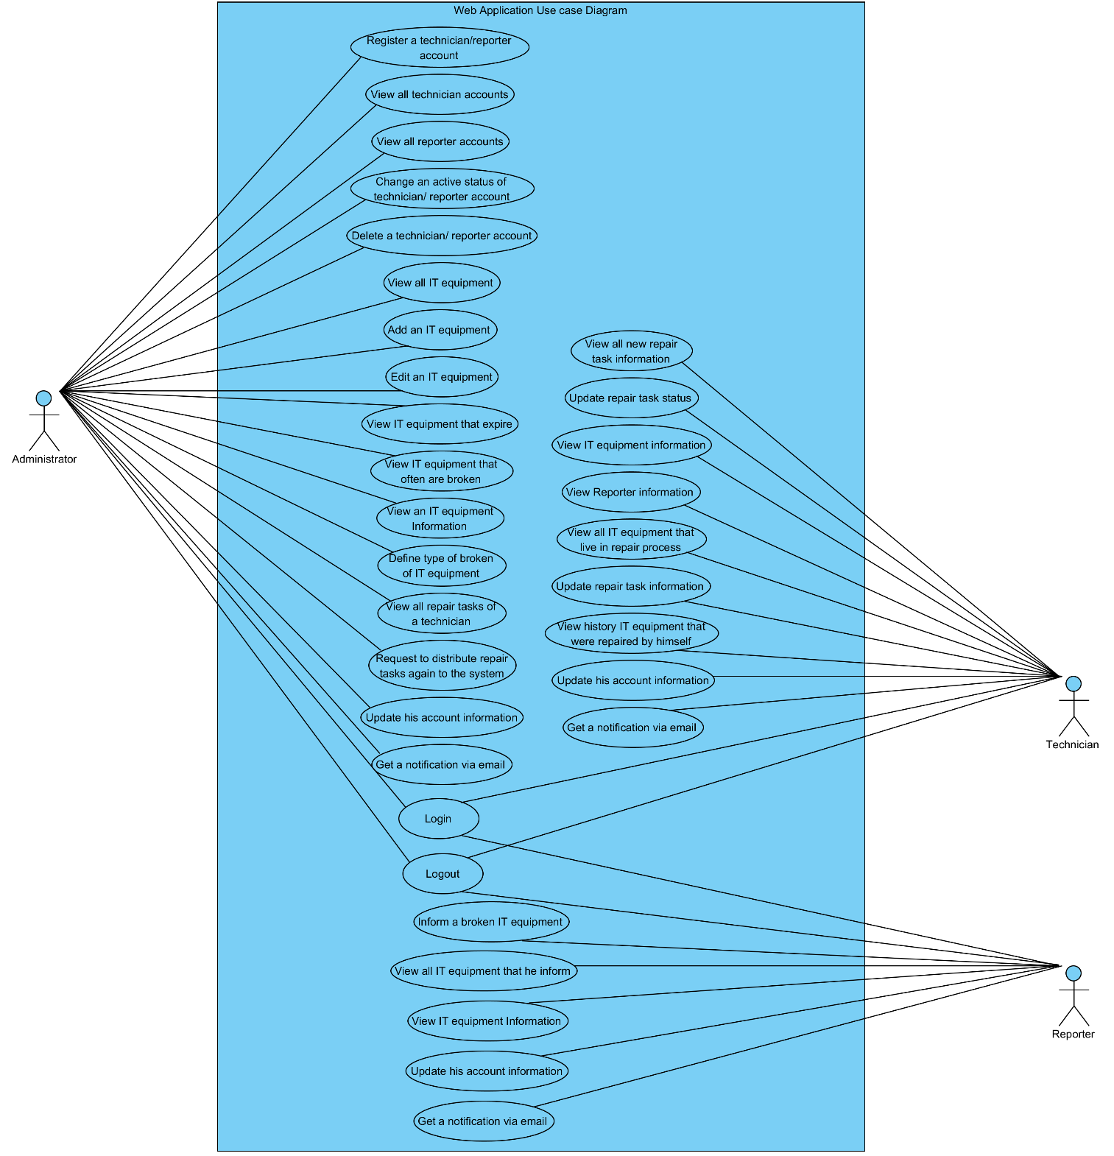

**3.1.2 Use case diagram in part of Administrator**

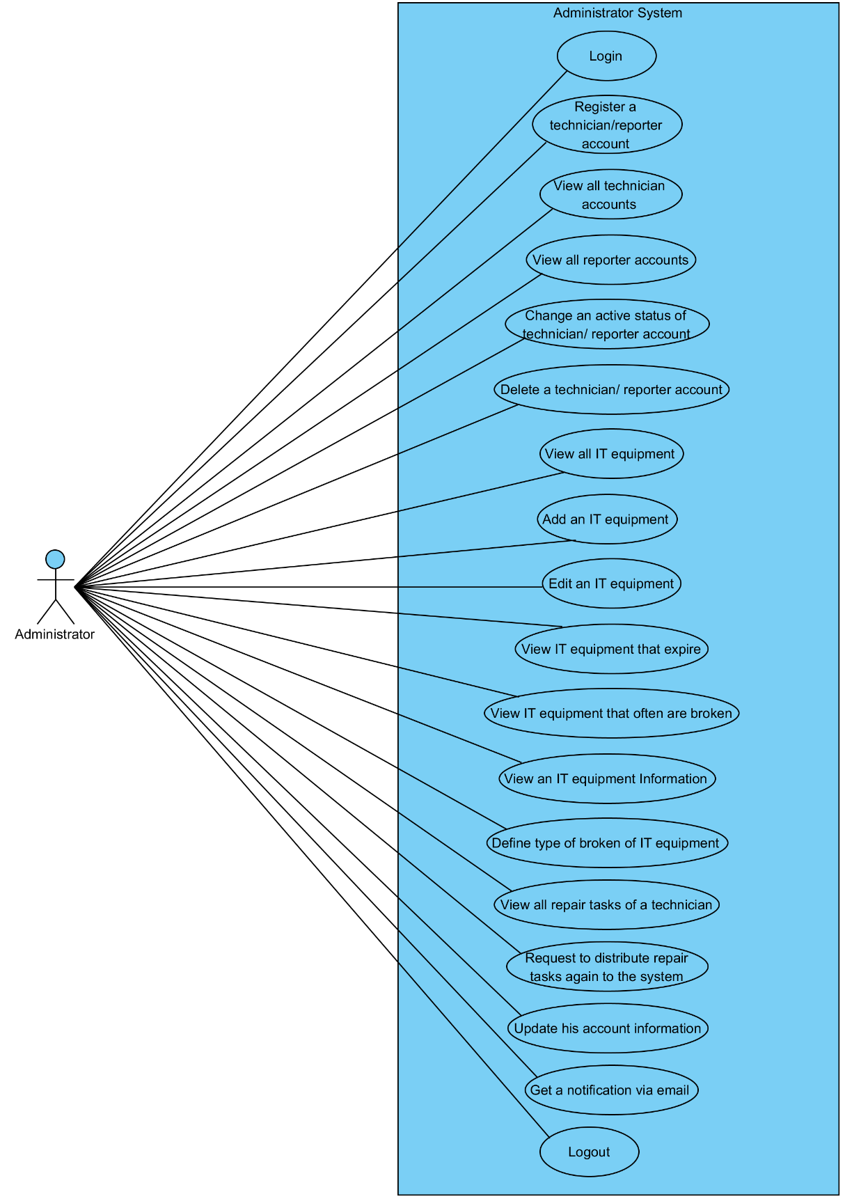

**3.1.3 Use case diagram in part of Technician**

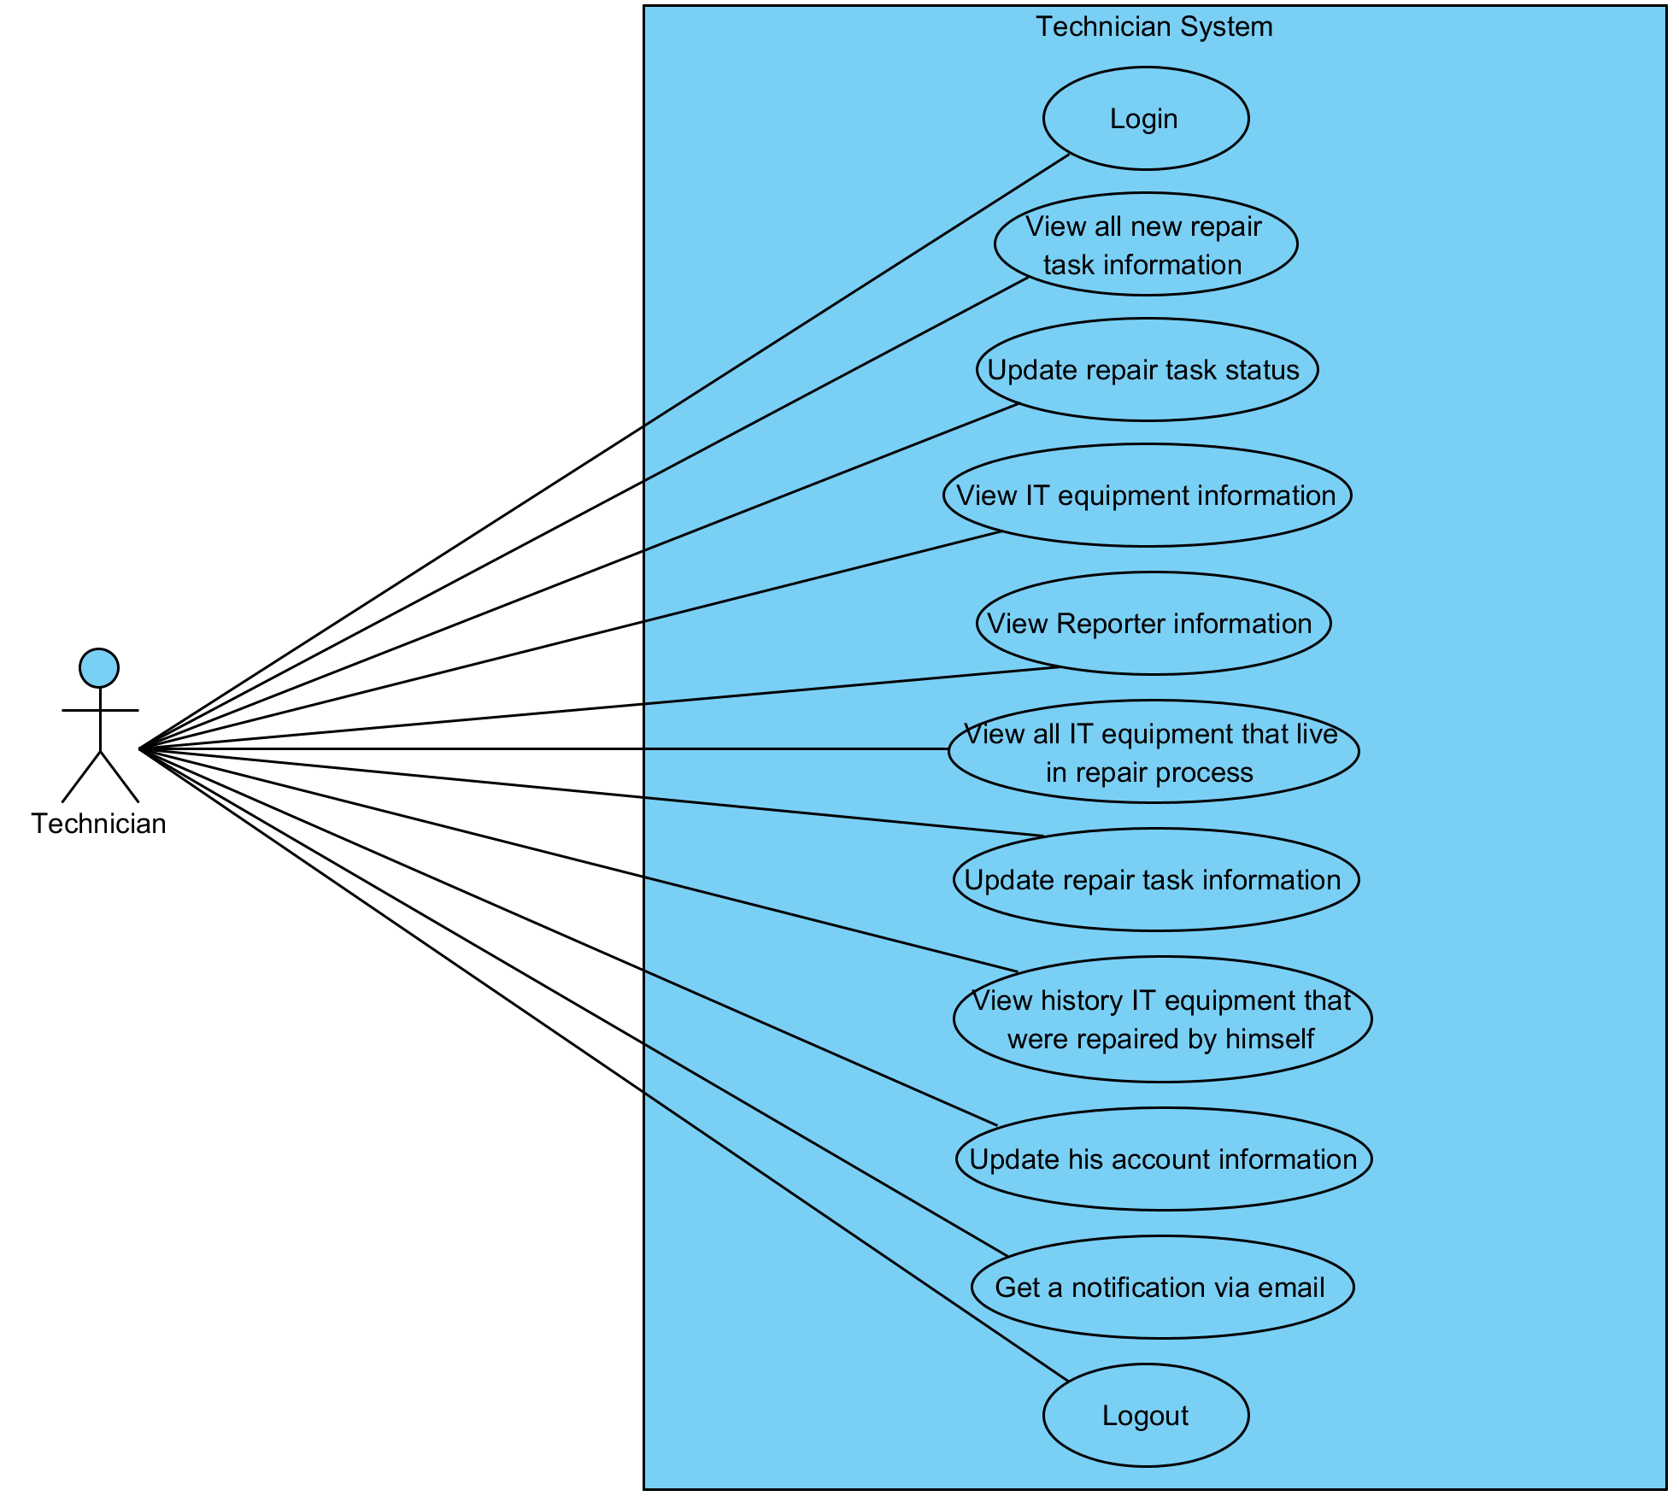

**3.1.4 Use case diagram in part of Reporter**

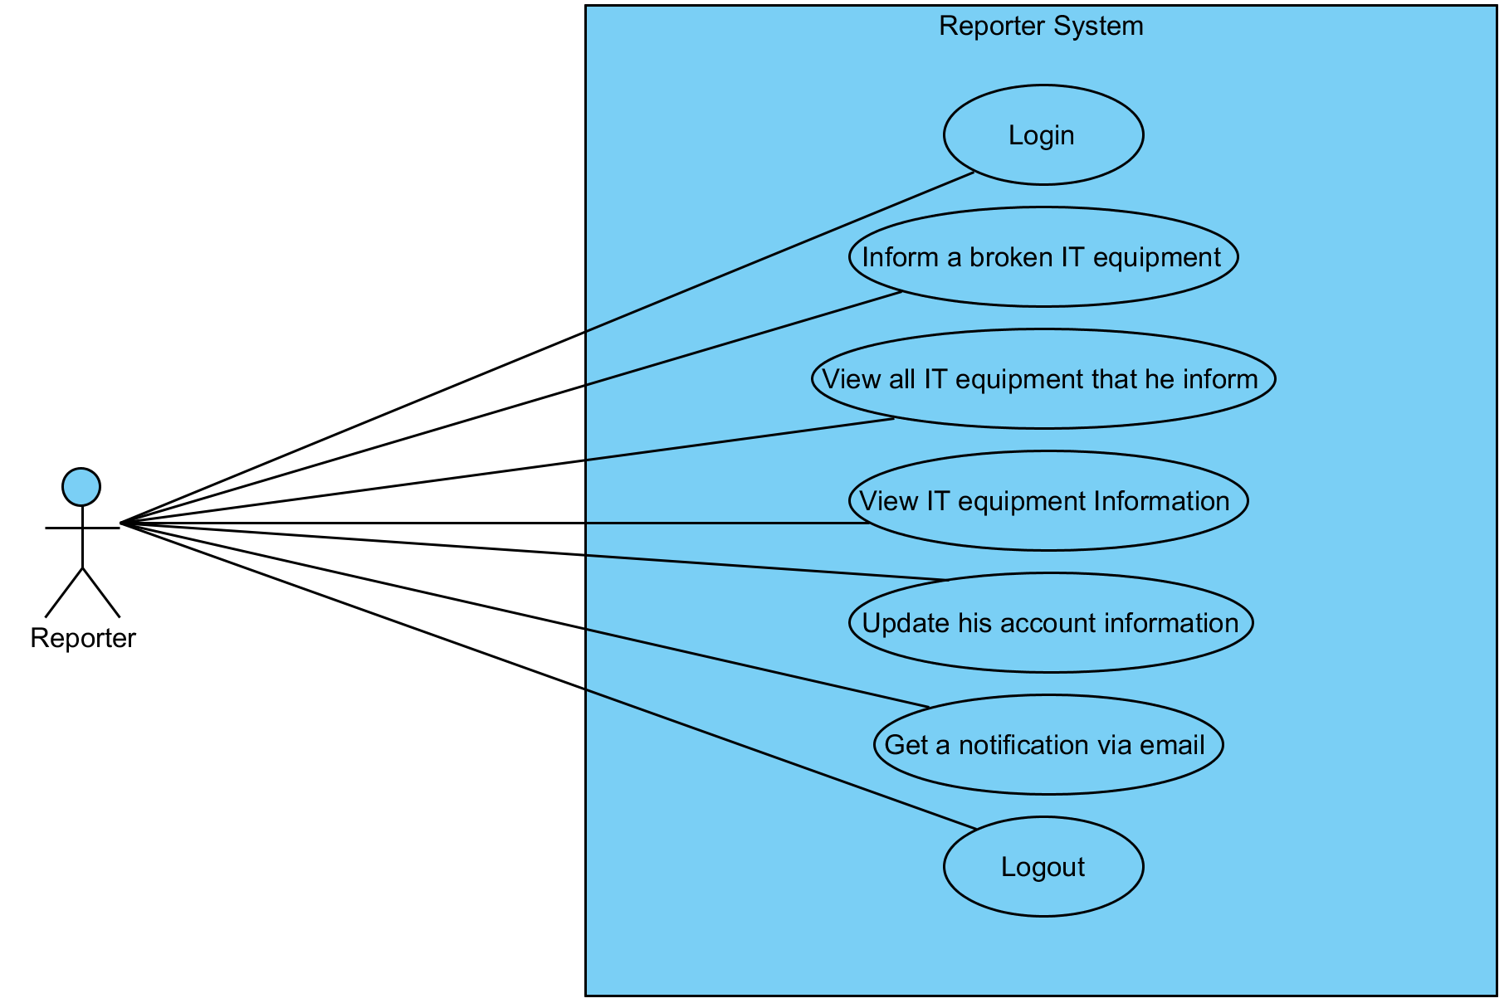

# **Chapter Four | Use case description**

## **4.1 User can login (UC1)**

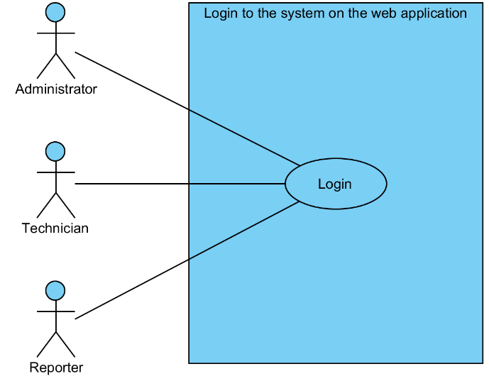

|  |  |  |  |  |
| --- | --- | --- | --- | --- |
| **Use Case ID:** | UC1 | | | |
| **Use Case Name:** | User can login | | | |
| **Created By:** | Mr.Tanadol Parn-ong | | **Last Updated By:** | Mr.Tanadol Parn-ong |
| **Date Created:** | 18/06/2015 | | **Last Revision Date:** | 18/06/2015 |
| **Actors:** | | User | | |
| **Description:** | | This use case is provided for user login to the system. | | |
| **Trigger:** | | User clicks the login button. | | |
| **Preconditions:** | | User must have a user account. | | |
| **Post conditions:** | | The system redirects to Administrator main page or Technician main page or Reporter main page on the web application. | | |
| **Normal Flow:** | | 1. User enters to login page. 2. User fills username and password. 3. User clicks the login button. 4. The system validates username and password. 5. The system redirect to Administrator main page or Technician main page or Reporter main page. 6. User enters to Administrator main page or Technician main page or Reporter main page. | | |
| **Alternative Flows:** | | N/A | | |
| **Exceptions:** | | 1. When user don’t fill username or password after he clicks the login button. The system provides the error message as followed:  1.1. The system displays “Please fill username and password” on the web application.  1.2. Use Case resumes on step 1 of normal flow.  2. When user fill username less than 4 characters or more than 16 characters after he clicks the login button. The system provides the error message as followed:  2.1. The system displays “Please fill username 4-16 characters” on the web application.  2.2. Use Case resumes on step 1 of normal flow.  3. When user fill password less than 4 characters or more than 16 characters after he clicks the login button. The system provides the error message as followed:  3.1. The system displays “Please fill password 4-16 characters” on the web application.  3.2. Use Case resumes on step 1 of normal flow.  4. When the username or password wrong. The system provides the error message as followed:  4.1. The system displays “username or password incorrect” on the web application.  4.2. Use Case resumes on step 1 of normal flow.  5. When the user account is not approved by Administrator. The system provides the error message as followed:  5.1. The system displays “your username still not approve from administrator” on the web application.  5.2. Use Case resumes on step 1 of normal flow. | | |
| **Includes:** | | N/A | | |
| **Frequency of Use:** | | Often | | |
| **Assumptions:** | | N/A | | |
| **Notes and Issues:** | | N/A | | |

**URS1 User can login.**

User can login to the system for using the system.

**Actor:** User

**Prerequisite:** User must have a user account.

**Input:**

**Administrator**

|  |  |  |  |
| --- | --- | --- | --- |
| Name | Description | Example | Remarks |
| username | Can be any character within the range of 4-16 characters. | “admin” |  |
| password | Can be any character within the range of 4-16 characters. | “123456” |  |

**Technician**

|  |  |  |  |
| --- | --- | --- | --- |
| Name | Description | Example | Remarks |
| username | Can be any character within the range of 4-16 characters. | “staff1” |  |
| password | Can be any character within the range of 4-16 characters. | “123456” |  |

**Reporter**

|  |  |  |  |
| --- | --- | --- | --- |
| Name | Description | Example | Remarks |
| username | Can be any character within the range of 4-16 characters. | “reporter1” |  |
| password | Can be any character within the range of 4-16 characters. | “123456” |  |

**Flow of Execution:**

1. User enters to login page.
2. User fills username and password.
3. User clicks the login button.
4. User enters to Administrator main page or Technician main page or Reporter main page.

**AC1 User can login.**

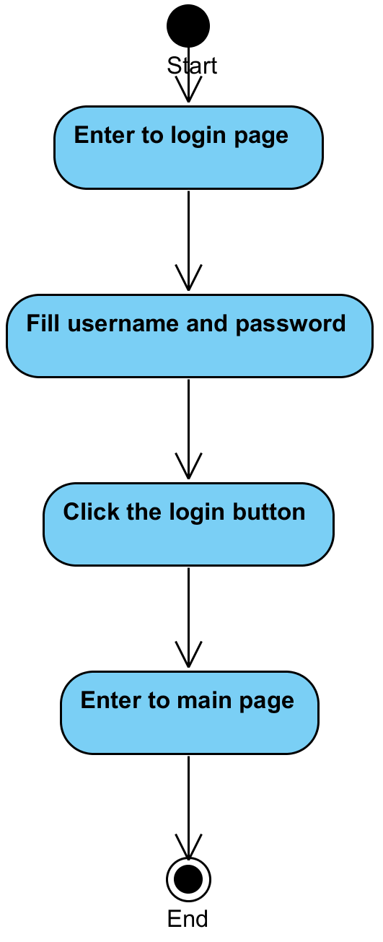

**System Requirement Specification of URS1**

SRS1-1 The system validates username and password.

SRS1-2 The system redirect to Administrator main page or Technician main page or Reporter main page

SRS1-3 The system displays “Please fill username and password” on the web application.

SRS1-4 The system displays “Please you fill username 4-16 characters” on the web application.

SRS1-5 The system displays “Please you fill password 4-16 characters” on the web application.

SRS1-6 The system displays “username or password incorrect” on the web application.

SRS1-7 The system displays “your username still not approve from administrator” on the web application.

## **4.2 Administrator can register a technician/reporter account (UC2)**

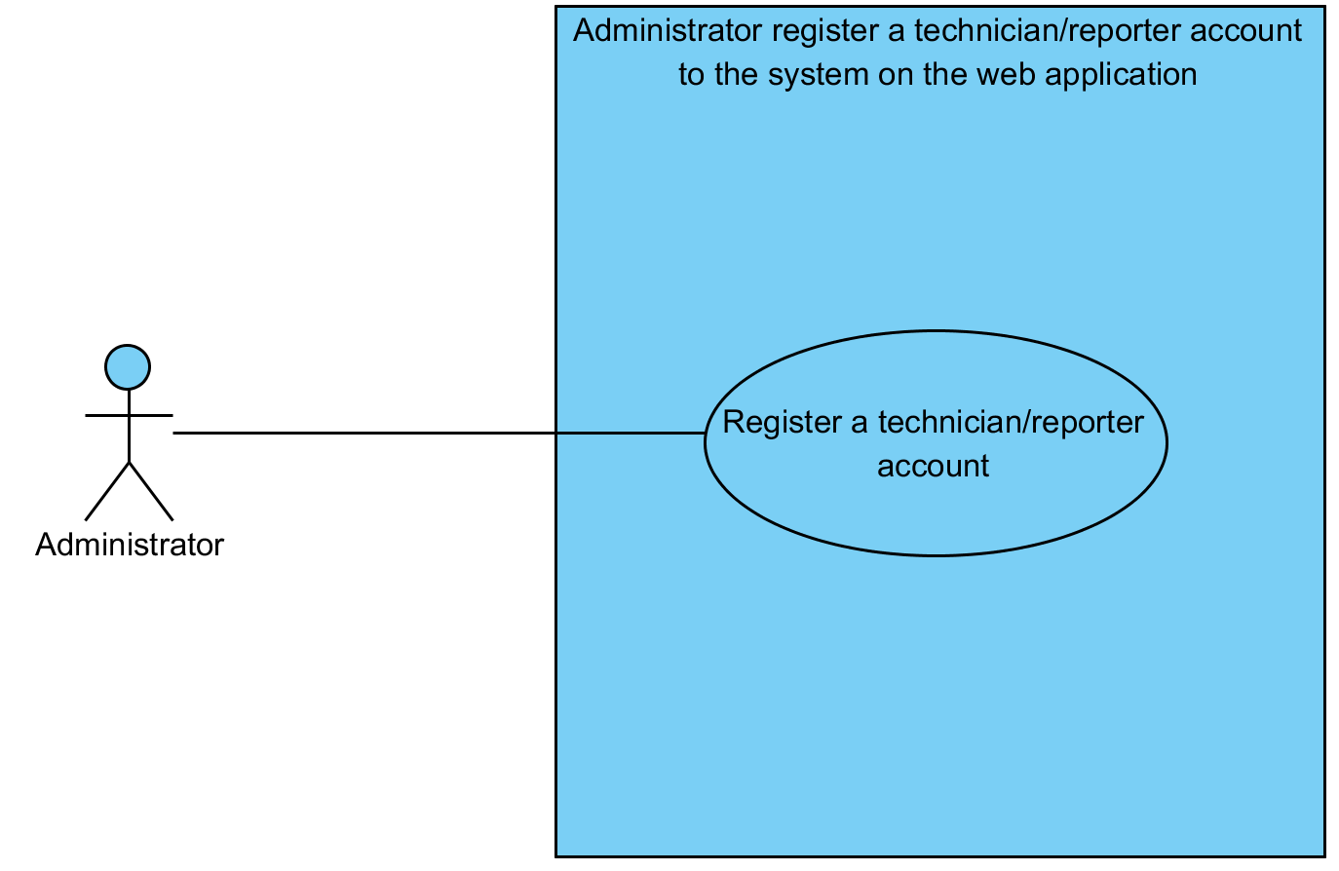

|  |  |  |  |  |
| --- | --- | --- | --- | --- |
| **Use Case ID:** | UC2 | | | |
| **Use Case Name:** | Administrator can register a technician/reporter account | | | |
| **Created By:** | Mr.Tanadol Parn-ong | | **Last Updated By:** | Mr.Tanadol Parn-ong |
| **Date Created:** | 18/06/2015 | | **Last Revision Date:** | 18/06/2015 |
| **Actors:** | | Administrator | | |
| **Description:** | | This use case is provided for Administrator can register a technician/reporter account. | | |
| **Trigger:** | | User clicks the register button. | | |
| **Preconditions:** | | N/A | | |
| **Post conditions:** | | The system displays “Registration successful” on the web application. | | |
| **Normal Flow:** | | 1. Administrator enters to User Registration page. 2. Administrator fills username, password, name, department, room, address, telephone number, email, and user type information to User Registration page. 3. Administrator clicks the register button. 4. The system displays yes/no dialog massage “Do you sure for registration ?”. 5. Administrator clicks yes button in yes/no dialog message. 6. The system validates username, password, name, department, room, address, telephone number, email, and user type information. 7. The system records username, password, name, department, room, address, telephone number, email, and user type information to the system. 8. The system displays “Registration successful” on the web application. | | |
| **Alternative Flows:** | | 1. When Administrator clicks the Reparation Management button.  1.1. Administrator clicks the Reparation Management button.  1.2. The system redirects to Reparation Management page.  2. When Administrator clicks the Users Management button.  2.1. Administrator clicks the Users Management button.  2.2. The system redirects to Users Management page.  3. When Administrator clicks the Items Management button.  3.1. Administrator clicks the Items Management button.  3.2. The system redirects to Items Management page.  4. When Administrator clicks the MIS button.  4.1. Administrator clicks the MIS button.  4.2. The system redirects to MIS page.  5. When Administrator clicks the Admin Information button.  4.1. Administrator clicks the Admin Information button.  4.2. The system redirects to Admin Information page.  6. When Administrator clicks the Logout button.  4.1. Administrator clicks the Logout button.  4.2. The system redirects to Login page.  4.3 The system clears the user session. | | |
| **Exceptions:** | | 1. When Administrator don’t fill username after he clicks the register button. The system provides the error message as followed:  1.1. The system displays “Please you fill username” on the web application.  1.2. Use Case resumes on step 1 of normal flow.  2. When Administrator don’t fill password after he clicks the register button. The system provides the error message as followed:  2.1. The system displays “Please you fill password” on the web application.  2.2. Use Case resumes on step 1 of normal flow.  3. When Administrator don’t fill name after he clicks the register button. The system provides the error message as followed:  3.1. The system displays “Please you fill name” on the web application.  3.2. Use Case resumes on step 1 of normal flow.  4. When Administrator don’t fill department after he clicks the register button. The system provides the error message as followed:  4.1. The system displays “Please you fill department” on the web application.  4.2. Use Case resumes on step 1 of normal flow.  5. When Administrator don’t fill room after he clicks the register button. The system provides the error message as followed:  5.1. The system displays “Please you fill room” on the web application.  5.2. Use Case resumes on step 1 of normal flow.  6. When Administrator don’t fill address after he clicks the register button. The system provides the error message as followed:  6.1. The system displays “Please you fill address” on the web application.  6.2. Use Case resumes on step 1 of normal flow.  7. When Administrator don’t fill telephone number after he clicks the register button. The system provides the error message as followed:  7.1. The system displays “Please you fill telephone number” on the web application.  7.2. Use Case resumes on step 1 of normal flow.  8. When Administrator don’t fill email after he clicks the register button. The system provides the error message as followed:  8.1. The system displays “Please you fill email” on the web application.  8.2. Use Case resumes on step 1 of normal flow.  9. When Administrator fill username less than 4 characters or more than 16 characters after he clicks the register button. The system provides the error message as followed:  9.1. The system displays “Please you fill username 4-16 characters” on the web application.  9.2. Use Case resumes on step 1 of normal flow.  10. When Administrator fill password less than 4 characters or more than 16 characters after he clicks the register button. The system provides the error message as followed:  10.1. The system displays “Please you fill password 4-16 characters” on the web application.  10.2. Use Case resumes on step 1 of normal flow.  11. When username is duplicate with other username. The system provides the error message as followed:  11.1. The system displays “Your username are duplicate with other username” on the web application.  11.2. Use Case resumes on step 1 of normal flow. | | |
| **Includes:** | | N/A | | |
| **Frequency of Use:** | | Often | | |
| **Assumptions:** | | N/A | | |
| **Notes and Issues:** | | N/A | | |

**URS2 Administrator can register a technician/reporter account.**

Administrator can register a technician/reporter account by filling username, password, name, department, room, address, telephone number, email, and user type information to User Registration page.

**Actor:** Administrator

**Prerequisite:** N/A.

**Input:**

|  |  |  |  |
| --- | --- | --- | --- |
| Name | Description | Example | Remarks |
| username | Can be any character within the range of 4-16 characters. | “reporter1” |  |
| password | Can be any character within the range of 4-16 characters. | “123456” |  |
| name | Can be any character only | “reporter one” |  |
| department | Can be any character only | “CAMT” |  |
| room | Can be any character only | “114” |  |
| address | Can be any character only | “Chiang Mai” |  |
| telephone number | Can be any character only | “0833201787” |  |
| email | Can be any character only | “se542115021.developer@gmail.com” |  |
| user type | Provide radio button to select technician or reporter type. | “reporter” |  |

**Flow of Execution:**

1. Administrator enters to User Registration page.
2. Administrator fills username, password, name, department, room, address, telephone number, email, and user type information to User Registration page.
3. Administrator clicks the register button.
4. Administrator clicks yes button in yes/no dialog message.

**AC2 Administrator can register a technician/reporter account.**

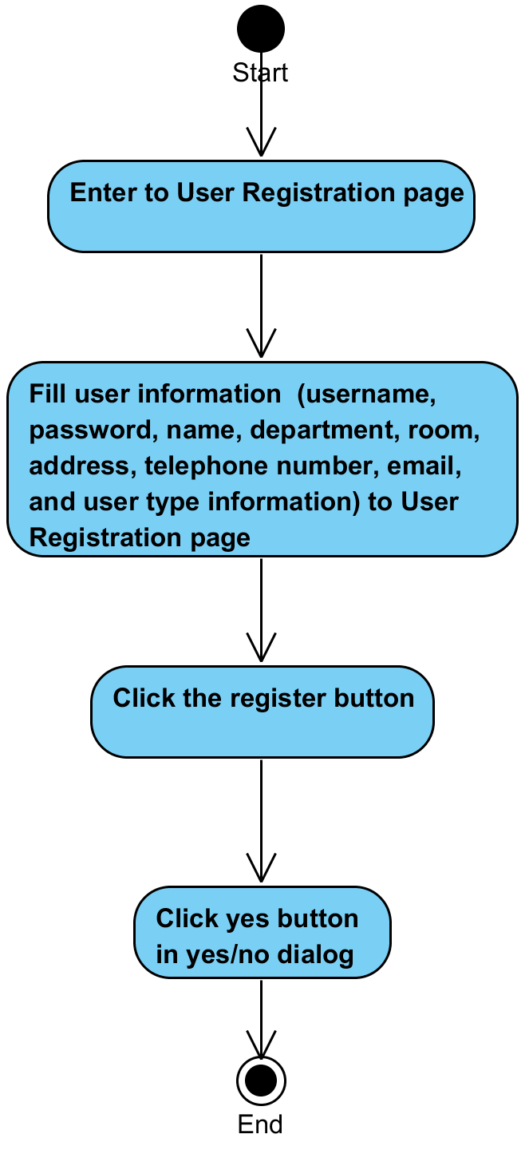

**System Requirement Specification of URS2**

SRS1-4 The system displays “Please you fill username 4-16 characters” on the web application.

SRS1-5 The system displays “Please you fill password 4-16 characters” on the web application.

SRS2-1 The system displays yes/no dialog massage “Do you sure for registration ?”.

SRS2-2 The system validates username, password, name, department, room, address, telephone number, email, and user type information.

SRS2-3 The system records username, password, name, department, room, address, telephone number, email, and user type information to the system.

SRS2-4 The system displays “Registration successful” on the web application.

SRS2-5 The system redirects to Reparation Management page.

SRS2-6 The system redirects to Users Management page.

SRS2-7 The system redirects to Items Management page.

SRS2-8 The system redirects to Items MIS page.

SRS2-9 The system redirects to Admin Information page.

SRS2-10 The system redirects to Login page.

SRS2-11 The system displays “Please you fill username” on the web application.

SRS2-12 The system displays “Please you fill password” on the web application.

SRS2-13 The system displays “Please you fill name” on the web application.

SRS2-14 The system displays “Please you fill department” on the web application.

SRS2-15 The system displays “Please you fill room” on the web application.

SRS2-16 The system displays “Please you fill address” on the web application.

SRS2-17 The system displays “Please you fill telephone number” on the web application.

SRS2-18 The system displays “Please you fill email” on the web application.

SRS2-19 The system displays “Your username are duplicate with other username” on the web application.

SRS2-20 The system clears the user session.

## **4.3 Administrator can view all technician accounts (UC3)**

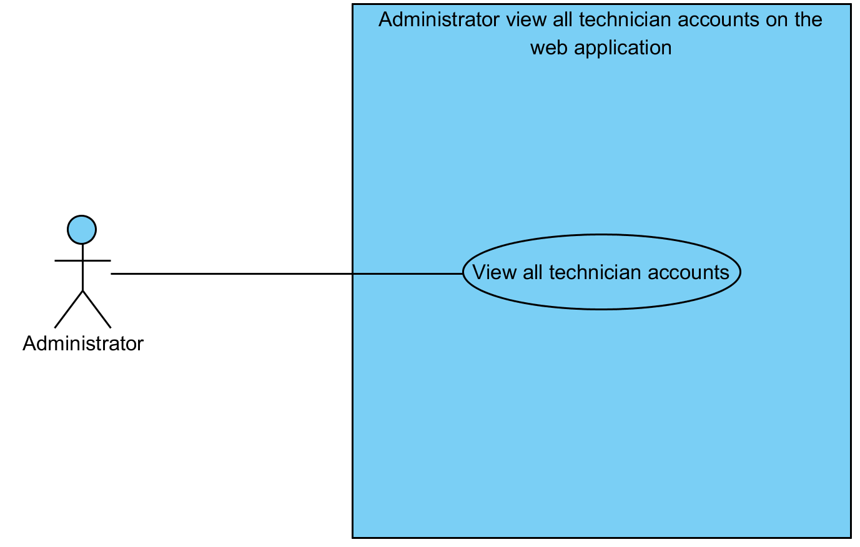

|  |  |  |  |  |
| --- | --- | --- | --- | --- |
| **Use Case ID:** | UC3 | | | |
| **Use Case Name:** | Administrator can view all technician accounts | | | |
| **Created By:** | Mr.Tanadol Parn-ong | | **Last Updated By:** | Mr.Tanadol Parn-ong |
| **Date Created:** | 18/06/2015 | | **Last Revision Date:** | 18/06/2015 |
| **Actors:** | | Administrator | | |
| **Description:** | | This use case is provided for Administrator can view all technician accounts. | | |
| **Trigger:** | | Administrator clicks Technician Management button. | | |
| **Preconditions:** | | The system must has technician information in the system. | | |
| **Post conditions:** | | The system displays all technician account information in Technician Management page. | | |
| **Normal Flow:** | | 1. Administrator enters to User Management page. 2. Administrator clicks the Technician Management button. 3. The system redirects to Technician Management page. 4. The system displays all technician account information in Technician Management page. 5. Administrator enters to Technician Management page. | | |
| **Alternative Flows:** | | 1. When Administrator clicks the Reparation Management button.  1.1. Administrator clicks the Reparation Management button.  1.2. The system redirects to Reparation Management page.  2. When Administrator clicks the Users Management button.  2.1. Administrator clicks the Users Management button.  2.2. The system redirects to Users Management page.  3. When Administrator clicks the Items Management button.  3.1. Administrator clicks the Items Management button.  3.2. The system redirects to Items Management page.  4. When Administrator clicks the MIS button.  4.1. Administrator clicks the MIS button.  4.2. The system redirects to MIS page.  5. When Administrator clicks the Admin Information button.  5.1. Administrator clicks the Admin Information button.  5.2. The system redirects to Admin Information page.  6. When Administrator clicks the Logout button.  6.1. Administrator clicks the Logout button.  6.2. The system redirects to Login page.  6.3 The system clears the user session. | | |
| **Exceptions:** | | N/A | | |
| **Includes:** | | N/A | | |
| **Frequency of Use:** | | Often | | |
| **Assumptions:** | | N/A | | |
| **Notes and Issues:** | | N/A | | |

**URS3 Administrator can view all technician accounts.**

Administrator can view all technician account information in Technician Management page

**Actor:** Administrator

**Prerequisite:** N/A.

**Input:**N/A **Flow of Execution:**

1. Administrator enters to User Management page.
2. Administrator clicks the Technician Management button.
3. Administrator enters to Technician Management page.

**AC3 Administrator can view all technician accounts.**

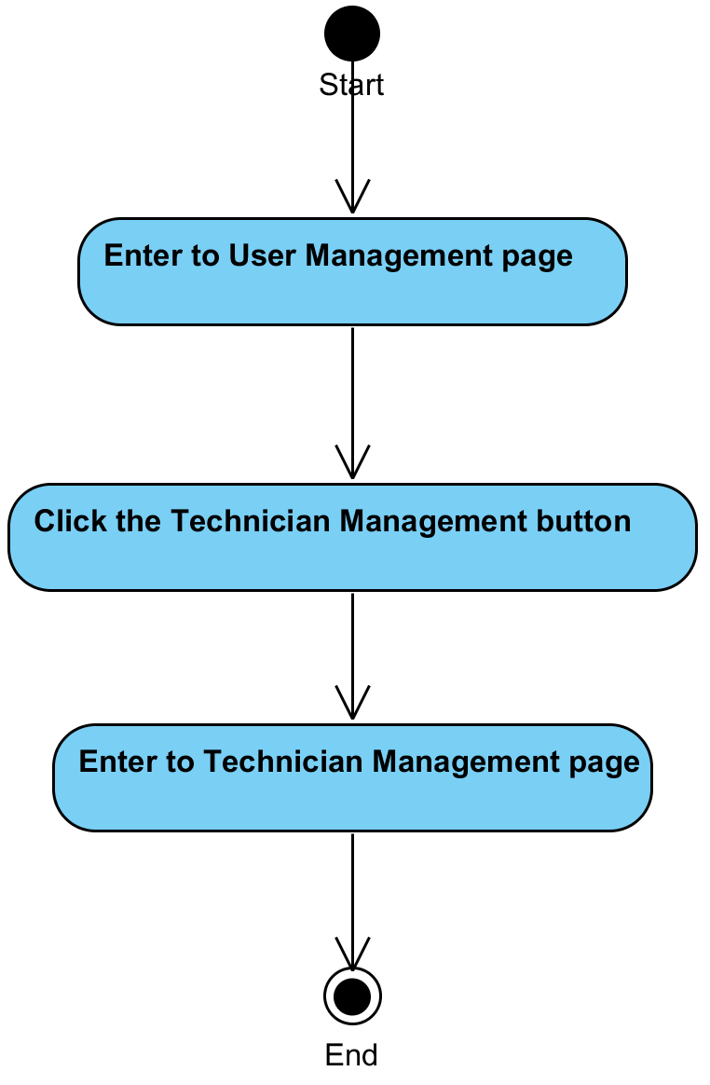

**System Requirement Specification of URS3**

SRS2-5 The system redirects to Reparation Management page.

SRS2-6 The system redirects to Users Management page.

SRS2-7 The system redirects to Items Management page.

SRS2-8 The system redirects to Items MIS page.

SRS2-9 The system redirects to Admin Information page.

SRS2-10 The system redirects to Login page.

SRS2-20 The system clears the user session.

SRS3-1 The system redirects to Technician Management page.

SRS3-2 The system displays all technician account information in Technician Management page.

## **4.4 Administrator can view all reporter accounts (UC4)**

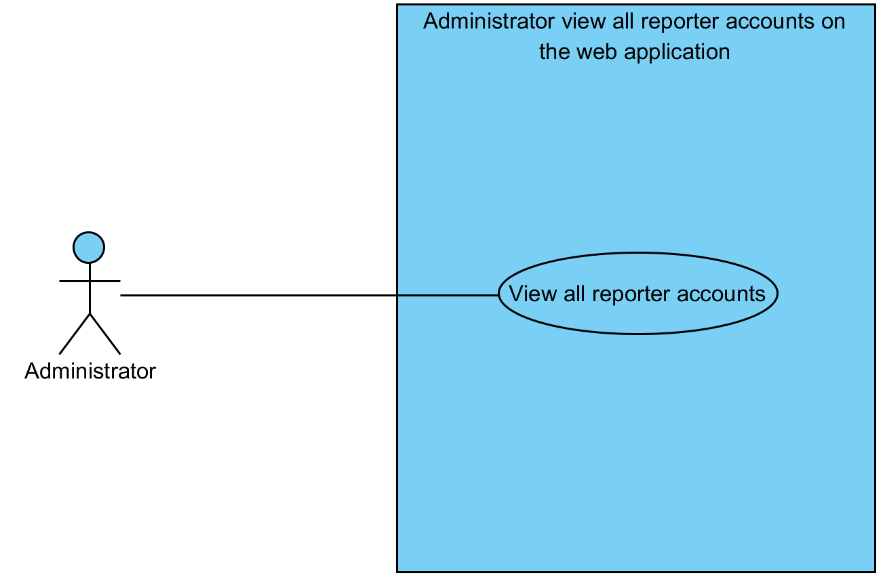

|  |  |  |  |  |
| --- | --- | --- | --- | --- |
| **Use Case ID:** | UC4 | | | |
| **Use Case Name:** | Administrator can view all reporter accounts | | | |
| **Created By:** | Mr.Tanadol Parn-ong | | **Last Updated By:** | Mr.Tanadol Parn-ong |
| **Date Created:** | 18/06/2015 | | **Last Revision Date:** | 18/06/2015 |
| **Actors:** | | Administrator | | |
| **Description:** | | This use case is provided for Administrator can view all reporter accounts. | | |
| **Trigger:** | | Administrator clicks Reporter Management button. | | |
| **Preconditions:** | | The system must has reporter information in the system. | | |
| **Post conditions:** | | The system displays all reporter account information in Reporter Management page. | | |
| **Normal Flow:** | | 1. Administrator enters to User Management page. 2. Administrator clicks the Reporter Management button 3. The system redirects to Reporter Management page. 4. The system displays all reporter account information in Reporter Management page. 5. Administrator enters to Reporter Management page. | | |
| **Alternative Flows:** | | 1. When Administrator clicks the Reparation Management button.  1.1. Administrator clicks the Reparation Management button.  1.2. The system redirects to Reparation Management page.  2. When Administrator clicks the Users Management button.  2.1. Administrator clicks the Users Management button.  2.2. The system redirects to Users Management page.  3. When Administrator clicks the Items Management button.  3.1. Administrator clicks the Items Management button.  3.2. The system redirects to Items Management page.  4. When Administrator clicks the MIS button.  4.1. Administrator clicks the MIS button.  4.2. The system redirects to MIS page.  5. When Administrator clicks the Admin Information button.  5.1. Administrator clicks the Admin Information button.  5.2. The system redirects to Admin Information page.  6. When Administrator clicks the Logout button.  6.1. Administrator clicks the Logout button.  6.2. The system redirects to Login page.  6.3 The system clears the user session. | | |
| **Exceptions:** | | N/A | | |
| **Includes:** | | N/A | | |
| **Frequency of Use:** | | Often | | |
| **Assumptions:** | | N/A | | |
| **Notes and Issues:** | | N/A | | |

**URS4 Administrator can view all reporter accounts.**

Administrator can view all reporter account information in Reporter Management page

**Actor:** Administrator

**Prerequisite:** N/A.

**Input:**N/A **Flow of Execution:**

1. Administrator enters to User Management page.
2. Administrator clicks the Reporter Management button.
3. Administrator enters to Reporter Management page.

**AC4 Administrator can view all reporter accounts.**

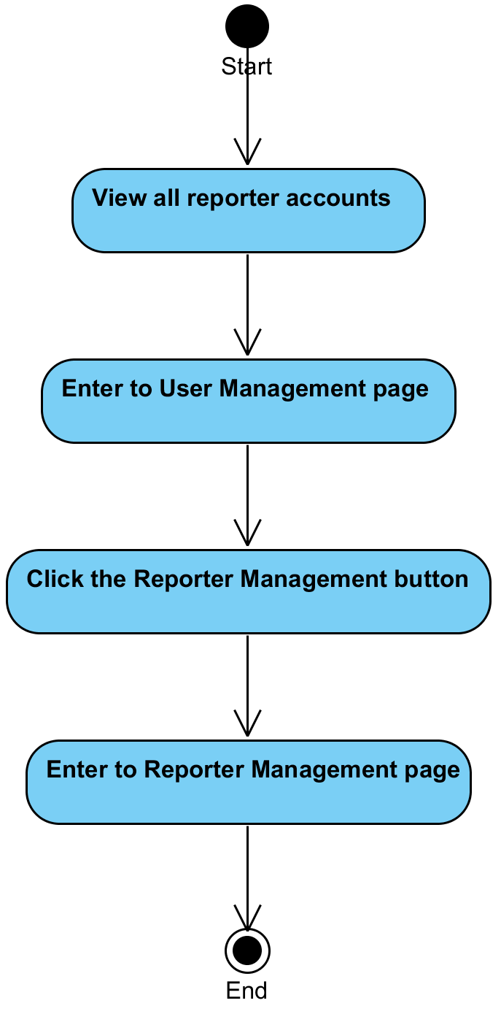

**System Requirement Specification of URS4**

SRS2-5 The system redirects to Reparation Management page.

SRS2-6 The system redirects to Users Management page.

SRS2-7 The system redirects to Items Management page.

SRS2-8 The system redirects to Items MIS page.

SRS2-9 The system redirects to Admin Information page.

SRS2-10 The system redirects to Login page.

SRS2-20 The system clears the user session.

SRS4-1 The system redirects to Reporter Management page.

SRS4-2 The system displays all reporter account information in Reporter Management page.

## **4.5 Administrator can change an active status of technician/ reporter account (UC5)**

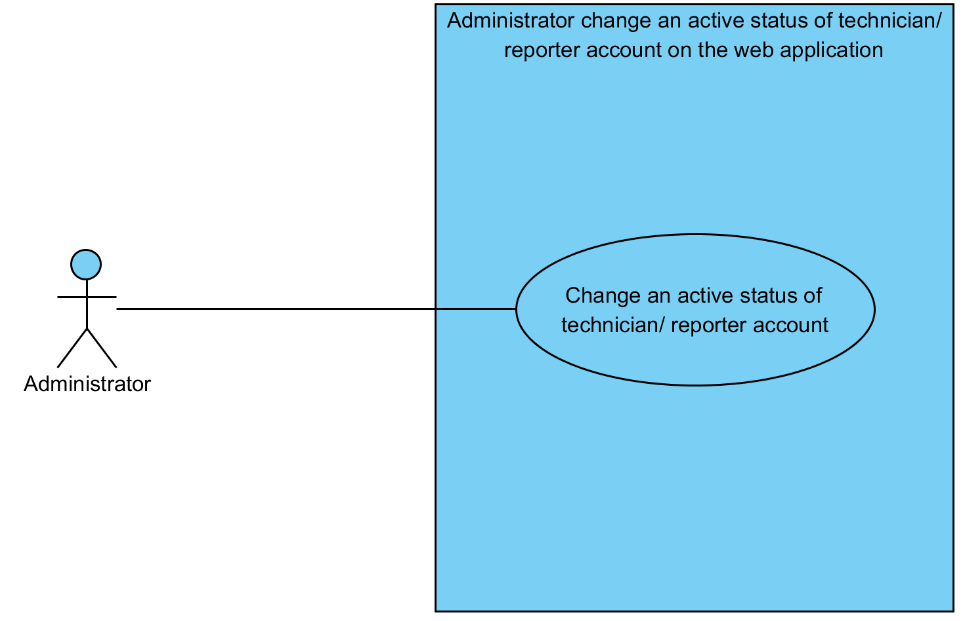

|  |  |  |  |  |
| --- | --- | --- | --- | --- |
| **Use Case ID:** | UC5 | | | |
| **Use Case Name:** | Administrator can change an active status of technician/ reporter account | | | |
| **Created By:** | Mr.Tanadol Parn-ong | | **Last Updated By:** | Mr.Tanadol Parn-ong |
| **Date Created:** | 18/06/2015 | | **Last Revision Date:** | 18/06/2015 |
| **Actors:** | | Administrator | | |
| **Description:** | | This use case is provided for Administrator changes an active status of technician/ reporter accounts. | | |
| **Trigger:** | | Administrator clicks Active/Inactive button. | | |
| **Preconditions:** | | The system must has reporter/ technician information in the system. | | |
| **Post conditions:** | | 1. Situation of Technician accounts.  The system displays “Active” to “Inactive” status or “Inactive” to “Active” status of a technician in Technician management.  2. Situation of Reporter accounts.  The system displays “Active” to “Inactive” status or “Inactive” to “Active” status of a reporter in Reporter management. | | |
| **Normal Flow:** | | 1. Situation of Technician account  1.1 Administrator enters to Technician Management page.  1.2 The system displays all technician account information in Technician Management page.  1.3 Administrator clicks Active/Inactive button.  1.4 The system displays yes/no dialog massage “Do you sure to change active status?”.  1.5 Administrator clicks yes button in yes/no dialog message.  1.6 The system changes active status of a technician in the system.  1.7 The system displays “Active” to “Inactive” status or “Inactive” to “Active” status of a technician in Technician management.  2. Situation of Reporter account  2.1 Administrator enters to Reporter Management page.  2.2 The system displays all reporter account information in Reporter Management page.  2.3 Administrator clicks Active/Inactive button.  2.4 The system displays yes/no dialog massage “Do you sure to change active status?”.  2.5 Administrator clicks yes button in yes/no dialog message.  2.6 The system changes active status of a reporter in the system.  2.7 The system displays “Active” to “Inactive” status or “Inactive” to “Active” status of a reporter in Reporter management | | |
| **Alternative Flows:** | | 1. When Administrator clicks the Reparation Management button.  1.1. Administrator clicks the Reparation Management button.  1.2. The system redirects to Reparation Management page.  2. When Administrator clicks the Users Management button.  2.1. Administrator clicks the Users Management button.  2.2. The system redirects to Users Management page.  3. When Administrator clicks the Items Management button.  3.1. Administrator clicks the Items Management button.  3.2. The system redirects to Items Management page.  4. When Administrator clicks the MIS button.  4.1. Administrator clicks the MIS button.  4.2. The system redirects to MIS page.  5. When Administrator clicks the Admin Information button.  5.1. Administrator clicks the Admin Information button.  5.2. The system redirects to Admin Information page.  6. When Administrator clicks the Logout button.  6.1. Administrator clicks the Logout button.  6.2. The system redirects to Login page.  6.3 The system clears the user session. | | |
| **Exceptions:** | | N/A | | |
| **Includes:** | | N/A | | |
| **Frequency of Use:** | | Often | | |
| **Assumptions:** | | N/A | | |
| **Notes and Issues:** | | N/A | | |

**URS5 Administrator can change an active status of technician/ reporter account.**

Administrator can change an active status of technician account in Technician Management page. Moreover, he can change an active status of reporter account in Reporter Management page.

**Actor:** Administrator

**Prerequisite:** The system must has reporter/ technician information in the system.

**Input:**N/A **Flow of Execution:**

1. Situation of Technician accounts.
   1. Administrator enters to Technician Management page.
   2. Administrator clicks Active/Inactive button.
   3. Administrator clicks yes button in yes/no dialog message
2. Situation of Reporter accounts.
   1. Administrator enters to Reporter Management page.
   2. Administrator clicks Active/Inactive button.
   3. Administrator clicks yes button in yes/no dialog message

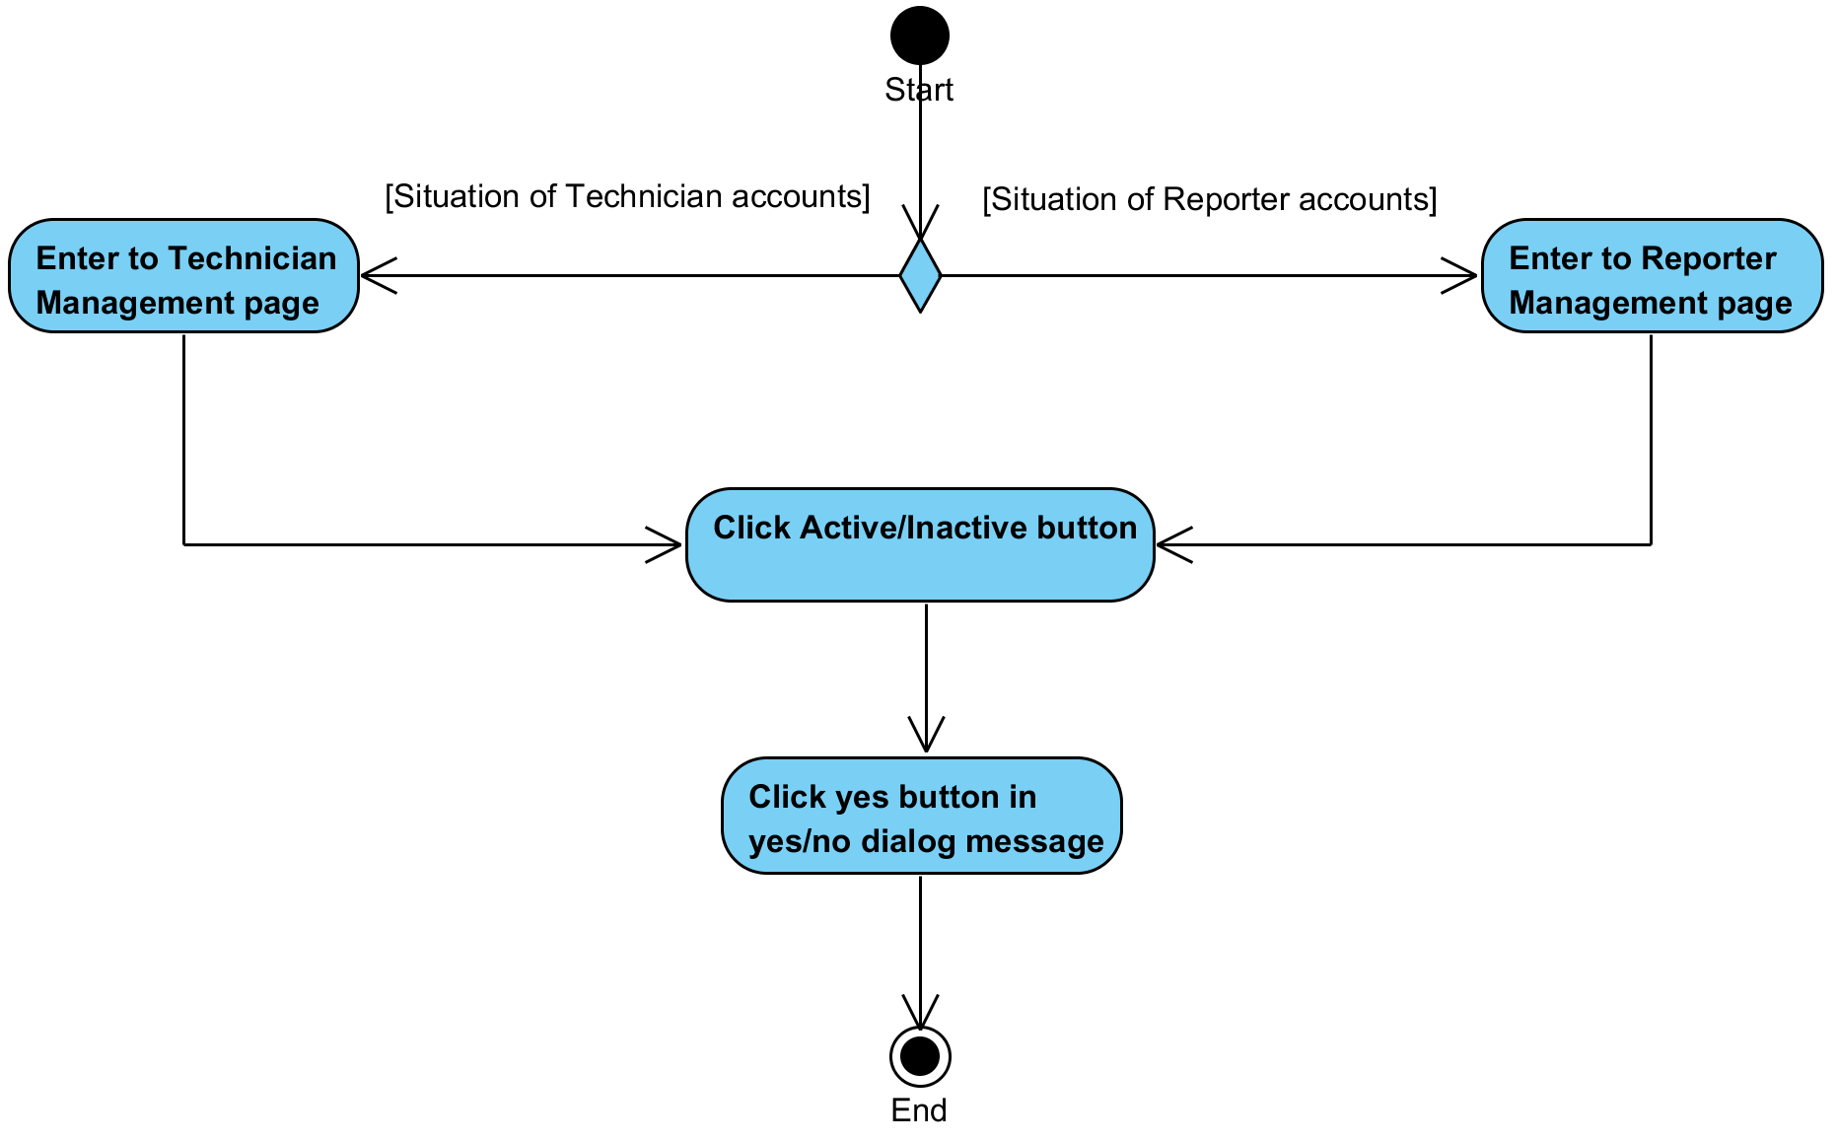**AC5 Administrator can change an active status of technician/ reporter account.**

**System Requirement Specification of URS5**

SRS2-5 The system redirects to Reparation Management page.

SRS2-6 The system redirects to Users Management page.

SRS2-7 The system redirects to Items Management page.

SRS2-8 The system redirects to Items MIS page.

SRS2-9 The system redirects to Admin Information page.

SRS2-10 The system redirects to Login page.

SRS2-20 The system clears the user session.

SRS3-2 The system displays all technician account information in Technician Management page.

SRS4-2 The system displays all reporter account information in Reporter Management page.

SRS5-1 The system displays yes/no dialog massage “Do you sure to change active status?”.

SRS5-2 The system changes active status of a technician in the system.

SRS5-3 The system displays “Active” to “Inactive” status or “Inactive” to “Active” status of a technician in Technician management.

SRS5-4 The system changes active status of a reporter in the system.

SRS5-5 The system displays “Active” to “Inactive” status or “Inactive” to “Active” status of a reporter in Reporter management.

## **4.6 Administrator can delete a technician/ reporter account (UC6)**

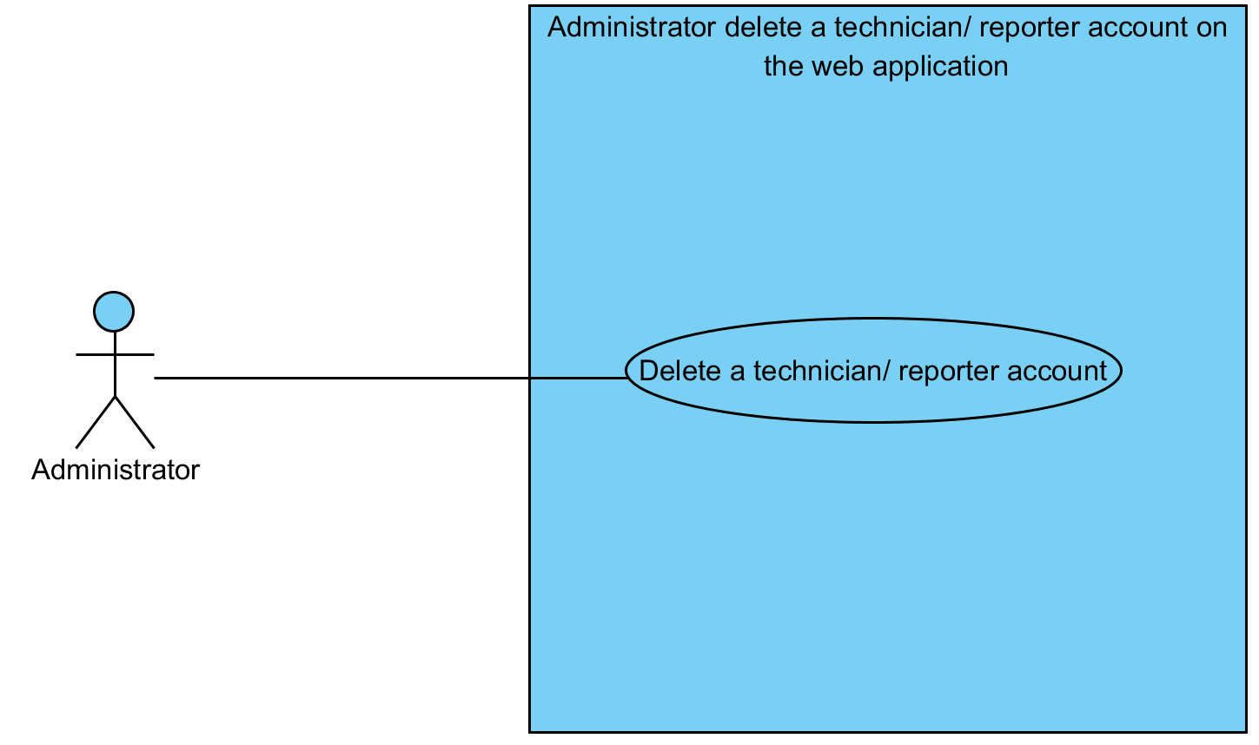

|  |  |  |  |  |
| --- | --- | --- | --- | --- |
| **Use Case ID:** | UC6 | | | |
| **Use Case Name:** | Administrator can delete a technician/ reporter account | | | |
| **Created By:** | Mr.Tanadol Parn-ong | | **Last Updated By:** | Mr.Tanadol Parn-ong |
| **Date Created:** | 18/06/2015 | | **Last Revision Date:** | 18/06/2015 |
| **Actors:** | | Administrator | | |
| **Description:** | | This use case is provided for Administrator can delete a technician/ reporter account. | | |
| **Trigger:** | | Administrator clicks delete button. | | |
| **Preconditions:** | | The system must has reporter/ technician information in the system. | | |
| **Post conditions:** | | 1. Situation of Technician accounts.  - The system displays “Delete user successful” on the web application.  2. Situation of Reporter accounts.  - The system displays “Delete user successful” on the web application. | | |
| **Normal Flow:** | | 1. Situation of Technician account  1.1 Administrator enters to Technician Management page.  1.2 The system displays all technician account information in Technician Management page.  1.3 Administrator clicks delete button.  1.4 The system displays yes/no dialog massage “Do you sure to delete this account?”  1.5 Administrator clicks yes button in yes/no dialog message.  1.6 The system deletes a technician account in the system.  1.7 The system displays “Delete user successful” on the web application.  2. Situation of Reporter account  2.1 Administrator enters to Reporter Management page.  2.2 The system displays all reporter account information in Reporter Management page.  2.3 Administrator clicks delete button.  2.4 The system displays yes/no dialog massage “Do you sure to delete this account?”  2.6 Administrator clicks yes button in yes/no dialog message.  2.7 The system deletes a reporter account in the system.  2.8 The system displays “Delete user successful” on the web application. | | |
| **Alternative Flows:** | | 1. When Administrator clicks the Reparation Management button.  1.1. Administrator clicks the Reparation Management button.  1.2. The system redirects to Reparation Management page.  2. When Administrator clicks the Users Management button.  2.1. Administrator clicks the Users Management button.  2.2. The system redirects to Users Management page.  3. When Administrator clicks the Items Management button.  3.1. Administrator clicks the Items Management button.  3.2. The system redirects to Items Management page.  4. When Administrator clicks the MIS button.  4.1. Administrator clicks the MIS button.  4.2. The system redirects to MIS page.  5. When Administrator clicks the Admin Information button.  5.1. Administrator clicks the Admin Information button.  5.2. The system redirects to Admin Information page.  6. When Administrator clicks the Logout button.  6.1. Administrator clicks the Logout button.  6.2. The system redirects to Login page.  6.3 The system clears the user session. | | |
| **Exceptions:** | | 1. When Administrator cannot delete a technician/reporter account. The system provides the error message as followed:  1.1. The system displays “Can't delete user” on the web application.  1.2. Use Case resumes on step 1 of normal flow. | | |
| **Includes:** | | N/A | | |
| **Frequency of Use:** | | Often | | |
| **Assumptions:** | | N/A | | |
| **Notes and Issues:** | | N/A | | |

**URS6 Administrator can delete a technician/ reporter account.**

Administrator can delete a technician account in Technician Management page. Moreover, he can delete a reporter account in Reporter Management page.

**Actor:** Administrator

**Prerequisite:** The system must has reporter/ technician information in the system.

**Input:**N/A **Flow of Execution:**

1. Situation of Technician accounts.

* 1. Administrator enters to Technician Management page.
  2. Administrator clicks delete button.
  3. Administrator clicks yes button in yes/no dialog message.

2. Situation of Reporter accounts.

* 1. Administrator enters to Reporter Management page.
  2. Administrator clicks delete button.
  3. Administrator clicks yes button in yes/no dialog message

**AC6 Administrator can delete a technician/ reporter account.**

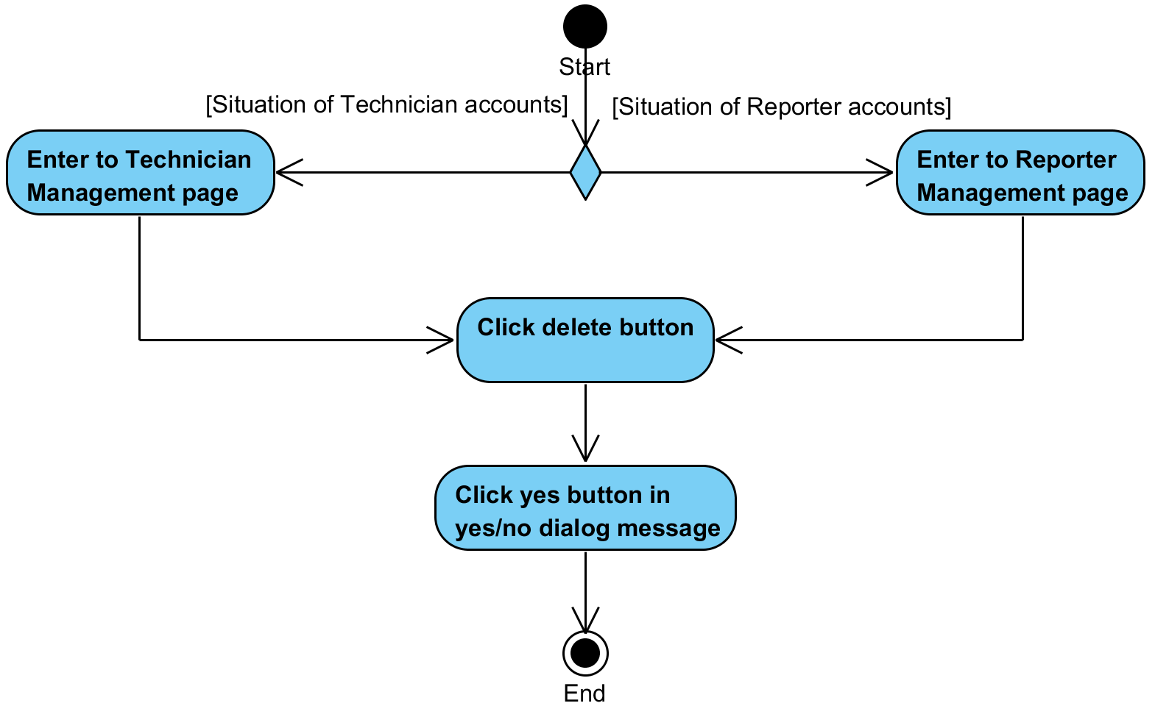

**System Requirement Specification of URS6**

SRS2-5 The system redirects to Reparation Management page.

SRS2-6 The system redirects to Users Management page.

SRS2-7 The system redirects to Items Management page.

SRS2-8 The system redirects to Items MIS page.

SRS2-9 The system redirects to Admin Information page.

SRS2-10 The system redirects to Login page.

SRS2-20 The system clears the user session.

SRS3-2 The system displays all technician account information in Technician Management page.

SRS4-2 The system displays all reporter account information in Reporter Management page.

SRS6-1 The system displays yes/no dialog massage “Do you sure to delete this account?”

SRS6-2 The system deletes a technician account in the system.

SRS6-3 The system deletes a reporter account in the system.

SRS6-4 The system displays “Delete user successful” on the web application.

SRS6-5 The system displays “Can't delete user” on the web application.

## **4.7 Administrator can view all IT equipment (UC7)**

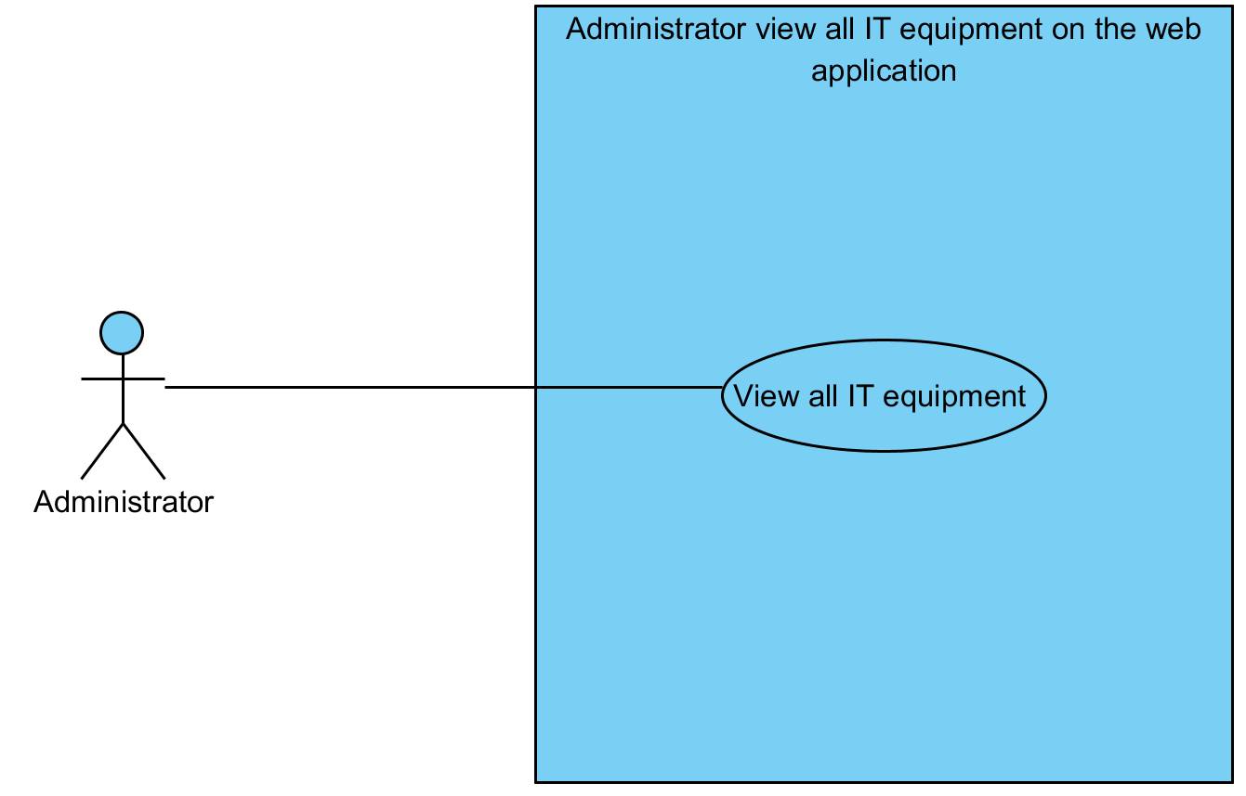

|  |  |  |  |  |
| --- | --- | --- | --- | --- |
| **Use Case ID:** | UC7 | | | |
| **Use Case Name:** | Administrator can view all IT equipment | | | |
| **Created By:** | Mr.Tanadol Parn-ong | | **Last Updated By:** | Mr.Tanadol Parn-ong |
| **Date Created:** | 18/06/2015 | | **Last Revision Date:** | 18/06/2015 |
| **Actors:** | | Administrator | | |
| **Description:** | | This use case is provided for Administrator can view all IT equipment. | | |
| **Trigger:** | | Administrator clicks the Items Management button. | | |
| **Preconditions:** | | The system must has IT equipment information in the system. | | |
| **Post conditions:** | | The system displays all IT equipment information in Items Management page. | | |
| **Normal Flow:** | | 1. Administrator clicks the Items Management button. 2. The system redirects to Items Management page. 3. The system displays all IT equipment information in Items Management page. 4. Administrator enters to the Items Management page | | |
| **Alternative Flows:** | | 1. When Administrator clicks the Reparation Management button.  1.1. Administrator clicks the Reparation Management button.  1.2. The system redirects to Reparation Management page.  2. When Administrator clicks the Users Management button.  2.1. Administrator clicks the Users Management button.  2.2. The system redirects to Users Management page.  3. When Administrator clicks the Items Management button.  3.1. Administrator clicks the Items Management button.  3.2. The system redirects to Items Management page.  4. When Administrator clicks the MIS button.  4.1. Administrator clicks the MIS button.  4.2. The system redirects to MIS page.  5. When Administrator clicks the Admin Information button.  5.1. Administrator clicks the Admin Information button.  5.2. The system redirects to Admin Information page.  6. When Administrator clicks the Logout button.  6.1. Administrator clicks the Logout button.  6.2. The system redirects to Login page.  6.3 The system clears the user session.  7. When Administrator clicks the Add Item button.  7.1. Administrator clicks the Add Item button.  7.2. The system redirects to Add Item page.  8. When Administrator clicks the Edit button.  8.1. Administrator clicks the Edit button.  8.2. The system redirects to Item Information page. | | |
| **Exceptions:** | | N/A | | |
| **Includes:** | | N/A | | |
| **Frequency of Use:** | | Often | | |
| **Assumptions:** | | N/A | | |
| **Notes and Issues:** | | N/A | | |

**URS7 Administrator can view all IT equipment.**

Administrator can view all IT equipment information in Items Management page

**Actor:** Administrator

**Prerequisite:** The system must has IT equipment information in the system.

**Input:**N/A **Flow of Execution:**

1. Administrator clicks the Items Management button.
2. Administrator enters to the Items Management page.

**AC7 Administrator can view all IT equipment.**

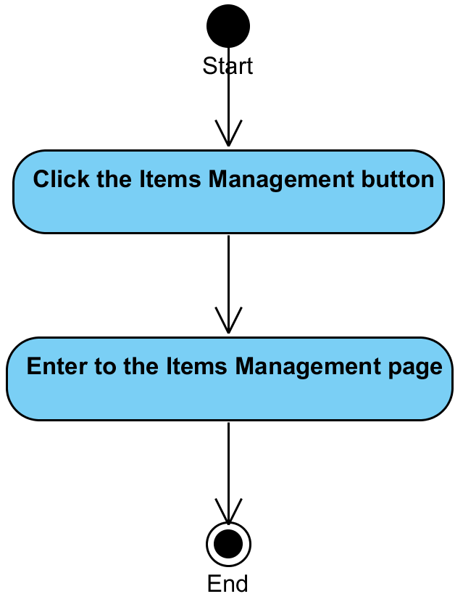

**System Requirement Specification of URS7**

SRS2-5 The system redirects to Reparation Management page.

SRS2-6 The system redirects to Users Management page.

SRS2-7 The system redirects to Items Management page.

SRS2-8 The system redirects to Items MIS page.

SRS2-9 The system redirects to Admin Information page.

SRS2-10 The system redirects to Login page.

SRS2-20 The system clears the user session.

SRS7-1 The system displays all IT equipment information in Items Management page**.**

SRS7-2 The system redirects to Add Item page.

SRS7-3 The system redirects to Item Information page.

## **4.8 Administrator can add IT equipment (UC8)**

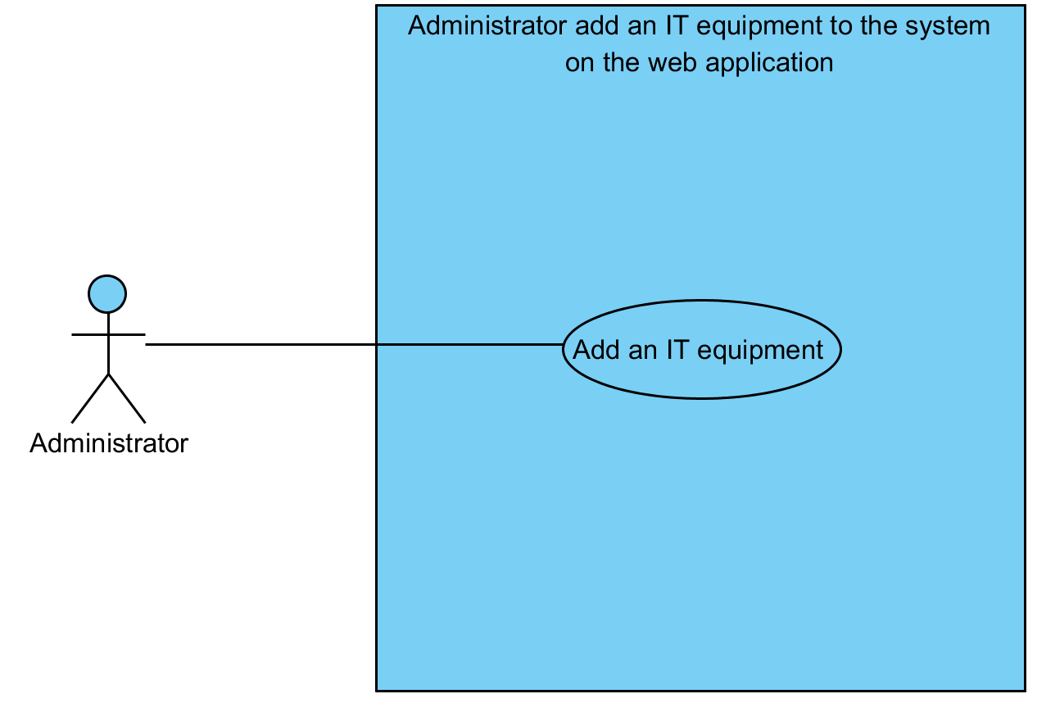

|  |  |  |  |  |
| --- | --- | --- | --- | --- |
| **Use Case ID:** | UC8 | | | |
| **Use Case Name:** | Administrator can add IT equipment | | | |
| **Created By:** | Mr.Tanadol Parn-ong | | **Last Updated By:** | Mr.Tanadol Parn-ong |
| **Date Created:** | 18/06/2015 | | **Last Revision Date:** | 18/06/2015 |
| **Actors:** | | Administrator | | |
| **Description:** | | This use case is provided for Administrator can add IT equipment. | | |
| **Trigger:** | | Administrator clicks the Add Item button. | | |
| **Preconditions:** | | N/A | | |
| **Post conditions:** | | The system displays “Add items is success” on the web application. | | |
| **Normal Flow:** | | 1. Administrator enters to Add Item page. 2. Administrator fills item brand, item name, item description, CAMT number, CMU number, serial number, time end, and item status information. 3. Administrator clicks the Owner button. 4. The system redirects to Owner page. 5. The system displays all technician and reporter information. 6. Administrator enters to Owner page. 7. Administrator selects an owner. 8. Administrator click Add Owner button. 9. The system redirects to Add Item page. 10. Administrator enters to Add Item page. 11. Administrator click browse button for adding a picture. 12. Administrator clicks Add Item button. 13. The system displays yes/no dialog massage “Do you sure to add an item?”. 14. Administrator clicks yes button in yes/no dialog message. 15. The system validates item brand, item name, item description, CAMT number, CMU number, serial number, time end, item status, owner, and picture information. 16. The system records item information in the system. 17. The system records a component information to the system. 18. The system displays “Add items is success” on the web application. | | |
| **Alternative Flows:** | | 1. When Administrator clicks the Reparation Management button.  1.1. Administrator clicks the Reparation Management button.  1.2. The system redirects to Reparation Management page.  2. When Administrator clicks the Users Management button.  2.1. Administrator clicks the Users Management button.  2.2. The system redirects to Users Management page.  3. When Administrator clicks the Items Management button.  3.1. Administrator clicks the Items Management button.  3.2. The system redirects to Items Management page.  4. When Administrator clicks the MIS button.  4.1. Administrator clicks the MIS button.  4.2. The system redirects to MIS page.  5. When Administrator clicks the Admin Information button.  5.1. Administrator clicks the Admin Information button.  5.2. The system redirects to Admin Information page.  6. When Administrator clicks the Logout button.  6.1. Administrator clicks the Logout button.  6.2. The system redirects to Login page.  6.3 The system clears the user session.  7. When Administrator would like to add a component of IT equipment.  7.1. After step 9 of normal flow.  7.2 Administrator clicks the Add Component button.  7.3 The system displays “Add Component” form.  7.4 Administrator fills item brand, item name, item description, CAMT number, CMU number, serial number, time end, item status information, and item picture.  7.5 Use Case resumes on step 12 of normal flow  8. When Administrator don’t fill item brand or item name or item description or item status or item picture information after he clicks the Add Item button. The system provides the error message as followed:  8.1. The system displays “Please you fill Item brand, Item name, Item description, Item status, and Item picture information” on the web application.  8.2. Use Case resumes on step 1 of normal flow.  9. When Administrator don’t fill CAMT number and CMU number and Serial number after he clicks the Add Item button. The system provides the error message as followed:  9.1. The system displays “Please you fill CAMT number, CMU number, or Serial number” on the web application.  9.2. Use Case resumes on step 1 of normal flow. | | |
| **Exceptions:** | | N/A | | |
| **Includes:** | | N/A | | |
| **Frequency of Use:** | | Often | | |
| **Assumptions:** | | N/A | | |
| **Notes and Issues:** | | N/A | | |

**URS8 Administrator can add an IT equipment.**

Administrator can add IT equipment information in Add Item page. IT equipment detail consists item brand, item name, item description, CAMT number, CMU number, serial number, time end, item status information, and item picture. Administrator can add a component of IT equipment.

**Actor:** Administrator

**Prerequisite:** N/A

**Input:**

**IT equipment**

|  |  |  |  |
| --- | --- | --- | --- |
| Name | Description | Example | Remarks |
| item brand | Can be any character only | “Apple” |  |
| item name | Can be any character only | “Mac” |  |
| item description | Can be any character only | “iMac” |  |
| CAMT number | - Can be any character only  - Can be null value | “CAMT01” |  |
| CMU number | - Can be any character only  - Can be null value | “CMU01” |  |
| serial number | - Can be any character only  - Can be null value | “” |  |
| time end | Time format | “2015-06-20 00:00:00.0000000” |  |
| item status | Can be any character only | “Good” |  |
| item picture | Picture file | “picItem-1.jpg” |  |
| Item Owner | Users in the system | “reporter one” |  |

**IT equipment Component**

|  |  |  |  |
| --- | --- | --- | --- |
| Name | Description | Example | Remarks |
| item brand | Can be any character only | “RAM Thailand” |  |
| item name | Can be any character only | “RAM” |  |
| item description | Can be any character only | “RAM” |  |
| CAMT number | - Can be any character only  - Can be null value | “CAMT02” |  |
| CMU number | - Can be any character only  - Can be null value | “CMU02” |  |
| serial number | - Can be any character only  - Can be null value | “” |  |
| time end | Time format | “2015-06-20 00:00:00.0000000” |  |
| item status | Can be any character only | “Good” |  |
| item picture | Picture file | “picItem-2.jpg” |  |

**Flow of Execution:**

1. Administrator enters to Add Item page.
2. Administrator fills item brand, item name, item description, CAMT number, CMU number, serial number, time end, and item status information.
3. Administrator clicks the Owner button.
4. Administrator enters to Owner page.
5. Administrator selects an owner.
6. Administrator click Add Owner button.
7. Administrator enters to Add Item page.
8. Administrator click browse button for adding a picture.
9. Administrator clicks Add Item button.
10. Administrator clicks yes button in yes/no dialog message

**Alternative:**

If Administrator would like to add a component.

1. After step 7 in flow of execution.
2. Administrator clicks the Add Component button.
3. Administrator fills item brand, item name, item description, CAMT number, CMU number, serial number, time end, and item status information.
4. Administrator click browse button for adding a picture.
5. Administrator clicks Add Item button.

**AC8 Administrator can add an IT equipment.**

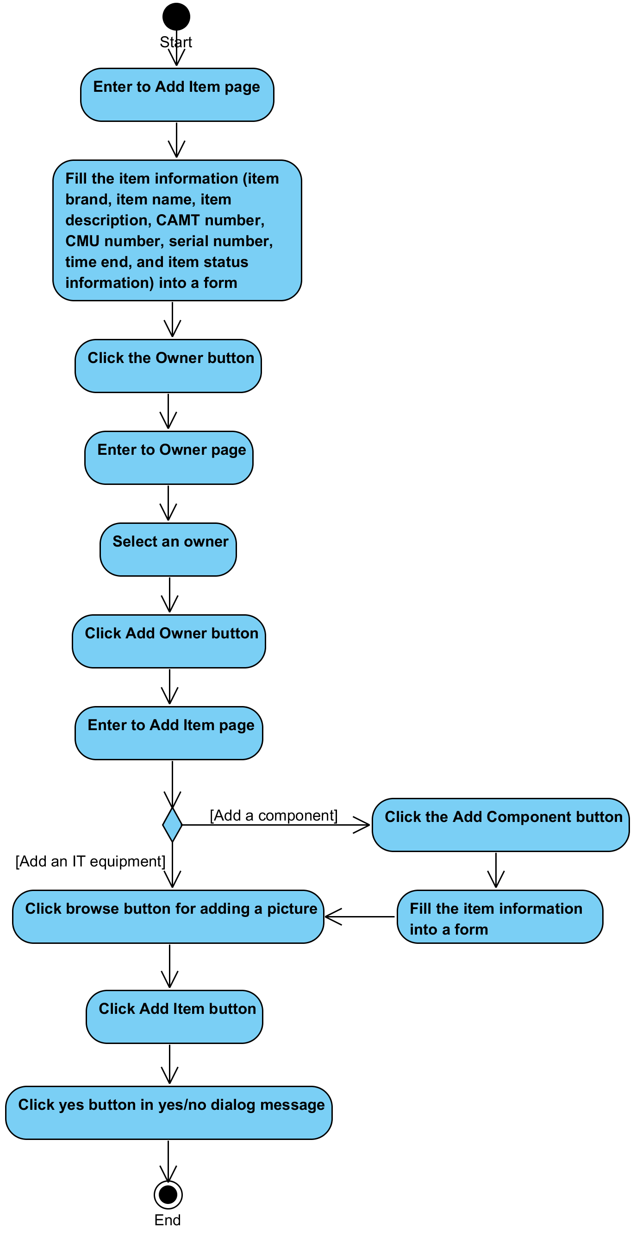

**System Requirement Specification of URS8**

SRS2-5 The system redirects to Reparation Management page.

SRS2-6 The system redirects to Users Management page.

SRS2-7 The system redirects to Items Management page.

SRS2-8 The system redirects to Items MIS page.

SRS2-9 The system redirects to Admin Information page.

SRS2-10 The system redirects to Login page.

SRS2-20 The system clears the user session.

SRS7-2 The system redirects to Add Item page.

SRS8-1 The system redirects to Owner page.

SRS8-2 The system displays all technician and reporter information.

SRS8-3 The system displays yes/no dialog massage “Do you sure to add an item?”.

SRS8-4 The system validates item brand, item name, item description, CAMT number, CMU number, serial number, time end, item status, owner, and picture information.

SRS8-5 The system records item information in the system.

SRS8-6 The system records a component information to the system.

SRS8-7 The system displays “Add items is success” on the web application.

SRS8-8 The system displays “Add Component” form.

SRS8-9 The system displays “Please you fill Item brand, Item name, Item description, Item status, and Item picture information” on the web application.

SRS8-10 The system displays “Please you fill CAMT number, CMU number, or Serial number” on the web application.

## **4.9 Administrator can edit IT equipment (UC9)**

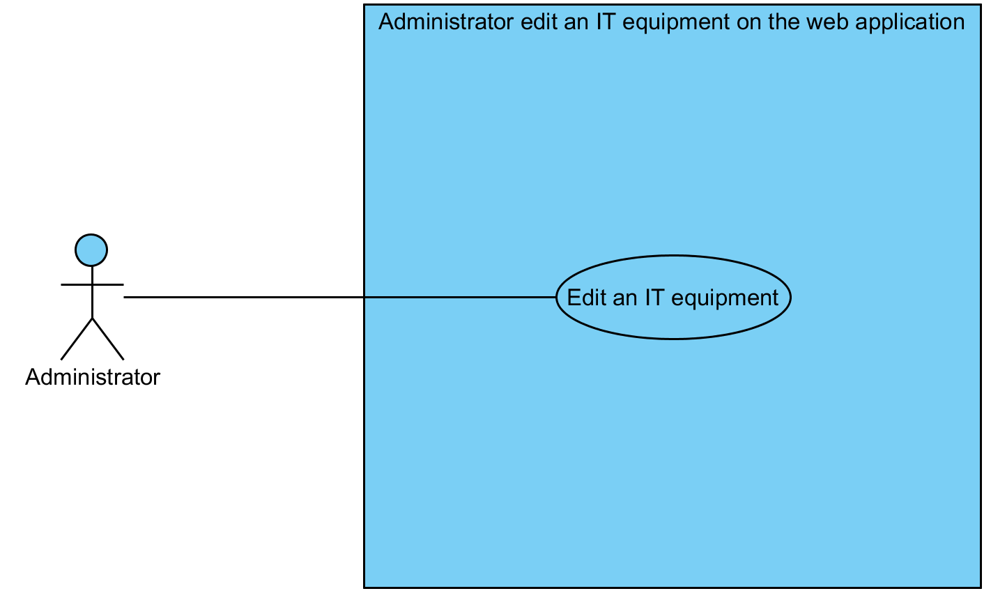

|  |  |  |  |  |
| --- | --- | --- | --- | --- |
| **Use Case ID:** | UC9 | | | |
| **Use Case Name:** | Administrator can edit IT equipment | | | |
| **Created By:** | Mr.Tanadol Parn-ong | | **Last Updated By:** | Mr.Tanadol Parn-ong |
| **Date Created:** | 18/06/2015 | | **Last Revision Date:** | 18/06/2015 |
| **Actors:** | | Administrator | | |
| **Description:** | | This use case is provided for Administrator can edit IT equipment. | | |
| **Trigger:** | | Administrator clicks the Edit item button. | | |
| **Preconditions:** | | The system must has IT equipment information in the system. | | |
| **Post conditions:** | | The system displays “Edit this item is success” on the web application. | | |
| **Normal Flow:** | | 1. Administrator enters to Item information page. 2. The system displays item information and item component information. 3. Administrator clicks the Edit Item Information button. 4. The system redirects to Edit Item page. 5. The system display item information in editing form. 6. Administrator enters to Edit Item page. 7. Administrator fills item brand, item name, item description, CAMT number, CMU number, serial number, time end, and item status information. 8. Administrator clicks the Owner button. 9. The system redirects to Edit Owner page. 10. The system displays all technician and reporter information. 11. Administrator enters to Edit Owner page. 12. Administrator selects an owner. 13. Administrator clicks Edit Owner button. 14. The system redirects to Edit Item page. 15. The system displays item information in editing form. 16. Administrator enters to Edit Item page. 17. Administrator clicks browse button for editing a picture. 18. Administrator clicks Edit Item button. 19. The system displays yes/no dialog massage “Do you sure to edit this item?”. 20. Administrator clicks yes button in yes/no dialog message. 21. The system validates item brand, item name, item description, CAMT number, CMU number, serial number, time end, item status, owner, and picture information. 22. The system updates item information in the system. 23. The system displays “Edit this item is success” on the web application. | | |
| **Alternative Flows:** | | 1. When Administrator clicks the Reparation Management button.  1.1. Administrator clicks the Reparation Management button.  1.2. The system redirects to Reparation Management page.  2. When Administrator clicks the Users Management button.  2.1. Administrator clicks the Users Management button.  2.2. The system redirects to Users Management page.  3. When Administrator clicks the Items Management button.  3.1. Administrator clicks the Items Management button.  3.2. The system redirects to Items Management page.  4. When Administrator clicks the MIS button.  4.1. Administrator clicks the MIS button.  4.2. The system redirects to MIS page.  5. When Administrator clicks the Admin Information button.  5.1. Administrator clicks the Admin Information button.  5.2. The system redirects to Admin Information page.  6. When Administrator clicks the Logout button.  6.1. Administrator clicks the Logout button.  6.2. The system redirects to Login page.  6.3 The system clears the user session.  7. When Administrator would like to add a component of IT equipment.  7.1. After step 2 of normal flow.  7.2 Administrator clicks the Add Component button.  7.3 The system redirects to Add Component page.  7.4 The system displays Add Component form.  7.5 Administrator enters to Add Component page.  7.6 Administrator fills item brand, item name, item description, CAMT number, CMU number, serial number, time end, item status information, and item picture.  7.7 Administrator clicks Add Item Component button.  7.8 The system displays yes/no dialog massage “Do you sure to add Item Component?”.  7.9 Administrator clicks yes button in yes/no dialog message.  7.10 The system validates item brand, item name, item description, CAMT number, CMU number, serial number, time end, item status, owner, and picture information.  7.11 The system records a component information to the system.  7.12 The system displays “Add component success” on the web application.  7.13 Use Case resumes on step 1 of normal flow  8. When Administrator would like to remove a component of IT equipment.  8.1. After step 2 of normal flow.  8.2 Administrator clicks the Remove Component button.  8.3 The system displays yes/no dialog massage “Do you sure to remove this item component?”.  8.4 Administrator clicks yes button in yes/no dialog message.  8.5 The system updates item information in the system.  8.6 Use Case resumes on step 2 of normal flow  9. When Administrator don’t fill item brand information after he clicks the Edit Item button. The system provides the error message as followed:  9.1. The system displays “Please you fill Item brand” on the web application.  9.2. Use Case resumes on step 6 of normal flow.  10. When Administrator don’t fill item name information after he clicks the Edit Item button. The system provides the error message as followed:  10.1. The system displays “Please you fill Item name” on the web application.  10.2. Use Case resumes on step 6 of normal flow.  11. When Administrator don’t fill item description after he clicks the Edit Item button. The system provides the error message as followed:  11.1. The system displays “Please you fill Item description” on the web application.  11.2. Use Case resumes on step 6 of normal flow.  12. When Administrator don’t fill item status information after he clicks the Edit Item button. The system provides the error message as followed:  12.1. The system displays “Please you fill Item status” on the web application.  12.2. Use Case resumes on step 6 of normal flow.  13. When Administrator don’t fill CAMT number and CMU number and Serial number after he clicks the Eit Item button. The system provides the error message as followed:  13.1. The system displays “Please you fill CAMT number, CMU number, or Serial number” on the web application.  13.2. Use Case resumes on step 6 of normal flow.  14. When Administrator don’t fill item brand information after he clicks the Add component button. The system provides the error message as followed:  14.1. The system displays “Please you fill Item brand” on the web application.  14.2. Use Case resumes on step 7.5 of normal flow.  15. When Administrator don’t fill item name information after he clicks the Add component button. The system provides the error message as followed:  15.1. The system displays “Please you fill Item name” on the web application.  15.2. Use Case resumes on step 7.5 of normal flow.  16. When Administrator don’t fill item description after he clicks the Add component button. The system provides the error message as followed:  16.1. The system displays “Please you fill Item description” on the web application.  16.2. Use Case resumes on step 7.5 of normal flow.  17. When Administrator don’t fill item status information after he clicks the Add component button. The system provides the error message as followed:  17.1. The system displays “Please you fill Item status” on the web application.  17.2. Use Case resumes on step 7.5 of normal flow.  18. When Administrator don’t select item picture information after he clicks the Add component button. The system provides the error message as followed:  18.1. The system displays “Please you select Item picture” on the web application.  18.2. Use Case resumes on step 7.5 of normal flow.  19. When Administrator don’t fill CAMT number and CMU number and Serial number after he clicks the Add component button. The system provides the error message as followed:  19.1. The system displays “Please you fill CAMT number, CMU number, or Serial number” on the web application.  19.2. Use Case resumes on step 7.5 of normal flow. | | |
| **Exceptions:** | | N/A | | |
| **Includes:** | | N/A | | |
| **Frequency of Use:** | | Often | | |
| **Assumptions:** | | N/A | | |
| **Notes and Issues:** | | N/A | | |

**URS9 Administrator can edit an IT equipment.**

Administrator can edit IT equipment information in Edit Item page. IT equipment detail consists item brand, item name, item description, CAMT number, CMU number, serial number, time end, item status information, and item picture. Moreover, Administrator can edit or remove a component of IT equipment information.

**Actor:** Administrator

**Prerequisite:** The system must has IT equipment information in the system.

**Input:**

**IT equipment**

|  |  |  |  |
| --- | --- | --- | --- |
| Name | Description | Example | Remarks |
| item brand | Can be any character only | “Apple” |  |
| item name | Can be any character only | “Mac” |  |
| item description | Can be any character only | “iMac” |  |
| CAMT number | - Can be any character only  - Can be null value | “CAMT01” |  |
| CMU number | - Can be any character only  - Can be null value | “CMU01” |  |
| serial number | - Can be any character only  - Can be null value | “” |  |
| time end | Time format | “2015-06-20 00:00:00.0000000” |  |
| item status | Can be any character only | “Good” |  |
| item picture | Picture file | “picItem-1.jpg” |  |
| Item Owner | Users in the system | “reporter one” |  |

**IT equipment Component**

|  |  |  |  |
| --- | --- | --- | --- |
| Name | Description | Example | Remarks |
| item brand | Can be any character only | “RAM Thailand” |  |
| item name | Can be any character only | “RAM” |  |
| item description | Can be any character only | “RAM” |  |
| CAMT number | - Can be any character only  - Can be null value | “CAMT02” |  |
| CMU number | - Can be any character only  - Can be null value | “CMU02” |  |
| serial number | - Can be any character only  - Can be null value | “” |  |
| time end | Time format | “2015-06-20 00:00:00.0000000” |  |
| item status | Can be any character only | “Good” |  |
| item picture | Picture file | “picItem-2.jpg” |  |

**Flow of Execution:**

1. Administrator enters to Item information page.
2. Administrator clicks the Edit Item Information button.
3. Administrator enters to Edit Item page.
4. Administrator fills item brand, item name, item description, CAMT number, CMU number, serial number, time end, and item status information.
5. Administrator clicks the Owner button.
6. Administrator enters to Edit Owner page.
7. Administrator selects an owner.
8. Administrator clicks Edit Owner button.
9. Administrator enters to Edit Item page.
10. Administrator clicks browse button for editing a picture.
11. Administrator clicks Edit Item button.
12. Administrator clicks yes button in yes/no dialog message.

**Alternative:**

If Administrator would like to add a component.

1. After step 1 in flow of execution.
2. Administrator clicks the Add Component button.
3. Administrator enters to Add Component page.
4. Administrator fills item brand, item name, item description, CAMT number, CMU number, serial number, time end, item status information, and item picture.
5. Administrator clicks Add Item Component button.
6. Administrator clicks yes button in yes/no dialog message.

If Administrator would like to romove a component.

1. After step 1 in flow of execution.
2. Administrator clicks the Remove Component button.
3. Administrator clicks yes button in yes/no dialog message.

**AC9 Administrator can edit an IT equipment.**

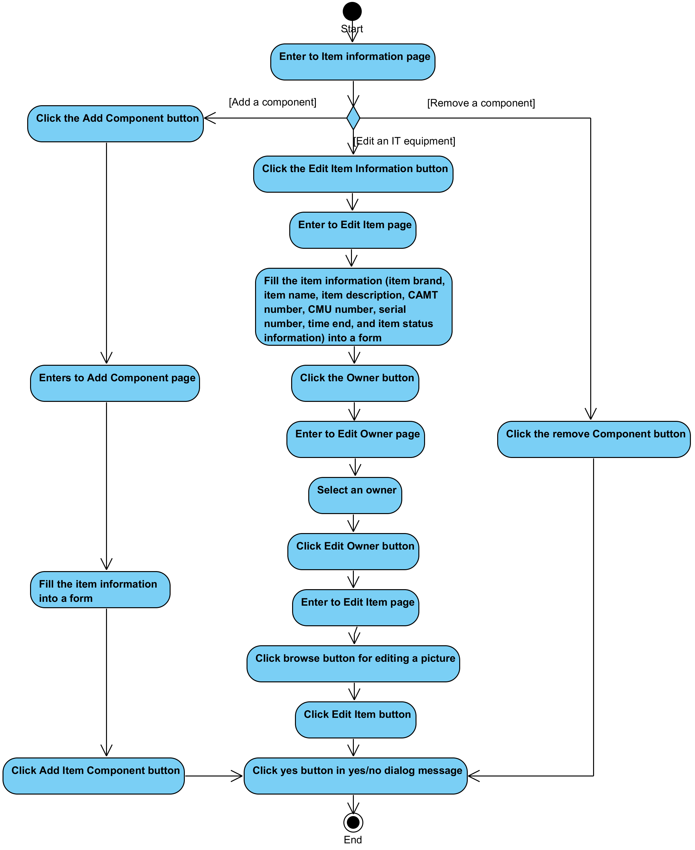

**System Requirement Specification of URS9**

SRS2-5 The system redirects to Reparation Management page.

SRS2-6 The system redirects to Users Management page.

SRS2-7 The system redirects to Items Management page.

SRS2-8 The system redirects to Items MIS page.

SRS2-9 The system redirects to Admin Information page.

SRS2-10 The system redirects to Login page.

SRS2-20 The system clears the user session.

SRS8-2 The system displays all technician and reporter information.

SRS8-4 The system validates item brand, item name, item description, CAMT number, CMU number, serial number, time end, item status, owner, and picture information.

SRS8-10 The system displays “Please you fill CAMT number, CMU number, or Serial number” on the web application.

SRS9-1 The system displays item information and item component information.

SRS9-2 The system redirects to Edit Item page.

SRS9-3 The system display item information in editing form.

SRS9-4 The system redirects to Edit Owner page.

SRS9-5 The system displays item information in editing form.

SRS9-6 The system displays yes/no dialog massage “Do you sure to edit this item?”.

SRS9-7 The system updates item information in the system.

SRS9-8 The system displays “Edit this item is success” on the web application.

SRS9-9 The system redirects to Add Component page.

SRS9-10 The system displays Add Component form.

SRS9-11 The system displays yes/no dialog massage “Do you sure to add Item Component?”

SRS9-12 The system records a component information to the system.

SRS9-13 The system displays “Add component success” on the web application.

SRS9-14 The system displays yes/no dialog massage “Do you sure to remove this item component?”.

SRS9-15 The system displays “Please you fill Item brand” on the web application.

SRS9-16 The system displays “Please you fill Item name” on the web application.

SRS9-17 The system displays “Please you fill Item description” on the web application.

SRS9-18 The system displays “Please you fill Item status” on the web application.

## **4.10 Administrator can view IT equipment that expire (UC10)**

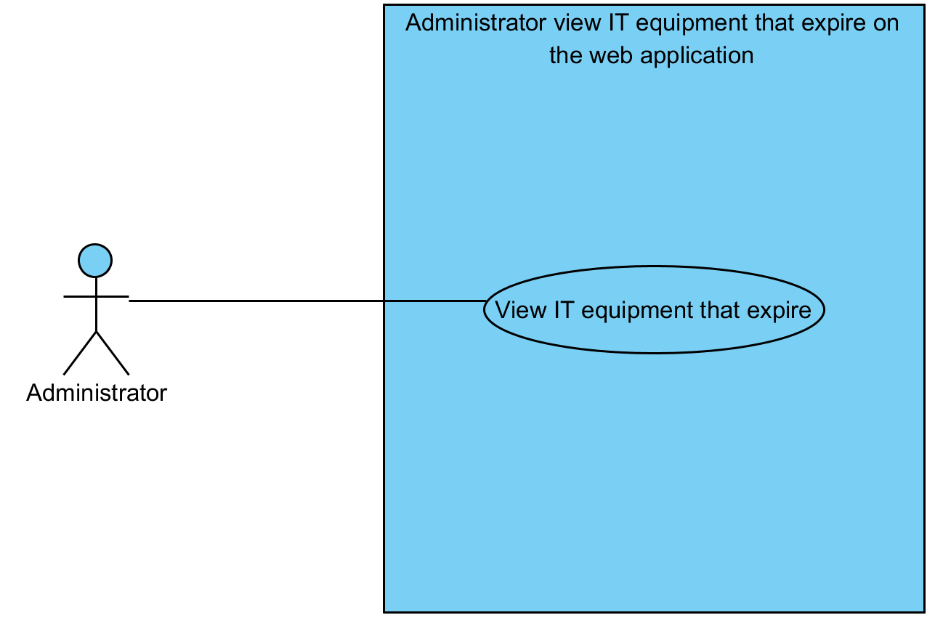

|  |  |  |  |  |
| --- | --- | --- | --- | --- |
| **Use Case ID:** | UC10 | | | |
| **Use Case Name:** | Administrator can view IT equipment that expire | | | |
| **Created By:** | Mr.Tanadol Parn-ong | | **Last Updated By:** | Mr.Tanadol Parn-ong |
| **Date Created:** | 18/06/2015 | | **Last Revision Date:** | 18/06/2015 |
| **Actors:** | | Administrator | | |
| **Description:** | | This use case is provided for Administrator can view IT equipment that expire | | |
| **Trigger:** | | Administrator clicks the View Item Expire button. | | |
| **Preconditions:** | | The system must has IT equipment information in the system. | | |
| **Post conditions:** | | The system displays all IT equipment that will expire in Items MIS page. | | |
| **Normal Flow:** | | 1. Administrator enters MIS page. 2. Administrator clicks the Items MIS button. 3. The system redirects to Items MIS page. 4. Administrator enters to Items MIS page. 5. Administrator selects time start and time end in Items MIS page. 6. Administrator clicks the View Item Expire button. 7. The system displays all IT equipment that will expire in Items MIS page. | | |
| **Alternative Flows:** | | 1. When Administrator clicks the Reparation Management button.  1.1. Administrator clicks the Reparation Management button.  1.2. The system redirects to Reparation Management page.  2. When Administrator clicks the Users Management button.  2.1. Administrator clicks the Users Management button.  2.2. The system redirects to Users Management page.  3. When Administrator clicks the Items Management button.  3.1. Administrator clicks the Items Management button.  3.2. The system redirects to Items Management page.  4. When Administrator clicks the MIS button.  4.1. Administrator clicks the MIS button.  4.2. The system redirects to MIS page.  5. When Administrator clicks the Admin Information button.  5.1. Administrator clicks the Admin Information button.  5.2. The system redirects to Admin Information page.  6. When Administrator clicks the Logout button.  6.1. Administrator clicks the Logout button.  6.2. The system redirects to Login page.  6.3 The system clears the user session. | | |
| **Exceptions:** | | N/A | | |
| **Includes:** | | N/A | | |
| **Frequency of Use:** | | Often | | |
| **Assumptions:** | | N/A | | |
| **Notes and Issues:** | | N/A | | |

**URS10 Administrator can view IT equipment that expire.**

Administrator can view IT equipment that expire. He must select time start and time end to define duration time of expire date.

**Actor:** Administrator

**Prerequisite:** The system must has IT equipment information in the system.

**Input:**N/A **Flow of Execution:**

1. Administrator enters MIS page.
2. Administrator clicks the Items MIS button.
3. Administrator enters to Items MIS page.
4. Administrator selects time start and time end in Items MIS page.
5. Administrator clicks the View Item Expire button.

**AC10 Administrator can view IT equipment that expire.**

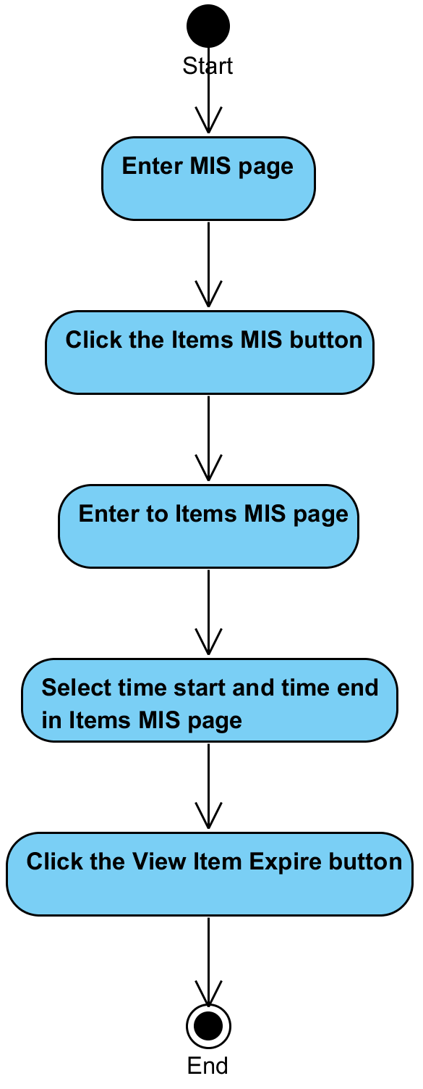

**System Requirement Specification of URS10**

SRS2-5 The system redirects to Reparation Management page.

SRS2-6 The system redirects to Users Management page.

SRS2-7 The system redirects to Items Management page.

SRS2-8 The system redirects to Items MIS page.

SRS2-9 The system redirects to Admin Information page.

SRS2-10 The system redirects to Login page.

SRS2-20 The system clears the user session.

SRS10-1 The system redirects to Items MIS page.

SRS10-2 The system displays all IT equipment that will expire in Items MIS page.

## **4.11 Administrator can view IT equipment that are often broken (UC11)**

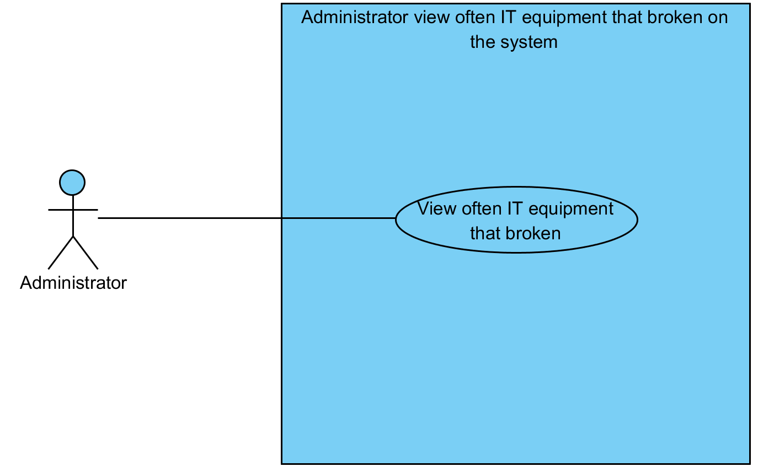

|  |  |  |  |  |
| --- | --- | --- | --- | --- |
| **Use Case ID:** | UC11 | | | |
| **Use Case Name:** | Administrator can view IT equipment that are often broken | | | |
| **Created By:** | Mr.Tanadol Parn-ong | | **Last Updated By:** | Mr.Tanadol Parn-ong |
| **Date Created:** | 18/06/2015 | | **Last Revision Date:** | 18/06/2015 |
| **Actors:** | | Administrator | | |
| **Description:** | | This use case is provided for Administrator can view IT equipment that are often broken | | |
| **Trigger:** | | Administrator clicks the View Items button. | | |
| **Preconditions:** | | The system must has IT equipment information in the system. | | |
| **Post conditions:** | | The system displays all IT equipment that are often broken from information type in Items MIS page. | | |
| **Normal Flow:** | | 1. Administrator enters MIS page. 2. The system redirects to Items MIS page. 3. Administrator enters to Items MIS page. 4. Administrator selects information type (item brand, item name) in Items MIS page. 5. Administrator clicks the View Items button. 6. The system displays all IT equipment that are often broken from information type in Items MIS page. | | |
| **Alternative Flows:** | | 1. When Administrator clicks the Reparation Management button.  1.1. Administrator clicks the Reparation Management button.  1.2. The system redirects to Reparation Management page.  2. When Administrator clicks the Users Management button.  2.1. Administrator clicks the Users Management button.  2.2. The system redirects to Users Management page.  3. When Administrator clicks the Items Management button.  3.1. Administrator clicks the Items Management button.  3.2. The system redirects to Items Management page.  4. When Administrator clicks the MIS button.  4.1. Administrator clicks the MIS button.  4.2. The system redirects to MIS page.  5. When Administrator clicks the Admin Information button.  5.1. Administrator clicks the Admin Information button.  5.2. The system redirects to Admin Information page.  6. When Administrator clicks the Logout button.  6.1. Administrator clicks the Logout button.  6.2. The system redirects to Login page.  6.3 The system clears the user session. | | |
| **Exceptions:** | | N/A | | |
| **Includes:** | | N/A | | |
| **Frequency of Use:** | | Often | | |
| **Assumptions:** | | N/A | | |
| **Notes and Issues:** | | N/A | | |

**URS11 Administrator can view IT equipment that are often broken.**

Administrator can view IT equipment that are often broken. Administrator must select information type (item brand, item name) for finding.

**Actor:** Administrator

**Prerequisite:** The system must has IT equipment information in the system.

**Input:**N/A **Flow of Execution:**

1. Administrator enters MIS page.
2. Administrator clicks the Items MIS button.
3. Administrator enters to Items MIS page.
4. Administrator selects information type (item brand, item name) in Items MIS page.
5. Administrator clicks the View Items button.

**AC11 Administrator can view IT equipment that are often broken.**

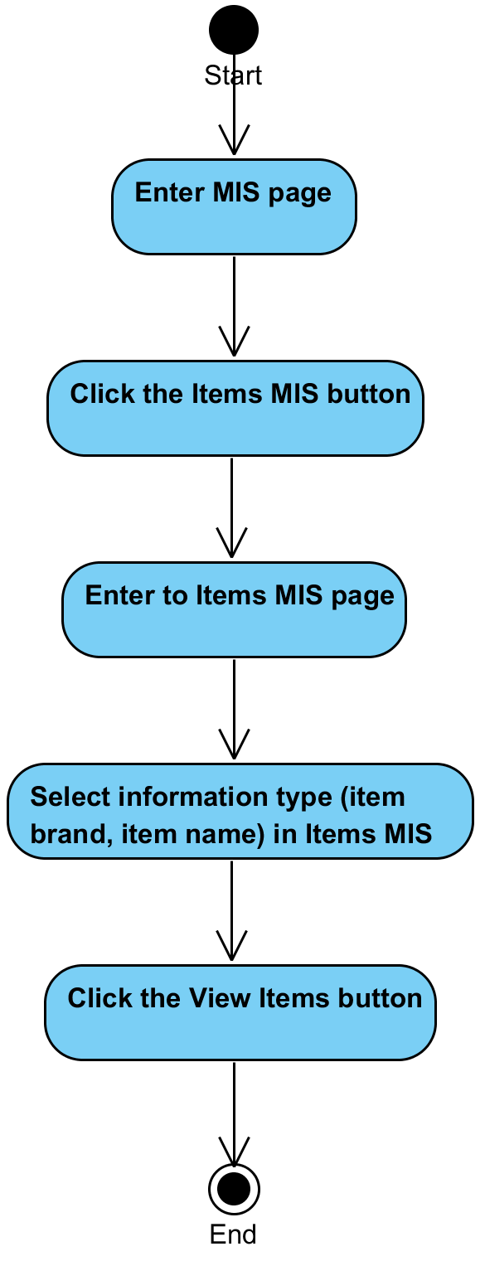

**System Requirement Specification of URS11**

SRS2-5 The system redirects to Reparation Management page.

SRS2-6 The system redirects to Users Management page.

SRS2-7 The system redirects to Items Management page.

SRS2-8 The system redirects to Items MIS page.

SRS2-9 The system redirects to Admin Information page.

SRS2-10 The system redirects to Login page.

SRS2-20 The system clears the user session.

SRS10-1 The system redirects to Items MIS page.

SRS11-1 The system displays all IT equipment that are often broken from information type in Items MIS page.

## **4.12 Administrator can view an IT equipment Information (UC12)**

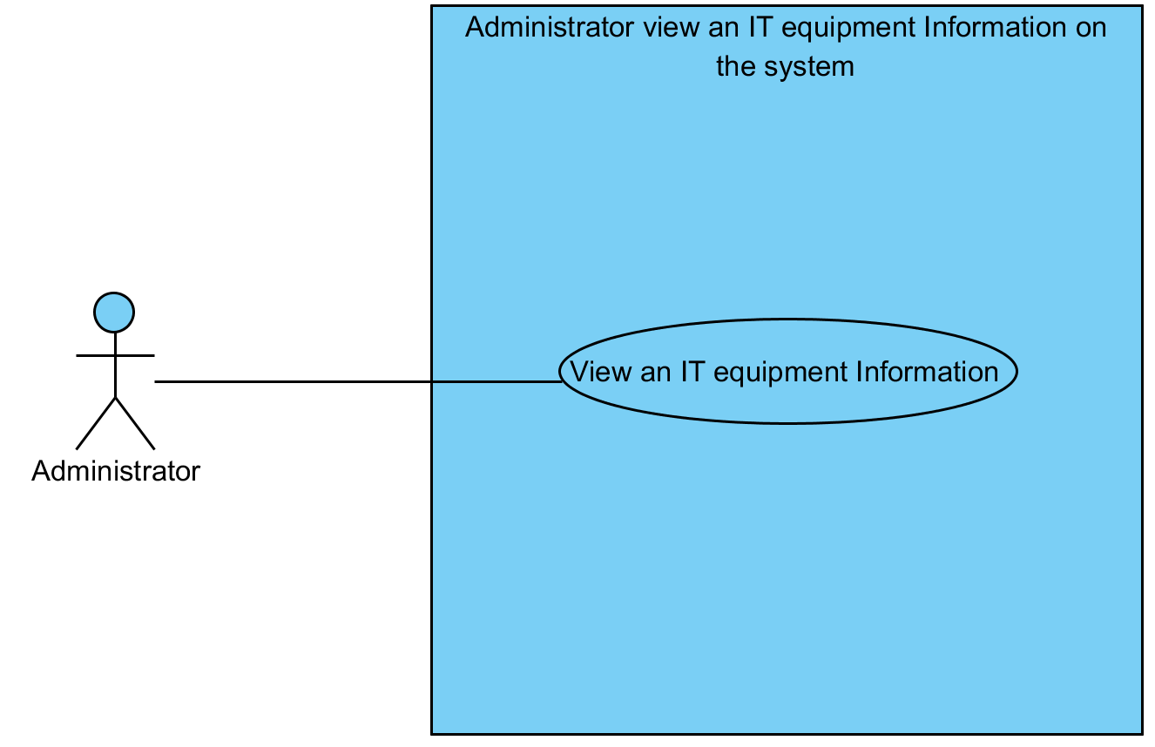

|  |  |  |  |  |
| --- | --- | --- | --- | --- |
| **Use Case ID:** | UC12 | | | |
| **Use Case Name:** | Administrator can view an IT equipment Information | | | |
| **Created By:** | Mr.Tanadol Parn-ong | | **Last Updated By:** | Mr.Tanadol Parn-ong |
| **Date Created:** | 18/06/2015 | | **Last Revision Date:** | 18/06/2015 |
| **Actors:** | | Administrator | | |
| **Description:** | | Administrator can view an IT equipment Information | | |
| **Trigger:** | | Administrator clicks the View button. | | |
| **Preconditions:** | | The system must has IT equipment information in the system. | | |
| **Post conditions:** | | The system displays IT equipment information in Items Information page. | | |
| **Normal Flow:** | | 1. Administrator clicks the View button. 2. The system redirects to Item Information page. 3. The system displays IT equipment information in Items Information page. 4. Administrator enter to the Items Information page. | | |
| **Alternative Flows:** | | 1. When Administrator clicks the Reparation Management button.  1.1. Administrator clicks the Reparation Management button.  1.2. The system redirects to Reparation Management page.  2. When Administrator clicks the Users Management button.  2.1. Administrator clicks the Users Management button.  2.2. The system redirects to Users Management page.  3. When Administrator clicks the Items Management button.  3.1. Administrator clicks the Items Management button.  3.2. The system redirects to Items Management page.  4. When Administrator clicks the MIS button.  4.1. Administrator clicks the MIS button.  4.2. The system redirects to MIS page.  5. When Administrator clicks the Admin Information button.  5.1. Administrator clicks the Admin Information button.  5.2. The system redirects to Admin Information page.  6. When Administrator clicks the Logout button.  6.1. Administrator clicks the Logout button.  6.2. The system redirects to Login page.  6.3 The system clears the user session. | | |
| **Exceptions:** | | N/A | | |
| **Includes:** | | N/A | | |
| **Frequency of Use:** | | Often | | |
| **Assumptions:** | | N/A | | |
| **Notes and Issues:** | | N/A | | |

**URS12 Administrator can view an IT equipment Information.**

Administrator can view an IT equipment Information in Items Information page

**Actor:** Administrator

**Prerequisite:** The system must has IT equipment information in the system.

**Input:**N/A **Flow of Execution:**

1. Administrator clicks the View button.
2. Administrator enter to the Items Information page.

**AC12 Administrator can view an IT equipment Information.**

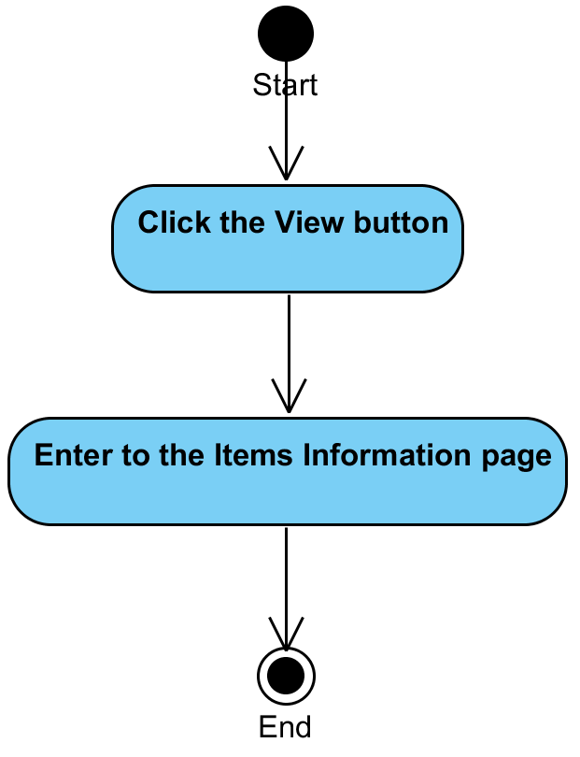

**System Requirement Specification of URS12**

SRS2-5 The system redirects to Reparation Management page.

SRS2-6 The system redirects to Users Management page.

SRS2-7 The system redirects to Items Management page.

SRS2-8 The system redirects to Items MIS page.

SRS2-9 The system redirects to Admin Information page.

SRS2-10 The system redirects to Login page.

SRS2-20 The system clears the user session.

SRS7-3 The system redirects to Item Information page.

SRS12-1 The system displays IT equipment information in Items Information page.

## **4.13 Administrator can define type of broken of IT equipment (UC13)**

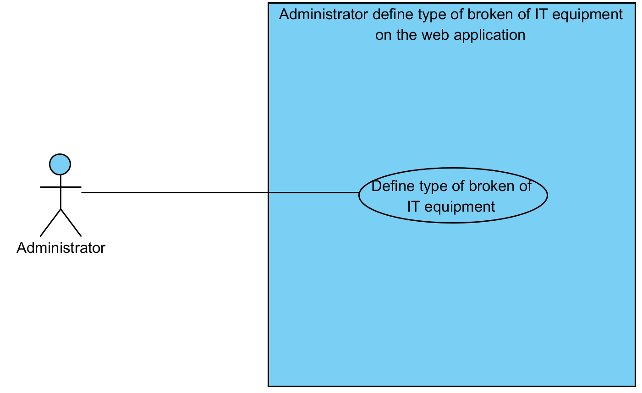

|  |  |  |  |  |
| --- | --- | --- | --- | --- |
| **Use Case ID:** | UC13 | | | |
| **Use Case Name:** | Administrator can define type of broken of IT equipment | | | |
| **Created By:** | Mr.Tanadol Parn-ong | | **Last Updated By:** | Mr.Tanadol Parn-ong |
| **Date Created:** | 18/06/2015 | | **Last Revision Date:** | 18/06/2015 |
| **Actors:** | | Administrator | | |
| **Description:** | | Administrator can define type of broken of IT equipment. | | |
| **Trigger:** | | Administrator clicks the Define type button. | | |
| **Preconditions:** | | The system must has IT equipment information in the system. | | |
| **Post conditions:** | | The system displays “Define type of broken already” on the web application. | | |
| **Normal Flow:** | | 1. Administrator enters to Reparation Management page. 2. Administrator clicks the New Reparation button. 3. The system redirects to New Reparation page. 4. The system displays all new reparation that are informed by Reporter. 5. Administrator enters to New Reparation page. 6. Administrator selects type of broken in New Reparation page. 7. Administrator clicks the Define type button. 8. The system displays yes/no dialog massage “Do you sure to define type of broken?”. 9. Administrator clicks yes button in yes/no dialog message. 10. The system distributes a task automatically by calculating the average of time to repair in each job of the technician. 11. The system updates report information in the system. 12. The system displays “Define type of broken already” on the web application. | | |
| **Alternative Flows:** | | 1. When Administrator clicks the Reparation Management button.  1.1. Administrator clicks the Reparation Management button.  1.2. The system redirects to Reparation Management page.  2. When Administrator clicks the Users Management button.  2.1. Administrator clicks the Users Management button.  2.2. The system redirects to Users Management page.  3. When Administrator clicks the Items Management button.  3.1. Administrator clicks the Items Management button.  3.2. The system redirects to Items Management page.  4. When Administrator clicks the MIS button.  4.1. Administrator clicks the MIS button.  4.2. The system redirects to MIS page.  5. When Administrator clicks the Admin Information button.  5.1. Administrator clicks the Admin Information button.  5.2. The system redirects to Admin Information page.  6. When Administrator clicks the Logout button.  6.1. Administrator clicks the Logout button.  6.2. The system redirects to Login page.  6.3 The system clears the user session. | | |
| **Exceptions:** | | N/A | | |
| **Includes:** | | N/A | | |
| **Frequency of Use:** | | Often | | |
| **Assumptions:** | | N/A | | |
| **Notes and Issues:** | | N/A | | |

**URS13 Administrator can define type of broken of IT equipment.**

Administrator can define type of broken of IT equipment in New Reparation page.

**Actor:** Administrator

**Prerequisite:** The system must has IT equipment information in the system.

**Input:**N/A **Flow of Execution:**

1. Administrator enters to Reparation Management page.
2. Administrator clicks the New Reparation button.
3. Administrator enters to New Reparation page.
4. Administrator selects type of broken in New Reparation page.
5. Administrator clicks the Define type button.
6. Administrator clicks yes button in yes/no dialog message.

**AC13 Administrator can define type of broken of IT equipment.**

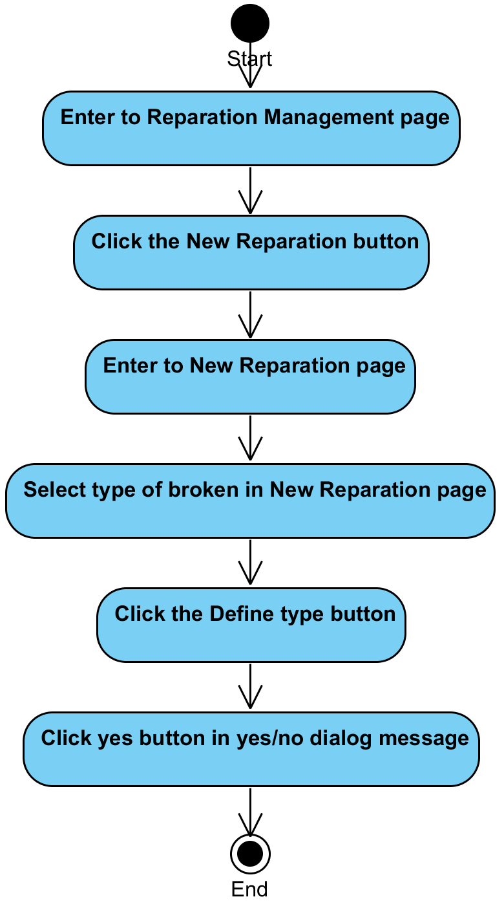

**System Requirement Specification of URS13**

SRS2-5 The system redirects to Reparation Management page.

SRS2-6 The system redirects to Users Management page.

SRS2-7 The system redirects to Items Management page.

SRS2-8 The system redirects to Items MIS page.

SRS2-9 The system redirects to Admin Information page.

SRS2-10 The system redirects to Login page.

SRS2-20 The system clears the user session.

SRS13-1 The system redirects to New Reparation page.

SRS13-2 The system displays all new reparation that are informed by Reporter.

SRS13-3 The system displays yes/no dialog massage “Do you sure to define type of broken?”.

SRS13-4 The system distributes a task automatically by calculating the average of time to repair in each job of the technician

SRS13-5 The system updates report information in the system.

SRS13-6 The system displays “Define type of broken already” on the web application.

## **4.14 Administrator can view all repair tasks of a technician (UC14)**

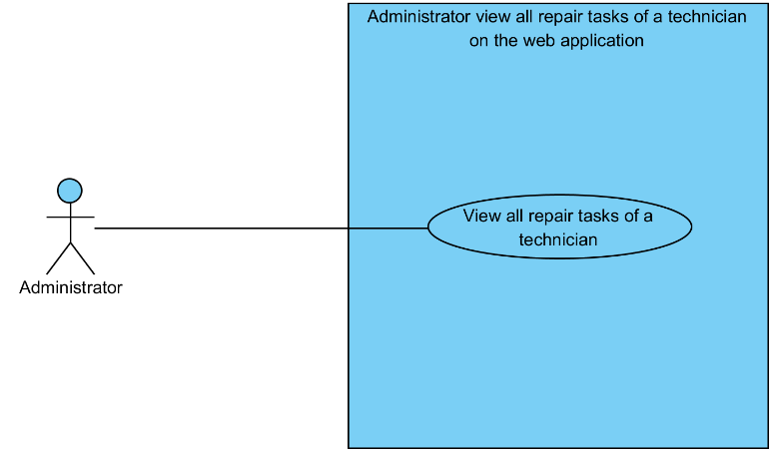

|  |  |  |  |  |
| --- | --- | --- | --- | --- |
| **Use Case ID:** | UC14 | | | |
| **Use Case Name:** | Administrator can view all repair tasks of a technician | | | |
| **Created By:** | Mr.Tanadol Parn-ong | | **Last Updated By:** | Mr.Tanadol Parn-ong |
| **Date Created:** | 18/06/2015 | | **Last Revision Date:** | 18/06/2015 |
| **Actors:** | | Administrator | | |
| **Description:** | | This use case is provided for Administrator can view all repair tasks of a technician | | |
| **Trigger:** | | Administrator clicks the View Reparation button. | | |
| **Preconditions:** | | The system must has repair task information in the system. | | |
| **Post conditions:** | | The system displays all repair task information of that Technician in Technician’s Reparation page. | | |
| **Normal Flow:** | | 1. Administrator enters to Reparation Management page. 2. Administrator clicks All Reparation button. 3. The system redirects to All Reparation page. 4. The system displays all technician information. 5. Administrator enters to All Reparation page. 6. Administrator clicks the View Reparation button. 7. The system redirects to Technician’s Reparation page. 8. The system displays all repair task information of that Technician in Technician’s Reparation page. 9. Administrator enters to Technician’s Reparation page. | | |
| **Alternative Flows:** | | 1. When Administrator clicks the Reparation Management button.  1.1. Administrator clicks the Reparation Management button.  1.2. The system redirects to Reparation Management page.  2. When Administrator clicks the Users Management button.  2.1. Administrator clicks the Users Management button.  2.2. The system redirects to Users Management page.  3. When Administrator clicks the Items Management button.  3.1. Administrator clicks the Items Management button.  3.2. The system redirects to Items Management page.  4. When Administrator clicks the MIS button.  4.1. Administrator clicks the MIS button.  4.2. The system redirects to MIS page.  5. When Administrator clicks the Admin Information button.  5.1. Administrator clicks the Admin Information button.  5.2. The system redirects to Admin Information page.  6. When Administrator clicks the Logout button.  6.1. Administrator clicks the Logout button.  6.2. The system redirects to Login page.  6.3 The system clears the user session. | | |
| **Exceptions:** | | N/A | | |
| **Includes:** | | N/A | | |
| **Frequency of Use:** | | Often | | |
| **Assumptions:** | | N/A | | |
| **Notes and Issues:** | | N/A | | |

**URS14 Administrator can view all repair tasks of a technician.**

Administrator can view all repair tasks of a technician in Technician’s Reparation page

**Actor:** Administrator

**Prerequisite:** The system must has repair task information in the system.

**Input:**N/A **Flow of Execution:**

1. Administrator enters to Reparation Management page.
2. Administrator clicks All Reparation button.
3. Administrator enters to All Reparation page.
4. Administrator clicks the View Reparation button.
5. Administrator enters to Technician’s Reparation page.

**AC14 Administrator can view all repair tasks of a technician**

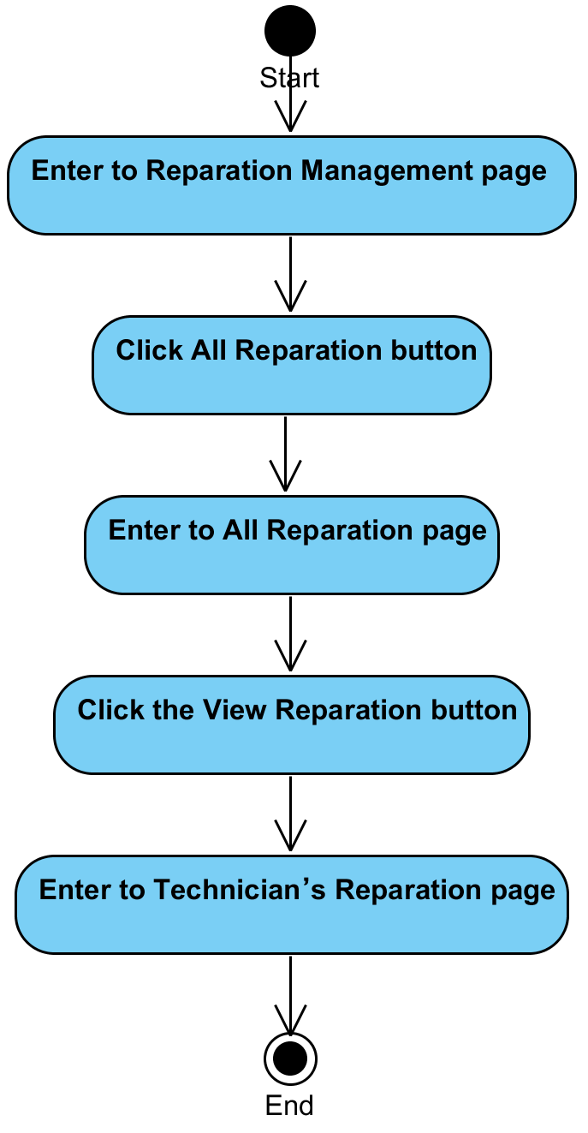

**System Requirement Specification of URS14**

SRS2-5 The system redirects to Reparation Management page.

SRS2-6 The system redirects to Users Management page.

SRS2-7 The system redirects to Items Management page.

SRS2-8 The system redirects to Items MIS page.

SRS2-9 The system redirects to Admin Information page.

SRS2-10 The system redirects to Login page.

SRS2-20 The system clears the user session.

SRS14-1 The system redirects to All Reparation page.

SRS14-2 The system displays all technician information.

SRS14-3 The system redirects to Technician’s Reparation page.

SRS14-4 The system displays all repair task information of that Technician in Technician’s Reparation page.

## **4.15 Administrator can request to distribute repair tasks again to the system (UC15)**

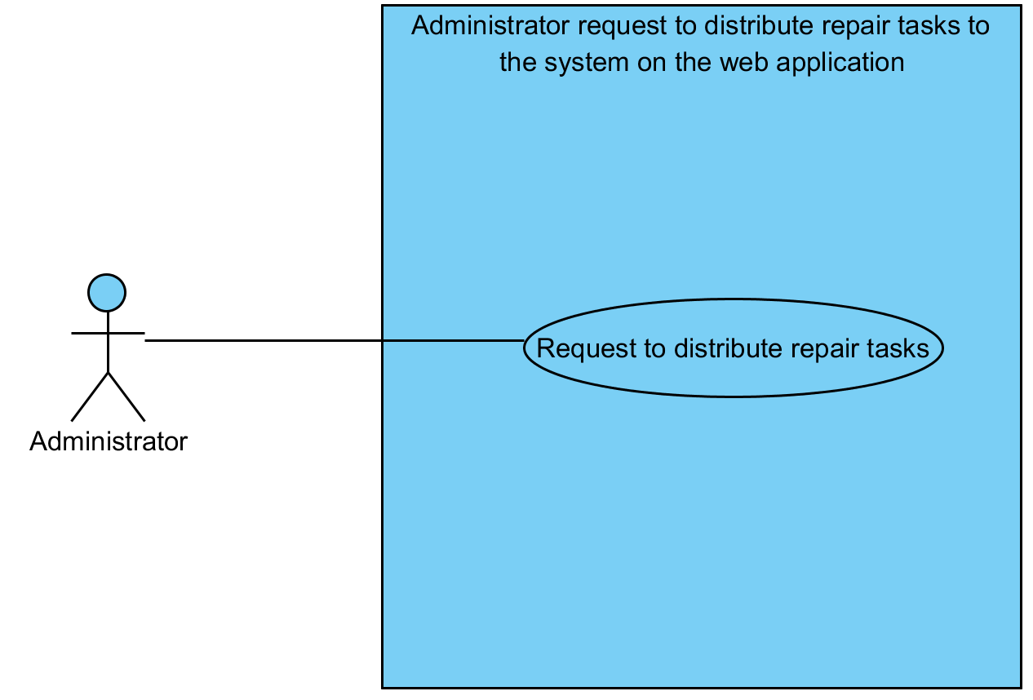

|  |  |  |  |  |
| --- | --- | --- | --- | --- |
| **Use Case ID:** | UC15 | | | |
| **Use Case Name:** | Administrator can request to distribute repair tasks again to the system | | | |
| **Created By:** | Mr.Tanadol Parn-ong | | **Last Updated By:** | Mr.Tanadol Parn-ong |
| **Date Created:** | 18/06/2015 | | **Last Revision Date:** | 18/06/2015 |
| **Actors:** | | Administrator | | |
| **Description:** | | This use case is provided for Administrator can request to distribute repair tasks again to the system. Which the system will distributes a task automatically by calculating the average of time to repair in each job of the technician. | | |
| **Trigger:** | | Administrator clicks the Distribute button. | | |
| **Preconditions:** | | The system must has repair task information in the system. | | |
| **Post conditions:** | | The system displays “Repair task is distributed to a technician.” on the web application. | | |
| **Normal Flow:** | | 1. Administrator enters to Technician’s Reparation page. 2. Administrator clicks the Distribute button. 3. The system displays yes/no dialog massage “Do you sure to distribute repair tasks again ?”. 4. Administrator clicks yes button in yes/no dialog message. 5. The system distributes a task automatically by calculating the average of time to repair in each job of the technician. 6. The system updates report information in the system. 7. The system displays “Repair task is distributed to a technician” on the web application. | | |
| **Alternative Flows:** | | 1. When Administrator clicks the Reparation Management button.  1.1. Administrator clicks the Reparation Management button.  1.2. The system redirects to Reparation Management page.  2. When Administrator clicks the Users Management button.  2.1. Administrator clicks the Users Management button.  2.2. The system redirects to Users Management page.  3. When Administrator clicks the Items Management button.  3.1. Administrator clicks the Items Management button.  3.2. The system redirects to Items Management page.  4. When Administrator clicks the MIS button.  4.1. Administrator clicks the MIS button.  4.2. The system redirects to MIS page.  5. When Administrator clicks the Admin Information button.  5.1. Administrator clicks the Admin Information button.  5.2. The system redirects to Admin Information page.  6. When Administrator clicks the Logout button.  6.1. Administrator clicks the Logout button.  6.2. The system redirects to Login page.  6.3 The system clears the user session. | | |
| **Exceptions:** | | N/A | | |
| **Includes:** | | N/A | | |
| **Frequency of Use:** | | Often | | |
| **Assumptions:** | | N/A | | |
| **Notes and Issues:** | | N/A | | |

**URS15 Administrator can request to distribute repair tasks again to the system**

Administrator can request to distribute repair tasks again to the system. Which Administrator clicks the Distribute button in Technician’s Reparation page

**Actor:** Administrator

**Prerequisite:** The system must has repair task information in the system.

**Input:**N/A **Flow of Execution:**

1. Administrator enters to Technician’s Reparation page.
2. Administrator clicks the Distribute button.
3. Administrator clicks yes button in yes/no dialog message.

**AC15 Administrator can request to distribute repair tasks again to the system**

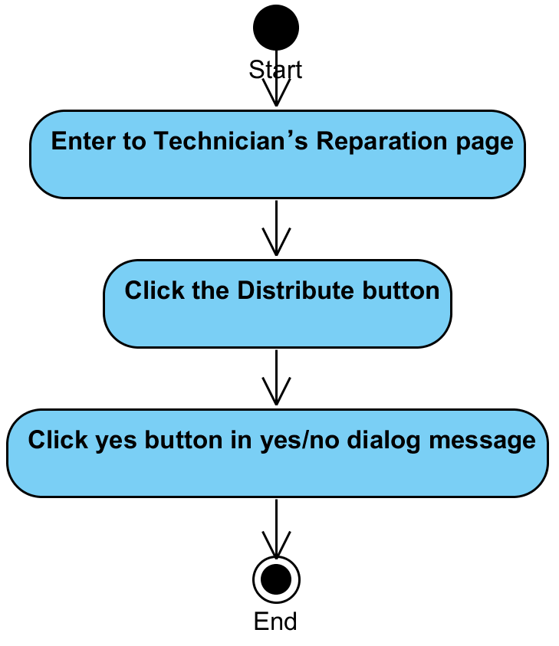

**System Requirement Specification of URS15**

SRS2-5 The system redirects to Reparation Management page.

SRS2-6 The system redirects to Users Management page.

SRS2-7 The system redirects to Items Management page.

SRS2-8 The system redirects to Items MIS page.

SRS2-9 The system redirects to Admin Information page.

SRS2-10 The system redirects to Login page.

SRS2-20 The system clears the user session.

SRS13-4 The system distributes a task automatically by calculating the average of time to repair in each job of the technician

SRS13-5 The system updates report information in the system.

SRS15-1 The system displays yes/no dialog massage “Do you sure to distribute repair tasks again ?

SRS15-2 The system displays “Repair task is distributed to a technician” on the web application.

## **4.16 Administrator can update his account information (UC16)**

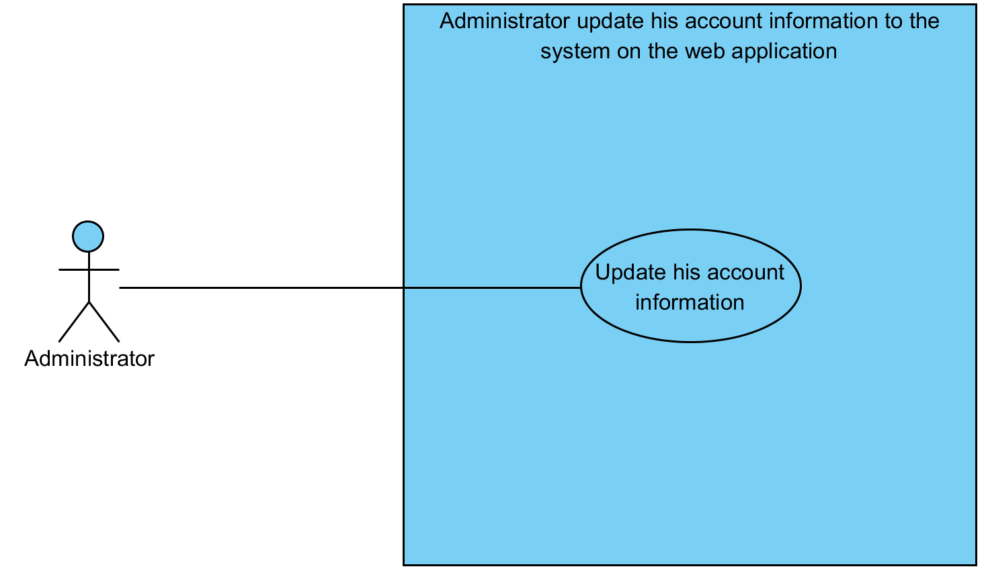

|  |  |  |  |  |
| --- | --- | --- | --- | --- |
| **Use Case ID:** | UC16 | | | |
| **Use Case Name:** | Administrator can update his account information | | | |
| **Created By:** | Mr.Tanadol Parn-ong | | **Last Updated By:** | Mr.Tanadol Parn-ong |
| **Date Created:** | 18/06/2015 | | **Last Revision Date:** | 18/06/2015 |
| **Actors:** | | Administrator | | |
| **Description:** | | This use case is provided for Administrator can update his account information in the system. | | |
| **Trigger:** | | When Administrator would like to edit basic information.   * Administrator clicks the Update Information button.   When Administrator would like to edit his password.   * Administrator clicks the Change Password button. | | |
| **Preconditions:** | | The system must has an administrator account information in the system. | | |
| **Post conditions:** | | When Administrator would like to edit basic information.   * The system displays “Update Administrator information successful.” on the web application.   When Administrator would like to edit his password.   * The system displays “Update your password successful” on the web application. | | |
| **Normal Flow:** | | When Administrator would like to edit basic information.   1. Administrator enters to Admin Information page. 2. The system provides Admin Information form. Which consists username, name, room, address, phone, email, old password, new password, and confirm password textbox. 3. The system provides username text field that cannot edit text. 4. Administrator fills username, name, room, address, phone, and email. 5. Administrator clicks Update Information button 6. The system displays yes/no dialog massage “Do you sure for edit information ?”. 7. Administrator clicks yes button in yes/no dialog message. 8. The system validates name, department, room, address, telephone number, and email. 9. The system updates user account information in the system. 10. The system displays “Update Administrator information successful” on the web application.   When Administrator would like to edit his password.   1. Administrator enters to Admin Information page. 2. The system provides Admin Information form. Which consists username, name, room, address, phone, email, old password, new password, and confirm password textbox. 3. The system provides username text field that cannot edit text. 4. Administrator fills old password, new password, and confirm password. 5. Administrator clicks the Change Password button. 6. The system displays yes/no dialog massage “Do you sure for edit password ?”. 7. Administrator clicks yes button in yes/no dialog message. 8. The system validates new password, old password, and confirm password. 9. The system updates user account information in the system. 10. The system displays “Update your password successful” on the web application. | | |
| **Alternative Flows:** | | 1. When Administrator clicks the Reparation Management button.  1.1. Administrator clicks the Reparation Management button.  1.2. The system redirects to Reparation Management page.  2. When Administrator clicks the Users Management button.  2.1. Administrator clicks the Users Management button.  2.2. The system redirects to Users Management page.  3. When Administrator clicks the Items Management button.  3.1. Administrator clicks the Items Management button.  3.2. The system redirects to Items Management page.  4. When Administrator clicks the MIS button.  4.1. Administrator clicks the MIS button.  4.2. The system redirects to MIS page.  5. When Administrator clicks the Admin Information button.  5.1. Administrator clicks the Admin Information button.  5.2. The system redirects to Admin Information page.  6. When Administrator clicks the Logout button.  6.1. Administrator clicks the Logout button.  6.2. The system redirects to Login page.  6.3 The system clears the user session.  7. When Administrator don’t fill name after he clicks the Update Information button. The system provides the error message as followed:  7.1. The system displays “Please you fill name” on the web application.  7.2. Use Case resumes on step 1 of normal flow.  8. When Administrator don’t fill department after he clicks the Update Information button. The system provides the error message as followed:  8.1. The system displays “Please you fill department” on the web application.  8.2. Use Case resumes on step 1 of normal flow.  9. When Administrator don’t fill room after he clicks the Update Information button. The system provides the error message as followed:  9.1. The system displays “Please you fill room” on the web application.  9.2. Use Case resumes on step 1 of normal flow.  10. When Administrator don’t fill address after he clicks the Update Information button. The system provides the error message as followed:  10.1. The system displays “Please you fill address” on the web application.  10.2. Use Case resumes on step 1 of normal flow.  11. When Administrator don’t fill telephone number after he clicks the Update Information button. The system provides the error message as followed:  11.1. The system displays “Please you fill telephone number” on the web application.  11.2. Use Case resumes on step 1 of normal flow.  12. When Administrator don’t fill email after he clicks the Update Information button. The system provides the error message as followed:  12.1. The system displays “Please you fill email” on the web application.  12.2. Use Case resumes on step 1 of normal flow.  13. When Administrator don’t fill old password after he clicks the Change Password button. The system provides the error message as followed:  13.1. The system displays “Please you fill old password” on the web application.  13.2. Use Case resumes on step 1 of normal flow.  14. When Administrator don’t fill new password after he clicks the Change Password button. The system provides the error message as followed:  14.1. The system displays “Please you fill new password” on the web application.  14.2. Use Case resumes on step 1 of normal flow.  15. When Administrator don’t fill confirm password after he clicks the Change Password button. The system provides the error message as followed:  15.1. The system displays “Please you fill confirm password” on the web application.  15.2. Use Case resumes on step 1 of normal flow.  16. When Administrator fills new password less than 4 characters or more than 16 characters after he clicks the Change Password button. The system provides the error message as followed:  16.1. The system displays “Please you fill new password 4-16 characters” on the web application.  16.2. Use Case resumes on step 1 of normal flow.  17. When Administrator fills confirm password less than 4 characters or more than 16 characters after he clicks the Change Password button. The system provides the error message as followed:  17.1. The system displays “Please you fill confirm password 4-16 characters” on the web application.  17.2. Use Case resumes on step 1 of normal flow.  18. When Administrator fills confirm password and new password that are not match. The system provides the error message as followed:  18.1. The system displays “New Password and confirm password are not match” on the web application.  18.2. Use Case resumes on step 1 of normal flow.  19. When Administrator fills incorrect old password. The system provides the error message as followed:  18.1. The system displays “Old password incorrect” on the web application.  18.2. Use Case resumes on step 1 of normal flow. | | |
| **Exceptions:** | | N/A | | |
| **Includes:** | | N/A | | |
| **Frequency of Use:** | | Often | | |
| **Assumptions:** | | N/A | | |
| **Notes and Issues:** | | N/A | | |

**URS16 Administrator can update his account information**

Administrator can update his account information, which can update basic information or password in Admin Information page

**Actor:** Administrator

**Prerequisite:** The system must has an administrator account information in the system.

**Input:**

**Change basic information**

|  |  |  |  |
| --- | --- | --- | --- |
| Name | Description | Example | Remarks |
| name | Can be any character only | “Admin one” |  |
| department | Can be any character only | “CAMT” |  |
| room | Can be any character only | “114” |  |
| address | Can be any character only | “Chiang Mai” |  |
| telephone number | Can be any character only | “0833201787” |  |
| email | Can be any character only | “se542115021.developer@gmail.com” |  |

**Change password**

|  |  |  |  |
| --- | --- | --- | --- |
| Name | Description | Example | Remarks |
| Old Password | Can be any character only | “123456” |  |
| New Password | Can be any character only | “12345678” |  |
| Confirm Password | Can be any character only | “12345678” |  |

**Flow of Execution:**

When Administrator would like to edit basic information.

1. Administrator enters to Admin Information page.
2. Administrator fills username, name, room, address, phone, and email.
3. Administrator click Update Information button
4. Administrator clicks yes button in yes/no dialog message.

When Administrator would like to edit his password.

1. Administrator enters to Admin Information page.
2. Administrator fills old password, new password, and confirm password.
3. Administrator clicks the Change Password button.
4. Administrator clicks yes button in yes/no dialog message.

**AC16 Administrator can update his account information**

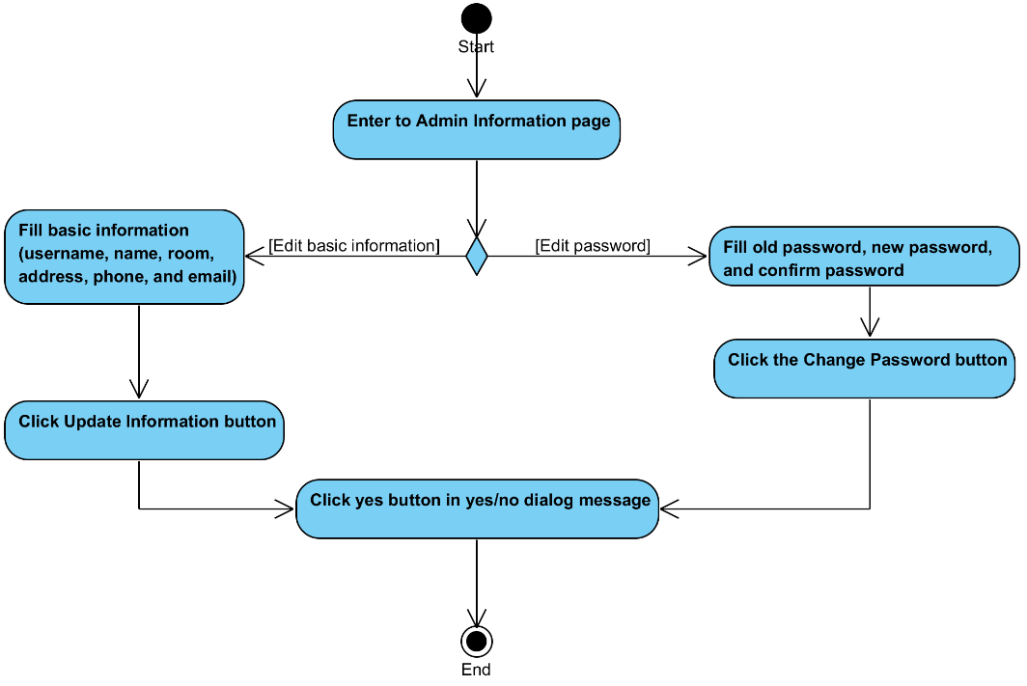

**System Requirement Specification of URS16**

SRS2-5 The system redirects to Reparation Management page.

SRS2-6 The system redirects to Users Management page.

SRS2-7 The system redirects to Items Management page.

SRS2-8 The system redirects to Items MIS page.

SRS2-9 The system redirects to Admin Information page.

SRS2-10 The system redirects to Login page.

SRS2-20 The system clears the user session.

SRS2-13 The system displays “Please you fill name” on the web application.

SRS2-14 The system displays “Please you fill department” on the web application.

SRS2-15 The system displays “Please you fill room” on the web application.

SRS2-16 The system displays “Please you fill address” on the web application.

SRS2-17 The system displays “Please you fill telephone number” on the web application.

SRS2-18 The system displays “Please you fill email” on the web application.

SRS16-1 The system provides Admin Information form. Which consists username, name, room, address, phone, email, old password, new password, and confirm password textbox.

SRS16-2 The system provides username text field that cannot edit text.

SRS16-3 The system displays yes/no dialog massage “Do you sure for edit information ?”

SRS16-4 The system validates name, department, room, address, telephone number, and email.

SRS16-5 The system updates user account information in the system

SRS16-6 The system displays “Update Administrator information successful” on the web application.

SRS16-7 The system displays yes/no dialog massage “Do you sure for edit password?”.

SRS16-8 The system validates new password, old password, and confirm password.

SRS16-9 The system displays “Update your password successful” on the web application

SRS16-10 The system displays “Please you fill old password” on the web application.

SRS16-11 The system displays “Please you fill new password” on the web application.

SRS16-12 The system displays “Please you fill confirm password” on the web application.

SRS16-13 The system displays “Please you fill new password 4-16 characters” on the web application.

SRS16-14 The system displays “Please you fill confirm password 4-16 characters” on the web application.

SRS16-15 The system displays “New Password and confirm password are not match” on the web application.

SRS16-16 The system displays “Old password incorrect” on the web application.

## **4.17 Administrator can get a notification via email. (UC17)**

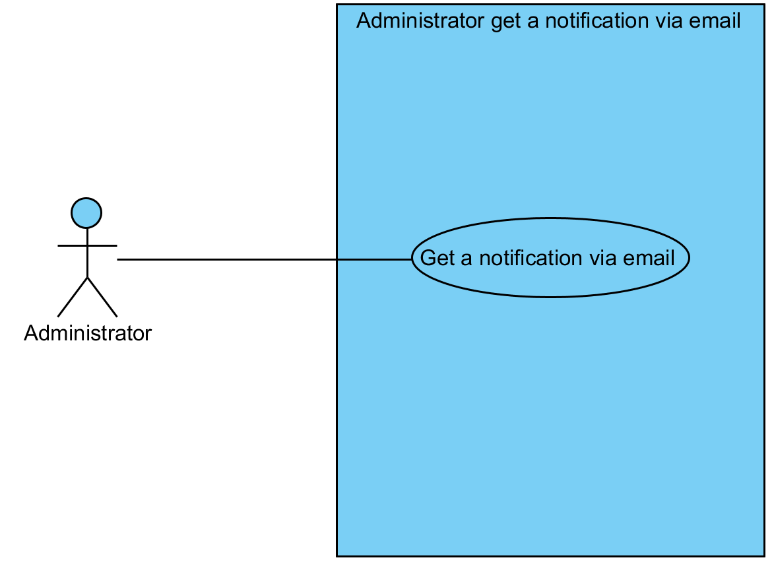

|  |  |  |  |  |
| --- | --- | --- | --- | --- |
| **Use Case ID:** | UC17 | | | |
| **Use Case Name:** | Administrator can get a notification via email. | | | |
| **Created By:** | Mr.Tanadol Parn-ong | | **Last Updated By:** | Mr.Tanadol Parn-ong |
| **Date Created:** | 18/06/2015 | | **Last Revision Date:** | 18/06/2015 |
| **Actors:** | | Administrator, Reporter | | |
| **Description:** | | This use case is provided for Administrator can get a notification via email when reporter informs a broken IT equipment information to the system. | | |
| **Trigger:** | | Reporter inform a broken IT equipment information. | | |
| **Preconditions:** | | Reporter must inform a broken IT equipment information. | | |
| **Post conditions:** | | Administrator get an email in his mail box. | | |
| **Normal Flow:** | | 1. After Use case 27 2. The system send an email about IT equipment information to mail box of Administrator. 3. Administrator get an email in his box. | | |
| **Alternative Flows:** | | N/A | | |
| **Exceptions:** | | N/A | | |
| **Includes:** | | UC27 | | |
| **Frequency of Use:** | | Often | | |
| **Assumptions:** | | N/A | | |
| **Notes and Issues:** | | N/A | | |

**URS17 Administrator can get a notification via email.**

Administrator can get a notification via email when reporter informs a broken IT equipment information to the system.

**Actor:** Administrator

**Prerequisite:** Reporter must inform a broken IT equipment information.

**Input:**N/A **Flow of Execution:**

1. After Use case 27
2. Administrator get an email in his box.

**AC17 Administrator can get a notification via email.**

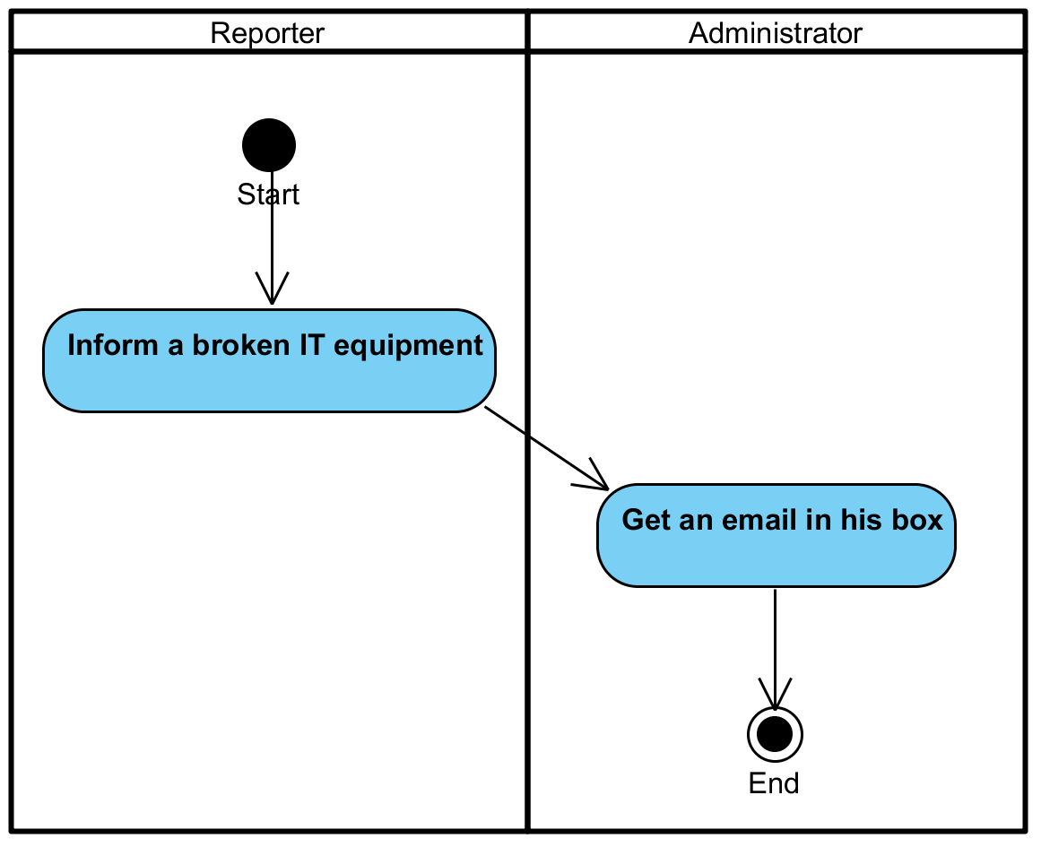

**System Requirement Specification of URS17**

SRS17-1 The system send an email about IT equipment information to mail box of Administrator.

## **4.18 Technician can view all new repair task information (UC18)**

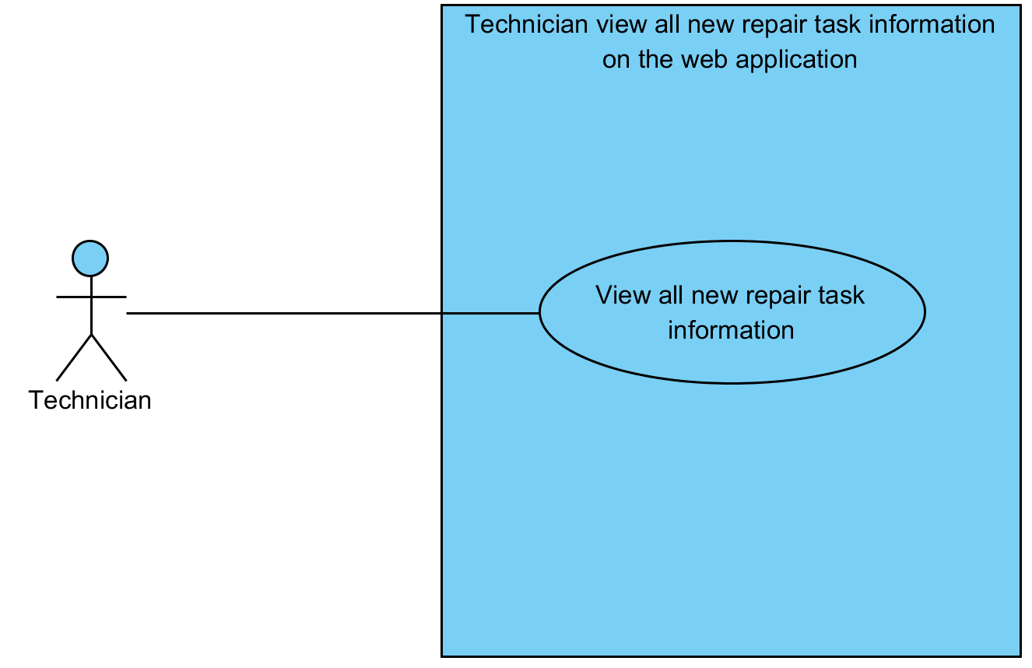

|  |  |  |  |  |
| --- | --- | --- | --- | --- |
| **Use Case ID:** | UC18 | | | |
| **Use Case Name:** | Technician can view all new repair task information | | | |
| **Created By:** | Mr.Tanadol Parn-ong | | **Last Updated By:** | Mr.Tanadol Parn-ong |
| **Date Created:** | 18/06/2015 | | **Last Revision Date:** | 18/06/2015 |
| **Actors:** | | Technician | | |
| **Description:** | | This use case is provided for Technician can view all new repair task information in Technician Main page. | | |
| **Trigger:** | | N/A | | |
| **Preconditions:** | | The system must has repair task information in the system. | | |
| **Post conditions:** | | The system displays all new repair task information in Technician Main page. | | |
| **Normal Flow:** | | 1. Technician enters to Technician Main page. 2. The system displays all new repair task information in Technician Main page. | | |
| **Alternative Flows:** | | 1. When Technician clicks the Technician button.  1.1. Technician clicks the Technician button.  1.2. The system redirects to Technician Main page.  2. When Technician clicks the Repairing button.  2.1. Technician clicks the Repairing button.  2.2. The system redirects to Repairing page.  3. When Technician clicks the History button.  3.1. Technician clicks the History button.  3.2. The system redirects to History page.  4. When Technician clicks the Technician Information button.  4.1. Technician clicks the Technician Information button.  4.2. The system redirects to Technician Information page.  5. When Technician clicks the Logout button.  5.1. Technician clicks the Logout button.  5.2. The system redirects to Login page.  5.3 The system clears the user session. | | |
| **Exceptions:** | | N/A | | |
| **Includes:** | | N/A | | |
| **Frequency of Use:** | | Often | | |
| **Assumptions:** | | N/A | | |
| **Notes and Issues:** | | N/A | | |

**URS18 Technician can view all new repair task information.**

Technician can view all new repair task information in Technician Main page.

**Actor:** Technician

**Prerequisite:** The system must has repair task information in the system.

**Input:**N/A **Flow of Execution:**

1. Technician enters to Technician Main page

**AC18 Technician can view all new repair task information.**

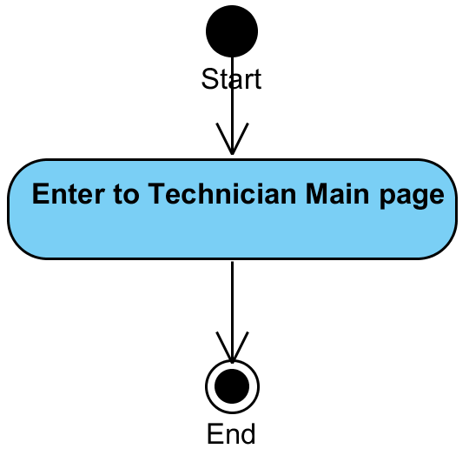

**System Requirement Specification of URS18**

SRS2-10 The system redirects to Login page.

SRS2-20 The system clears the user session.

SRS18-1 The system displays all new repair task information in Technician Main page.

SRS18-2 The system redirects to Technician Main page.

SRS18-3 The system redirects to Repairing page.

SRS18-4 The system redirects to History page.

SRS18-5 The system redirects to Technician Information page.

## **4.19** **Technician can update repair task status (UC19)**

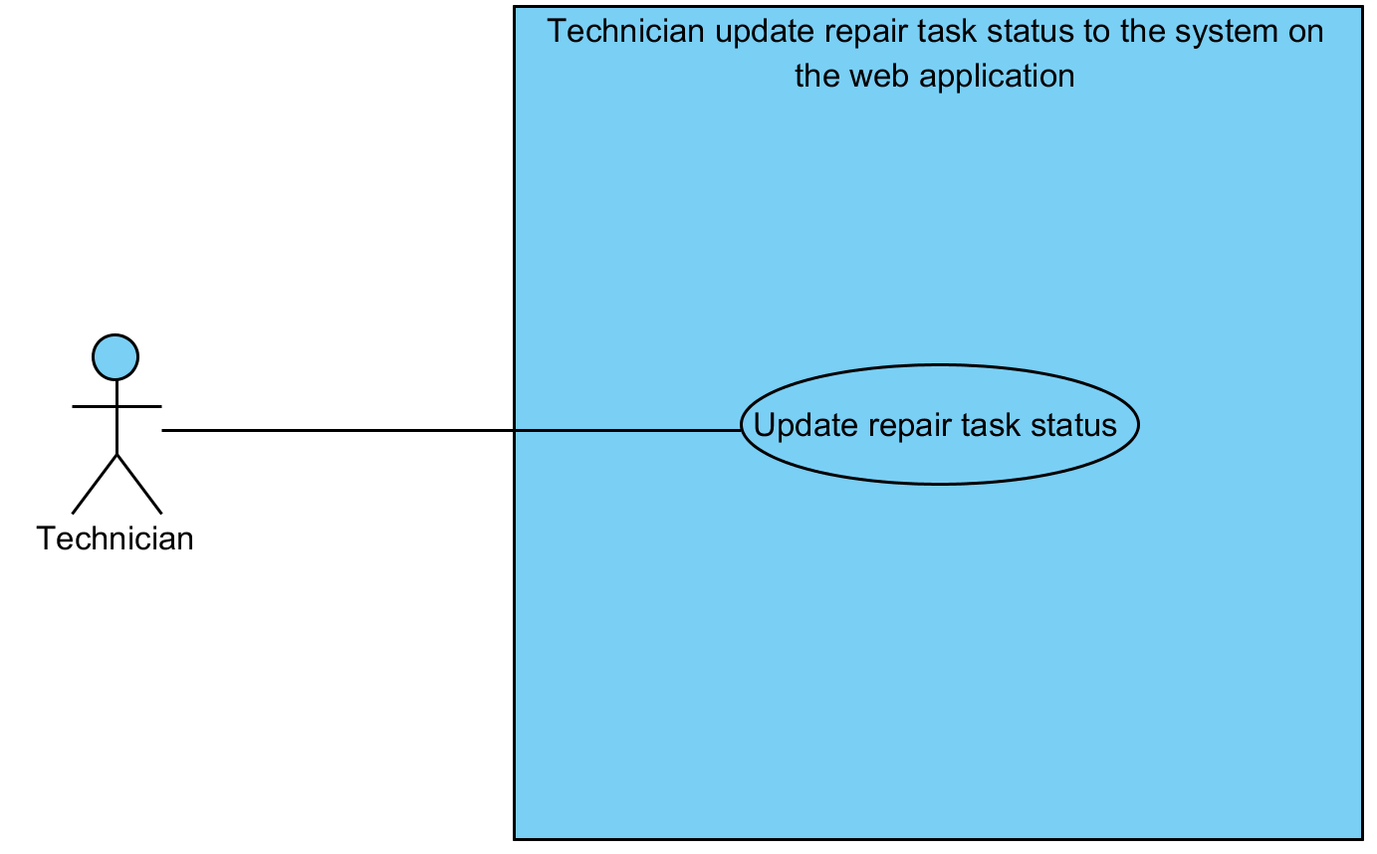

|  |  |  |  |  |
| --- | --- | --- | --- | --- |
| **Use Case ID:** | UC19 | | | |
| **Use Case Name:** | Technician can update repair task status | | | |
| **Created By:** | Mr.Tanadol Parn-ong | | **Last Updated By:** | Mr.Tanadol Parn-ong |
| **Date Created:** | 18/06/2015 | | **Last Revision Date:** | 18/06/2015 |
| **Actors:** | | Technician | | |
| **Description:** | | This use case is provided for Technician can update repair task status for changing status from “Wait to process” to “In processing”. | | |
| **Trigger:** | | Technician clicks the Repair button beside repair task information. | | |
| **Preconditions:** | | The system must has repair task information in the system. | | |
| **Post conditions:** | | The system displays a repair task that was updated in Repairing page. | | |
| **Normal Flow:** | | 1. Technician enters to Technician Main page. 2. The system displays all new repair task information in Technician Main page. 3. Technician clicks the Repair button beside repair task information. 4. The system changes a repair task status from “Wait to process” to “In processing” in the system. 5. The system displays a repair task that was updated in Repairing page. | | |
| **Alternative Flows:** | | 1. When Technician clicks the Technician button.  1.1. Technician clicks the Technician button.  1.2. The system redirects to Technician Main page.  2. When Technician clicks the Repairing button.  2.1. Technician clicks the Repairing button.  2.2. The system redirects to Repairing page.  3. When Technician clicks the History button.  3.1. Technician clicks the History button.  3.2. The system redirects to History page.  4. When Technician clicks the Technician Information button.  4.1. Technician clicks the Technician Information button.  4.2. The system redirects to Technician Information page.  5. When Technician clicks the Logout button.  5.1. Technician clicks the Logout button.  5.2. The system redirects to Login page.  5.3 The system clears the user session. | | |
| **Exceptions:** | | N/A | | |
| **Includes:** | | N/A | | |
| **Frequency of Use:** | | Often | | |
| **Assumptions:** | | N/A | | |
| **Notes and Issues:** | | N/A | | |

**URS19 Technician can update repair task status.**

Technician can update repair task status for changing status from “Wait to process” to “In processing”.in Technician Main page.

**Actor:** Technician

**Prerequisite:** The system must has repair task information in the system.

**Input:**N/A **Flow of Execution:**

1. Technician enters to Technician Main page
2. Technician clicks the Repair button beside repair task information.

**AC19 Technician can update repair task status.**

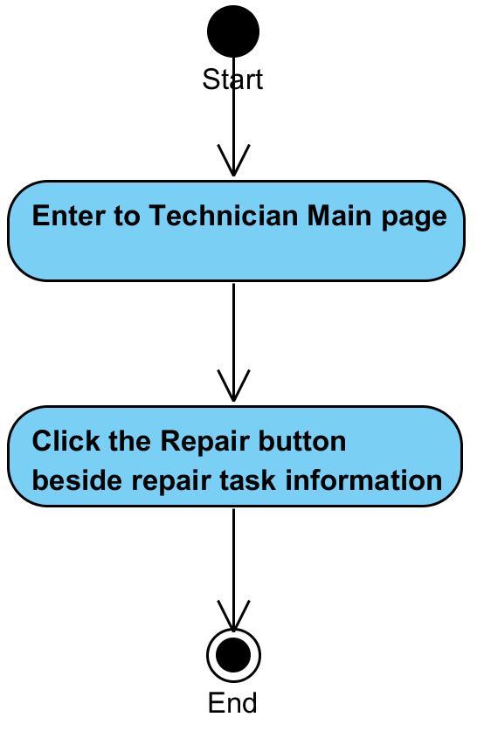

**System Requirement Specification of URS19**

SRS2-10 The system redirects to Login page.

SRS2-20 The system clears the user session.

SRS18-1 The system displays all new repair task information in Technician Main page.

SRS18-2 The system redirects to Technician Main page.

SRS18-3 The system redirects to Repairing page.

SRS18-4 The system redirects to History page.

SRS18-5 The system redirects to Technician Information page.

SRS19-1 The system changes a repair task status from “Wait to process” to “In processing” in the system.

SRS19-2 The system displays a repair task that was updated in Repairing page.

## **4.20** **Technician can view IT equipment information (UC20)**

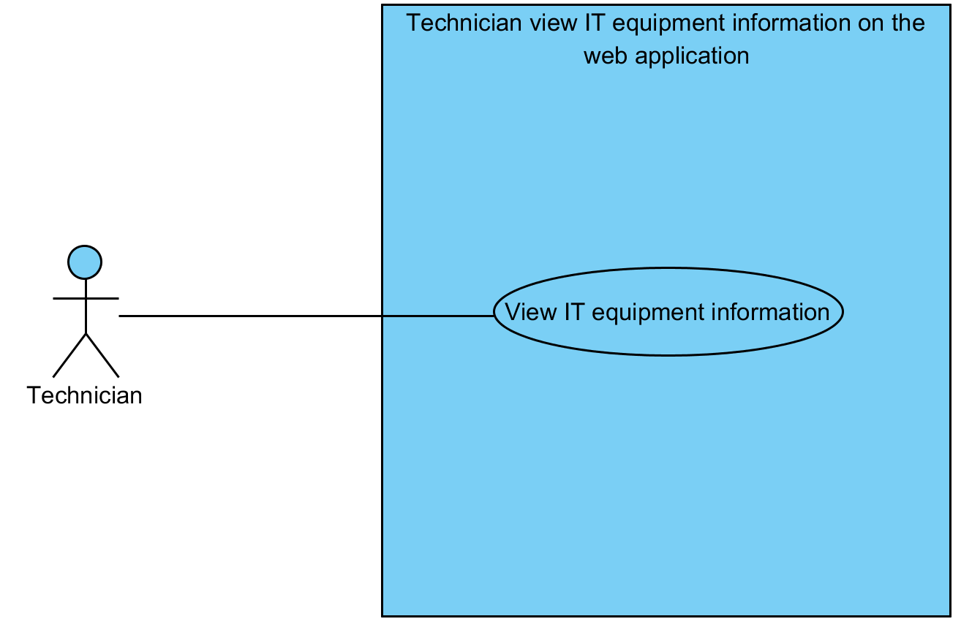

|  |  |  |  |  |
| --- | --- | --- | --- | --- |
| **Use Case ID:** | UC20 | | | |
| **Use Case Name:** | Technician can view IT equipment information | | | |
| **Created By:** | Mr.Tanadol Parn-ong | | **Last Updated By:** | Mr.Tanadol Parn-ong |
| **Date Created:** | 18/06/2015 | | **Last Revision Date:** | 18/06/2015 |
| **Actors:** | | Technician | | |
| **Description:** | | This use case is provided for Technician can view IT equipment information, which is a broken IT equipment. | | |
| **Trigger:** | | Technician clicks an IT equipment name button. | | |
| **Preconditions:** | | The system must has repair task information in the system. | | |
| **Post conditions:** | | The system displays IT equipment information in IT equipment information page. | | |
| **Normal Flow:** | | 1. Technician clicks an IT equipment name button. 2. The system redirects to IT equipment information page. 3. The system displays IT equipment information in IT equipment information page. | | |
| **Alternative Flows:** | | 1. When Technician clicks the Technician button.  1.1. Technician clicks the Technician button.  1.2. The system redirects to Technician Main page.  2. When Technician clicks the Repairing button.  2.1. Technician clicks the Repairing button.  2.2. The system redirects to Repairing page.  3. When Technician clicks the History button.  3.1. Technician clicks the History button.  3.2. The system redirects to History page.  4. When Technician clicks the Technician Information button.  4.1. Technician clicks the Technician Information button.  4.2. The system redirects to Technician Information page.  5. When Technician clicks the Logout button.  5.1. Technician clicks the Logout button.  5.2. The system redirects to Login page.  5.3 The system clears the user session. | | |
| **Exceptions:** | | N/A | | |
| **Includes:** | | N/A | | |
| **Frequency of Use:** | | Often | | |
| **Assumptions:** | | N/A | | |
| **Notes and Issues:** | | N/A | | |

**URS20 Technician can view IT equipment information.**

Technician can view IT equipment information in IT equipment information page, which is a broken IT equipment.

**Actor:** Technician

**Prerequisite:** The system must has repair task information in the system.

**Input:**N/A **Flow of Execution:**

1. Technician clicks an IT equipment name.

**AC20 Technician can view IT equipment information.**

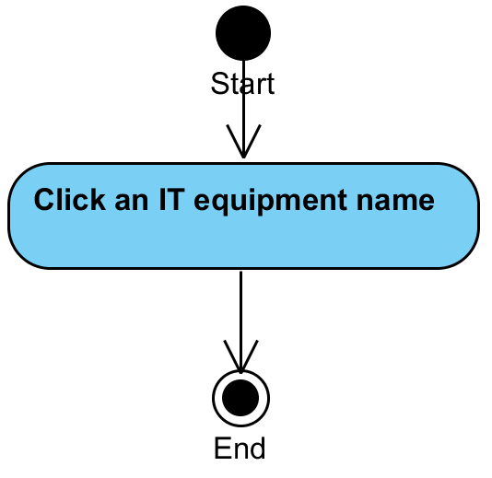

**System Requirement Specification of URS20**

SRS2-10 The system redirects to Login page.

SRS2-20 The system clears the user session.

SRS18-2 The system redirects to Technician Main page.

SRS18-3 The system redirects to Repairing page.

SRS18-4 The system redirects to History page.

SRS18-5 The system redirects to Technician Information page.

SRS20-1 The system redirects to IT equipment information page.

SRS20-2 The system displays IT equipment information in IT equipment information page.

## **4.21** **Technician can view Reporter information (UC21)**

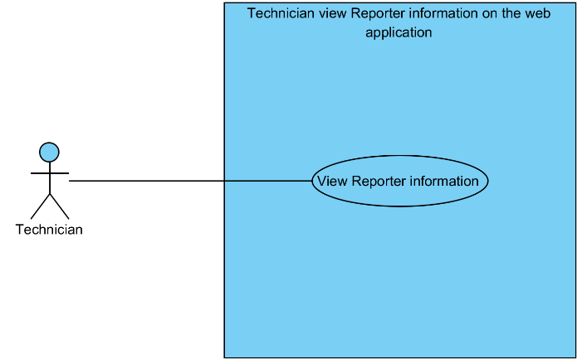

|  |  |  |  |  |
| --- | --- | --- | --- | --- |
| **Use Case ID:** | UC21 | | | |
| **Use Case Name:** | Technician can view Reporter information | | | |
| **Created By:** | Mr.Tanadol Parn-ong | | **Last Updated By:** | Mr.Tanadol Parn-ong |
| **Date Created:** | 18/06/2015 | | **Last Revision Date:** | 18/06/2015 |
| **Actors:** | | Technician | | |
| **Description:** | | This use case is provided for Technician can view Reporter information in Reporter information page. | | |
| **Trigger:** | | Technician clicks a reporter name button. | | |
| **Preconditions:** | | The system must has reporter information in the system. | | |
| **Post conditions:** | | The system displays reporter information in Reporter information page. | | |
| **Normal Flow:** | | 1. Technician clicks a reporter name button. 2. The system redirects to Reporter information page. 3. The system displays reporter information in Reporter information page. | | |
| **Alternative Flows:** | | 1. When Technician clicks the Technician button.  1.1. Technician clicks the Technician button.  1.2. The system redirects to Technician Main page.  2. When Technician clicks the Repairing button.  2.1. Technician clicks the Repairing button.  2.2. The system redirects to Repairing page.  3. When Technician clicks the History button.  3.1. Technician clicks the History button.  3.2. The system redirects to History page.  4. When Technician clicks the Technician Information button.  4.1. Technician clicks the Technician Information button.  4.2. The system redirects to Technician Information page.  5. When Technician clicks the Logout button.  5.1. Technician clicks the Logout button.  5.2. The system redirects to Login page.  5.3 The system clears the user session. | | |
| **Exceptions:** | | N/A | | |
| **Includes:** | | N/A | | |
| **Frequency of Use:** | | Often | | |
| **Assumptions:** | | N/A | | |
| **Notes and Issues:** | | N/A | | |

**URS21 Technician can view Reporter information.**

Technician can view Reporter information in Reporter information page.

**Actor:** Technician

**Prerequisite:** The system must has reporter information in the system.

**Input:**N/A **Flow of Execution:**

1. Technician clicks a reporter name button.

**AC21 Technician can view Reporter information.**

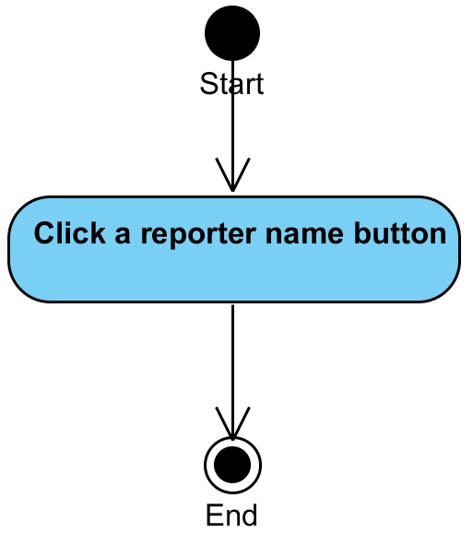

**System Requirement Specification of URS21**

SRS2-10 The system redirects to Login page.

SRS2-20 The system clears the user session.

SRS18-2 The system redirects to Technician Main page.

SRS18-3 The system redirects to Repairing page.

SRS18-4 The system redirects to History page.

SRS18-5 The system redirects to Technician Information page.

SRS21-1 The system redirects to Reporter information page.

SRS 21-2 The system displays reporter information in Reporter information page.

## **4.22** **Technician can view all IT equipment that live in repair process (UC22)**

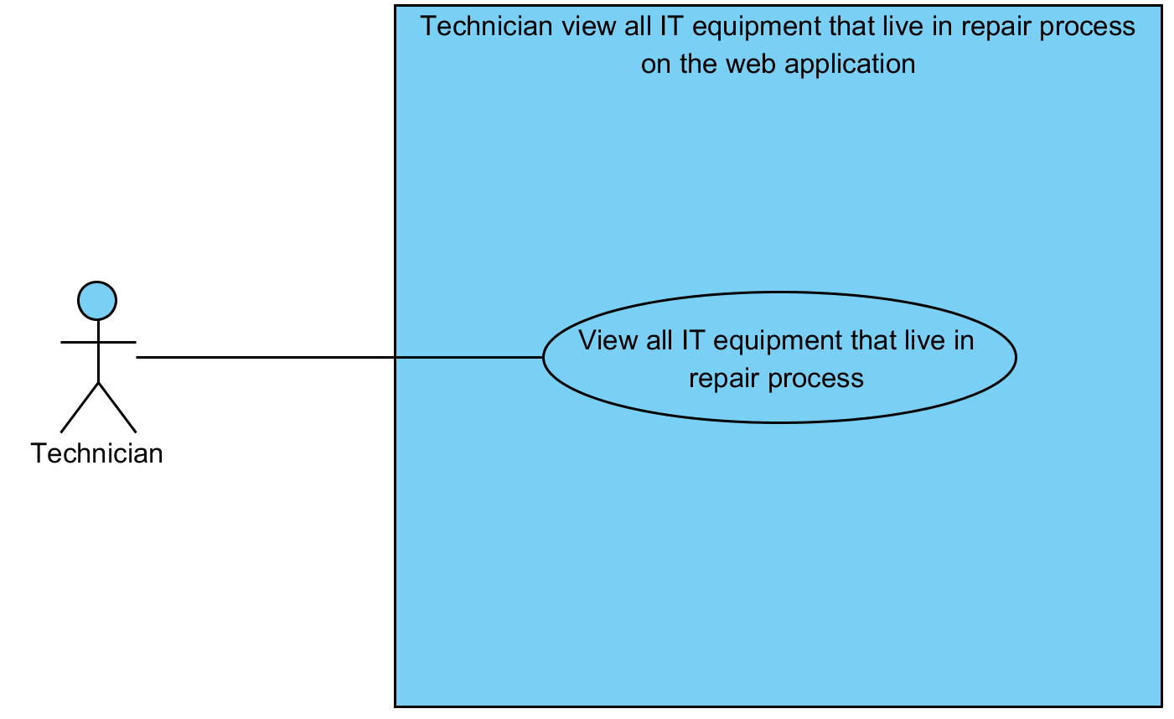

|  |  |  |  |  |
| --- | --- | --- | --- | --- |
| **Use Case ID:** | UC22 | | | |
| **Use Case Name:** | Technician can view all IT equipment that live in repair process | | | |
| **Created By:** | Mr.Tanadol Parn-ong | | **Last Updated By:** | Mr.Tanadol Parn-ong |
| **Date Created:** | 18/06/2015 | | **Last Revision Date:** | 18/06/2015 |
| **Actors:** | | Technician | | |
| **Description:** | | This use case is provided for Technician can view all IT equipment that live in repair process in Repairing page. | | |
| **Trigger:** | | Technician clicks the History button. | | |
| **Preconditions:** | | The system must has repair task information in the system. | | |
| **Post conditions:** | | The system displays all IT equipment that live in repair process in Repairing page. | | |
| **Normal Flow:** | | 1. Technician clicks the Repairing button. 2. The system redirects to Repairing page 3. The system displays all IT equipment that live in repair process in Repairing page. 4. Technician enters to Repairing page. | | |
| **Alternative Flows:** | | 1. When Technician clicks the Technician button.  1.1. Technician clicks the Technician button.  1.2. The system redirects to Technician Main page.  2. When Technician clicks the Repairing button.  2.1. Technician clicks the Repairing button.  2.2. The system redirects to Repairing page.  3. When Technician clicks the History button.  3.1. Technician clicks the History button.  3.2. The system redirects to History page.  4. When Technician clicks the Technician Information button.  4.1. Technician clicks the Technician Information button.  4.2. The system redirects to Technician Information page.  5. When Technician clicks the Logout button.  5.1. Technician clicks the Logout button.  5.2. The system redirects to Login page.  5.3 The system clears the user session. | | |
| **Exceptions:** | | N/A | | |
| **Includes:** | | N/A | | |
| **Frequency of Use:** | | Often | | |
| **Assumptions:** | | N/A | | |
| **Notes and Issues:** | | N/A | | |

**URS22 Technician can view all IT equipment that live in repair process.**

Technician can view all IT equipment that live in repair process in Repairing page.

**Actor:** Technician

**Prerequisite:** The system must has repair task information in the system.

**Input:**N/A **Flow of Execution:**

1. Technician clicks the Repairing button.
2. Technician enters to Repairing page.

**AC22 Technician can view all IT equipment that live in repair process.**

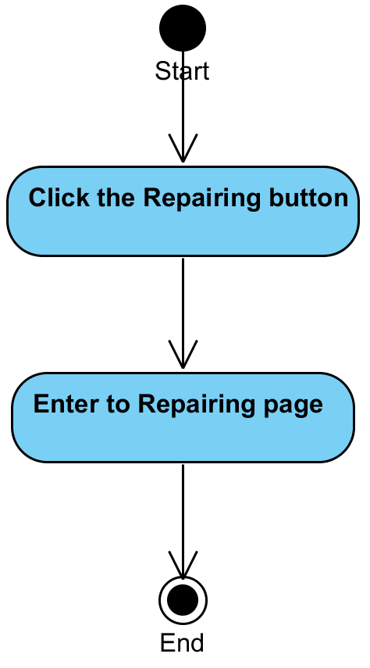

**System Requirement Specification of URS22**

SRS2-10 The system redirects to Login page.

SRS2-20 The system clears the user session.

SRS18-2 The system redirects to Technician Main page.

SRS18-3 The system redirects to Repairing page.

SRS18-4 The system redirects to History page.

SRS18-5 The system redirects to Technician Information page.

SRS22-1 The system displays all IT equipment that live in repair process in Repairing page.

## **4.23** **Technician can update repair task information (UC23)**

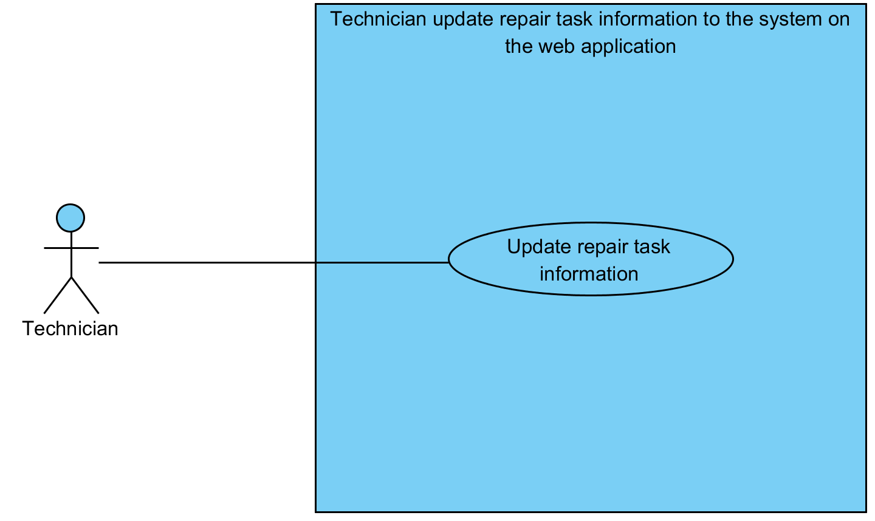

|  |  |  |  |  |
| --- | --- | --- | --- | --- |
| **Use Case ID:** | UC23 | | | |
| **Use Case Name:** | Technician can update repair task information | | | |
| **Created By:** | Mr.Tanadol Parn-ong | | **Last Updated By:** | Mr.Tanadol Parn-ong |
| **Date Created:** | 18/06/2015 | | **Last Revision Date:** | 18/06/2015 |
| **Actors:** | | Technician | | |
| **Description:** | | This use case is provided for Technician can update repair task information in Repairing Information page. In this process can do two method, which consists update repairing information and release repairing information. | | |
| **Trigger:** | | Technician clicks the Update Repairing button. | | |
| **Preconditions:** | | The system must has repair task information in the system. | | |
| **Post conditions:** | | The system displays “Repairing information is updated” on the web application. | | |
| **Normal Flow:** | | 1. Technician enters to Repairing page. 2. The system displays all IT equipment that live in repair process in Repairing page. 3. Technician clicks IT equipment name. 4. The system redirects to Repairing Information page. 5. The system displays IT equipment information in Repairing Information page. 6. The system provides a repairing process form, which consists broken type, broken description, reporter contact, and repairing description text field in Repairing information page. 7. The system provides the Update Repairing and Release Repairing button in Repairing information page. 8. Technician enters to Repairing information page 9. Technician fills a repairing description in Repairing information page. 10. Technician clicks the Update Repairing button. 11. The system displays yes/no dialog massage “Do you sure for updating reparing status?”. 12. Technician clicks yes button in yes/no dialog message. 13. The system validates repairing description. 14. The system updates repair task information in the system. 15. The system displays “Repairing information is updated” on the web application. | | |
| **Alternative Flows:** | | 1. When Technician clicks the Technician button.  1.1. Technician clicks the Technician button.  1.2. The system redirects to Technician Main page.  2. When Technician clicks the Repairing button.  2.1. Technician clicks the Repairing button.  2.2. The system redirects to Repairing page.  3. When Technician clicks the History button.  3.1. Technician clicks the History button.  3.2. The system redirects to History page.  4. When Technician clicks the Technician Information button.  4.1. Technician clicks the Technician Information button.  4.2. The system redirects to Technician Information page.  5. When Technician clicks the Logout button.  5.1. Technician clicks the Logout button.  5.2. The system redirects to Login page.  5.3 The system clears the user session.  6. When Technician would like to release a repair task.  6.1. After step 9 in normal flow.  6.2 Technician click the Release Repairing button.  6.2. Use Case resumes on step 11 of normal flow. | | |
| **Exceptions:** | | N/A | | |
| **Includes:** | | N/A | | |
| **Frequency of Use:** | | Often | | |
| **Assumptions:** | | N/A | | |
| **Notes and Issues:** | | N/A | | |

**URS23 Technician can update repair task information.**

Technician can update repair task information in Repairing Information page. In this process can do two method, which consists update repairing information and release repairing information.

**Actor:** Technician

**Prerequisite:** The system must has repair task information in the system.

**Input:**

|  |  |  |  |
| --- | --- | --- | --- |
| Name | Description | Example | Remarks |
| Repairing description | Can be any character. | “In processing” |  |

**Flow of Execution:**

When Technician would like to update repairing information.

1. Technician enters to Repairing page.
2. Technician clicks IT equipment name.
3. Technician enters to Repairing information page
4. Technician fills a repairing description in Repairing information page.
5. Technician clicks the Update Repairing button.
6. Technician clicks yes button in yes/no dialog message.

When Technician would like to release repairing information.

1. Technician enters to Repairing page.
2. Technician clicks IT equipment name.
3. Technician enters to Repairing information page
4. Technician fills a repairing description in Repairing information page.
5. Technician click the Release Repairing button.
6. Technician clicks yes button in yes/no dialog message.

**AC23 Technician can update repair task information.**

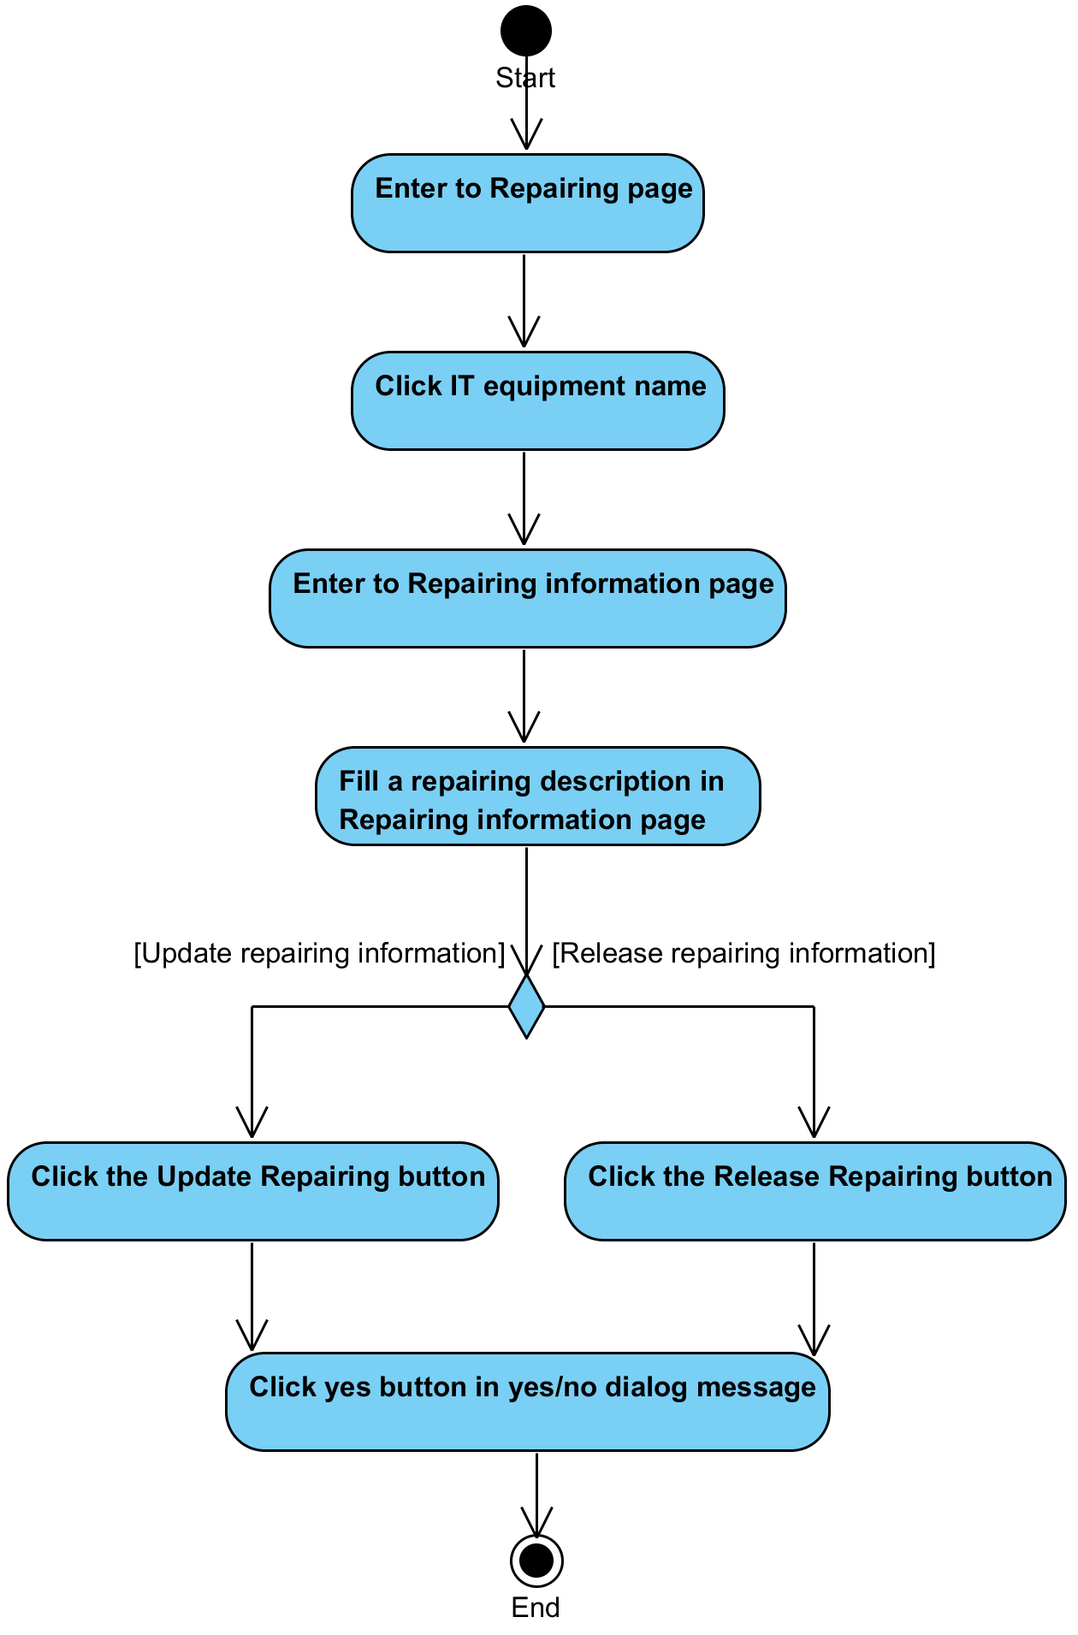

**System Requirement Specification of URS23**

SRS2-10 The system redirects to Login page.

SRS2-20 The system clears the user session.

SRS18-2 The system redirects to Technician Main page.

SRS18-3 The system redirects to Repairing page.

SRS18-4 The system redirects to History page.

SRS18-5 The system redirects to Technician Information page.

SRS22-1 The system displays all IT equipment that live in repair process in Repairing page.

SRS23-1 The system redirects to Repairing Information page.

SRS23-2 The system displays IT equipment information in Repairing Information page.

SRS23-3 The system provides a repairing process form, which consists broken type, broken description, reporter contact, and repairing description text field in Repairing information page.

SRS23-4 The system provides the Update Repairing and Release Repairing button in Repairing information page.

SRS23-5 The system displays yes/no dialog massage “Do you sure for updating reparing status?”.

SRS23-6 The system validates repairing description.

SRS23-7 The system updates repair task information in the system.

SRS23-8 The system displays “Repairing information is updated” on the web application.

## **4.24 Technician can view history IT equipment that were repaired by himself (UC24)**

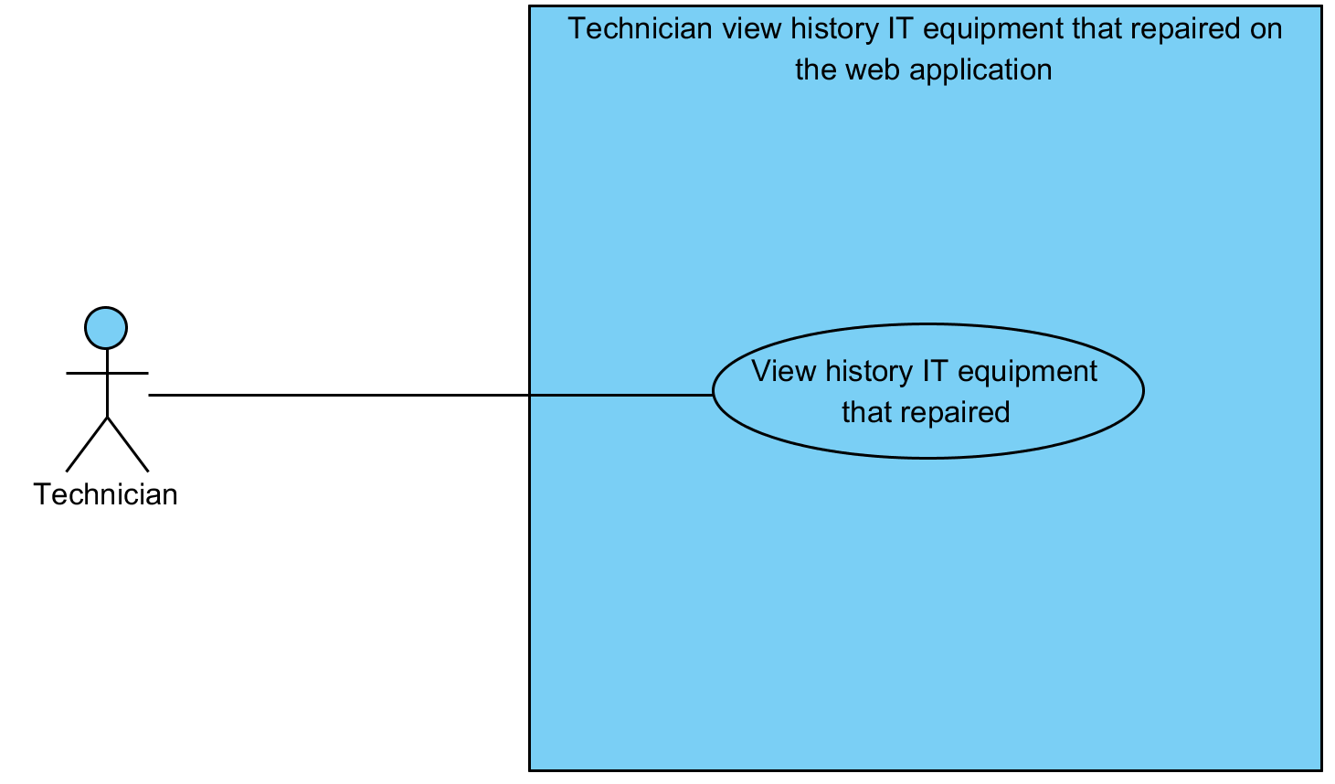

|  |  |  |  |  |
| --- | --- | --- | --- | --- |
| **Use Case ID:** | UC24 | | | |
| **Use Case Name:** | Technician can view history IT equipment that were repaired | | | |
| **Created By:** | Mr.Tanadol Parn-ong | | **Last Updated By:** | Mr.Tanadol Parn-ong |
| **Date Created:** | 18/06/2015 | | **Last Revision Date:** | 18/06/2015 |
| **Actors:** | | Technician | | |
| **Description:** | | This use case is provided for Technician can view history IT equipment that were repaired by himself in History page. | | |
| **Trigger:** | | N/A | | |
| **Preconditions:** | | The system must has repair task information in the system. | | |
| **Post conditions:** | | The system displays all IT equipment information that were repaired by that technician in History page. | | |
| **Normal Flow:** | | 1. Technician clicks the History button 2. The system redirects to History page. 3. The system displays all IT equipment information that were repaired by that technician in History page. 4. Technician enters to History page. | | |
| **Alternative Flows:** | | 1. When Technician clicks the Technician button.  1.1. Technician clicks the Technician button.  1.2. The system redirects to Technician Main page.  2. When Technician clicks the Repairing button.  2.1. Technician clicks the Repairing button.  2.2. The system redirects to Repairing page.  3. When Technician clicks the History button.  3.1. Technician clicks the History button.  3.2. The system redirects to History page.  4. When Technician clicks the Technician Information button.  4.1. Technician clicks the Technician Information button.  4.2. The system redirects to Technician Information page.  5. When Technician clicks the Logout button.  5.1. Technician clicks the Logout button.  5.2. The system redirects to Login page.  5.3 The system clears the user session. | | |
| **Exceptions:** | | N/A | | |
| **Includes:** | | N/A | | |
| **Frequency of Use:** | | Often | | |
| **Assumptions:** | | N/A | | |
| **Notes and Issues:** | | N/A | | |

**URS24 Technician can view history IT equipment that were repaired by himself.**

Technician can view history IT equipment that were repaired by himself in History page.

**Actor:** Technician

**Prerequisite:** The system must has repair task information in the system.

**Input:**N/A **Flow of Execution:**

1. Technician clicks the History button.
2. Technician enters to History page.

**AC24 Technician can view history IT equipment that were repaired by himself.**

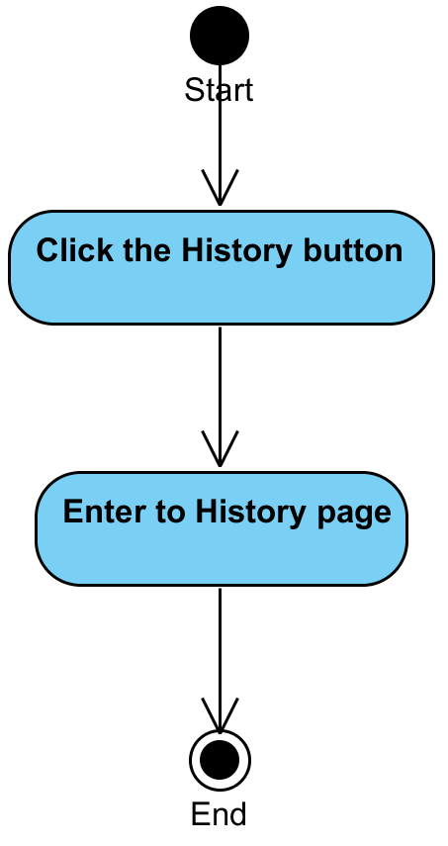

**System Requirement Specification of URS24**

SRS2-10 The system redirects to Login page.

SRS2-20 The system clears the user session.

SRS18-2 The system redirects to Technician Main page.

SRS18-3 The system redirects to Repairing page.

SRS18-4 The system redirects to History page.

SRS18-5 The system redirects to Technician Information page.

SRS24-1 The system displays all IT equipment information that were repaired by that technician in History page.

## **4.25 Technician can update his account information (UC25)**

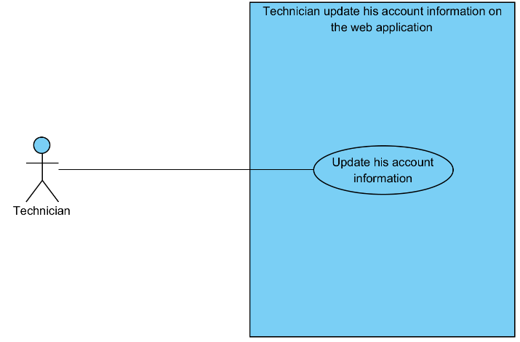

|  |  |  |  |  |
| --- | --- | --- | --- | --- |
| **Use Case ID:** | UC25 | | | |
| **Use Case Name:** | Technician can update his account information | | | |
| **Created By:** | Mr.Tanadol Parn-ong | | **Last Updated By:** | Mr.Tanadol Parn-ong |
| **Date Created:** | 18/06/2015 | | **Last Revision Date:** | 18/06/2015 |
| **Actors:** | | Technician | | |
| **Description:** | | This use case is provided for Technician can update his account information in Technician Information page. | | |
| **Trigger:** | | When Technician would like to edit basic information.  - Technician clicks the Update Information button.  When Technician would like to edit his password.  - Technician clicks the Change Password button. | | |
| **Preconditions:** | | The system must has a Technician account information in the system. | | |
| **Post conditions:** | | When Technician would like to edit basic information.  - The system displays “Update Technician information successful.” on the web application.  When Technician would like to edit his password.  - The system displays “Update your password successful” on the web application. | | |
| **Normal Flow:** | | When Technician would like to edit basic information.   1. Technician enters to Technician Information page. 2. The system provides Technician Information form. Which consists username, name, room, address, phone, email, old password, new password, and confirm password textbox. 3. The system provides username text field that cannot edit text. 4. Technician fills username, name, room, address, phone, and email. 5. Technician clicks Update Information button. 6. The system displays yes/no dialog massage “Do you sure for edit information ?”. 7. Technician clicks yes button in yes/no dialog message. 8. The system validates name, department, room, address, telephone number, and email. 9. The system updates user account information in the system. 10. The system displays “Update Technician information successful” on the web application.   When Technician would like to edit his password.   1. Technician enters to Technician Information page. 2. The system provides Technician Information form. Which consists username, name, room, address, phone, email, old password, new password, and confirm password textbox. 3. The system provides username text field that cannot edit text. 4. Technician fills old password, new password, and confirm password. 5. Technician clicks the Change Password button. 6. The system displays yes/no dialog massage “Do you sure for edit password ?”. 7. Technician clicks yes button in yes/no dialog message. 8. The system validates new password, old password, and confirm password. 9. The system updates user account information in the system. 10. The system displays “Update your password successful” on the web application. | | |
| **Alternative Flows:** | | 1. When Technician clicks the Technician button.  1.1. Technician clicks the Technician button.  1.2. The system redirects to Technician Main page.  2. When Technician clicks the Repairing button.  2.1. Technician clicks the Repairing button.  2.2. The system redirects to Repairing page.  3. When Technician clicks the History button.  3.1. Technician clicks the History button.  3.2. The system redirects to History page.  4. When Technician clicks the Technician Information button.  4.1. Technician clicks the Technician Information button.  4.2. The system redirects to Technician Information page.  5. When Technician clicks the Logout button.  5.1. Technician clicks the Logout button.  5.2. The system redirects to Login page.  5.3 The system clears the user session.  6. When Technician don’t fill name after he clicks the Update Information button. The system provides the error message as followed:  6.1. The system displays “Please you fill name” on the web application.  6.2. Use Case resumes on step 1 of normal flow.  7. When Technician don’t fill department after he clicks the Update Information button. The system provides the error message as followed:  7.1. The system displays “Please you fill department” on the web application.  7.2. Use Case resumes on step 1 of normal flow.  8. When Technician don’t fill room after he clicks the Update Information button. The system provides the error message as followed:  8.1. The system displays “Please you fill room” on the web application.  8.2. Use Case resumes on step 1 of normal flow.  9. When Technician don’t fill address after he clicks the Update Information button. The system provides the error message as followed:  9.1. The system displays “Please you fill address” on the web application.  9.2. Use Case resumes on step 1 of normal flow.  10. When Technician don’t fill telephone number after he clicks the Update Information button. The system provides the error message as followed:  10.1. The system displays “Please you fill telephone number” on the web application.  10.2. Use Case resumes on step 1 of normal flow.  11. When Technician don’t fill email after he clicks the Update Information button. The system provides the error message as followed:  11.1. The system displays “Please you fill email” on the web application.  11.2. Use Case resumes on step 1 of normal flow.  12. When Technician don’t fill old password after he clicks the Change Password button. The system provides the error message as followed:  12.1. The system displays “Please you fill old password” on the web application.  12.2. Use Case resumes on step 1 of normal flow.  13. When Technician don’t fill new password after he clicks the Change Password button. The system provides the error message as followed:  13.1. The system displays “Please you fill new password” on the web application.  13.2. Use Case resumes on step 1 of normal flow.  14. When Technician don’t fill confirm password after he clicks the Change Password button. The system provides the error message as followed:  14.1. The system displays “Please you fill confirm password” on the web application.  14.2. Use Case resumes on step 1 of normal flow.  15. When Technician fills new password less than 4 characters or more than 16 characters after he clicks the Change Password button. The system provides the error message as followed:  15.1. The system displays “Please you fill new password 4-16 characters” on the web application.  15.2. Use Case resumes on step 1 of normal flow.  16. When Technician fills confirm password less than 4 characters or more than 16 characters after he clicks the Change Password button. The system provides the error message as followed:  16.1. The system displays “Please you fill confirm password 4-16 characters” on the web application.  16.2. Use Case resumes on step 1 of normal flow.  17. When Technician fills confirm password and new password that are not match. The system provides the error message as followed:  17.1. The system displays “New Password and confirm password are not match” on the web application.  17.2. Use Case resumes on step 1 of normal flow.  18. When Technician fills incorrect old password. The system provides the error message as followed:  18.1. The system displays “Old password incorrect” on the web application.  18.2. Use Case resumes on step 1 of normal flow. | | |
| **Exceptions:** | | N/A | | |
| **Includes:** | | N/A | | |
| **Frequency of Use:** | | Often | | |
| **Assumptions:** | | N/A | | |
| **Notes and Issues:** | | N/A | | |

**URS25 Technician can update his account information.**

Technician can update his account information in Technician Information page.

**Actor:** Technician

**Prerequisite:** The system must has a Technician account information in the system.

**Input:**

**When Technician would like to edit basic information.**

|  |  |  |  |
| --- | --- | --- | --- |
| Name | Description | Example | Remarks |
| name | Can be any character only | “staff one” |  |
| department | Can be any character only | “CAMT” |  |
| room | Can be any character only | “114” |  |
| address | Can be any character only | “Chiang Mai” |  |
| telephone number | Can be any character only | “0833201787” |  |
| email | Can be any character only | “se542115021.developer@gmail.com” |  |

**When Technician would like to edit his password.**

|  |  |  |  |
| --- | --- | --- | --- |
| Name | Description | Example | Remarks |
| old password | Can be any character within the range of 4-16 characters. | “123456” |  |
| new password | Can be any character within the range of 4-16 characters. | “12345678” |  |
| confirm password | Can be any character within the range of 4-16 characters. | “12345678” |  |

**Flow of Execution:**

When Technician would like to edit basic information.

1. Technician enters to Technician Information page
2. Technician fills username, name, room, address, phone, and email.
3. Technician clicks Update Information button.
4. Technician clicks yes button in yes/no dialog message.

When Technician would like to edit his password.

1. Technician enters to Technician Information page
2. Technician fills old password, new password, and confirm password.
3. Technician clicks the Change Password button.
4. Technician clicks yes button in yes/no dialog message.

**AC25 Technician can update his account information.**

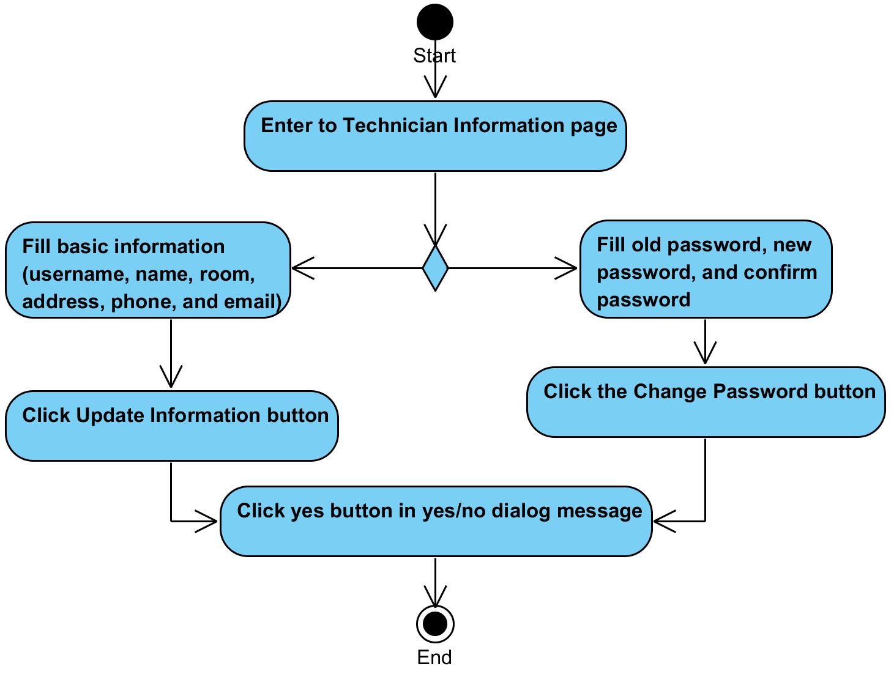

**System Requirement Specification of URS25**

SRS2-10 The system redirects to Login page.

SRS2-20 The system clears the user session.

SRS2-13 The system displays “Please you fill name” on the web application.

SRS2-14 The system displays “Please you fill department” on the web application.

SRS2-15 The system displays “Please you fill room” on the web application.

SRS2-16 The system displays “Please you fill address” on the web application.

SRS2-17 The system displays “Please you fill telephone number” on the web application.

SRS2-18 The system displays “Please you fill email” on the web application.

SRS16-2 The system provides username text field that cannot edit text.

SRS16-3 The system displays yes/no dialog massage “Do you sure for edit information ?”

SRS16-4 The system validates name, department, room, address, telephone number, and email.

SRS16-5 The system updates user account information in the system.

SRS16-8 The system validates new password, old password, and confirm password.

SRS16-9 The system displays “Update your password successful” on the web application

SRS16-10 The system displays “Please you fill old password” on the web application.

SRS16-11 The system displays “Please you fill new password” on the web application.

SRS16-12 The system displays “Please you fill confirm password” on the web application.

SRS16-13 The system displays “Please you fill new password 4-16 characters” on the web application.

SRS16-14 The system displays “Please you fill confirm password 4-16 characters” on the web application.

SRS16-15 The system displays “New Password and confirm password are not match” on the web application.

SRS16-16 The system displays “Old password incorrect” on the web application.

SRS18-2 The system redirects to Technician Main page.

SRS18-3 The system redirects to Repairing page.

SRS18-4 The system redirects to History page.

SRS18-5 The system redirects to Technician Information page.

SRS25-1 The system provides Technician Information form. Which consists username, name, room, address, phone, email, old password, new password, and confirm password textbox.

SRS25-2 The system displays “Update Technician information successful” on the web application

## **4.26 Technician can get a notification via email. (UC26)**

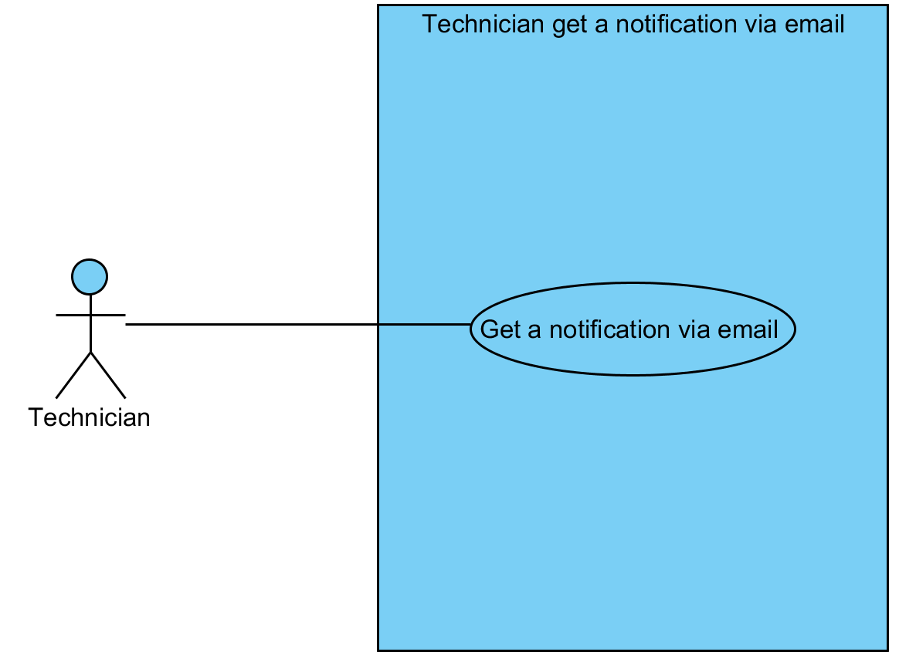

|  |  |  |  |  |
| --- | --- | --- | --- | --- |
| **Use Case ID:** | UC26 | | | |
| **Use Case Name:** | Technician can get a notification via email | | | |
| **Created By:** | Mr.Tanadol Parn-ong | | **Last Updated By:** | Mr.Tanadol Parn-ong |
| **Date Created:** | 18/06/2015 | | **Last Revision Date:** | 18/06/2015 |
| **Actors:** | | Administrator, Technician | | |
| **Description:** | | This use case is provided for Administrator define type of broken of IT equipment after that the system will distribute a repair task to a technician. After that, Technician can get a notification via email. | | |
| **Trigger:** | | Administrator clicks the Define type button. | | |
| **Preconditions:** | | The system distributes a repair task to a technician**.** | | |
| **Post conditions:** | | Technician get an email in his mail box. | | |
| **Normal Flow:** | | 1. After Use case 13. 2. The system send an email about broken IT equipment information to mail box of Technician. 3. Technician get an email in his box. | | |
| **Alternative Flows:** | | N/A | | |
| **Exceptions:** | | N/A | | |
| **Includes:** | | UC13 | | |
| **Frequency of Use:** | | Often | | |
| **Assumptions:** | | N/A | | |
| **Notes and Issues:** | | N/A | | |

**URS26 Technician can get a notification via email.**

Administrator define type of broken of IT equipment after that the system will distribute a repair task to a technician. After that, Technician can get a notification via email.

**Actor:** Administrator, Technician

**Prerequisite:** The system distributes a repair task to a technician**.**

**Input:**N/A **Flow of Execution:**

1. After Use case 13.
2. Technician get an email in his box.

**AC26 6 Technician can get a notification via email.**

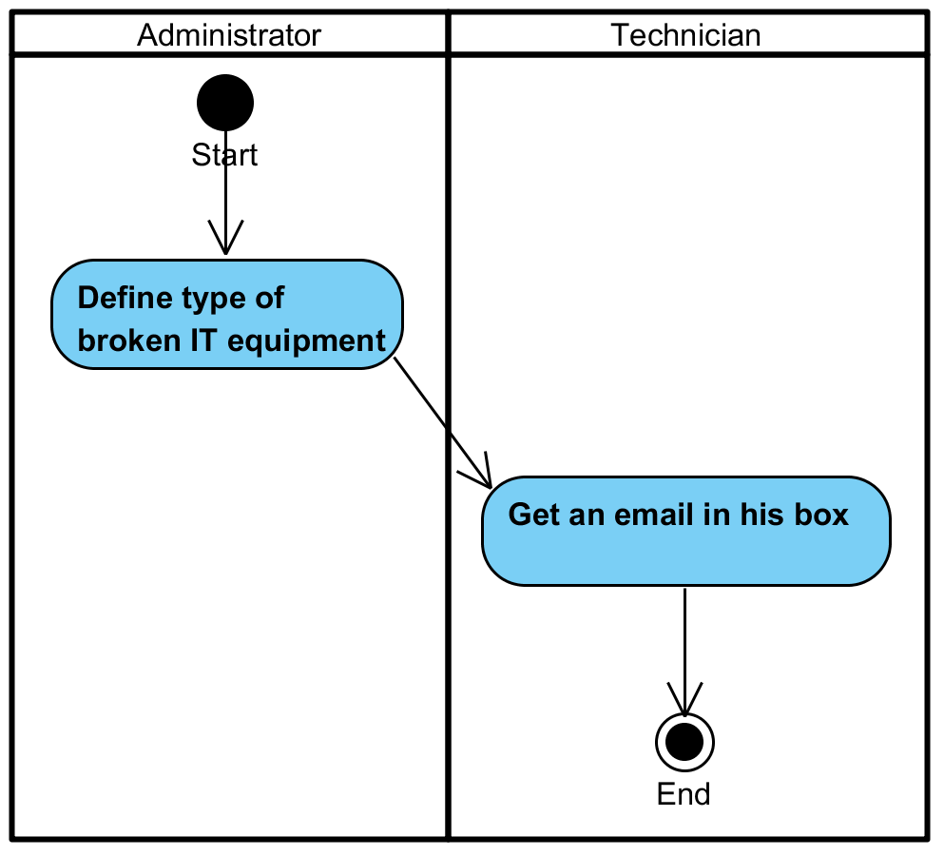

**System Requirement Specification of URS26**

SRS26-1 The system send an email about broken IT equipment information to mail box of Technician.

## **4.27 Reporter can inform a broken IT equipment. (UC27)**

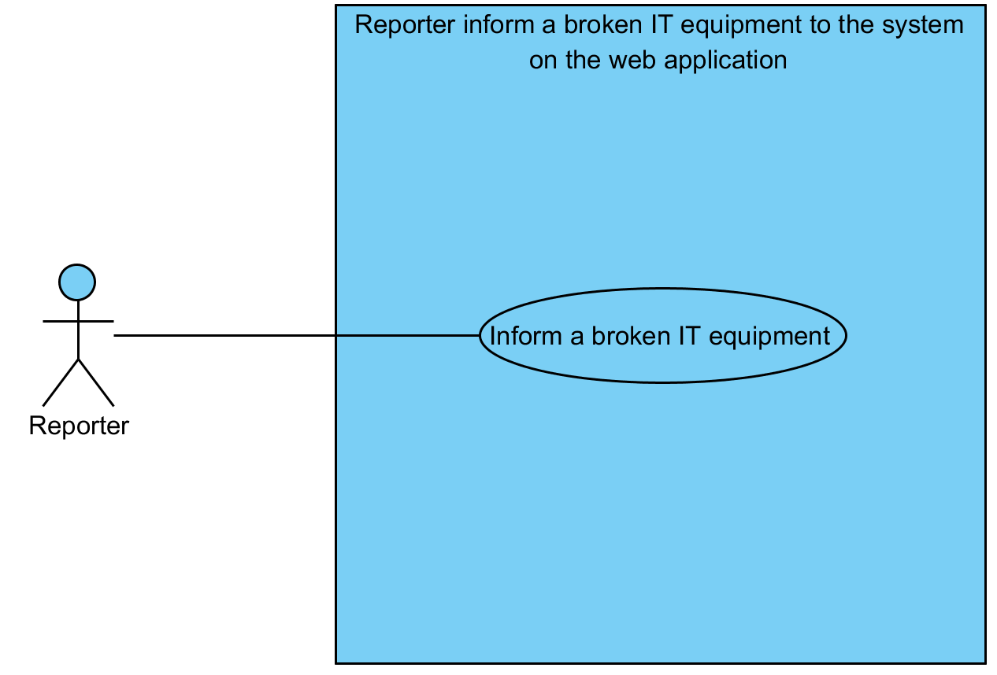

|  |  |  |  |  |
| --- | --- | --- | --- | --- |
| **Use Case ID:** | UC27 | | | |
| **Use Case Name:** | Reporter can inform a broken IT equipment | | | |
| **Created By:** | Mr.Tanadol Parn-ong | | **Last Updated By:** | Mr.Tanadol Parn-ong |
| **Date Created:** | 18/06/2015 | | **Last Revision Date:** | 18/06/2015 |
| **Actors:** | | Reporter | | |
| **Description:** | | This use case is provided for Reporter can inform a broken IT equipment in Reporter Main page. Reporter can select notification mode, which will define mail sending permission. | | |
| **Trigger:** | | Reporter clicks the Submit button. | | |
| **Preconditions:** | | The system must has IT equipment information in the system. | | |
| **Post conditions:** | | The system displays “Your report are send” on the web application. | | |
| **Normal Flow:** | | 1. Reporter enters to Reporter Main page. 2. The system provides reparation inform form. Which consists serial number text field, description text field, and contact information text field in Reporter Main page. 3. The system provides notification modes, which consists allow mode and disallow mode. 4. Reporter fills serial number, description, contact information, notification mode. 5. Reporter selects mode of notification. 6. Reporter click the Submit button. 7. The system validate serial number, description, contact information, and notification mode. 8. The system records repair task to the system. 9. The system displays “Your report are send” on the web application. | | |
| **Alternative Flows:** | | 1. When Reporter clicks the Reporter Main page button.  1.1. Reporter clicks the Reporter Main page button.  1.2. The system redirects to Reporter Main page.  2. When Reporter clicks the Report History button.  2.1. Reporter clicks the Report History button.  2.2. The system redirects to Report History page.  3. When Reporter clicks the Reporter Information button.  3.1. Reporter clicks the Reporter Information button.  3.2. The system redirects to Reporter Information page.  4. When Reporter clicks the Logout button.  4.1. Reporter clicks the Logout button.  4.2. The system redirects to Login page.  4.3 The system clears the user session.  5. When Reporter don’t fill serial number after he clicks the Submit button. The system provides the error message as followed:  5.1. The system displays “Please you fill Serial number” on the web application.  5.2. Use Case resumes on step 1 of normal flow.  6. When Reporter don’t fill description after he clicks the Submit button. The system provides the error message as followed:  6.1. The system displays “Please you fill description” on the web application.  6.2. Use Case resumes on step 1 of normal flow.  7. When Reporter don’t fill contact after he clicks the Submit button. The system provides the error message as followed:  7.1. The system displays “Please you fill contact” on the web application.  7.2. Use Case resumes on step 1 of normal flow.  8. When Reporter don’t select notification mode after he clicks the Submit button. The system provides the error message as followed:  8.1. The system displays “Please you select Notification mode” on the web application.  8.2. Use Case resumes on step 1 of normal flow.  9. When Reporter fills incorrect serial number after he clicks the Submit button. The system provides the error message as followed:  9.1. The system displays “Can't send report, please contact to Administrator” on the web application.  9.2. Use Case resumes on step 1 of normal flow. | | |
| **Exceptions:** | | N/A | | |
| **Includes:** | | N/A | | |
| **Frequency of Use:** | | Often | | |
| **Assumptions:** | | N/A | | |
| **Notes and Issues:** | | N/A | | |

**URS27 Reporter can inform a broken IT equipment.**

Reporter can inform a broken IT equipment in Reporter Main page. Reporter can select notification mode, which will define mail sending permission.

**Actor:** Reporter

**Prerequisite:** The system must has IT equipment information in the system.

**Input:**

|  |  |  |  |
| --- | --- | --- | --- |
| Name | Description | Example | Remarks |
| serial number | Can be any character only | “CAMT01” |  |
| description | Can be any character only | “Cannot open this computer” |  |
| contact information | Can be any character only | “0831112222” |  |
| Notification mode | Can be radio button for selecting | “Allow” |  |

**Flow of Execution:**

1. Reporter enters to Reporter Main page.
2. Reporter fills serial number, description, contact information, notification mode.
3. Reporter selects mode of notification.
4. Reporter click the Submit button.

**AC27 Reporter can inform a broken IT equipment.**

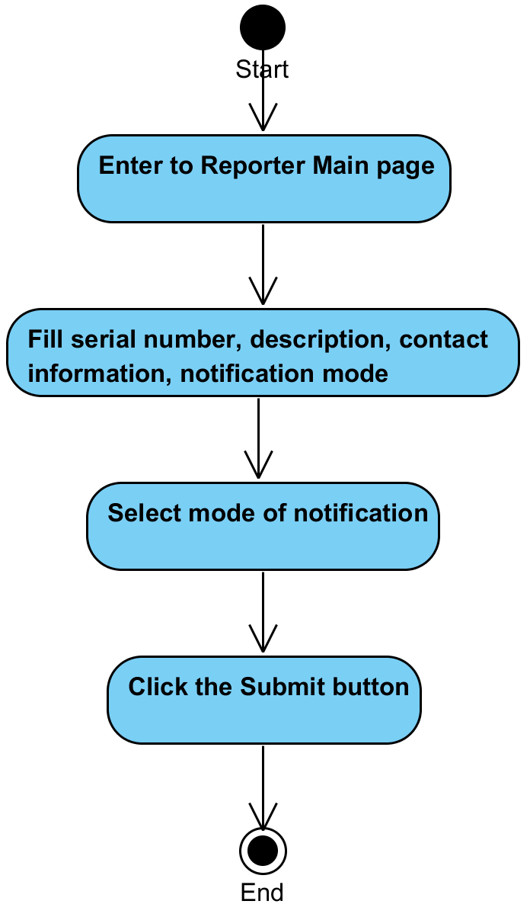

**System Requirement Specification of URS27**

SRS2-10 The system redirects to Login page.

SRS2-20 The system clears the user session.

SRS27-1 The system provides reparation inform form. Which consists serial number text field, description text field, and contact information text field in Reporter Main page.

SRS27-2 The system provides notification modes, which consists allow mode and disallow mode.

SRS27-3 The system validate serial number, description, contact information, and notification mode

SRS27-4 The system records repair task to the system.

SRS27-5 The system displays “Your report are send” on the web application

SRS27-6 The system redirects to Reporter Main page.

SRS27-7 The system redirects to Report History page.

SRS27-8 The system redirects to Reporter Information page.

SRS27-9 The system displays “Please you fill Serial number” on the web application.

SRS27-10 The system displays “Please you fill description” on the web application.

SRS27-11 The system displays “Please you fill contact” on the web application.

SRS27-12 The system displays “Please you select Notification mode” on the web application.

SRS27-13 The system displays “Can't send report, please contact to Administrator” on the web application.

## **4.28 Reporter can view all IT equipment that he inform. (UC28)**

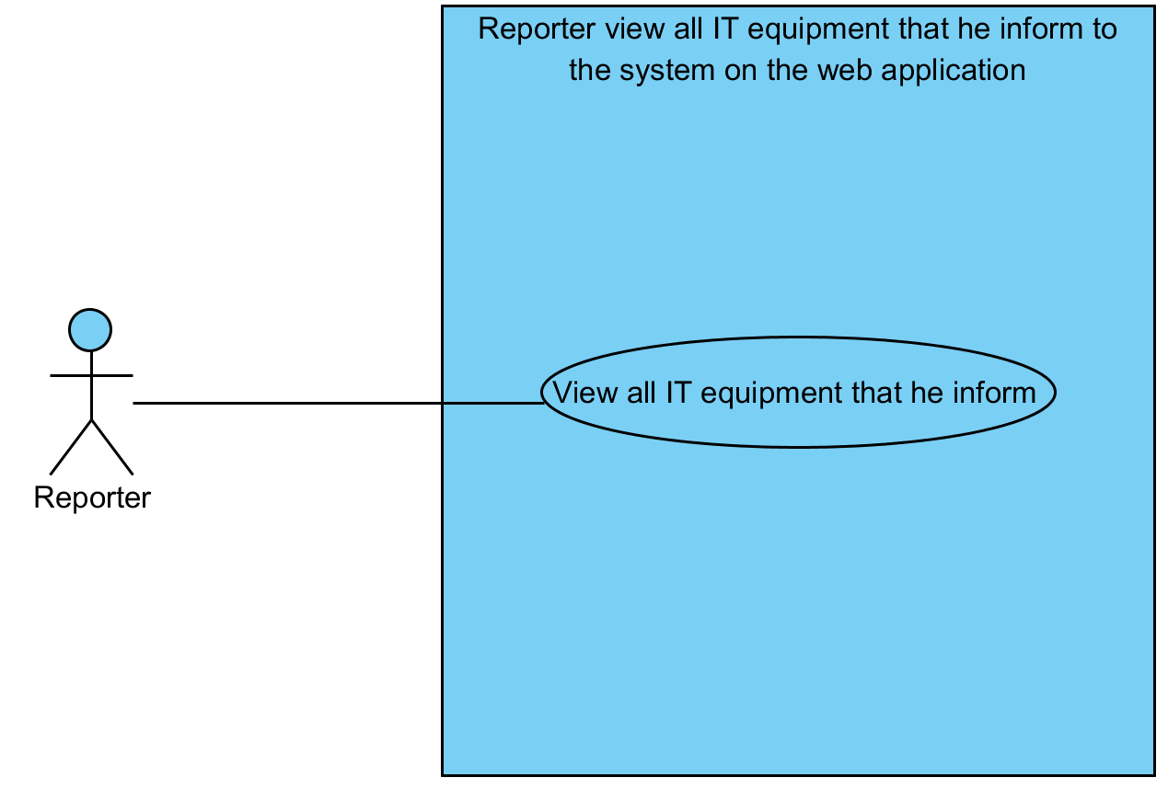

|  |  |  |  |  |
| --- | --- | --- | --- | --- |
| **Use Case ID:** | UC28 | | | |
| **Use Case Name:** | Reporter can view all IT equipment that he inform | | | |
| **Created By:** | Mr.Tanadol Parn-ong | | **Last Updated By:** | Mr.Tanadol Parn-ong |
|  |  | |  |  |
| **Date Created:** | 18/06/2015 | | **Last Revision Date:** | 18/06/2015 |
| **Actors:** | | Reporter | | |
| **Description:** | | This use case is provided for Reporter can view all IT equipment that he inform in Report History page. | | |
| **Trigger:** | | Reporter clicks the Report History button. | | |
| **Preconditions:** | | The system must has IT equipment information in the system. | | |
| **Post conditions:** | | The system displays all IT equipment that were informed by that reporter in Report History page. | | |
| **Normal Flow:** | | 1. Reporter clicks the Report History button. 2. The system redirects to Report History page. 3. The system displays all IT equipment that were informed by that reporter in Report History page. 4. Reporter enters to Report History page. | | |
| **Alternative Flows:** | | 1. When Reporter clicks the Reporter Main page button.  1.1. Reporter clicks the Reporter Main page button.  1.2. The system redirects to Reporter Main page.  2. When Reporter clicks the Report History button.  2.1. Reporter clicks the Report History button.  2.2. The system redirects to Report History page.  3. When Reporter clicks the Reporter Information button.  3.1. Reporter clicks the Reporter Information button.  3.2. The system redirects to Reporter Information page.  4. When Reporter clicks the Logout button.  4.1. Reporter clicks the Logout button.  4.2. The system redirects to Login page.  4.3 The system clears the user session. | | |
| **Exceptions:** | | N/A | | |
| **Includes:** | | N/A | | |
| **Frequency of Use:** | | Often | | |
| **Assumptions:** | | N/A | | |
| **Notes and Issues:** | | N/A | | |

**URS28 Reporter can view all IT equipment that he inform.**

Reporter can view all IT equipment that he inform in Report History page.

**Actor:** Reporter

**Prerequisite:** The system must has IT equipment information in the system.

**Input:**N/A  **Flow of Execution:**

1. Reporter clicks the Report History button.
2. Reporter enters to Report History page.

**AC28 Reporter can view all IT equipment that he inform.**

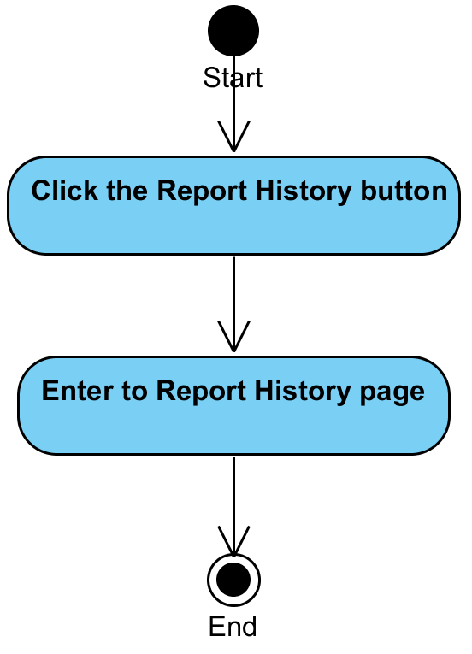

**System Requirement Specification of URS28**

SRS2-10 The system redirects to Login page.

SRS2-20 The system clears the user session.

SRS27-6 The system redirects to Reporter Main page.

SRS27-7 The system redirects to Report History page.

SRS27-8 The system redirects to Reporter Information page.

SRS28-1 The system displays all IT equipment that were informed by that reporter in Report History page.

## **4.29 Reporter can view IT equipment information. (UC29)**

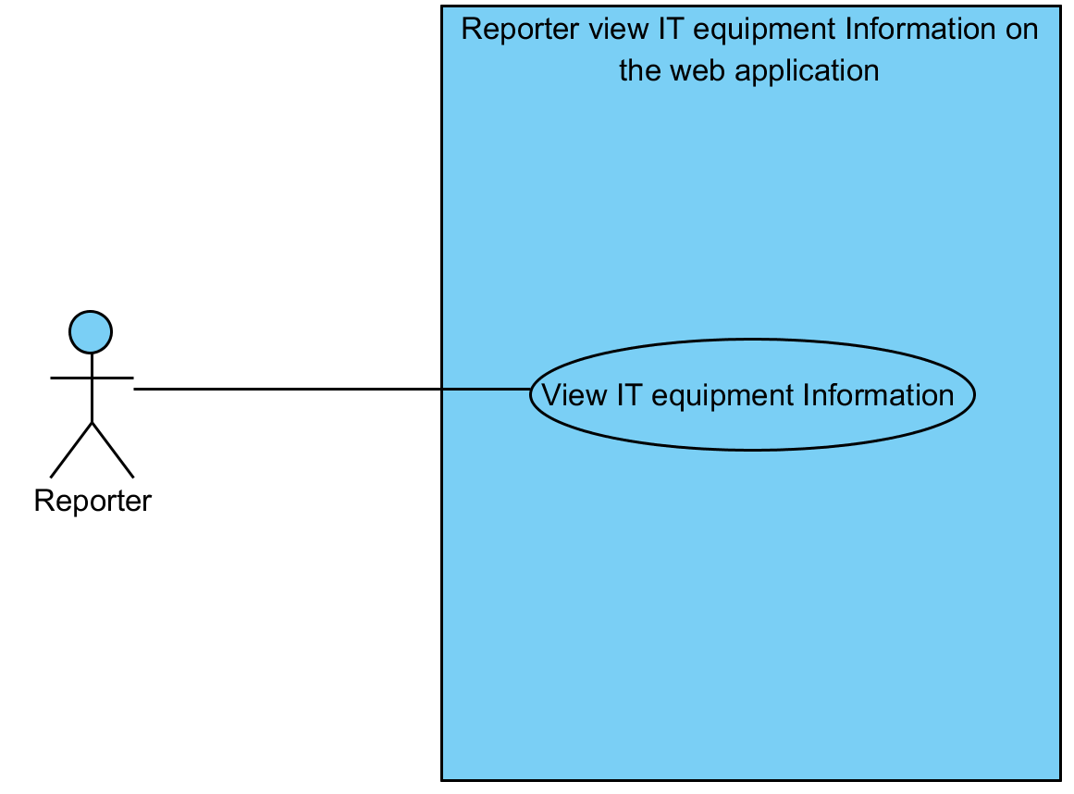

|  |  |  |  |  |
| --- | --- | --- | --- | --- |
| **Use Case ID:** | UC29 | | | |
| **Use Case Name:** | Reporter can view IT equipment Information | | | |
| **Created By:** | Mr.Tanadol Parn-ong | | **Last Updated By:** | Mr.Tanadol Parn-ong |
| **Date Created:** | 18/06/2015 | | **Last Revision Date:** | 18/06/2015 |
| **Actors:** | | Reporter | | |
| **Description:** | | This use case is provided for Reporter can view IT equipment Information. | | |
| **Trigger:** | | Reporter clicks the Report History button. | | |
| **Preconditions:** | | The system must has IT equipment information in the system. | | |
| **Post conditions:** | | The system displays IT equipment information in IT equipment information page. | | |
| **Normal Flow:** | | 1. Reporter enters to Report History page. 2. Reporter clicks an IT equipment name button. 3. The system redirects to IT equipment information page. 4. The system displays IT equipment information in IT equipment information page. | | |
| **Alternative Flows:** | | 1. When Reporter clicks the Reporter Main page button.  1.1. Reporter clicks the Reporter Main page button.  1.2. The system redirects to Reporter Main page.  2. When Reporter clicks the Report History button.  2.1. Reporter clicks the Report History button.  2.2. The system redirects to Report History page.  3. When Reporter clicks the Reporter Information button.  3.1. Reporter clicks the Reporter Information button.  3.2. The system redirects to Reporter Information page.  4. When Reporter clicks the Logout button.  4.1. Reporter clicks the Logout button.  4.2. The system redirects to Login page.  4.3 The system clears the user session. | | |
| **Exceptions:** | | N/A | | |
| **Includes:** | | N/A | | |
| **Frequency of Use:** | | Often | | |
| **Assumptions:** | | N/A | | |
| **Notes and Issues:** | | N/A | | |

**URS29 Reporter can view IT equipment information.**

Reporter can view IT equipment information in IT equipment information page.

**Actor:** Reporter

**Prerequisite:** The system must has IT equipment information in the system.

**Input:**N/A  **Flow of Execution:**

1. Reporter enters to Report History page.
2. Reporter clicks an IT equipment name button.

**AC29 Reporter can view IT equipment information.**

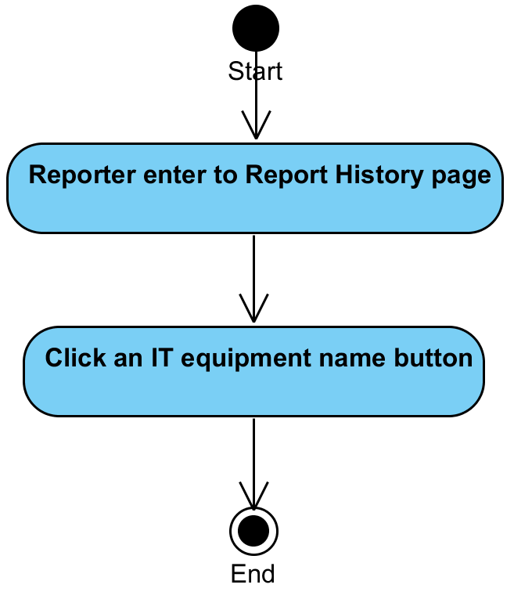

**System Requirement Specification of URS29**

SRS2-10 The system redirects to Login page.

SRS2-20 The system clears the user session.

SRS20-1 The system redirects to IT equipment information page.

SRS20-2 The system displays IT equipment information in IT equipment information page.

SRS27-6 The system redirects to Reporter Main page.

SRS27-7 The system redirects to Report History page.

SRS27-8 The system redirects to Reporter Information page.

SRS28-1 The system displays all IT equipment that were informed by that reporter in Report History page.

## **4.30 Reporter can update his account information (UC30)**

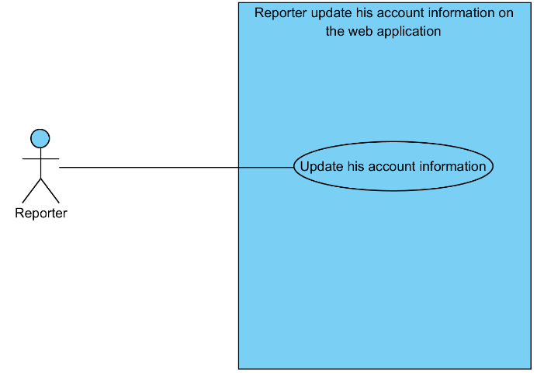

|  |  |  |  |  |
| --- | --- | --- | --- | --- |
| **Use Case ID:** | UC30 | | | |
| **Use Case Name:** | Reporter can update his account information | | | |
| **Created By:** | Mr.Tanadol Parn-ong | | **Last Updated By:** | Mr.Tanadol Parn-ong |
|  |  | |  |  |
| **Date Created:** | 18/06/2015 | | **Last Revision Date:** | 18/06/2015 |
| **Actors:** | | Reporter | | |
| **Description:** | | This use case is provided for Reporter can update his account information in Reporter Information page. | | |
| **Trigger:** | | When Reporter would like to edit basic information.  - Reporter clicks the Update Information button.  When Reporter would like to edit his password.  - Reporter clicks the Change Password button. | | |
| **Preconditions:** | | The system must has a Reporter account information in the system. | | |
| **Post conditions:** | | When Reporter would like to edit basic information.  - The system displays “Update Reporter information successful.” on the web application.  When Reporter would like to edit his password.  - The system displays “Update your password successful” on the web application. | | |
| **Normal Flow:** | | When Reporter would like to edit basic information.   1. Reporter enters to Reporter Information page. 2. The system provides Reporter Information form. Which consists username, name, room, address, phone, email, old password, new password, and confirm password textbox. 3. The system provides username text field that cannot edit text. 4. Reporter fills username, name, room, address, phone, and email. 5. Reporter clicks Update Information button. 6. The system displays yes/no dialog massage “Do you sure for edit information ?”. 7. Reporter clicks yes button in yes/no dialog message. 8. The system validates name, department, room, address, telephone number, and email. 9. The system updates user account information in the system. 10. The system displays “Update Reporter information successful” on the web application.   When Reporter would like to edit his password.   1. Reporter enters to Reporter Information page. 2. The system provides Reporter Information form. Which consists username, name, room, address, phone, email, old password, new password, and confirm password textbox. 3. The system provides username text field that cannot edit text. 4. Reporter fills old password, new password, and confirm password. 5. Reporter clicks the Change Password button. 6. The system displays yes/no dialog massage “Do you sure for edit password ?”. 7. Reporter clicks yes button in yes/no dialog message. 8. The system validates new password, old password, and confirm password. 9. The system updates user account information in the system. 10. The system displays “Update your password successful” on the web application. | | |
| **Alternative Flows:** | | 1. When Reporter clicks the Reporter Main page button.  1.1. Reporter clicks the Reporter Main page button.  1.2. The system redirects to Reporter Main page.  2. When Reporter clicks the Report History button.  2.1. Reporter clicks the Report History button.  2.2. The system redirects to Report History page.  3. When Reporter clicks the Reporter Information button.  3.1. Reporter clicks the Reporter Information button.  3.2. The system redirects to Reporter Information page.  4. When Reporter clicks the Logout button.  4.1. Reporter clicks the Logout button.  4.2. The system redirects to Login page.  4.3 The system clears the user session.  5. When Reporter don’t fill name after he clicks the Update Information button. The system provides the error message as followed:  5.1. The system displays “Please you fill name” on the web application.  5.2. Use Case resumes on step 1 of normal flow.  6. When Reporter don’t fill department after he clicks the Update Information button. The system provides the error message as followed:  6.1. The system displays “Please you fill department” on the web application.  6.2. Use Case resumes on step 1 of normal flow.  7. When Reporter don’t fill room after he clicks the Update Information button. The system provides the error message as followed:  7.1. The system displays “Please you fill room” on the web application.  7.2. Use Case resumes on step 1 of normal flow.  8. When Reporter don’t fill address after he clicks the Update Information button. The system provides the error message as followed:  8.1. The system displays “Please you fill address” on the web application.  8.2. Use Case resumes on step 1 of normal flow.  9. When Reporter don’t fill telephone number after he clicks the Update Information button. The system provides the error message as followed:  9.1. The system displays “Please you fill telephone number” on the web application.  9.2. Use Case resumes on step 1 of normal flow.  10. When Reporter don’t fill email after he clicks the Update Information button. The system provides the error message as followed:  10.1. The system displays “Please you fill email” on the web application.  10.2. Use Case resumes on step 1 of normal flow.  11. When Reporter don’t fill old password after he clicks the Change Password button. The system provides the error message as followed:  11.1. The system displays “Please you fill old password” on the web application.  11.2. Use Case resumes on step 1 of normal flow.  12. When Reporter don’t fill new password after he clicks the Change Password button. The system provides the error message as followed:  12.1. The system displays “Please you fill new password” on the web application.  12.2. Use Case resumes on step 1 of normal flow.  13. When Reporter don’t fill confirm password after he clicks the Change Password button. The system provides the error message as followed:  13.1. The system displays “Please you fill confirm password” on the web application.  13.2. Use Case resumes on step 1 of normal flow.  14. When Reporter fills new password less than 4 characters or more than 16 characters after he clicks the Change Password button. The system provides the error message as followed:  14.1. The system displays “Please you fill new password 4-16 characters” on the web application.  14.2. Use Case resumes on step 1 of normal flow.  15. When Reporter fills confirm password less than 4 characters or more than 16 characters after he clicks the Change Password button. The system provides the error message as followed:  15.1. The system displays “Please you fill confirm password 4-16 characters” on the web application.  15.2. Use Case resumes on step 1 of normal flow.  16. When Reporter fills confirm password and new password that are not match. The system provides the error message as followed:  16.1. The system displays “New Password and confirm password are not match” on the web application.  16.2. Use Case resumes on step 1 of normal flow.  17. When Reporter fills incorrect old password. The system provides the error message as followed:  17.1. The system displays “Old password incorrect” on the web application.  17.2. Use Case resumes on step 1 of normal flow. | | |
| **Exceptions:** | | N/A | | |
| **Includes:** | | N/A | | |
| **Frequency of Use:** | | Often | | |
| **Assumptions:** | | N/A | | |
| **Notes and Issues:** | | N/A | | |

**URS30 Reporter can update his account information.**

Reporter can update his account information in Reporter Information page.

**Actor:** Reporter

**Prerequisite:** The system must has a Reporter account information in the system.

**Input:**

When Reporter would like to edit basic information.

|  |  |  |  |
| --- | --- | --- | --- |
| Name | Description | Example | Remarks |
| name | Can be any character only | “reporter one” |  |
| department | Can be any character only | “CAMT” |  |
| room | Can be any character only | “114” |  |
| address | Can be any character only | “Chiang Mai” |  |
| telephone number | Can be any character only | “0833201787” |  |
| email | Can be any character only | “se542115021.developer@gmail.com” |  |

When Reporter would like to edit his password.

|  |  |  |  |
| --- | --- | --- | --- |
| Name | Description | Example | Remarks |
| old password | Can be any character within the range of 4-16 characters. | “123456” |  |
| new password | Can be any character within the range of 4-16 characters. | “12345678” |  |
| confirm password | Can be any character within the range of 4-16 characters. | “12345678” |  |

**Flow of Execution:**

When Administrator would like to edit basic information.

1. Reporter enters to Reporter Information page.
2. Reporter fills username, name, room, address, phone, and email.
3. Reporter clicks Update Information button.
4. Reporter clicks yes button in yes/no dialog message.

When Administrator would like to edit his password.

1. Reporter enters to Reporter Information page.
2. Reporter fills old password, new password, and confirm password.
3. Reporter clicks the Change Password button.
4. Reporter clicks yes button in yes/no dialog message.

**AC30 Reporter can update his account information.**

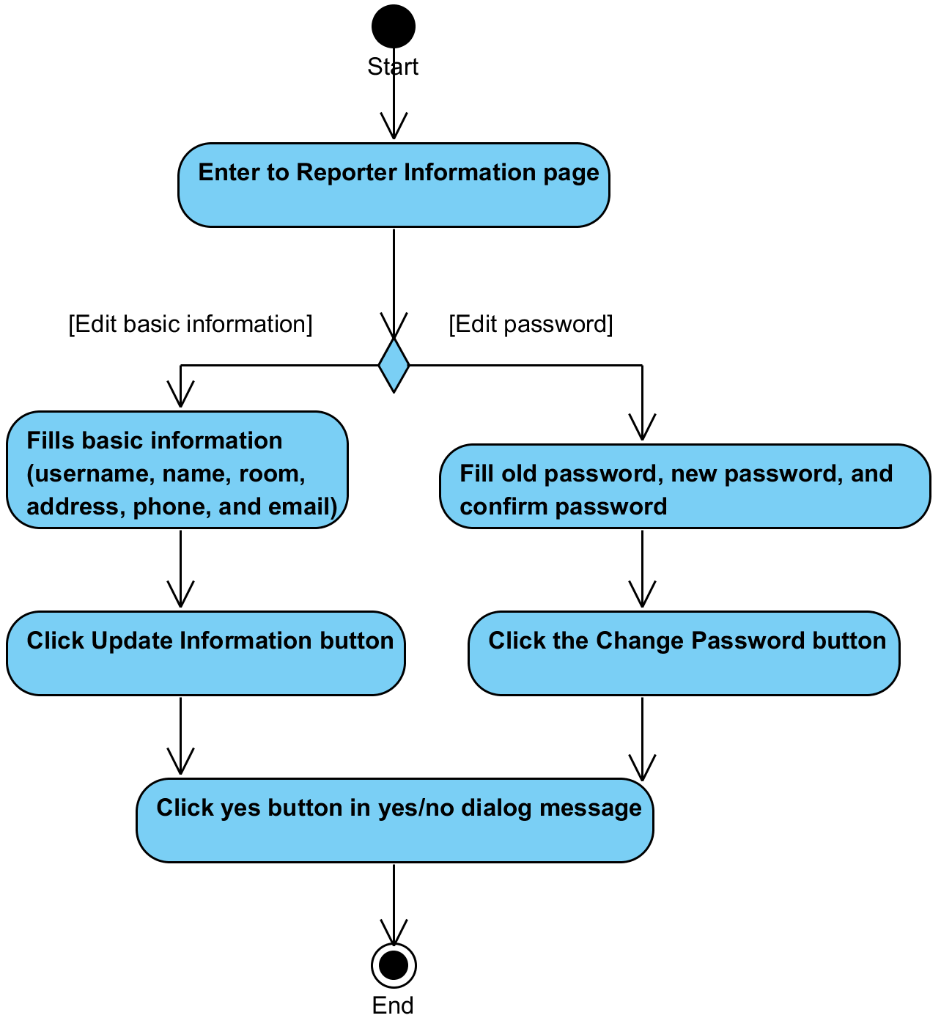

**System Requirement Specification of URS30**

SRS2-10 The system redirects to Login page.

SRS2-20 The system clears the user session.

SRS2-13 The system displays “Please you fill name” on the web application.

SRS2-14 The system displays “Please you fill department” on the web application.

SRS2-15 The system displays “Please you fill room” on the web application.

SRS2-16 The system displays “Please you fill address” on the web application.

SRS2-17 The system displays “Please you fill telephone number” on the web application.

SRS2-18 The system displays “Please you fill email” on the web application.

SRS16-2 The system provides username text field that cannot edit text.

SRS16-3 The system displays yes/no dialog massage “Do you sure for edit information ?”

SRS16-4 The system validates name, department, room, address, telephone number, and email.

SRS16-5 The system updates user account information in the system.

SRS16-8 The system validates new password, old password, and confirm password.

SRS16-9 The system displays “Update your password successful” on the web application

SRS16-10 The system displays “Please you fill old password” on the web application.

SRS16-11 The system displays “Please you fill new password” on the web application.

SRS16-12 The system displays “Please you fill confirm password” on the web application.

SRS16-13 The system displays “Please you fill new password 4-16 characters” on the web application.

SRS16-14 The system displays “Please you fill confirm password 4-16 characters” on the web application.

SRS16-15 The system displays “New Password and confirm password are not match” on the web application.

SRS16-16 The system displays “Old password incorrect” on the web application.

SRS27-6 The system redirects to Reporter Main page.

SRS27-7 The system redirects to Report History page.

SRS27-8 The system redirects to Reporter Information page.

SRS30-1 The system provides Reporter Information form. Which consists username, name, room, address, phone, email, old password, new password, and confirm password textbox.

SRS30-2 The system displays “Update Reporter information successful” on the web application.

## **4.31 Technician can get a notification via email. (UC31)**

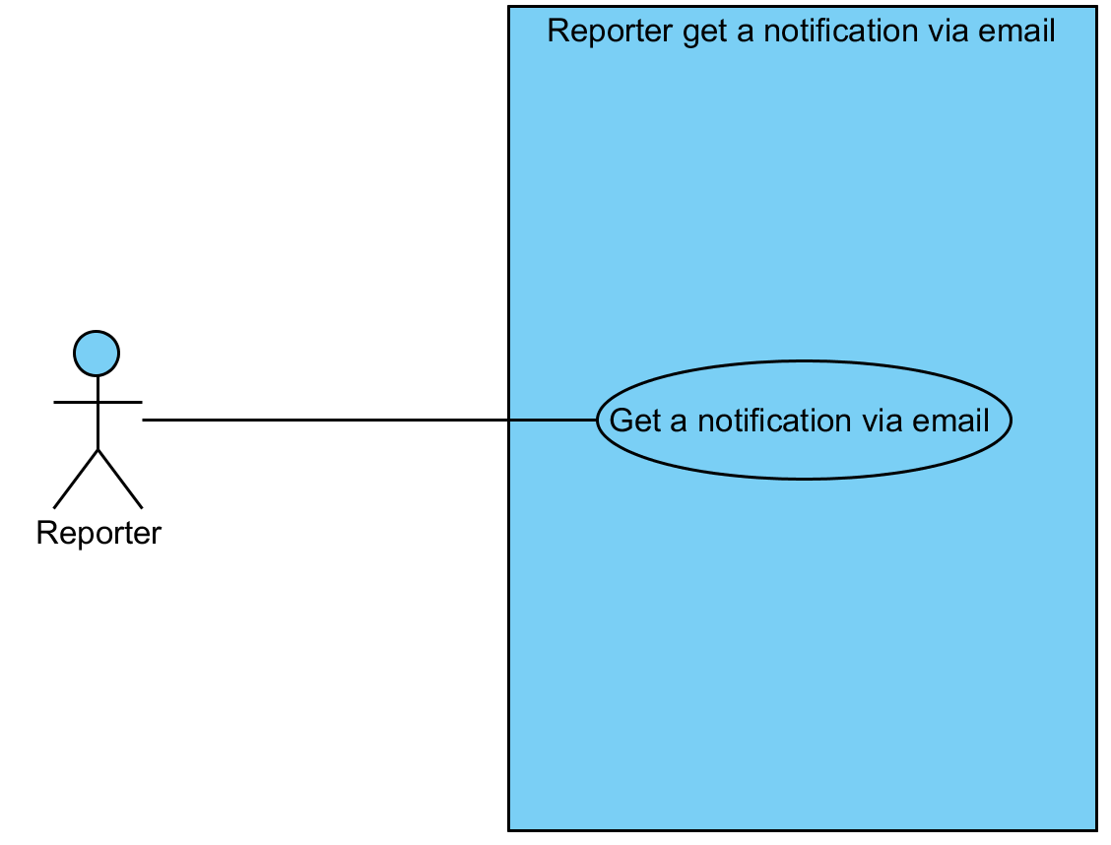

|  |  |  |  |  |
| --- | --- | --- | --- | --- |
| **Use Case ID:** | UC31 | | | |
| **Use Case Name:** | Technician can get a notification via email | | | |
| **Created By:** | Mr.Tanadol Parn-ong | | **Last Updated By:** | Mr.Tanadol Parn-ong |
| **Date Created:** | 18/06/2015 | | **Last Revision Date:** | 18/06/2015 |
| **Actors:** | | Technician, Reporter | | |
| **Description:** | | This use case is provided for Technician updates repair task information after that the system will send repair task information to a reporter. | | |
| **Trigger:** | | Technician clicks the Update Repairing button. | | |
| **Preconditions:** | | The system updates task information. | | |
| **Post conditions:** | | Reporter get an email in his mail box. | | |
| **Normal Flow:** | | 1. After Use case 23. 2. The system send an email about repair task information to mail box of Reporter. 3. Reporter get an email in his box. | | |
| **Alternative Flows:** | | N/A | | |
| **Exceptions:** | | N/A | | |
| **Includes:** | | UC23 | | |
| **Frequency of Use:** | | Often | | |
| **Assumptions:** | | N/A | | |
| **Notes and Issues:** | | N/A | | |

**URS31 Technician can get a notification via email.**

Technician updates repair task information after that the system will send repair task information to a reporter.

**Actor:** Technician, Reporter

**Prerequisite:** The system updates task information.

**Input:**N/A **Flow of Execution:**

1. After Use case 23.
2. Reporter get an email in his box.

**AC31 Technician can get a notification via email.**

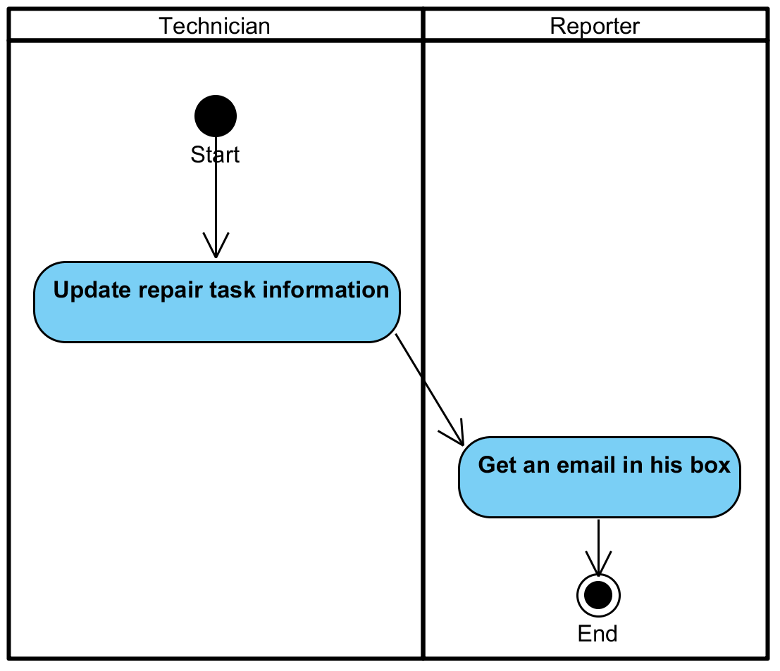

**System Requirement Specification of URS31**

SRS31-1 The system send an email about repair task information to mail box of Reporter.

## **4.32 User can logout. (UC32)**

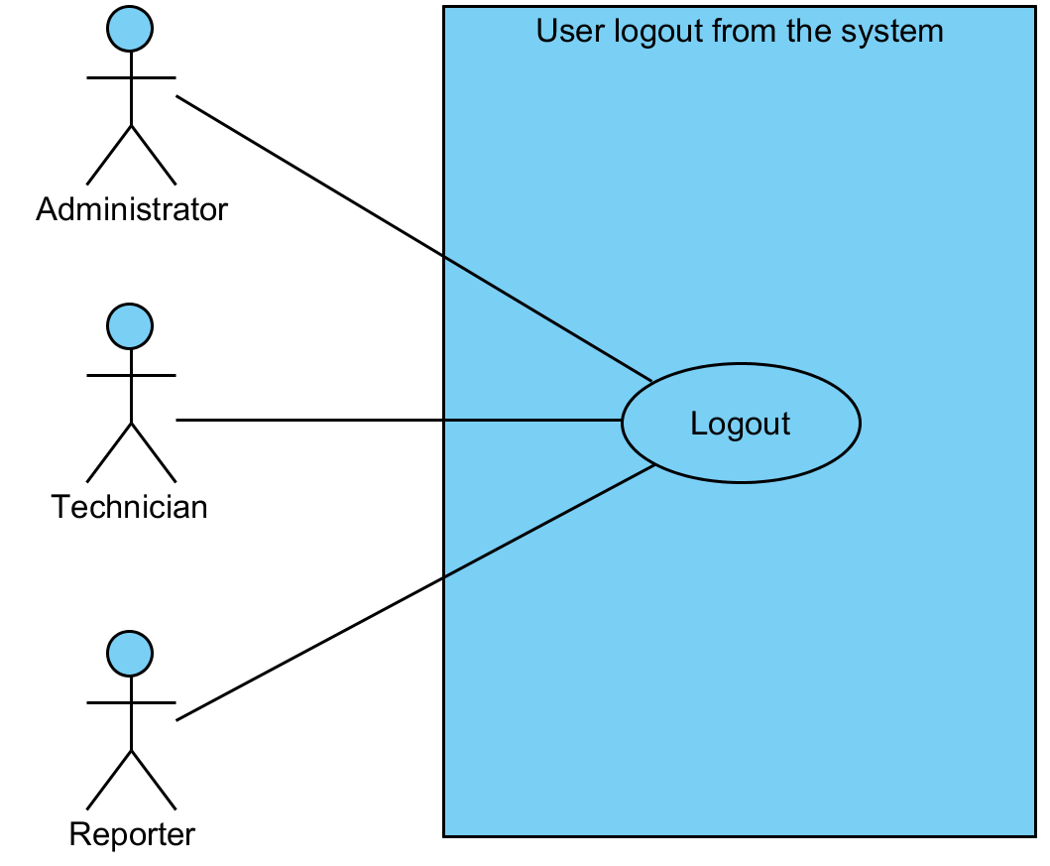

|  |  |  |  |  |
| --- | --- | --- | --- | --- |
| **Use Case ID:** | UC32 | | | |
| **Use Case Name:** | User can logout | | | |
| **Created By:** | Mr.Tanadol Parn-ong | | **Last Updated By:** | Mr.Tanadol Parn-ong |
| **Date Created:** | 18/06/2015 | | **Last Revision Date:** | 18/06/2015 |
| **Actors:** | | User | | |
| **Description:** | | This use case is provided for User can logout from the system. | | |
| **Trigger:** | | User clicks the Logout button. | | |
| **Preconditions:** | | User must login to the system. | | |
| **Post conditions:** | | User enters to Login page | | |
| **Normal Flow:** | | 1. User clicks the Logout button. 2. The system redirects to Login page. 3. The system clears the user session | | |
| **Alternative Flows:** | | N/A | | |
| **Exceptions:** | | N/A | | |
| **Includes:** | | N/A | | |
| **Frequency of Use:** | | Often | | |
| **Assumptions:** | | N/A | | |
| **Notes and Issues:** | | N/A | | |

**URS32 User can logout.**

User can logout from the system.

**Actor:** User

**Prerequisite:** User must login to the system.

**Input:**N/A **Flow of Execution:**

1. User clicks the Logout button.

**AC32 User can logout.**

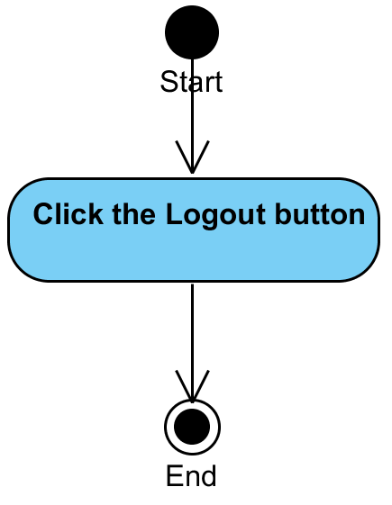

**System Requirement Specification of URS32**

SRS2-10 The system redirects to Login page.

SRS2-20 The system clears the user session.