**Analog Electronic Circuits – 2015-2016**

**Design Project Report**

1. **Group data**

|  |  |
| --- | --- |
| Group number | 8 |
| Name – Student 1 | Gauthier Duchêne |
| Name – Student 2 | Nathan Dwek |
| Name – Student 3 | Sacha Maes |

1. **Circuit Schematic**

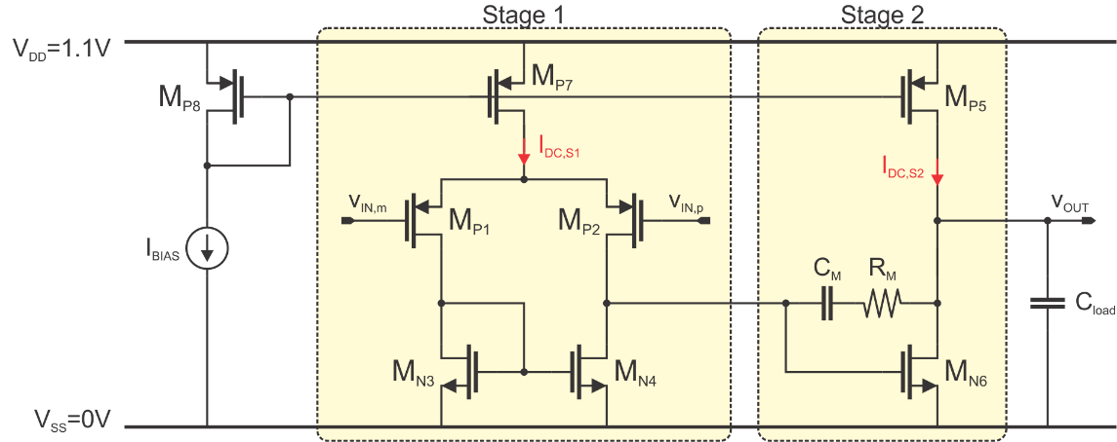

1. **Performance summary**

|  |  |  |  |  |
| --- | --- | --- | --- | --- |
| **Metric** | **Units** | **Specification** | **Matlab** | **Spectre** |
| Cload | pF | 50 |  |  |
| DC gain | dB | 48 | 52.53 | 51.86 |
| fGBW | MHz | 70 | 82.72 | 84.69 |
| Phase margin | ° | >60 | 83.78 | 90.78 |
| Output swing | V | >0.8 | 0.871 | 0.866 |
| Dominant pole | kHz |  | 195.4 | 191 |
| Input common mode range | V |  |  | 0.724 |
| Current consumption (IDC,S1+ IDC,S2) | A |  | 1.89m | 2.02m |
| FoM (fGBW.Cload/(IDC,S1+ IDC,S2)) | MHz.pF/mA | Maximize | 2184.4 | 2094 |
| (input-referred noise) | Vrms | Minimize |  | 1.3m |

1. **Device sizes and bias point parameters**

|  |  |  |  |  |  |  |  |  |  |
| --- | --- | --- | --- | --- | --- | --- | --- | --- | --- |
| **Device** | **W**  **[μm]** | **L**  **[nm]** | **Ids**  **[μA]** | **Voverdrive**  **[V]** | **gm**  **[S]** | **gds**  **[S]** | **gm/gds**  **[-]** | **Vds,sat**  **[V]** | **Vds**  **[V]** |
| Mp1 | 497 | 212 | 241 | 0.05 | 5.4m | 119u | 43.8 | -0.055 | -0.508 |
| Mp2 | 497 | 212 | 241 | 0.05 | 5.4m | 119u | 43.8 | -0.055 | -0.508 |
| Mn3 | 75.1 | 400 | 241 | 0.128 | 4.53m | 162u | 28.7 | 0.073 | 0.252 |
| Mn4 | 75.1 | 400 | 241 | 0.128 | 4.53m | 162u | 28.7 | 0.073 | 0.252 |
| Mp5 | 229 | 500 | 1540 | -0.2 | 12.5m | 364u | 23.8 | -0.182 | -0.681 |
| Mn6 | 493 | 132 | 1540 | 0.01 | 35m | 1339u | 33.6 | 0.05 | 0.418 |
| Mp7 | 80.4 | 500 | 482 | -0.2 | 3.9m | 246u | 15 | -0.184 | -0.338 |
| Mp8 | 0.767 | 500 | 4.51 | -0.194 | 38u | 1.64u | 23.16 | -0.176 | -0.434 |