# Example of bad UX



This is a screenshot of an older version of the DAW Pro Tools. It wasn’t intuitive, the UI wasn’t aesthetic, and it was notorious for causing bottlenecks on the average computer. Good UX should evoke a positive response from the user, this UX would leave you feeling frustrated.

# Example of good UX

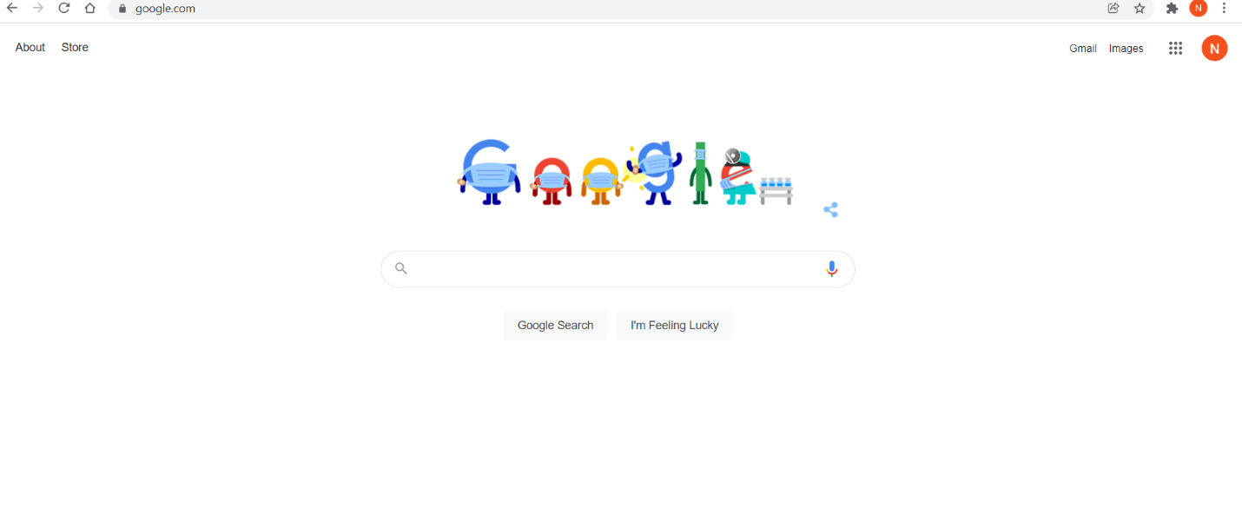

Most people can appreciate the beauty in simplicity, and I believe that’s one of the main reasons why Google is almost worth $2 billion dollars today.

<https://www.google.com/>