14: Environments

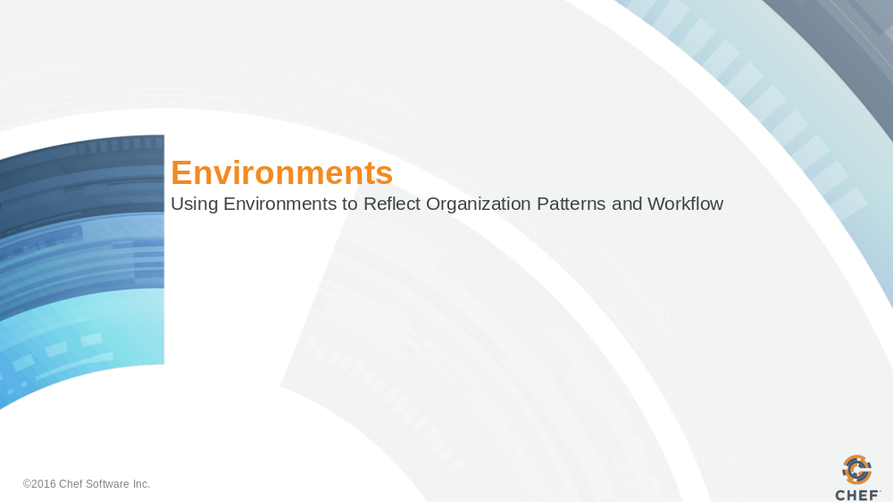

Slide 2

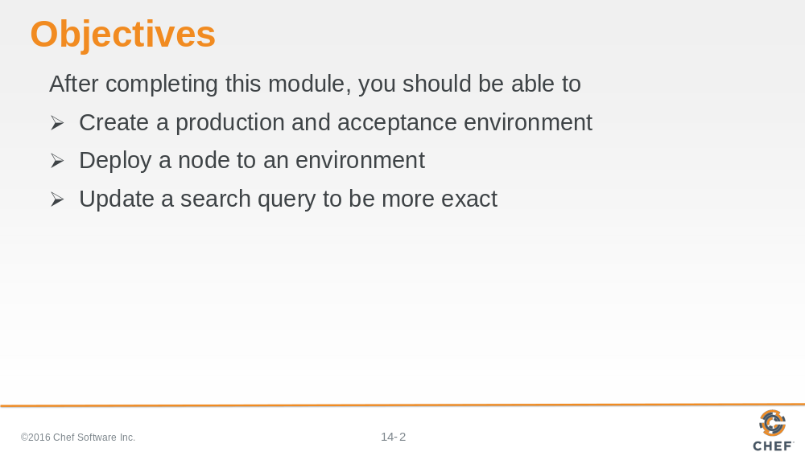
In this section, you will learn how to create an environment, deploy a node to an environment, and update a search query to be more exact.

Slide 3

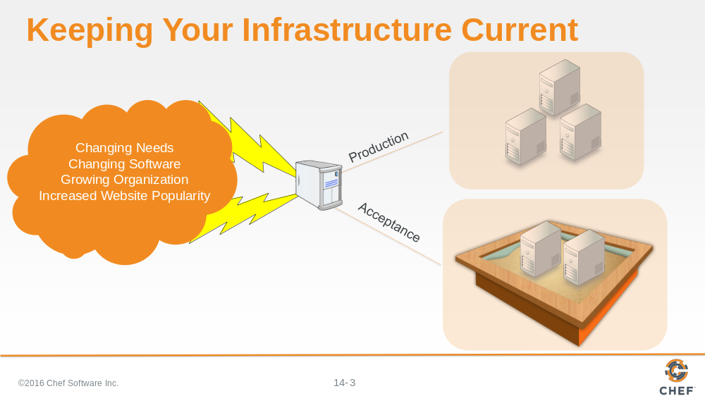

So, we have updated our load balancer's myhaproxy cookbook to dynamically search for and update nodes. Everything is as it should be. But our system is like a living, breathing thing that must grow and be updated to fit our changing needs. We need to find a way to update and test new tools, features and settings without impacting our current production system.

Of course, we have local testing tools like Test Kitchen to help us verify that our individual cookbooks work before we upload them to the Chef Server. But, that is not always enough. We may want to build, test, and release new features to our cookbooks but we do not immediately want all of our nodes to immediately use them. For example, what if we had a requirement to update our apache cookbook with a new front page for our application? The release date of our new service with the sign up page does not go live for a week. So, we want to build, test, and upload that cookbook to the Chef Server without actually applying the cookbook until the release date. How would we accomplish that?

This is where environments are useful.

Slide 4

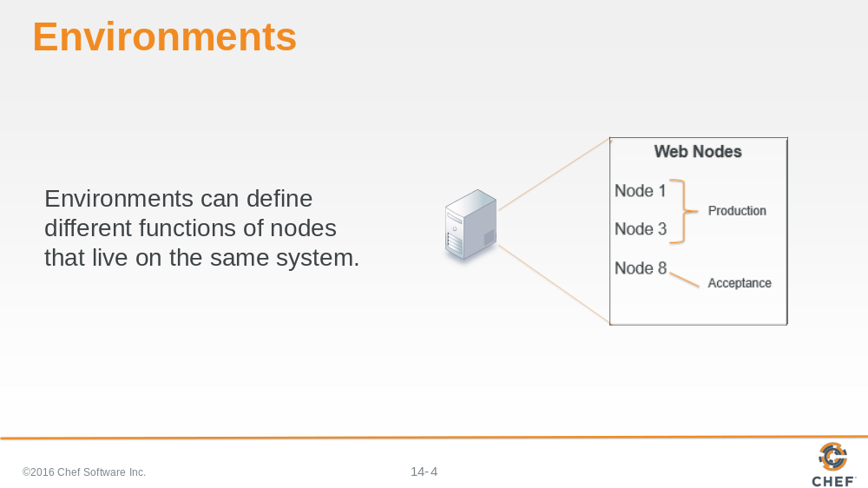

You likely are familiar with the concept of environments. An environment can best be defined as a logical separation of nodes that most often describe the life-cycle of an application. Each environment signifies different behaviors and policies to which a node adheres for a given application or platform.

For example, environments can be separated into 'acceptance’ and 'production'. “Acceptance” would be where we may make allowances for constant change and updates and for applications to be deployed with each release. “Production” might be where we lock down our infrastructure and policies. Production would be what the outside world sees, and would remain unaffected by changes and upgrades until you specifically release them. Chef also has a concept of an environment. A Chef environment allows us to define a list of policies that we will allow by defining a cookbook.

Slide 5

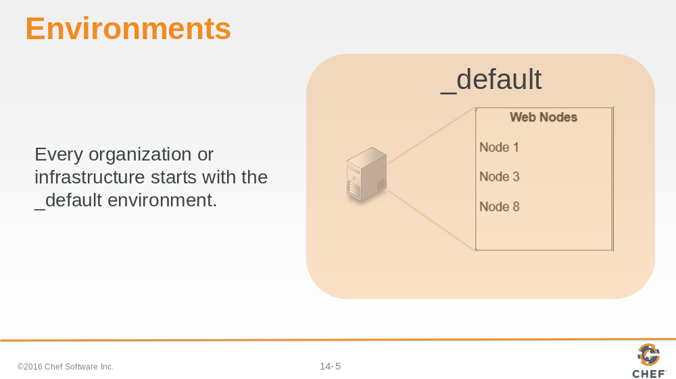

Chef also has a concept of an environment. Chef uses environments to map an organizations real-life workflow to what can be configured and managed using the Chef server.

Every organization begins with a single environment called the _default (underscore default) environment, which cannot be modified or deleted.

Therefore, you must create custom environments to define your organization’s workflow.

Slide 6

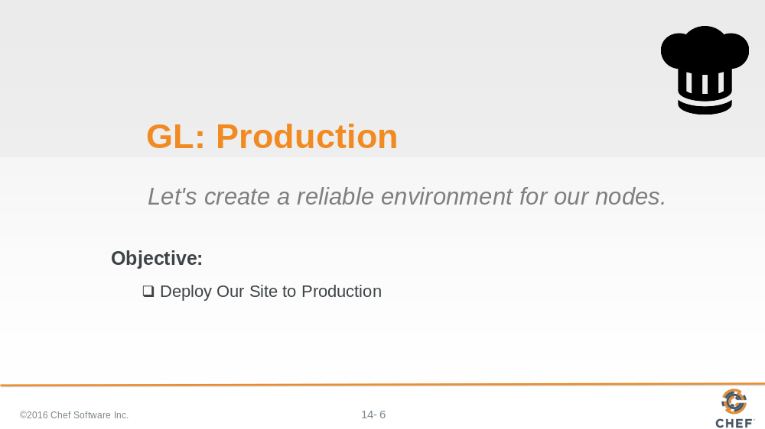

First, we need to create a Production environment. This is where we lock down our infrastructure and policies to a specific version of the myhaproxy cookbook.

Slide 7

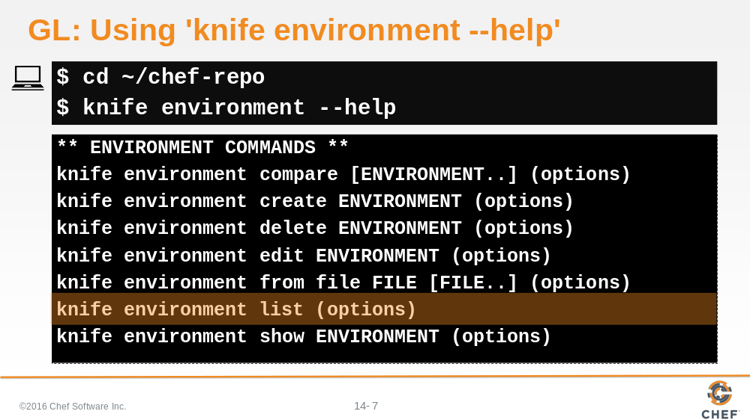

Because we still are communicating with the Chef server, let’s ask Chef for help regarding available environment commands.

So change into chef-repo and then run 'knife environment --help'.

Slide 8

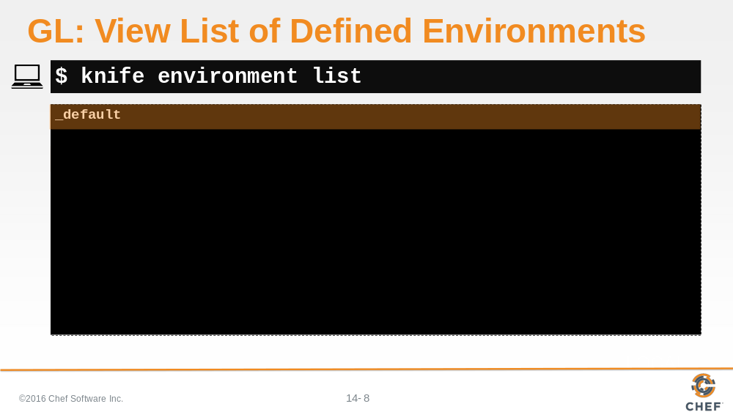

Remember, we use 'list' to view existing environments.

As previously stated, we see the _default environment has already been created.

Slide 9

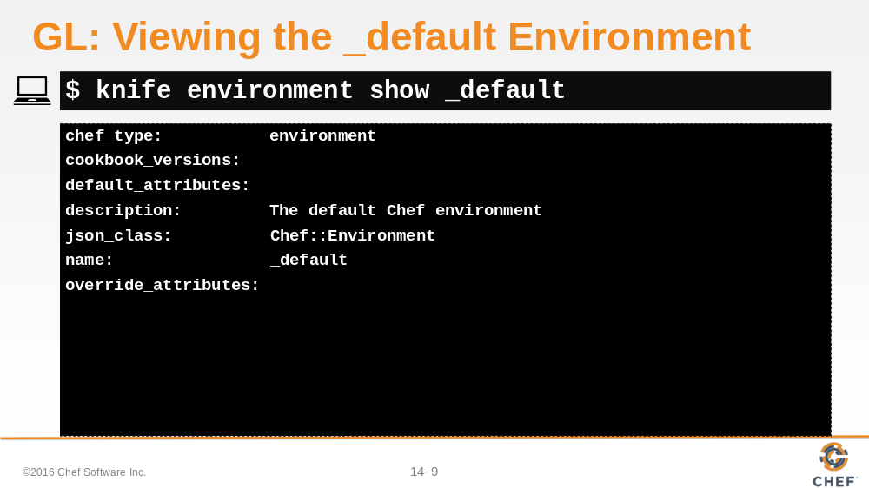

Let’s see how this environment looks.

Slide 10

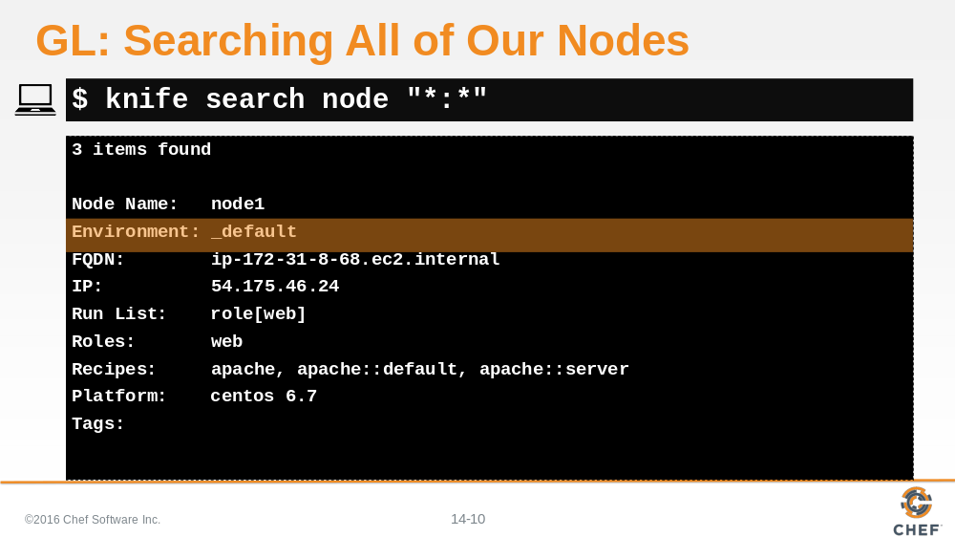

If we search our nodes, we see that all three nodes have been set to the _default environment. How do we change this?

Slide 11

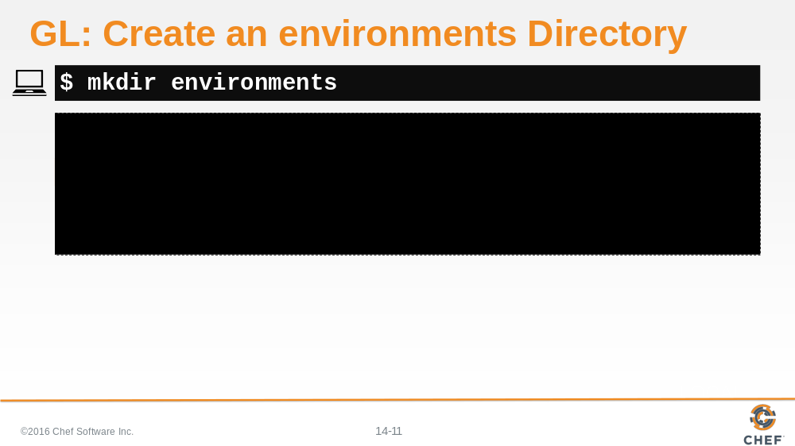

First, we need to make a new environments directory. (Be sure you are still in the chef-repo before you do this.)

Slide 12

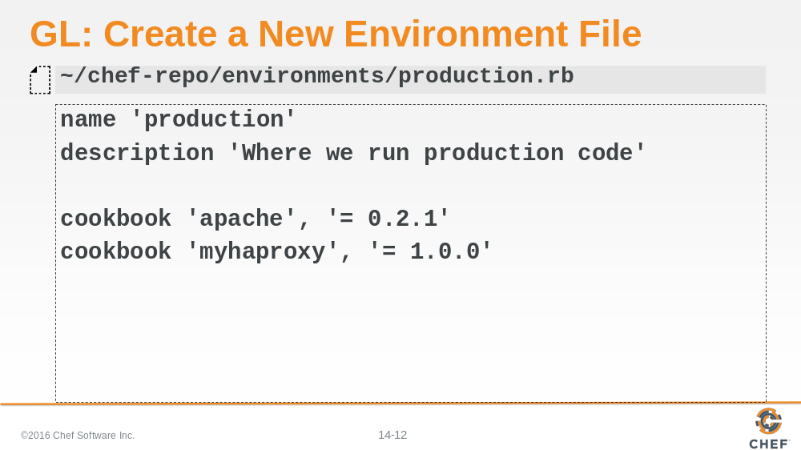

Then we need to create a production.rb file. Like in the roles.rb files, we must provide a name and description. Additionally, we need to define cookbook restrictions to lock down specific versions of both the apache and myhaproxy cookbooks.

By adding this information to production.rb, we are telling our nodes to use these specific versions of these specific cookbooks. Obviously, what this means is that as we work on newer versions of these cookbooks, we won’t break anything in the production environment. Okay, so now that we have captured our 'good' environment in this file, let’s save it and upload it.

Slide 13

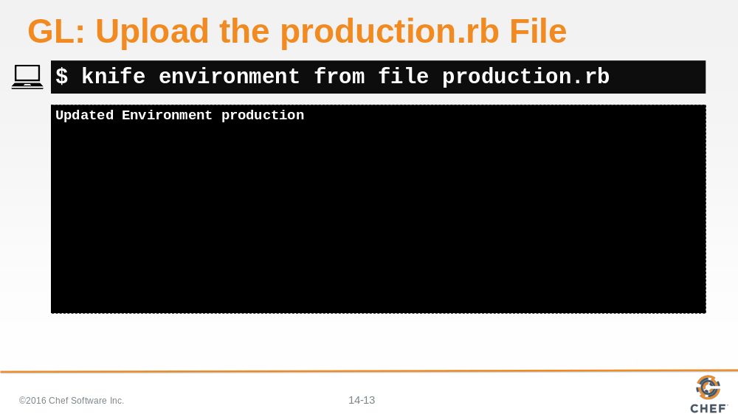

Using the knife environment command, let’s upload the production.rb file. This should be familiar because it is just like the command we used to upload roles.

Slide 14

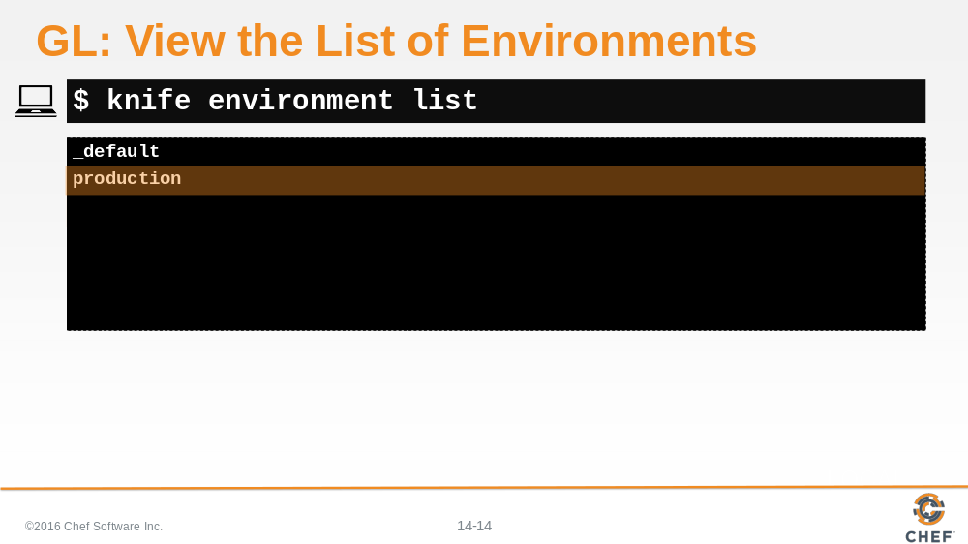

Okay, let’s use our list command to make sure the file uploaded correctly.

Slide 15

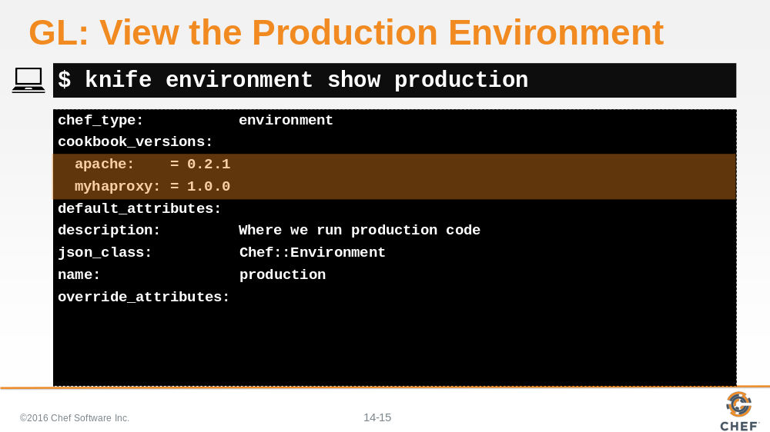

If we use the knife environment show command, we can see how the production.rb file looks.

Note the cookbook versions that we set are shown here.

Slide 16

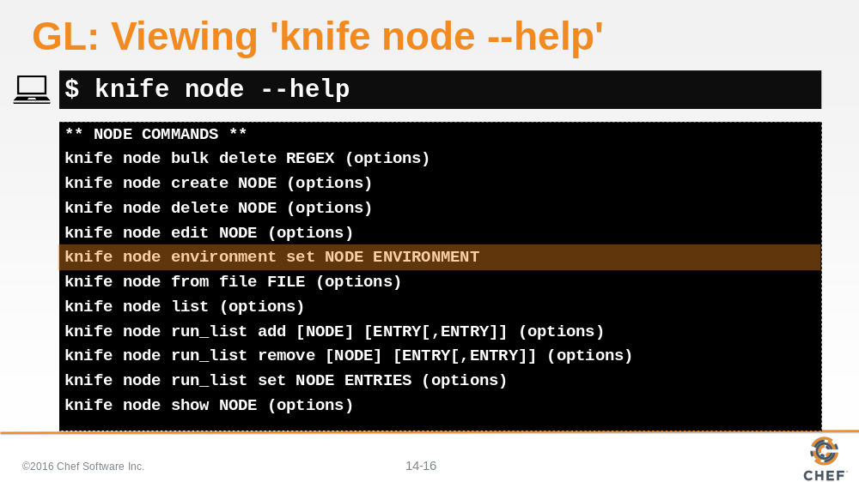

Now, we need to set the environments for our nodes. Let’s ask Chef for help on that as well.

Let’s use the knife node environment set command.

Slide 17

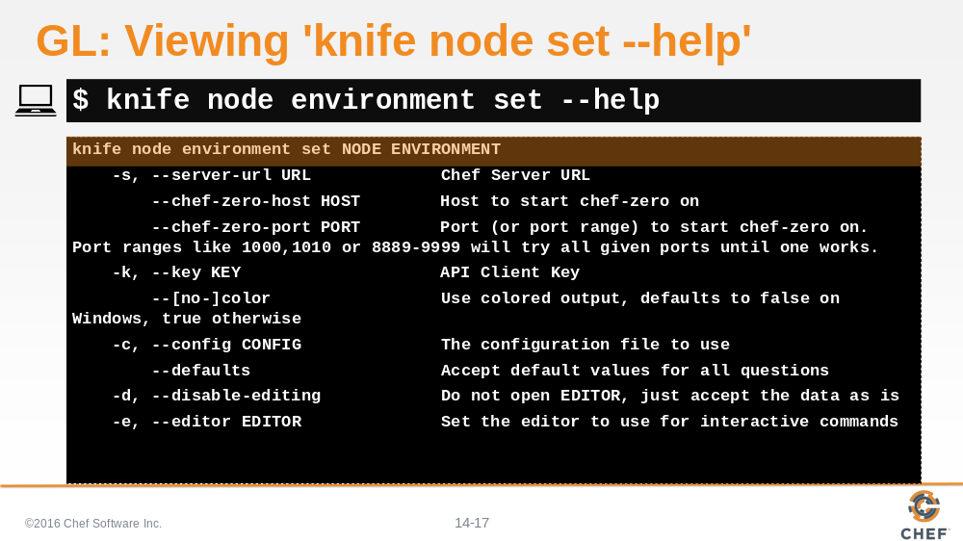

But how does that command work, exactly?

It looks like we just add the environment name at the end of the command to set that environment on a node.

Slide 18

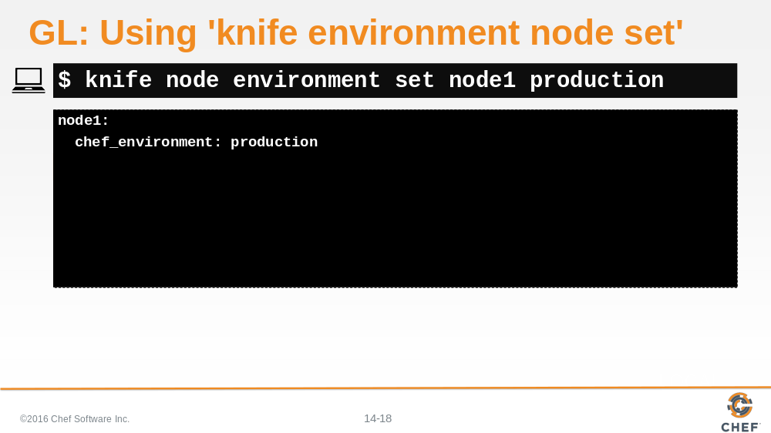

So, let’s do that for node1.

The results don’t really tell us much, so let’s take a look at node1.

Slide 19

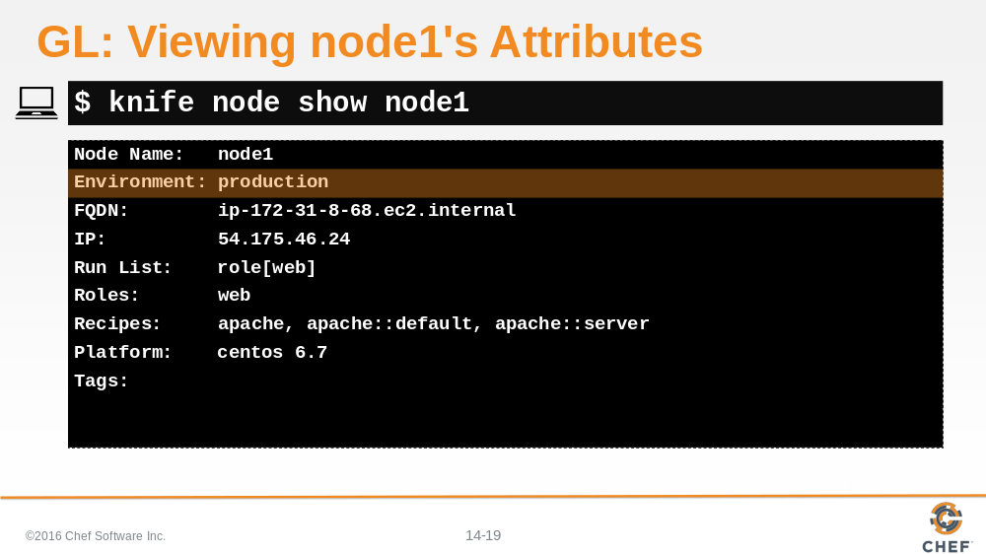

Using knife node show, we can see node1’s attributes. Note that it has indeed been set to the production environment.

Slide 20

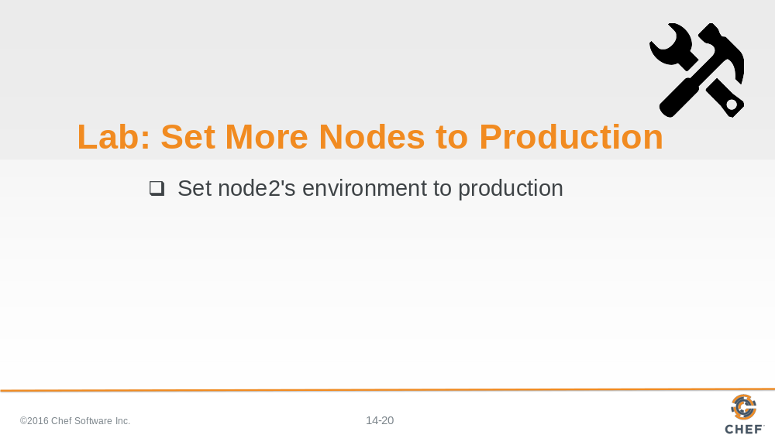

Let’s do the same thing for node2.

Slide 21

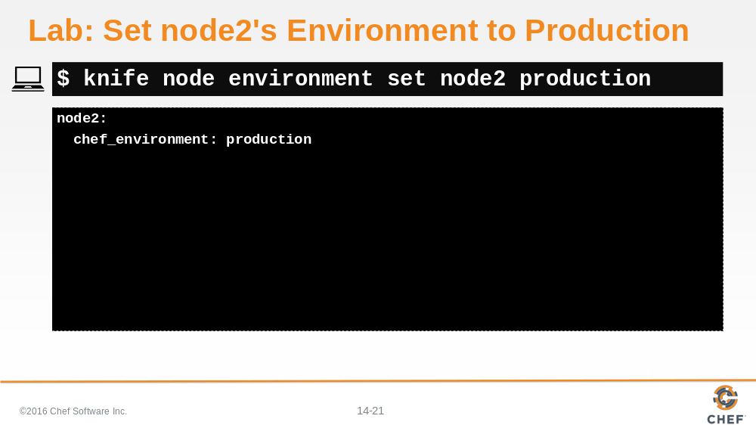

Slide 22

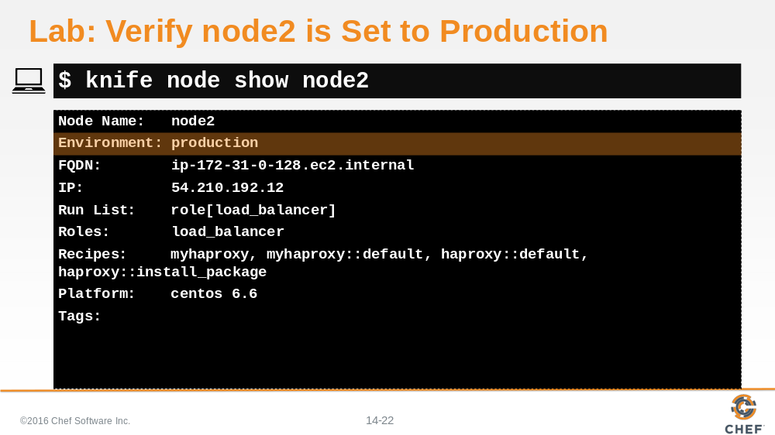

And, it looks like node2 was successfully set to the production environment.

Slide 23

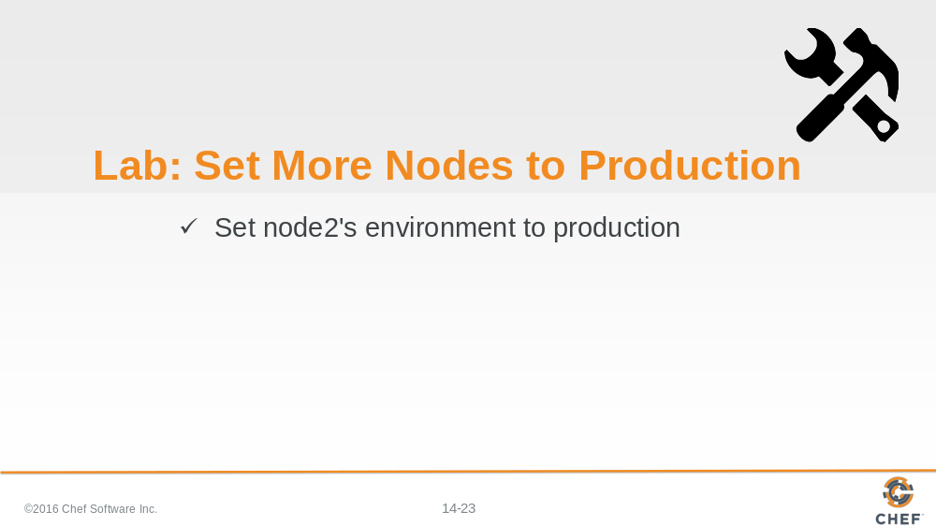

Node2 is now in production.

Slide 24

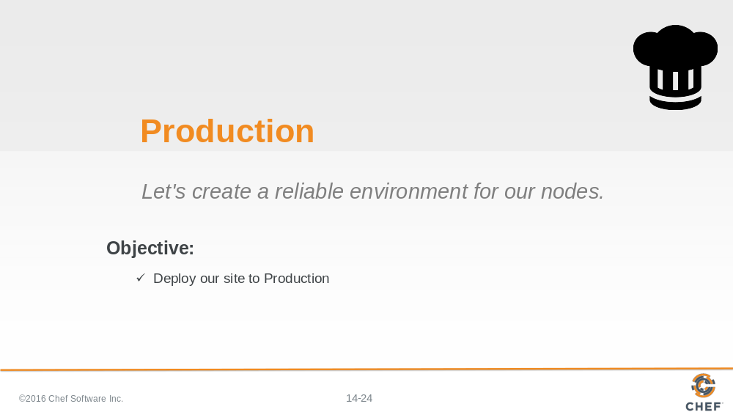

Slide 25

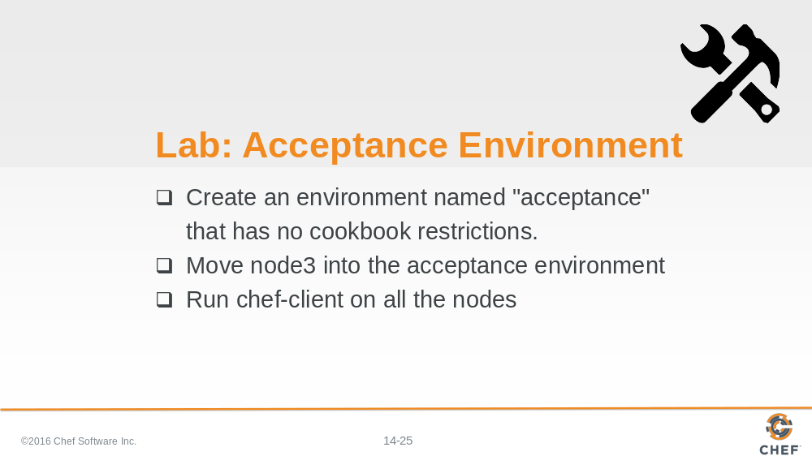

Now, let’s create the environment we can use to change and update the cookbooks without affecting our production environment. A sandbox, if you will.

Let’s call this our “Acceptance environment”.

Slide 26

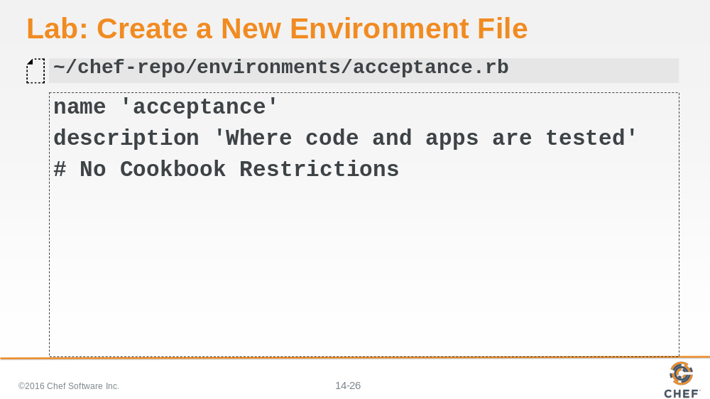

First, let’s create a new rb file in our chef-repo/environments directory. Let’s name it acceptance.

In the Acceptance environment, we don’t want to lock-down the cookbook versions, so we are not going to place restrictions on the cookbooks.

Slide 27

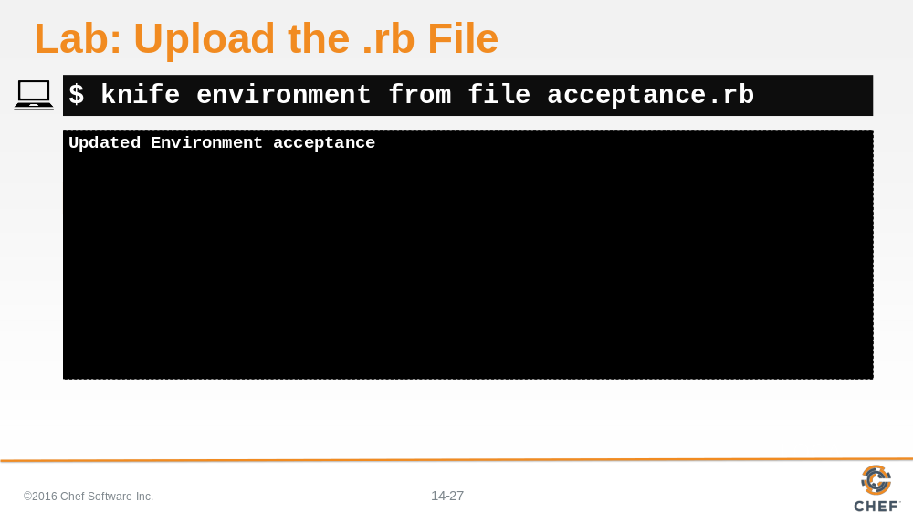

Let’s upload that .rb file to the Chef server.

Slide 28

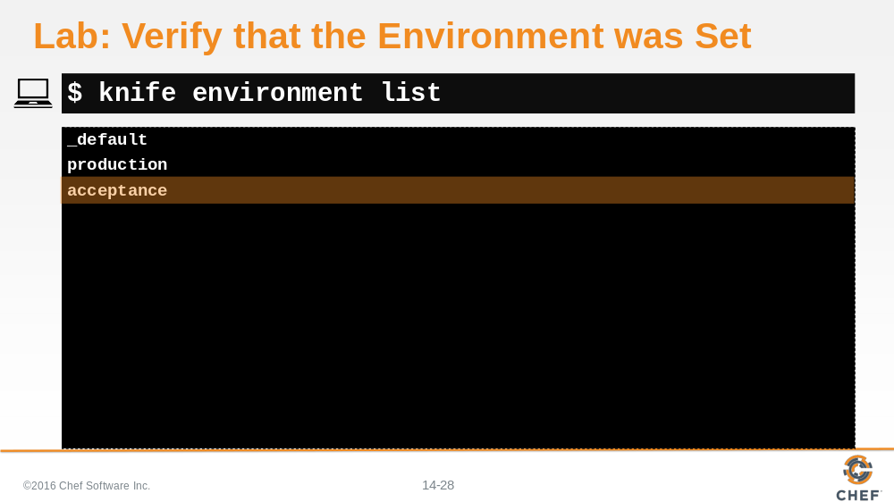

And let’s make sure that this environment file was added properly.

Slide 29

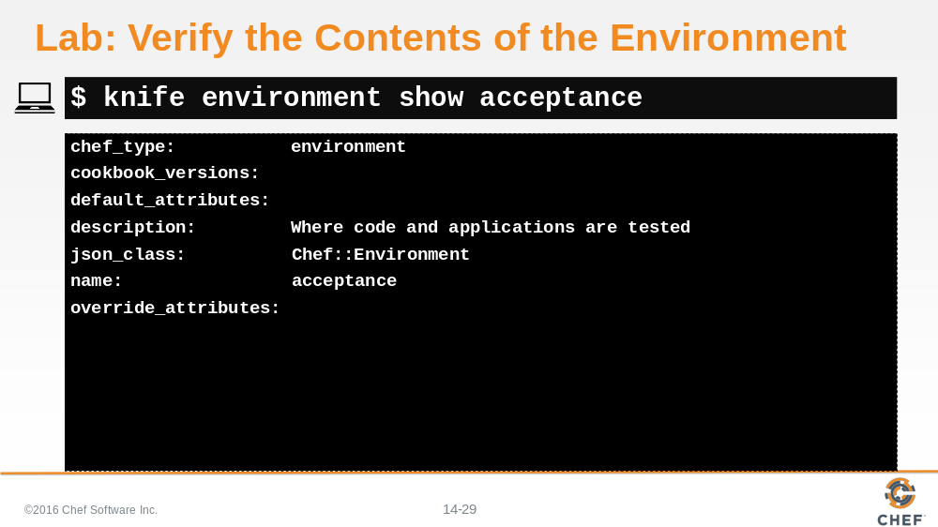

And last, but not least, let’s ask the Chef Server to show us the acceptance environment.

Slide 30

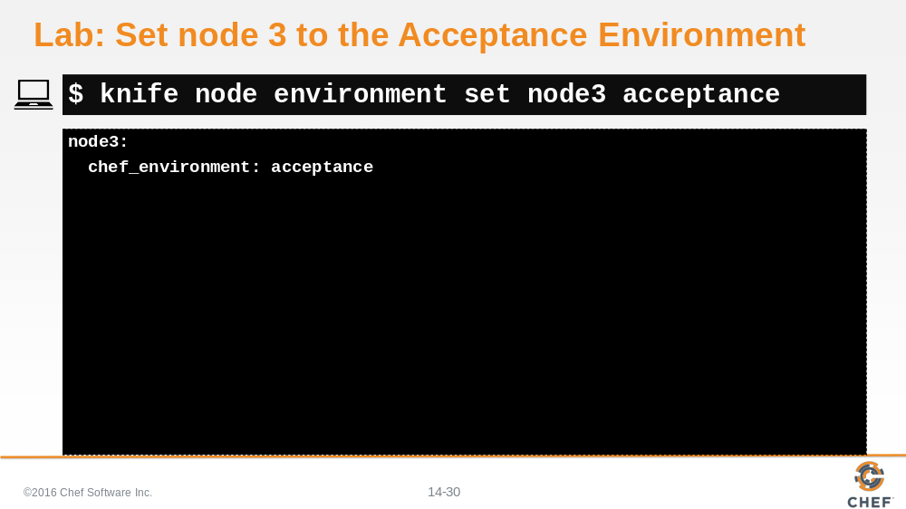

Okay, let’s set node3 to the acceptance environment.

Slide 31

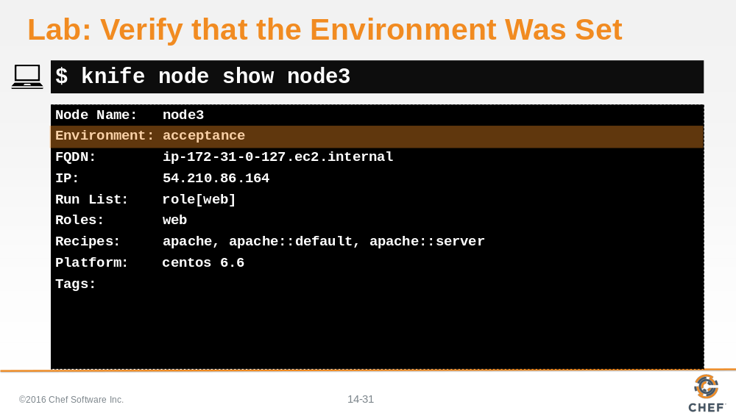

And confirm that it has been set properly.

Slide 32

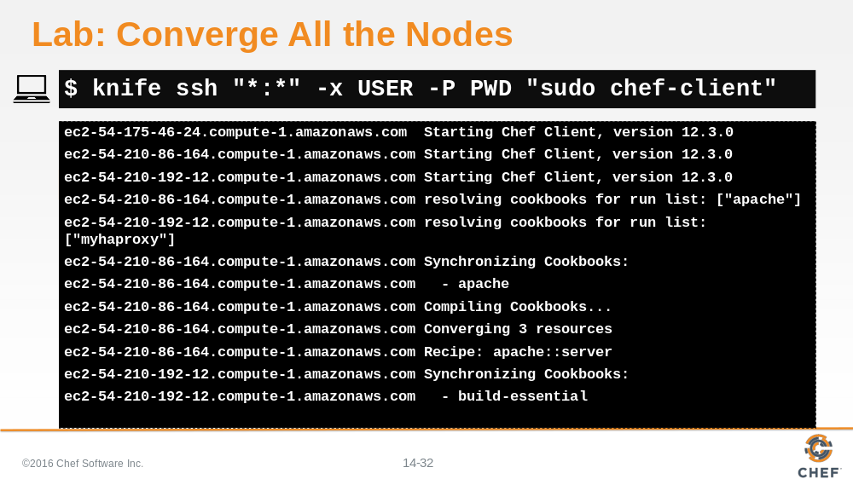

Using the knife ssh let’s run chef client on all the nodes.

Slide 33

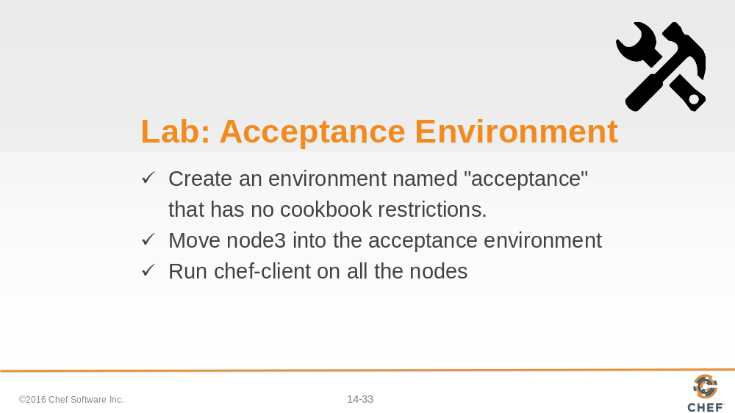

The Acceptance environment is setup and node3 is now its only member.

Slide 34

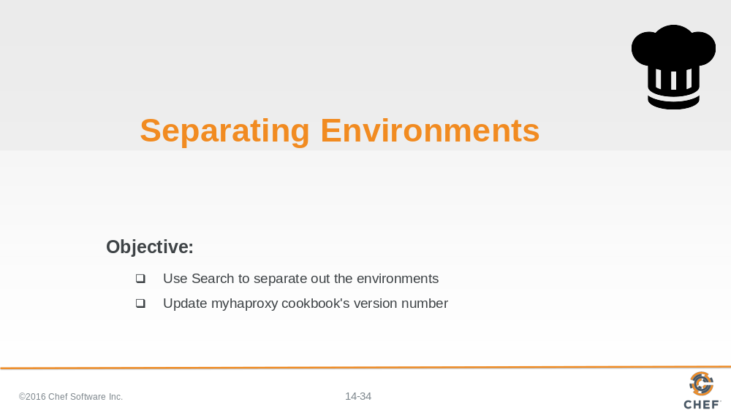

Now that we have created our two environments and set each node to a specific environment, we need to separate the environments to ensure that the load balancer only communicates with the production nodes.

Slide 35

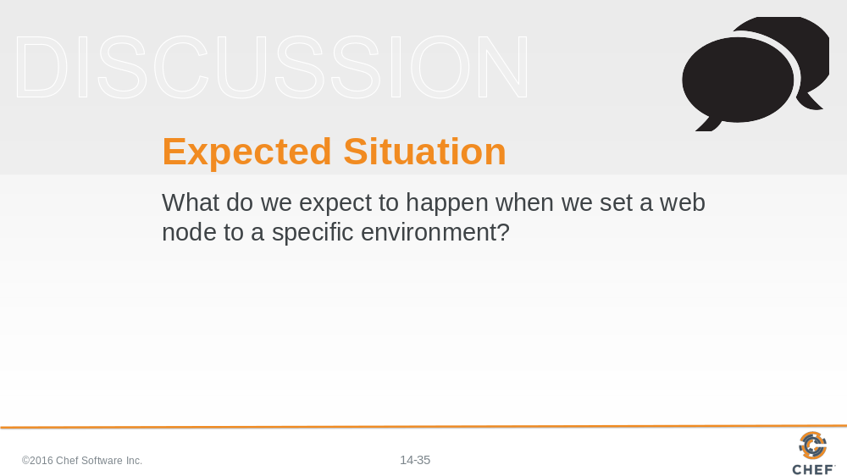

So we set our web nodes to specific environments. As we manage our nodes, making changes to our cookbooks and recipes, what do you think is going to happen to Node1?

What about Node 3?

Setting the nodes is not enough. Chef does not automatically know to separate the environments. So, we have to tell it how to do that.

Slide 36

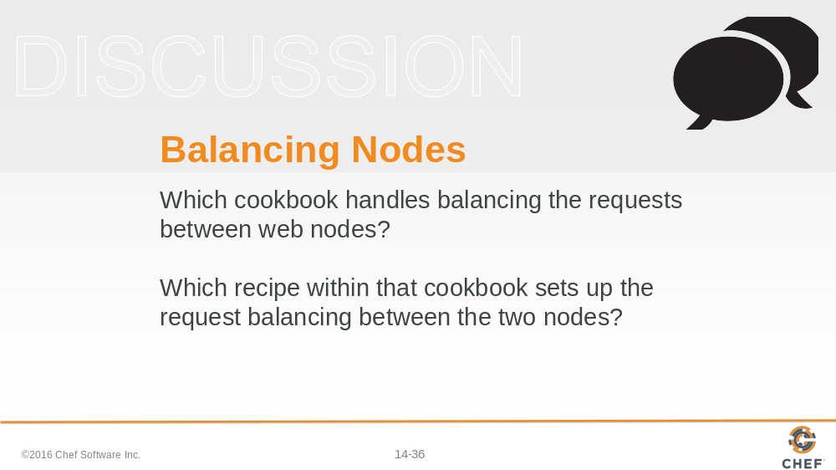

How do we do that?

First, let’s answer a couple of question. As you think about the infrastructure we have created, which cookbook handles balance requests between nodes?

So if we want to make changes to that cookbook, which recipe would we change?

Answer 1: myhaproxy Answer 2: default.rb

Slide 37

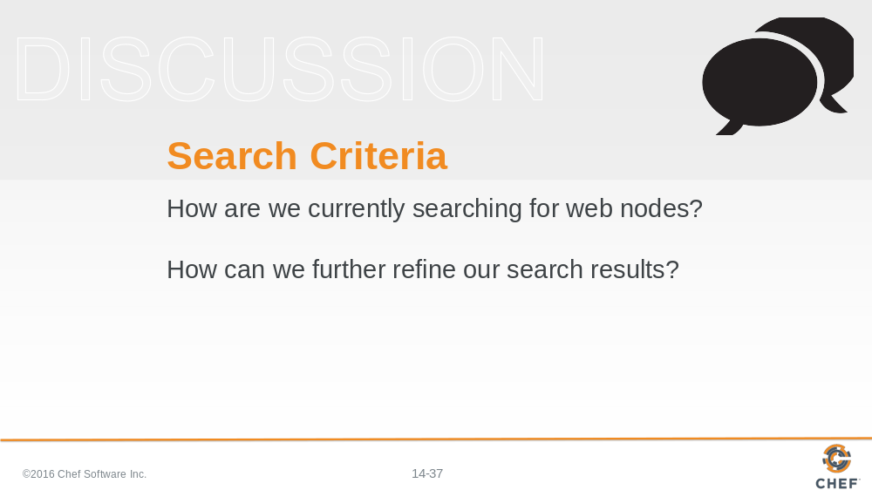

In our last module, we talked about searching our nodes using Chef. Do you recall what we used to search for web nodes?

Answer: all_web_nodes = search(“node”,”role:web”)

So, considering our search syntax, how can we further refine that syntax to search for a specific web node by environment?

Let’s take a look.

Slide 38

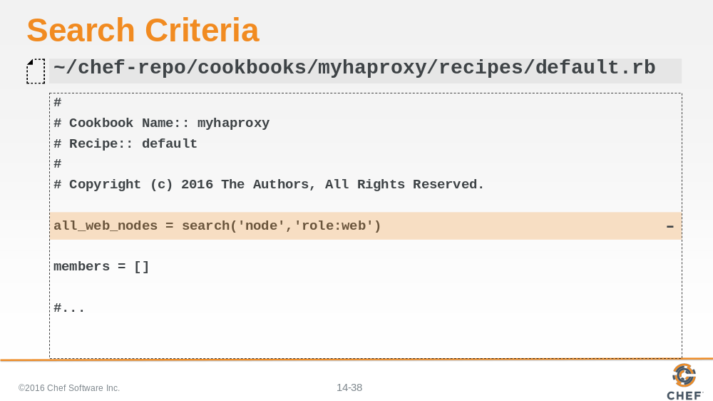

Looking at the default.rb file in the load balancer's myhaproxy cookbook, we can review the original search syntax. If we want to search by environments, what would we need to add here?

Slide 39

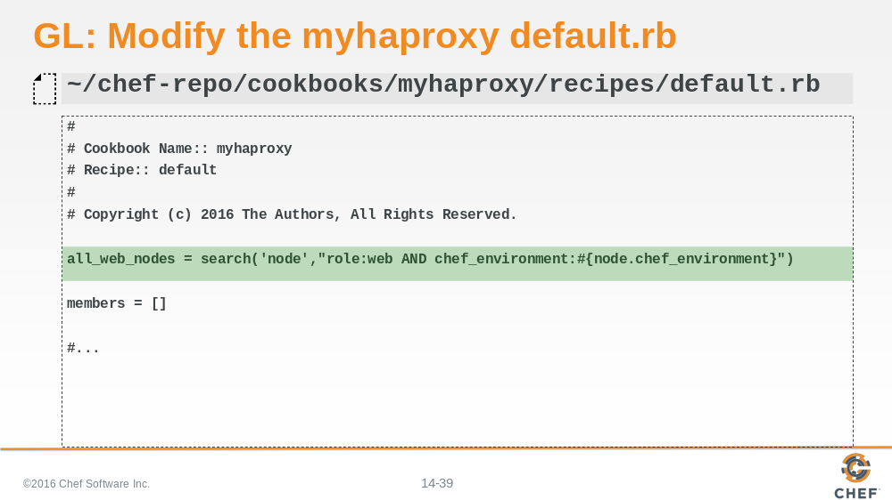

Search the Chef Server for all node objects that have the role equal to 'web' and also share the same environment as the current node applying this recipe. The nodes currently applying this recipe are the nodes with the role set to load_balancer.

Now that we’ve made our changes, let’s save this file.

Slide 40

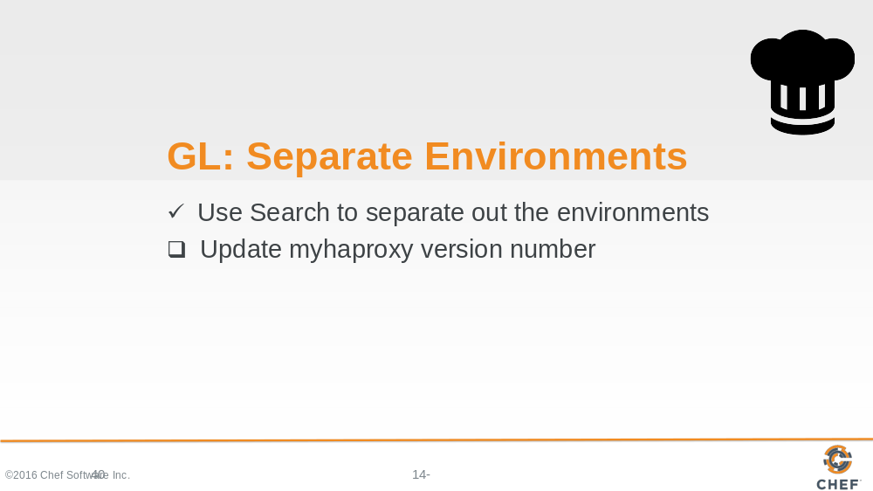

Now that we have created our two environments and set each node to a specific environment, we need to separate the environments to ensure that the load balancer only communicates with the production nodes.

Slide 41

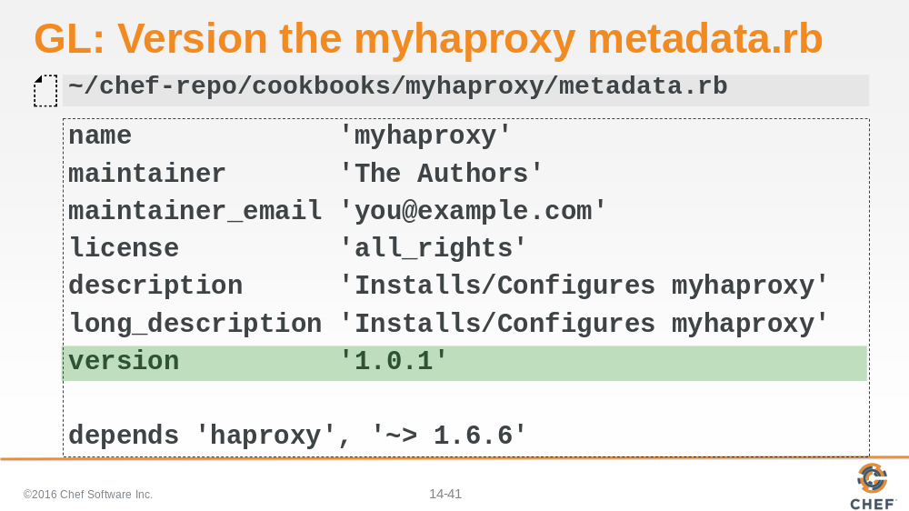

Before we upload the new myhaproxy cookbook to the server, we probably want to update the version number. What type of change have we made here?

Answer: Patch

Because we are performing a patch, let’s set the version number to 1.0.1.

Slide 42

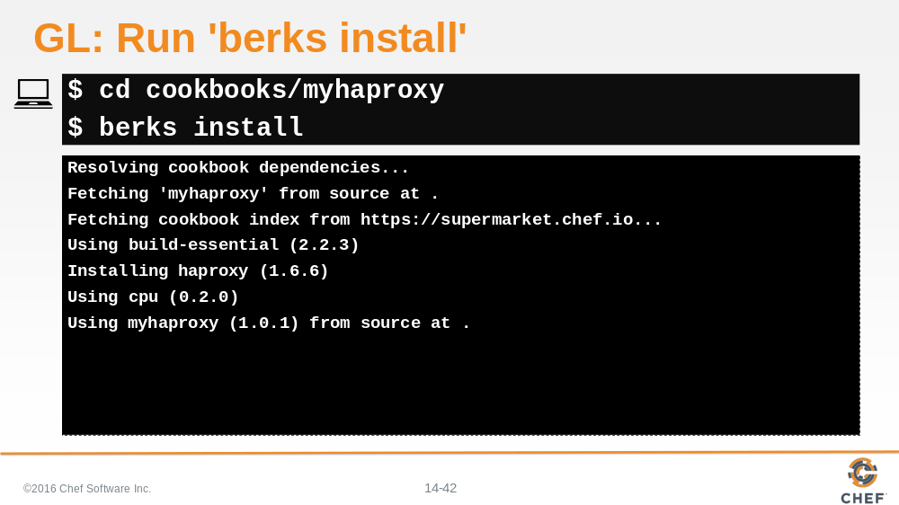

We are going to need to use Berks to upload this cookbook because it has dependencies. So first we need to cd into the cookbook.
Then run 'berks install'.

Slide 43

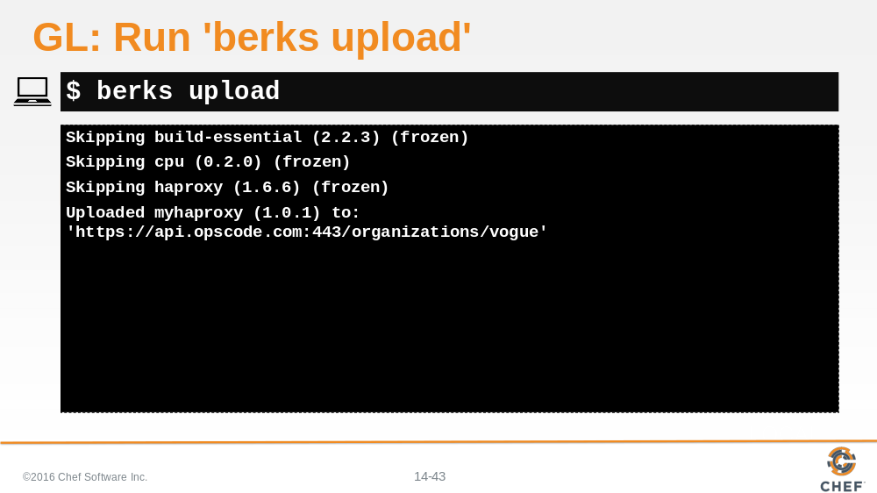

And finally berks upload.

Slide 44

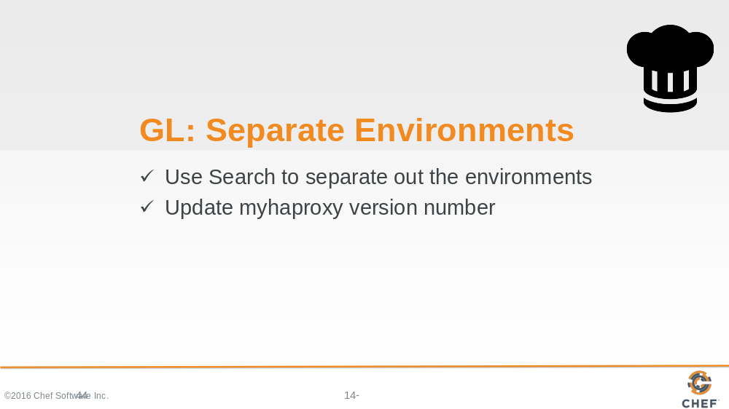

Slide 45

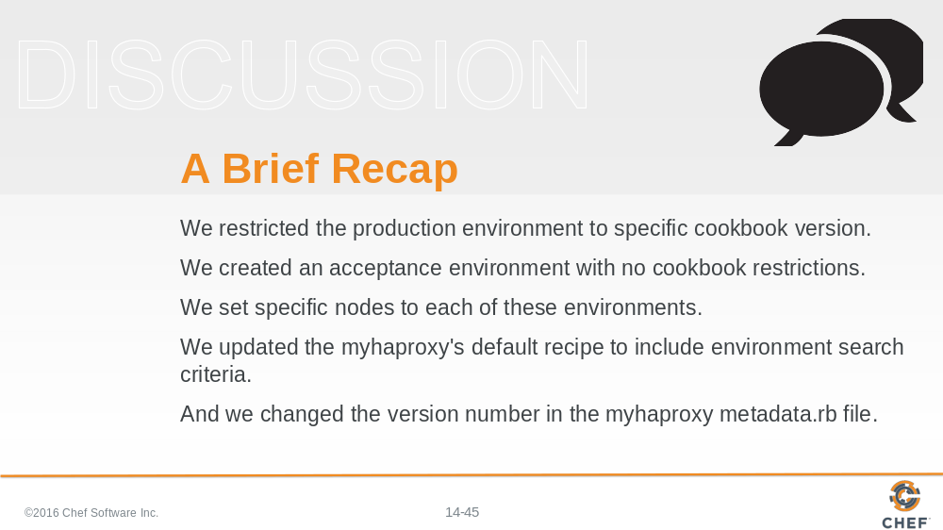

Before we run 'chef-client' to bring everything up to date, let’s think about what we’ve done. First, in the production environment, we restricted our cookbooks to a specific version. Second, we created an acceptance environment with no cookbook restrictions. Third, we set specific nodes to each of these environments. Fourth, we updated the myhaproxy default.rb to include environment search criteria. And lastly, we changed the version number in the myhaproxy metadata.rb file.

What problems do you think we may encounter, given all that we’ve done here?

Slide 46

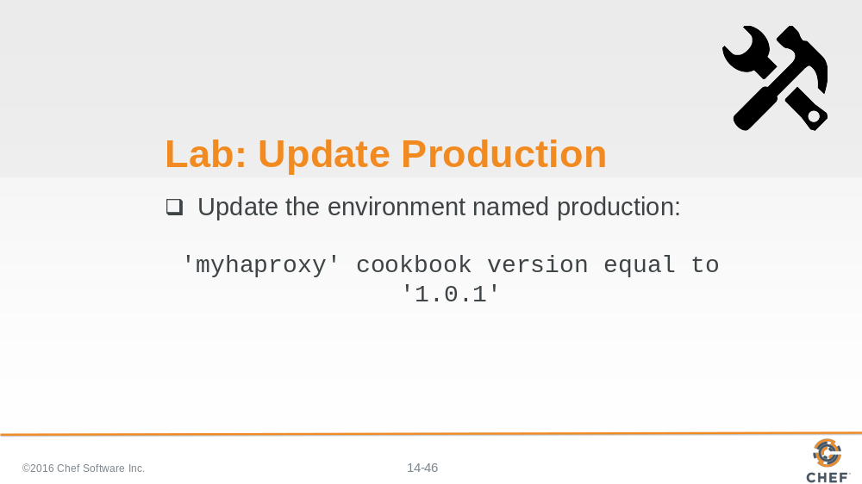

Since we changed the version of the myhaproxy cookbook, we need to revise the production.rb file to incorporate the new version.

Slide 47

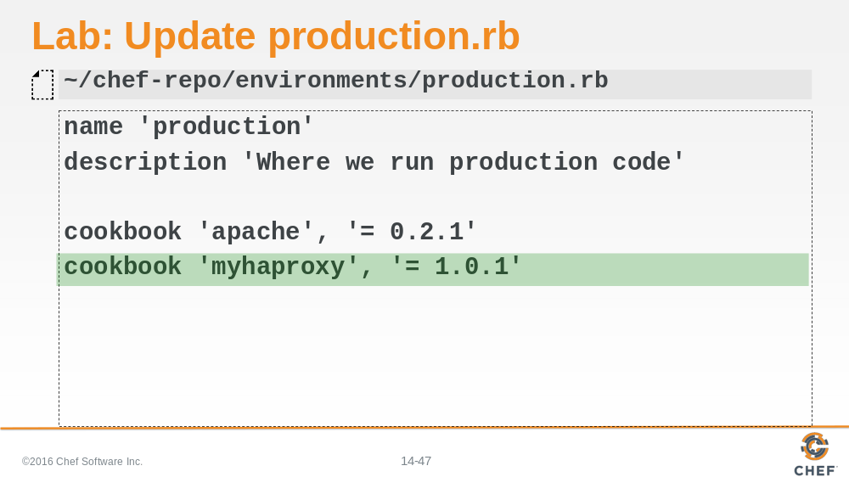

So let’s go back into our production.rb and update it to include the new version number.

Slide 48

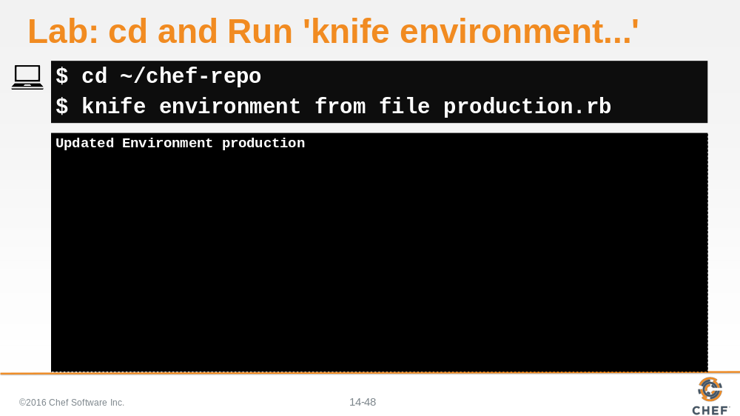

Change to ~/chef-repo and then run 'knife environment from file production.rb'.

Slide 49

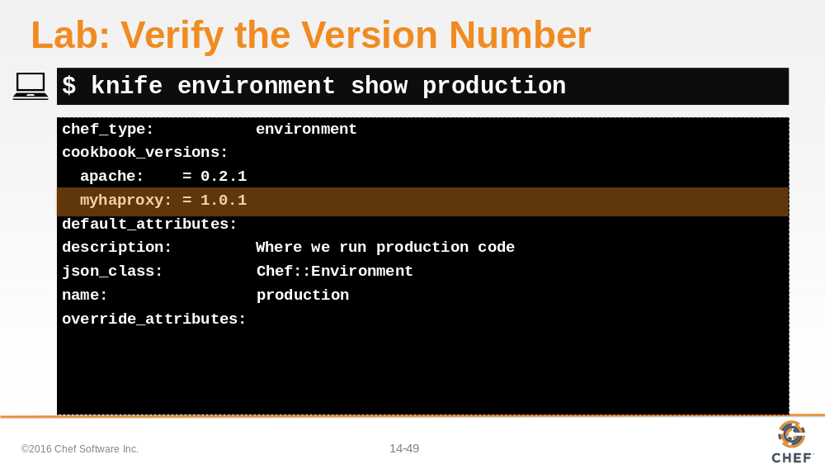

And let’s make sure that the production.rb on Chef server has the correct version of myhaproxy designated.

Slide 50

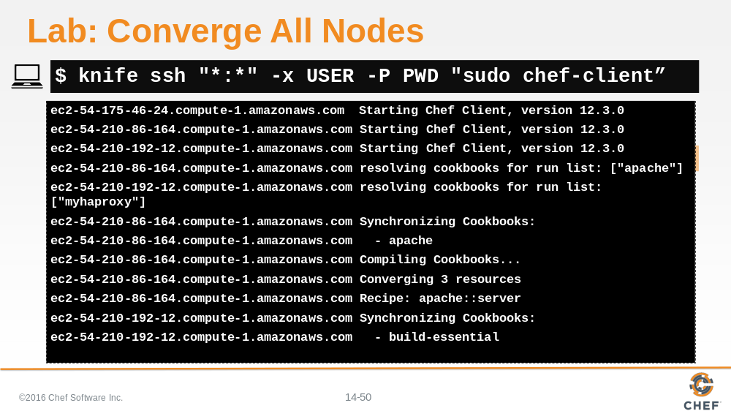

And use 'sudo chef-client' to converge all nodes.

Slide 51

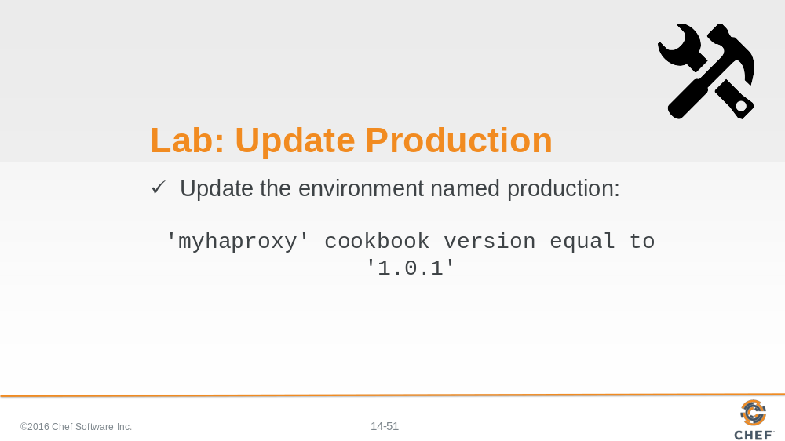

The environment has now that we have made the change and uploaded that change. Finally to see the effects to our existing nodes we need to ensure that they update themselves.

Slide 52

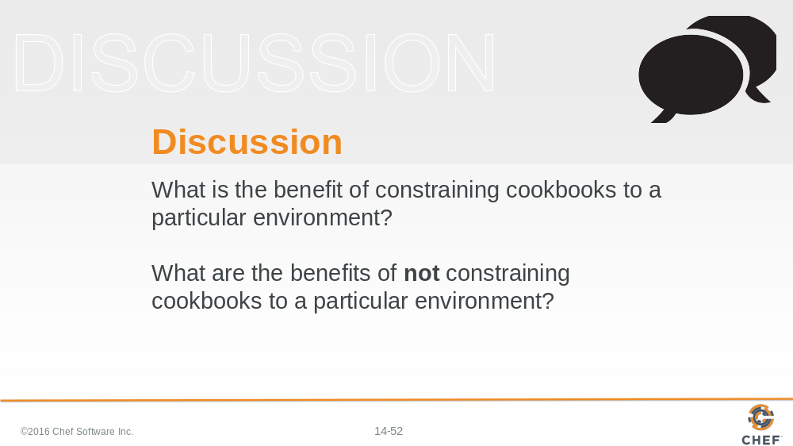

Answer these questions.

Slide 53

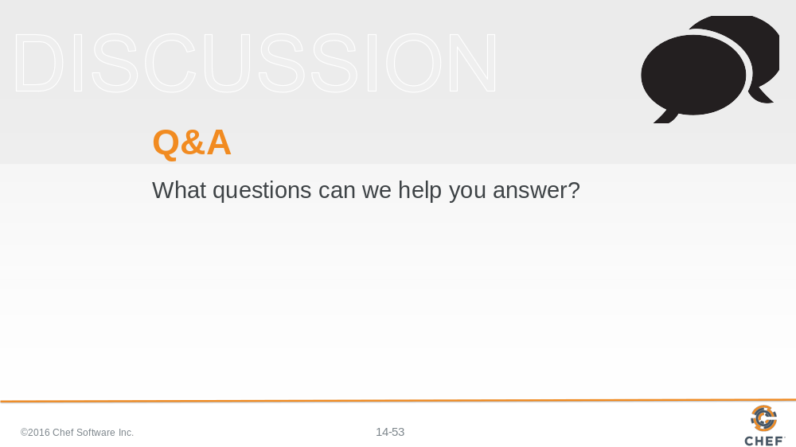

Slide 54

