5: Testing Cookbooks

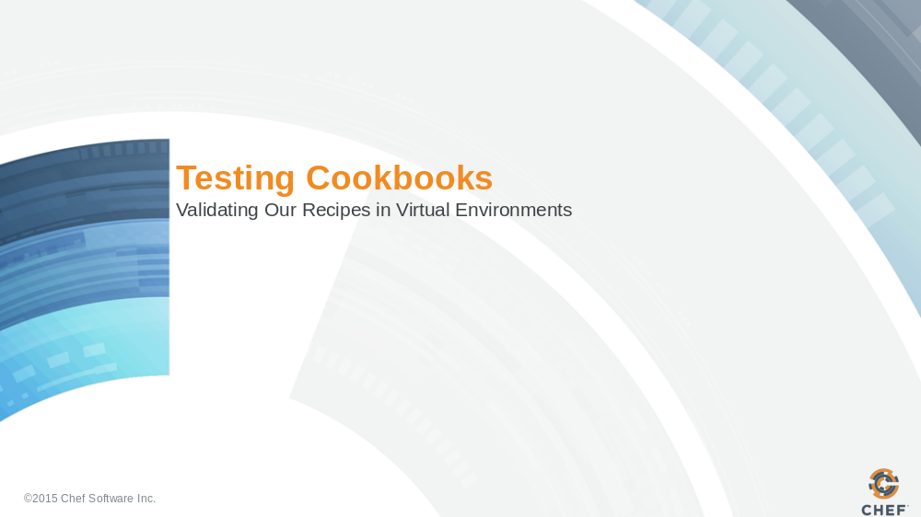

Slide 2

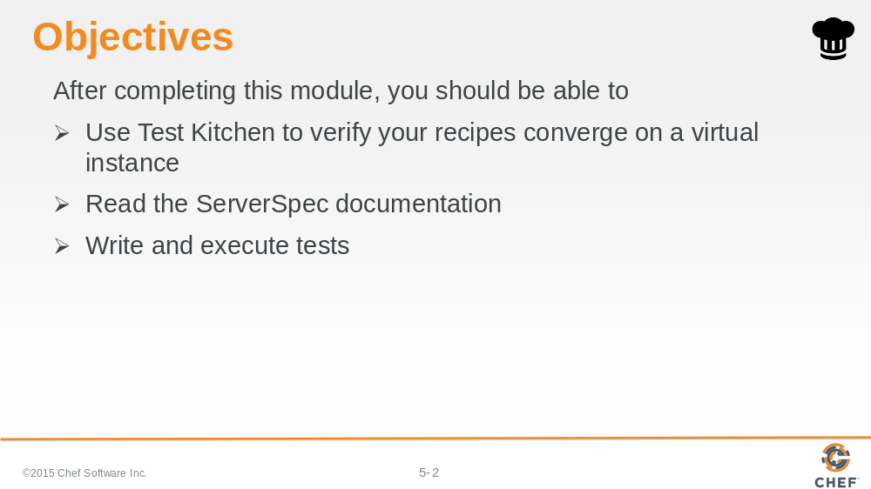

In this module you will learn how to use the Test Kitchen tool to execute your configured code, write and execute tests, and use Serverspec to test your servers' actual state.

Slide 3

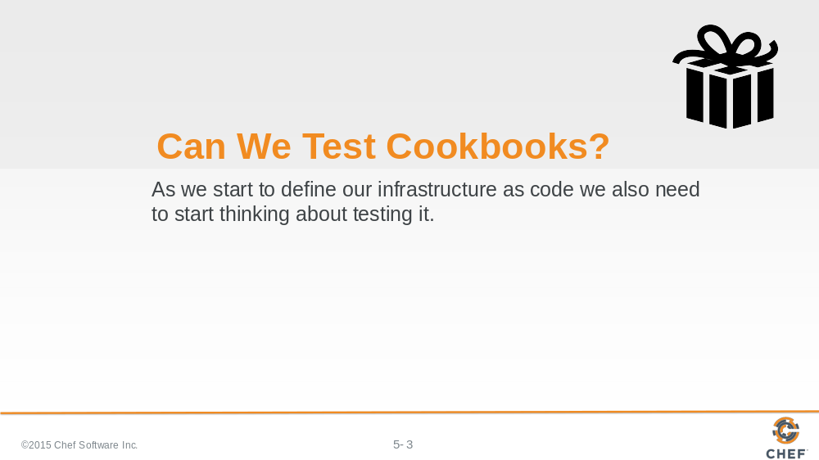

Will the recipes that we created work on another system similar to this one? Will they work in production?

When we develop our automation we need to start thinking about verifying it. Because it is all too common a story of automation failing when it reaches production because it was never validated against anything other than "my machine".

So how could we solve a problem like this?

Slide 4

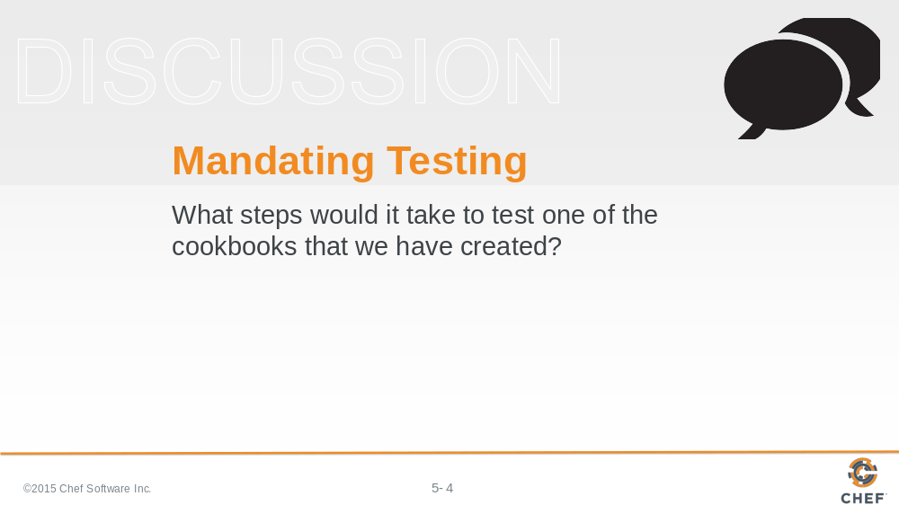

Write down or type out as many of the steps you can think of required to test one of the cookbooks.

When you are ready turn to another person and compare your lists. Create a complete list with all the steps that you have identified. Then as a group we will discuss all the steps necessary to test a cookbook.

Slide 5

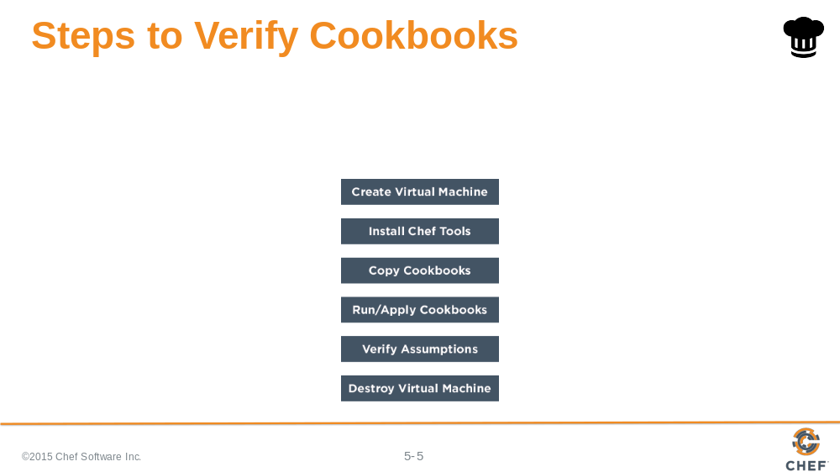

Here are the steps necessary to verify one of the cookbooks that you created.

- Create a virtual machine or setup an instance that resembles your current production infrastructure
- Install the necessary Chef tools
- Copy the cookbooks to this new instance
- Apply the cookbooks to the instance
- Verify that the instance is the desired state by executing various commands
- Clean up that instance by destroying it or rolling it back to a previous snapshot

Slide 6

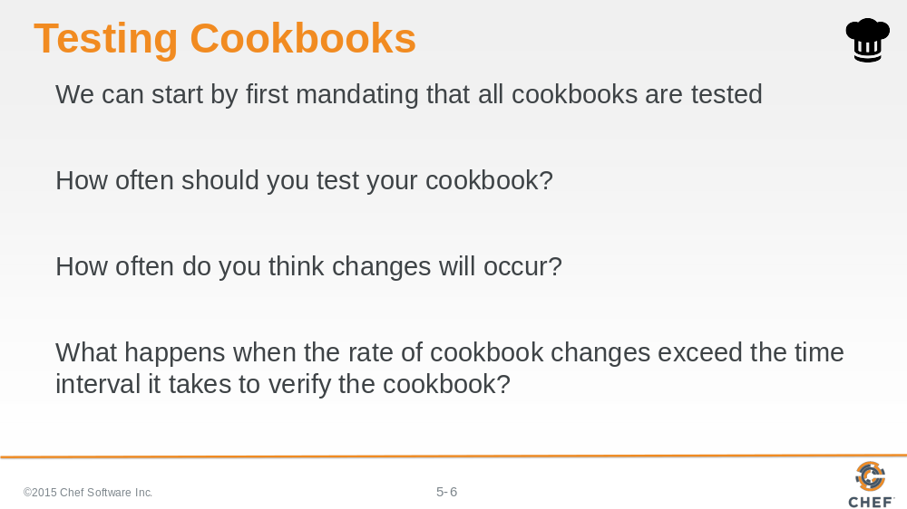

So we can start by mandating that all cookbooks are tested.

But we need to consider how often we need to test a cookbook and how often changes to our cookbooks will occur.

And what would happen if the rate of rate of cookbook changes exceed the time interval it takes to verify the cookbook?

Slide 7

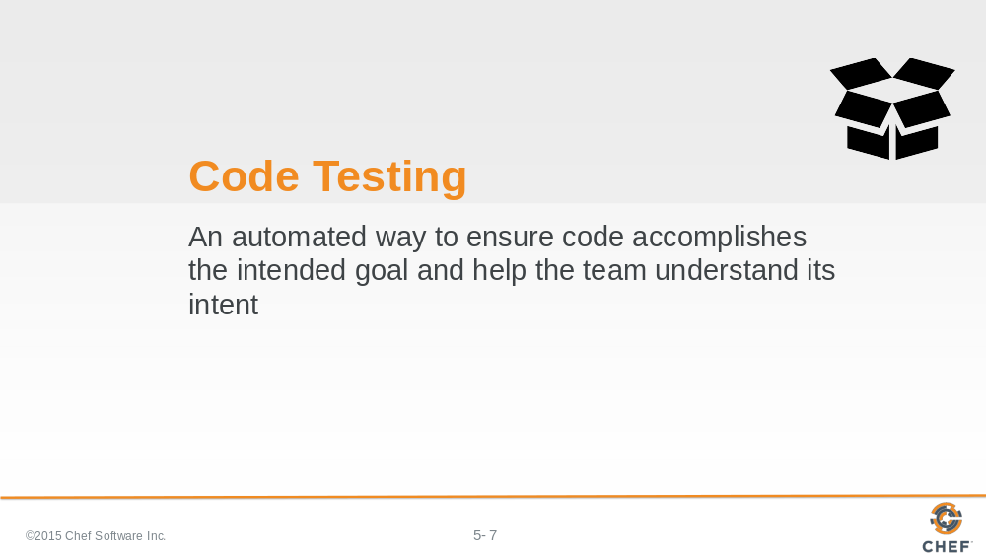

Testing tools provide automated ways to ensure that the code we write accomplishes its intended goal. It also helps us understand the intent of our code by providing executable documentation. We add new cookbook features and write tests to preserve this functionality.

This provides us, or anyone else on the team, the ability to make new changes with a less likely chance of breaking something. Whether returning to the cookbook code tomorrow or in six months.

Slide 8

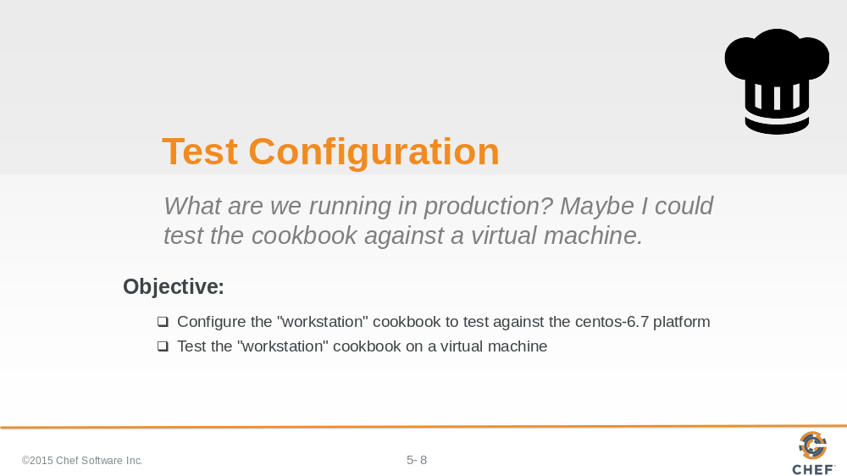

Well if Chef is to replace our existing tools, it is going to need to provide a way to make testing the policies more delightful.

Slide 9

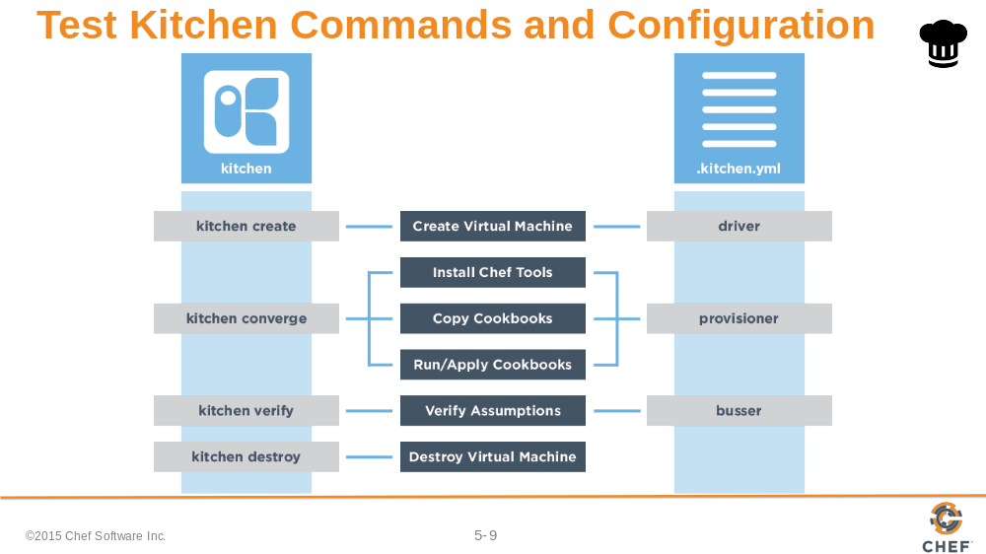

Test Kitchen allows us to create an instance solely for testing, installs Chef, converge a run list of recipes on that instance, verify that the instance is in the desired state, and then destroy the instance.

On the left are the commands by the kitchen command that map to the stages of the testing lifecycle.

On the right are the configuration fields within a kitchen configuration file.

These commands the configuration will be explained in more detail.

Slide 10

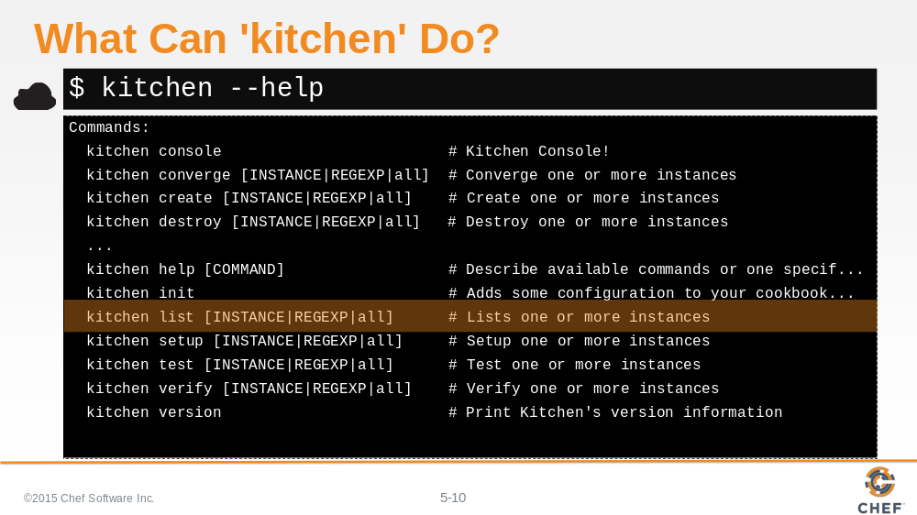

Kitchen is a command-line application that enables us to manage the testing lifecycle.

Similar to other tools within the ChefDK, we can ask for help to see the available commands.

The `init` command, by its name, seems like a good place to get started.

Slide 11

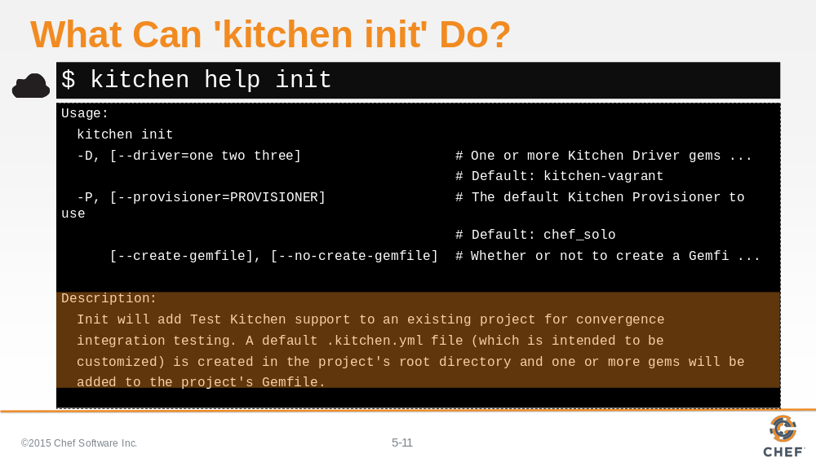

`kitchen help init` tells us that it will add Test Kitchen support to an existing project. It creates a .kitchen.yml file within the project's root directory.

There are a number of flags and other options but let's see if the cookbooks we created even needs us to initialize test kitchen.

Slide 12

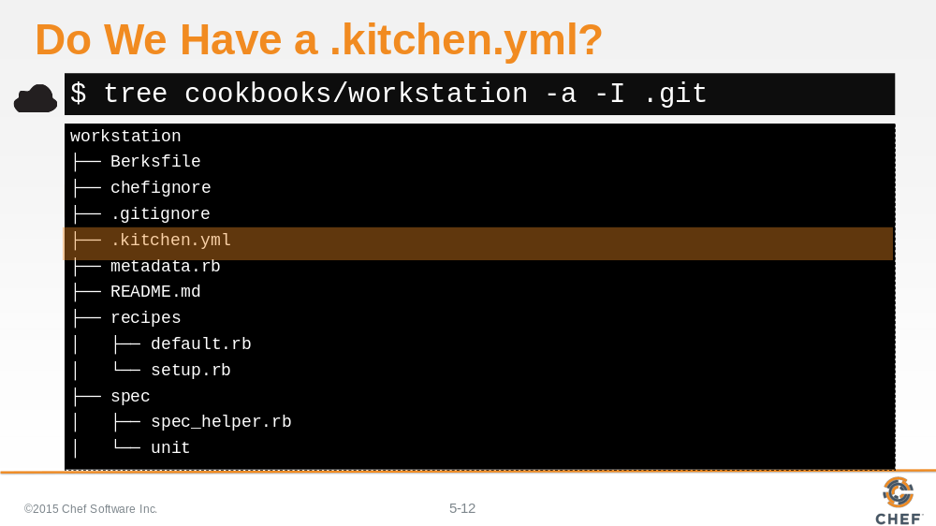

Using `tree` to look at the workstation cookbook, showing all hidden files and ignoring all git files, it looks like our cookbook already has a .kitchen.yml.

It was actually created alongside the other files when we ran the `chef generate cookbook` command when we originally created this cookbook.

Let's take a look at the contents of this file.

Slide 13

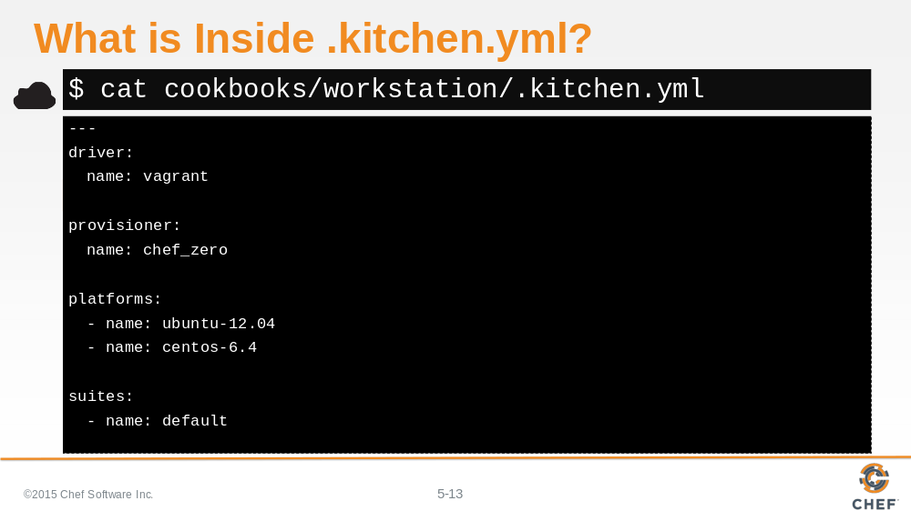

The .kitchen.yml file defines a number of configuration entries that the kitchen command uses during execution.

Slide 14

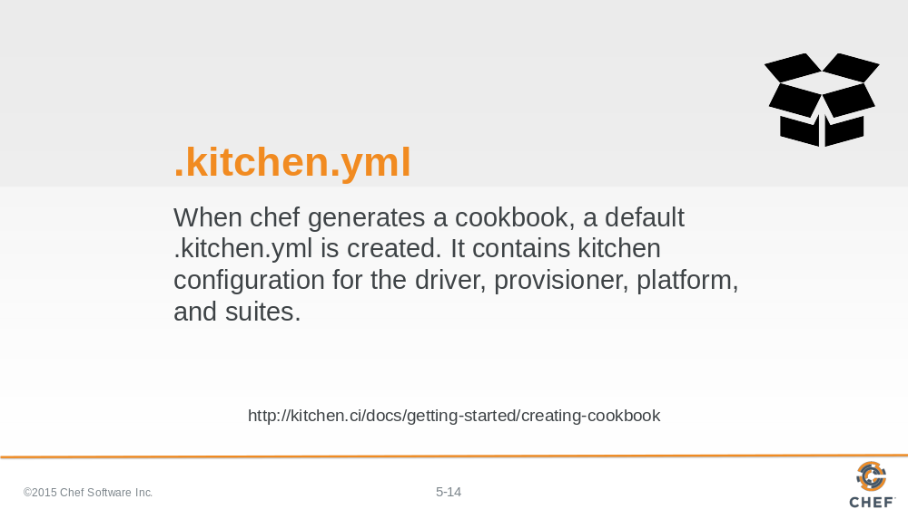

We don't need to run `kitchen init` because we already have a default kitchen file. We may still need to update it to accomplish our objectives so lets learn more about the various fields in the configuration file.

Slide 15

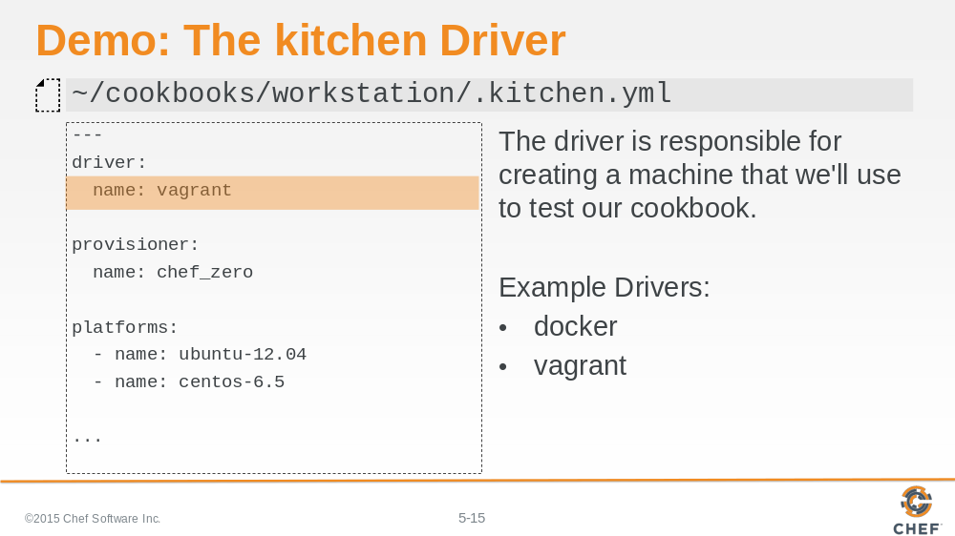

The first key is driver, which has a single key-value pair that specifies the name of the driver Kitchen will use when executed.

The driver is responsible for creating the instance that we will use to test our cookbook. There are lots of different drivers available--two very popular ones are the docker and vagrant driver.

Slide 16

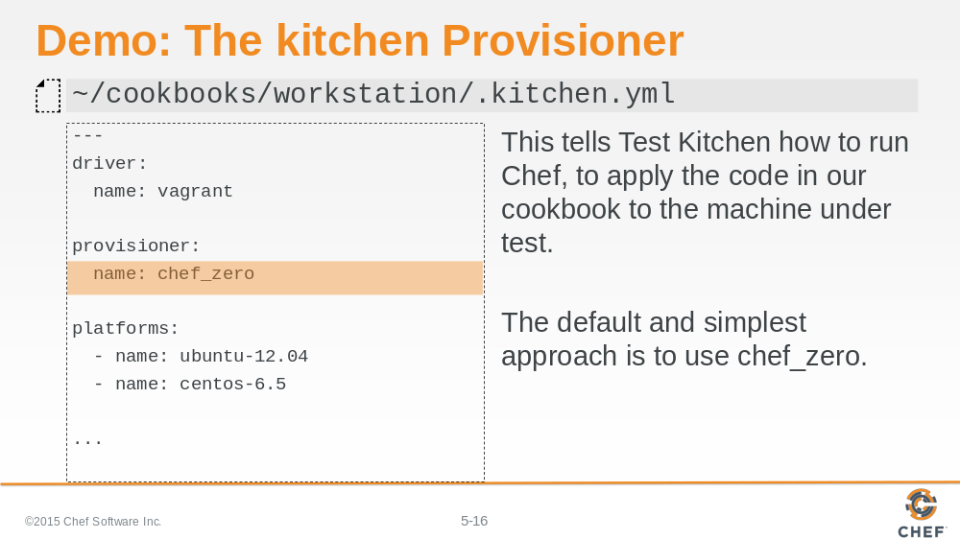

The second key is provisioner, which also has a single key-value pair which is the name of the provisioner Kitchen will use when executed. This provisioner is responsible for how it applies code to the instance that the driver created. Here the default value is chef_zero.

Slide 17

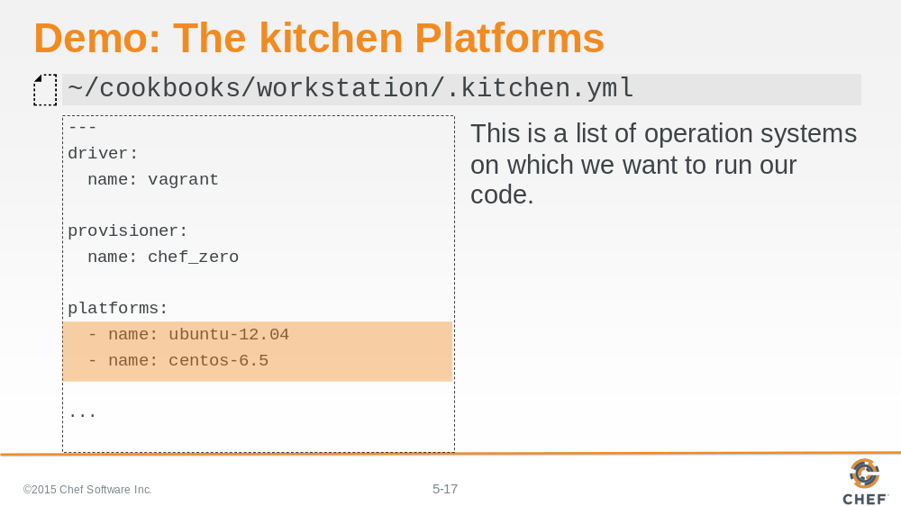

The third key is platforms, which contains a list of all the platforms that Kitchen will test against when executed. This should be a list of all the platforms that you want your cookbook to support.

Slide 18

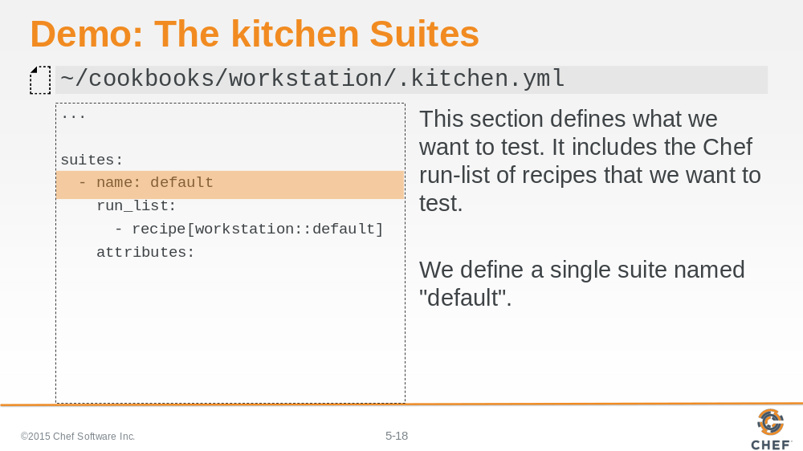

The fourth key is suites, which contains a list of all the test suites that Kitchen will test against when executed. Each suite usually defines a unique combination of run lists that exercise all the recipes within a cookbook.

In this example, this suite is named 'default'.

Slide 19

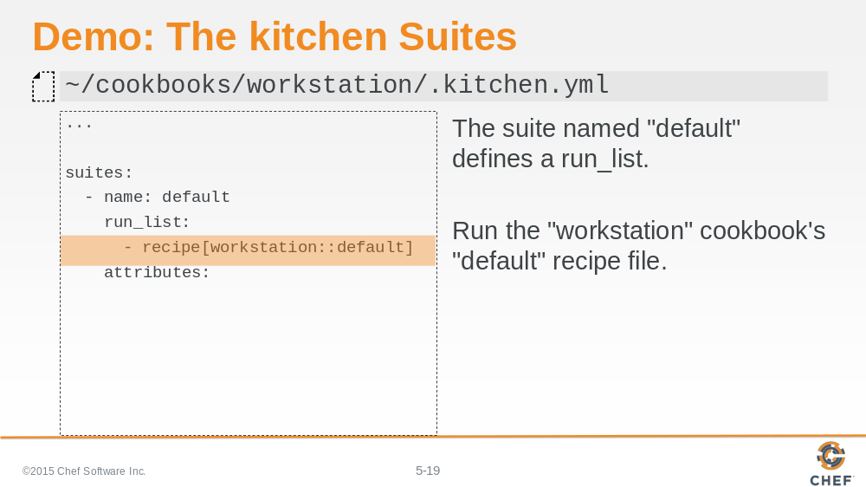

This default suite will execute the run list containing: The workstation cookbook's default recipe.

Slide 20

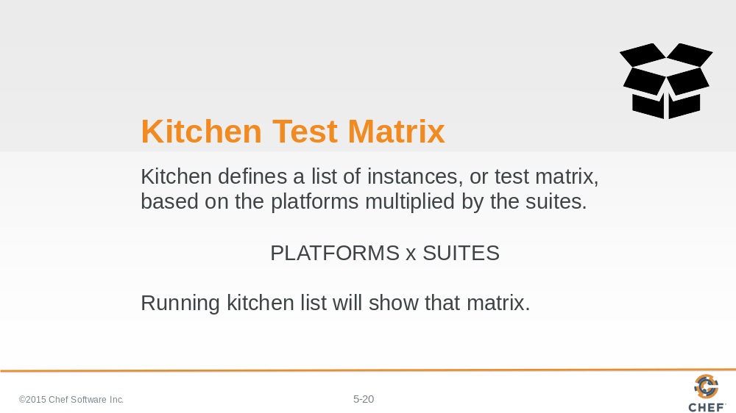

It is important to recognize that within the .kitchen.yml file we defined two fields that create a test matrix; The number of platforms we want to support multiplied by the number of test suites that we defined.

Slide 21

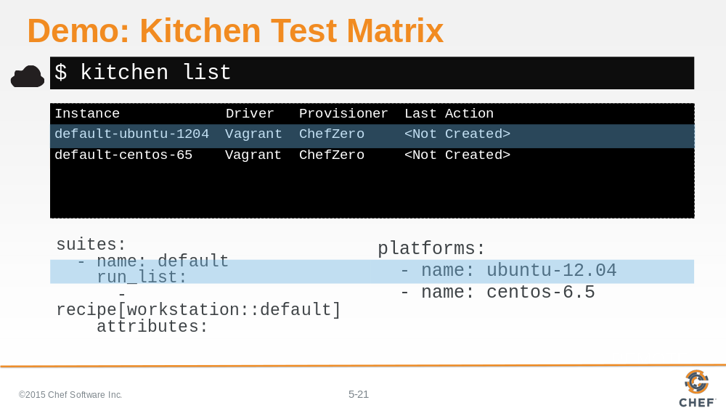

We can visualize this test matrix by running the command `kitchen list`.

In the output you can see that an instance is created in the list for every suite and every platform. In our current file we have one suite, named 'default', and two platforms. First the ubuntu 12.04 platform.

Slide 22

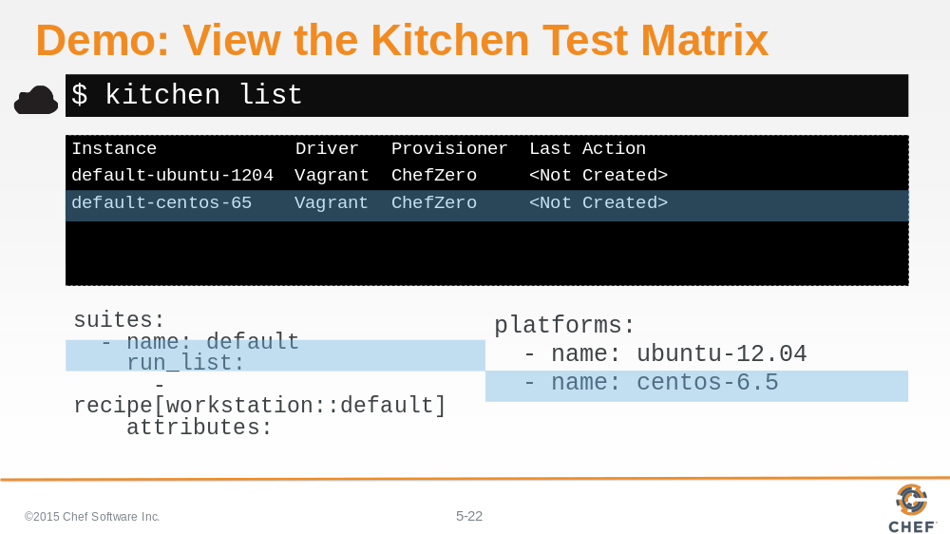

And the second centos 6.5 platform.

Slide 23

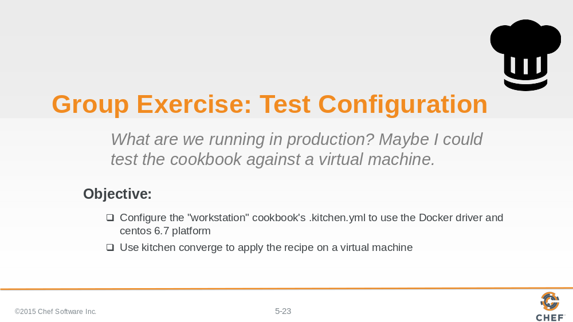

Remembering our objective, we want to update our .kitchen.yml file to use the Docker driver and we want to test against a single platform named centos 6.7.

Slide 24

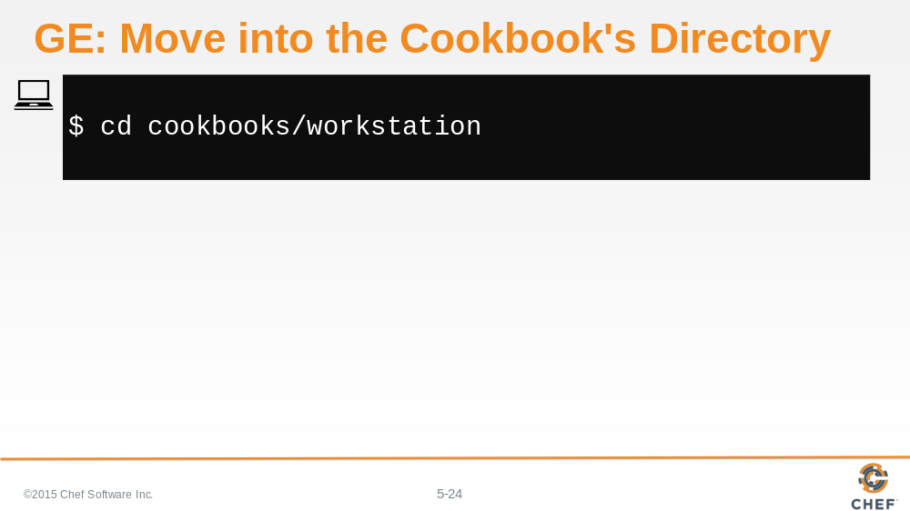

Let's change into our workstation cookbook's directory.

Slide 25

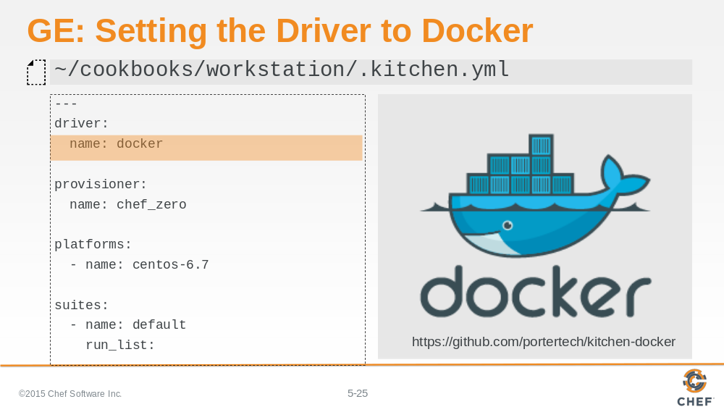

Docker is a driver. So replace the existing vagrant driver, in your .kitchen.yml, with the Docker driver.

.

Slide 26

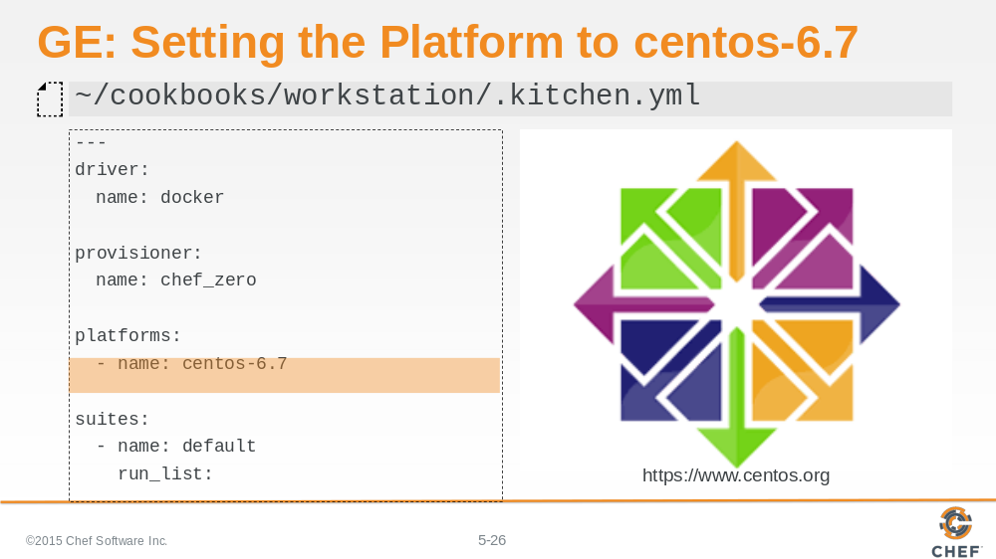

We also want to update our platforms to list only centos-6.7.

Slide 27

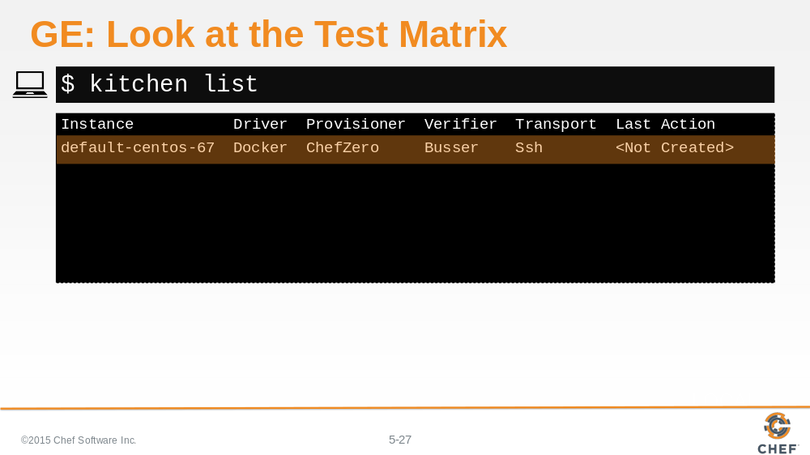

Run the `kitchen list` command to display our test matrix. You should see a single instance.

Slide 28

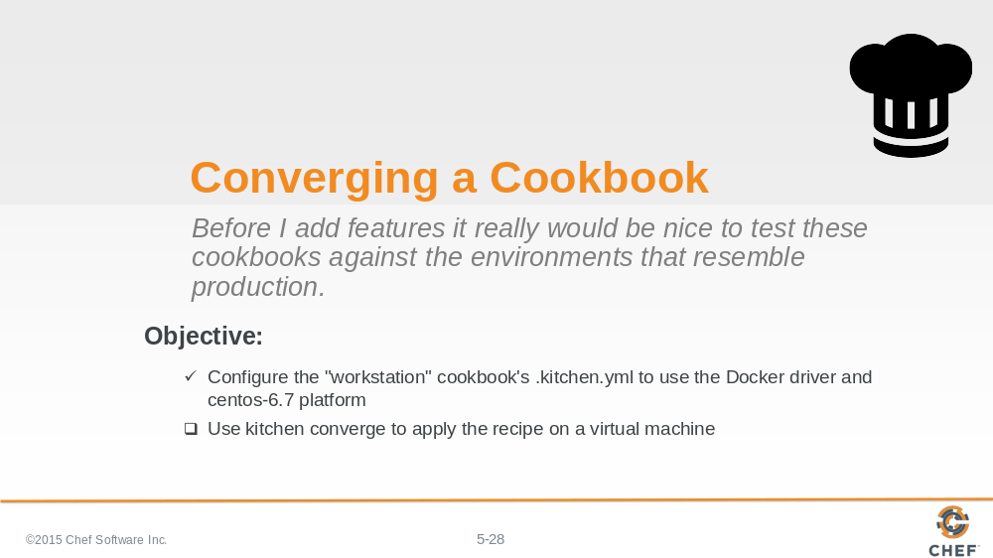

Now that we've defined the test matrix that we want to support, it is time to understand how to use Test Kitchen to create an instance, converge a run list of recipes on that instance, verify that the instance is in the desired state, and then destroy the instance.

Slide 29

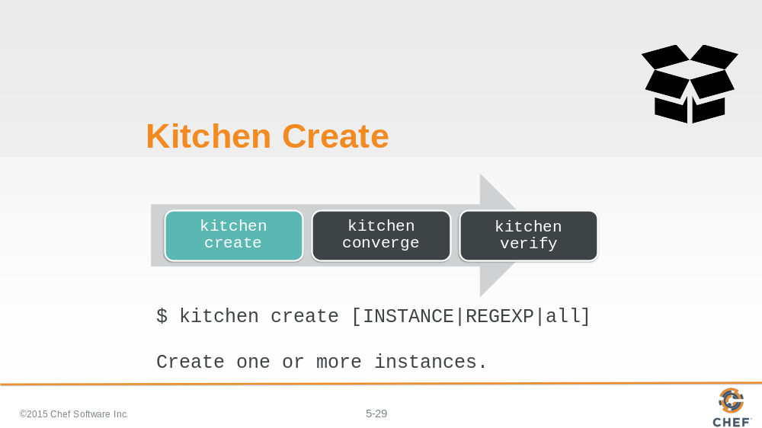

The first kitchen command is `kitchen create`.

To create an instance means to turn on virtual or cloud instances for the platforms specified in the kitchen configuration.

In our case, this command would use the Docker driver to create a docker image based on centos-6.7.

Slide 30

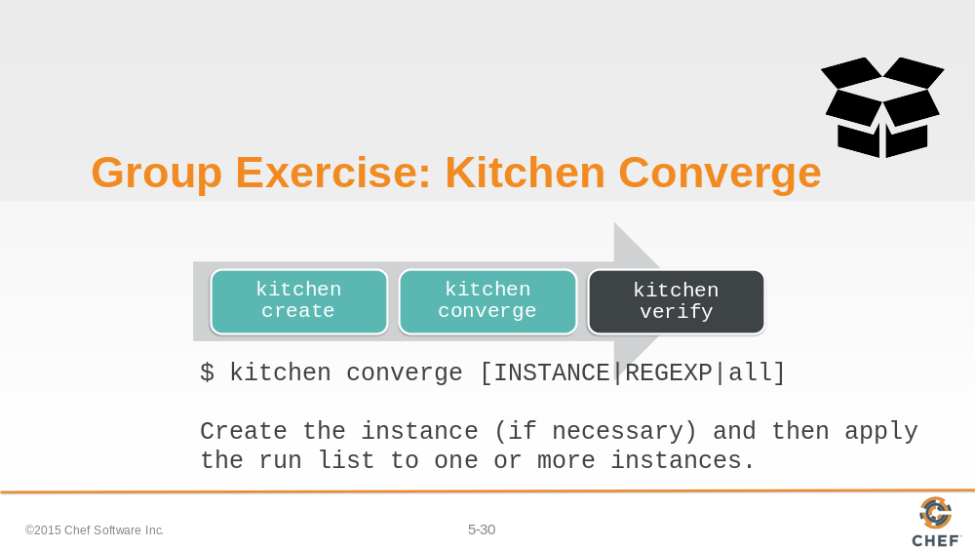

Creating an image gives us a instance to test our cookbooks but it still would leave us with the work of installing chef and applying the cookbook defined in our .kitchen.yml run list.

So let's introduce you to the second kitchen command: `kitchen converge`.

Converging an instance will create the instance if it has not already been created. Then it will install chef and apply that cookbook to that instance.

In our case, this command would take our image and install chef and apply the workstation cookbook's default recipe.

Slide 31

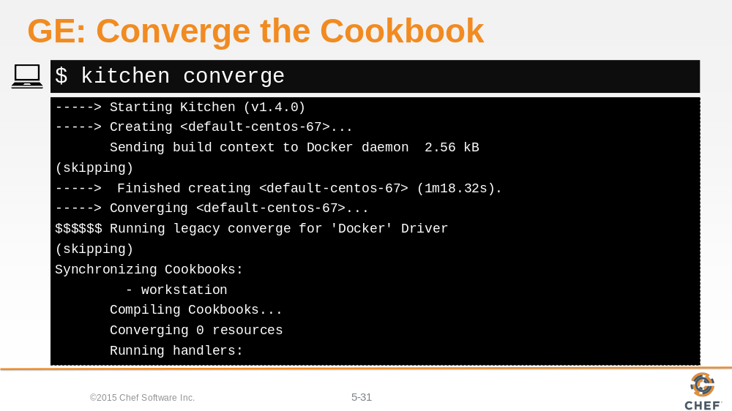

Be sure you are at ~/cookbooks/workstation and then run `kitchen converge` to verify that the workstation cookbook is able to converge the default recipe against the platform centos 6.7.

The workstation cookbook should successfully apply the default recipe. If an error occurs, lets stop and troubleshoot the issues.

Slide 32

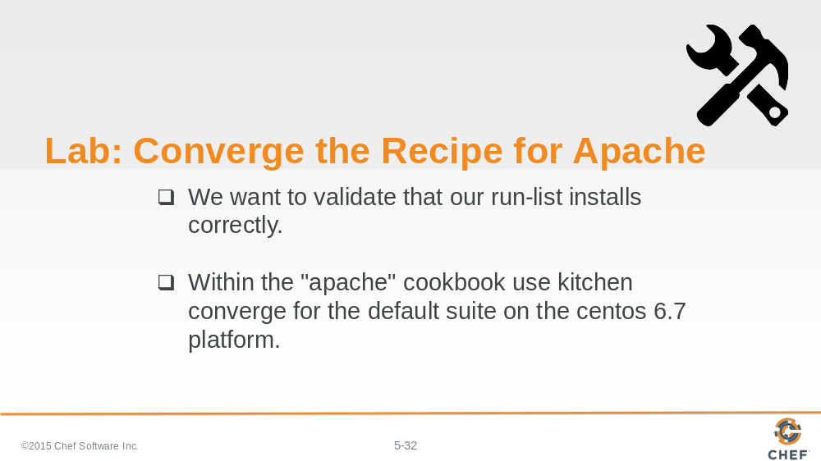

Do the same thing again for the apache cookbook. Update the .kitchen.yml file so that it converges the apache cookbook's default recipe on the centos-6.7 platform with the docker driver.

Slide 33

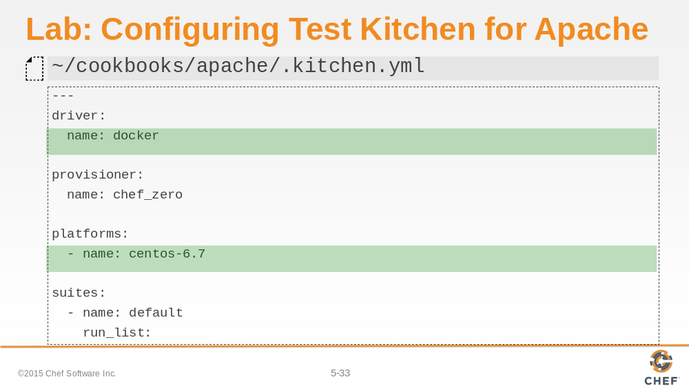

Like you did before, update the .kitchen.yml file to use the docker driver and the centos-6.7 platform.

Slide 34

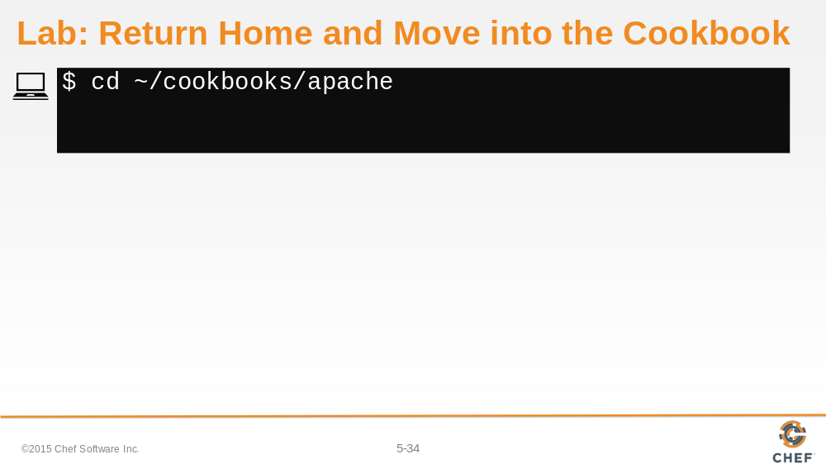

Change into the apache cookbook folder.

Slide 35

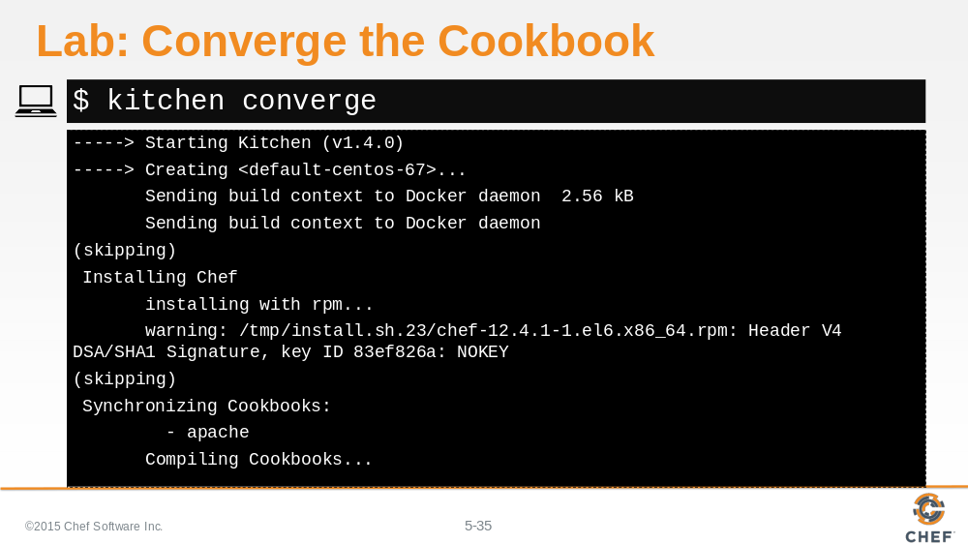

Execute `kitchen converge` to validate that our apache cookbook's default recipe is able to converge on the centos-6.7 instance.

Slide 36

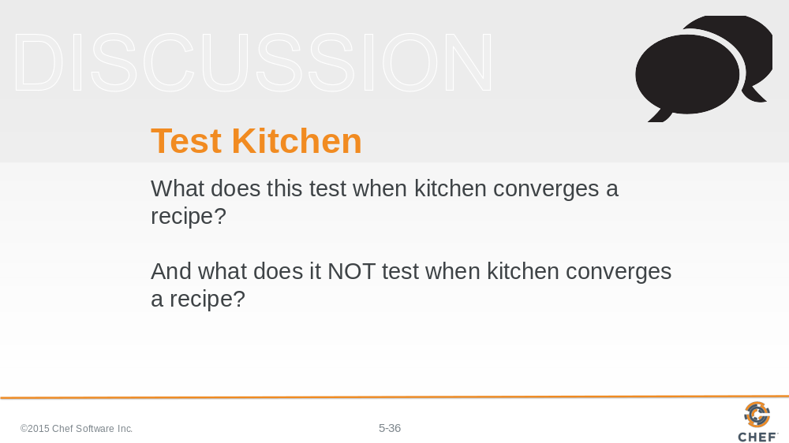

So what does this test when kitchen converges a recipe?

What does it NOT test when kitchen converges a recipe?

Slide 37

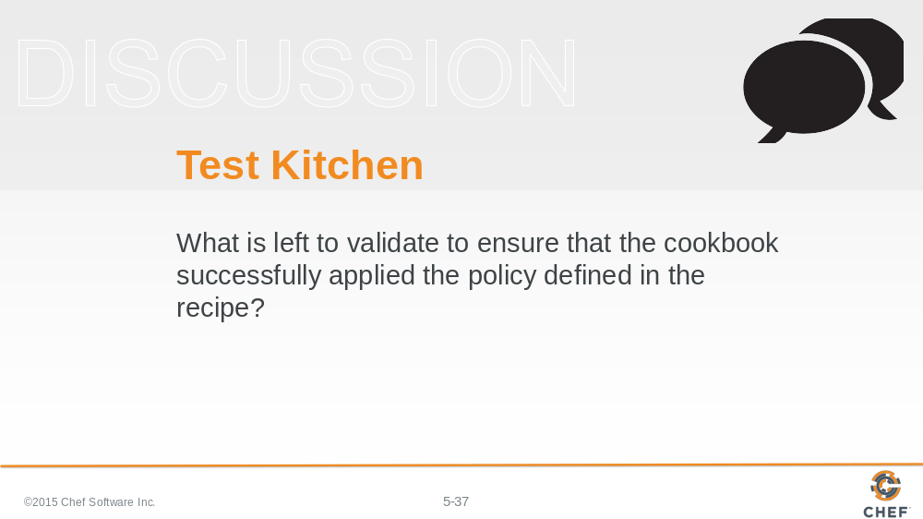

What is left to validate to ensure that the cookbook successfully applied the policy defined in the recipe?

Slide 38

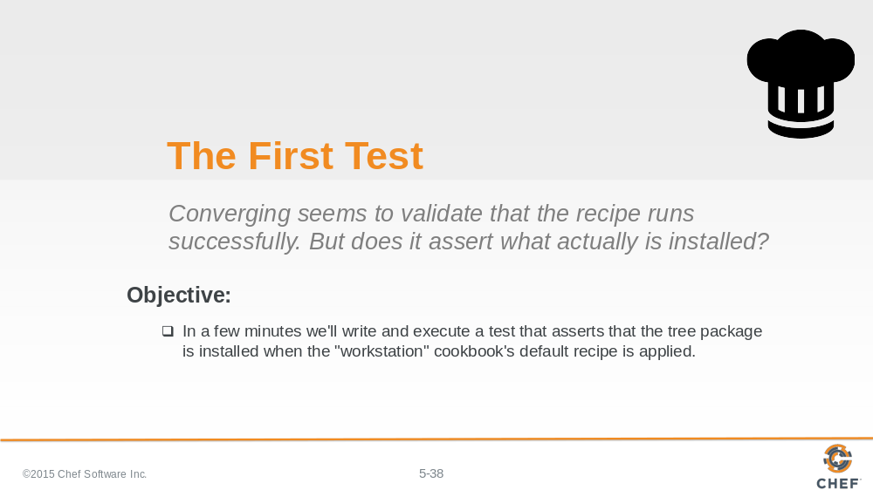

There is no automation that automatically understands the intention defined in the recipes we create. To do that we will define our own automated test.

Lets explore testing by adding a simple test to validate that the tree package is installed after converging the workstation cookbook's default recipe. We'll do this together in a few minutes.

Slide 39

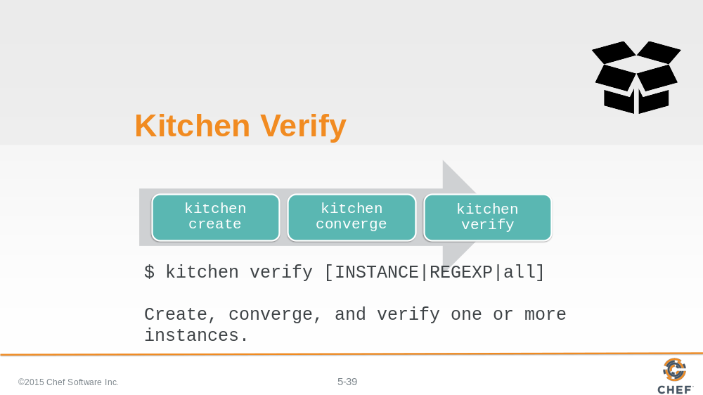

The third kitchen command is `kitchen verify`.

To verify an instance means to:

- Create a virtual or cloud instances, if needed
- Converge the instance, if needed
- And then execute a collection of defined tests against the instance

In our case, our instance has already been created and converged so when we run `kitchen verify` it will execute the tests that we will later define.

Slide 40

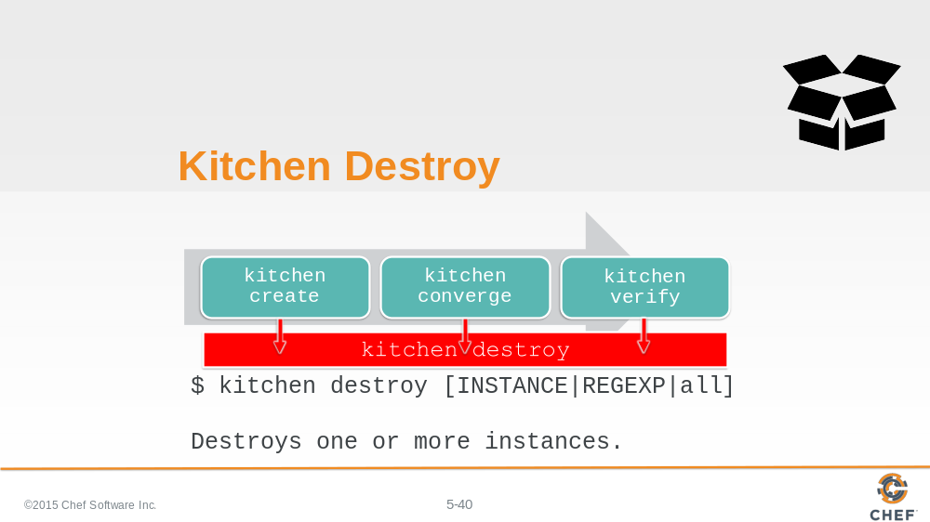

The fourth kitchen command is `kitchen destroy`.

Destroy is available at all stages and essentially cleans up the instance.

Slide 41

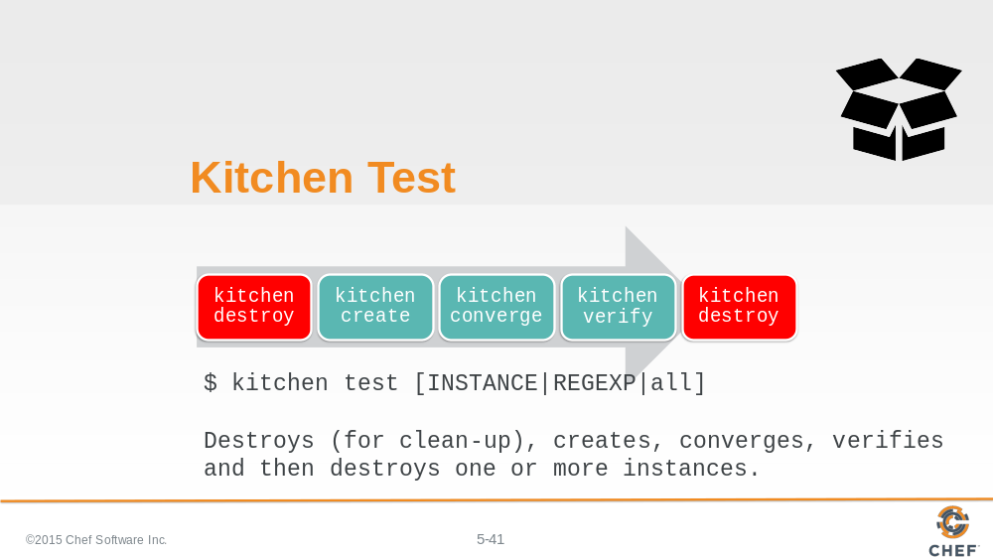

There a single command that encapsulates the entire workflow - that is `kitchen test`.

Kitchen test ensures that if the instance was in any state - created, converged, or verified - that it is immediately destroyed. This ensures a clean instance to perform all of the steps: create; converge; and verify. `kitchen test` completes the entire execution by destroying the instance at the end.

Traditionally this all encompassing workflow is useful to ensure that we have a clean state when we start and we do not leave a mess behind us.

Slide 42

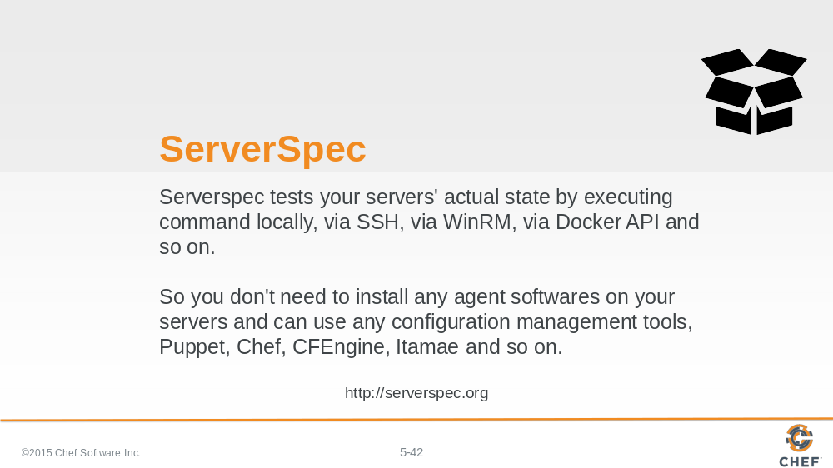

So `kitchen verify` and `kitchen test` are the two kitchen commands that we can use to execute a body of tests against our instances. Now it is time to define those tests with ServerSpec.

ServerSpec is one of many possible test frameworks that Test Kitchen supports. It is a popular choice for those doing Chef cookbook development because ServerSpec is built on a Ruby testing framework named RSpec.

RSpec is similar to Chef - as it is a Domain Specific Language, or DSL, layered on top of Ruby. Where Chef gives us a DSL to describe the policy of our system, RSpec allows us to describe the expectations of tests that we define. ServerSpec adds a number of helpers to RSpec to make it easy to test the state of a system.

Slide 43

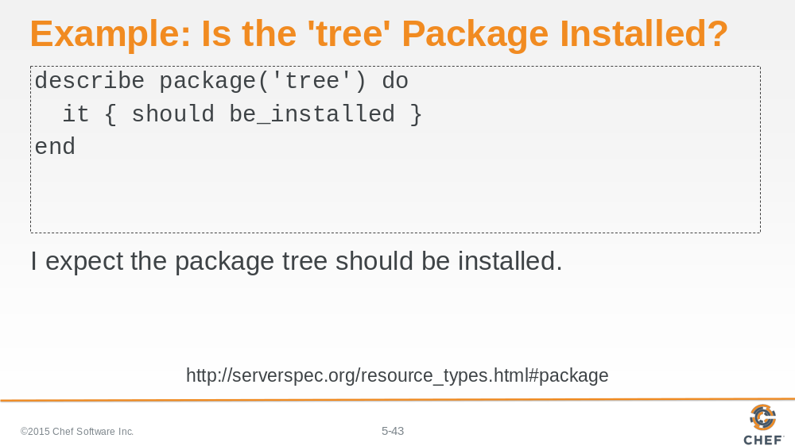

Here is an example of an isolated ServerSpec expectation that states: We expect the package named 'tree' to be installed.

Slide 44

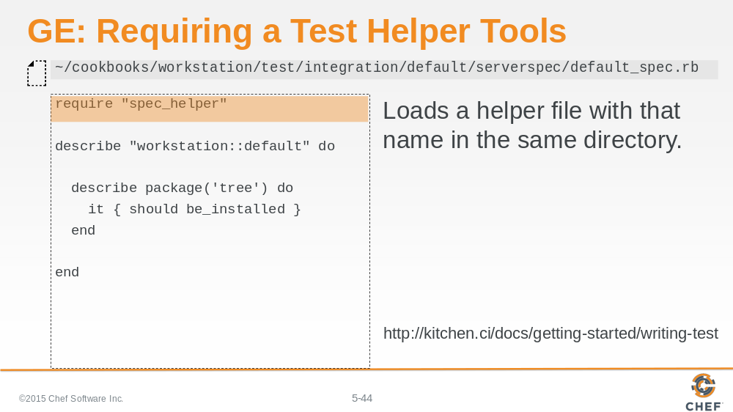

For our test to work with Test Kitchen there are a number of conventions that we need to adhere to have our test code load correctly.

First, we need to create a test file, often referred to as a spec file at the following path. The structure of the path is a convention defined by Test Kitchen and will automatically be loaded when we run `kitchen verify`. Fortunately for us the test file has already been created when we used 'chef' to generate the workstation cookbook.

Within the spec file we need to first require a helper file. The helper is were we keep common helper methods and library requires in one location. This is likely already present within the generated test file.

Slide 45

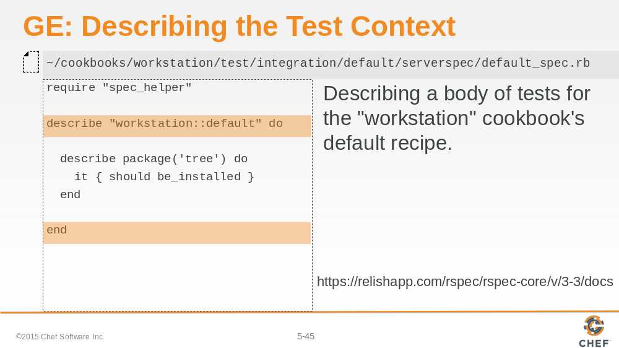

Second, we define a describe method. RSpec, which ServerSpec is built on uses an english-like syntax to help us describe the various scenarios and examples that we are testing.

The 'describe' method takes two parameters - the first is the name of fully-qualifed recipe to execute (cookbook_name::recipe_name).

The second parameter is the block between the do and end. Within that block we can define more describe blocks that allow us to further refine the scenario we are testing.

Slide 46

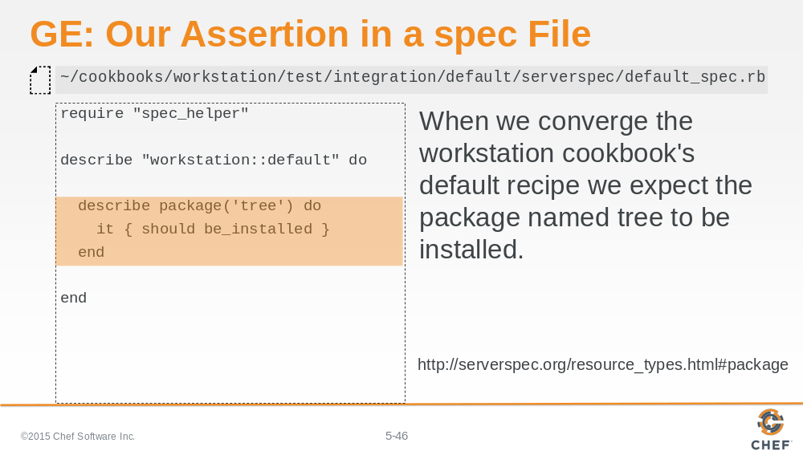

Here is that example expectation that we showed you earlier except now it is displayed here within this context. This states that when we converge the workstation cookbook's default recipe we want to assert that the tree package has been installed.

Add this expectation to the specification file at the specified path.

Slide 47

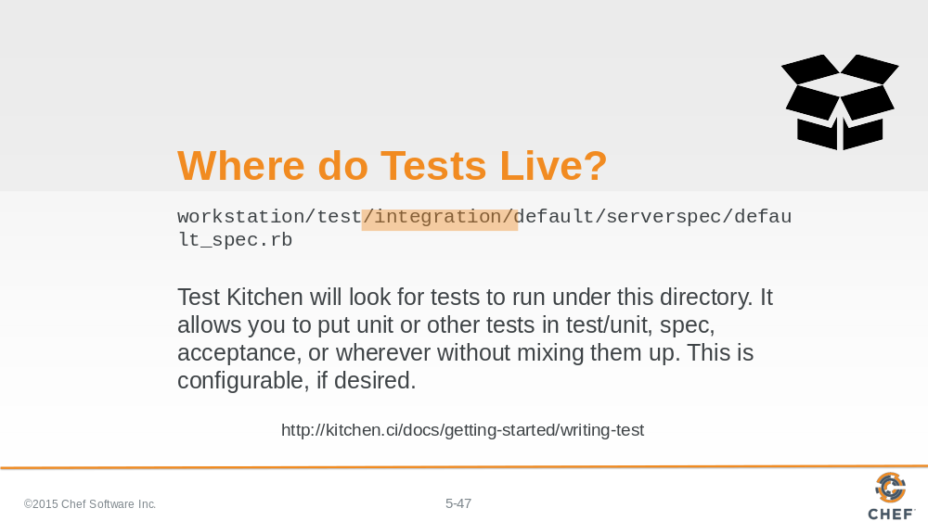

Lets take a moment to describe the reason behind this long directory path. Within our cookbook we define a test directory and within that test directory we define another directory named 'integration'. This is the basic file path that Test Kitchen expects to find the specifications that we have defined.

Slide 48

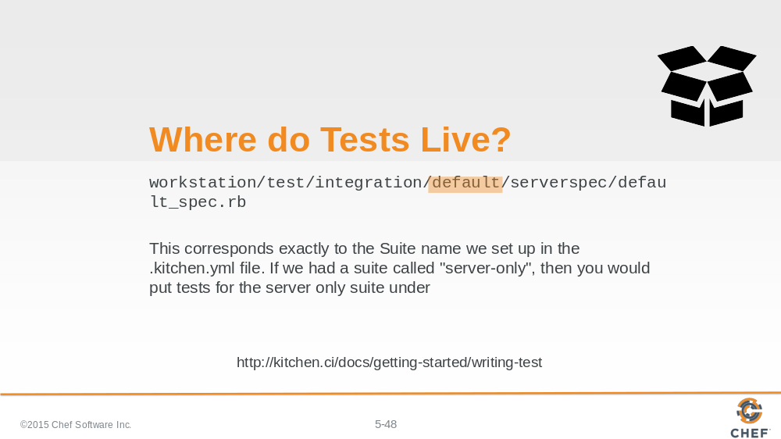

The next part the path, 'default', corresponds to the name of the test suite that is defined in the .kitchen.yml file. In our case the name of the suite is 'default' so when test kitchen performs a `kitchen verify` for the default suite it will look within the 'default' folder for the specifications to run.

Slide 49

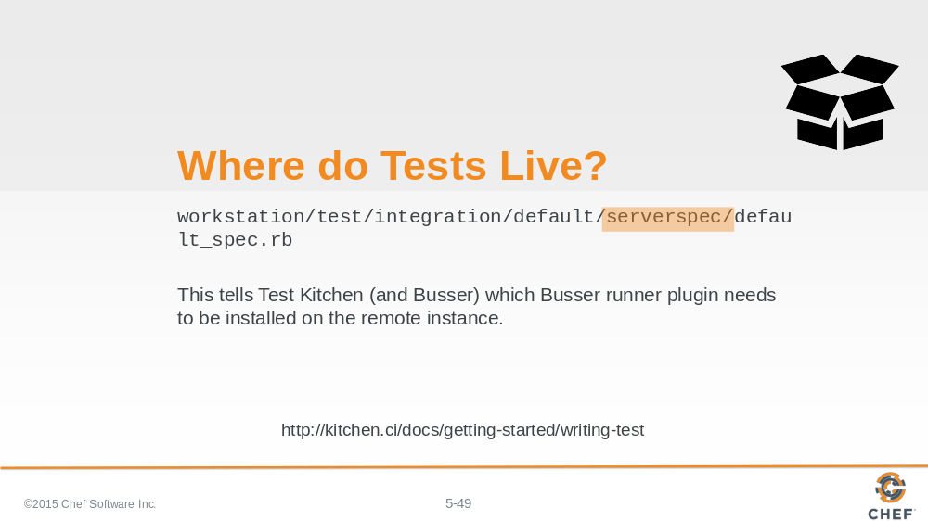

'serverspec' is the kind of tests that we want to define. Test Kitchen supports a number of testing frameworks.

Slide 50

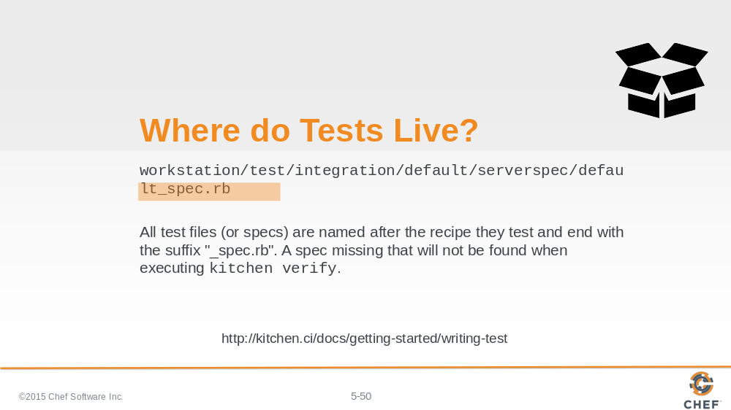

The final part of the path is the specification file. This is a ruby file. The naming convention for this file is the recipe name with the appended suffix of _spec.rb. All specification files must end with _spec.rb.

Slide 51

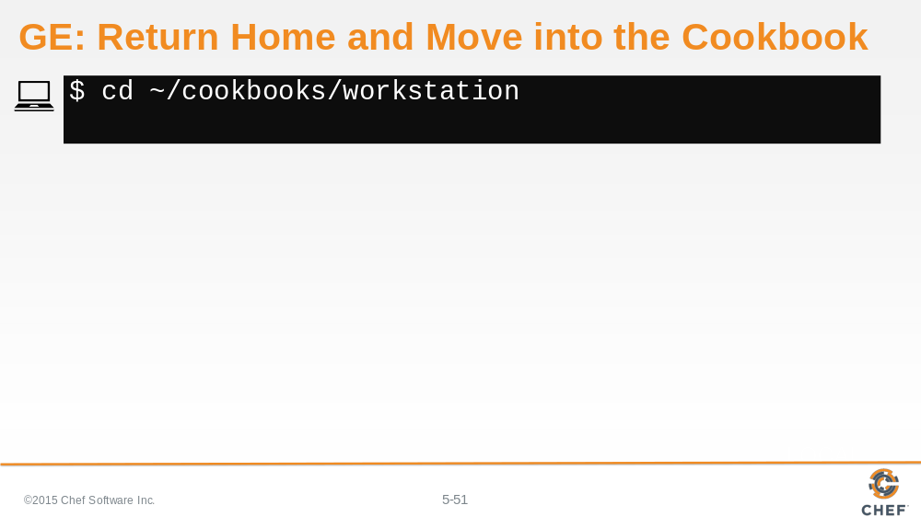

Change into the workstation cookbook directory.

Slide 52

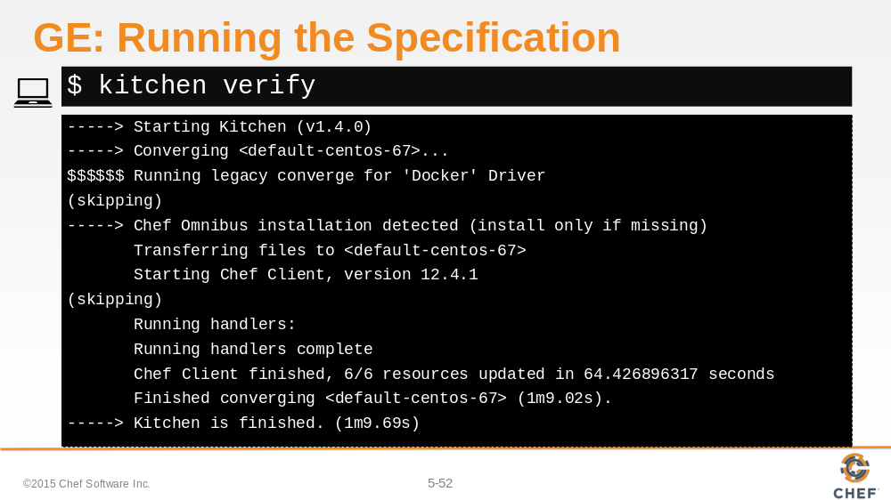

With the first test created, lets verify that the package named 'tree' is installed when we apply the workstation cookbooks default recipe using the `kitchen verify` command to execute our test

Slide 53

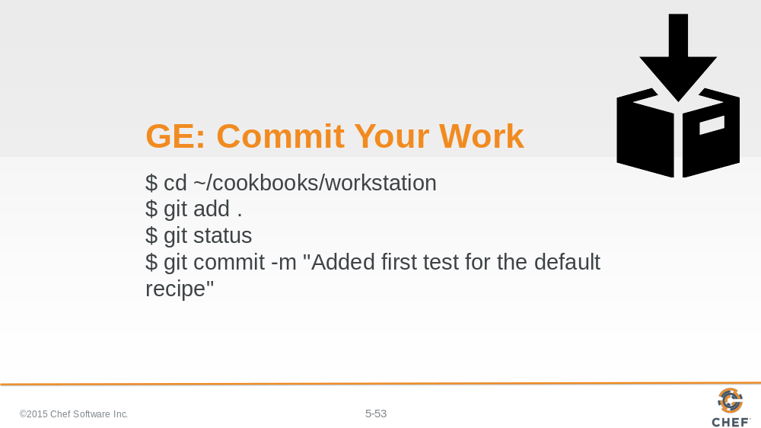

With the first test completed. It is time to commit the changes to source control.

Slide 54

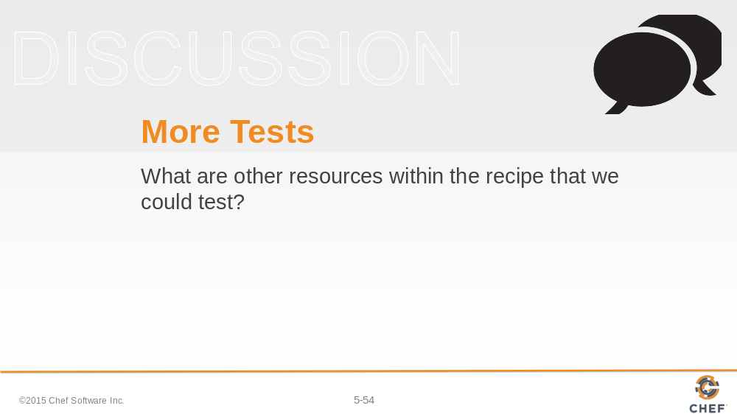

Now that we've explored the basic structure of writing tests to validate our cookbook.

What are other resources within the recipe that we could tests?

Slide 55

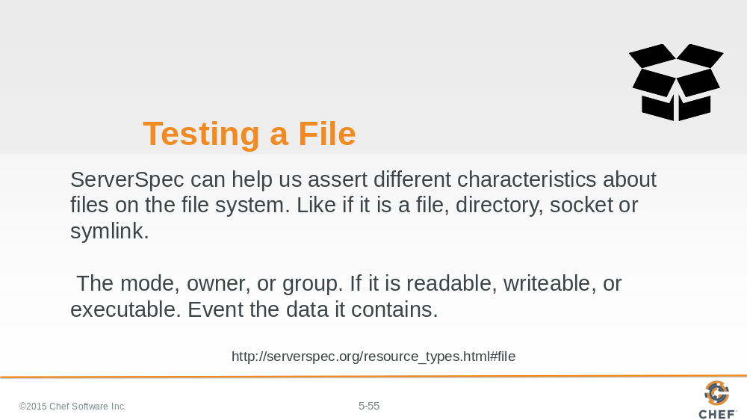

ServerSpec provides a large number of helpers to assist us with many different resources on our system. Important to us in testing more of our workstation cookbook's default recipe is the ability to verify if a file was written, what are the permissions of that file, and what are the contents.

Let's look at a few examples...

Slide 56

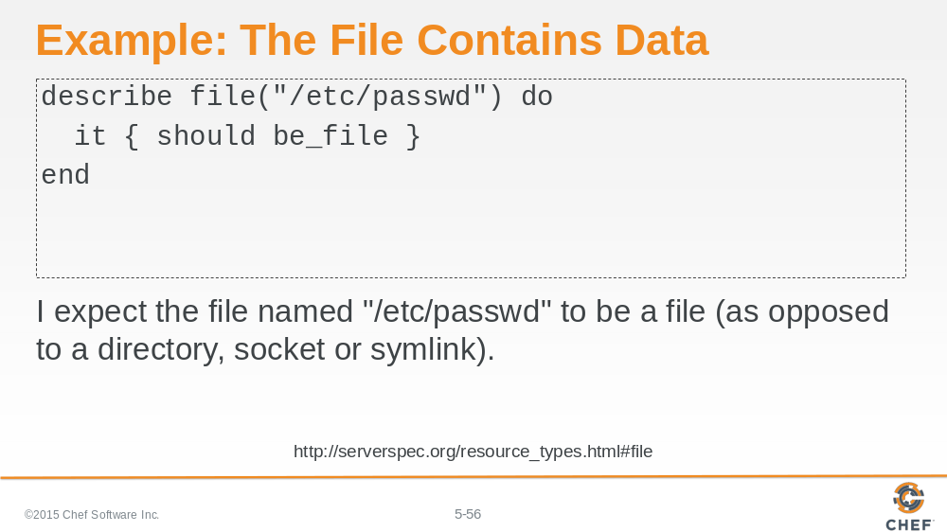

Here we are describing an expectation that the file named "/etc/passwd" is a file.

Slide 57

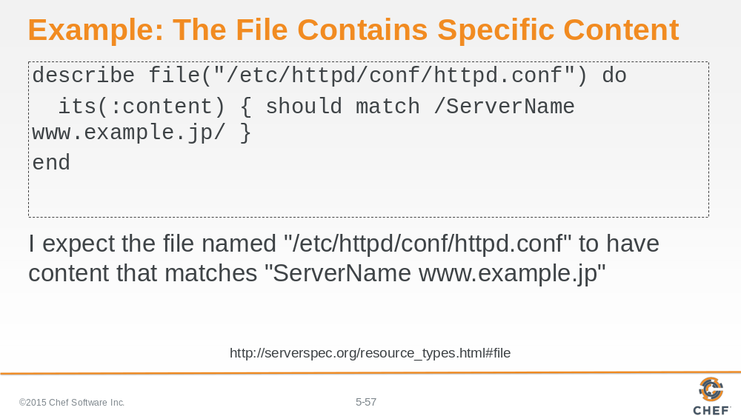

Here we are describing an expectation that the file named "/etc/httpd/conf/httpd.conf" has contents that match the following regular expression. Asserting that somewhere in the file we will find the following bit of text.

Slide 58

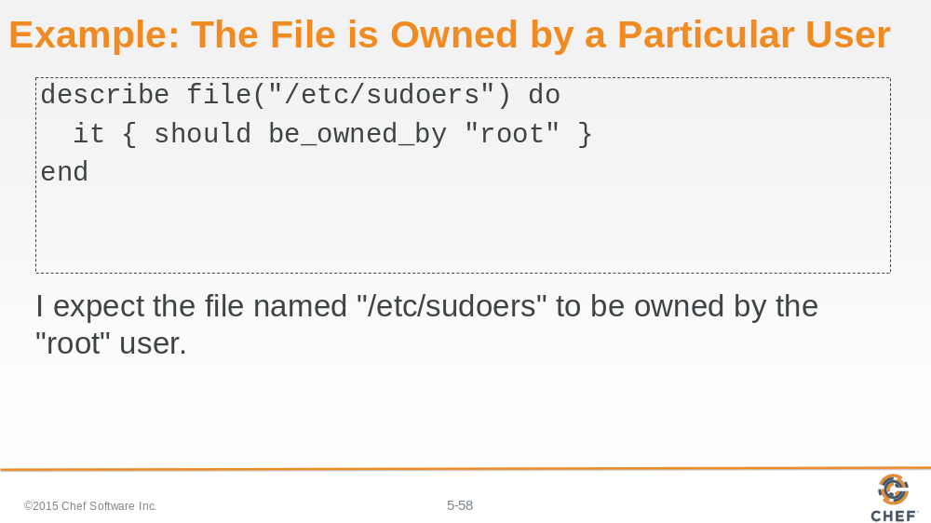

Here we are describing an expectation that the file named "/etc/sudoers" should be owned by the root user.

Slide 59

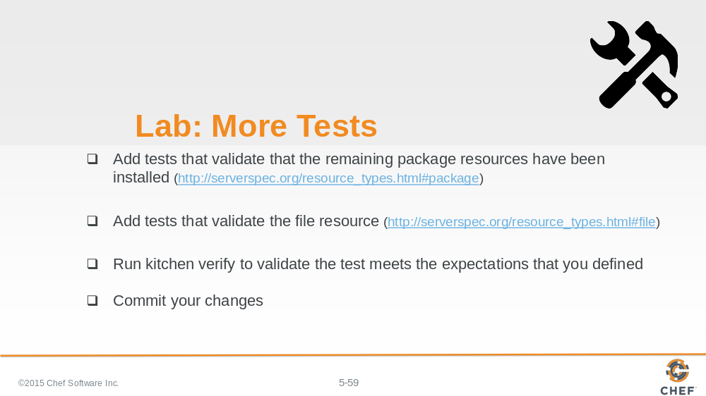

As a lab exercise, we want you to define additional tests that validate the remaining resources within our default recipe.

Add tests for the remaining package resources that are converged by the "workstation" cookbook's default recipe.

You may also add tests for the file resource to ensure the file is present, that the contents are correctly defined, that it is owned by a particular user and owned by a particular group.

Slide 60

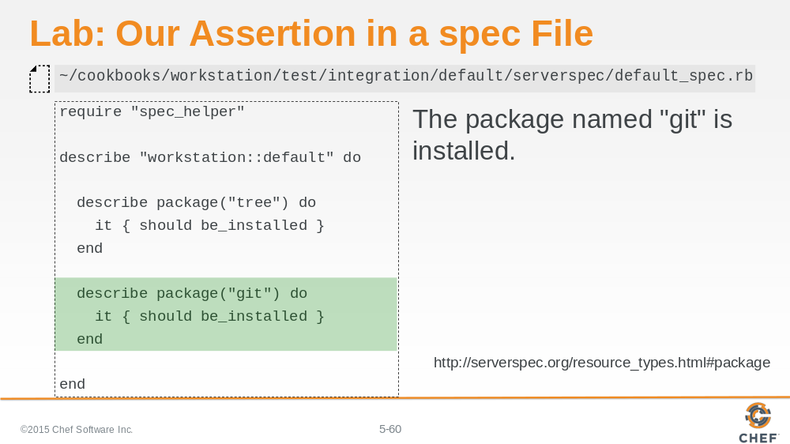

Let's review the lab.

Here we are verifying that the package git is installed. The structure of the test is very similar to the one we demonstrated earlier. You'll likely have another test that validates the editor you specified is also installed.

Slide 61

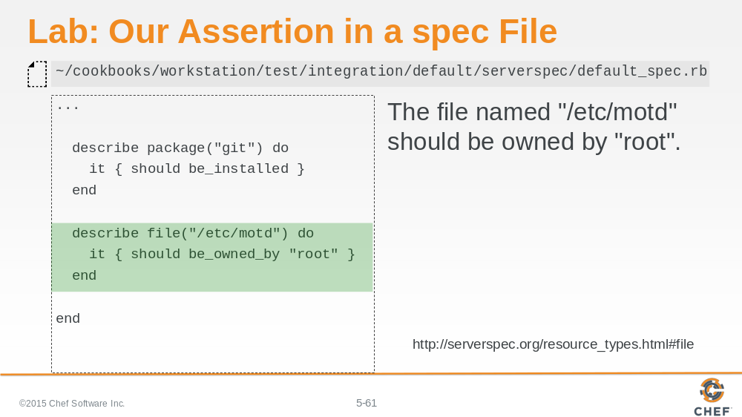

For the file resource, we chose only to verify that the file named "/etc/motd" is owned by the root user. You may have verified that it was a file, that it belonged to a group, and that it contained content you felt important to verify.

Slide 62

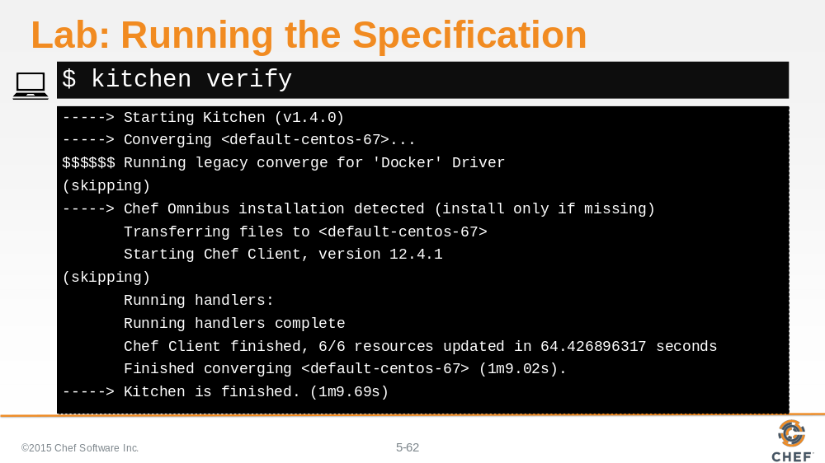

With more tests created lets verify all of these tests pass when we converged the workstation cookbooks default recipe. Use the `kitchen verify` command to execute the test

Slide 63

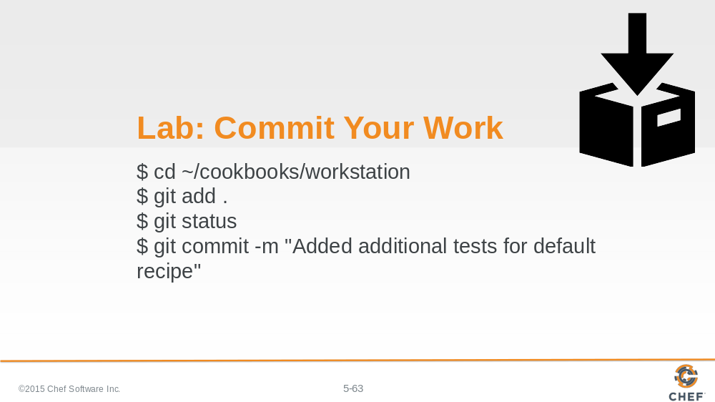

If all the tests that you defined are working then it is time to commit our changes to version control.

Slide 64

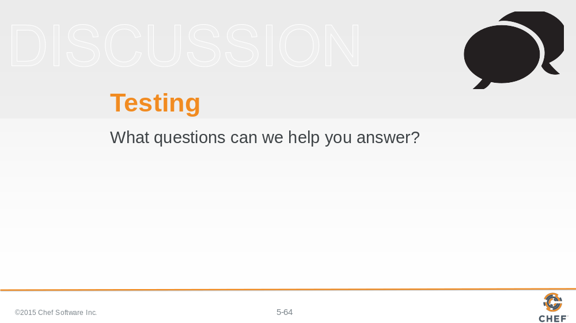

What questions can we help you answer?

Slide 65

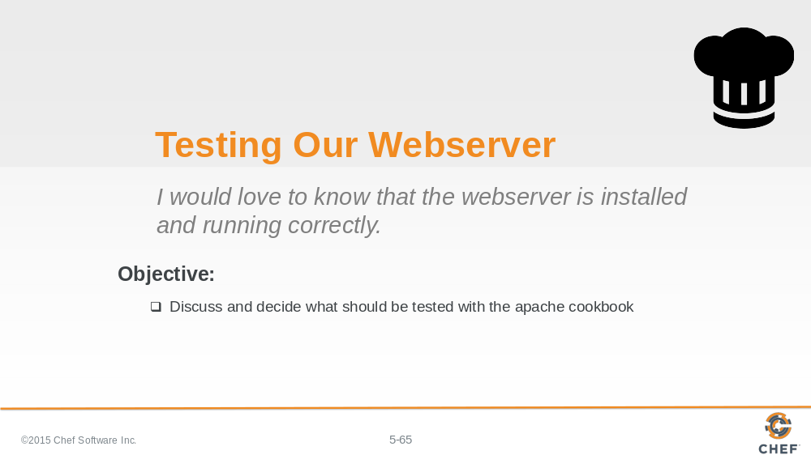

Now lets turn our focus towards testing the apache cookbook.

Slide 66

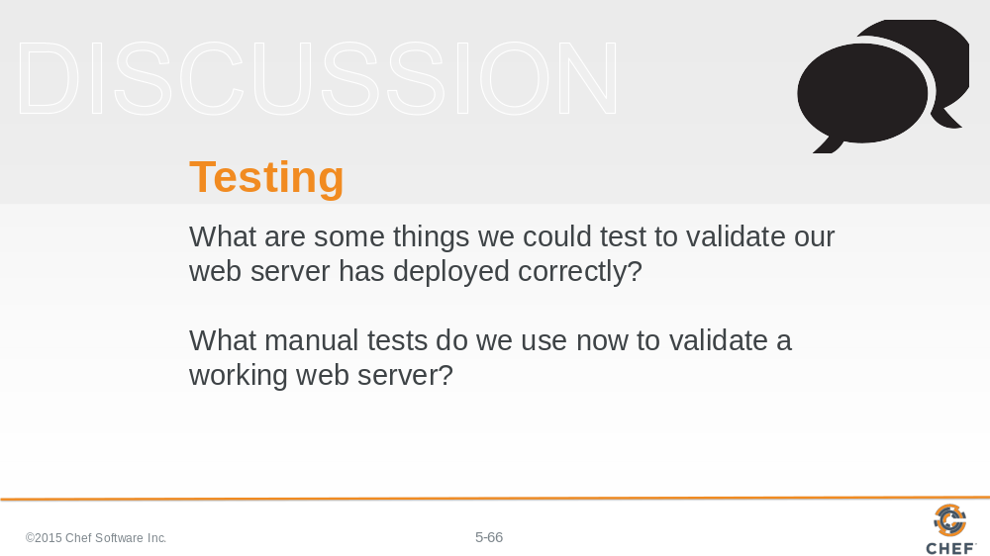

What are some things we could test to validate our web server has deployed correctly?

The apache cookbook is similar to the workstation cookbook. It has a package and file which are things that we have already tested. The new thing is the service. We could review the ServerSpec documentation to find examples on how to test the service.

But does testing the package, file and service validate that apache is hosting our static web page and returning the content to visitors of the instance?

What manual tests do we use now to validate a working web server?

After applying the recipes in the past we visited the site through a browser or verified the content through running the command 'curl localhost'.
Is that something that we could test as well? Does ServerSpec provide the way for us to execute a command and verify the results?

Slide 67

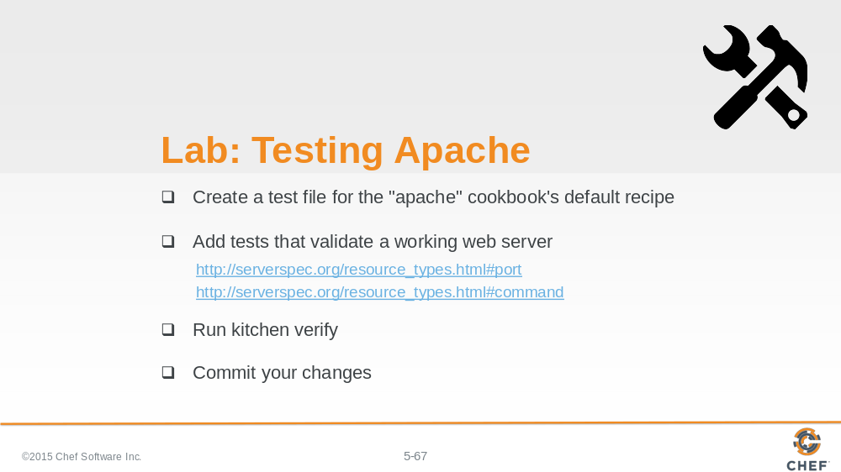

So for this final exercise, you are going to create a test file for the apache cookbook's default recipe.

That test will validate that you have a working web server. This means I want you to add the tests that you feel are necessary that the system is installed and working correctly.

When you are done execute your tests with `kitchen verify`.

Slide 68

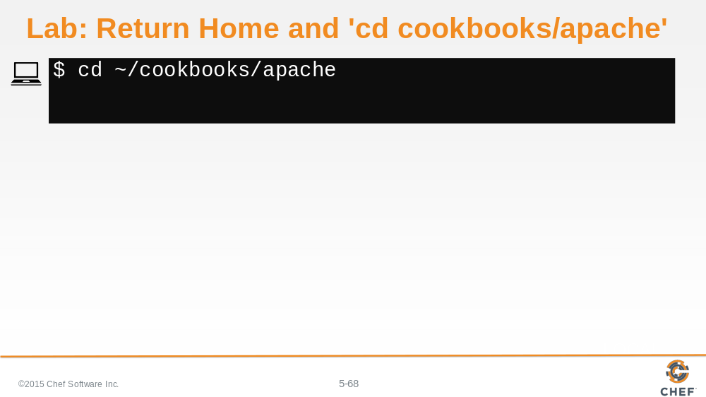

Return home and then move into the apache cookbook's directory.

Slide 69

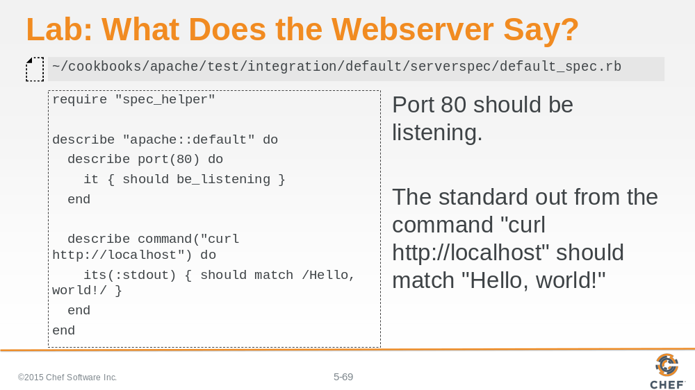

Here we chose to validate that port 80 should be listening for incoming connections.

And we also validated that the standard out from the command "curl http://localhost" should match "Hello, world!".

Slide 70

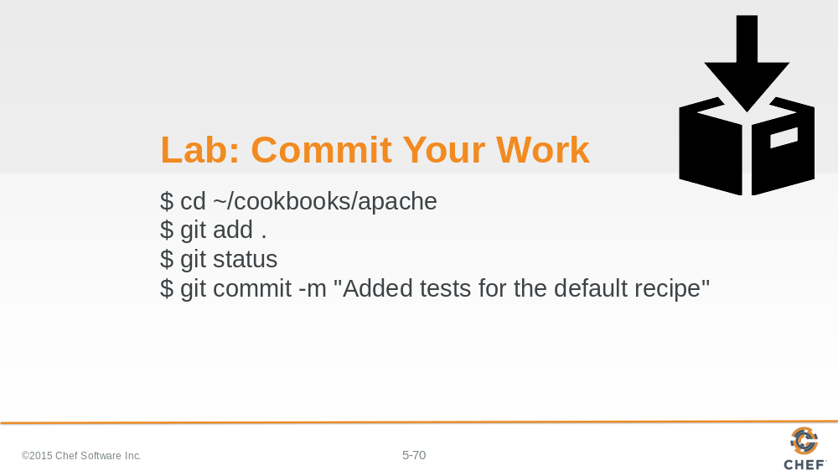

Again, lets commit the work.

Slide 71

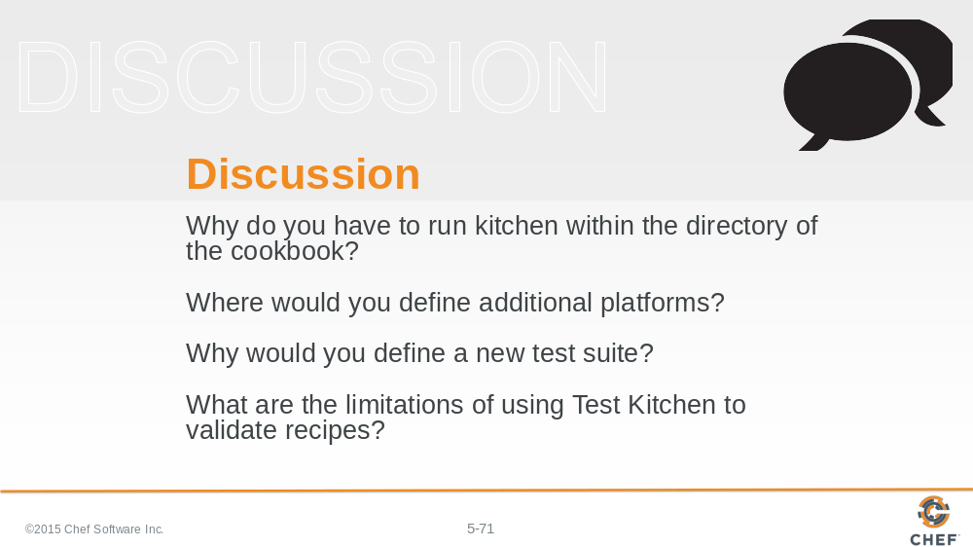

Answer these questions.

With your answers, turn to another person and alternate asking each other asking these questions and sharing your answers.

Slide 72

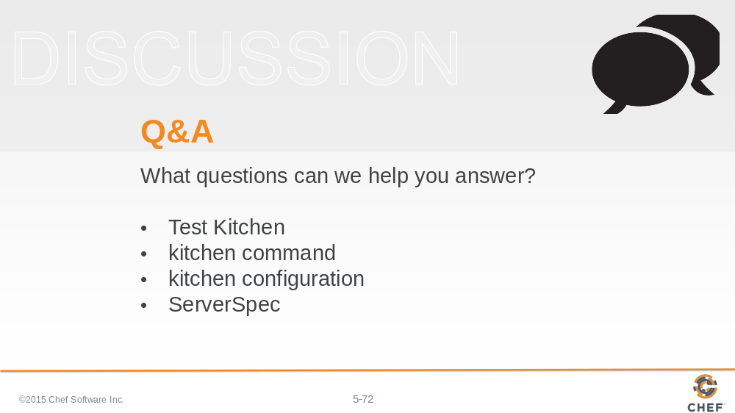

What questions can we help you answer?

Generally or specifically about chef-client, local mode, run lists, and include_recipe.

Slide 73



