

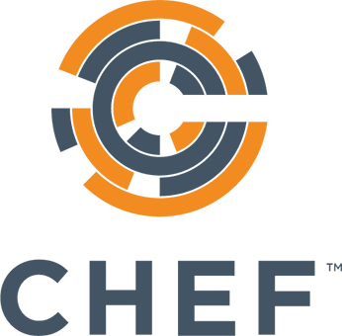

Chef Training Services

Chef Essentials (CentOS)

Participant Guide