|  |  |
| --- | --- |
| **Project Case** |  |
| COMP6583 | COMP6583001  Computer Graphics |
| **Computer Science** | **O232-COMP6583-GH02-00** |
| ***Valid on*** *Odd Semester Year 2022/2023* | **Revision 00** |

1. Seluruh kelompok tidak diperkenankan untuk:

*The whole group is not allowed to:*

* + - Melihat sebagian atau seluruh proyek kelompok lain,

*Seeing a part or the whole project from another groups*

* + - Menyadur sebagian maupun seluruh proyek dari buku,

*Adapted a part or the whole project from the book*

* + - Mendownload sebagian maupun seluruh proyek dari internet,

*Downloading a part or the whole project from the internet,*

* + - Mengerjakan soal yang tidak sesuai dengan tema yang ada di soal proyek,

*Working with another theme which is not in accordance with the existing theme in the matter of the project,*

* + - Melakukan tindakan kecurangan lainnya,

*Committing other dishonest actions,*

* + - Secara sengaja maupun tidak sengaja melakukan segala tindakan kelalaian yang menyebabkan hasil karyanya berhasil dicontek oleh orang lain / kelompok lain.

*Accidentally or intentionally conduct any failure action that cause the results of the project was copied by someone else / other groups.*

1. Jika kelompok terbukti melakukan tindakan seperti yang dijelaskan butir 1 di atas, maka **nilai kelompok** yang melakukan kecurangan (menyontek maupun dicontek) akan di – **NOL** – kan.

*If the group is proved to the actions described in point 1 above, the score of the group which committed dishonest acts (cheating or being cheated) will be “Zero”.*

1. Perhatikan jadwal pengumpulan proyek, segala jenis pengumpulan proyek di luar jadwal tidak dilayani.

*Pay attention to the submission schedule for the project, all kinds of submission outside the project schedule will not be accepted.*

1. Bila Anda tidak membaca peraturan ini, maka Anda dianggap telah membaca dan menyetujuinya.

*If you have missed to read these regulations, so you are considered to have read and agreed on it.*

1. Persentase penilaiaan untuk matakuliah ini adalah sebagai berikut:

*Marking percentage for this subject is described as follows:*

|  |  |  |
| --- | --- | --- |
| **Tugas Mandiri**  *Assignment* | **Proyek**  *Project* | **UAP**  *Final Exam* |
| 40% | 60% | - |

1. Software yang digunakan pada matakuliah ini adalah sebagai berikut:

*Software will be used in this subject are described as follows:*

|  |
| --- |
| **Software**  *Software* |
| Chrome / Firefox / Microsoft Edge  Three JS  Visual Studio Code |

1. Ekstensi file yang harus disertakan dalam pengumpulan tugas mandiri, proyek, dan uap untuk matakuliah ini adalah sebagai berikut:

*File extensions should be included in assignment, project, and final exam collection for this subject are described as follows:*

|  |  |  |
| --- | --- | --- |
| **Tugas Mandiri**  *Assignment* | **Proyek**  *Project* | **UAP**  *Final Exam* |
| HTML, CSS, JS, Image Files (JPG / PNG), GLB | HTML, CSS, JS, Image Files (JPG / PNG), GLB | - |

## Soal

*Case*

**Snowball**

A game developer is currently building his new fantasy game called Snowball. The game will feature snow, a snowman, a winter house, and some trees. Due to lack of the visualization of the final scene of the game, you are pointed to design the scene using three.js library.

1. **Project Structure**

Your project should contain a main html file, several JavaScript files, assets, and the three.js library. You are to acquire three.js either from the three.js [official website](https://threejs.org/), [github repository](https://github.com/mrdoob/three.js/), or [CDN link](https://cdnjs.com/libraries/three.js).

You are required to include the following piece of code in your html file.

|  |
| --- |
| <style>  * { margin: 0; padding: 0; }  body { width: 100vw; height: 100vh; overflow: hidden; }  </style>  <script src="[path to index.js file]" type="module"></script> |

You are free to split your code into several different JavaScript file, but code the main logic for creating the scene inside “index.js” file.

1. **Scene**

Create a **full screen** scene that can be **dynamically resized** to **fit the window**. The scene also has **shadow map** **enabled** using **PCFShadowMap** as the shadow map **type** and **anti-aliasing** turned on.

1. **Camera**

Create **camera** which details will be specified below.

* 1. **Third Person Camera**
     + This camera will have the following specifications:

|  |  |
| --- | --- |
| Property | Value |
| Type | Perspective Camera |
| FoV | 45 |
| Position | Vector3 (0, -50, 70) |

* + - This camera will focus on **Vector3 (0, 0, 0)** position and can be rotated around said position using **OrbitControls.**
    - If user presses **space**, the camera will **be at the start position** and then **going down** while still looking at the center of the snowball as long the **z position** is still greater than **10**.

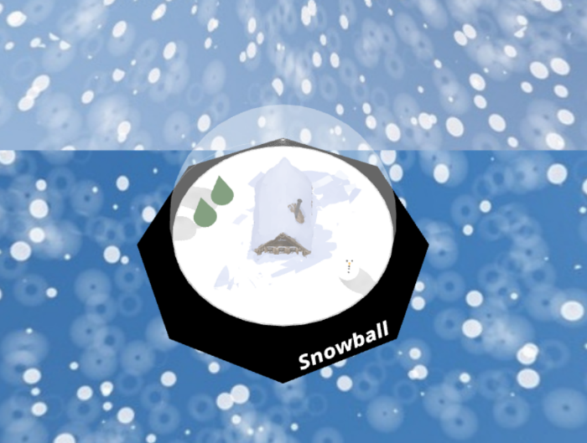

**Figure 1. View of the camera’s start position**

**Figure 2. View after camera going down**

1. **Lighting**

There will be two global lights to illuminate the entire scene

* 1. **Ambient Light**
     + Below are the specifications:

|  |  |
| --- | --- |
| Property | Value |
| Type | Ambient |
| Intensity | 1 |
| Color | #FFFFFF |

* 1. **Point Light**
     + Below are the specifications

|  |  |
| --- | --- |
| Property | Value |
| Type | Point |
| Intensity | 1 |
| Color | #FFFFFF |
| Position | Vector3 (0, 0, 10) |
| Cast Shadow | Yes |

1. **Objects**
   1. **Ground**

* Below are the specifications:

|  |  |
| --- | --- |
| Property | Value |
| Geometry Type | Circle |
| Radius | 14.5 |
| Segments | 40 |
| Material Type | Mesh Standard Material |
| Side | Double Side |
| Position | Vector3 (0, 0, 0) |
| Receive Shadow | Yes |
| Texture Map |  |

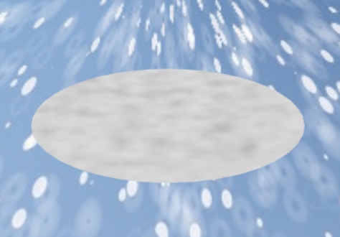

**Figure 3. Ground**

* 1. **Base**
     + Below are the specifications:

|  |  |
| --- | --- |
| Property | Value |
| Geometry Type | Cylinder |
| Radius Top | 15 |
| Radius Bottom | 20 |
| Radial Segments | 4 |
| Radial Heights | 8 |
| Material Type | Mesh Basic Material |
| Color | #000000 |
| Position | Vector3 (0, 0, -2.1) |
| Rotation | Euler (1.57, 0, 0) |

**Figure 4. Base**

* 1. **Winter House**
* Load model from the **GLTF** **file** **“**winterhouse/scene.gltf**”**
* When first load the model’s **size** and **orientation** is not the most optimal, so you need to **adjust** it yourself
* Below are the specifications

|  |  |
| --- | --- |
| Property | Value |
| Cast Shadow | Yes |
| Receive Shadow | Yes |
| Position | Vector3 (-69, 50, -1) |
| Rotation | Euler (1.57, 0, 0) |

**Figure 4 Winter House**

* 1. **Text**
     + Below are the specifications:

|  |  |
| --- | --- |
| Property | Value |
| String | Snowball |
| Font Type | Droid Sans Bold |
| Material Type | Mesh Basic Material |
| Color | #FFFFFF |
| Position | Vector3 (2, -19, -2.5) |
| Rotation | Euler (1, 0.37, 0.2) |
| Size | 2 |

**Figure 5. Text**

* 1. **Globe**
     + Adjust the placement and rotation of the globe.
     + Below are the specifications:

|  |  |
| --- | --- |
| Property | Value |
| Radius | 14.5 |
| Width Segments | 32 |
| Height Segments | 16 |
| phiLength | 6.3 |
| thetaStart | 1.1 |
| thetaLength | 3 |
| Material Type | Mesh Lambert Material |
| Color | #FFFFFF |
| Transparent | Yes |
| Opacity | 0.4 |

**Figure 6. Globe**

* 1. **Snowman**
     + Snowman is consisted of **3 stacked spheres**. Adjust the positions and rotations of the snowman’s body, eyes, nose, and buttons.
     + Below the specifications for the **body**:

|  |  |
| --- | --- |
| Property | Value |
| Geometry Type | Sphere Geometry |
| Material Type | Mesh Standard Material |
| Color | #FFFFFF |
| Cast Shadow | Yes |
| Width Segments | 32 |
| Height Segments | 6 |
| Base Body Radius | 1.5 |
| Middle Body Radius | 1 |
| Upper Body Radius | 0.8 |

* + - Below the specifications for the **eyes**:

|  |  |
| --- | --- |
| Property | Value |
| Geometry Type | Sphere Geometry |
| Material Type | Mesh Basic Material |
| Color | #000000 |
| Cast Shadow | Yes |
| Width Segments | 32 |
| Height Segments | 6 |
| Radius | 0.1 |

* + - Below the specifications for the **nose**:

|  |  |
| --- | --- |
| Property | Value |
| Geometry Type | Cone Geometry |
| Material Type | Mesh Basic Material |
| Color | #FFA500 |
| Cast Shadow | Yes |
| Radius | 0.15 |
| Height | 0.5 |
| Radial Segment | 32 |

* + - Below the specifications for the **buttons**:

|  |  |
| --- | --- |
| Property | Value |
| Geometry Type | Sphere Geometry |
| Material Type | Mesh Basic Material |
| Color | #000000 |
| Cast Shadow | Yes |
| Width Segments | 32 |
| Height Segments | 6 |
| Radius | 0.1 |

**Figure 7. Snowman**

* 1. **Trees**
* There are **2 trees** beside the house. Each tree consists of a **leaf** and a **trunk**. Adjust the positions and rotations of each tree.
* Below the specifications for the **trunk**:

|  |  |
| --- | --- |
| Property | Value |
| Geometry Type | Box Geometry |
| Material Type | Mesh Phong Material |
| Color | #03F301D |
| Shine | 100 |
| Cast Shadow | Yes |
| Width | 0.5 |
| Height | 7 |
| Depth | 0.5 |
|  |  |

* + - Below the specifications for the **leaf**:

|  |  |
| --- | --- |
| Property | Value |
| Geometry Type | Cone Geometry |
| Material Type | Mesh Basic Material |
| Color | #32612D |
| Cast Shadow | Yes |
| Radius | 1.5 |
| Height | 5 |
| Radial Segment | 32 |

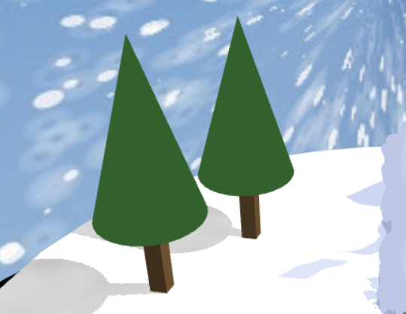

**Figure 8. Trees**

* 1. **Snow**
     + The snow will be **spawn and start falling** inside the globe when the mouse is **ray cast to the globe and clicked**. There are **10 spheres** that will be falling and every time the snow is disappear to the ground, the snow will **fall repeatedly** from the start position the snow was spawned. Adjust the start position and the limit position of the snow.
     + Below the specifications for the **snow**:

|  |  |
| --- | --- |
| Property | Value |
| Geometry Type | Sphere Geometry |
| Material Type | Mesh Basic Material |
| Color | #FFFFFF |
| Cast Shadow | Yes |
| Width Segments | 32 |
| Height Segments | 6 |
| Radius | 0.1 |

**Figure 9. Snow**

1. **Skybox**

Create the skybox using **cube mapping technique** with the following specifications:

|  |  |
| --- | --- |
| Property | Value |
| Size | 300 x 300 x 300 |
| Texture  (in sequence: px, nx, py, ny, pz, nz) |  |

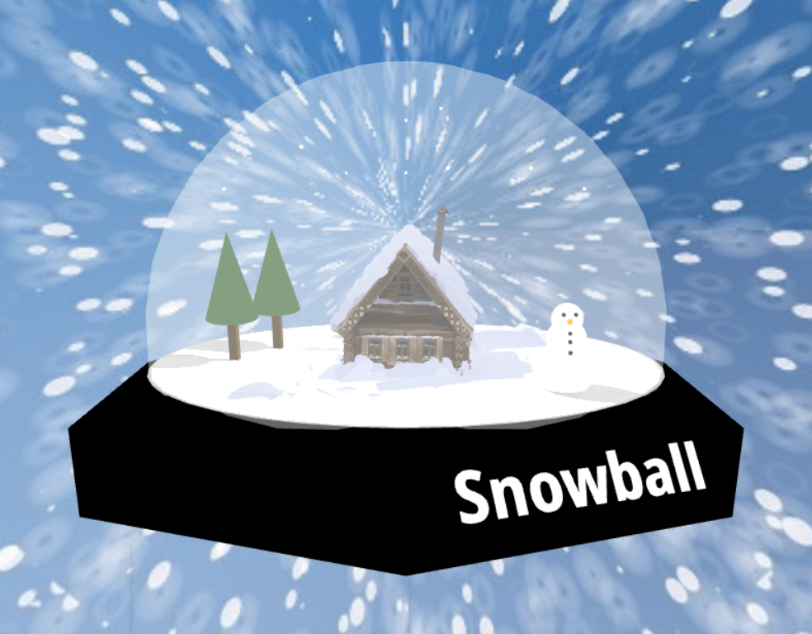

**Figure 10. Final Result**

**References**

<https://unsplash.com/photos/JXIFjYVbAS8>

<https://sketchfab.com/3d-models/quill-little-house-ed5660f12f6c4c19b1d7d93a7afd038d>

Here are the **rules** that you must follow to create your project:

1. Use **appropriate software** for this subject based on **Sistem Praktikum** that can be downloaded from Binusmaya.
2. Collect **appropriate files** for this subject based on **Sistem Praktikum** that can be downloaded from Binusmaya.
3. Include the **other files** that can support your project, such as:
   * All files in your project.
   * Other files (image, audio, video, etc.) used in your project.
   * *.doc file (documentation of your project) that contains all pages in your project, reference links of additional files (image, audio, video, etc.) used in your project, the description about how to use your application, etc.

**If you do not understand, please ask your assistant! Do not make your own assumption!**