**3D Printing - Getting started with Eclipse Java development**

To get you started with Eclipse:

* using the File Explorer of your operating system, in your home directory, create a folder named ‘Workspace’ that will be used as a work folder for Eclipse development
* unpack the startup archive that you received in this folder. Do not unpack the archive into a subfolder – straight into the Workspace folder.
* start Eclipse. The ‘Eclipse Launcher’ dialog box will appear. Paste the path of your Workspace folder into the ‘Workspace’ field then click ‘OK’. Do not click ‘Use this as the default and do not ask again’, as it is convenient to have the Workspace directory displayed on startup and change your mind later if things go wrong.
* Once Eclipse has started, expand everything by clicking this button:  
  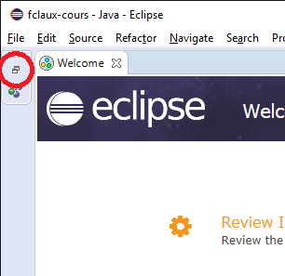
* in the Package Explorer view (that should be displayed, otherwise enable it in the Window > Show View menu), right click inside the window, then click ‘Import…’, then select ‘Existing projects into Workspace’ and click Next
* select ‘Select root directory’ and click ‘Browse’. Here, select your Workspace directory. It should be the location proposed by default. Click OK.
* In the ‘Projects’ list, you should now see all projects provided to you, as part of the startup code. You should see three projects (two libraries, and one application).
* Click Finish. All projects now show up in Package Explorer.
* Now right-click the ‘fc.PrintingApplication.Students’ project in Package Explorer, select ‘Refactor’ then ‘Rename’, and make it ‘fc.PrintingApplication.Students.<YourName>’. This step is important as it individualises your project name.

To run the code, select the application project in the Package Explorer window, then click the  button (eg. Run). Select ‘Java Application’ to run the code, not ‘Java Applet’. Click  to debug the application.

The provided sample code shows how to parse a 3D mesh, eg. how to enumerate vertices, faces and face triangles.