Title - Brainstorm engineering 2D design drafting software
Name of the inventor- Nathnael Shawl
- Abstract
This software(Brainstorm) is a pseudo computer aided design(CAD) software that combines paint application and CAD application to give engineers/designers easy place to start a design. The software is packaged with intuitive and necessary tools with almost a zero learning curve having a main goal to create design drafts on the fly during a brainstorming stage as the name indicates. The added benefit of the software is, it is an open source program and free to use for a life time. The software contains designing tools/2/, parameter adjustment options/3/ and also file managing tools/1/.
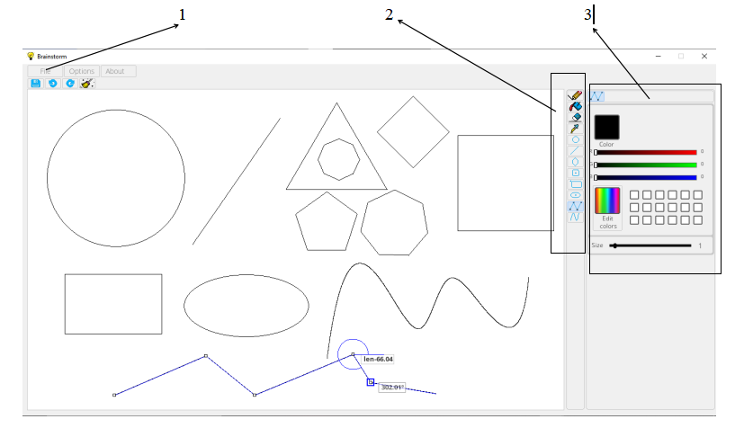
Figure 1

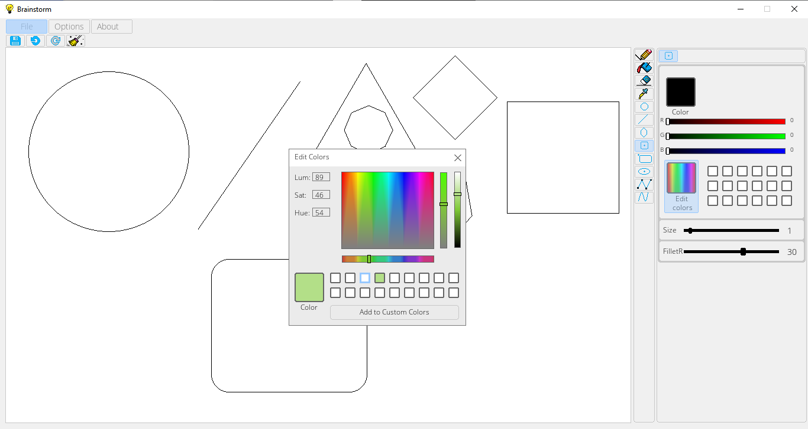
Figure 2
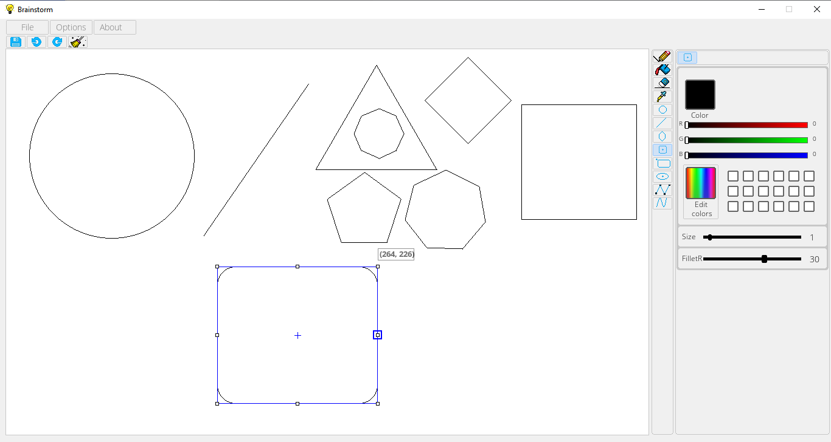
Figure 3

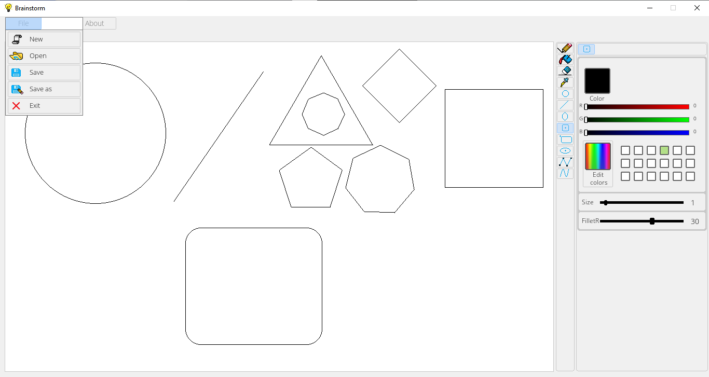
Figure 4
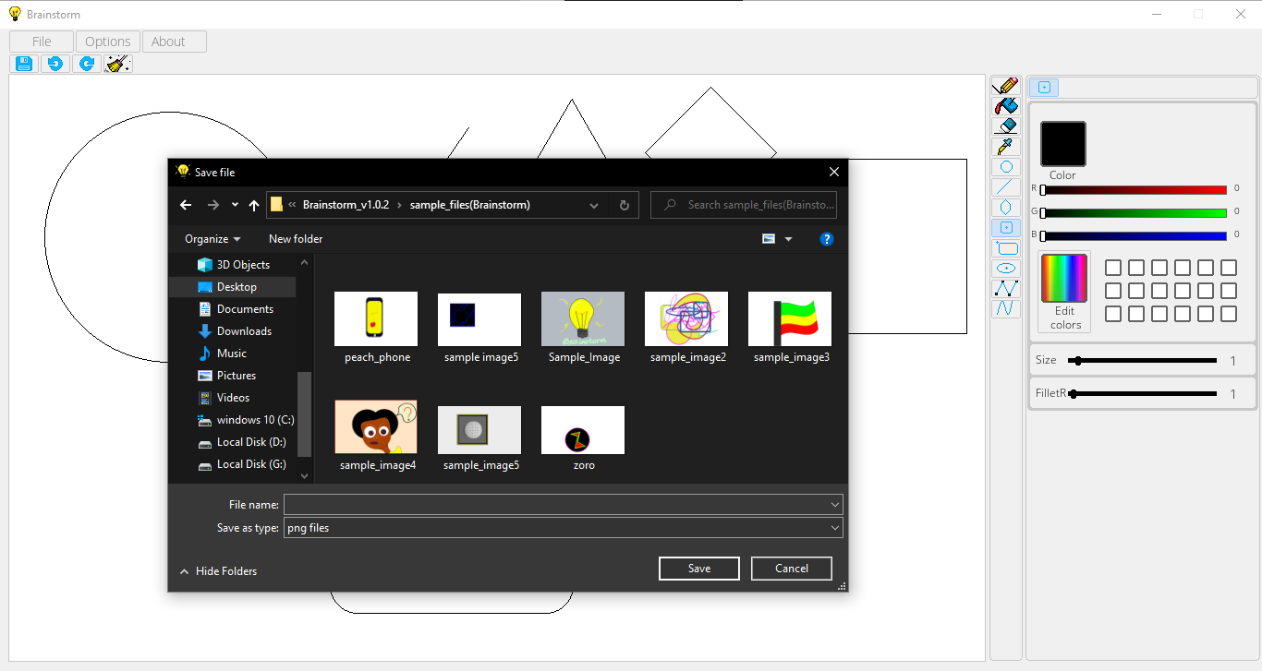
Figure 5

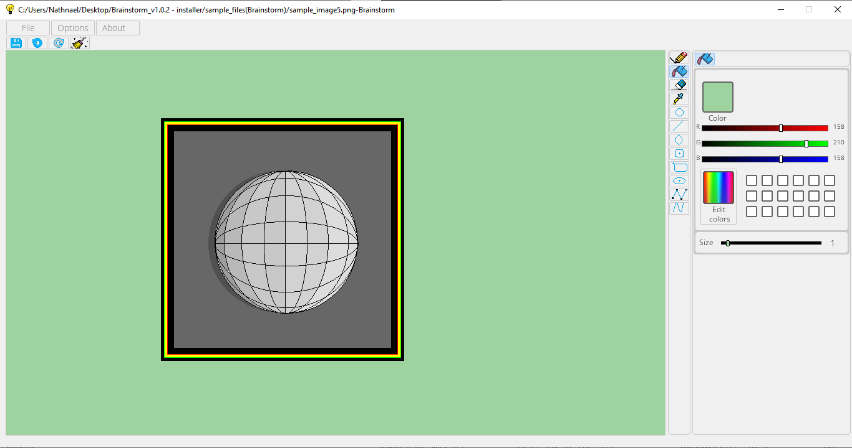
Figure 6
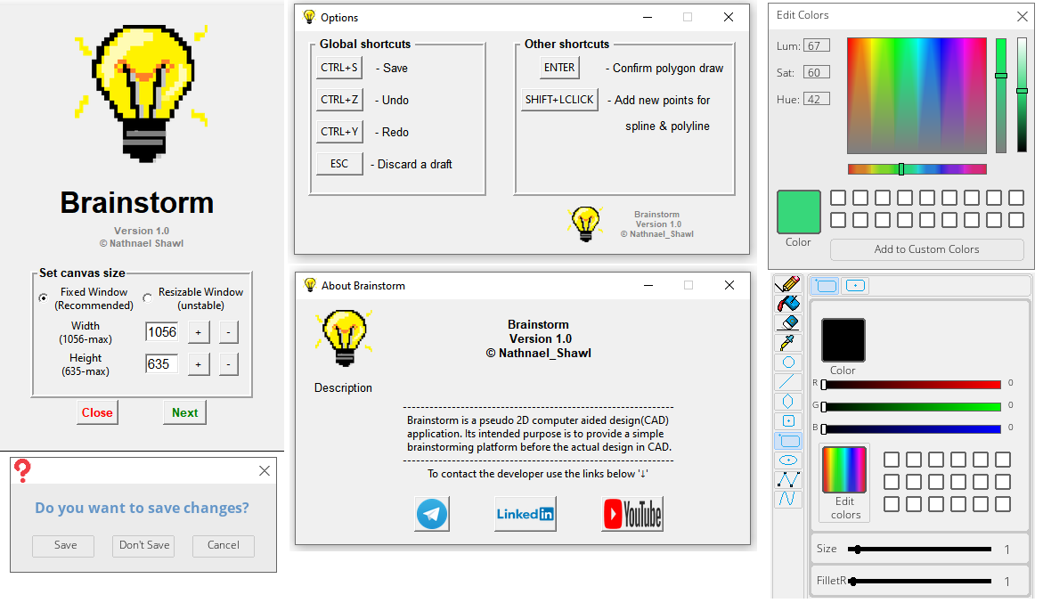 Figure 7
Engineering 2D design drafting software
- Background of the Invention
2.1. field of invention
The field of invention is a software programmed with python programming language that is a brainstorming engineering design 2D drafting software . The software currently is supported only on windows operating system.
2.2. Prior Art
There is a load of software collection written using python programming language or other programming languages but these are not cheap and cost a lot. The programs also expects engineers or trained professional users to master them. The programs also need huge amount of hardware resources to function with the desired speed. But most of the time we may not even need too much tools just to make drafts or to brainstorm ideas.
The programs mostly are on a different genera compared to other and most of the time frustrating for beginners to use.
- Objective of the Invention
The main objective of the software is to enable users create 2D design drafts easily with good speed. It has a potential to facilitate the brainstorming stage of designing in any field of engineering. The main features that allows such qualities are:
- Easy to use and user friendly user interface.
- Light weight design that uses minimal hardware resources.
- Intuitive icons, responsive user interface and similarities in functions.
- Use of free and open-source programming tools
- Easy to understand programming techniques

- Description of the figures (List of figures)
Figure 1: General view of the software user interface and available tools.
Figure 2: Custom designed HSV color-space color editor and selector
Figure 3: Shows a cad feature to allow users edit shapes with desired dimensions and also applying a filleting function.
Figure 4: Shows the file manager window.
Figure 5: Using the file manager to open a earlier work.
Figure 6: Painting feature on use.( The image is created using Brainstorm application.)
Figure 7: Custom designed pop up windows and user interface functions.
4.1. Brief Description of the drawings
Figure 1- The main user interface of the program programmed using an open-source python library called ‘pygame’. Pygame is a community based python that is totally free to use and the full library code is available for every body. The rest of the user interface is created using a python builtin library called ‘tkinter’ that is also free to use.
Figure 2- HSV color model is created by computer researchers for computer graphics. I have used the idea to construct my own version of the interface using pygame having motivations from tkinter library color selector. It allows you to select colors and also edit them easily. It can store custom color pallets for future use.
Figure 3- Shows a single functionality of Brainstorm in action. It can draw basic preventive shapes like polygons, ellipses, lines, circles , pencil and marker drawings and others like bezier curves and poly-lines(chain of lines). It allows users to create the shapes at first and also edit them as their wish.
Figure 4, 5, 6- Brainstorm currently allows users to create and open ‘.png’ format design images.

- Claims
- The software is designed genuinely from scratch using the python programming language and doesn’t use any pirated or illegal to distribute python libraries.
- The design of the user interface is purely my work that is motivated by the current software development standards and not a copy of another software interface.
- The application icons and any images used in the applications I.e application icon, button icons are created and drawn by me and no ones work is used although the icons used in the ‘about’ window I.e linked-In, You-tube and Telegram icons are a property of the respective companies and free to use to direct users to my accounts in the respective platforms.
- The algorithms used to program are from the libraries documentations, free-learning platforms or my own creations.

