- Names
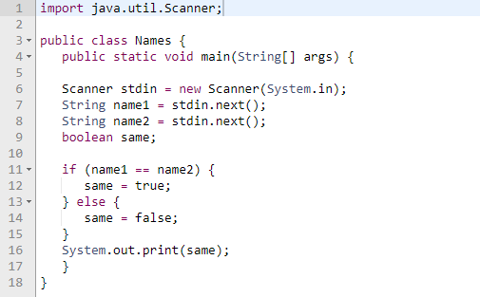

Determine the output of the following program with the inputs:
John John
A: compile error on line 26
B: true
C: false
D: compile error on line 31

2. Grades

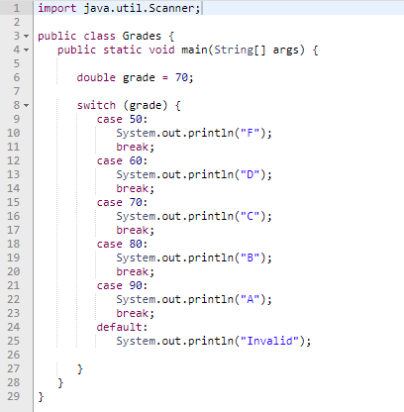

What will the program output be?

A: There is a compile error

B: C

C: C
B
A
Invalid

D: There is no output

3.GPA
Analyze the following code and determine the output:
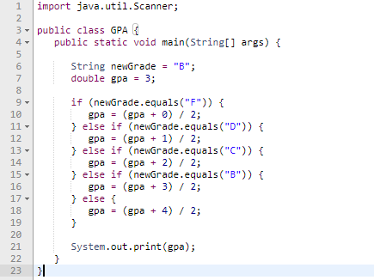

4. Days
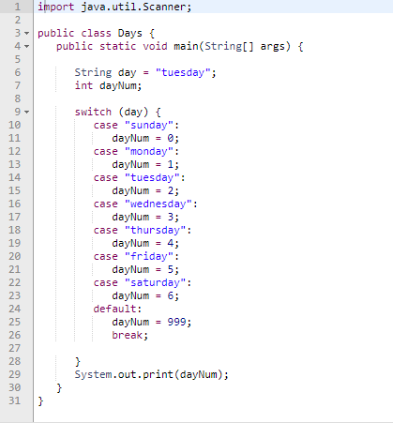

What does the following code output?

A: Compile error on line 23
B: Compile error on line 43
C: 999
D: 2

