TYPES OF USERS

* Employee – Requester
* Employee – Approver

TRAVEL TYPE

1. Domestic
   1. Expatriate Domestic
   2. Local Domestic
   3. Training Domestic
2. Overseas
   1. Foreign Trip
   2. Training Abroad (OTC)

MODE OF TRAVEL WITH THEIR CLASSES

1. Air
   1. Economy
   2. Business
2. Train
   1. AC-I
   2. AC-II
3. Deluxe Bus
4. Self
   1. Bike
   2. Car
5. Other

EXPENSE TYPE

1. Air Ticket
2. Airport Tax
3. Visa Cost
4. Accommodation
5. Car
   1. Self-driven
   2. Taxi
   3. Rental Taxi
6. Communication
   1. Calls
   2. Mobile data
7. Entertainment
8. Gift
9. Daily Allowance
10. Miscellaneous
    1. Books and Periodicals
    2. Cellphone Expenses
    3. Conveyance
    4. Office Maintenance Expenses
    5. Pantry Expenses
    6. Postage and Courier Charge
    7. Printing and Stationery
    8. Staff Welfare

TRAVEL WORKFLOW

1. Travel Details

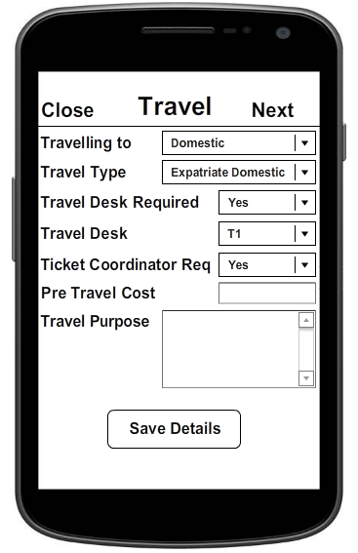

Input fields:

* Travelling to: Domestic or Overseas
* Travel Type: If above field is ‘Domestic’, the list should consist of only the three travel types for domestic travel. Similarly, if the above field is ‘Overseas’, the two relevant options should be listed.
* Travel Desk Req: Whether travel desk is required or the ticket will be self-booked.
* Travel Desk:
* Travel Coordinator Req:
* Pre Travel Cost:
* Travel Purpose: A text area that gives users flexibility to mention the purpose of travel. For example, Business Meet.

Once the button is clicked, the details are saved and the ‘Next’ Button in the title row is set visible.

1. Travel Schedule

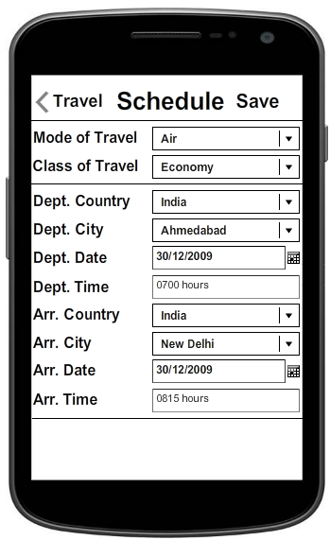

Input fields:

* Mode of Travel: To select the mode of travel from the options mentioned in the previous section.
* Class of Travel: According to the mode of Travel, the possible classes of travel will be enabled.
* Dept. Country
* Dept. City: According to departure country, cities will be part of the drop down.
* Dept. Date
* Dept. Time
* Arr. Country
* Arr. City: According to arrival country, cities will be part of the drop down.
* Arr. Date
* Arr. Time

In case of domestic travel, the Dept. Country should be same as Arr. Country.

As soon as the user clicks on ‘Save’, the following alert is issued:

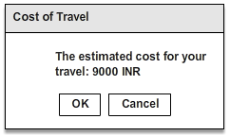

On Click:

OK: The alert box will get closed, the travel information will be saved and the Travel Summary will be displayed.

Cancel: The alert box will get closed and the user can continue editing the Travel Schedule.

The same cost is added to the Trip. This will look as follows:

DATABASE REQUIREMENTS

If you need data to be available offline without internet connectivity then you should you SQLITE database which comes as part of android/ios.

If your app saves the data on server which in turn is used by other portal or other devices (sharing) then consider storing data via web/server and mysql database.

So really it depends on the usage and sharing requirements. Storing data locally has much benefit because it is faster, no network required, data always available, and not using network also increases battery life.

need server component too. Server should expose webservice. Webservice could be of REST/JSON type which are best suited for phones. To give best user experience, you should sync data with server and store locally in SQLITE (in iOS you use core data to use sqlite).

1) Your application get data via a webservice in your server. You can use Soap solution based on XML communication, or simple REST access (simple http request in GET or POST method) and use your own choice: XML or JSON. Today, there is a lot of solution based on REST GET/POST with JSON file communication.

2) After, if you want that your application can turn in offline mode or just be more reactive, you can store old loaded data by webservice in local database. For this, in Android you can use direct access to sqlite database, and in iOs, you can use the CoreData api.

The technologies that provide client-side storage APIs provide facilities to detect the current network connectivity. For example, HTML5 provides a property on the navigator object (navigator.onLine) to indicate whether the client is currently online, and dispatches two events on the Window object to indicate a change of network state (online and offline).

However, these APIs should be used with caution. Even if the browser is reporting an online state, on an intermittent network this is no guarantee that a subsequent connection will succeed. The most effective approach is to fail gracefully in the event of a connection failure, store unsaved data in a queue of uncommitted changes, and set a timer to try again later.

Master Data

* Employee details that get recorded at the time of Sign Up’
* Exchange rates of currencies. Also the city and country.
* Expense type
* HR designation
* Profit Center and Cost Center

For each client

* Travel and Expenses

CALCULATION OF DAILY ALLOWANCE:

The three criteria that determine the daily allowance are:

1. Travelling to:
   1. Domestic
   2. Overseas
2. Staff Grade:
   1. Director on Board
   2. Director
   3. Associate Director
   4. Senior General Manager
   5. General Manager
   6. Dy. General Manager
   7. Assistant General Manager
   8. Sr. Manager
   9. Manager
   10. Dy. Manager
   11. Assistant Manager
   12. Sr. Executive
   13. Executive
   14. Executive VP
3. Travel Type: (as mentioned earlier)

EMPLOYEE DETAILS

The employee details are available in the company’s database present with the HR. It contains the following details:

1. Employee Name
2. Employee ID
3. Company Name
4. Division Name
5. Department Name
6. Profit Center Name
7. Branch Name
8. Staff Grade

These details are needed to be verified by the user at the time of generation of travel or expense requisition. The same will be fetched from the server and can be edited. Once these are saved, the employee can begin the generation of the requisition.

APPROVAL

Two types of approvals can be sent:

1. Travel Requisitions
2. Expense Requisitions

For the Travel Requisitions,

The approval workflow varies for the following cases:

* When approval is needed from more than one person, the following cases will be handled:

1. The first person to approve the requisition can either:
   1. Approve it and then send it further
   2. Just add a comment and send it further
2. The approval is finalized only once the final authority approves it

* When the booking is done in the following possible ways:

1. Using the travel desk: The estimate cost based upon the departure and arrival cities as well as the mode and class of travel is sent for approval.
2. Self-booking:

NON FUNCTIONAL REQUIREMENTS

1. Speed: The time required to perform the various functionalities must be minimized to improve speed.
2. Accuracy: The exchange rates and the calculation of expenses according to the company currency must be accurate.
3. Integrated: The travel and expenses must be integrated. Master data must exist to avoid inconsistencies.
4. User-friendly: The workflow must be defined in a way that the user finds the application simple to use. One activity (single screen with a UI) must be cohesive.
5. Security: Clients' credit card information must stay in a secure data center only – not on the mobile device. As an added precaution after losing a device, the company's mobile administrator may remotely wipe data from device through the User Administration tool.

POLICY DECISION EXAMPLES

* Reject meals above 999 rupees
* Reject hotel rooms above 9999 rupees
* Class of Service for Staff Grade of Director or Director on Board must be set to ‘Business’

RESTRICTIONS IN MOBILE APPS AS COMPARED TO DESKTOP APPLICATIONS

1. A smaller screen results in the following constraints:
   1. Less content can be displayed.
   2. Since the previous content gets scrolled up (or disappears), it is mandatory for the mobile app to have high degree of cohesion and minimum coupling, i.e. each activity must contain actions and data related to a single functionality.
   3. Screen space would also have to be managed in case of long drop down lists. Its inefficiency would worsen user experience.
   4. This also means that the mobile app will be less comprehensive.
   5. Large header information cannot be added.
2. Input is more time consuming in mobile apps compared to that in a desktop.
3. The CPU speed is lower. Since the app does computing of values and loads dynamic drop down lists according to input data, the app has to undergo Stress testing for the same.
4. Similarly, fetching of data is slower on mobile devices, rendering the use of large tables with improper indexing inefficient.
5. Memory occupied by the app has to be kept to a few GBs to be able to cater to the users with low memory size. This makes it more complex to handle data since large tables cannot be used.
6. Database management is a big issue for mobile apps. In case of android, SQLite database and for iOS, Core data api can be used.

To handle data effectively and maximize speed, minimum amount of data should be stored locally.

1. Typing is more error-prone on small screen devices. A way to handle this is to use a review page. For example, once the entries for Sign Up are done, the information can be displayed on a single page for verification. Or before sending the approval out, an alert box can be displayed notifying users to verify details.
2. Hover is not a feature for mobile apps. So possible options to compensate are:
   1. Display all the information on the screen itself (reducing readability)
   2. Display required information based on user action like ’click’ or ‘long click’
3. Added security will be needed (as mentioned in section Non Functional Requirements).
4. Connectivity is a bigger issue for mobiles. So it is necessary to support offline browsing. This way the user can fill in details and save it on their own device when offline- that can be uploaded once connection to a network is established.

ADVANTAGES OF MOBILE APPS AS COMPARED TO DESKTOP APPLICATIONS

1. Mobile is an active mode of communication. Notifications can be issued for quick response.

OPTIONS FOR BOOKING TRAVEL

1. Provide link for the various airlines, deluxe bus or the Indian railway reservation portal
   1. This reduces app overhead- the booking module need not be developed.
   2. But a separate workflow has to be created to get the details about the ticket reserved to manage travel.
2. Directly provide forms via which preferences for booking travel are identified and booking is complete
   1. A major advantage is that this way the cycle time is reduced since data can directly be fetched from the selected airline or train ticket.
   2. But, separate booking modules would need to be developed for the various modes of travel.

FUNCTIONAL REQUIREMENTS

PAGE ONE: SIGN UP

Details required (compulsorily):

* Employee Name
* Employee ID
* Company Name
* Division Name
* Department Name
* Profit Center Name
* Branch Name
* Staff Grade

Button: “Submit Button”

1. If user enters all the details and they are verified to be compatible\* and unique (not same as existing user):

Toast: “Profile successfully created”

Alert Dialogue Box: “Your application PIN is XYZ123”

Redirected to PAGE THREE

1. If user does not enter one or more details:

Alert Dialogue Box: “All fields are to be filled compulsorily”

1. If user already exists:

Alert Dialogue Box: “User already exists. Please Sign In.”

PAGE TWO: SIGN IN

The ways by which user can sign in:

* Company Email ID
* Employee Number

Clickable Text:

* Forgot Employee Number?
* Forgot Email ID?
* Forgot Password?

Button: “Continue”

Test Cases (on button click):

1. If user enters one of the fields and it gets authorized successfully:

Redirected to PAGE THREE

1. If user enters incorrect Sign In field:

“Incorrect information. Please try again”

PAGE THREE: PASSWORD

Clickable Text: “Forgot Password?”

Button: “Submit Button”

Text Cases (on button click):

1. If user enters correct Password:

Redirected to PAGE FOUR

1. If user enters incorrect Password (less than four tries):

Alert Dialogue Box: “Incorrect Password. Please try again”

1. If user enters incorrect Password for the fourth time:

Alert Dialogue Box: “Please try after 30 seconds”

Action: Password entering field disabled for 30 seconds

1. If user tries to enter Password within 30 seconds:

Alert Dialogue Box: “Please try after X seconds”

PAGE FOUR: MENU

1. Title
2. Buttons:

* Trips
  + Active (Number)
  + Upcoming (Number)
* Expenses
* Expense Reports
* Approvals
  + Pending

1. Options menu:

* Book
* Receipt
* Expense

TRAVEL

1. Request:

* Request Name
* Purpose

1. Options:
   * Attachments
   * Print/Email
   * Cancel Request
   * Submit Request
2. Status:

* To be approved before DD/MM/YYYY

1. Amount:

* *123*

EXPENSES

1. Add Expense

* Book Hotel
  + Name
  + City
  + Date of check in
  + Time of check in
  + Date of check out
* Book Car (Rental/Taxi)
  + City
* Book Rail
  + Name
  + Time of Departure
  + City of Departure
  + Time of Arrival
  + City of Arrival
  + Class
* Food
  + City
  + Restaurant
  + Time