Azrieli College of Engineering Jerusalem
Department of Industrial Engineering and Management
Final Project – Knowledge Discovery and Machine Learning

AutoGuard AI
Machine Learning System for Insurance Claim Risk Prediction

Submitted by: [Student Name] – [Student ID]
Submitted to: Dr. Roni Horowitz
Date: August 17, 2026

Table of Contents
1. Introduction 4
2. Dataset and Problem Definition 4
2.1 Dataset Overview 4
2.2 Target Variable 4
2.3 Selected Features 4
3. Data Preparation and Exploratory Data Analysis 4
3.1 Data Quality Checks 4
3.2 Exploratory Data Analysis 5
3.3 Key Insights from EDA 5
4. Model Development and Comparison 5
4.1 Baseline Model 5
4.2 Logistic Regression 5
4.3 Random Forest 5
4.4 Neural Network A 5
4.5 Neural Network B 5
4.6 Neural Network C 5
4.7 Validation Comparison 6
5. Final Model and Results 6
5.1 Final Model Selection 6
5.2 Threshold Selection 6
5.3 Test Performance 6
5.4 Feature Importance 7
5.5 Error Analysis 8
6. Business Value and ROI 8
6.1 Business Interpretation 8
6.2 ROI Summary 8
7. System Interfaces 8
7.1 Gradio Interface 9
7.2 Production Web Interface 9
8. Conclusion 9
9. Appendices 10
Appendix A — Additional ML Figures 10
Appendix B — Gradio Interface Screenshots 12
Appendix C — Production Interface Screenshots 14
Appendix D — Economic Model Outputs 16
1. Introduction
Manual review of every insurance application does not scale and introduces reviewer-to-reviewer inconsistency. AutoGuard AI addresses this by learning to estimate the probability that a policyholder will file a claim, so low-risk applications can be processed automatically while higher-risk applications are routed to human review. This report summarizes the complete, reproducible pipeline behind the production model, from the source dataset through model comparison, threshold selection, and the business case for deployment. This is decision support, not automated adjudication: significant underwriting consequences still require human review.

2. Dataset and Problem Definition

2.1 Dataset Overview
The project uses a single authoritative dataset, `02_Data/Car_Insurance_Claim_50000_FINAL.csv`, containing 50,000 policyholder records with 19 raw columns. Two numeric columns have modest missingness (CREDIT_SCORE and ANNUAL_MILEAGE, each under 10%), handled by median imputation; there are no full-row duplicates once the identifier column is excluded.

2.2 Target Variable
The target is OUTCOME, a binary indicator (1 = the policyholder filed a claim, 0 = they did not). It is imbalanced — roughly three in ten policyholders filed a claim — so every model in this report is judged on Accuracy, Precision, Recall, F1, and ROC-AUC together, not Accuracy alone.
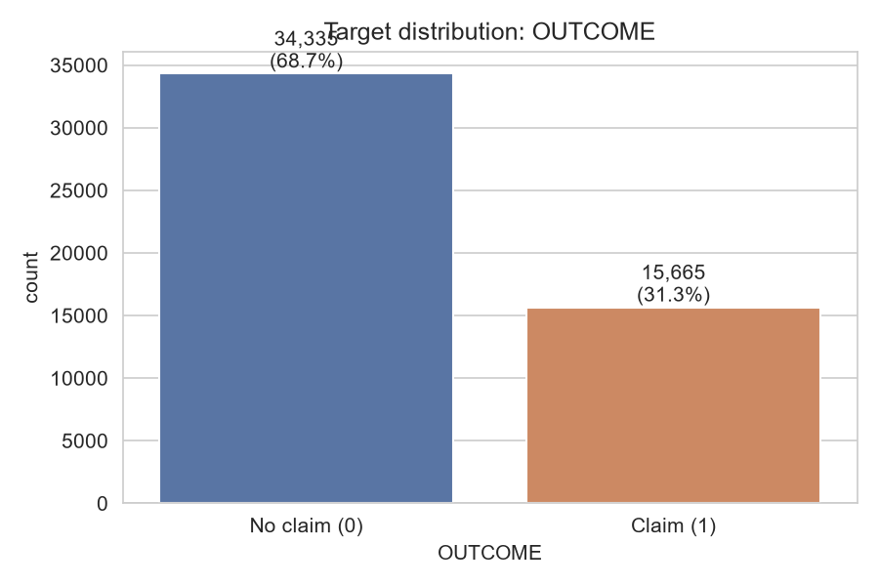
Figure 1. Distribution of the target variable, OUTCOME.

2.3 Selected Features
The final feature set is the behavioral and vehicle attributes with the clearest, most business-plausible relationship to OUTCOME, all already collected on the production intake form:
- AGE
- DRIVING_EXPERIENCE
- PAST_ACCIDENTS
- SPEEDING_VIOLATIONS
- DUIS
- ANNUAL_MILEAGE
- VEHICLE_OWNERSHIP
- VEHICLE_YEAR
Excluded: identifiers (ID, POSTAL_CODE — the latter also a geographic proxy for protected characteristics); demographic/protected attributes (GENDER, RACE, MARRIED, CHILDREN), on fairness grounds; EDUCATION, INCOME, and CREDIT_SCORE, as coarse or partially missing proxies that overlap with protected attributes; and VEHICLE_TYPE, since over 95% of records share one value.

3. Data Preparation and Exploratory Data Analysis

3.1 Data Quality Checks
Missing values, duplicate rows, and dtype consistency were verified directly from the dataset. The Train / Validation / Test split uses a stratified, content-fingerprint-grouped method: rows with identical attribute content are grouped before splitting so no such row can appear in more than one partition. All preprocessing (encoding, imputation, scaling) is fit on Train only.
Partition | Rows
Train | 31,999
Validation | 8,000
Test | 10,001
Total | 50,000

3.2 Exploratory Data Analysis
Claim rate falls sharply as age and driving experience rise, is higher for drivers who do not own their vehicle, and is higher for older vehicles — four strong, business-plausible signals that anchor the final feature set.
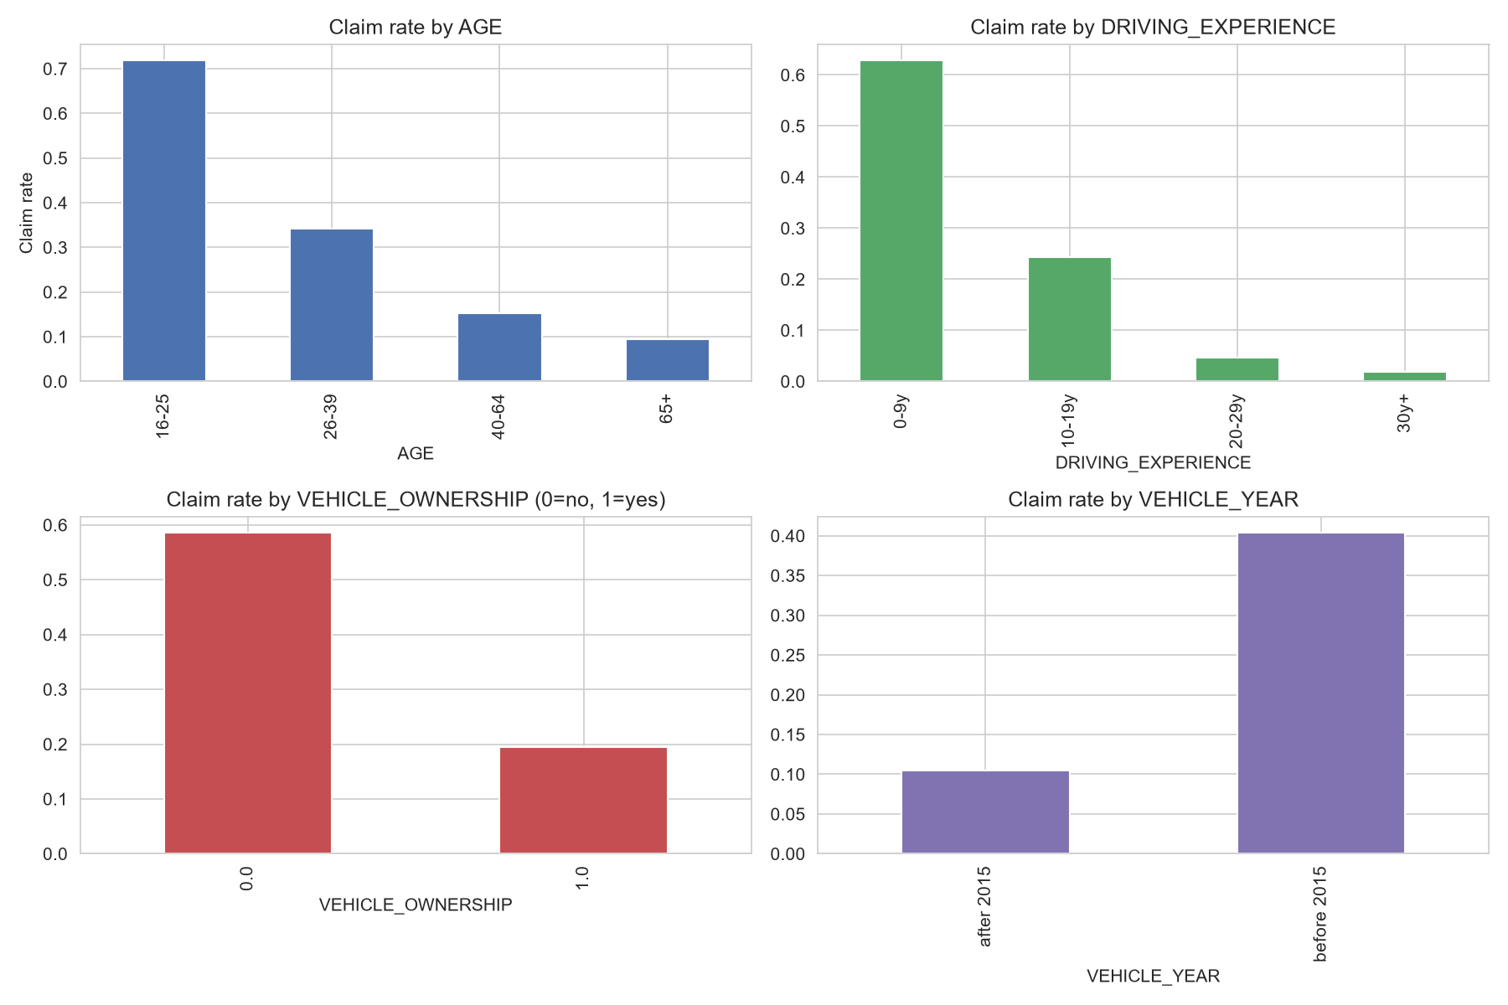
Figure 2. Claim rate against four of the selected features.

3.3 Key Insights from EDA
Correlation analysis shows PAST_ACCIDENTS, DUIS, and SPEEDING_VIOLATIONS correlating most positively with OUTCOME and VEHICLE_OWNERSHIP correlating negatively, with no strongly collinear predictor pairs. Additional distribution, correlation, and ROC-curve figures are provided in Appendix A.

4. Model Development and Comparison
Six candidates were trained on Train and evaluated on Validation with an identical metric set. Each is summarized below; the full comparison follows in Section 4.7.

4.1 Baseline Model
A majority-class DummyClassifier, establishing the floor any real model must beat. Accuracy 0.6866, F1 0.0000, ROC-AUC 0.5000.

4.2 Logistic Regression
A linear model fit on the preprocessed features. Accuracy 0.8273, F1 0.7346, ROC-AUC 0.8932.

4.3 Random Forest
An ensemble of 300 decision trees. Accuracy 0.8549, F1 0.7786, ROC-AUC 0.9324.

4.4 Neural Network A
A PyTorch network: Dense(64) → ReLU → Output. Accuracy 0.8304, F1 0.7423, ROC-AUC 0.8960.

4.5 Neural Network B
A deeper PyTorch network: Dense(128) → ReLU → Dense(64) → ReLU → Output. Accuracy 0.8294, F1 0.7432, ROC-AUC 0.9025.

4.6 Neural Network C
A regularized PyTorch network: Dense(128) → LeakyReLU → Dropout(0.30) → Dense(64) → LeakyReLU → Dropout(0.30) → Output, demonstrating a documented Dropout architecture. Accuracy 0.8304, F1 0.7477, ROC-AUC 0.8979.

4.7 Validation Comparison
Model | Accuracy | Precision | Recall | F1 | ROC-AUC | PR-AUC
Random Forest | 0.8549 | 0.7460 | 0.8141 | 0.7786 | 0.9324 | 0.8524
Neural Network B (128-64, ReLU) | 0.8294 | 0.7033 | 0.7878 | 0.7432 | 0.9025 | 0.8060
Neural Network C (128-64, LeakyReLU, Dropout 0.30) | 0.8304 | 0.7002 | 0.8022 | 0.7477 | 0.8979 | 0.8004
Neural Network A (64, ReLU) | 0.8304 | 0.7085 | 0.7794 | 0.7423 | 0.8960 | 0.7975
Logistic Regression | 0.8273 | 0.7083 | 0.7631 | 0.7346 | 0.8932 | 0.7899
Baseline | 0.6866 | 0.0000 | 0.0000 | 0.0000 | 0.5000 | 0.3134
Table 1. Validation-set performance for all six candidates, sorted by ROC-AUC.
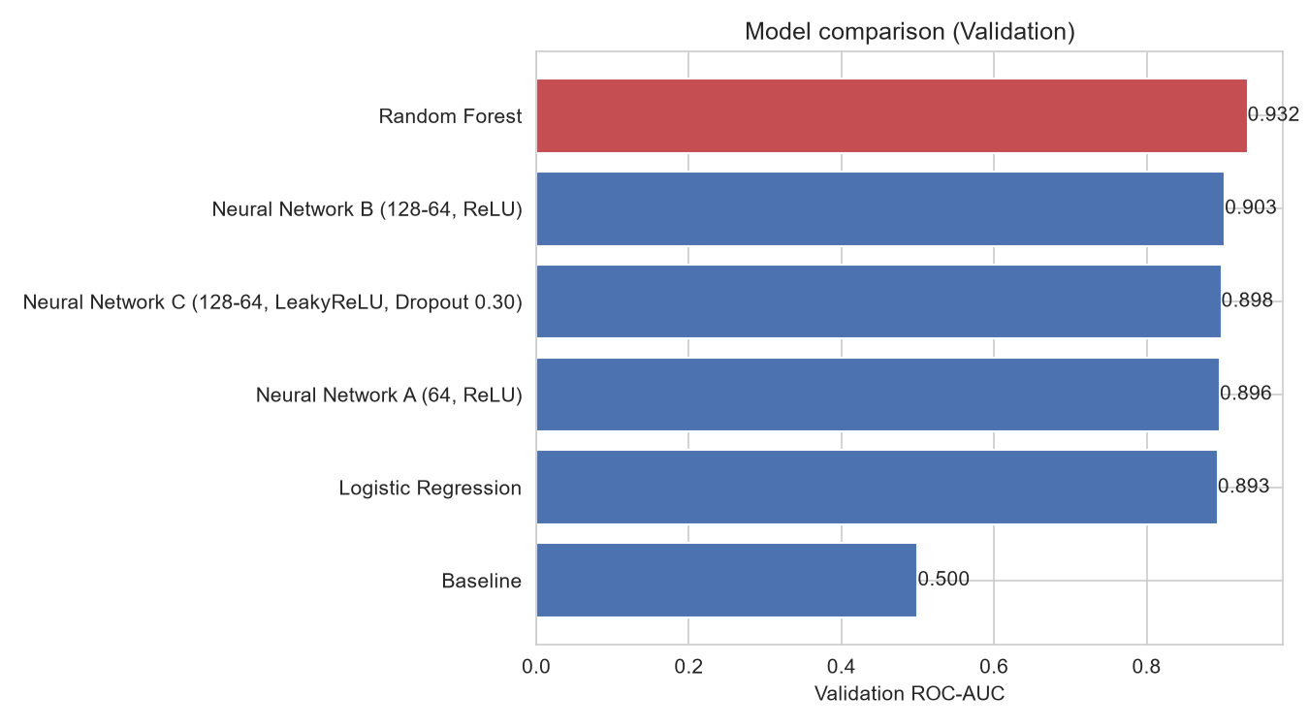
Figure 3. Validation ROC-AUC by model.
Random Forest achieved the strongest discrimination performance among all six candidates and was therefore selected as the final model (Section 5.1).

5. Final Model and Results

5.1 Final Model Selection
Selection rule: Highest Validation ROC-AUC; F1 breaks ties. Selected once, before Test is touched. Random Forest achieved the highest Validation ROC-AUC (0.9324) and was selected. It was then refit on Train plus Validation combined before the single Test evaluation in Section 5.3.

5.2 Threshold Selection
This is a statistical decision threshold, selected on Validation for classification performance: the notebook sweeps candidate thresholds from 0.05 to 0.95 and measures Precision, Recall, and F1 at each one. The threshold that maximizes Validation F1 — 0.35 — is the ML threshold, used for the Test evaluation below. It answers a purely statistical question, independent of any dollar figures. A separate business/economic operating threshold, used for the production routing decision, is derived independently in Section 6.1.
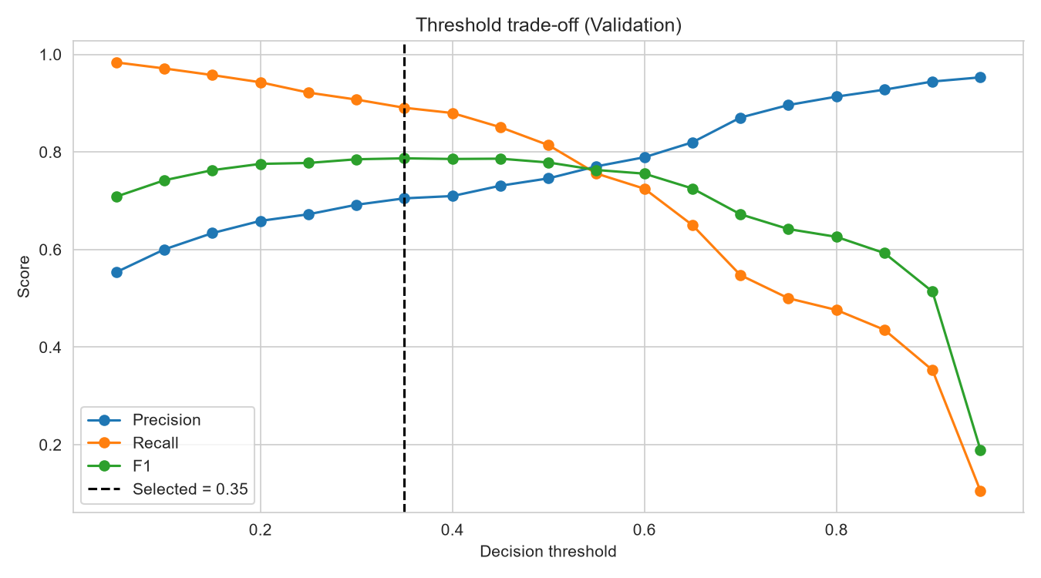
Figure 4. Precision/Recall/F1 vs. threshold on Validation; the dashed line marks the selected ML threshold (0.35).

5.3 Test Performance
The Test partition (10,001 records) was used for nothing until this point. It is scored exactly once, with Random Forest refit on Train + Validation, at the ML threshold (0.35).
Metric | Test result
Accuracy | 0.8546
Precision | 0.7131
Recall | 0.8966
F1 | 0.7944
ROC-AUC | 0.9350
PR-AUC | 0.8562
Table 2. Final Test-set results, Random Forest, ML threshold = 0.35.
 | Predicted: No claim | Predicted: Claim
Actual: No claim | 5738 | 1130
Actual: Claim | 324 | 2809
Table 3. Test confusion matrix at ML threshold 0.35 (n = 10,001).
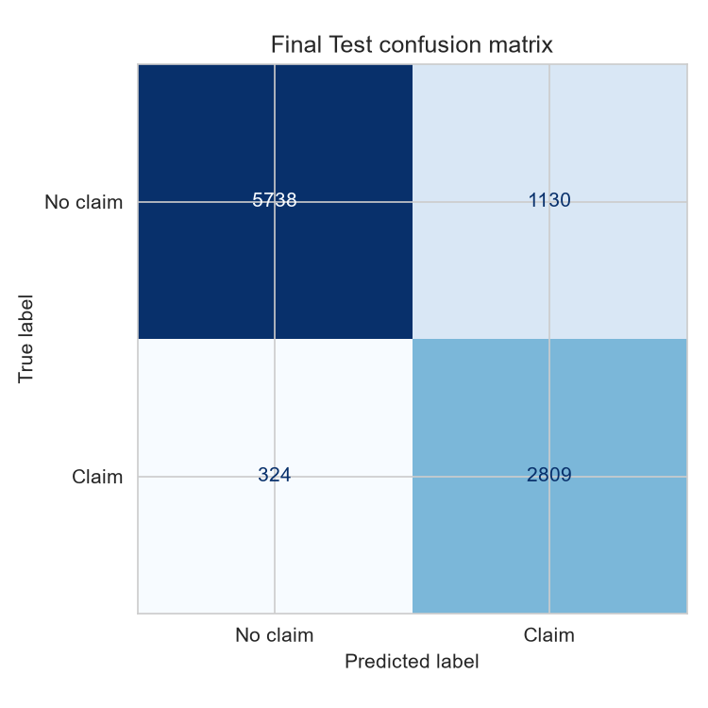
Figure 5. Test confusion matrix, threshold = 0.35.
1,000 bootstrap resamples of Test give a 95% confidence interval around each headline metric:
Metric | 95% CI lower | 95% CI upper
Accuracy | 0.8476 | 0.8616
Precision | 0.6988 | 0.7271
Recall | 0.8868 | 0.9077
F1 | 0.7845 | 0.8054
ROC-AUC | 0.9304 | 0.9394
PR-AUC | 0.8450 | 0.8682
Table 4. 95% bootstrap confidence intervals, Test set, 1,000 resamples.

5.4 Feature Importance
Permutation importance, computed on the final fitted pipeline against Test, measures the mean drop in ROC-AUC when a feature's values are shuffled. DRIVING_EXPERIENCE is the most influential feature, followed by VEHICLE_OWNERSHIP and VEHICLE_YEAR — consistent with how underwriters already reason about risk. This is an association measured on held-out data, not a causal claim.
Feature | Mean ROC-AUC drop
DRIVING_EXPERIENCE | 0.1303
VEHICLE_OWNERSHIP | 0.0799
VEHICLE_YEAR | 0.0705
ANNUAL_MILEAGE | 0.0613
SPEEDING_VIOLATIONS | 0.0590
AGE | 0.0543
PAST_ACCIDENTS | 0.0448
DUIS | 0.0212
Table 5. Permutation feature importance, sorted by impact.
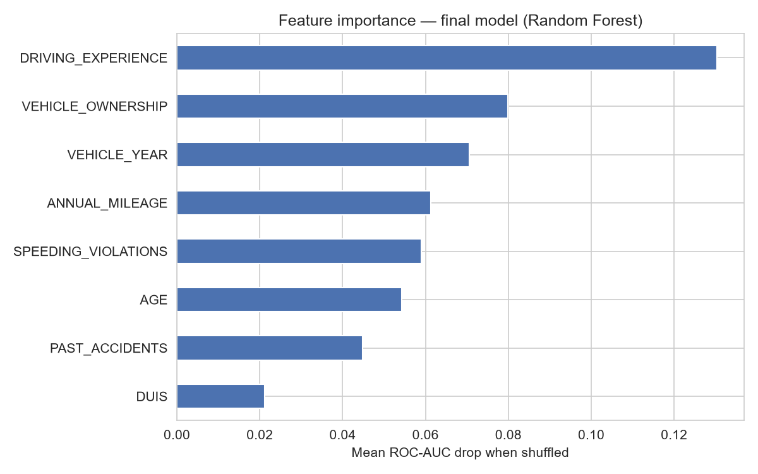
Figure 6. Permutation feature importance.

5.5 Error Analysis
At the ML threshold (0.35), the model produced 1,130 False Positives (low-risk drivers flagged unnecessarily) and 324 False Negatives (claimants missed) out of 10,001 Test records. A False Negative is typically the more expensive mistake for an insurer — an unpriced claim payout — while a False Positive costs only extra review time. This is why the business threshold (Section 6.1) is set lower than the ML threshold.

6. Business Value and ROI

6.1 Business Interpretation
This is a business/economic operating threshold, reflecting an operational decision policy rather than a statistical one: the economic model sweeps the same Validation probabilities through a cost model and picks the threshold maximizing expected annual net benefit in dollars, not F1 — 0.1. This is the threshold actually enforced in production. It is deliberately lower than the ML threshold (0.35, Section 5.2): because a missed claimant costs far more than an unnecessary review, the economically optimal policy accepts more False Positives for fewer False Negatives. At 0.1 the model produces 73 False Negatives on Test versus 324 at 0.35, at the cost of 1984 vs. 1130 False Positives routed to review. In summary: the statistical decision threshold (Section 5.2) and the business operating threshold (this section) answer different questions and are both reported explicitly so neither is mistaken for the other.
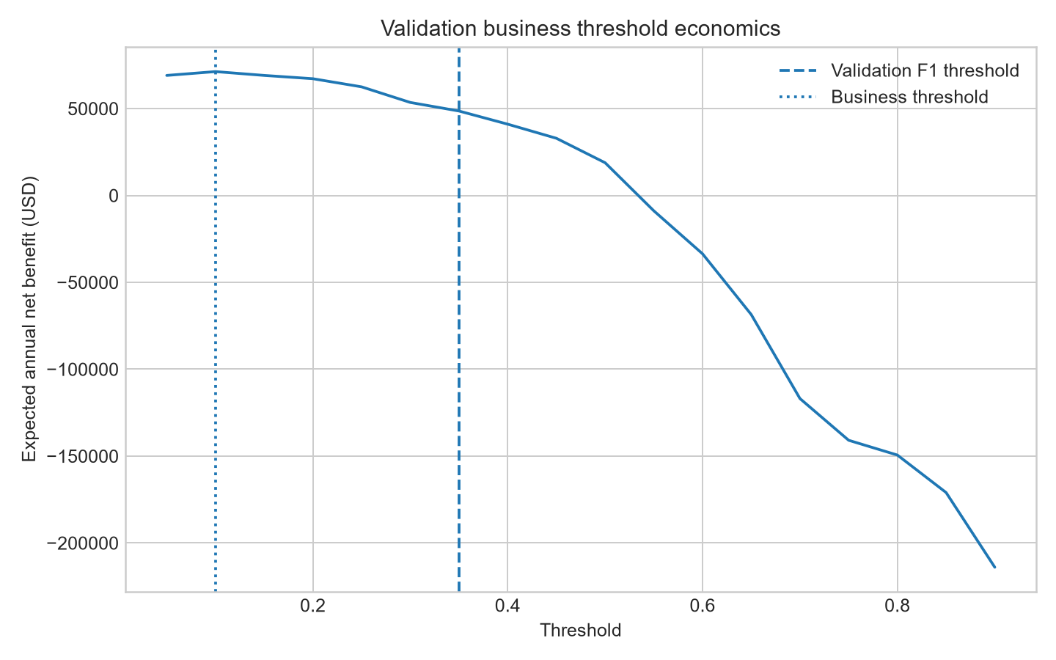
Figure 7. Expected annual net benefit vs. threshold, with both the ML threshold (0.35) and the business threshold (0.1) marked.

6.2 ROI Summary
The economic model is a transparent scenario model, not proprietary insurer financial data. It selects the business threshold on Validation only, maximizing expected annual net benefit under three scenarios, then evaluates the frozen threshold once on Test.
Scenario | Annual applications | Year-1 ROI | Recurring ROI | Payback (months) | Annual net benefit
Conservative | 8,000 | -75.16% | 17.52% | 48.3 | $19,873
Expected | 12,000 | 18.80% | 65.56% | 10.1 | $71,277
Optimistic | 18,000 | 180.30% | 110.78% | 4.3 | $126,135
Table 6. ROI by scenario, business threshold = 0.1.
Under Expected-scenario assumptions (12,000 annual applications, $60,000 implementation cost, $18,000/year maintenance), automation reaches 49.21% of applications for a projected Year-1 ROI of 18.80% and payback in 10.1 months. Evaluated once on the untouched Test set, the observed Year-1 ROI is 6.88% — lower than the Expected projection because Test applies Expected-scenario cost assumptions to the actually observed confusion matrix rather than the Validation-derived rates the scenario table projects forward. These are scenario estimates, not promised savings.
Supporting ROI visuals (tornado sensitivity, manual-review reduction) are provided in Appendix D.

7. System Interfaces
The same artifact, `01_ML_Model/model_v2.pkl`, is the single source of truth for every serving surface — no separate model is trained for demo versus production use.

7.1 Gradio Interface
A standalone, inference-only demonstration interface (`05_Gradio_Interface/gradio_app.py`) that loads the pipeline via joblib and never calls .fit() on anything. It displays the model's headline metrics read directly from `model_v2_metadata.json`.
See Appendix B for Gradio interface screenshots.

7.2 Production Web Interface
A FastAPI backend (`06_Production_Interface/backend/`) exposing `/api/v2/quick-predict` and `/api/v2/health`, combined with a web frontend. The service integrates a live vehicle-registry lookup and applies the Section 6.1 business policy to produce an operational recommendation alongside the raw claim probability.
See Appendix C for production web interface screenshots.

8. Conclusion
AutoGuard AI's production model is Random Forest, selected on Validation ROC-AUC among six candidates including a documented baseline and three PyTorch architectures. It reaches a final, one-time Test ROC-AUC of 0.9350 (95% CI [0.9304, 0.9394]) at its statistically selected ML threshold of 0.35. In production, a separately derived, ROI-optimized business threshold of 0.1 governs the actual automate-vs-review decision, projected to deliver a positive Year-1 ROI with sub-year payback under Expected-case assumptions. Every number in this report traces back to the notebook's own artifacts and can be reproduced by re-running `01_ML_Model/AutoGuard_AI_Final_ML_Pipeline.ipynb` end to end.

9. Appendices
Supporting figures and interface screenshots referenced from the main body are collected here, grouped by topic.

Appendix A — Additional ML Figures
← Back to Section 3.3 (Key Insights from EDA)
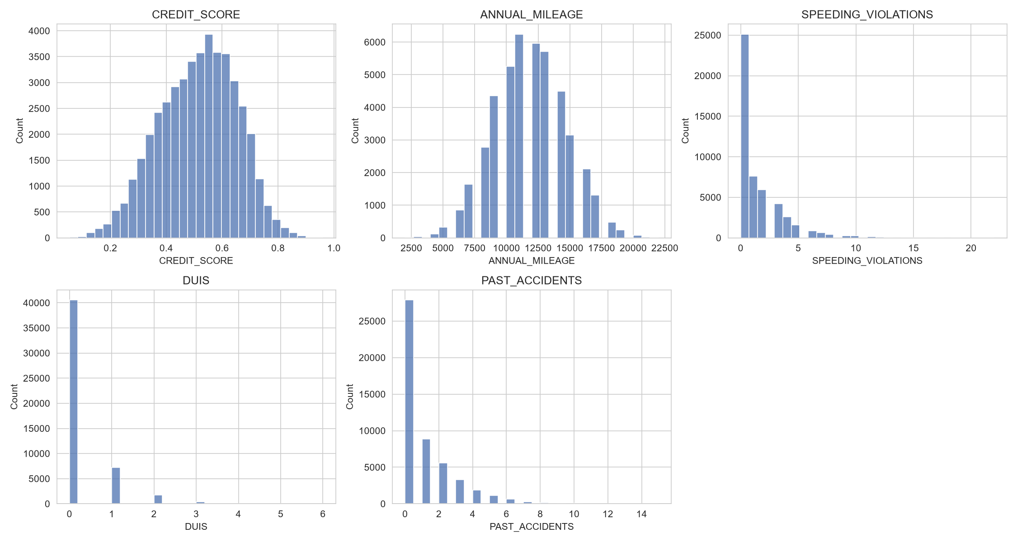
Figure A1. Distributions of key numeric features.
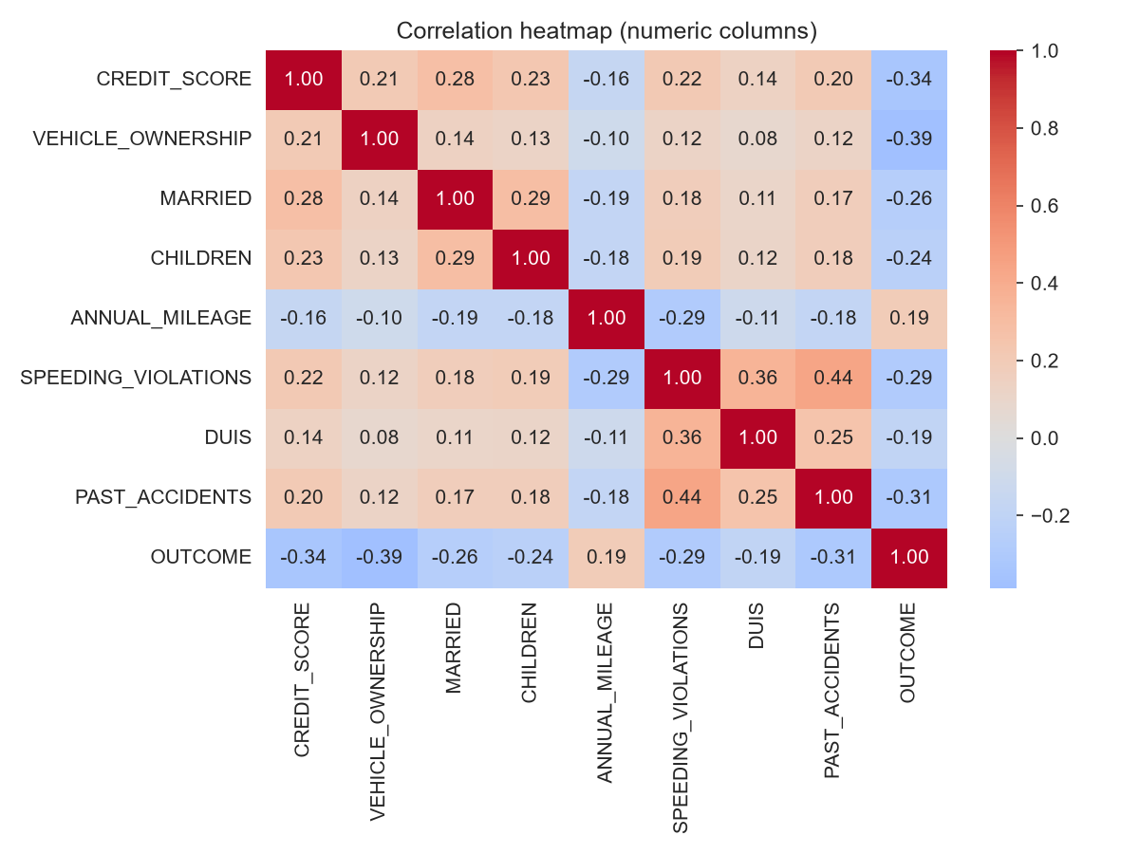
Figure A2. Correlation heatmap of numeric columns, including OUTCOME.
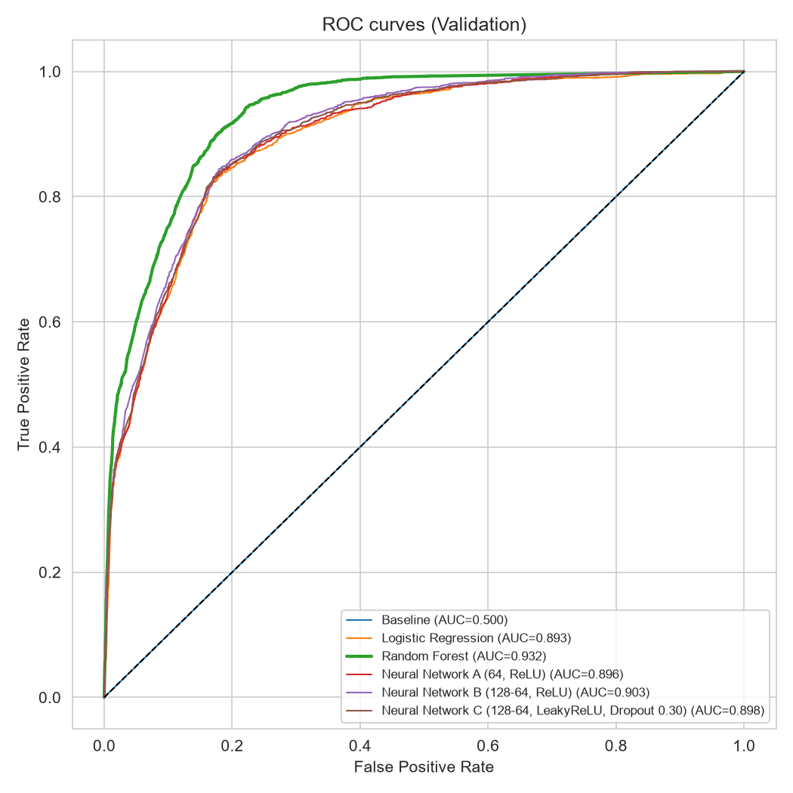
Figure A3. ROC curves for all six candidates on Validation.
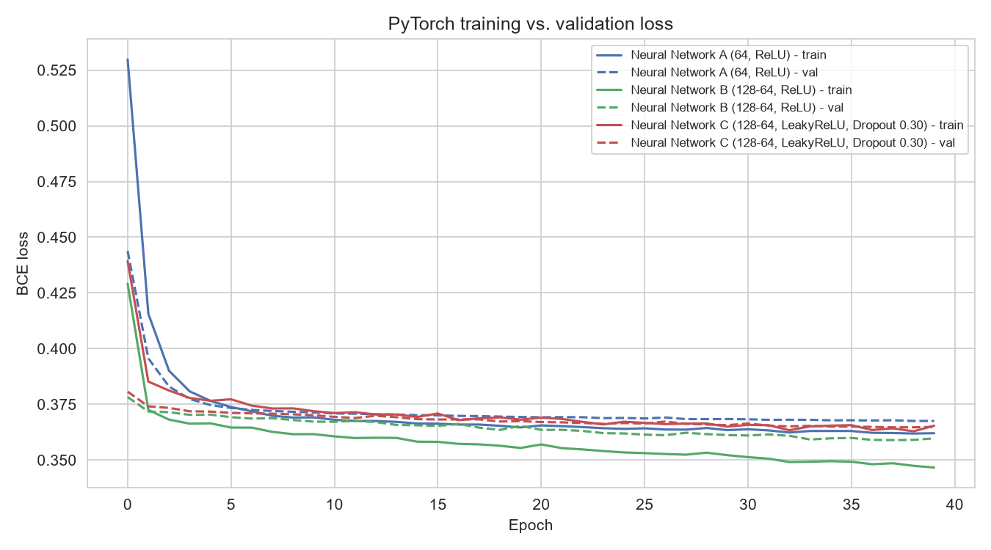
Figure A4. Training vs. validation loss for the three PyTorch networks (Sections 4.4–4.6).

Appendix B — Gradio Interface Screenshots
← Back to Section 7.1 (Gradio Interface)
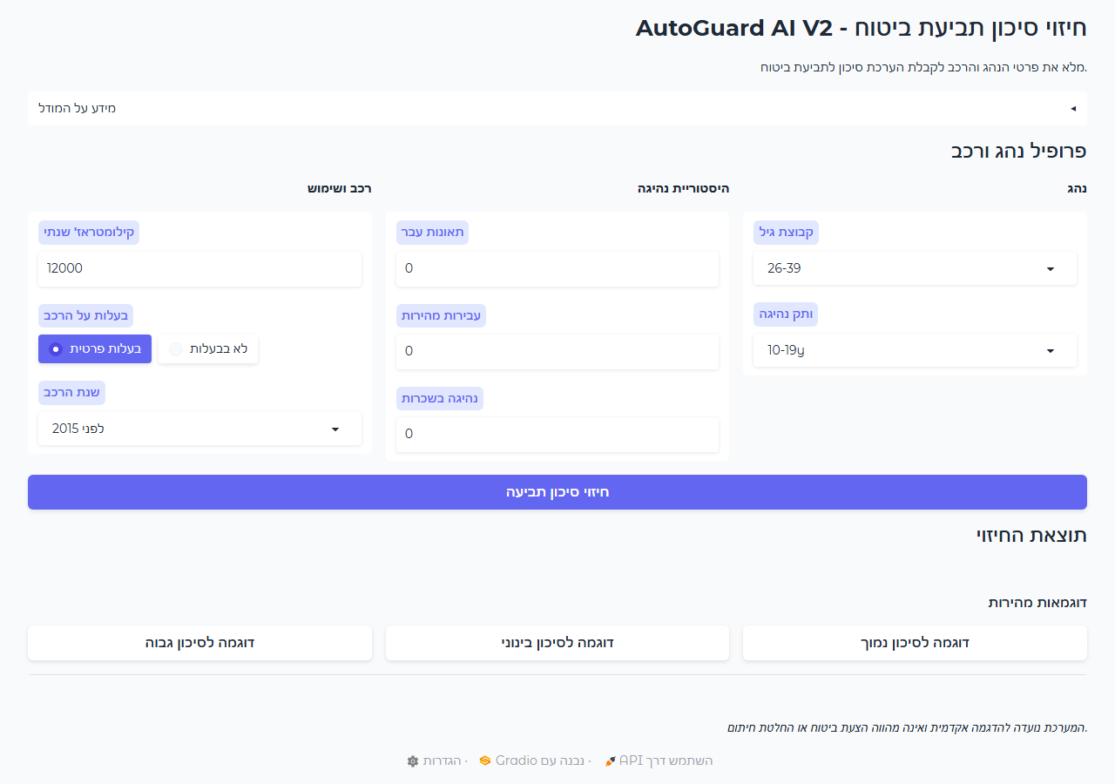
Figure B1. Gradio interface — driver and vehicle profile input form.
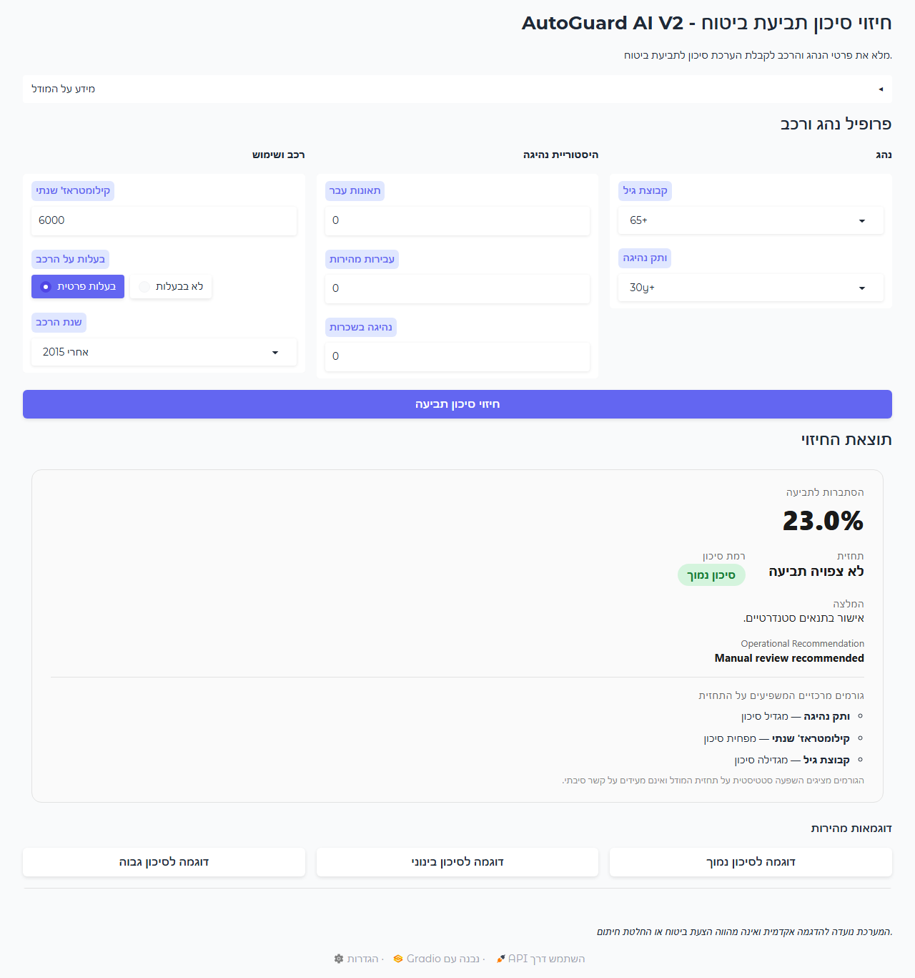
Figure B2. Gradio prediction output — low-risk example (23.0% claim probability).
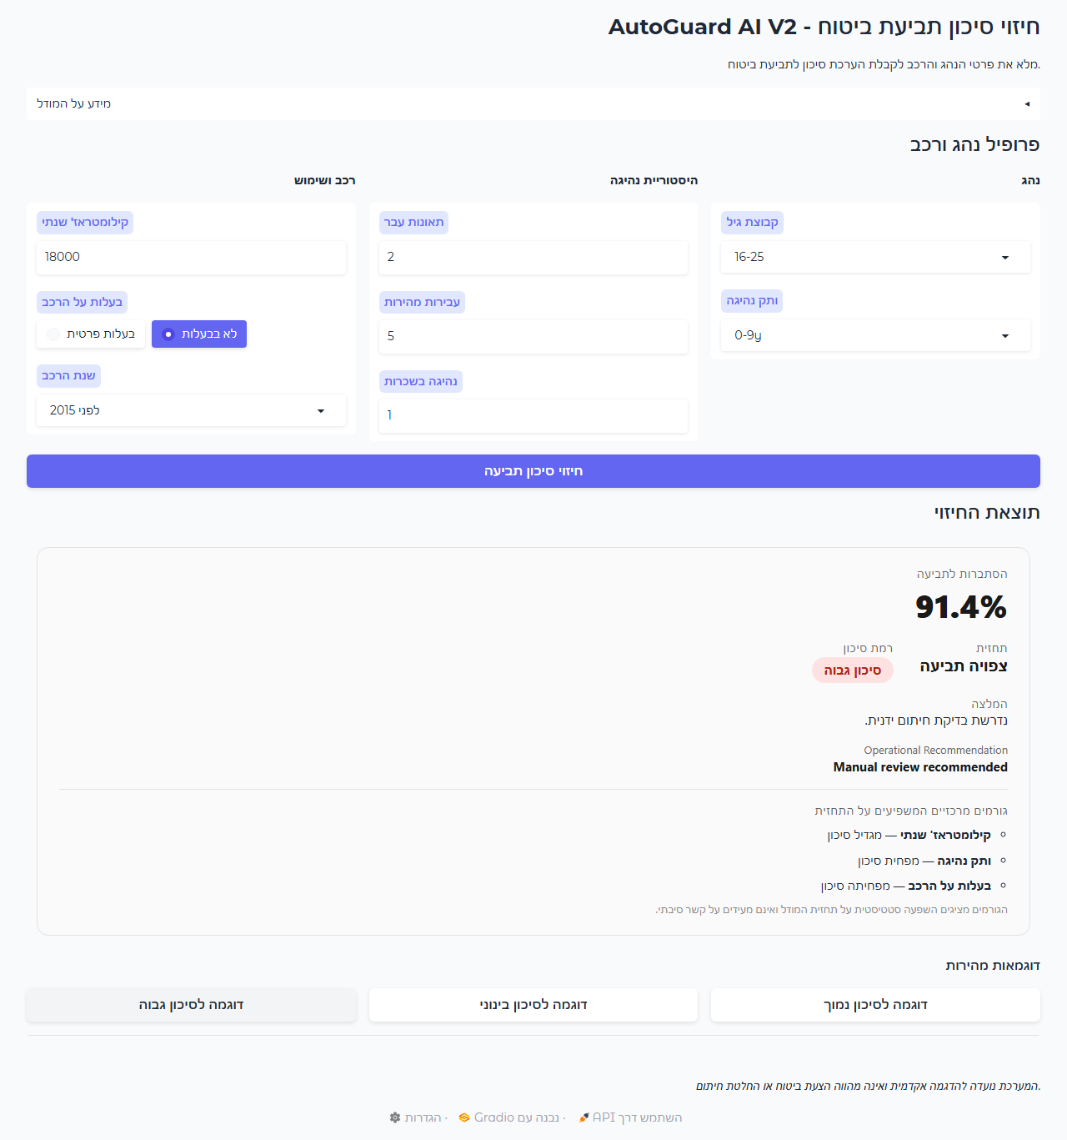
Figure B3. Gradio prediction output — high-risk example (91.4% claim probability).

Appendix C — Production Interface Screenshots
← Back to Section 7.2 (Production Web Interface)

Figure C1. Production interface — landing page.

Figure C2. Production interface — quick-prediction input form.
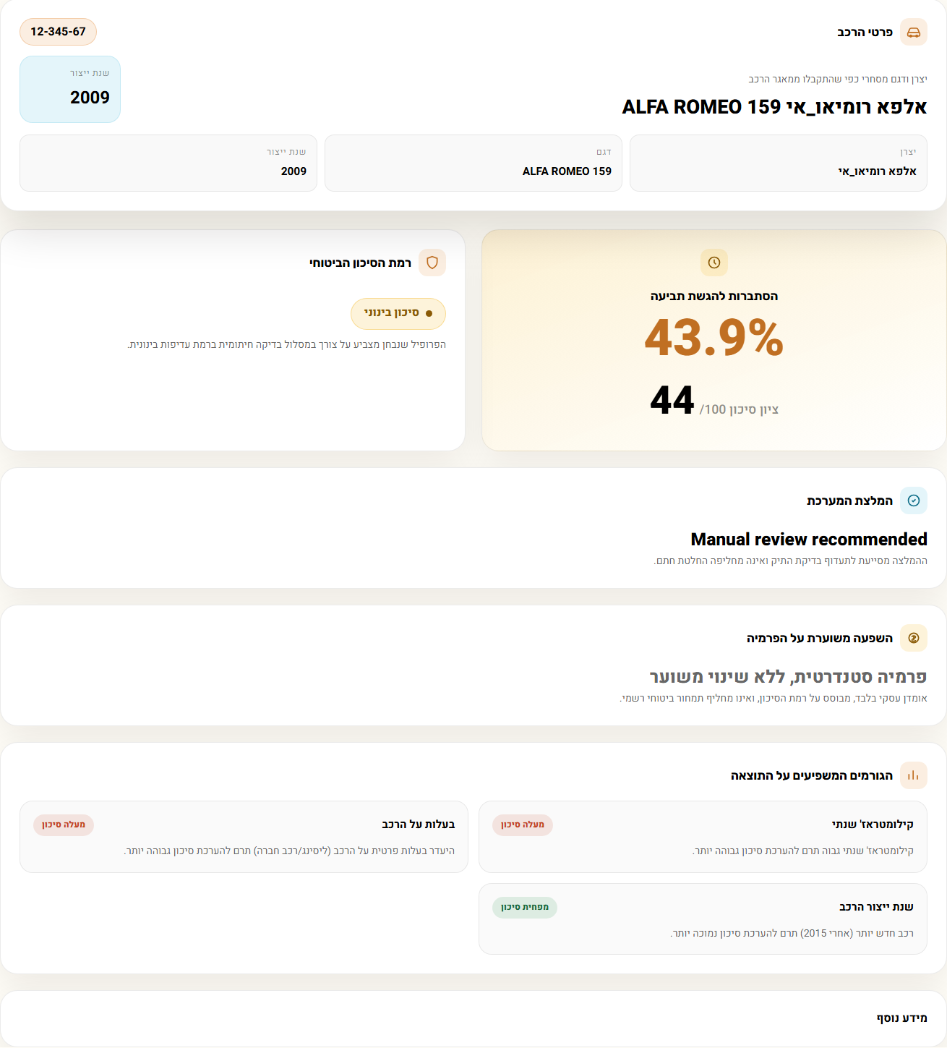
Figure C3. Production interface — risk assessment result panel.

Appendix D — Economic Model Outputs
← Back to Section 6.2 (ROI Summary)
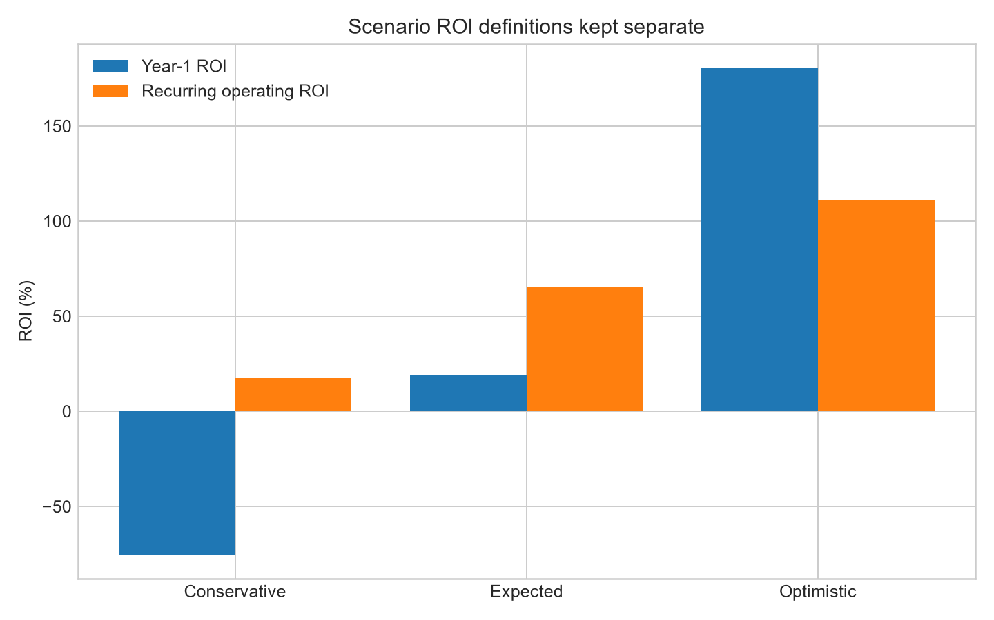
Figure D1. Year-1 vs. recurring-operating ROI by scenario.
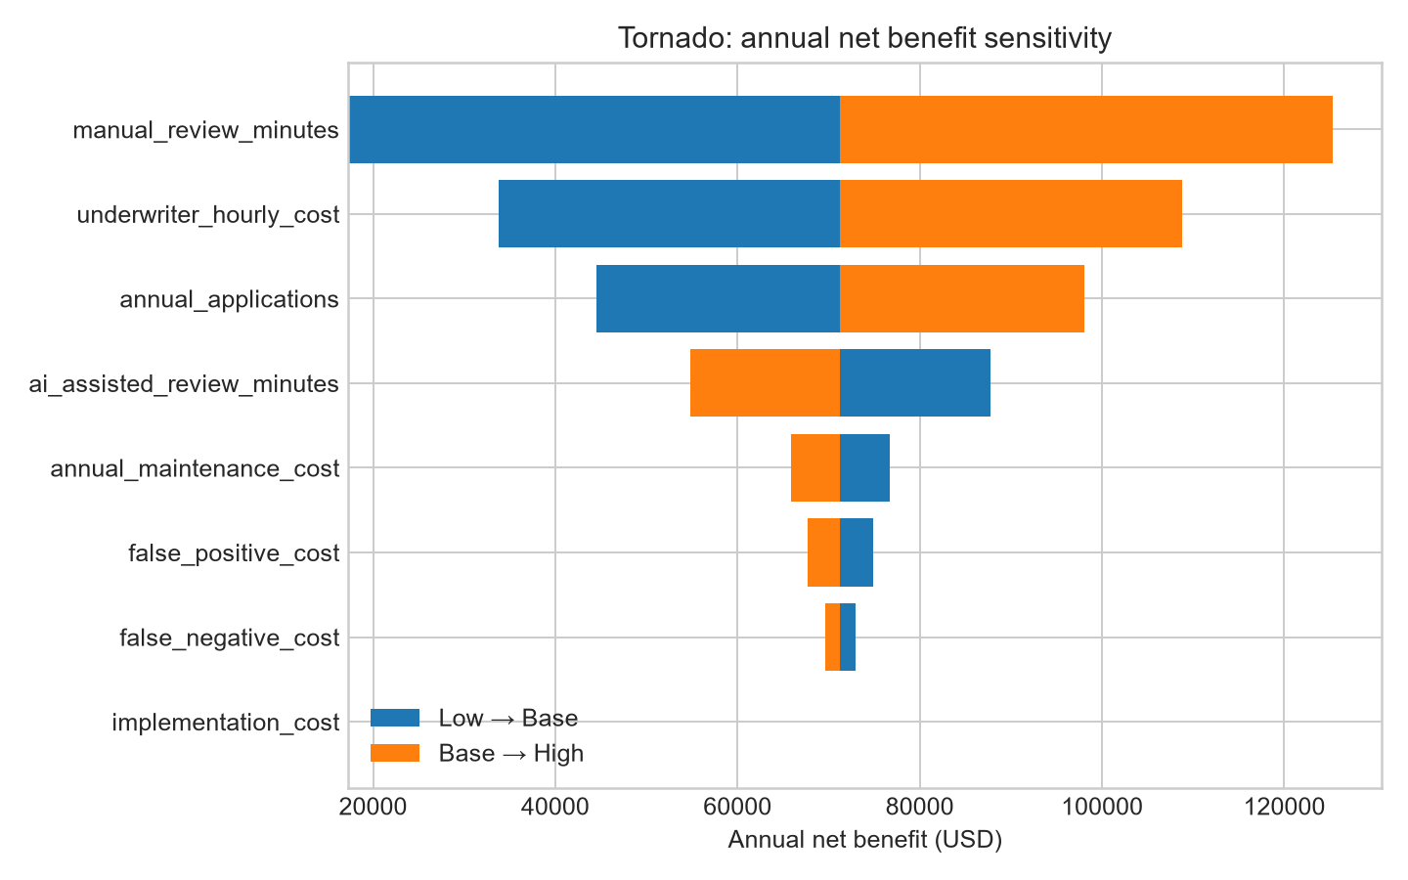
Figure D2. Sensitivity of annual net benefit to each cost assumption (±30%).
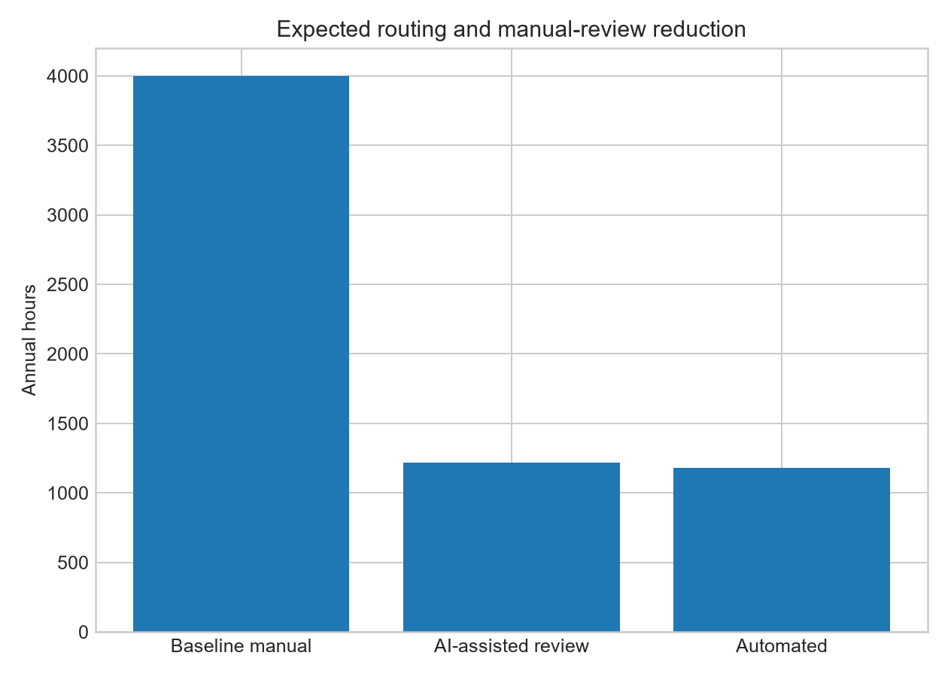
Figure D3. Expected routing and manual-review-hour reduction.

