Azrieli College of Engineering Jerusalem
Department of Industrial Engineering and Management — Final Project, Knowledge Discovery and Machine Learning
AutoGuard AI
Machine Learning System for Insurance Claim Risk Prediction
Submitted by: Noam Eitam · Shirel Nir · Abanau (Nati) Workneh · Avishai Goss · Oz Ofir
Submitted to: Dr. Roni Horowitz | Date: August 17, 2026

1. Introduction
Manual review of every insurance application does not scale and introduces reviewer-to-reviewer inconsistency. AutoGuard AI addresses this by learning to estimate the probability that a policyholder will file a claim, so low-risk applications can be processed automatically while higher-risk applications are routed to human review. This report summarizes the complete, reproducible pipeline behind the production model — from the source dataset through model comparison, threshold selection, and the business case for deployment. This is decision support, not automated adjudication: significant underwriting consequences still require human review.

2. Dataset and Problem Definition
The project uses a single authoritative dataset, Car_Insurance_Claim_50000_FINAL.csv, containing 50,000 policyholder records with 19 raw columns. CREDIT_SCORE and ANNUAL_MILEAGE have modest missingness (each under 10%), handled by median imputation; ID values are unique with no fully duplicated rows; 155 rows share an identical feature profile under a different unique ID and are retained as distinct records.
Target variable: OUTCOME — binary (1 = claim filed, 0 = not filed), imbalanced (~30% positive), so every model is judged on Accuracy, Precision, Recall, F1 and ROC-AUC together, not Accuracy alone.
Selected features (all already collected on the production intake form): AGE, DRIVING_EXPERIENCE, PAST_ACCIDENTS, SPEEDING_VIOLATIONS, DUIS, ANNUAL_MILEAGE, VEHICLE_OWNERSHIP, VEHICLE_YEAR. Excluded: identifiers (ID, POSTAL_CODE — a geographic proxy for protected characteristics); demographic/protected attributes (GENDER, RACE, MARRIED, CHILDREN) on fairness grounds; EDUCATION, INCOME and CREDIT_SCORE as coarse or partially-missing proxies overlapping with protected attributes; and VEHICLE_TYPE, since over 95% of records share one value.

3. Data Preparation and Exploratory Data Analysis
Missing values, duplicate rows and dtype consistency were verified directly from the dataset. The Train / Validation / Test split uses a stratified, content-fingerprint-grouped method so no row with identical attribute content appears in more than one partition. All preprocessing (encoding, imputation, scaling) is fit on Train only.
Partition | Rows
Train | 31,999
Validation | 8,000
Test | 10,001
Total | 50,000
Table 1. Train / Validation / Test partition sizes.
Claim rate falls sharply as age and driving experience rise, is higher for drivers who do not own their vehicle, and is higher for older vehicles — four strong, business-plausible signals anchoring the final feature set. Correlation analysis shows PAST_ACCIDENTS, DUIS and SPEEDING_VIOLATIONS correlating most positively with OUTCOME and VEHICLE_OWNERSHIP correlating negatively, with no strongly collinear predictor pairs.
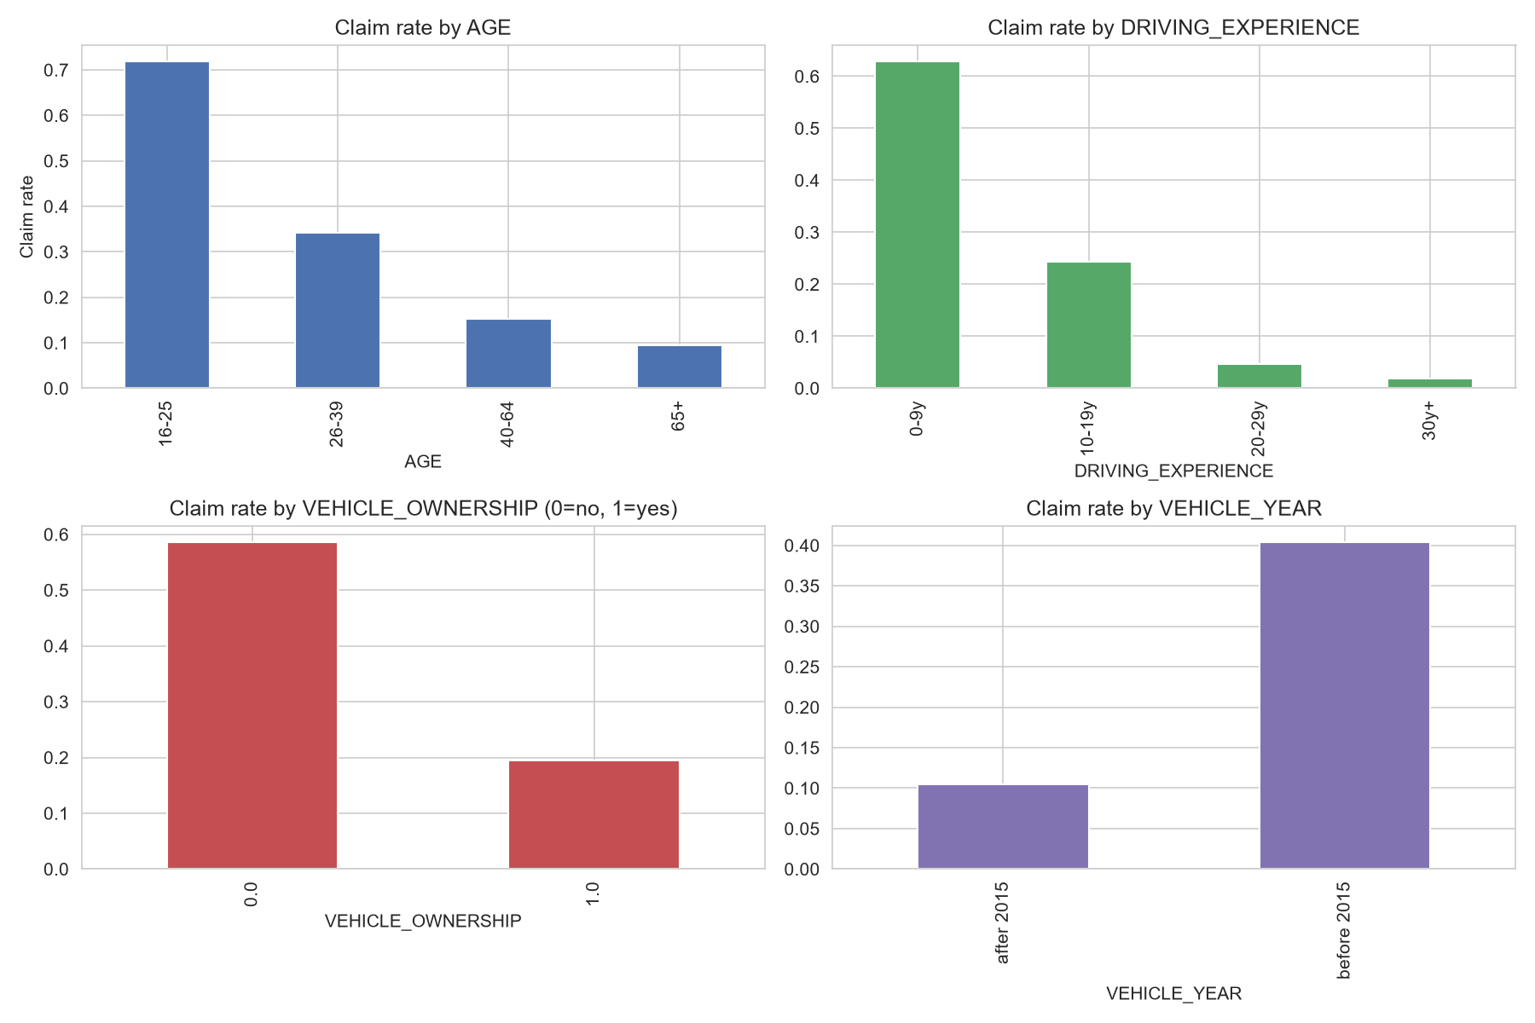
Figure 1. Claim rate against four of the selected features.

4. Model Development and Comparison
Six candidates were trained on Train and evaluated on Validation with an identical metric set: a majority-class Baseline; Logistic Regression; Random Forest (300 trees); and three PyTorch networks — A (Dense 64 → ReLU), B (Dense 128 → 64, ReLU) and C (Dense 128 → 64 with LeakyReLU and Dropout 0.30).
Model | Accuracy | Precision | Recall | F1 | ROC-AUC
Random Forest | 0.8549 | 0.7460 | 0.8141 | 0.7786 | 0.9324
Neural Net B | 0.8294 | 0.7033 | 0.7878 | 0.7432 | 0.9025
Neural Net C | 0.8304 | 0.7002 | 0.8022 | 0.7477 | 0.8979
Neural Net A | 0.8304 | 0.7085 | 0.7794 | 0.7423 | 0.8960
Logistic Regression | 0.8273 | 0.7083 | 0.7631 | 0.7346 | 0.8932
Baseline | 0.6866 | 0.0000 | 0.0000 | 0.0000 | 0.5000
Table 2. Validation-set performance for all six candidates, sorted by ROC-AUC.
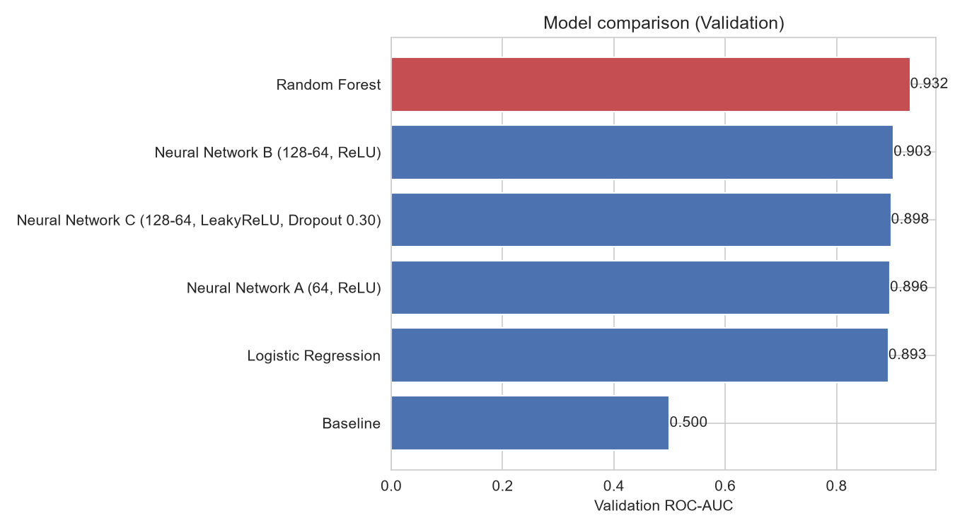
Figure 2. Validation ROC-AUC by model.
Random Forest achieved the strongest discrimination performance among all six candidates and was selected as the final model.

5. Final Model and Results

5.1 Selection and Threshold
Selection rule: highest Validation ROC-AUC, with F1 breaking ties — selected once, before Test is touched. Random Forest achieved the highest Validation ROC-AUC (0.9324) and was refit on Train + Validation before the single Test evaluation. The ML decision threshold — selected on Validation by sweeping candidate thresholds from 0.05 to 0.95 and maximizing F1 — is 0.35. This answers a purely statistical question, independent of dollar figures; a separate business/economic threshold is derived in Section 6.1.

5.2 Test Performance
The Test partition (10,001 records) was untouched until this point and is scored exactly once, at the ML threshold (0.35).
Metric | Test result | 95% CI
Accuracy | 0.8546 | [0.8476, 0.8616]
Precision | 0.7131 | [0.6988, 0.7271]
Recall | 0.8966 | [0.8868, 0.9077]
F1 | 0.7944 | [0.7845, 0.8054]
ROC-AUC | 0.9350 | [0.9304, 0.9394]
PR-AUC | 0.8562 | [0.8450, 0.8682]
Table 3. Final Test results (Random Forest, threshold = 0.35) with 95% bootstrap confidence intervals (1,000 resamples).
Confusion matrix at threshold 0.35 (n = 10,001): 5,738 true negatives, 1,130 false positives, 324 false negatives, 2,809 true positives.
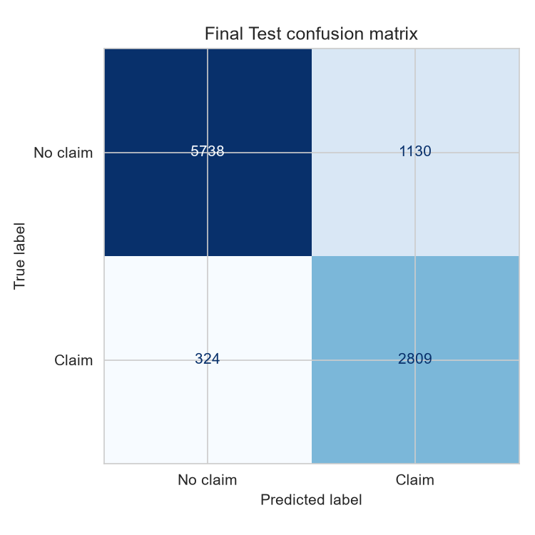
Figure 3. Test confusion matrix, threshold = 0.35.

5.3 Feature Importance and Error Analysis
Permutation importance, computed on the final fitted pipeline against Test, measures the mean drop in ROC-AUC when a feature's values are shuffled. This is an association measured on held-out data, not a causal claim.
Feature | Mean ROC-AUC drop
DRIVING_EXPERIENCE | 0.1303
VEHICLE_OWNERSHIP | 0.0799
VEHICLE_YEAR | 0.0705
ANNUAL_MILEAGE | 0.0613
SPEEDING_VIOLATIONS | 0.0590
AGE | 0.0543
PAST_ACCIDENTS | 0.0448
DUIS | 0.0212
Table 4. Permutation feature importance, sorted by impact.
DRIVING_EXPERIENCE is the most influential feature, followed by VEHICLE_OWNERSHIP and VEHICLE_YEAR — consistent with how underwriters already reason about risk.
At the ML threshold, the model produced 1,130 false positives (low-risk drivers flagged unnecessarily) and 324 false negatives (claimants missed) out of 10,001 Test records. A false negative — an unpriced claim payout — is typically the costlier mistake, which is why the business threshold (Section 6.1) is set lower than the ML threshold.

6. Business Value and ROI
The business/economic threshold reflects an operational decision, not a statistical one: the economic model sweeps the same Validation probabilities through a cost model and picks the threshold maximizing expected annual net benefit in dollars — 0.1, the threshold actually enforced in production. Because a missed claimant costs far more than an unnecessary review, this policy accepts more false positives for fewer false negatives: at 0.1 the model produces 73 false negatives on Test (vs. 324 at 0.35), at the cost of 1,984 false positives (vs. 1,130).
Scenario | Annual apps. | Year-1 ROI | Recurring ROI | Payback (mo.) | Annual net benefit
Conservative | 8,000 | -75.16% | 17.52% | 48.3 | $19,873
Expected | 12,000 | 18.80% | 65.56% | 10.1 | $71,277
Optimistic | 18,000 | 180.30% | 110.78% | 4.3 | $126,135
Table 5. ROI by scenario, business threshold = 0.1. The economic model is a transparent scenario model, not proprietary insurer financial data.
Under Expected-scenario assumptions (12,000 annual applications, $60,000 implementation cost, $18,000/year maintenance), automation reaches 49.21% of applications for a projected Year-1 ROI of 18.80% and payback in 10.1 months. Evaluated once on the untouched Test set, the observed Year-1 ROI is 6.88% — lower than the Expected projection because Test applies Expected-scenario cost assumptions to the actually observed confusion matrix. These are scenario estimates, not promised savings.
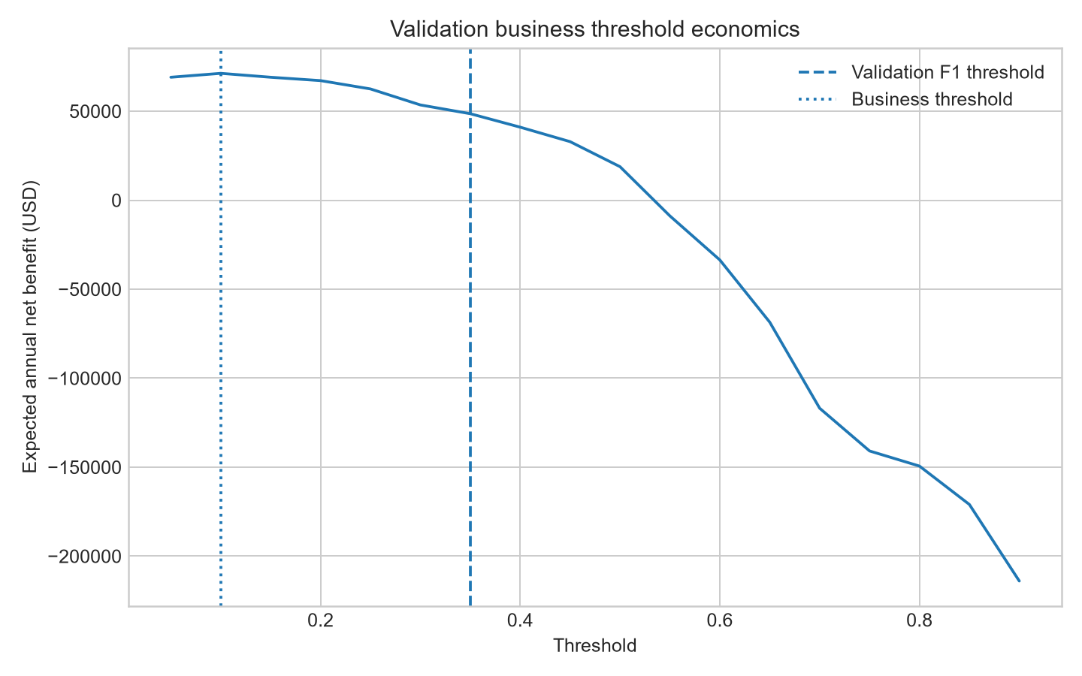
Figure 5. Expected annual net benefit vs. threshold, with the ML threshold (0.35) and business threshold (0.1) marked.

7. System Interfaces
The same artifact, 01_ML_Model/model_v2.pkl, is the single source of truth for every serving surface — no separate model is trained for demo versus production use. A standalone Gradio interface (05_Gradio_Interface/gradio_app.py) is an inference-only demo that loads the pipeline via joblib, never calls .fit(), and displays headline metrics read directly from model_v2_metadata.json. The production web interface pairs a FastAPI backend (06_Production_Interface/backend/, exposing /api/v2/quick-predict and /api/v2/health) with a web frontend, integrating a live vehicle-registry lookup and applying the Section 6.1 business policy to produce an operational recommendation alongside the raw claim probability.
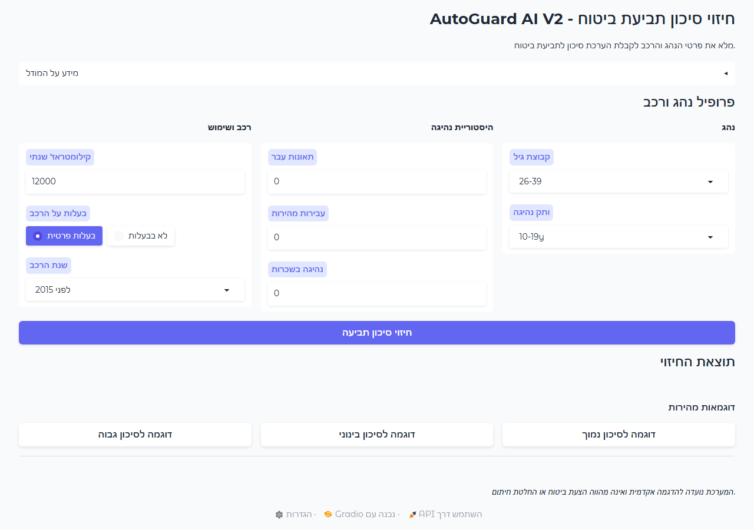 | 
Figure 6. Gradio demo interface (left) and production web interface (right).

8. Conclusion
AutoGuard AI's production model is Random Forest, selected on Validation ROC-AUC among six candidates including a documented baseline and three PyTorch architectures. It reaches a final, one-time Test ROC-AUC of 0.9350 (95% CI [0.9304, 0.9394]) at its statistically selected ML threshold of 0.35. In production, a separately derived, ROI-optimized business threshold of 0.1 governs the actual automate-vs-review decision, projected to deliver a positive Year-1 ROI with sub-year payback under Expected-case assumptions. Every number in this report traces back to the notebook's own artifacts and can be reproduced by re-running 01_ML_Model/AutoGuard_AI_Final_ML_Pipeline.ipynb end to end.

