

Installation and User Guide for

Magento 2 AJAX Infinite Scroll Extension

Table of Contents

1. Installation 3
2. Configuration Settings for Optimiser Base 3
• General Settings 3
3. Configuration Settings for Infinite Scrolling 4
• General Settings 4
4. Front-end Site View of Infinite Scroll 5
• Infinite Scroll with ‘Load More Button’ on the Category Page 5
• Infinite Scroll with Auto Loading on the Category and Search Pages 6
• Auto Loading on the Category Page 7
• Auto Loading on the Search Page 7
• Infinite Scroll with ‘Load More Button’ and Page Number 8

Installation

- Upload Package: Upload the content of the module to your root folder. This will not overwrite the existing Magento folder or files, only the new contents will be added.

- Install Extension: After the successful upload of the package, run below commands on Magento 2 root directory.

composer require scommerce/optimiserbase
php bin/magento setup:upgrade
php bin/magento setup:di:compile
php bin/magento setup:static-content:deploy

Configuration Settings for Optimiser Base
Go to Admin > Stores > Configuration > Scommerce Configuration > Optimiser Base

General Settings
- Enabled – Select “Yes” or “No” to enable or disable the module.
- License Key – Please add the license for the extension which is provided in the order confirmation email. Please note license keys are site URL specific. If you require license keys for dev/staging sites then please email us at core@scommerce-mage.com

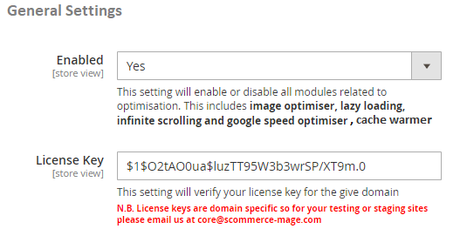
Select “Yes” to enable the module
Enter the License key for the module

Configuration Settings for Infinite Scrolling

Go to Admin > Stores > Configuration > Scommerce Configuration > Infinite Scrolling

General Settings
- Enabled - Select “Yes” or “No” to enable or disable the module.
- Loading Type - Select loading type “Load Automatically” or “Load with Button”.
- Button Label - Enter button label. This will be shown only when the “Loading Type” is set to “Load with Button”.
- Button Label Font Color - Set font color for "Load with Button" which appears on site front-end.
- Button Label Background Color - Select button label background color. This will be shown only when the “Loading Type” is set to “Load with Button”.
- Button Label Size – Define font size for the “Load with Button” which appears on the site.
- Display Page Numbers (Yes/No) – Select “Yes” to show the page information on the side panel.
- Grid Dom Class – This is the class for grid view of product listing pages.
- List Dom Class – This is the class for list view of product listing pages.

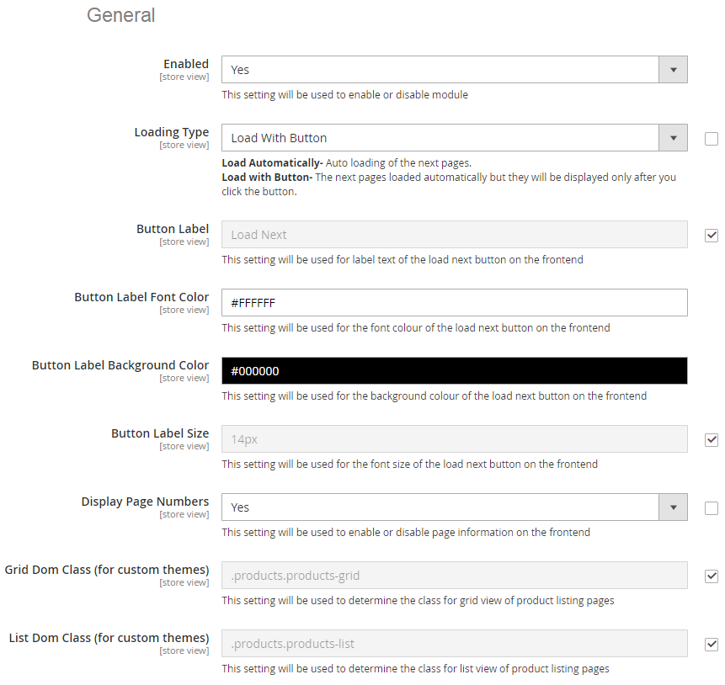
Select “Yes” to enable the module

Please select the loading type

Please add the Button Label text

Please select the Button Label Font Color

Please select the Button Label Background Color

Please select the Button Label Size

Select “Yes” to enable the Display Page Numbers

Please add the Grid Dom Class for custom themes

Please add the List Dom Class for custom themes

Front-end Site View of Infinite Scroll

Infinite Scroll with ‘Load More Button’ on the Category Page – You can display the “Load More Button” on the category page by selecting “Load with Button” option from Admin > Stores > Configuration > Infinite Scrolling > Loading Type.

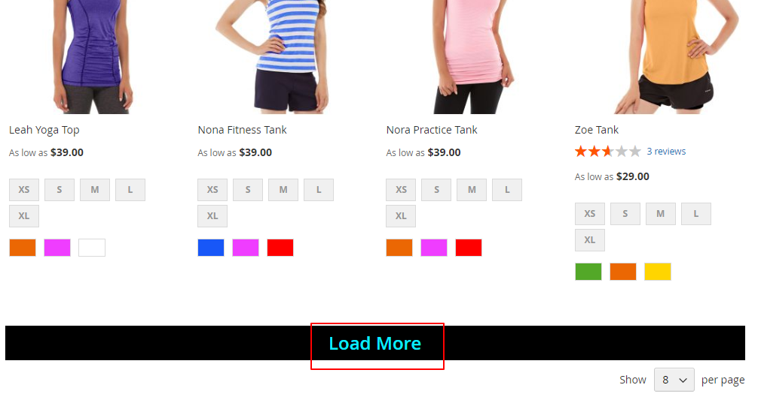

Infinite Scroll with Auto Loading on the Category and Search Pages – You can implement auto loading on the category and search pages by selecting the option "Load Automatically" from Admin > Stores > Configuration > Infinite Scrolling > Loading Type.

Auto Loading on the Category Page

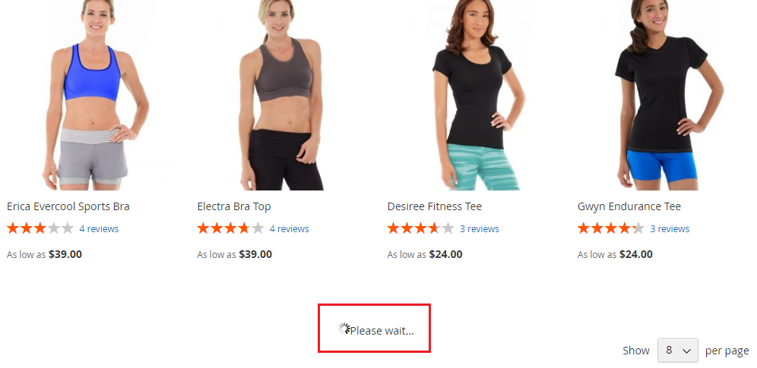

Auto Loading on the Search Page

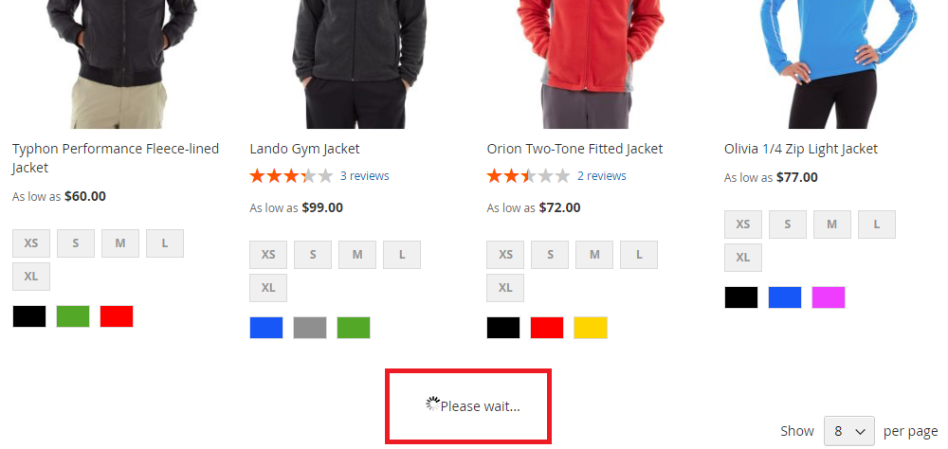

Infinite Scroll with ‘Load More Button’ and Page Number – To display Load More Button with page numbers on category and search pages first select option “Load with Button” from Admin > Stores > Configuration > Infinite Scrolling > Loading Type and then select “Yes “ from Admin > Stores > Configuration > Infinite Scrolling > Display Page Numbers. This will display page numbers with Load More Button as shown in screen grab below.

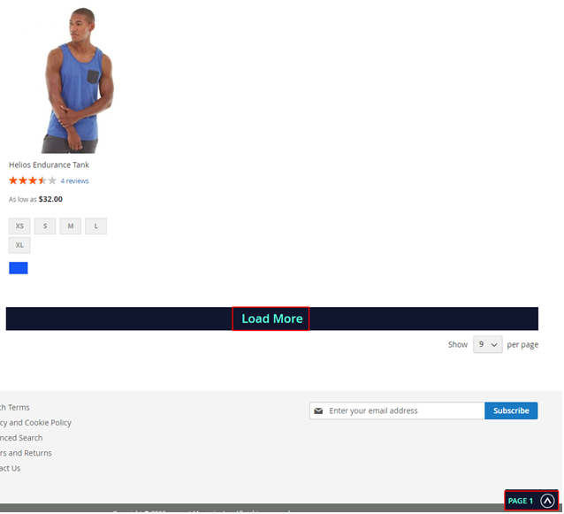

Please contact core@scommerce-mage.com for any queries.

