

Installation and User Guide for
Magento 2 Google Page Speed Optimizer Extension

Table of Contents

1. Installation 4
• Upload Package 4
• Install Extension 4
2. Configuration Settings for Optimiser Base 4
• General Settings 4
3. Configuration Settings for Speed Optimiser 5
• General Settings 5
• Minify HTML 5
• Javascript Settings 6
• CSS Settings 7
• Flat Tables 7
4. Configuration Settings for Lazy Loading 8
• General Settings 8
• Lazy Loading on the Homepage 10
• Home Page Excluded from Lazy Loading 10
• Lazy Loading on the Category Page 11
• Lazy Loading on the Search Page 12
• Lazy Loading on the Cart Page 13
5. Configuration Settings for Image Optimizer 14
• General Settings 14
• Compress/Optimize Product Image. 17
• Compress/Optimize Category Image 17
• Compress/Optimize CMS Image 18
6. Configuration Settings for Infinite Scrolling 18
• General 18
7. Front-end Site View of Infinite Scroll 20
• Infinite Scroll with ‘Load More Button’ on the Category Page 20
• Infinite Scroll with Auto Loading on the Category and Search Pages 20
• Auto Loading on the Category Page 21
• Auto Loading on the Search Page 22
• Infinite Scroll with ‘Load More Button’ and Page Number. 22
8. Configuration Settings for Cache Warmer 24
• General Settings 24
• Cron Settings 26
9. Cache Warmer Grid 26
10. Console Commands 28
• Category Page 28
• Product Page 28
• CMS Page 28
11. Front-end Screenshots 28
• Cache Hit for the category page after the execution of category page command 28
• Cache Miss for the Category Page 29

Installation

- Upload Package: Upload the content of the module to your root folder. This will not overwrite the existing Magento folder or files, only the new contents will be added.

- Install Extension: After the successful upload of the package, run below commands on Magento 2 root directory.

composer require scommerce/optimiserbase
php bin/magento setup:upgrade
php bin/magento setup:di:compile
php bin/magento setup:static-content:deploy

Configuration Settings for Optimiser Base
Go to Admin > Stores > Configuration > Scommerce Configuration > Optimiser Base

General Settings
- Enabled – Select “Yes” or “No” to enable or disable the module.
- License Key – Please add the license for the extension which is provided in the order confirmation email. Please note license keys are site URL specific. If you require license keys for dev/staging sites then please email us at core@scommerce-mage.com

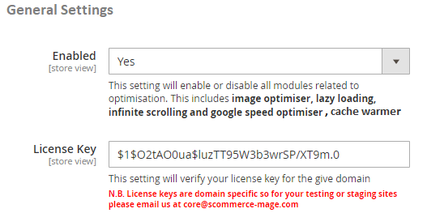
Select “Yes” to enable the module
Enter the License key for the module

Configuration Settings for Speed Optimiser
Go to Admin > Stores > Configuration > Scommerce Configuration > Speed Optimiser

General Settings
- Enabled - Select “Yes” or “No” to enable or disable the module.

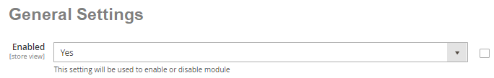
Select “Yes” to enable the module

Minify HTML
- Enabled - Select “Yes” or “No” to enable or disable the module. If set to “Yes” then the module will remove all the unnecessary comments, line breaks, tabs and spaces from your HTML to reduce its size.
- Defer Iframes – Select “Yes” or “No”. If set to “Yes” then attribute defer will be added to the iframe.

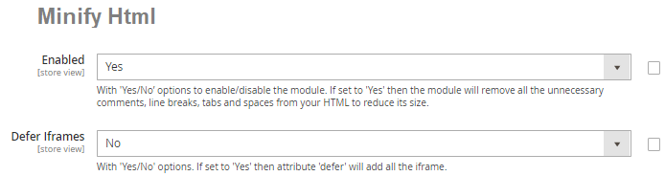
Select “Yes” to enable the minify Html
Select “Yes” to enable the Defer Iframes

Javascript Settings
- Merge Javascript Files – Select “Yes” or “No”. If set to “Yes” then it will merge all JS files into one to reduce the number of queries.
- Enable Javascript Bundling – Select “Yes” or “No”. If set to “Yes” then it will combine all JS files into few bundles and download them for each page. This will save time by reducing the number of server requests.
- Javascript Files Minification – Please select “Yes” or “No”. If set to “Yes” then the module will remove all the unnecessary comments, line breaks, tabs and spaces from your Java Script to reduce its size.
- Move Javascript to Page Bottom (footer) – Select “Yes” or “No”. If set to “Yes” then it will load all the important content before loading JS which will improve pages loading time.
- Exclude Pages to Move Javascript to Page Bottom – Please select page(s) you want to exclude from move javascript to page bottom.

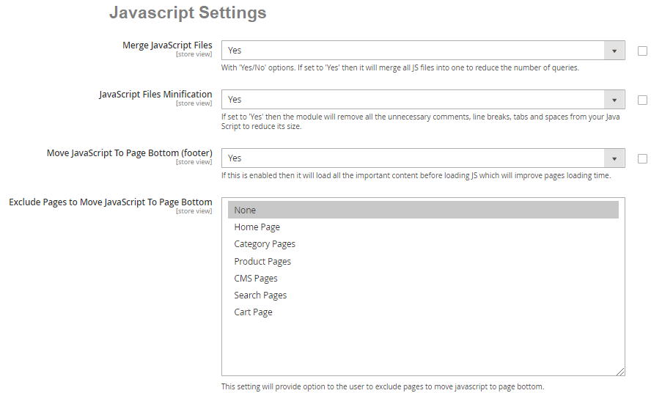
Select “Yes” to merge the Javascript files
Select “Yes” for Javascript files minification
Please select the exclude pages to Move Javascript
Select “Yes” for Move Javascript to Page Bottom

CSS Settings
- Merge CSS Files – Select “Yes/No”. If set to “Yes” then it will merge all CSS files into one to reduce the number of queries.
- Defer Font Loading – Select “Yes/No”. If set to “Yes” then browser will load the page with system fonts and replace them with your fonts when they are loaded. It makes store pages load faster.
- CSS Files Minification – Select “Yes” or “No”. If set to “Yes” then the module will remove all the unnecessary comments, line breaks, tabs and spaces from your CSS to reduce its size.

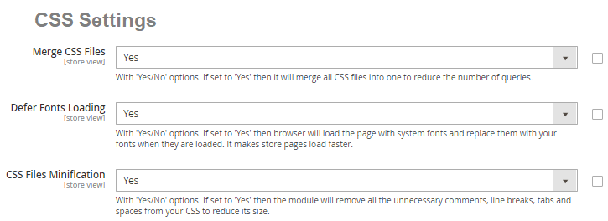
Select “Yes” to Merge the CSS file
Select “Yes: for Defer Fonts Loading
Select “Yes” for CSS Files Minification

Flat Tables
- Use Flat Catalog Category – Select “Yes/No”. If set to “Yes” then it will short the query in the database. The shorter the query, the better the store performance. Pays off for large stores with massive databases.
- Use Flat Catalog Product – Select “Yes/No”. If set to “Yes” then it will short the query in the database.

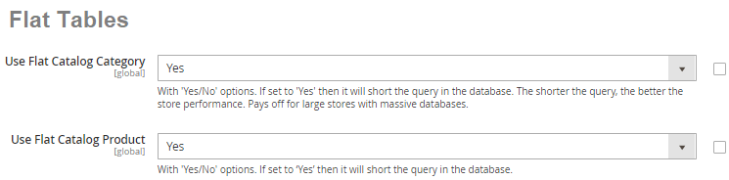
Select “Yes” to Use Flat Catalog Category
Select “Yes” to Use Flat Catalog Product

Configuration Settings for Lazy Loading
Go to Admin > Stores > Configuration > Scommerce Configuration > Lazy Loading

General Settings
- Enabled - Select “Yes” or “No” to enable or disable the module.
- Preload Images – Select “Yes” to preload the images.
- Skip Images Count – Enter a valid image count to skip the images from lazy load. Based on the count this option will decide how many images to load without lazy loading.
- Ignore Images that Contain – Provide a part of an image tag content into the field to exclude the image from the lazy load.
- Exclude Pages – Select the page(s) from multi-select options to exclude from the lazy load.

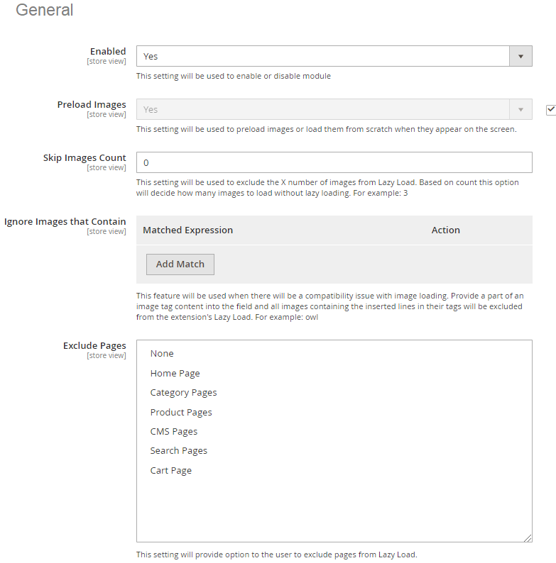
Select “Yes” to enable the module

Please select the preload images or load them

Please select the skip images count

Please select the exclude pages

Please select ignore images that contain

Lazy Loading on the Homepage – Enable the module to implement lazy loading on the homepage, here is the configuration path Admin > Stores > Configuration > Lazy Loading- Enable "Yes". In the below screen grab you can see the product "Radiant Tee" with lazy loading.

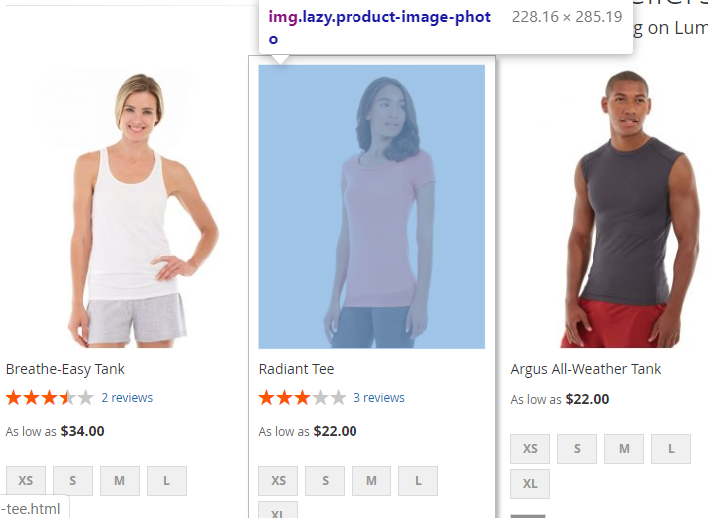

Home Page Excluded from Lazy Loading – There is an option " Exclude Pages" available in the backend, from where you can select the page to exclude from the lazy loading.

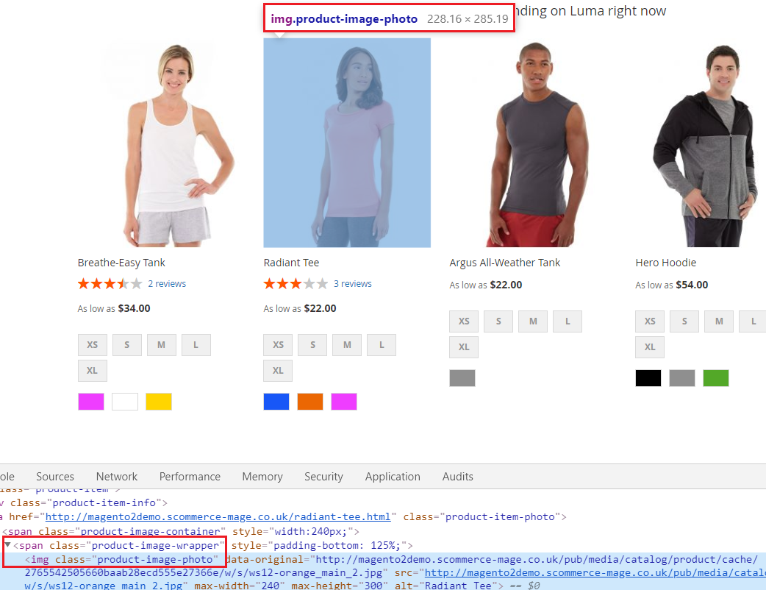

Lazy Loading on the Category Page – Enable the module to implement the lazy loading on the category page Admin > Stores > Configuration > Lazy Loading- Enable "Yes".
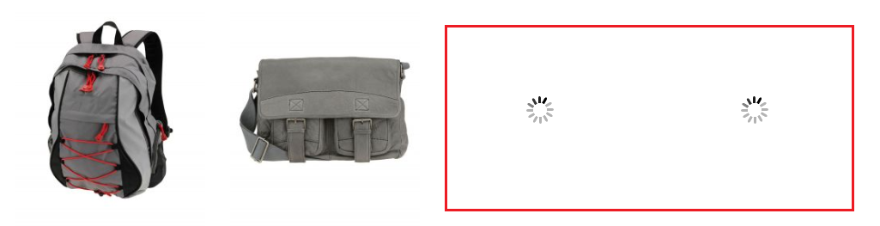

Lazy Loading on the Search Page – There is an option available in the configuration settings at Admin > Stores > Configuration > Lazy Loading- Enable and by selecting "Yes" or "No" you can enable or disable the lazy loading on the search page.

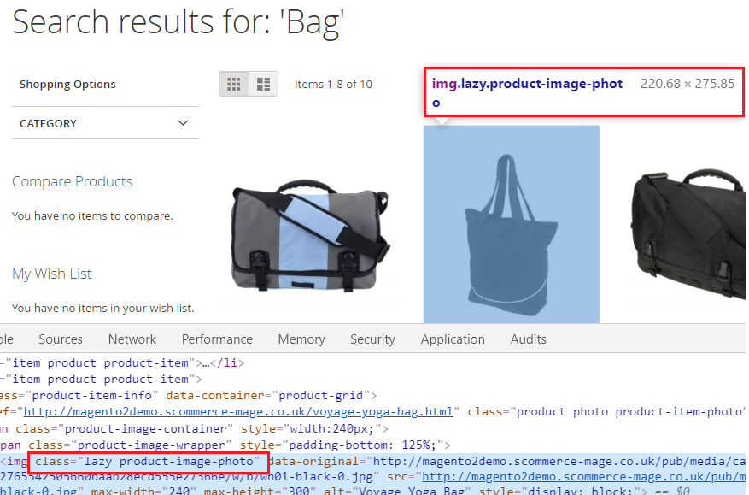

Lazy Loading on the Cart Page – You can implement lazy loading on the cart page by by enabling the module from the back-end configuration Admin > Stores > Configuration > Lazy Loading- Enable "Yes".

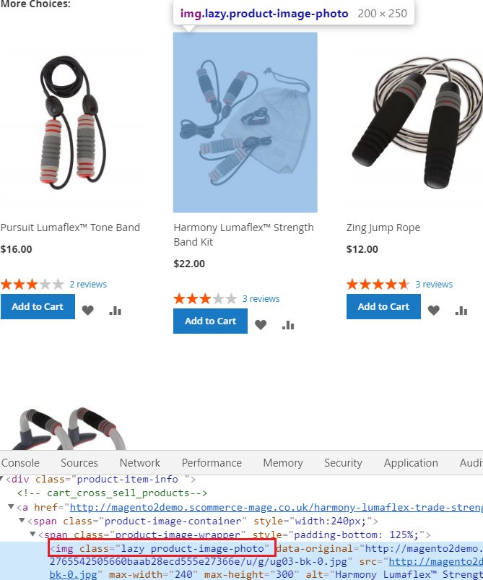

Configuration Settings for Image Optimizer

Go to Admin > Stores > Configuration > Scommerce Configuration > Image Optimizer

General Settings
- Enabled - Select “Yes” or “No” to enable or disable the module.
- Compress Images while uploading (All pages, CMS, Category and Product): Select available options to enable compression for new images uploaded via Magento admin. We recommend this to be enabled because all the new things will be compressed straight away.
- Number of images to processed – Define how many number of images you want to process when the cron job runs. Please note this number should be reasonable especially when you have multiple stores and many additional product images.
- Include folders – Please select list of folders you want to include for compressing the image.
- Compress Cached Product Images (Yes/No) – Select “Yes” to compress cached product images generated by Magento. We could recommend to leave this setting turned off especially when you clear your cached images frequently and you have more than 5 additional images on the product page.
- Image Compression Provider – Please select image compression provider.
Provider API URL: Provider API URL
smush it – http://api.resmush.it/ws.php?img=
imageoptim – https://im2.io/{ {username} }/full/
kraken.io – https://api.kraken.io./v1/url
- API Key – Please enter API Key (if provider is kraken.io).
- API Secret Key – This will be required for certain providers like kraken.io
- Exclude folders – Please enter the list of folders you want to exclude from media directory (comma separated) for example foldername1, foldername2, /foldername /subfolder1, foldername/subfolder2
- Backup Images (Yes/No) – Select “Yes” to enable this feature to backup original images before compressing original file.
- Debugging (Yes/No) – Select “Yes” to enable debugging. This will write logs in var – log – imageoptimize.log
- Image Optimiser Schedule – Please define the Cron frequency to optimize images.

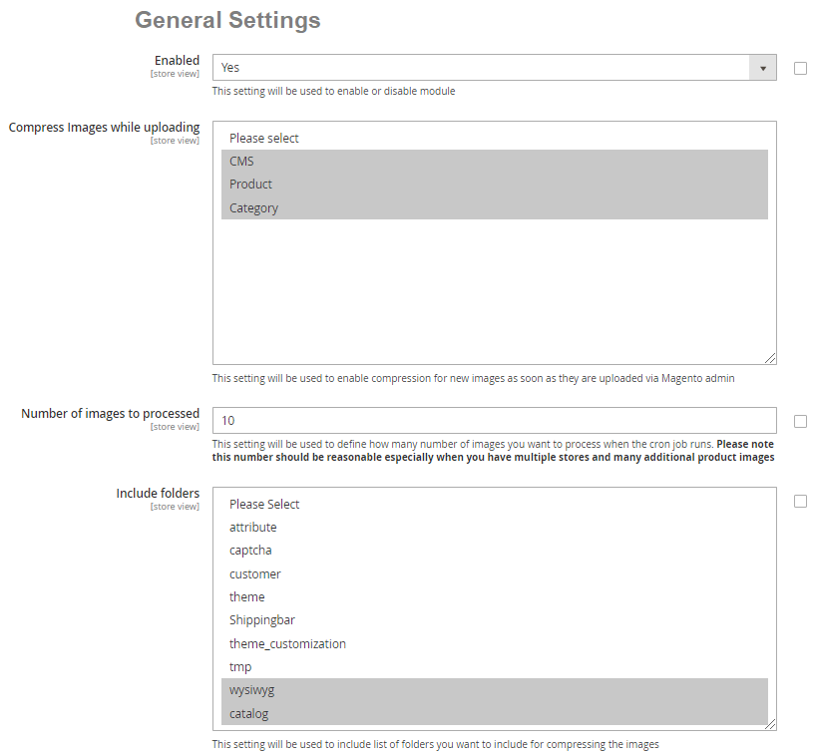
Select “Yes” to enable the module

Please select the compress image while uploading
Please add the number of images to processed

Please select the include folders for compressing

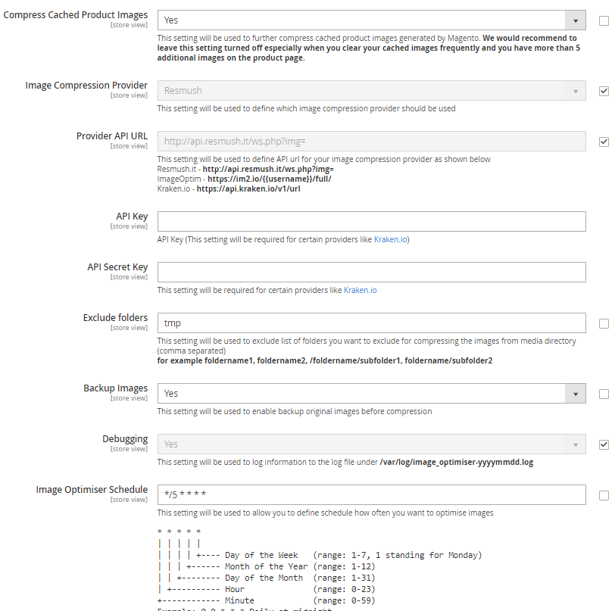
Select “Yes” to compress cached product images

Please add the Image compression provider

Please provide the API URL

Please provide the API Key

Please provide the API Secret Key

Please add the exclude folders for compressing

Select “Yes” to Backup the image before compression

Select “Yes” to log information to the log file

Please add the image optimiser schedule for cron

Compress/Optimize Product Image - You can compress product images by enabling module from Admin > Stores > Configuration > Scommerce Configuration > Image Optimiser > Enabled - "Yes" > Compress Images while uploading - Select "Product ".

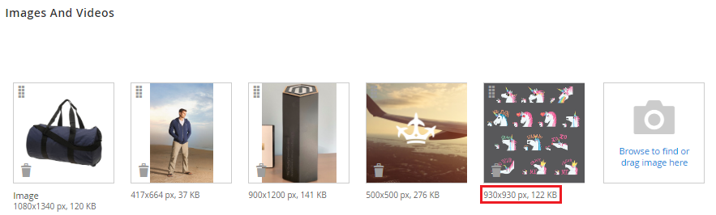

Compress/Optimize Category Image - You can compress category images by enabling module from Admin > Stores > Configuration > Scommerce Configuration > Image Optimiser > Enabled - "Yes" > Compress Images while uploading - Select "Category ".

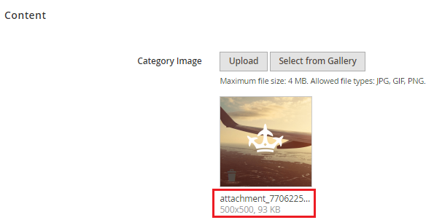

Compress/Optimize CMS Image - You can compress CMS images by enabling module from Admin > Stores > Configuration > Scommerce Configuration > Image Optimiser > Enabled - "Yes" > Compress Images while uploading - Select "CMS ".

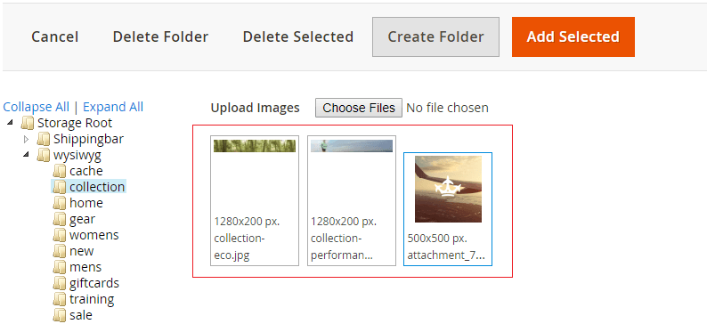

Configuration Settings for Infinite Scrolling

Go to Admin > Stores > Configuration > Scommerce Configuration > Infinite Scrolling

General
- Enabled - Select “Yes” or “No” to enable or disable the module.
- Loading Type - Select loading type “Load Automatically” or “Load with Button”.
- Button Label - Enter button label. This will be shown only when the “Loading Type” is set to “Load with Button”.
- Button Label Font Color - Set font color here for "Load Next" button which appears on site frontend.
- Button Label Background Color - Select button label background color. This will be shown only when the “Loading Type” is set to “Load with Button”.
- Button Label Size – Define font size for the “Load next Button” which appears on the site.
- Display Page Numbers (Yes/No) – Select “Yes” to show the page information on the side panel.
- Grid Dom Class – This is the class for grid view of product listing pages.
- List Dom Class – This is the class for list view of product listing pages.

–

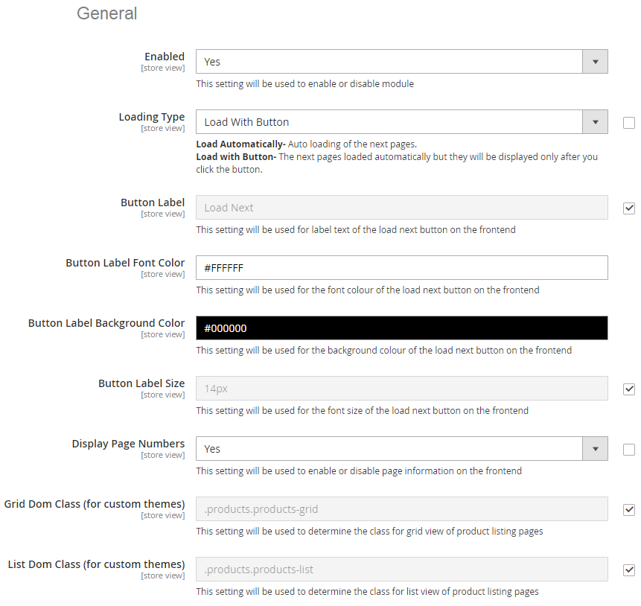
Select “Yes” to enable the module

Please select the loading type

Please add the Button Label Text

Please select the Button Label Font Color

Please select the Button Label Background Color

Please select the Button Label Size

Select “Yes” to enable the display page numbers.

Please add the Grid Dom Class for custom themes

Please add the List Dom Class for custom themes

Front-end Site View of Infinite Scroll

Infinite Scroll with ‘Load More Button’ on the Category Page – You can display the “Load More Button” on the category page by selecting “Load with Button” option from Admin > Stores > Configuration > Infinite Scrolling > Loading Type.

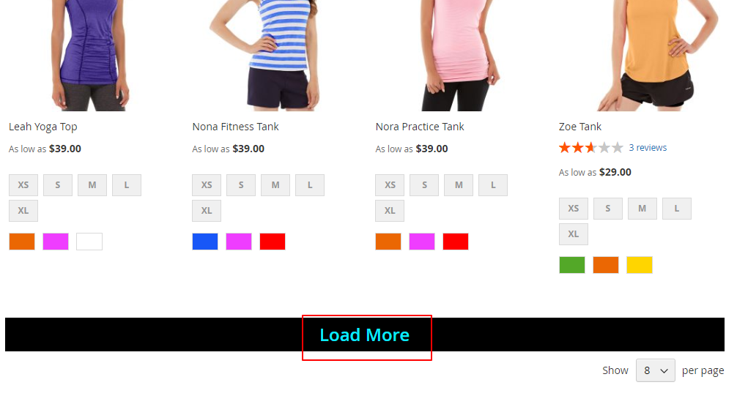

Infinite Scroll with Auto Loading on the Category and Search Pages – You can implement auto loading on the category and search pages by selecting the option "Load Automatically" from Admin > Stores > Configuration > Infinite Scrolling > Loading Type.

Auto Loading on the Category Page

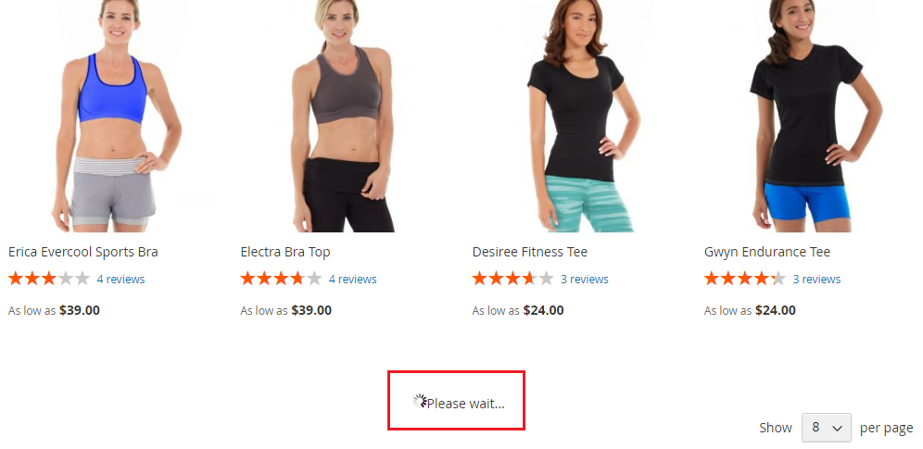

Auto Loading on the Search Page

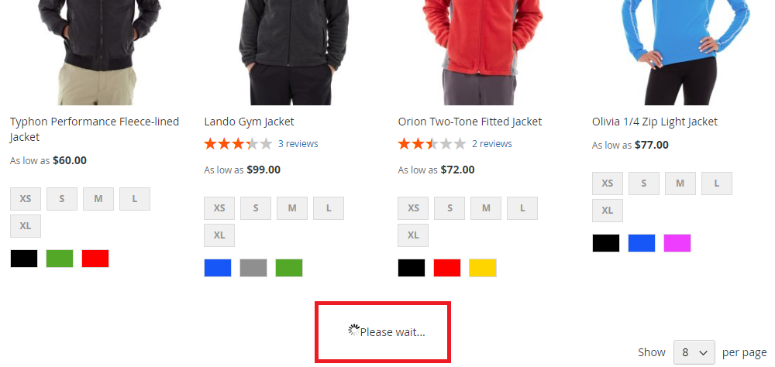

Infinite Scroll with ‘Load More Button’ and Page Number – To display Load More Button with page numbers on category and search pages first select option “Load with Button” from Admin > Stores > Configuration > Infinite Scrolling > Loading Type and then select “Yes “ from Admin > Stores > Configuration > Infinite Scrolling > Display Page Numbers. This will display page numbers with Load More Button as shown in screen grab below.

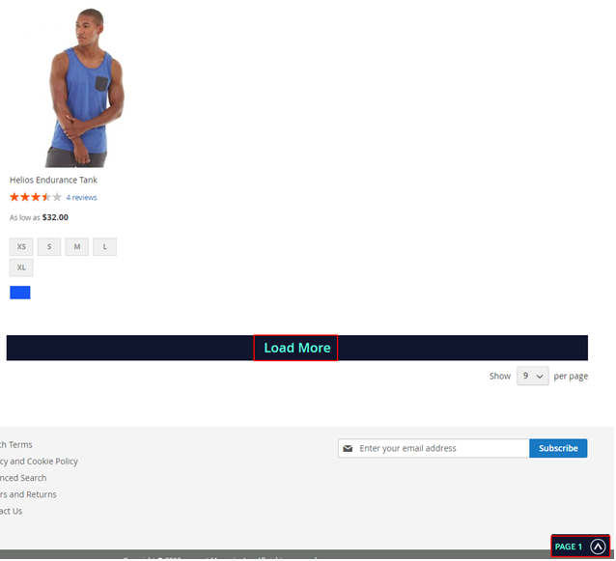

Configuration Settings for Cache Warmer

Go to Admin > Stores > Configuration > Scommerce Configuration > Cache Warmer

General Settings
- Enabled - Select “Yes” or “No” to enable or disable the module
- Regenerate cache after page update - Please select "Yes" or "No" to regenerate cache for updated page.
- Select Page - Please select the page(s) from the multi-select option. This will regenerate the cache selected page(s) on page update.
- Can Regenerate Cache Manually - Please select " Yes" or "No". If set to "Yes" then you can regenerate cache manually from cache warmer grid.
- Generate Log - Select "Yes" to generate the log.

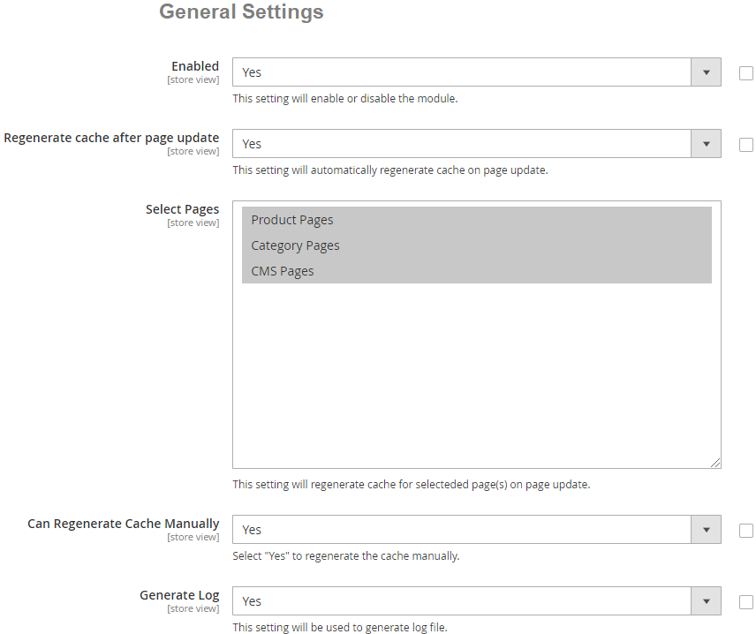
Select pages(s) to regenerate cache on page update
Select "Yes" to enable the module

Select “Yes” to regenerate cache on page update
Select “Yes” to regenerate cache manually

Select "Yes" to generate the log

Cron Settings
- Cache Cron Schedule - Schedule cron job to regenerate the cache for all non cached page(s).
- Delay in Request - Please define delay in request in seconds. This setting will apply a delay in seconds between the concurrent request.
- Number of Concurrent Regeneration request - Please define the number of concurrent request.

Schedule the cron job to generate the cache for all non cached pages
Define delay in request time in seconds
Define number of concurrent regeneration request

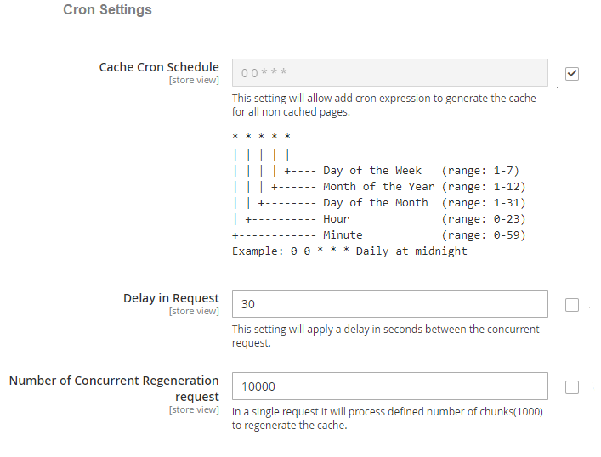

Cache Warmer Grid

When you enable the module and set General Settings > Can Regenerate Cache Manually > to "Yes" then it adds an additional option "Regenerate" under the "Actions->Select" drop-down at Admin > System > Cache Warmer > Actions. This grid will have Id, Page URL, Page Type - (Home, Product, Category, CMS), Status - (Cached/Un-cached), Last Cached - (Date, Time) and Action- (Regenerate, Delete).

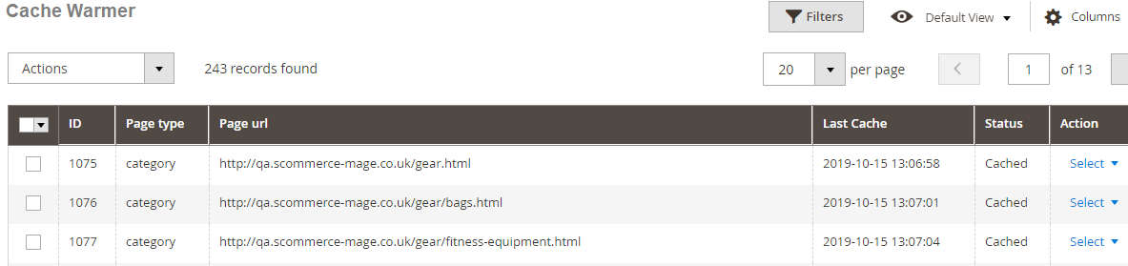

- Regenerate - It regenerates cache manually for Category/Product/CMS pages. By clicking on the "Regenerate" action you can regenerate cache manually for a specific URL.
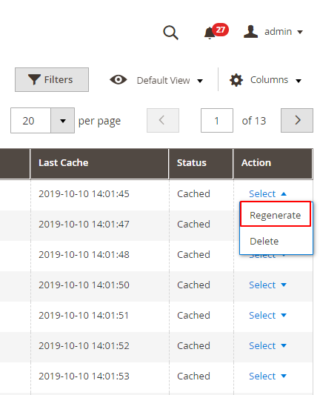

10. Console Commands

You can regenerate cache for Product/Category/CMS page(s) by running the following
console commands: -

- Category Page - If you want to regenerate cache for the category page then run this command scommerce:cachewarmer:category

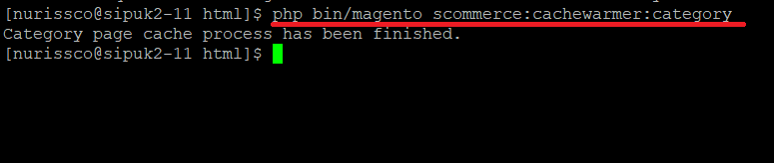

- Product Page - To regenerate cache for the product page(s), use this command scommerce:cachewarmer:product

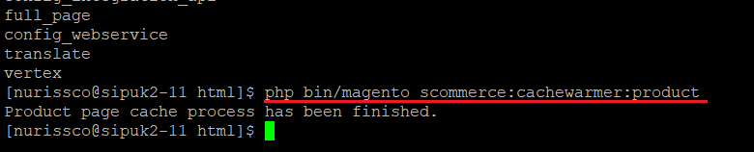

- CMS Page - To regenerate cache for CMS page please use this command scommerce:cachewarmer:cmspage

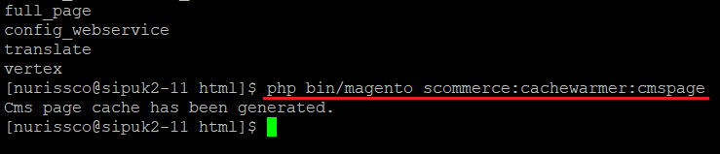

11. Front-end Screenshots

- Cache Hit for the category page after the execution of category page command - When you run the command for category then it regenerates the cache. On the front-end you can debug the cache and check the status "Hit" or "Miss" using browser tool (Inspect element) under Network > Select Page URL > Header > Cache Debug: HIT

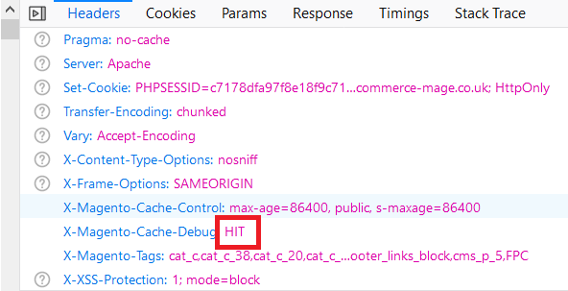

- Cache Miss for the Category Page - Flush the cache by executing the command (c:f) and then check cache using browser tool .

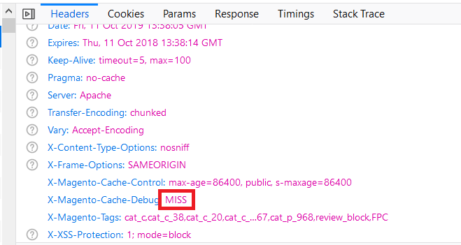

Please contact core@scommerce-mage.com for any queries.

