

**IN THE UPPER TRIBUNAL Appeal No.** **UA-2023-001629-T**

**ADMINISTRATIVE APPEALS CHAMBER NCN: [2024] UKUT 326 (AAC)**

On appeal from the Decision of Simon Evans, Deputy Traffic Commissioner for the North East of England dated 1st September 2023

**ANDERSON REMOUNTS LIMITED**

**Appellant**

**Before: Her Honour Judge Beech, Judge of the Upper Tribunal**

**Kerry Pepperell, Specialist Member of the Upper Tribunal**

**Gary Roantree, Specialist Member of the Upper Tribunal**

Hearing date: 8th October 2024

**Representation:**

Appellant: None

**DECISION**

**The appeal is ALLOWED** and the matter is remitted for redetermination on all issues

**Subject Matter:** Good repute, financial standing and professional competence

**Cases referred to:** None

**REASONS FOR DECISION**

1. This is an appeal from the decision of the Deputy Traffic Commissioner (“DTC”) for the North East of England dated 1st September 2023 in which the Appellant’s licence (OB2040287) was revoked and its director disqualified from holding or obtaining an operator’s licence in any traffic area in any capacity for a period of two years.
2. On 3rd October 2023, the Appellant made an application for a stay to the DTC which was granted on 6th October 2023 as a result of material errors being present in the DTC’s decision. The DTC invited the Tribunal to set aside his decision of 1st September 2023 and remit the matter for a rehearing. The Appellant then filed an Appellant’s Notice on 6th November 2023 and an extension of time was granted to do so.
3. This appeal was determined on the papers. In view of the DTC’s acceptance that errors had been made in his decision, the Tribunal is satisfied that the appropriate course of action is to allow the appeal and remit the matter for redetermination on all issues. The appeal is allowed.

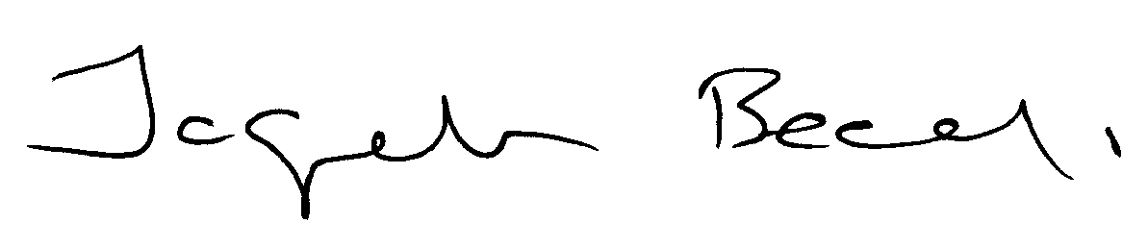

**Her Honour Judge Beech**

**Judge of the Upper Tribunal**

**14th October 2024**