Gallery 2, Stage 2: Plan a speech

It is Christmas 1914. You are British Prime Minister Herbert Asquith. Like most British people, you thought the war would be over by Christmas. It is now obvious to everyone that it will not be over for some time.

You are going to give a speech in Parliament that will be reported in all the newspapers. Your aim is to remind people why Britain went to war in August 1914 and to convince them that the cause is worth the suffering.

Use the boxes in the diagram below to plan your speech. In each box, make a list of the key points you want to make and the evidence you will use to convince people you are right.
Points and evidence about Germany being a threat to Britain
Points and evidence about Belgium
Points and evidence about supporting Russia and France
PM Herbert Asquith
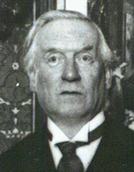
Points and evidence about public support for the war

