Name: _____________________
Class: _____________________

Worksheet

Everyday Life – Salvage

Tasks

The Ministry of Information was the government department responsible for producing these posters. For this task, imagine that you are working in the Ministry of Information during the war. Two new sets of posters have been produced for the Salvage campaign to go up in public places. Your job is to decide which of these sets should be used, and write a short report explaining your choice.

Set 1: Serious factual modern images:
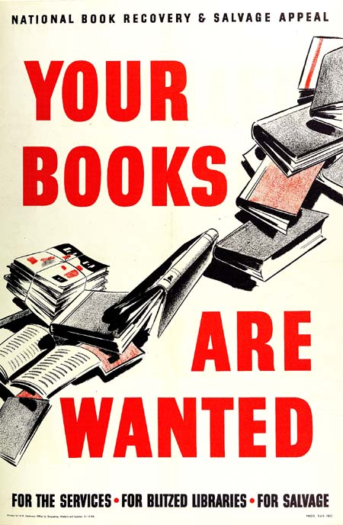 | 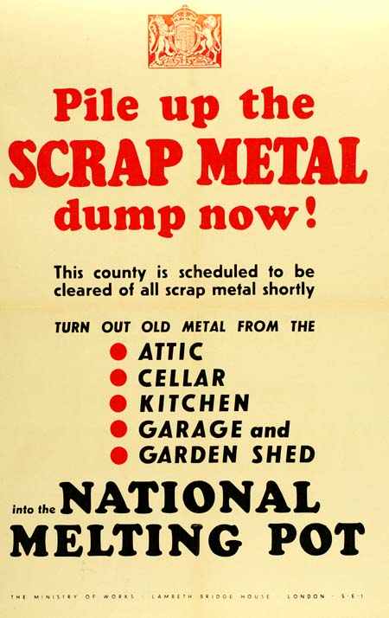

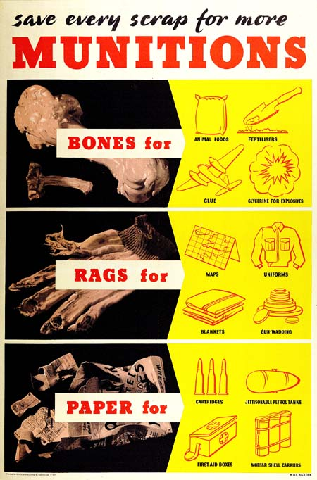 | 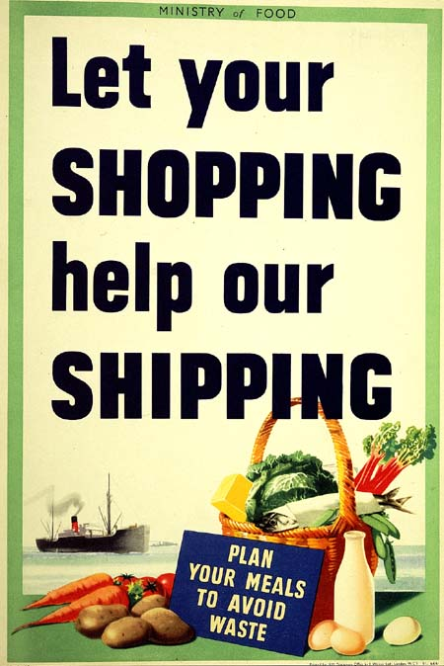

Set 2: Bright Cartoon Characters:
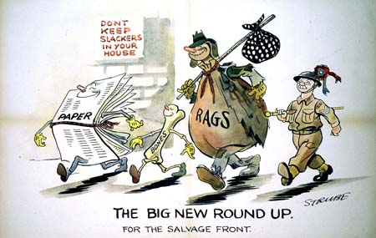 | 